# Statistical methods

Continuous variables were described by their means and SDs, medians and IQRs, and their range; while categorical variables were described by their counts and percentages in each category.

Average treatment effects were estimated using multilevel models with a random effect for participant. All reported models were adjusted for the sex of the participant (to correspond to the sex-stratified randomization lists). We also estimated a model with an added period effect, and another that also included an adjustment for period-specific baseline values of the outcome measure (REF). Following advice from Senn (REF), we did not formally test for a carry-over effect. All model-based estimates are reported with 95% CIs and p-values based on conditional F-tests with Kenward-Roger degrees of freedom (REF). We did not apply any adjustment for multiple testing, but have provided enough information for the reader to do so it they wish. Data were analysed on an intent-to-treat basis.

Senn REF: Cross-over Trials in Clinical Research. Stephen Senn. Second Edition: Published August 2002 ISBN 0 471 49653 7

KR REF: Ulrich Halekoh, Søren Højsgaard (2014)., A Kenward-Roger Approximation and Parametric Bootstrap Methods for Tests in Linear Mixed Models - The R Package pbkrtest., Journal of Statistical Software, 58(10), 1-30., <http://www.jstatsoft.org/v59/i09/>

To evalaute the possilbity of heterogeneity of treatment effects, we followed the advice of Cortes et al. (REF) and calulated the various outcome variances for the baseline and end-of-period values under the active treatment condtion, and tested wheher the resulting outcome-specific variance ratios were equal to 1 using a two-sided Pitman Morgan test for paired observations (REF). We reported exact p-values from this test.

Cortes REF: Cortés J, González JA, Medina MN et al. Does evidence support the high expectations placed in precision medicine? A bibliographic review [version 5; peer review: 2 approved, 1 approved with reservations, 3 not approved]. F1000Research 2019, 7:30 (<https://doi.org/10.12688/f1000research.13490.5>)

Pitman-Morgan REFs: Sachs L: Applied Statistics: A Handbook of Techniques. 2nd ed. New York: Springer-Verlag, 1984.

Morgan, W.A. (1939) A test for the significance of the difference between two variances in a sample from a normal bivariate distribution. Biometrika, 31, 13-19.

All analyses were conducted using R language for statistical computing software V3.6.0 (2019-04-26). We used the lme4 package (REF) to estimate mixed effects models; ggplot2 (REF) to generate plots; and sjPlot to produce tables of model results. All anonymized data and the code used for the analysis and to generate outputs can be found on the Open Science Framework (<https://osf.io/zq4y9/>).

Table 1. Respondent characteristics

|  |  |  |  |  |
| --- | --- | --- | --- | --- |
| Variable | N | Mean SD | Median [IQR] | (Min, Max) |
| Sequence | 83 | 0.5 ± 0.5 | 0 (0, 1) | (0, 1) |
| Sex | 83 |  |  |  |
| Male |  | 46 (55.4%) |  |  |
| Female |  | 37 (44.6%) |  |  |
| Age Screening | 83 | 57.7 ± 6.2 | 57 (52.5, 63) | (45, 70) |
| Height m | 83 | 1.7 ± 0.1 | 1.7 (1.6, 1.8) | (1.5, 1.9) |
| Weight Kg Screen | 83 | 80.4 ± 13 | 80.9 (70.6, 91) | (53.5, 106.3) |
| Bmi Screening | 83 | 27.7 ± 3.5 | 27.9 (25, 29.9) | (20.4, 37.2) |
| Sbpscreening | 83 | 140.4 ± 10.1 | 140 (132.5, 146) | (124, 171) |
| Dbpscreening | 83 | 89.5 ± 8.8 | 89 (83.5, 95) | (67, 112) |
| Smoking Ever | 83 |  |  |  |
| No |  | 60 (72.3%) |  |  |
| Yes |  | 23 (27.7%) |  |  |
| Alcohol Consumption | 83 |  |  |  |
| No |  | 21 (25.3%) |  |  |
| Yes |  | 62 (74.7%) |  |  |
| Physical Mins | 55 | 43.7 ± 32.1 | 34.3 (19.6, 57.9) | (4.3, 148) |
| Tv Hours | 82 | 1.9 ± 1.7 | 1.5 (1, 2.5) | (0, 12) |
| Sleep Hours | 82 | 7 ± 1.1 | 7 (6.5, 8) | (3.5, 10) |
| Occupation | 82 |  |  |  |
| Professional/Managerial/Technical |  | 37 (45.1%) |  |  |
| Non-Manual Skilled |  | 20 (24.4%) |  |  |
| Manual Skilled |  | 15 (18.3%) |  |  |
| Semi Skilled/Unskilled (Including Students) |  | 1 (1.2%) |  |  |
| Not Disclosed |  | 9 (11%) |  |  |
| Educationcategory | 82 |  |  |  |
| Primary School |  | 2 (2.4%) |  |  |
| Secondary School |  | 22 (26.8%) |  |  |
| University Degree |  | 34 (41.5%) |  |  |
| Other Professional Qualification |  | 24 (29.3%) |  |  |

Table 2. Blood pressure outcomes

|  |  |  |  |  |  |  |  |  |
| --- | --- | --- | --- | --- | --- | --- | --- | --- |
| Outcome | n_control | Control | n_active | Active | n_diff | Difference | Estimate | p |
| SBP | 81 | 140 (14) | 83 | 140 (14) | 81 | 0.37 (11) | -0.078 (-2.92 to 2.77) | 0.96 |
| C SBP | 82 | 140 (14) | 81 | 140 (15) | 80 | 1.1 (11) | 0.47 (-2.33 to 3.27) | 0.74 |
| DBP | 81 | 89 (9.5) | 83 | 89 (9) | 81 | -0.26 (7.6) | -0.14 (-1.97 to 1.69) | 0.88 |
| C DBP | 82 | 77 (7.1) | 81 | 77 (6.7) | 80 | -0.31 (6.5) | -0.27 (-1.76 to 1.22) | 0.72 |

Figure 1. Mixed-effect model estimated treatment effects for blood pressure outcomes.

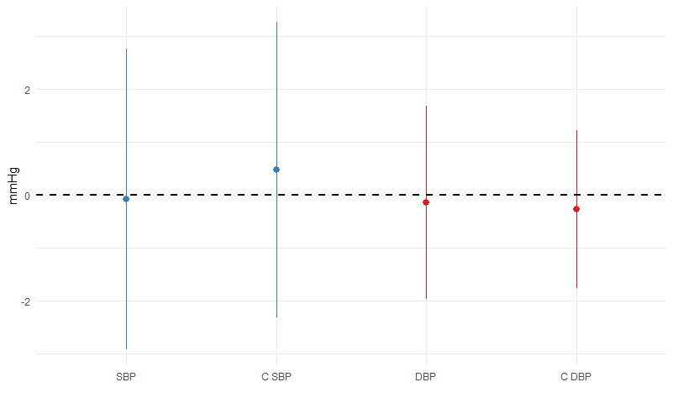

Figure 2. Change in systolic blood pressure across the two study periods

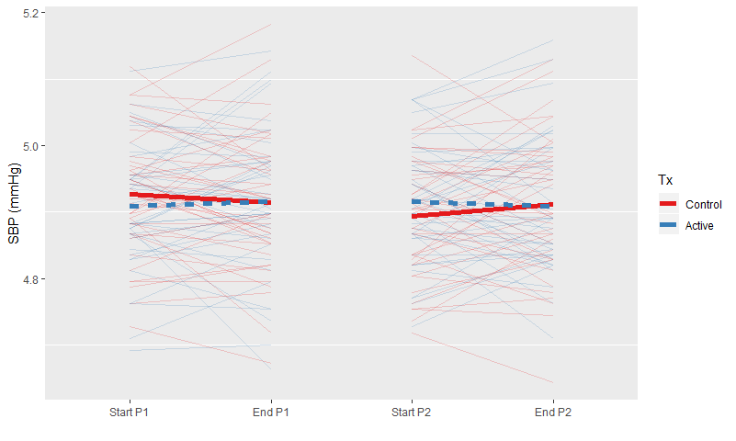

Heterogenity

|  |  |  |
| --- | --- | --- |
| var | vr | p |
| SBP | 1.40 | 0.065 |
| DBP | 1.10 | 0.546 |
| Central SBP | 1.10 | 0.562 |
| Central DBP | 0.69 | 0.056 |
| Arterial Stiffness | 0.82 | 0.327 |
| Glucose | 0.75 | 0.111 |
| log(HDL) | 0.68 | 0.030 |
| LDL | 1.30 | 0.087 |
| log(OxLDL) | 1.30 | 0.145 |
| PWA Augment | 0.76 | 0.123 |
| log(TAG) | 0.91 | 0.535 |
| log(Total Cholesterol) | 1.00 | 0.877 |