Untitled

Darren L Dahly

6 July 2017

# Methods

Continuous variables were described by their means and SDs, medians and IQRs, and their ranges. Categorical variables were described by the counts in each category and their respective proportions.

The key outcome for this study was meal completion, described above. Analyzing these data presented two important challenges. The first was that that the measurements are ordinal in nature, i.e meal consumption was reflected by > 2 categories and these had a natural ordering. While it would have been possible to further categorize meal consumption into a binary outcome (e.g. low vs high), this would have discarded useful information, and inevitably lowered the power of the study to detect given effects, and decreased the precision of effect estimates. The second challenge was that the outcomes were measured repeatedly in the same patients, so that the observations were not independent. Failure to respect that would have led to inappropriately smaller standard errors.

To account for these issues, we used mixed-effect ordinal regression models with a logistic link function (i.e. the “proportional odds” model). For an ordinal outcome Y with k categories, these regressions model the probability that Yi≤k as a function of the predictors (or independent variables) included in the model. Thus, for each of k-1 levels of the ordinal outcomes, the basic form of the model estimates the following:

P(Yi≤k) = exp(αk−x⊤iβ) / 1 + exp(αk−x⊤iβ)

This formulation means that the larger values of β (the difference in the log-odds of Yi≤k associated with predictor x) indicate a higher probability of the outcome falling in the higher end of the ordinal scale. Like the more familiar logistic regression, β can be exponentiated, resulting in an odds-ratio (OR) where values > 1 (< 1) indicate a higher (lower) odds of higher outcome values (i.e. greater meal completion) associated with a given predictor.

Given the exploratory nature of this study, we estimated the effect of each predictor in separate models where the only covariate was meal type (breakfast, lunch, or tea). Results for each predictor were presented as ORs with 95% confidence intervals (CIs), alongside p-values from a likelihood ratio test comparing two nested models (with and without the predictor).

All analyses were conducting using R version 3.6.3. Mixed-effect ordinal regression models were estimated using the ordinal package.

REFs: ordinal: Christensen, R. H. B. (2019). ordinal - Regression Models for Ordinal Data. R package version 2019.12-10. <https://CRAN.R-project.org/package=ordinal>.

R: R Core Team (2020). R: A language and environment for statistical computing. R Foundation for Statistical Computing, Vienna, Austria. URL <https://www.R-project.org/>.

# DATA

# Descriptive

## Figure X. Patient-level distribution of intake values by day and meal.

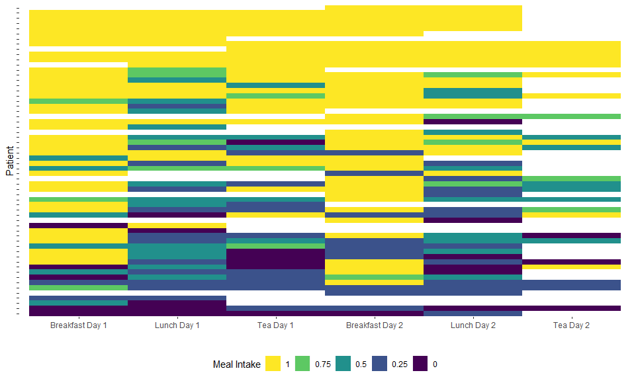

Caption: Each row reflects the observed meal intake values for a single patient, across the mealtimes/days of observation. White space indicated a missing values for that meal. Patients are ordered along the y-axis by their average meal completion.

This is a plot of every meal and how much the intake was for each of them. Each row is a patient. You can see the degree to which people are missing observations, and also how there is so much more meal completion for the breakfast meals (but not much apparent difference between the 2 sets of days). It’s also ordered, so the people with the highest average meal completion over all meals are at the top.

## Table 1. Patient level characteristics

| Variable | Missing | Mean SD or N(%) | Median [IQR] | (Min, Max) |
| --- | --- | --- | --- | --- |
| age | 60 | 80.9 ± 7 | 82 (75.8, 87) | (65, 94) |
| gender | 60 |  |  |  |
| Male |  | 32 (53.3%) |  |  |
| Female |  | 28 (46.7%) |  |  |
| patient_type | 60 |  |  |  |
| Medical |  | 52 (86.7%) |  |  |
| Surgical |  | 8 (13.3%) |  |  |
| comorbid | 58 | 3.4 ± 1.8 | 3.5 (2, 5) | (0, 8) |
| meds | 58 | 8.5 ± 5.1 | 8 (5, 11.8) | (0, 21) |
| cfs | 60 |  |  |  |
| Very fit |  | 3 (5%) |  |  |
| Well |  | 6 (10%) |  |  |
| Managing well |  | 2 (3.3%) |  |  |
| Vulnerable |  | 8 (13.3%) |  |  |
| Mildly frail |  | 13 (21.7%) |  |  |
| Moderately frail |  | 17 (28.3%) |  |  |
| Severely frail |  | 10 (16.7%) |  |  |
| Very Severely frail |  | 0 (0%) |  |  |
| Terminally frail |  | 1 (1.7%) |  |  |
| must_screen | 60 |  |  |  |
| No |  | 1 (1.7%) |  |  |
| Yes |  | 53 (88.3%) |  |  |
| Incomplete |  | 6 (10%) |  |  |
| must_score | 60 | 0.9 ± 1.5 | 0 (0, 1.2) | (0, 6) |
| dementia | 60 |  |  |  |
| No |  | 48 (80%) |  |  |
| Yes |  | 12 (20%) |  |  |
| delirium | 60 |  |  |  |
| No |  | 57 (95%) |  |  |
| Yes |  | 3 (5%) |  |  |
| dysphagia | 60 |  |  |  |
| No |  | 51 (85%) |  |  |
| Yes |  | 9 (15%) |  |  |
| stroke | 60 |  |  |  |
| No |  | 51 (85%) |  |  |
| Yes |  | 9 (15%) |  |  |
| paralysis | 60 |  |  |  |
| No |  | 57 (95%) |  |  |
| Yes |  | 3 (5%) |  |  |
| restrict_diet | 60 |  |  |  |
| No |  | 59 (98.3%) |  |  |
| Yes |  | 1 (1.7%) |  |  |
| modified_diet | 60 |  |  |  |
| No |  | 47 (78.3%) |  |  |
| Yes |  | 13 (21.7%) |  |  |
| diet_ref | 60 |  |  |  |
| No |  | 51 (85%) |  |  |
| Yes |  | 9 (15%) |  |  |
| diet_plan | 60 |  |  |  |
| No |  | 51 (85%) |  |  |
| Yes |  | 9 (15%) |  |  |
| red_tray | 60 |  |  |  |
| No |  | 60 (100%) |  |  |
| Yes |  | 0 (0%) |  |  |
| ward | 60 |  |  |  |
| Surgical |  | 16 (26.7%) |  |  |
| Medical (A) |  | 29 (48.3%) |  |  |
| Medical (B) |  | 15 (25%) |  |  |

## Table 2. Meal-level characteristics

|  |  |  |
| --- | --- | --- |
| Variable | Missing | N(%) |
| meal | 279 |  |
| Breakfast |  | 105 (37.6%) |
| Lunch |  | 103 (36.9%) |
| Tea |  | 71 (25.4%) |
| diet_code | 279 |  |
| General |  | 154 (55.2%) |
| HPHE |  | 51 (18.3%) |
| Texture modified |  | 63 (22.6%) |
| Medical retriction (salt, fluid,fat) |  | 11 (3.9%) |
| position | 279 |  |
| Bed, lying down |  | 20 (7.2%) |
| Bed, propped up |  | 108 (38.7%) |
| Bed, sitting up |  | 42 (15.1%) |
| Chair |  | 109 (39.1%) |
| tray_table | 279 |  |
| Not in reach |  | 25 (9%) |
| Within reach |  | 254 (91%) |
| red_tray | 279 |  |
| Normal tray |  | 176 (63.1%) |
| Red tray |  | 103 (36.9%) |
| assist_reqd | 279 |  |
| No |  | 136 (48.7%) |
| Yes |  | 143 (51.3%) |
| assist_provd | 279 |  |
| no |  | 158 (56.6%) |
| nurse |  | 13 (4.7%) |
| hca |  | 82 (29.4%) |
| family |  | 21 (7.5%) |
| catering |  | 1 (0.4%) |
| other |  | 2 (0.7%) |
| Nurse + HCA |  | 2 (0.7%) |
| assist_10min | 279 |  |
| assistance not req |  | 136 (48.7%) |
| yes assitence within 10 mins |  | 112 (40.1%) |
| No assistance within 10mins |  | 31 (11.1%) |
| feed_reqd | 279 |  |
| No |  | 229 (82.1%) |
| Yes |  | 50 (17.9%) |
| feed_provd | 279 |  |
| no |  | 232 (83.2%) |
| nurse |  | 5 (1.8%) |
| hca |  | 36 (12.9%) |
| family |  | 3 (1.1%) |
| other |  | 2 (0.7%) |
| Pt refused |  | 1 (0.4%) |
| feed_10min | 279 |  |
| Assistance not required |  | 225 (80.6%) |
| yes assitence within 10 mins |  | 34 (12.2%) |
| No, assitance not provided within 10 mins |  | 20 (7.2%) |
| interrupted | 279 |  |
| no |  | 250 (89.6%) |
| nurse |  | 7 (2.5%) |
| doctor |  | 8 (2.9%) |
| proceedure |  | 1 (0.4%) |
| other staff |  | 8 (2.9%) |
| other |  | 5 (1.8%) |

# Models

## Meal-level factors

### Figure X. Mealtime-adjusted associations between meal-level factors and meal completion.

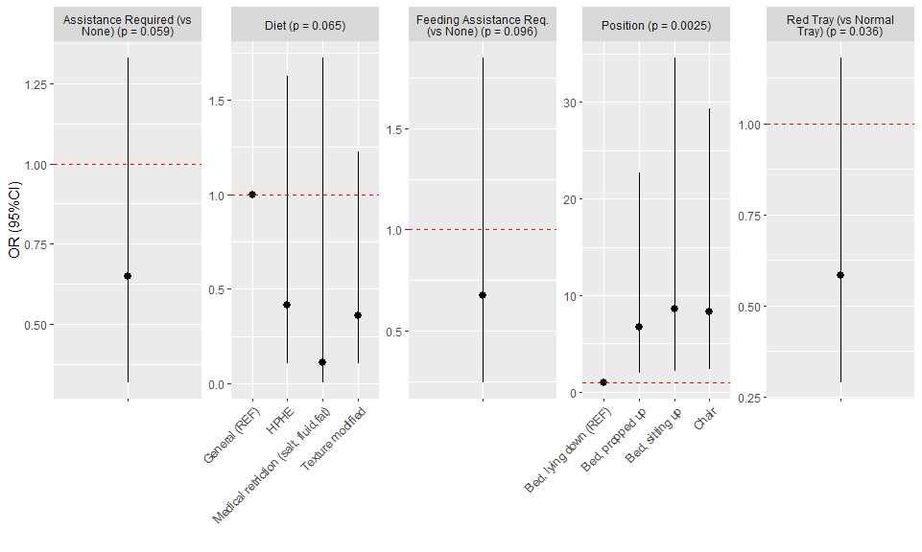

Caption: The results from the mixed-effect ordinal regression models are presented as ORs with 95% CIs, where OR > 1 mean greater odds of higher meal completion relative to the reference category.

### Supplemental table 1

|  |  |  |  |
| --- | --- | --- | --- |
| var | level | Effect | lrt_p |
| Diet | HPHE | 0.41 (0.11 to 1.63) | 0.0650 |
| Diet | Texture modified | 0.36 (0.11 to 1.22) | 0.0650 |
| Diet | Medical retriction (salt, fluid,fat) | 0.11 (0.01 to 1.72) | 0.0650 |
| Diet | General (REF) | 1 (1 to 1) | 0.0650 |
| Position | Bed, propped up | 6.72 (1.99 to 22.66) | 0.0025 |
| Position | Bed, sitting up | 8.58 (2.13 to 34.59) | 0.0025 |
| Position | Chair | 8.32 (2.36 to 29.38) | 0.0025 |
| Position | Bed, lying down (REF) | 1 (1 to 1) | 0.0025 |
| Red Tray (vs Normal Tray) |  | 0.58 (0.29 to 1.18) | 0.0360 |
| Assistance Required (vs None) |  | 0.65 (0.32 to 1.33) | 0.0590 |
| Feeding Assistance Req. (vs None) |  | 0.67 (0.25 to 1.85) | 0.0960 |

## Patient-level factors

### Figure X. Mealtime-adjusted associations between patient-level factors and meal completion.

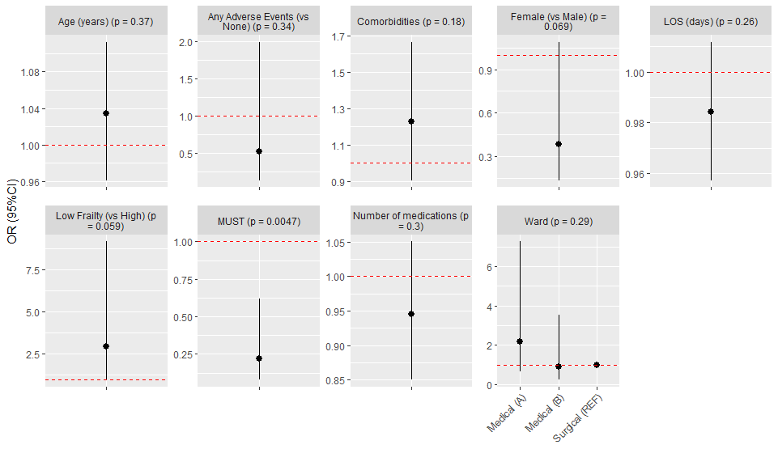

Caption: The results from the mixed-effect ordinal regression models are presented as ORs with 95% CIs, where OR > 1 mean greater odds of higher meal completion relative to the reference category.

### Supplemental table 2

|  |  |  |  |
| --- | --- | --- | --- |
| var | level | Effect | lrt_p |
| Female (vs Male) |  | 0.38 (0.14 to 1.09) | 0.0690 |
| Age (years) |  | 1.03 (0.96 to 1.11) | 0.3700 |
| Low Frailty (vs High) |  | 2.97 (0.96 to 9.17) | 0.0590 |
| Comorbidities |  | 1.23 (0.91 to 1.67) | 0.1800 |
| Number of medications |  | 0.94 (0.85 to 1.05) | 0.3000 |
| MUST |  | 0.22 (0.08 to 0.62) | 0.0047 |
| LOS (days) |  | 0.98 (0.96 to 1.01) | 0.2600 |
| Any Adverse Events (vs None) |  | 0.52 (0.14 to 1.99) | 0.3400 |
| Ward | Medical (A) | 2.18 (0.66 to 7.26) | 0.2900 |
| Ward | Medical (B) | 0.9 (0.23 to 3.54) | 0.2900 |
| Ward | Surgical (REF) | 1 (1 to 1) | 0.2900 |

# Results

In total there were 68 patients eligible for inclusion in the study. Of these, 8 were excluded for missing data or because they were only on the ward for a single meal. The 60 remaining in the sample were observed for a total of 279 mealtimes.

Meal intakes for each patient, across mealtimes and days, are plotted in figure X. Of the 279 meals observed, 51% were eaten completely, while 10% were not eaten at all (18% at a quarter of their meal; 15% ate half; and 6% ate three quarters).

For the meal-level predictors (figure X; supplemental table 1), requiring assistance, special diets, laying down in bed, and use of the red tray were all associated with less meal completion. However, estimates generally had wide 95% CIs that were consistent with a wide range of possible associations. The notable exception was for position: laying down was unambiguously associated with lower odds of higher meal completion relative to other positions.

For patient level predictors (figure X; supplemental table 2), older age, lower frailty scores, and more comorbidities were associated with more meal completion; whereas females, having experienced any adverse events, longer length of stay, higher MUST scores, and higher numbers of medications were associated with less meal completion. However, similarly to the meal-level predictors, most estimates were accompanied by wide confidence intervals straddling the null of no association. The exceptions were low frailty (vs high; OR 2.97 (0.96 to 9.17); p = 0.059), and high/medium MUST score (vs low; OR 0.22 (0.08 to 0.62); p = 0.0047)

# Discussion

Some thoughts…

There are lots of “null” results, in that you have very wide CIs and high p-values all over the place. That said, most (all?) of the associations seem to go in the direction one might have expected at the start of the study. Overall you have a small number of patients, and so your ability to accurately estimate associations, even when they are “true” is hampered.

Regarding sample size, from my point of view, a sample size calculation is a pre-data tool; something we use before we run the study to help ensure that we will collect enough data to provide reliable tests of the pre-specified hypotheses we are interested in. I would view this study are more exploratory - that is not to say that you didn’t have any hypotheses in mind when you collected the data - just that the data collection was driven by other constraints beyond any hypotheses. Once the data are collected, they are what they are and they say what they say, so there is little point in reverse-engineering a sample size calculation after the fact.

Something that people often do in more exploratory work like this is to run a bunch of univariate tests (or models) and then take the “significant” ones and shove them into a multivariable model which they then go on to interpret. While this is certainly a popular approach to data analysis across the health sciences, it actually isn’t very informative. Most important analyses can be grouped into two aims: we are either trying to identify causal associations (to test the effects of interventions, or identify new targets for intervention) or to make accurate predictions of outcomes (e.g. to inform prognosis and subsequent decision making). We aren’t in the current study trying to develop a prediction tool/score (and the study would be way too small to support that if we wanted to) - but if we want to try and answer causal questions, we would have to take every factor, one at a time, and think through the plausible causal structures that might imply an association between that factor and meal completion - and then estimate different models based on those structures. The key point here is that we can’t just use 1 model to approximate this.

All that said, I think the best way to frame this (from my point of view with is obviously not the only one or the most important!) is as an exploratory study of factors associated with meal completion that might inform future studies about what kind of data to collect (MUST, frailly, position, mealtime seem key) and a better characerization of the variability in meal level factors, which could also inform future studies, trials, etc.

My 2 cents.

# Supplemental information

## Meal level predictors

Figure X. Distribution of meal intake values

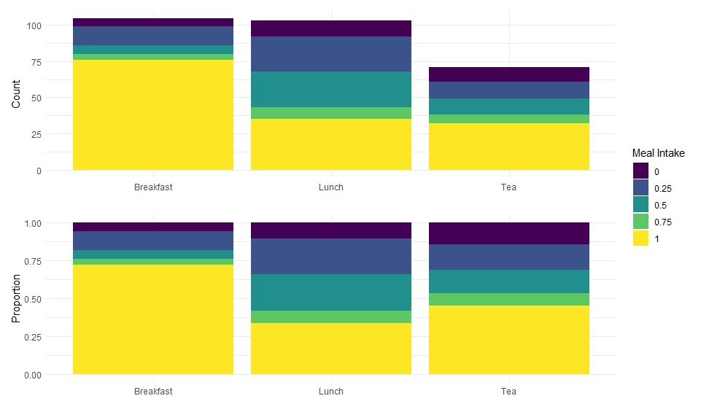

This just gives another view of the fairly dramatic meal effect. The two facets of the plot are the same data, but in the bottom facet the data are normalized to a proportion of meals (rather than a count, as in the top facet).

The plots that follow just give the distribution of meal completion across levels of the different meal-level predictors. They are just to help us confirm and interpret the results from the models. They can all probably go into the supplemental info for the paper.

More meal completion in the general meal.

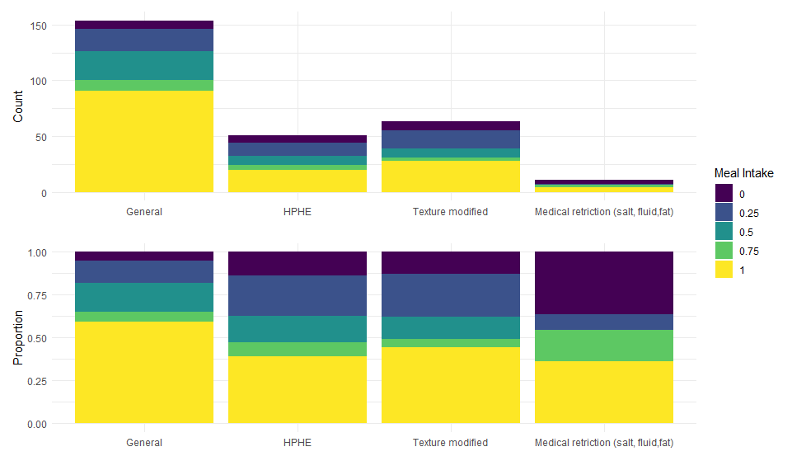

Less meal completion lying down.

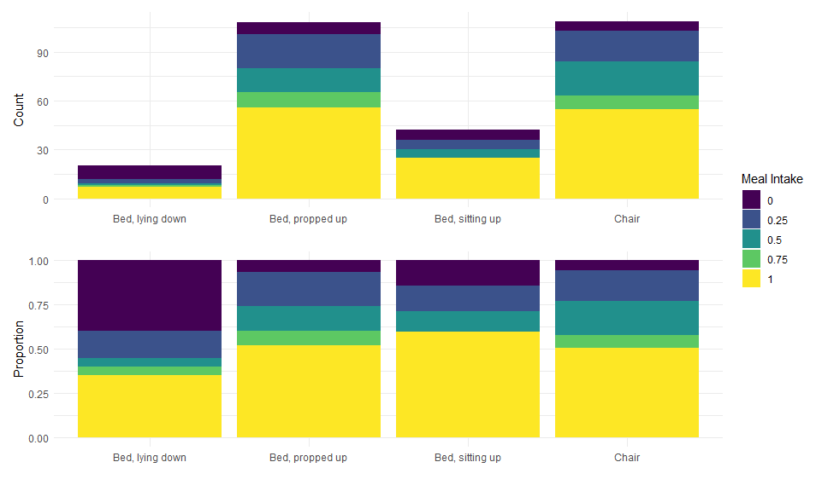

Less meal completion with the red tray.

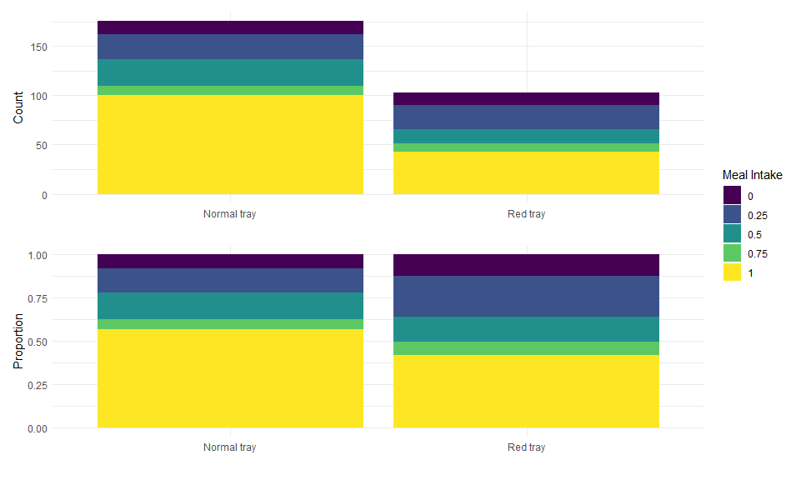

Less meal completion when assistance was required.

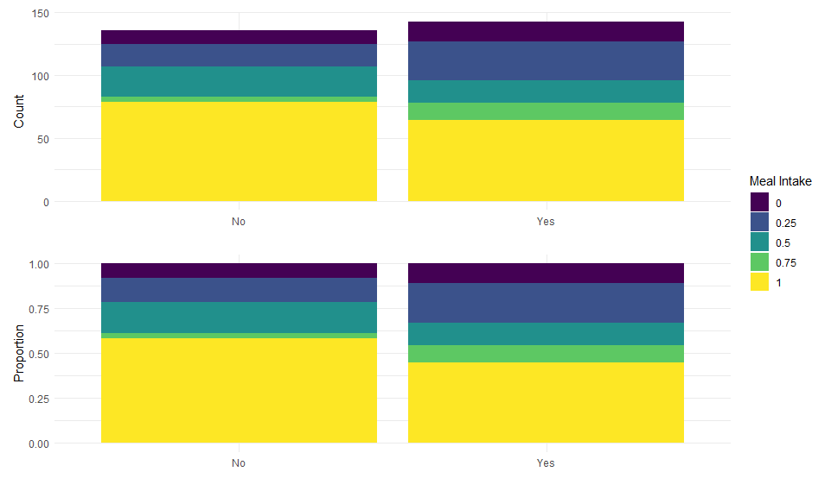

Less completion when feeding assistance was required.

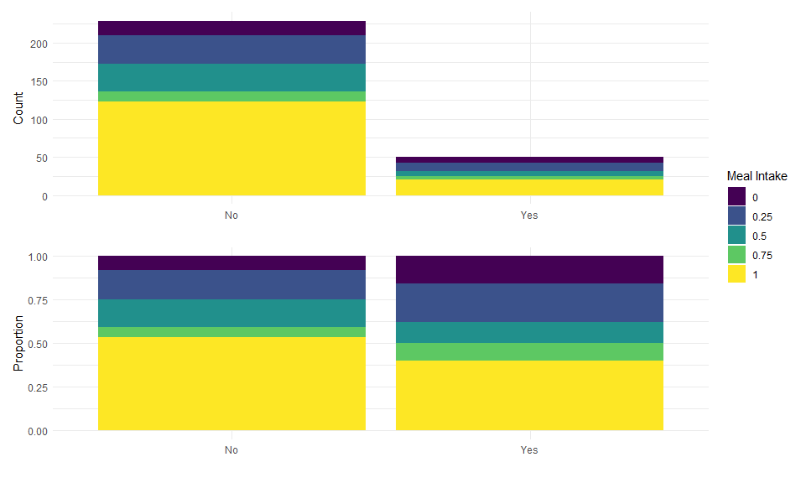

## Patient level predictors

Next we do the same thing for the patient level characteristics.

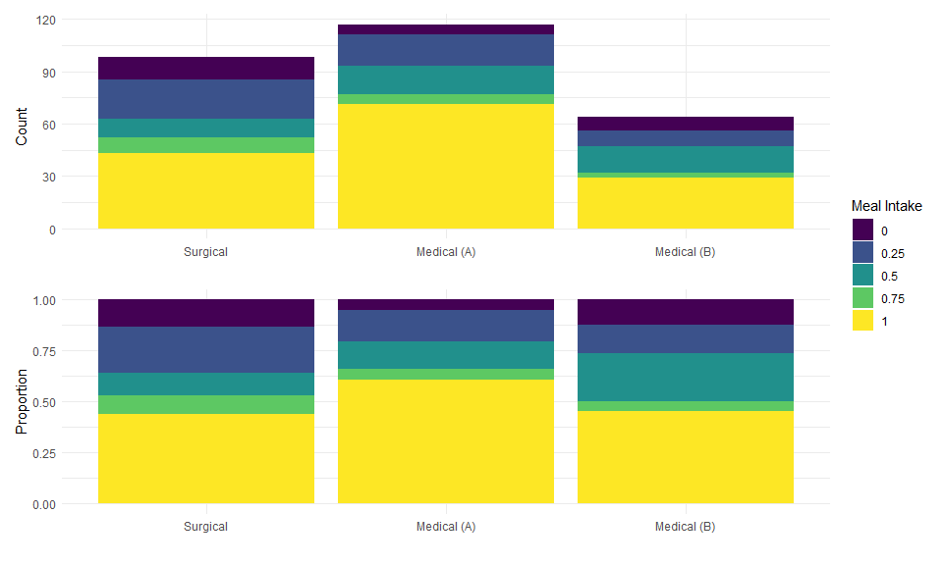

Less completion for females.

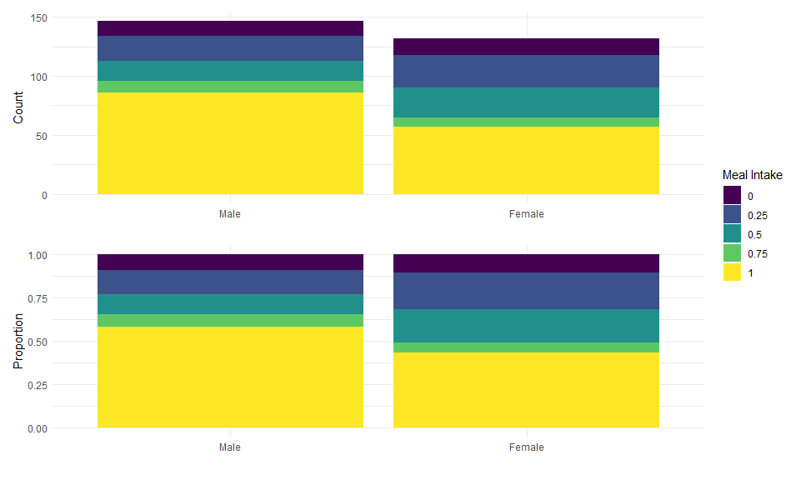

No discernible pattern for age.

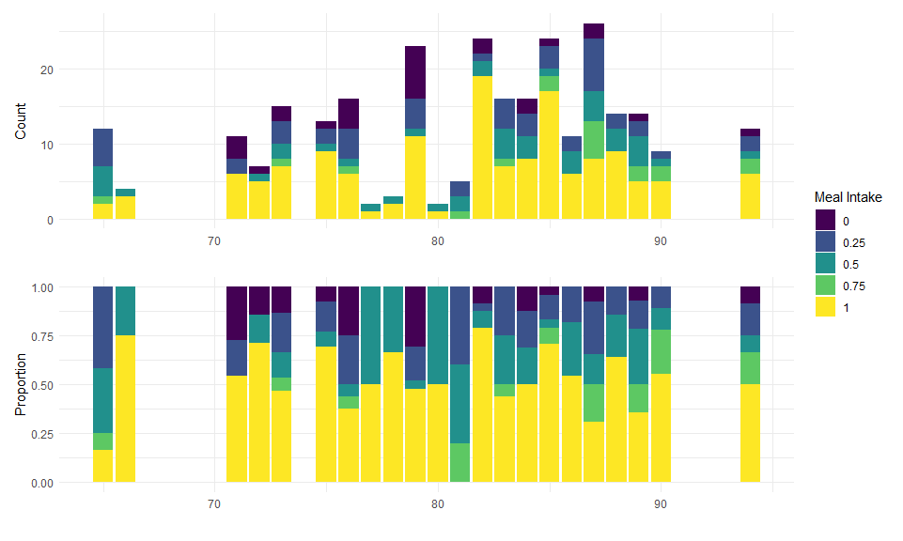

Less meal completion with worsening status, except for very fit, which is odd. Might needs to collapse these.

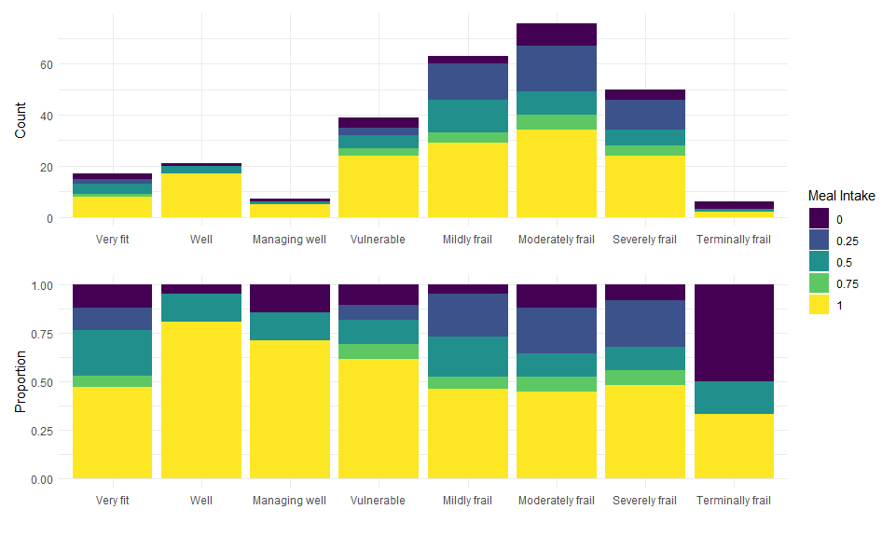

Less meal completion with “high” frailty.

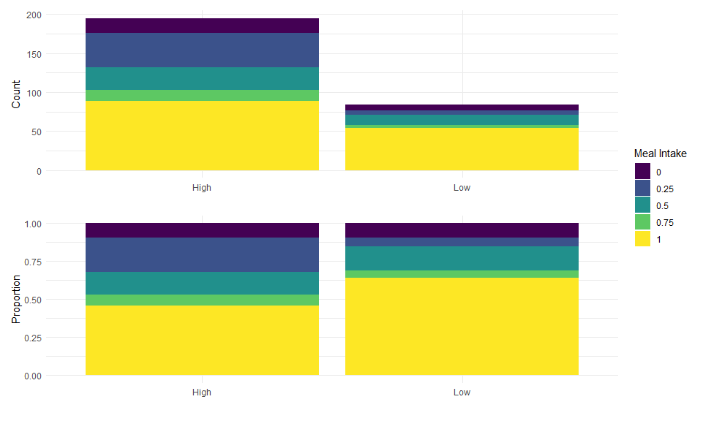

No discernible pattern for comorbidities

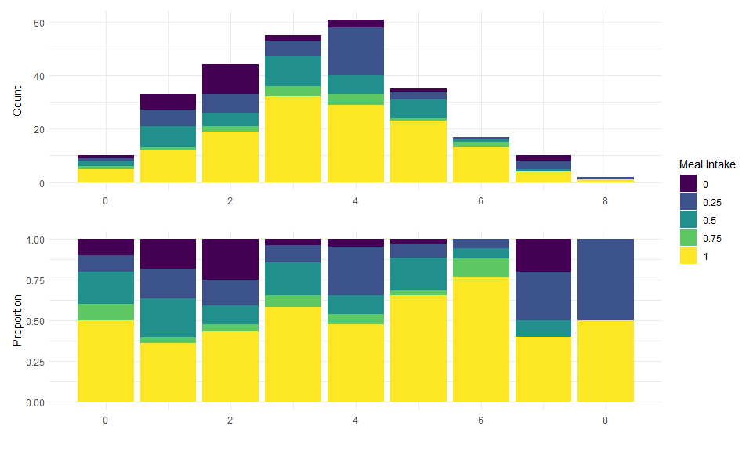

No discernible pattern for meds

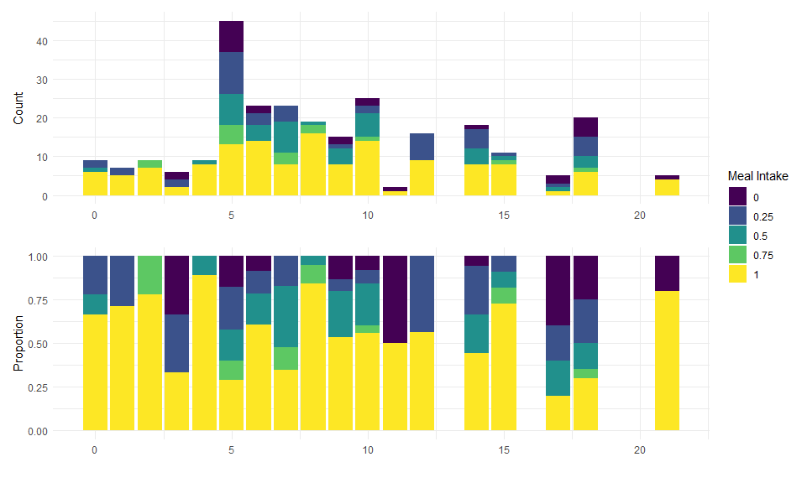

Less meal completion with higher MUST.

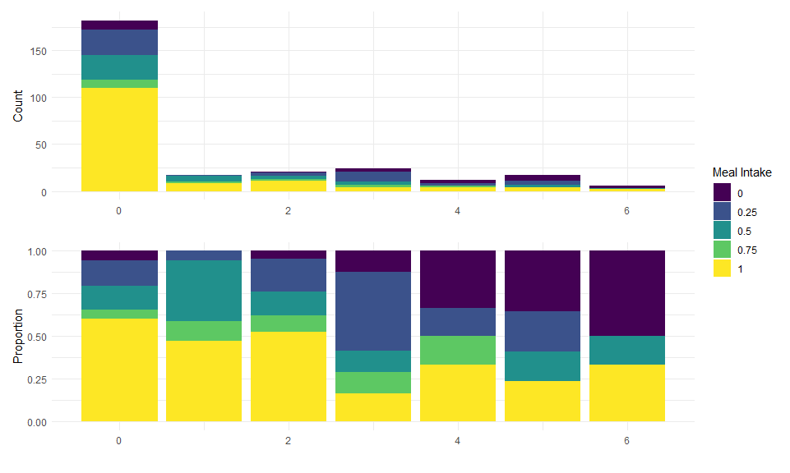

No discernible patter for los.

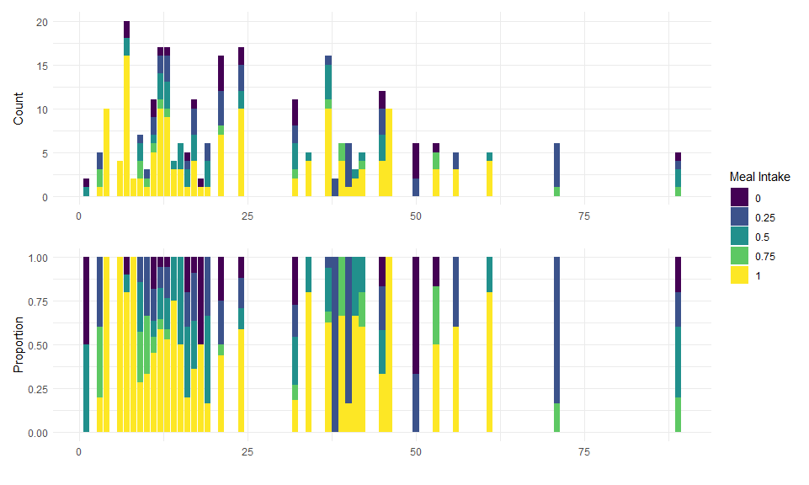

Less meal completion with AES

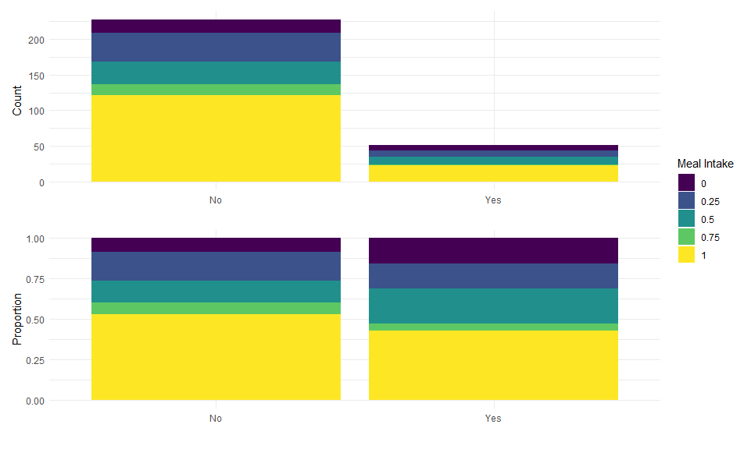

##   
## System: Windows 10 x64 build 18363  
## Nodename: DESKTOP-JKQ7LTN, User: Darren  
## Total Memory: 16168 MB  
##   
## R version 3.6.3 (2020-02-29)   
## x86_64-w64-mingw32/x64 (64-bit)   
##   
## Loaded Packages:   
## knitr (1.29), mixor (1.0.4), testthat (2.3.2), ordinal (2019.12-10), patchwork (1.0.1), flextable (0.5.10), viridis (0.5.1), viridisLite (0.3.0), sjPlot (2.8.4), rms (6.0-1), SparseM (1.78), Hmisc (4.4-1), Formula (1.2-3), survival (3.2-3), lattice (0.20-38), forcats (0.5.0), stringr (1.4.0), dplyr (1.0.2), purrr (0.3.4), readr (1.3.1), tidyr (1.1.2), tibble (3.0.3), ggplot2 (3.3.2), tidyverse (1.3.0)