# Respondent characteristics

|  |  |  |  |  |
| --- | --- | --- | --- | --- |
| Variable | N | Mean SD | Median [IQR] | (Min, Max) |
| **Age** | 4914 |  |  |  |
| F |  | 1889 (38.4%) |  |  |
| M |  | 3025 (61.6%) |  |  |
| **Age (years)** | 4914 | 47.3 ± 11.7 | 47 (38, 56) | (24, 90) |
| Groups: |  |  |  |  |
| 34 and under |  | 780 (15.9%) |  |  |
| 35 – 44 |  | 1372 (27.9%) |  |  |
| 45 – 54 |  | 1374 (28%) |  |  |
| 55+ |  | 1388 (28.2%) |  |  |
| **Years on register** | 4914 | 14.6 ± 11.6 | 12 (4, 23) | (0, 37) |
| Groups: |  |  |  |  |
| 0 – 4 |  | 1995 (40.6%) |  |  |
| 5 – 14 |  | 1362 (27.7%) |  |  |
| 15 – 24 |  | 831 (16.9%) |  |  |
| 25+ |  | 726 (14.8%) |  |  |
| **Enrolled on the scheme** | 4914 |  |  |  |
| Yes |  | 4755 (96.8%) |  |  |
| No |  | 159 (3.2%) |  |  |
| **Division** | 4914 |  |  |  |
| General |  | 1894 (38.5%) |  |  |
| Specialist |  | 2896 (58.9%) |  |  |
| Supervised |  | 31 (0.6%) |  |  |
| Training Specialist |  | 93 (1.9%) |  |  |
| **Status** | 4914 |  |  |  |
| Active |  | 4832 (98.3%) |  |  |
| Application Under Review |  | 1 (0%) |  |  |
| Withdrawn |  | 81 (1.6%) |  |  |
| **Hours** | 3732 |  |  |  |
| 10 to 20 hours per week |  | 263 (7%) |  |  |
| 21 to 30 hours per week |  | 303 (8.1%) |  |  |
| 31 to 40 hours per week |  | 1156 (31%) |  |  |
| Fewer than 10 hours per week |  | 147 (3.9%) |  |  |
| More than 40 hours per week |  | 1863 (49.9%) |  |  |
| **Role** | 3737 |  |  |  |
| Community Health Doctor |  | 66 (1.8%) |  |  |
| General practitioner |  | 1364 (36.5%) |  |  |
| Healthcare related management and administration |  | 19 (0.5%) |  |  |
| Hospital Consultant |  | 1250 (33.4%) |  |  |
| Non-consultant hospital doctor, in training |  | 67 (1.8%) |  |  |
| Non-consultant hospital doctor, not in training |  | 684 (18.3%) |  |  |
| Other |  | 74 (2%) |  |  |
| Other Consultant or Specialist |  | 184 (4.9%) |  |  |
| Public Health Doctor |  | 29 (0.8%) |  |  |
| **Service model** | 3228 |  |  |  |
| Provision of privately funded services only |  | 248 (7.7%) |  |  |
| Provision of publicly and privately funded services |  | 1788 (55.4%) |  |  |
| Provision of publicly funded services only |  | 1192 (36.9%) |  |  |
| **Country** | 3723 |  |  |  |
| Both within and outside the Republic of Ireland |  | 281 (7.5%) |  |  |
| Outside the Republic of Ireland only |  | 71 (1.9%) |  |  |
| Within the Republic of Ireland only |  | 3371 (90.5%) |  |  |
| **Country group** | 4914 |  |  |  |
| Ireland |  | 2763 (56.2%) |  |  |
| EU |  | 715 (14.6%) |  |  |
| Non EU |  | 1436 (29.2%) |  |  |
| **County** | 3674 |  |  |  |
| Dublin |  | 1362 (37.1%) |  |  |
| Other |  | 2312 (62.9%) |  |  |
| **Passport** | 3790 |  |  |  |
| Ireland |  | 2490 (65.7%) |  |  |
| Other |  | 1300 (34.3%) |  |  |

# 

# Survey items and intent

## F1: Items 1-7 & 21: Attitudes to Maintenance of Professional Competence

Do you argree with the following statements about the MPC? 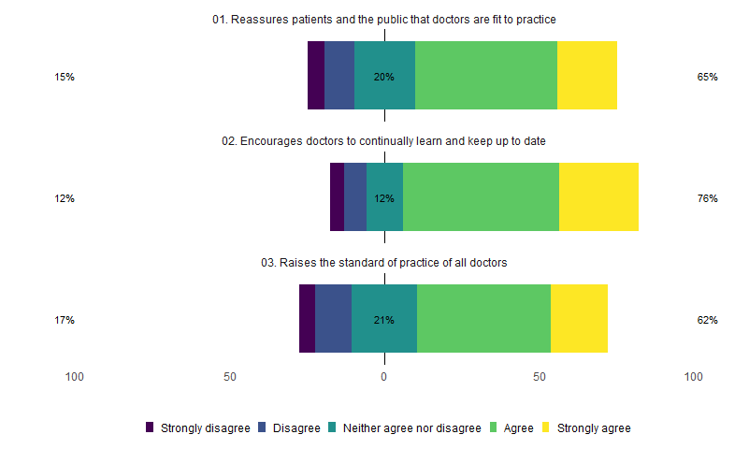

By intent to comply (yes/no) 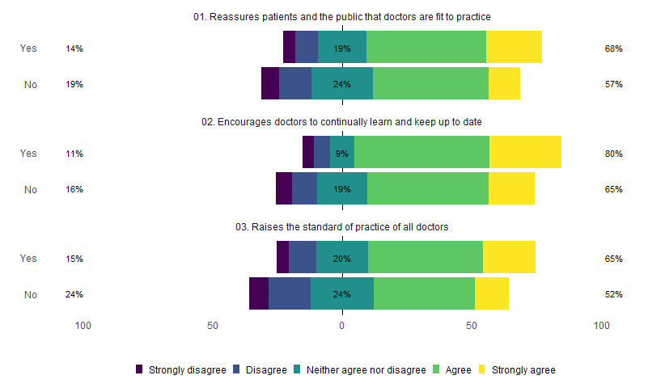

Do you argree with the following statements about personal impact of participation? 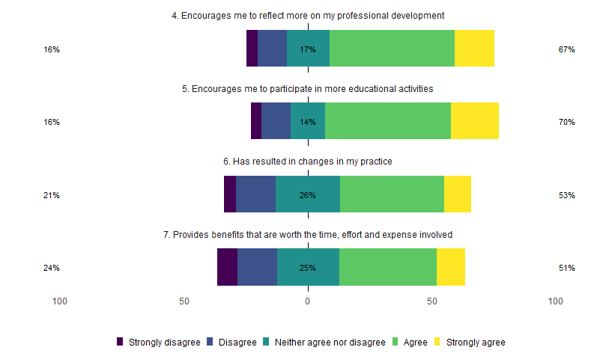

By intent to comply (yes/no) 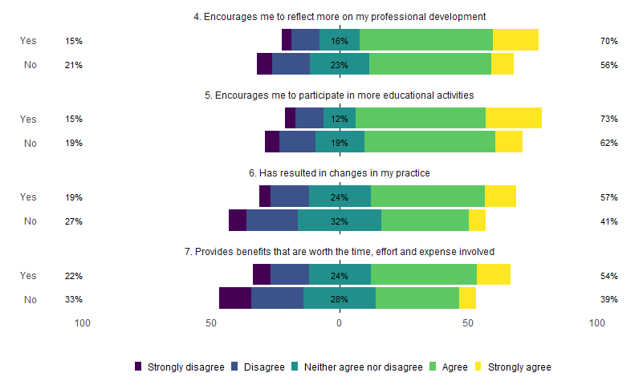

How do all of these items relate to intention? 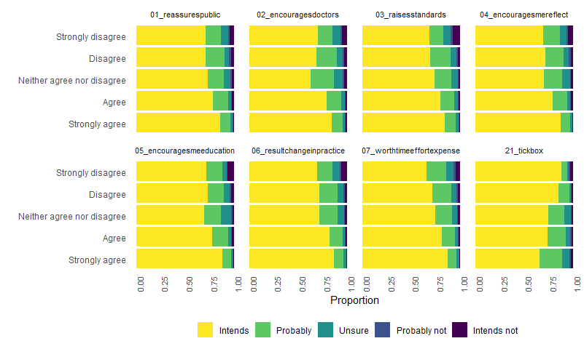

Proportional odds models for intent regressed on each item 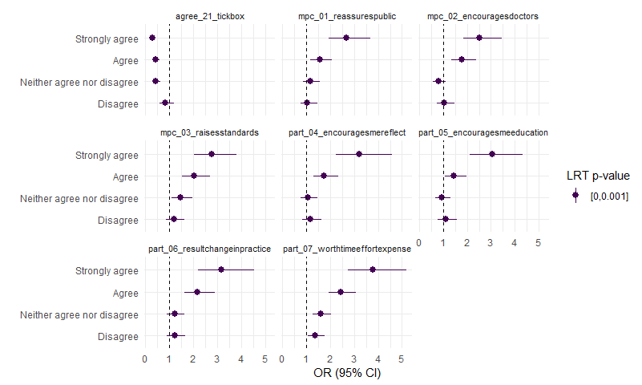

## F2: Items 8-15 & 26: Barriers to Engagement with Maintenance of Professional Competence

Please indicate your agreement with these statements about BARRIERS to your own engagement with Maintenance of Professional Competence in Ireland 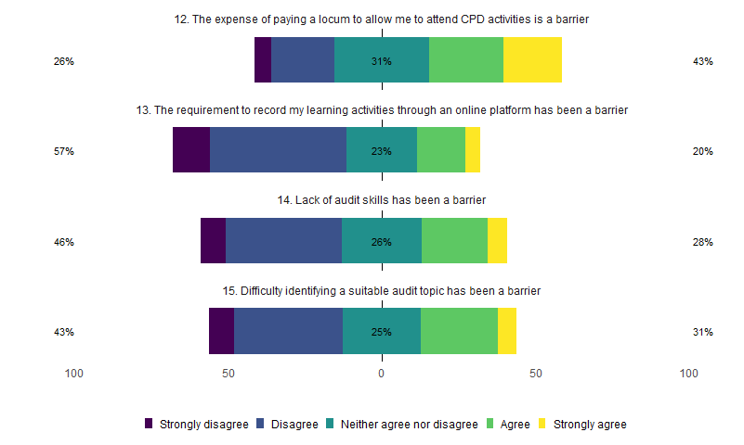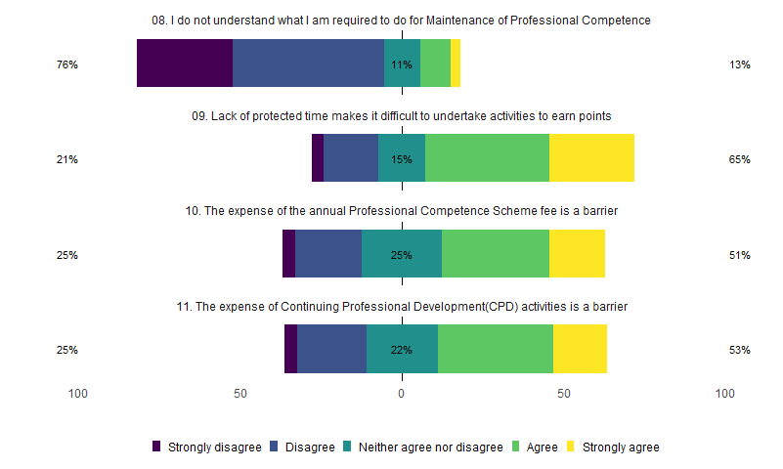

By intent to comply (yes/no) 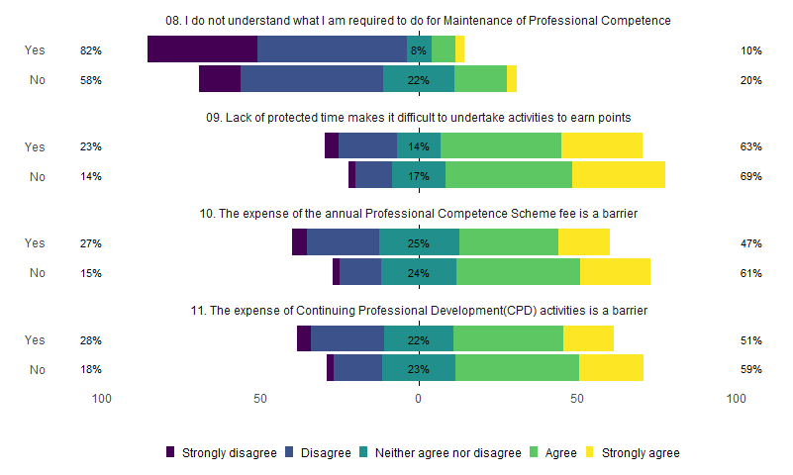

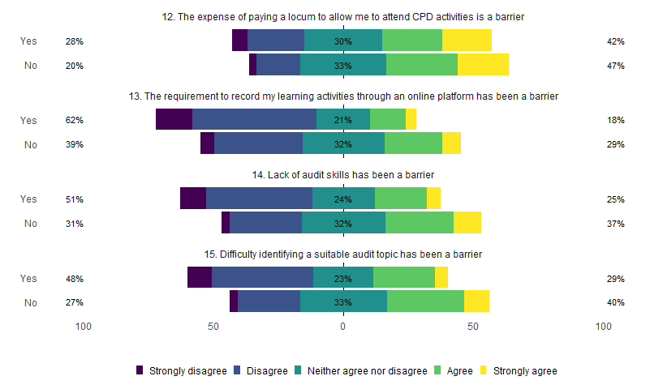

How do all of these items relate to intention? 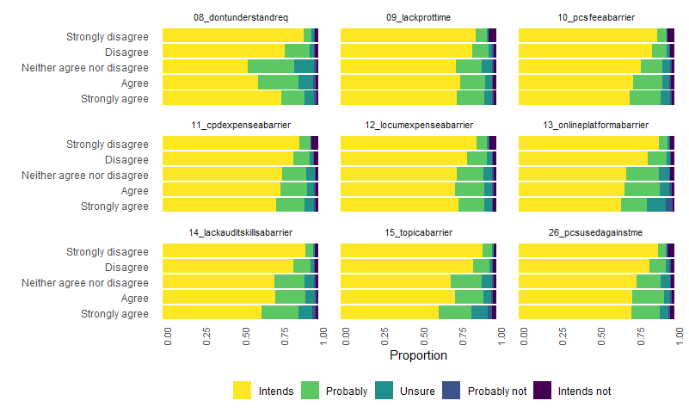

Proportional odds models for intent regressed on each item 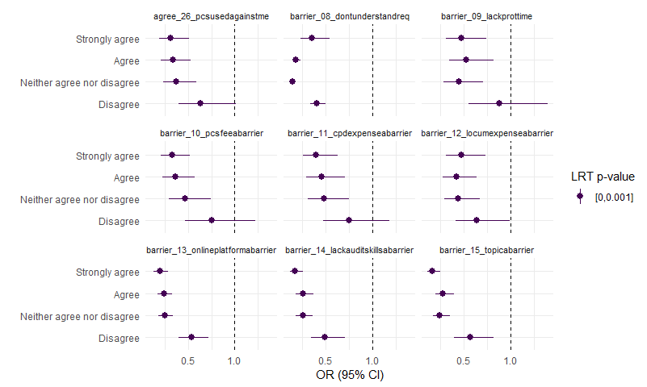

## F3: Items 17-20: Facilitators of Engagement with Maintenance of Professional Competence

Please indicate your agreement with the following statements about factors which SUPPORT your own engagement with Maintenance of Professional Competence in Ireland 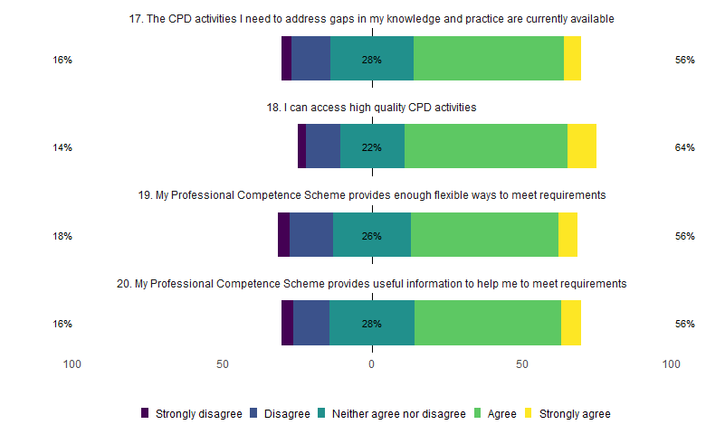

By intent to comply (yes/no) 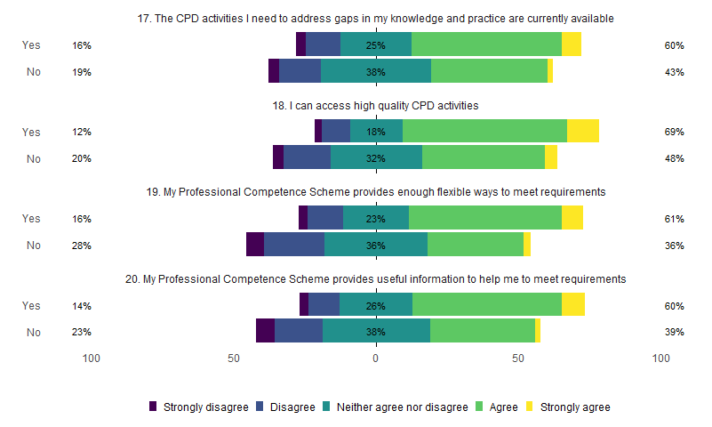

How do all of these items relate to intention? 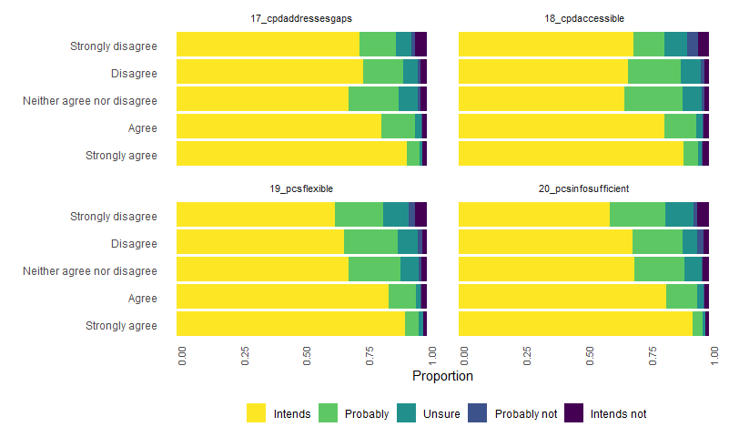

Proportional odds models for intent regressed on each item 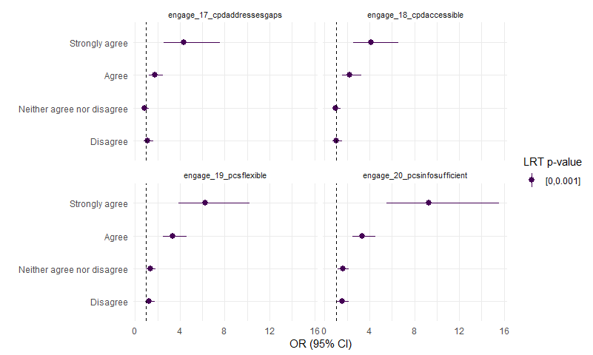

## F4: Items 27-29: Social Norms relating to Maintenance of Professional Competence

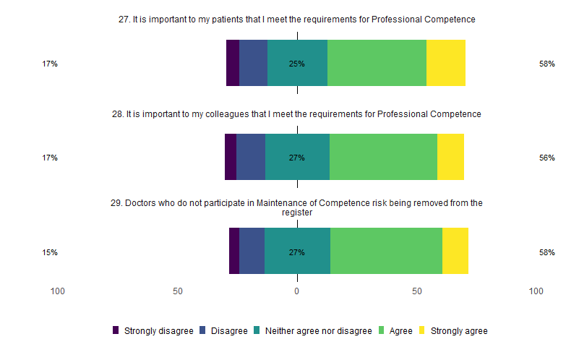

Intends to comply 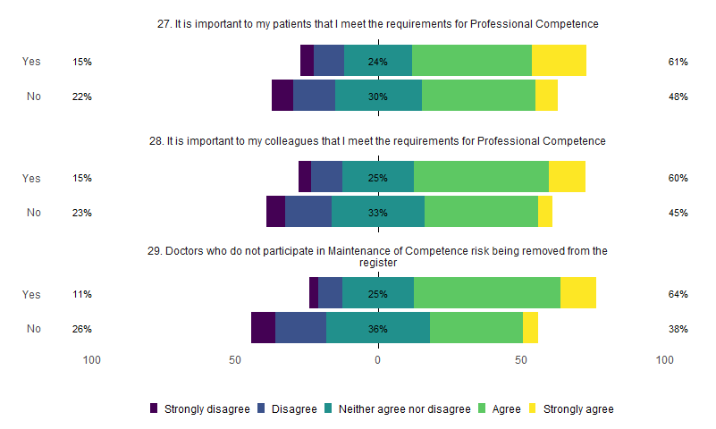

How do all of these items relate to intention? 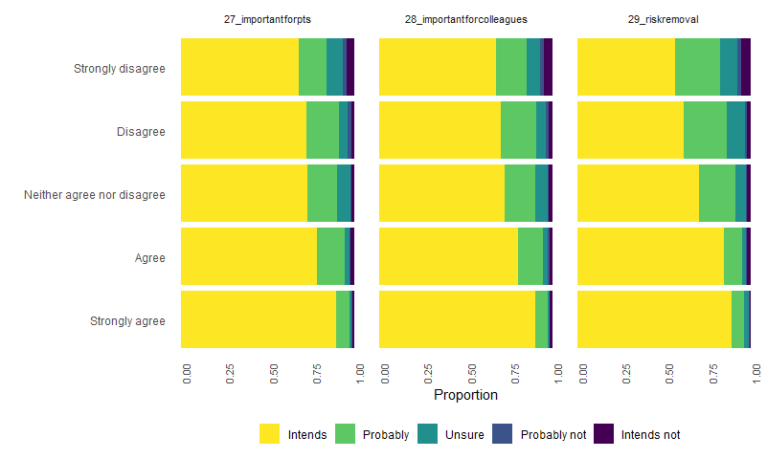

Proportional odds models for intent regressed on each item 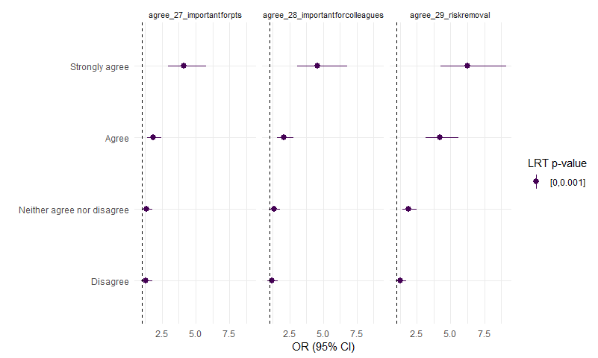

# Full CFA

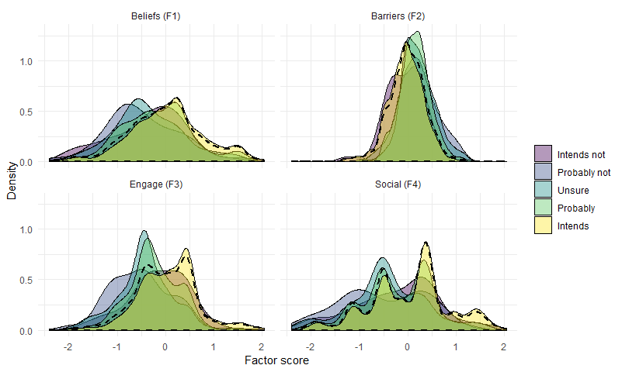

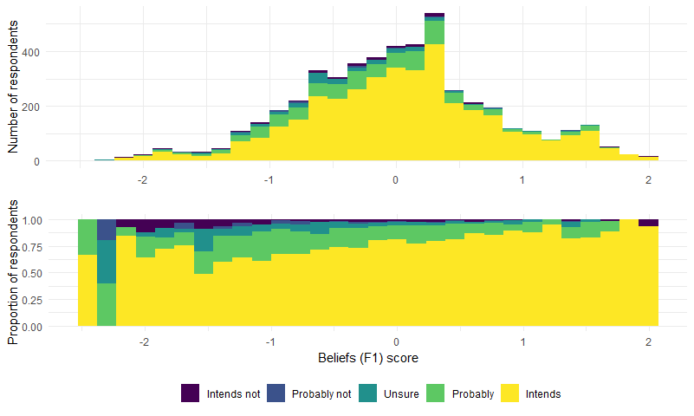

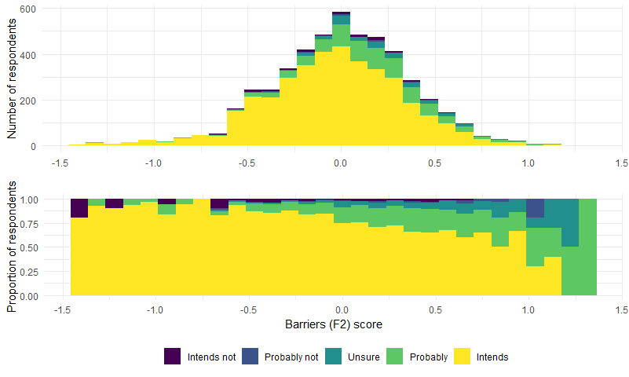

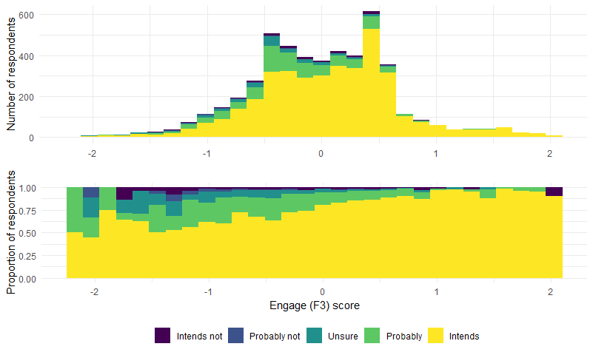

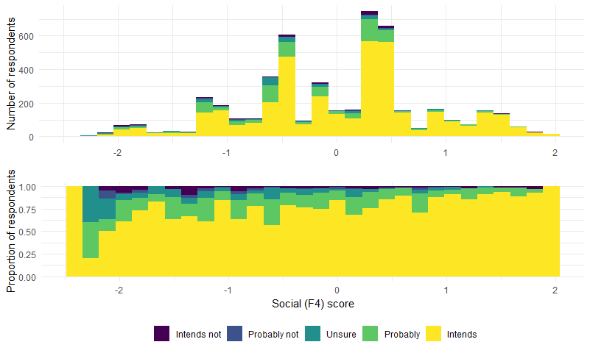

Factor Loadings

|  |  |  |  |  |  |  |
| --- | --- | --- | --- | --- | --- | --- |
| Latent Factor | Indicator | B | SE | Z | p-value | Beta |
| Beliefs_f1 | mpc_01_reassurespublic | 1.000 | 0.000 | - | - | 0.804 |
| Beliefs_f1 | mpc_02_encouragesdoctors | 1.106 | 0.008 | 144.496 | 0 | 0.889 |
| Beliefs_f1 | mpc_03_raisesstandards | 1.104 | 0.008 | 143.764 | 0 | 0.888 |
| Beliefs_f1 | part_04_encouragesmereflect | 1.094 | 0.008 | 144.280 | 0 | 0.879 |
| Beliefs_f1 | part_05_encouragesmeeducation | 1.016 | 0.008 | 124.525 | 0 | 0.817 |
| Beliefs_f1 | part_06_resultchangeinpractice | 1.019 | 0.008 | 123.646 | 0 | 0.819 |
| Beliefs_f1 | part_07_worthtimeeffortexpense | 1.067 | 0.008 | 134.274 | 0 | 0.858 |
| Beliefs_f1 | agree_21_tickbox | -0.611 | 0.014 | -43.093 | 0 | -0.491 |
| Barriers_f2 | barrier_08_dontunderstandreq | 1.000 | 0.000 | - | - | 0.433 |
| Barriers_f2 | barrier_09_lackprottime | 1.331 | 0.045 | 29.685 | 0 | 0.577 |
| Barriers_f2 | barrier_10_pcsfeeabarrier | 1.972 | 0.060 | 32.641 | 0 | 0.854 |
| Barriers_f2 | barrier_11_cpdexpenseabarrier | 1.951 | 0.061 | 32.079 | 0 | 0.845 |
| Barriers_f2 | barrier_13_onlineplatformabarrier | 1.251 | 0.043 | 29.189 | 0 | 0.542 |
| Barriers_f2 | barrier_14_lackauditskillsabarrier | 1.549 | 0.047 | 32.945 | 0 | 0.671 |
| Barriers_f2 | barrier_15_topicabarrier | 1.608 | 0.051 | 31.570 | 0 | 0.697 |
| Barriers_f2 | agree_26_pcsusedagainstme | 0.930 | 0.041 | 22.912 | 0 | 0.403 |
| Engage_f3 | engage_17_cpdaddressesgaps | 1.000 | 0.000 | - | - | 0.695 |
| Engage_f3 | engage_18_cpdaccessible | 1.044 | 0.017 | 59.736 | 0 | 0.726 |
| Engage_f3 | engage_19_pcsflexible | 1.167 | 0.018 | 63.760 | 0 | 0.811 |
| Engage_f3 | engage_20_pcsinfosufficient | 1.201 | 0.019 | 62.739 | 0 | 0.835 |
| Social_f4 | agree_27_importantforpts | 1.000 | 0.000 | - | - | 0.907 |
| Social_f4 | agree_28_importantforcolleagues | 0.997 | 0.012 | 82.328 | 0 | 0.904 |
| Social_f4 | agree_29_riskremoval | 0.300 | 0.018 | 16.360 | 0 | 0.272 |

Model fit

|  |  |
| --- | --- |
| Measure | Value |
| chisq | 12400.889 |
| df | 224.000 |
| pvalue | 0.000 |
| cfi | 0.973 |
| tli | 0.970 |
| rmsea | 0.105 |
| rmsea.pvalue | 0.000 |

# 

# Proportional odds models for intends

|  |  |  |  |
| --- | --- | --- | --- |
|  | Chi-Square | d.f. | P |
| beliefs_f1 | 22.000 | 4 | 0.00025 |
| Nonlinear | 9.300 | 3 | 0.02500 |
| barriers_f2 | 19.000 | 4 | 0.00082 |
| Nonlinear | 1.500 | 3 | 0.67000 |
| engage_f3 | 20.000 | 4 | 0.00043 |
| Nonlinear | 4.400 | 3 | 0.22000 |
| social_f4 | 18.000 | 4 | 0.00120 |
| Nonlinear | 13.000 | 3 | 0.00370 |
| country_groups | 7.900 | 2 | 0.02000 |
| sex | 9.100 | 1 | 0.00260 |
| division | 0.066 | 1 | 0.80000 |
| role | 13.000 | 8 | 0.11000 |
| servicemodel | 0.850 | 2 | 0.65000 |
| passport_ireland | 1.300 | 1 | 0.25000 |
| TOTAL NONLINEAR | 31.000 | 12 | 0.00220 |
| TOTAL | 290.000 | 31 | 0.00000 |

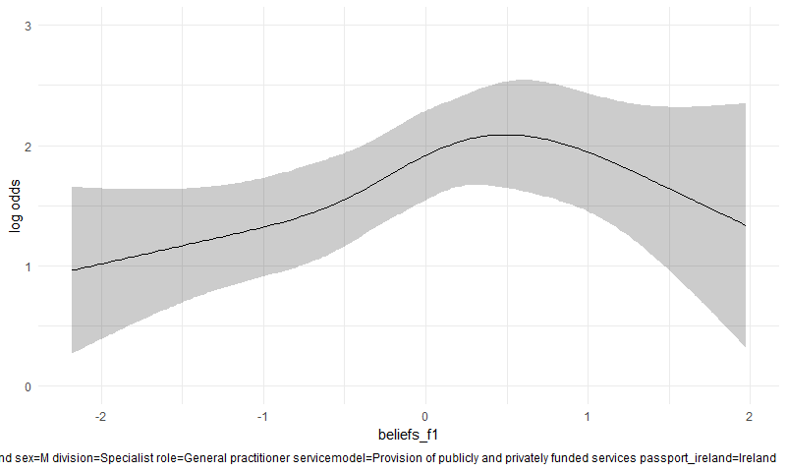

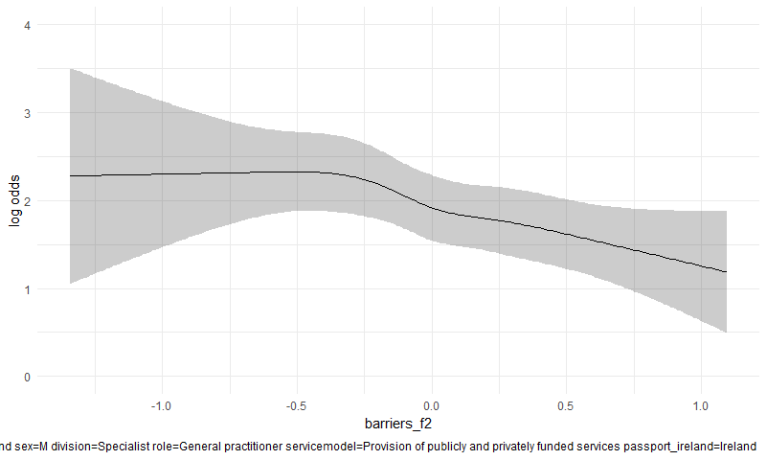

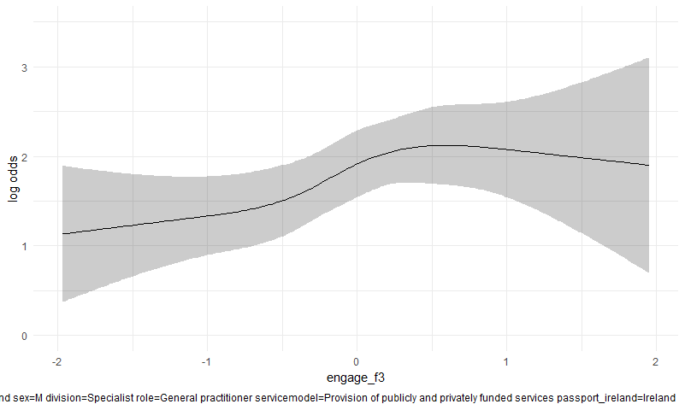

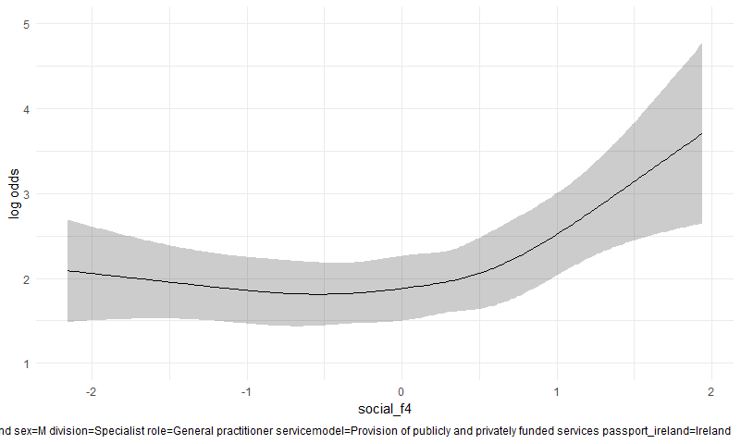

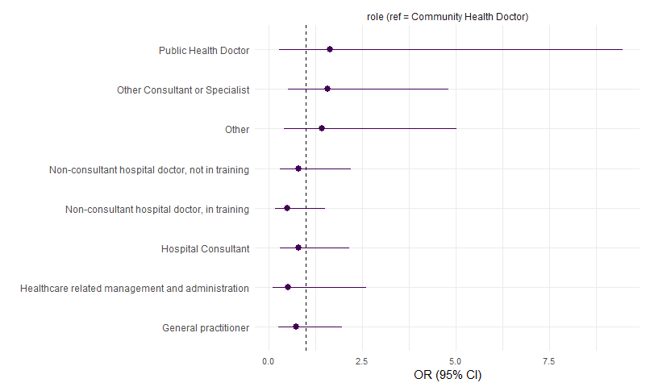

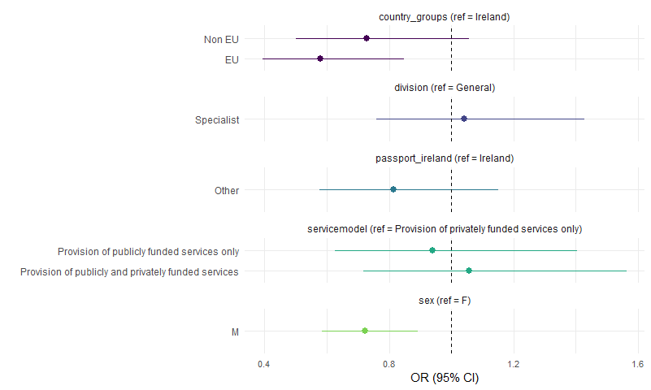

# Proportional odds models for confidence

|  |  |  |  |
| --- | --- | --- | --- |
|  | Chi-Square | d.f. | P |
| beliefs_f1 | 1.5e+01 | 4 | 0.00470 |
| Nonlinear | 2.3e+00 | 3 | 0.51000 |
| barriers_f2 | 5.0e+01 | 4 | 0.00000 |
| Nonlinear | 1.3e+01 | 3 | 0.00500 |
| engage_f3 | 8.4e+01 | 4 | 0.00000 |
| Nonlinear | 1.7e+01 | 3 | 0.00072 |
| social_f4 | 9.2e+01 | 4 | 0.00000 |
| Nonlinear | 6.7e+01 | 3 | 0.00000 |
| country_groups | 1.6e+00 | 2 | 0.44000 |
| sex | 4.3e-03 | 1 | 0.95000 |
| division | 4.9e-01 | 1 | 0.48000 |
| role | 6.2e+00 | 8 | 0.62000 |
| servicemodel | 3.1e+00 | 2 | 0.21000 |
| passport_ireland | 9.0e-02 | 1 | 0.76000 |
| TOTAL NONLINEAR | 1.3e+02 | 12 | 0.00000 |
| TOTAL | 3.9e+02 | 31 | 0.00000 |

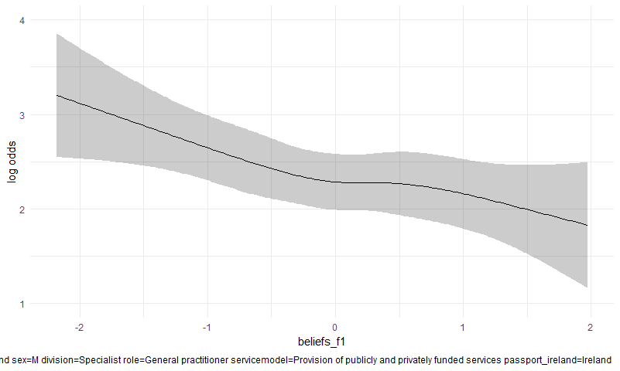

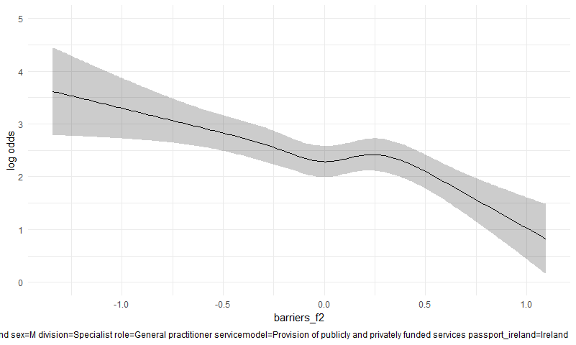

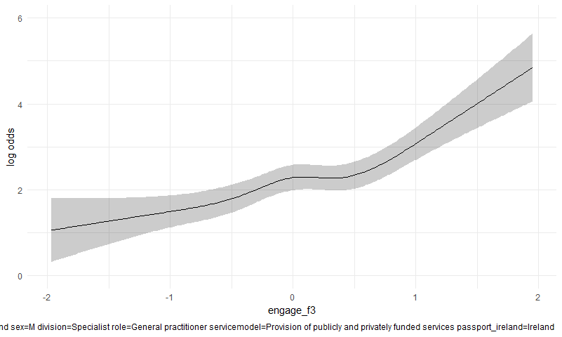

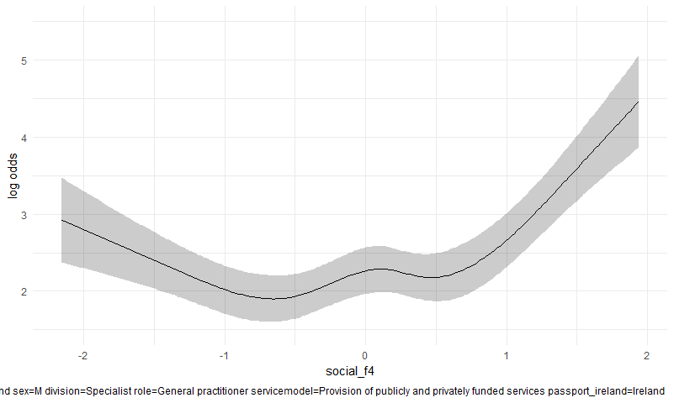

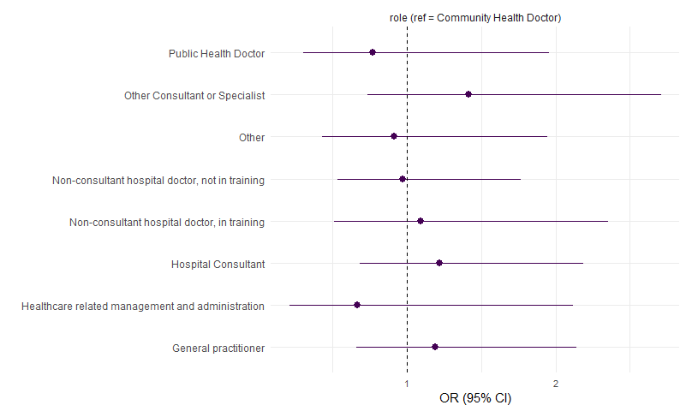

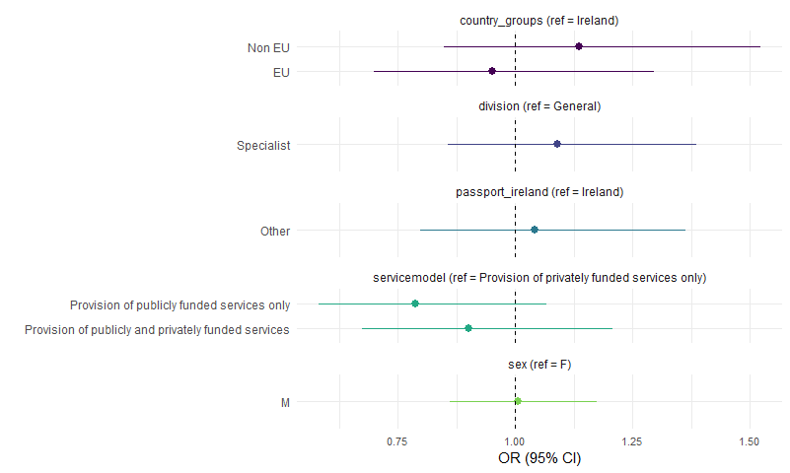

# The relationship between gender, country_groups, division and questionnaire responses, using the binary responses.

This plots and tests (using chi squared) the relationships between the binary responses and the key respondent characteristics. The multiple comparisons are addressed with the Benjamini–Hochberg procedure, controlling for a false discovery rate of 5%. Binary questionnaire responses flagged as sig = TRUE are those we might treat as statistically significant after the adjustment for multiplicity.

Sex

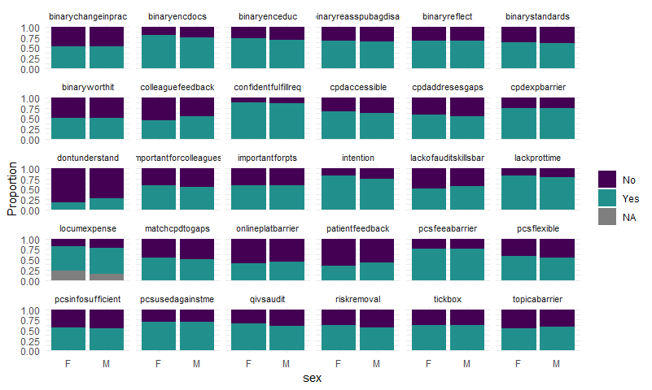

|  |  |  |  |  |  |  |
| --- | --- | --- | --- | --- | --- | --- |
| var | p | m | i | q | fdrp | sig |
| binary_dontunderstand | 0.00e+00 | 23 | 1 | 0.05 | 0.0021739 | TRUE |
| binary_intention | 0.00e+00 | 23 | 2 | 0.05 | 0.0043478 | TRUE |
| binary_patientfeedback | 0.00e+00 | 23 | 3 | 0.05 | 0.0065217 | TRUE |
| binary_colleaguefeedback | 0.00e+00 | 23 | 4 | 0.05 | 0.0086957 | TRUE |
| binary_qivsaudit | 8.00e-07 | 23 | 5 | 0.05 | 0.0108696 | TRUE |
| binary_riskremoval | 1.00e-06 | 23 | 6 | 0.05 | 0.0130435 | TRUE |
| binary_onlineplatbarrier | 1.38e-03 | 23 | 7 | 0.05 | 0.0152174 | TRUE |
| binary_cpdaccessible | 5.73e-03 | 23 | 8 | 0.05 | 0.0173913 | TRUE |
| binary_lackofauditskillsbar | 6.06e-03 | 23 | 9 | 0.05 | 0.0195652 | TRUE |
| binary_lackprottime | 1.47e-02 | 23 | 10 | 0.05 | 0.0217391 | TRUE |
| binary_cpdaddresesgaps | 1.48e-02 | 23 | 11 | 0.05 | 0.0239130 | TRUE |
| binary_pcsflexible | 2.98e-02 | 23 | 12 | 0.05 | 0.0260870 | FALSE |
| binary_importantforcolleagues | 4.96e-02 | 23 | 13 | 0.05 | 0.0282609 | FALSE |
| binary_locumexpense | 5.06e-02 | 23 | 14 | 0.05 | 0.0304348 | FALSE |
| binary_topicabarrier | 5.83e-02 | 23 | 15 | 0.05 | 0.0326087 | FALSE |
| binary_confidentfulfillreq | 7.58e-02 | 23 | 16 | 0.05 | 0.0347826 | FALSE |
| binary_matchcpdtogaps | 1.26e-01 | 23 | 17 | 0.05 | 0.0369565 | FALSE |
| binary_pcsinfosufficient | 2.06e-01 | 23 | 18 | 0.05 | 0.0391304 | FALSE |
| binary_tickbox | 5.77e-01 | 23 | 19 | 0.05 | 0.0413043 | FALSE |
| binary_importantforpts | 6.45e-01 | 23 | 20 | 0.05 | 0.0434783 | FALSE |
| binary_cpdexpbarrier | 6.55e-01 | 23 | 21 | 0.05 | 0.0456522 | FALSE |
| binary_pcsfeeabarrier | 9.40e-01 | 23 | 22 | 0.05 | 0.0478261 | FALSE |
| binary_pcsusedagainstme | 9.95e-01 | 23 | 23 | 0.05 | 0.0500000 | FALSE |

Division

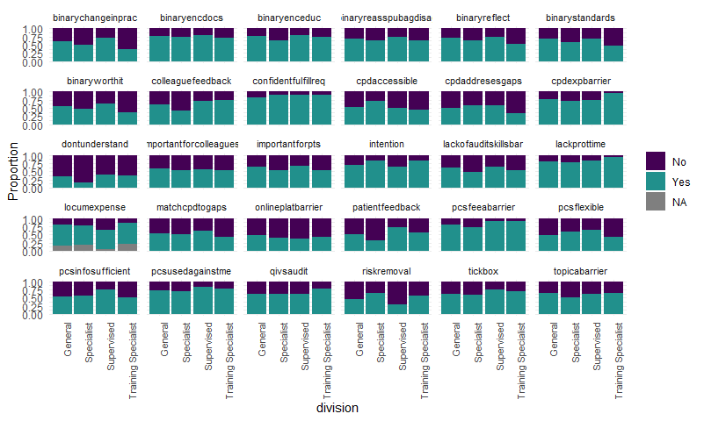

|  |  |  |  |  |  |  |
| --- | --- | --- | --- | --- | --- | --- |
| var | p | m | i | q | fdrp | sig |
| binary_patientfeedback | 0.00e+00 | 23 | 1 | 0.05 | 0.0021739 | TRUE |
| binary_dontunderstand | 0.00e+00 | 23 | 2 | 0.05 | 0.0043478 | TRUE |
| binary_colleaguefeedback | 0.00e+00 | 23 | 3 | 0.05 | 0.0065217 | TRUE |
| binary_cpdaccessible | 0.00e+00 | 23 | 4 | 0.05 | 0.0086957 | TRUE |
| binary_riskremoval | 0.00e+00 | 23 | 5 | 0.05 | 0.0108696 | TRUE |
| binary_intention | 0.00e+00 | 23 | 6 | 0.05 | 0.0130435 | TRUE |
| binary_lackofauditskillsbar | 0.00e+00 | 23 | 7 | 0.05 | 0.0152174 | TRUE |
| binary_pcsfeeabarrier | 0.00e+00 | 23 | 8 | 0.05 | 0.0173913 | TRUE |
| binary_topicabarrier | 0.00e+00 | 23 | 9 | 0.05 | 0.0195652 | TRUE |
| binary_pcsflexible | 0.00e+00 | 23 | 10 | 0.05 | 0.0217391 | TRUE |
| binary_cpdaddresesgaps | 0.00e+00 | 23 | 11 | 0.05 | 0.0239130 | TRUE |
| binary_confidentfulfillreq | 0.00e+00 | 23 | 12 | 0.05 | 0.0260870 | TRUE |
| binary_cpdexpbarrier | 0.00e+00 | 23 | 13 | 0.05 | 0.0282609 | TRUE |
| binary_importantforpts | 0.00e+00 | 23 | 14 | 0.05 | 0.0304348 | TRUE |
| binary_onlineplatbarrier | 2.70e-06 | 23 | 15 | 0.05 | 0.0326087 | TRUE |
| binary_lackprottime | 3.90e-03 | 23 | 16 | 0.05 | 0.0347826 | TRUE |
| binary_matchcpdtogaps | 7.05e-03 | 23 | 17 | 0.05 | 0.0369565 | TRUE |
| binary_qivsaudit | 1.51e-02 | 23 | 18 | 0.05 | 0.0391304 | TRUE |
| binary_importantforcolleagues | 1.94e-02 | 23 | 19 | 0.05 | 0.0413043 | TRUE |
| binary_pcsusedagainstme | 2.32e-02 | 23 | 20 | 0.05 | 0.0434783 | TRUE |
| binary_locumexpense | 2.55e-02 | 23 | 21 | 0.05 | 0.0456522 | TRUE |
| binary_pcsinfosufficient | 6.17e-02 | 23 | 22 | 0.05 | 0.0478261 | FALSE |
| binary_tickbox | 1.07e-01 | 23 | 23 | 0.05 | 0.0500000 | FALSE |

Country groups

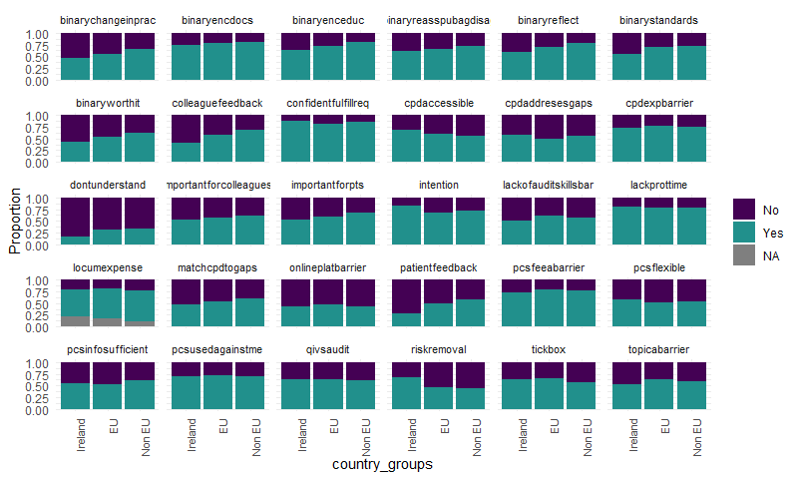

|  |  |  |  |  |  |  |
| --- | --- | --- | --- | --- | --- | --- |
| var | p | m | i | q | fdrp | sig |
| binary_patientfeedback | 0.00e+00 | 23 | 1 | 0.05 | 0.0021739 | TRUE |
| binary_colleaguefeedback | 0.00e+00 | 23 | 2 | 0.05 | 0.0043478 | TRUE |
| binary_riskremoval | 0.00e+00 | 23 | 3 | 0.05 | 0.0065217 | TRUE |
| binary_dontunderstand | 0.00e+00 | 23 | 4 | 0.05 | 0.0086957 | TRUE |
| binary_intention | 0.00e+00 | 23 | 5 | 0.05 | 0.0108696 | TRUE |
| binary_importantforpts | 0.00e+00 | 23 | 6 | 0.05 | 0.0130435 | TRUE |
| binary_cpdaccessible | 0.00e+00 | 23 | 7 | 0.05 | 0.0152174 | TRUE |
| binary_matchcpdtogaps | 0.00e+00 | 23 | 8 | 0.05 | 0.0173913 | TRUE |
| binary_lackofauditskillsbar | 0.00e+00 | 23 | 9 | 0.05 | 0.0195652 | TRUE |
| binary_topicabarrier | 0.00e+00 | 23 | 10 | 0.05 | 0.0217391 | TRUE |
| binary_importantforcolleagues | 1.00e-07 | 23 | 11 | 0.05 | 0.0239130 | TRUE |
| binary_confidentfulfillreq | 7.83e-05 | 23 | 12 | 0.05 | 0.0260870 | TRUE |
| binary_pcsinfosufficient | 9.35e-05 | 23 | 13 | 0.05 | 0.0282609 | TRUE |
| binary_cpdaddresesgaps | 1.39e-04 | 23 | 14 | 0.05 | 0.0304348 | TRUE |
| binary_tickbox | 4.04e-04 | 23 | 15 | 0.05 | 0.0326087 | TRUE |
| binary_pcsfeeabarrier | 5.25e-04 | 23 | 16 | 0.05 | 0.0347826 | TRUE |
| binary_pcsflexible | 3.44e-02 | 23 | 17 | 0.05 | 0.0369565 | TRUE |
| binary_cpdexpbarrier | 9.34e-02 | 23 | 18 | 0.05 | 0.0391304 | FALSE |
| binary_locumexpense | 1.08e-01 | 23 | 19 | 0.05 | 0.0413043 | FALSE |
| binary_onlineplatbarrier | 1.32e-01 | 23 | 20 | 0.05 | 0.0434783 | FALSE |
| binary_qivsaudit | 1.59e-01 | 23 | 21 | 0.05 | 0.0456522 | FALSE |
| binary_lackprottime | 3.31e-01 | 23 | 22 | 0.05 | 0.0478261 | FALSE |
| binary_pcsusedagainstme | 3.67e-01 | 23 | 23 | 0.05 | 0.0500000 | FALSE |