# Respondent characteristics

These are based on the full data set (n = 5368) with no observations dropped for missing data.

|  |  |  |  |  |
| --- | --- | --- | --- | --- |
| Variable | N | Mean SD | Median [IQR] | (Min, Max) |
| sex | 5368 |  |  |  |
| F |  | 2082 (38.8%) |  |  |
| M |  | 3286 (61.2%) |  |  |
| age | 5368 | 47.5 ± 11.9 | 47 (38, 56) | (24, 93) |
| age_groups | 5368 |  |  |  |
| 34 and under |  | 856 (15.9%) |  |  |
| 35 – 44 |  | 1469 (27.4%) |  |  |
| 45 – 54 |  | 1473 (27.4%) |  |  |
| 55+ |  | 1570 (29.2%) |  |  |
| yearsonregister | 5368 | 14.6 ± 11.7 | 12 (4, 24) | (0, 37) |
| years_groups | 5368 |  |  |  |
| 0 – 4 |  | 2201 (41%) |  |  |
| 5 – 14 |  | 1454 (27.1%) |  |  |
| 15 – 24 |  | 888 (16.5%) |  |  |
| 25+ |  | 825 (15.4%) |  |  |
| enrolledonscheme | 5368 |  |  |  |
| Yes |  | 5194 (96.8%) |  |  |
| No |  | 174 (3.2%) |  |  |
| division | 5368 |  |  |  |
| General |  | 2109 (39.3%) |  |  |
| Specialist |  | 3123 (58.2%) |  |  |
| Supervised |  | 36 (0.7%) |  |  |
| Training Specialist |  | 100 (1.9%) |  |  |
| status | 5368 |  |  |  |
| Active |  | 5277 (98.3%) |  |  |
| Application Under Review |  | 1 (0%) |  |  |
| Withdrawn |  | 90 (1.7%) |  |  |
| hours | 4008 |  |  |  |
| 10 to 20 hours per week |  | 290 (7.2%) |  |  |
| 21 to 30 hours per week |  | 318 (7.9%) |  |  |
| 31 to 40 hours per week |  | 1244 (31%) |  |  |
| Fewer than 10 hours per week |  | 181 (4.5%) |  |  |
| More than 40 hours per week |  | 1975 (49.3%) |  |  |
| role | 4015 |  |  |  |
| Community Health Doctor |  | 75 (1.9%) |  |  |
| General practitioner |  | 1414 (35.2%) |  |  |
| Healthcare related management and administration |  | 24 (0.6%) |  |  |
| Hospital Consultant |  | 1334 (33.2%) |  |  |
| Non-consultant hospital doctor, in training |  | 72 (1.8%) |  |  |
| Non-consultant hospital doctor, not in training |  | 734 (18.3%) |  |  |
| Other |  | 100 (2.5%) |  |  |
| Other Consultant or Specialist |  | 218 (5.4%) |  |  |
| Public Health Doctor |  | 44 (1.1%) |  |  |
| servicemodel | 3457 |  |  |  |
| Provision of privately funded services only |  | 278 (8%) |  |  |
| Provision of publicly and privately funded services |  | 1875 (54.2%) |  |  |
| Provision of publicly funded services only |  | 1304 (37.7%) |  |  |
| country | 3997 |  |  |  |
| Both within and outside the Republic of Ireland |  | 300 (7.5%) |  |  |
| Outside the Republic of Ireland only |  | 81 (2%) |  |  |
| Within the Republic of Ireland only |  | 3616 (90.5%) |  |  |
| country_groups | 5368 |  |  |  |
| Ireland |  | 2984 (55.6%) |  |  |
| EU |  | 805 (15%) |  |  |
| Non EU |  | 1579 (29.4%) |  |  |
| county_dublin | 3941 |  |  |  |
| Dublin |  | 1482 (37.6%) |  |  |
| Other |  | 2459 (62.4%) |  |  |
| passport_ireland | 4099 |  |  |  |
| Ireland |  | 2689 (65.6%) |  |  |
| Other |  | 1410 (34.4%) |  |  |

# Survey items and intent

These are based on the full data set (n = 5368) with no observations dropped for missing data.

## F1: Items 1-7 & 21: Attitudes to Maintenance of Professional Competence

Do you argree with the following statements about the MPC? 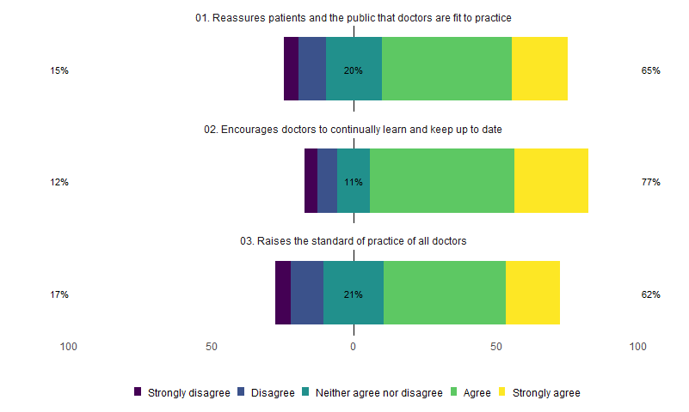

By intent to comply (yes/no) 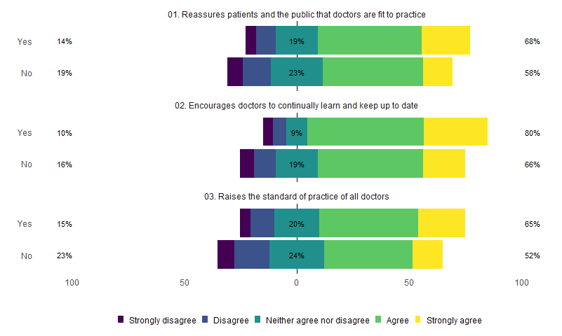

Do you argree with the following statements about personal impact of participation? 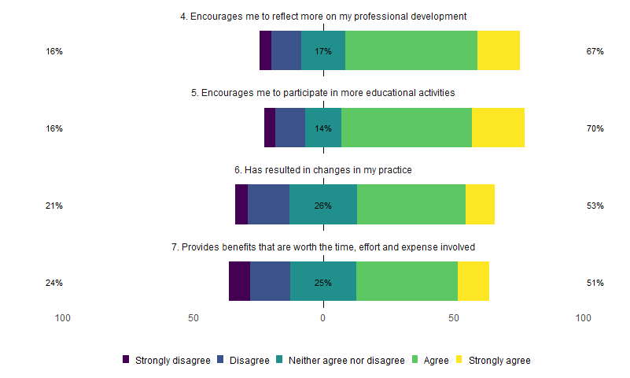

By intent to comply (yes/no) 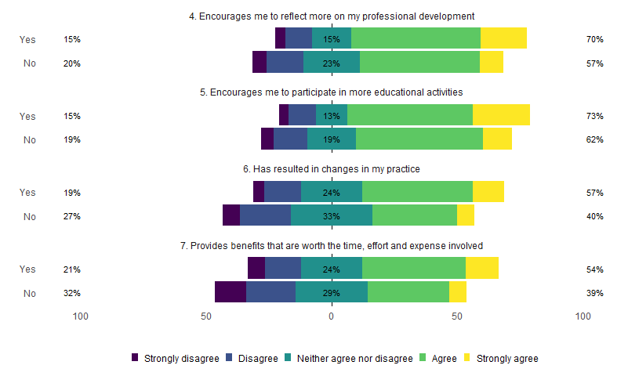

How do all of these items relate to intention? 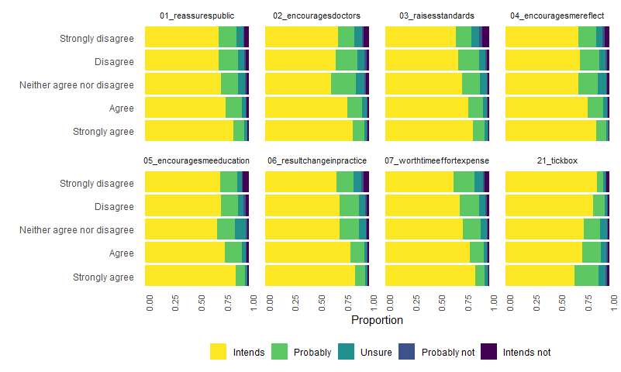

Proportional odds models for intent regressed on each item 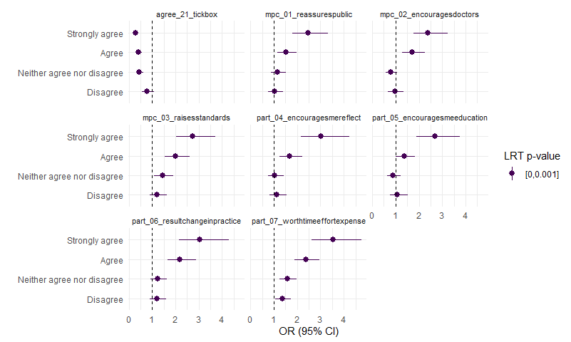

## F2: Items 8-15 & 26: Barriers to Engagement with Maintenance of Professional Competence

Please indicate your agreement with these statements about BARRIERS to your own engagement with Maintenance of Professional Competence in Ireland 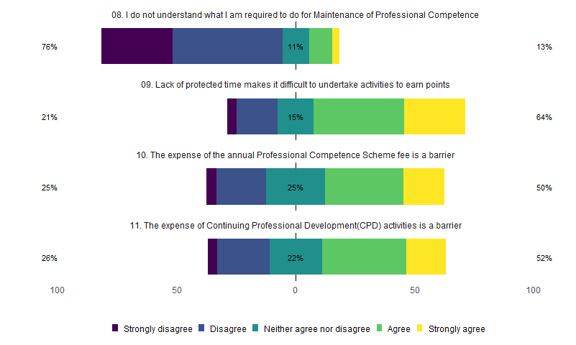

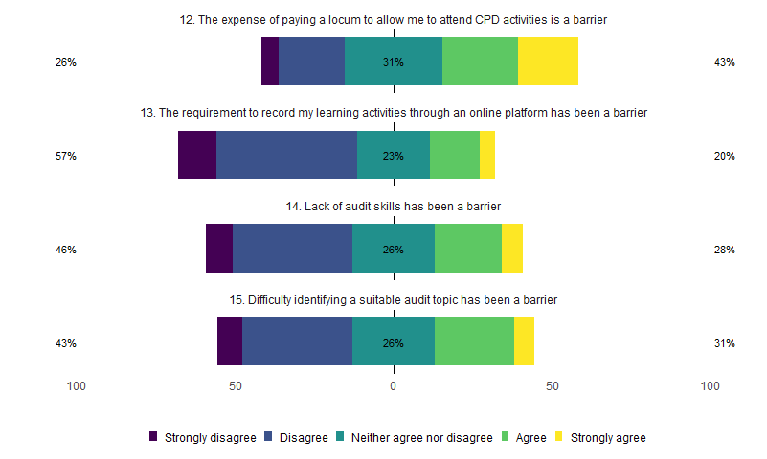

By intent to comply (yes/no)

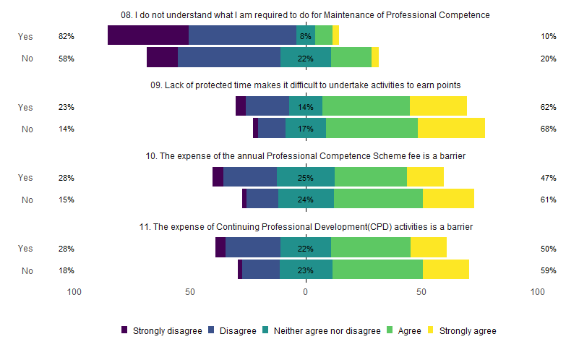

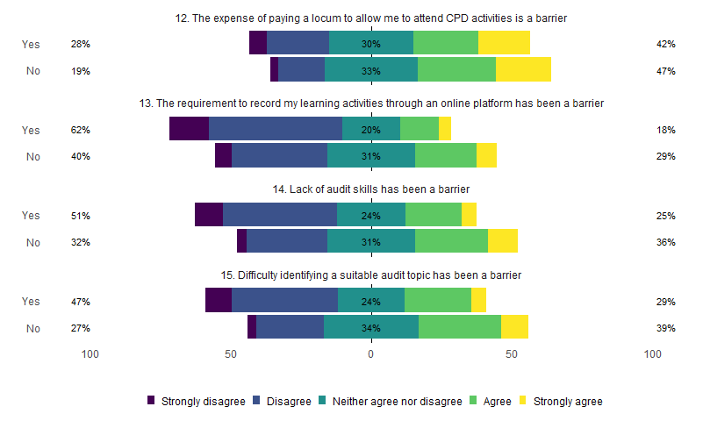

How do all of these items relate to intention? 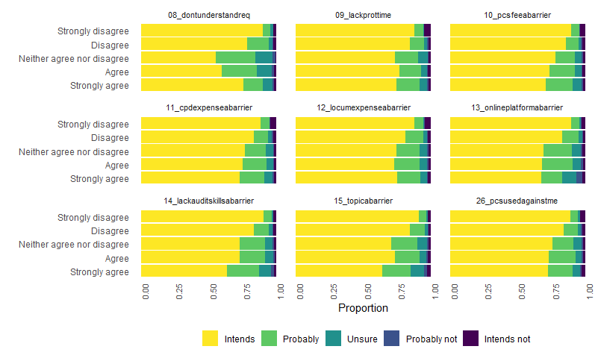

Proportional odds models for intent regressed on each item 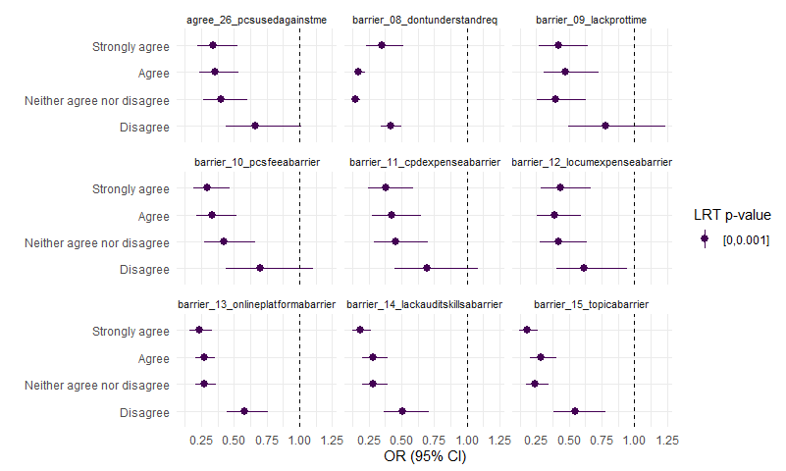

## F3: Items 17-20: Facilitators of Engagement with Maintenance of Professional Competence

Please indicate your agreement with the following statements about factors which SUPPORT your own engagement with Maintenance of Professional Competence in Ireland 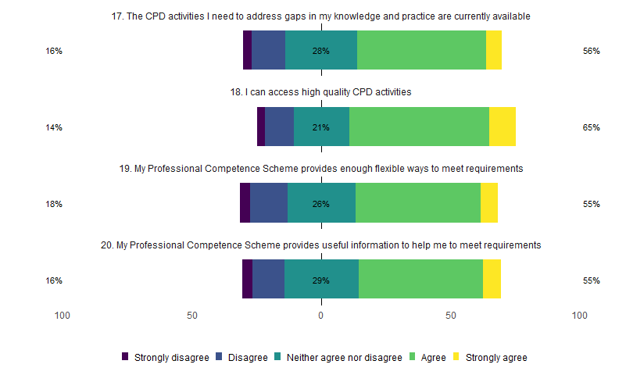

By intent to comply (yes/no) 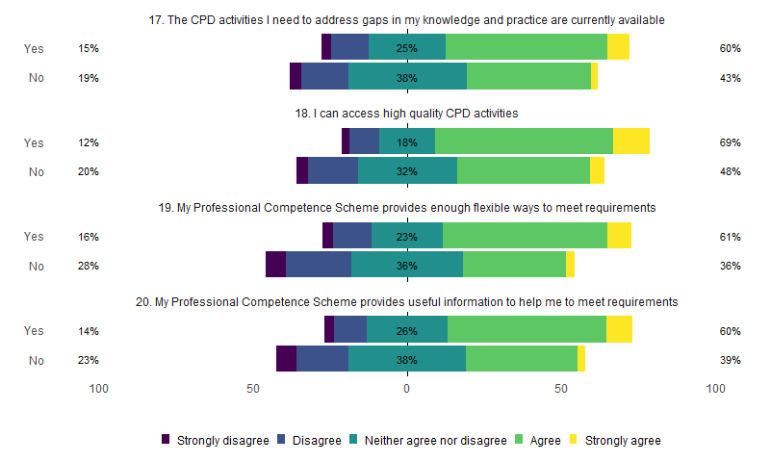

How do all of these items relate to intention? 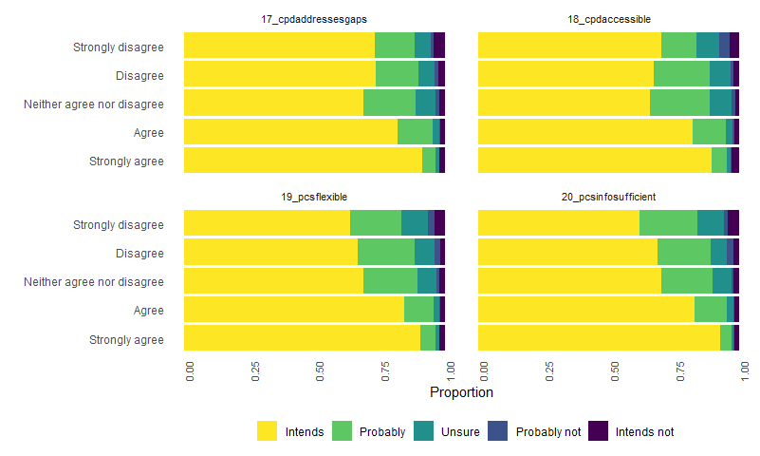

Proportional odds models for intent regressed on each item 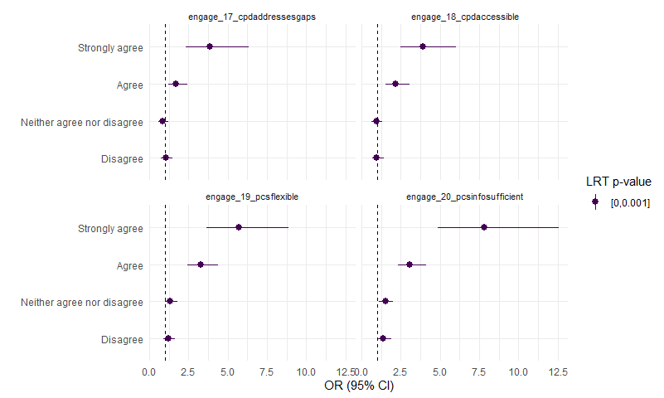

## F4: Items 27-29: Social Norms relating to Maintenance of Professional Competence

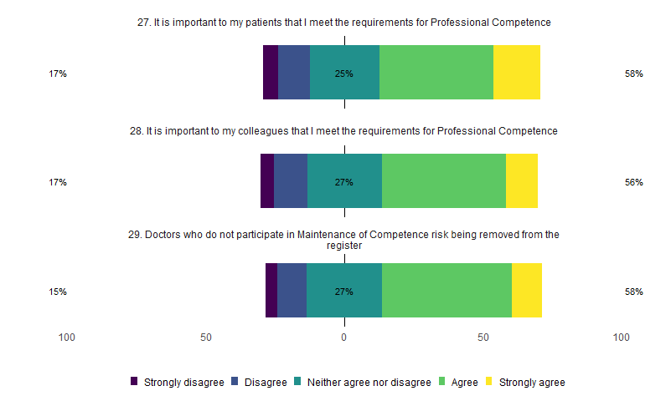

Intends to comply 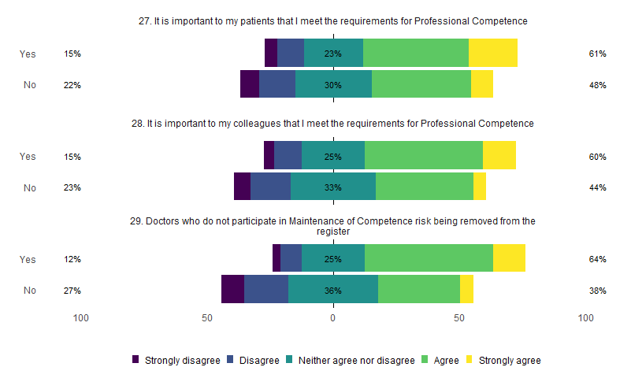

How do all of these items relate to intention? 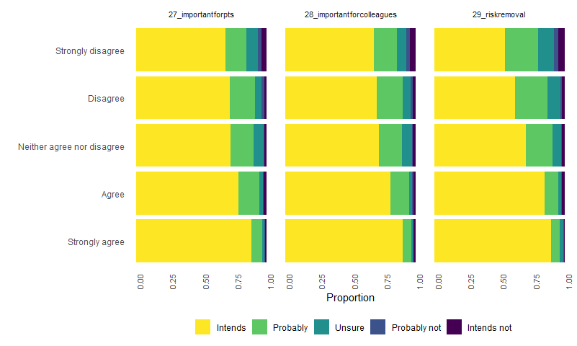

Proportional odds models for intent regressed on each item 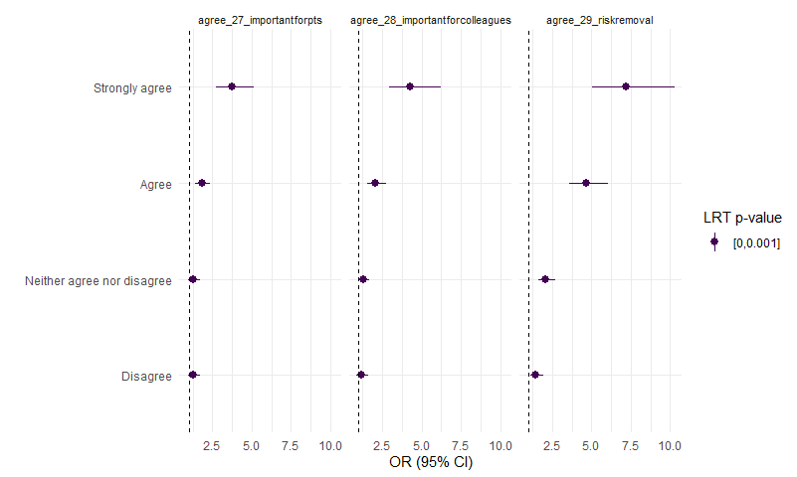

# Full CFA

These are based on the reduced data set (n = 4914) with observations dropped for missing values for measurements used in the CFA.

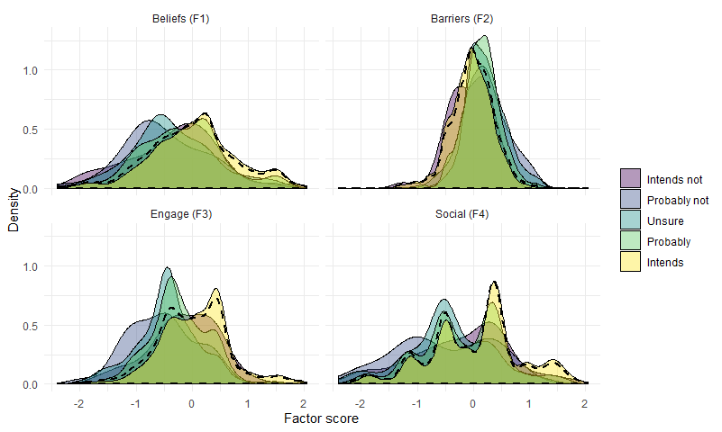

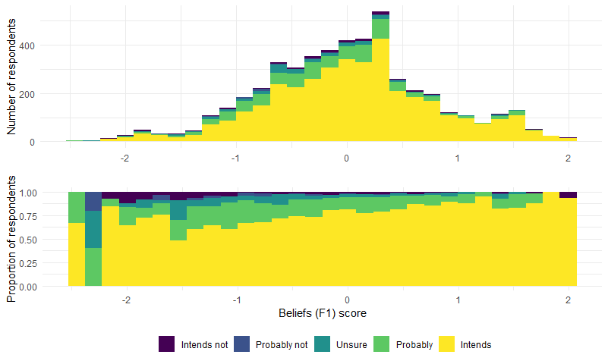

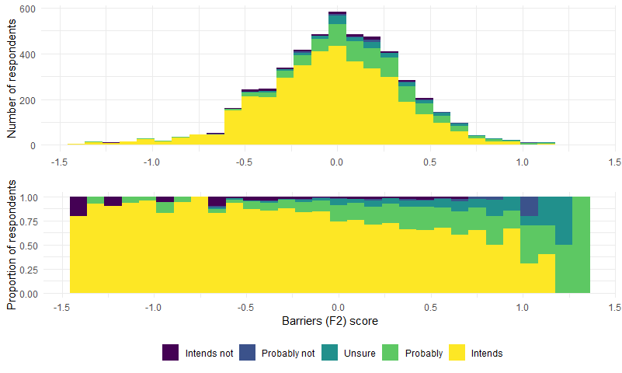

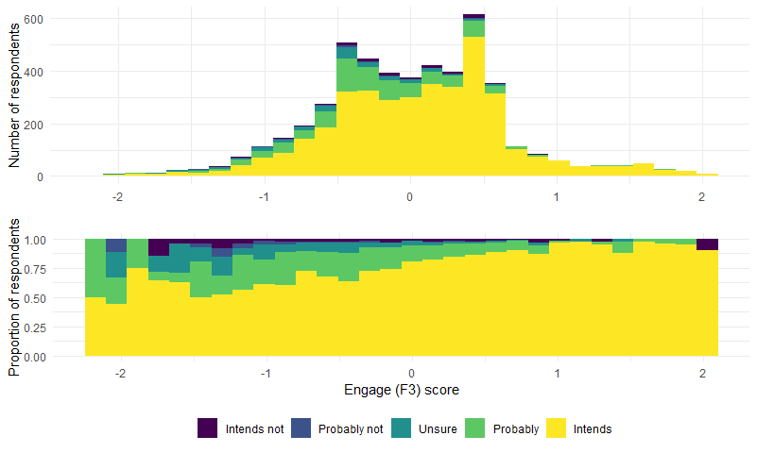

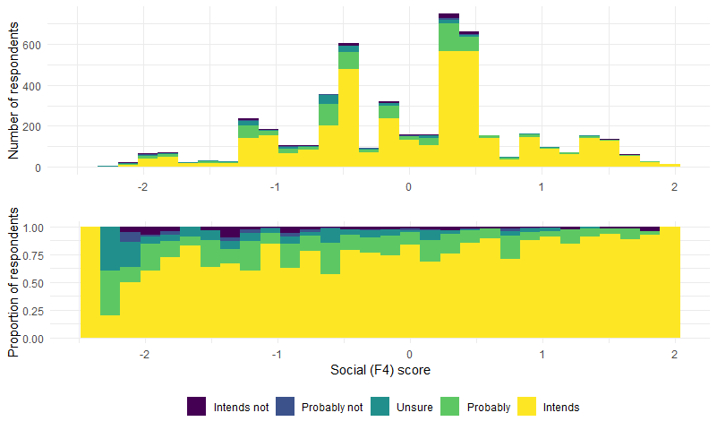

Factor Loadings

|  |  |  |  |  |  |  |
| --- | --- | --- | --- | --- | --- | --- |
| Latent Factor | Indicator | B | SE | Z | p-value | Beta |
| Beliefs_f1 | mpc_01_reassurespublic | 1.000 | 0.000 | NA | NA | 0.804 |
| Beliefs_f1 | mpc_02_encouragesdoctors | 1.106 | 0.008 | 144.496 | 0 | 0.889 |
| Beliefs_f1 | mpc_03_raisesstandards | 1.104 | 0.008 | 143.764 | 0 | 0.888 |
| Beliefs_f1 | part_04_encouragesmereflect | 1.094 | 0.008 | 144.280 | 0 | 0.879 |
| Beliefs_f1 | part_05_encouragesmeeducation | 1.016 | 0.008 | 124.525 | 0 | 0.817 |
| Beliefs_f1 | part_06_resultchangeinpractice | 1.019 | 0.008 | 123.646 | 0 | 0.819 |
| Beliefs_f1 | part_07_worthtimeeffortexpense | 1.067 | 0.008 | 134.274 | 0 | 0.858 |
| Beliefs_f1 | agree_21_tickbox | -0.611 | 0.014 | -43.093 | 0 | -0.491 |
| Barriers_f2 | barrier_08_dontunderstandreq | 1.000 | 0.000 | NA | NA | 0.433 |
| Barriers_f2 | barrier_09_lackprottime | 1.331 | 0.045 | 29.685 | 0 | 0.577 |
| Barriers_f2 | barrier_10_pcsfeeabarrier | 1.972 | 0.060 | 32.641 | 0 | 0.854 |
| Barriers_f2 | barrier_11_cpdexpenseabarrier | 1.951 | 0.061 | 32.079 | 0 | 0.845 |
| Barriers_f2 | barrier_13_onlineplatformabarrier | 1.251 | 0.043 | 29.189 | 0 | 0.542 |
| Barriers_f2 | barrier_14_lackauditskillsabarrier | 1.549 | 0.047 | 32.945 | 0 | 0.671 |
| Barriers_f2 | barrier_15_topicabarrier | 1.608 | 0.051 | 31.570 | 0 | 0.697 |
| Barriers_f2 | agree_26_pcsusedagainstme | 0.930 | 0.041 | 22.912 | 0 | 0.403 |
| Engage_f3 | engage_17_cpdaddressesgaps | 1.000 | 0.000 | NA | NA | 0.695 |
| Engage_f3 | engage_18_cpdaccessible | 1.044 | 0.017 | 59.736 | 0 | 0.726 |
| Engage_f3 | engage_19_pcsflexible | 1.167 | 0.018 | 63.760 | 0 | 0.811 |
| Engage_f3 | engage_20_pcsinfosufficient | 1.201 | 0.019 | 62.739 | 0 | 0.835 |
| Social_f4 | agree_27_importantforpts | 1.000 | 0.000 | NA | NA | 0.907 |
| Social_f4 | agree_28_importantforcolleagues | 0.997 | 0.012 | 82.328 | 0 | 0.904 |
| Social_f4 | agree_29_riskremoval | 0.300 | 0.018 | 16.360 | 0 | 0.272 |

Latent Factor Correlations

|  |  |  |  |
| --- | --- | --- | --- |
| Factor 1 | Factor 2 | Correlation | P value |
| Beliefs_f1 | Beliefs_f1 | 0.646 | 0 |
| Barriers_f2 | Barriers_f2 | 0.188 | 0 |
| Beliefs_f1 | Barriers_f2 | -0.093 | 0 |
| Beliefs_f1 | Engage_f3 | 0.300 | 0 |
| Beliefs_f1 | Social_f4 | 0.416 | 0 |
| Barriers_f2 | Engage_f3 | -0.137 | 0 |
| Barriers_f2 | Social_f4 | -0.101 | 0 |

Model fit

|  |  |
| --- | --- |
| Measure | Value |
| chisq | 12400.889 |
| df | 224.000 |
| pvalue | 0.000 |
| cfi | 0.973 |
| tli | 0.970 |
| rmsea | 0.105 |
| rmsea.pvalue | 0.000 |

# Proportional odds models for intends

These are based on the reduced data set (n = 4914) with observations dropped for missing values for measurements used in the CFA (as factor scores are used as predictors in these models).

|  |  |  |  |
| --- | --- | --- | --- |
|  | Chi-Square | d.f. | P |
| beliefs_f1 | 22.000 | 4 | 0.00025 |
| Nonlinear | 9.300 | 3 | 0.02500 |
| barriers_f2 | 19.000 | 4 | 0.00082 |
| Nonlinear | 1.500 | 3 | 0.67000 |
| engage_f3 | 20.000 | 4 | 0.00043 |
| Nonlinear | 4.400 | 3 | 0.22000 |
| social_f4 | 18.000 | 4 | 0.00120 |
| Nonlinear | 13.000 | 3 | 0.00370 |
| country_groups | 7.900 | 2 | 0.02000 |
| sex | 9.100 | 1 | 0.00260 |
| division | 0.066 | 1 | 0.80000 |
| role | 13.000 | 8 | 0.11000 |
| servicemodel | 0.850 | 2 | 0.65000 |
| passport_ireland | 1.300 | 1 | 0.25000 |
| TOTAL NONLINEAR | 31.000 | 12 | 0.00220 |
| TOTAL | 290.000 | 31 | 0.00000 |

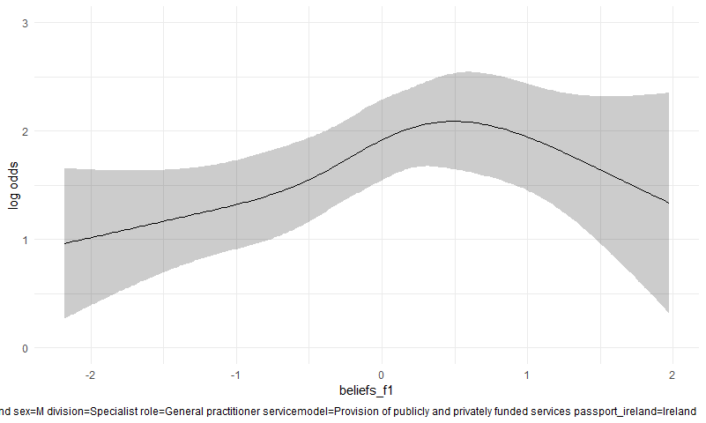

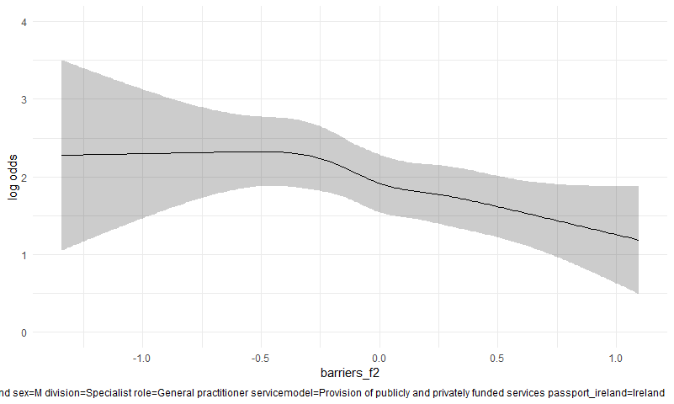

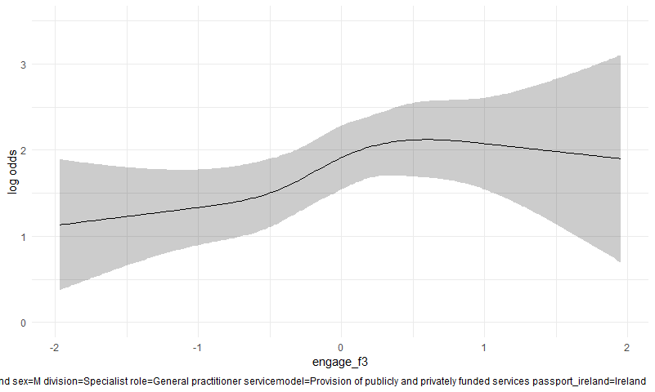

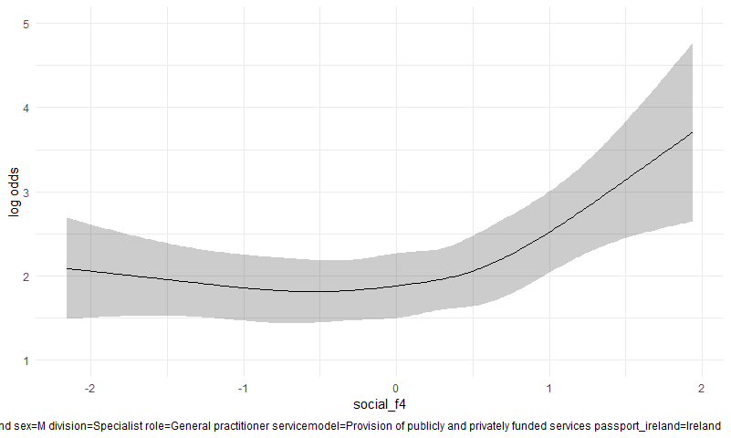

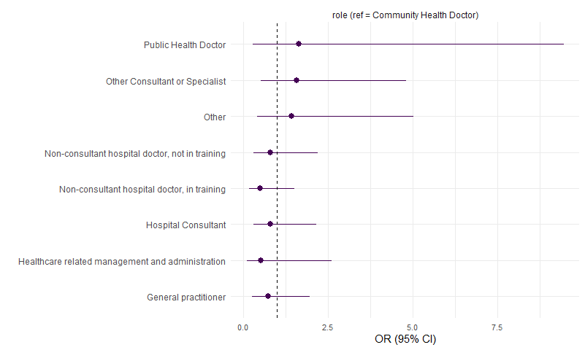

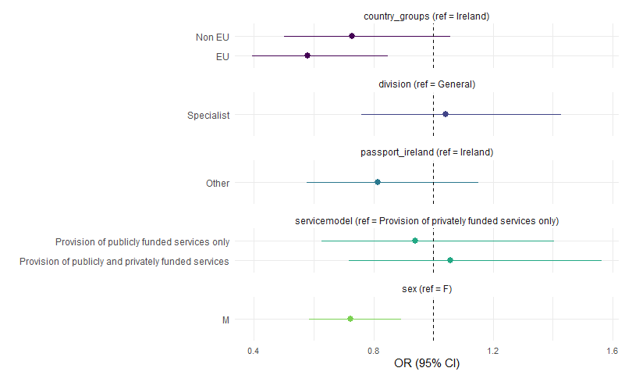

# Proportional odds models for confidence

These are based on the reduced data set (n = 4914) with observations dropped for missing values for measurements used in the CFA (as factor scores are used as predictors in these models).

|  |  |  |  |
| --- | --- | --- | --- |
|  | Chi-Square | d.f. | P |
| beliefs_f1 | 1.5e+01 | 4 | 0.00470 |
| Nonlinear | 2.3e+00 | 3 | 0.51000 |
| barriers_f2 | 5.0e+01 | 4 | 0.00000 |
| Nonlinear | 1.3e+01 | 3 | 0.00500 |
| engage_f3 | 8.4e+01 | 4 | 0.00000 |
| Nonlinear | 1.7e+01 | 3 | 0.00072 |
| social_f4 | 9.2e+01 | 4 | 0.00000 |
| Nonlinear | 6.7e+01 | 3 | 0.00000 |
| country_groups | 1.6e+00 | 2 | 0.44000 |
| sex | 4.3e-03 | 1 | 0.95000 |
| division | 4.9e-01 | 1 | 0.48000 |
| role | 6.2e+00 | 8 | 0.62000 |
| servicemodel | 3.1e+00 | 2 | 0.21000 |
| passport_ireland | 9.0e-02 | 1 | 0.76000 |
| TOTAL NONLINEAR | 1.3e+02 | 12 | 0.00000 |
| TOTAL | 3.9e+02 | 31 | 0.00000 |

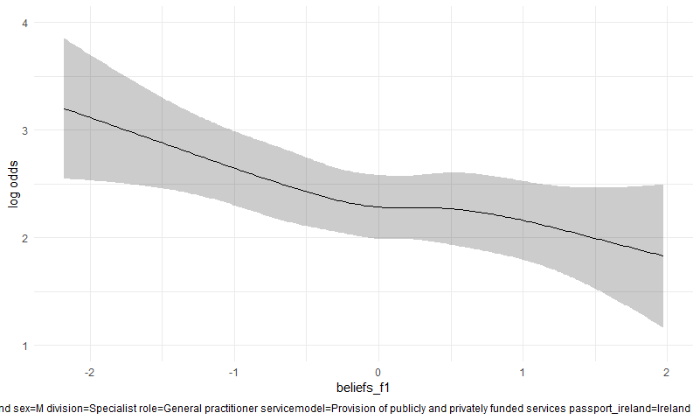

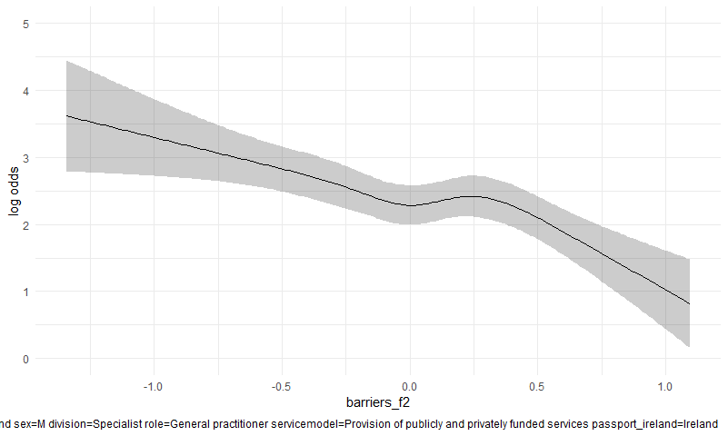

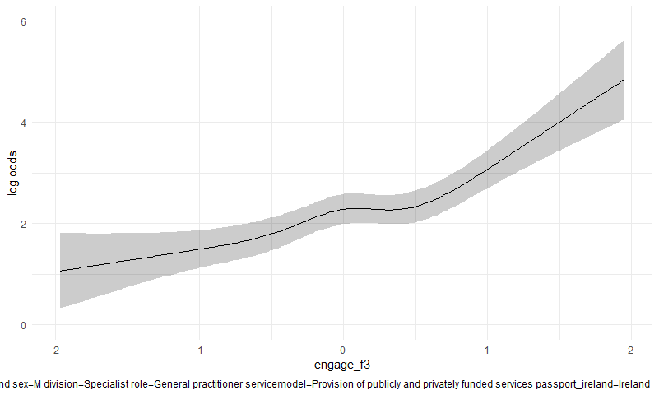

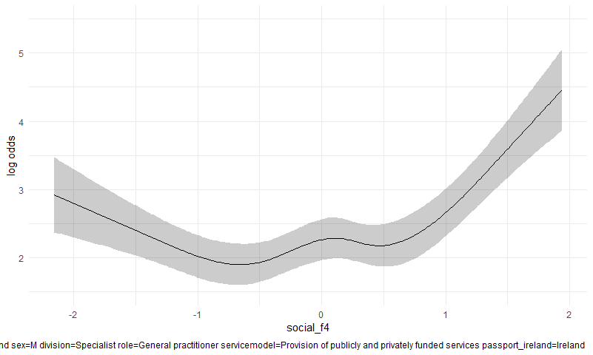

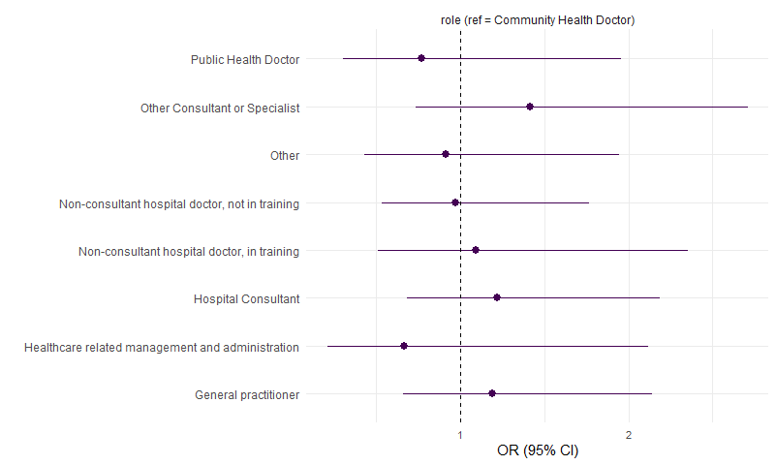

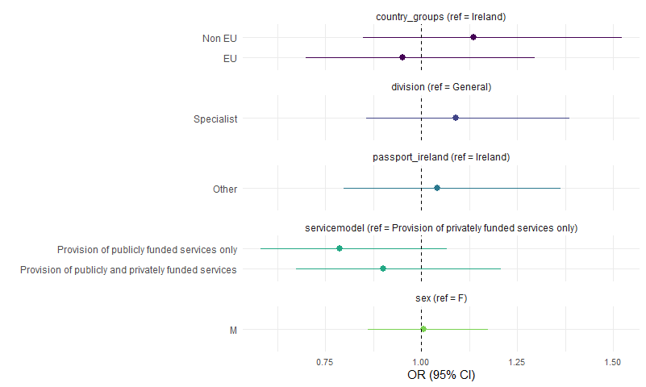

# The relationship between gender, country_groups, division and questionnaire responses, using the binary responses.

These are based on the full data set (n = 5368) with no observations dropped for missing data.

## Sex

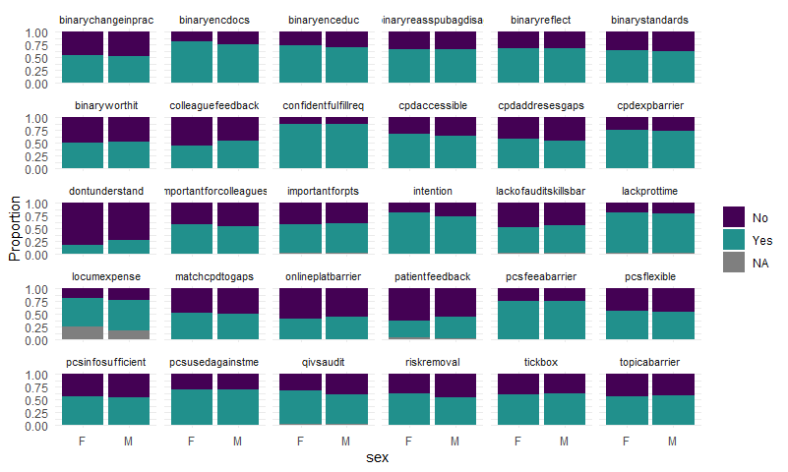

|  |  |  |  |  |  |  |
| --- | --- | --- | --- | --- | --- | --- |
| var | p | m | i | q | fdrp | sig |
| binary_dontunderstand | 0.00e+00 | 23 | 1 | 0.05 | 0.0021739 | TRUE |
| binary_intention | 0.00e+00 | 23 | 2 | 0.05 | 0.0043478 | TRUE |
| binary_colleaguefeedback | 0.00e+00 | 23 | 3 | 0.05 | 0.0065217 | TRUE |
| binary_patientfeedback | 0.00e+00 | 23 | 4 | 0.05 | 0.0086957 | TRUE |
| binary_riskremoval | 1.00e-07 | 23 | 5 | 0.05 | 0.0108696 | TRUE |
| binary_qivsaudit | 2.00e-07 | 23 | 6 | 0.05 | 0.0130435 | TRUE |
| binary_onlineplatbarrier | 7.67e-05 | 23 | 7 | 0.05 | 0.0152174 | TRUE |
| binary_lackofauditskillsbar | 2.04e-03 | 23 | 8 | 0.05 | 0.0173913 | TRUE |
| binary_cpdaccessible | 4.76e-03 | 23 | 9 | 0.05 | 0.0195652 | TRUE |
| binary_cpdaddresesgaps | 6.24e-03 | 23 | 10 | 0.05 | 0.0217391 | TRUE |
| binary_pcsflexible | 2.10e-02 | 23 | 11 | 0.05 | 0.0239130 | TRUE |
| binary_lackprottime | 3.63e-02 | 23 | 12 | 0.05 | 0.0260870 | FALSE |
| binary_locumexpense | 4.53e-02 | 23 | 13 | 0.05 | 0.0282609 | FALSE |
| binary_importantforcolleagues | 6.59e-02 | 23 | 14 | 0.05 | 0.0304348 | FALSE |
| binary_confidentfulfillreq | 7.21e-02 | 23 | 15 | 0.05 | 0.0326087 | FALSE |
| binary_matchcpdtogaps | 1.11e-01 | 23 | 16 | 0.05 | 0.0347826 | FALSE |
| binary_topicabarrier | 1.35e-01 | 23 | 17 | 0.05 | 0.0369565 | FALSE |
| binary_pcsinfosufficient | 1.65e-01 | 23 | 18 | 0.05 | 0.0391304 | FALSE |
| binary_tickbox | 3.13e-01 | 23 | 19 | 0.05 | 0.0413043 | FALSE |
| binary_importantforpts | 6.54e-01 | 23 | 20 | 0.05 | 0.0434783 | FALSE |
| binary_cpdexpbarrier | 7.76e-01 | 23 | 21 | 0.05 | 0.0456522 | FALSE |
| binary_pcsusedagainstme | 9.86e-01 | 23 | 22 | 0.05 | 0.0478261 | FALSE |
| binary_pcsfeeabarrier | 1.00e+00 | 23 | 23 | 0.05 | 0.0500000 | FALSE |

## Division

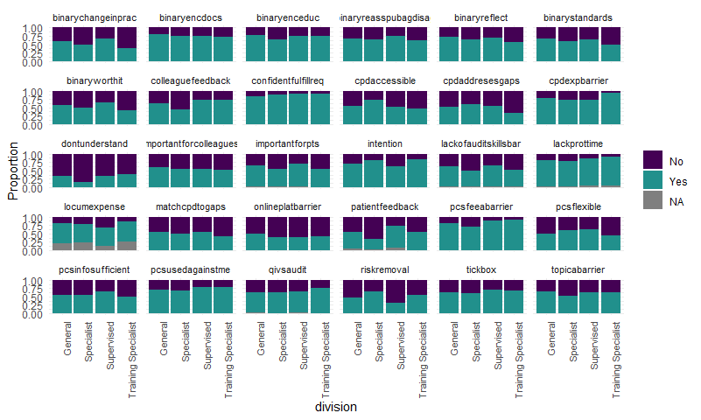

|  |  |  |  |  |  |  |
| --- | --- | --- | --- | --- | --- | --- |
| var | p | m | i | q | fdrp | sig |
| binary_dontunderstand | 0.00e+00 | 23 | 1 | 0.05 | 0.0021739 | TRUE |
| binary_patientfeedback | 0.00e+00 | 23 | 2 | 0.05 | 0.0043478 | TRUE |
| binary_colleaguefeedback | 0.00e+00 | 23 | 3 | 0.05 | 0.0065217 | TRUE |
| binary_cpdaccessible | 0.00e+00 | 23 | 4 | 0.05 | 0.0086957 | TRUE |
| binary_riskremoval | 0.00e+00 | 23 | 5 | 0.05 | 0.0108696 | TRUE |
| binary_intention | 0.00e+00 | 23 | 6 | 0.05 | 0.0130435 | TRUE |
| binary_pcsfeeabarrier | 0.00e+00 | 23 | 7 | 0.05 | 0.0152174 | TRUE |
| binary_lackofauditskillsbar | 0.00e+00 | 23 | 8 | 0.05 | 0.0173913 | TRUE |
| binary_topicabarrier | 0.00e+00 | 23 | 9 | 0.05 | 0.0195652 | TRUE |
| binary_pcsflexible | 0.00e+00 | 23 | 10 | 0.05 | 0.0217391 | TRUE |
| binary_cpdaddresesgaps | 0.00e+00 | 23 | 11 | 0.05 | 0.0239130 | TRUE |
| binary_confidentfulfillreq | 0.00e+00 | 23 | 12 | 0.05 | 0.0260870 | TRUE |
| binary_importantforpts | 0.00e+00 | 23 | 13 | 0.05 | 0.0282609 | TRUE |
| binary_cpdexpbarrier | 0.00e+00 | 23 | 14 | 0.05 | 0.0304348 | TRUE |
| binary_onlineplatbarrier | 3.00e-07 | 23 | 15 | 0.05 | 0.0326087 | TRUE |
| binary_matchcpdtogaps | 1.14e-03 | 23 | 16 | 0.05 | 0.0347826 | TRUE |
| binary_lackprottime | 2.01e-03 | 23 | 17 | 0.05 | 0.0369565 | TRUE |
| binary_locumexpense | 1.42e-02 | 23 | 18 | 0.05 | 0.0391304 | TRUE |
| binary_qivsaudit | 1.52e-02 | 23 | 19 | 0.05 | 0.0413043 | TRUE |
| binary_pcsusedagainstme | 3.05e-02 | 23 | 20 | 0.05 | 0.0434783 | TRUE |
| binary_importantforcolleagues | 3.14e-02 | 23 | 21 | 0.05 | 0.0456522 | TRUE |
| binary_pcsinfosufficient | 1.91e-01 | 23 | 22 | 0.05 | 0.0478261 | FALSE |
| binary_tickbox | 2.83e-01 | 23 | 23 | 0.05 | 0.0500000 | FALSE |

## Country groups

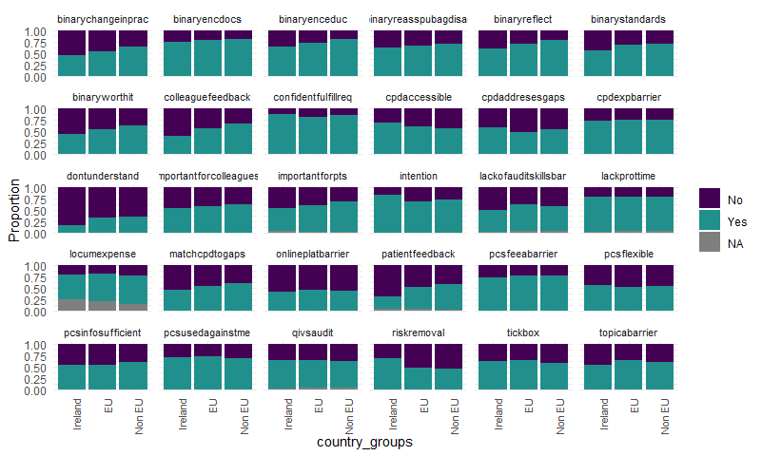

|  |  |  |  |  |  |  |
| --- | --- | --- | --- | --- | --- | --- |
| var | p | m | i | q | fdrp | sig |
| binary_patientfeedback | 0.00e+00 | 23 | 1 | 0.05 | 0.0021739 | TRUE |
| binary_colleaguefeedback | 0.00e+00 | 23 | 2 | 0.05 | 0.0043478 | TRUE |
| binary_riskremoval | 0.00e+00 | 23 | 3 | 0.05 | 0.0065217 | TRUE |
| binary_dontunderstand | 0.00e+00 | 23 | 4 | 0.05 | 0.0086957 | TRUE |
| binary_intention | 0.00e+00 | 23 | 5 | 0.05 | 0.0108696 | TRUE |
| binary_importantforpts | 0.00e+00 | 23 | 6 | 0.05 | 0.0130435 | TRUE |
| binary_cpdaccessible | 0.00e+00 | 23 | 7 | 0.05 | 0.0152174 | TRUE |
| binary_matchcpdtogaps | 0.00e+00 | 23 | 8 | 0.05 | 0.0173913 | TRUE |
| binary_lackofauditskillsbar | 0.00e+00 | 23 | 9 | 0.05 | 0.0195652 | TRUE |
| binary_topicabarrier | 0.00e+00 | 23 | 10 | 0.05 | 0.0217391 | TRUE |
| binary_importantforcolleagues | 1.00e-07 | 23 | 11 | 0.05 | 0.0239130 | TRUE |
| binary_pcsfeeabarrier | 4.05e-05 | 23 | 12 | 0.05 | 0.0260870 | TRUE |
| binary_cpdaddresesgaps | 9.83e-05 | 23 | 13 | 0.05 | 0.0282609 | TRUE |
| binary_confidentfulfillreq | 9.91e-05 | 23 | 14 | 0.05 | 0.0304348 | TRUE |
| binary_pcsinfosufficient | 2.19e-04 | 23 | 15 | 0.05 | 0.0326087 | TRUE |
| binary_tickbox | 6.53e-04 | 23 | 16 | 0.05 | 0.0347826 | TRUE |
| binary_pcsflexible | 1.47e-02 | 23 | 17 | 0.05 | 0.0369565 | TRUE |
| binary_cpdexpbarrier | 3.04e-02 | 23 | 18 | 0.05 | 0.0391304 | TRUE |
| binary_qivsaudit | 4.05e-02 | 23 | 19 | 0.05 | 0.0413043 | TRUE |
| binary_locumexpense | 6.14e-02 | 23 | 20 | 0.05 | 0.0434783 | FALSE |
| binary_onlineplatbarrier | 1.27e-01 | 23 | 21 | 0.05 | 0.0456522 | FALSE |
| binary_pcsusedagainstme | 1.48e-01 | 23 | 22 | 0.05 | 0.0478261 | FALSE |
| binary_lackprottime | 8.51e-01 | 23 | 23 | 0.05 | 0.0500000 | FALSE |