# Main Sample

The overall dataset includes 18118 patients. Of these, only 892 (4.92%) are missing a surgery time, so these patients are removed from the dataset.

There are different pathways that patients take, starting with their injury and leading up to their surgery. This could include multiple hospitals, ED visits, etc. However, the main pathway should be described by the following times:

* Time of Arrival to AE of treating Hospital (adm_ae_date_time)
* Time of Arrival to Ortho Ward (adm_orth_ward_date_time)
* Time of Surgery (adm_primary_surgery_date_time)
* Discharge date (dis_date)

Then there is a second pathway that is relevant for MDRO patients. In this pathway, their admission to the ward *follows* surgery. This can happen because there isn’t a orth ward bed for them yet, so they get put in a private room somewhere until surgery, but this will obviously lead to delays because the surgery can’t happen until a space on the orth ward *does* open up (since the other wards can’t handle the patient post-op). So if we only look at the main pathway (arrival -> orth -> surg -> discharge) we will miss out these cases, which might be among those with the longest delays.

At this point, to cover both of these pathways, we restrict the analysis to the patients with values for all 4 relevant time points.

Doing this takes the sample from 17226 to nrow(data_2_paths) patients (75.47% of the original dataset of 18118 patients).

## Pathways

Of the 13673 patients, 11809 patients are on the main path; and 1751 are on the alternative path.

Just to confirm the dates are in the right order:

Main path (n = 11809) 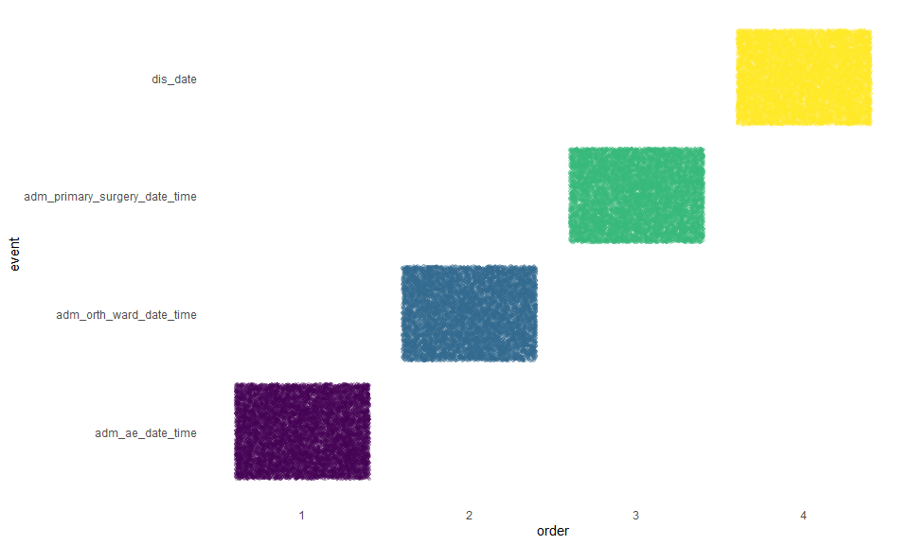

Alternative path (n = 1751) 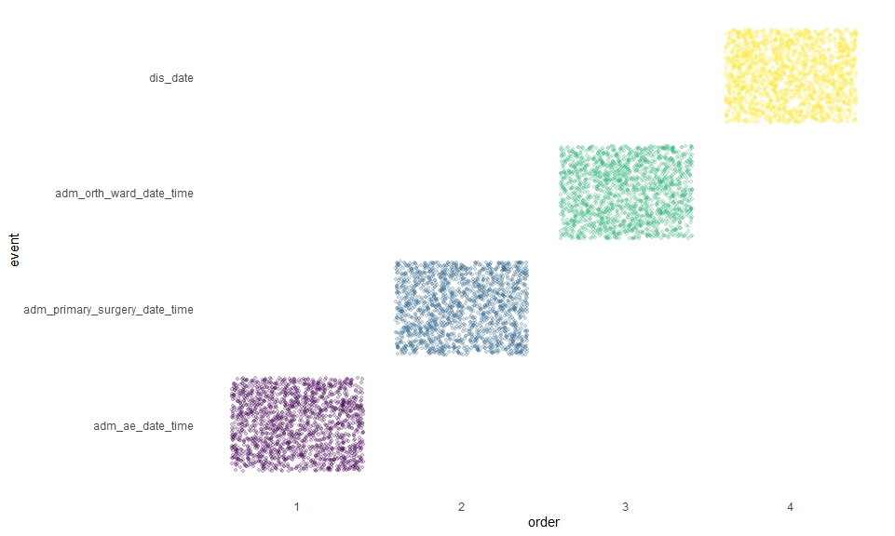

# Analysis - Main pathway

## Outcome descriptions

Now we want to start looking at the actual timing itself for people on the main pathway (n = 1751), and see if any of the differences are implausible.

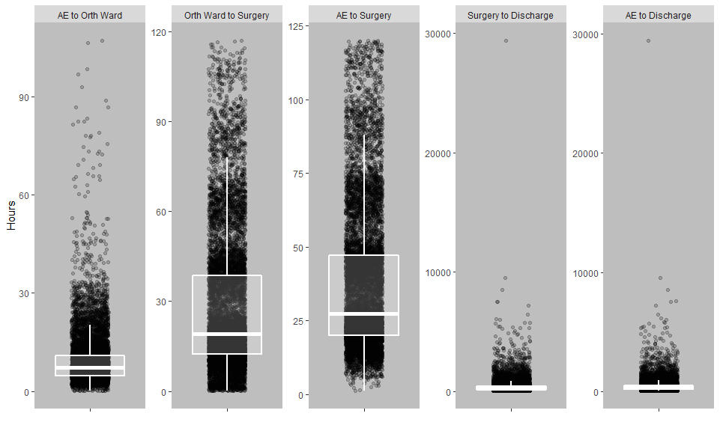

We know the overall dataset is heterogeneous with respect to how/why/when decisions were made for hip surgery. For example, there will be cases where a patient was admitted for something else and only then, perhaps much later, did the need for a hip surgery become necessary. So from this point, we will limit the dataset to those patients where the time between admission and surgery is < 5 days (n = 11309 (62.42% of the original dataset)).

## Table 1

| Variable | Missing | Mean SD or n (%) | Median [IQR] | (Min, Max) |
| --- | --- | --- | --- | --- |
| sex | 11309 |  |  |  |
| Male |  | 3195 (28.3%) |  |  |
| Female |  | 8114 (71.7%) |  |  |
| age | 11309 | 80.6 ± 8.7 | 82 (74, 87) | (60, 103) |
| marr_status | 11309 |  |  |  |
| 1 |  | 1934 (17.1%) |  |  |
| 2 |  | 4341 (38.4%) |  |  |
| 3 |  | 4128 (36.5%) |  |  |
| 4 |  | 317 (2.8%) |  |  |
| 5 |  | 480 (4.2%) |  |  |
| 6 |  | 107 (0.9%) |  |  |
| 7 |  | 0 (0%) |  |  |
| 8 |  | 2 (0%) |  |  |
| los | 11309 | 18.3 ± 24.2 | 12 (8, 20) | (1, 1227) |
| has_med_card | 11269 |  |  |  |
| No |  | 3671 (32.6%) |  |  |
| Yes |  | 7598 (67.4%) |  |  |
| adm_asa_grade | 10330 |  |  |  |
| 1 |  | 346 (3.3%) |  |  |
| 2 |  | 4226 (40.9%) |  |  |
| 3 |  | 5210 (50.4%) |  |  |
| 4 |  | 539 (5.2%) |  |  |
| 5 |  | 9 (0.1%) |  |  |
| ae_orth_diff | 11309 | 9.3 ± 7.8 | 7.2 (4.7, 10.9) | (0, 107) |
| orth_surg_diff | 11309 | 27.6 ± 22.4 | 19.1 (12.2, 38.6) | (0, 117) |
| surg_dis_diff | 11309 | 395.6 ± 577.1 | 250.4 (153, 440) | (5, 29386.2) |
| ae_surg_diff | 11309 | 37 ± 23.5 | 27.4 (20, 47.2) | (1.2, 120) |
| ae_dis_diff | 11309 | 432.6 ± 578.6 | 288.6 (179, 470.3) | (13.9, 29457.1) |
| mdro | 11309 |  |  |  |
| No |  | 10875 (96.2%) |  |  |
| Yes |  | 434 (3.8%) |  |  |
| anticoag | 11309 |  |  |  |
| No |  | 10591 (93.7%) |  |  |
| Yes |  | 718 (6.3%) |  |  |

## Time to event models

For patients in path way 1 where the time from admission to surgery was < 5 days (n = 11309), we have 3 key outcomes: - AE admission to the orth ward - AE admission to the surgery - AE admission to discharge

* Orth ward to Surgery
* Surgery to Discharge

By MDRO status (unadjusted)

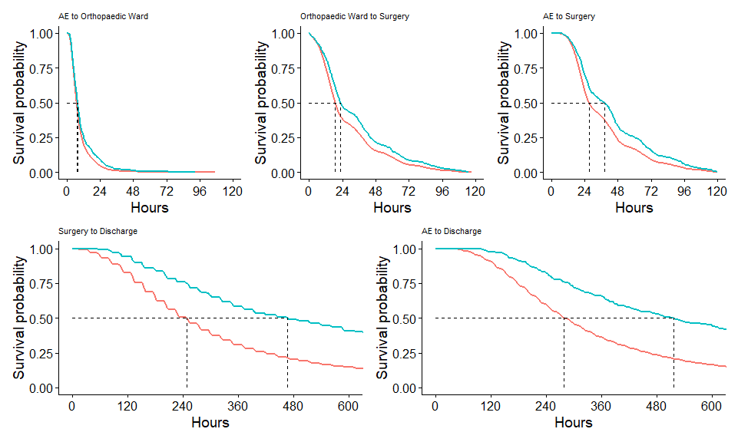

Proportion >= 48 hours (compare survival proportions)

## Call: survfit(formula = Surv(ae_surg_diff, out) ~ mdro, data = data_4_pmain_5d)  
##   
## mdro=No   
## time n.risk n.event survival std.err lower 95% CI   
## 4.80e+01 2.54e+03 8.35e+03 2.33e-01 4.05e-03 2.25e-01   
## upper 95% CI   
## 2.41e-01   
##   
## mdro=Yes   
## time n.risk n.event survival std.err lower 95% CI   
## 48.0000 146.0000 289.0000 0.3341 0.0226 0.2925   
## upper 95% CI   
## 0.3816

Cox models

All the tables report HRs, so that values < 1 indicate *longer* times to surgery.

Times from AE (the total times)

AE to Orthopeadic Ward

AE to Orthopeadic Ward

Orthopeadic Ward to Surgry

Orthopeadic Ward to Surgry

AE to Surgery

AE to Surgery

Surgery to Discharge

Surgery to Discharge

AE to Discharge

AE to Discharge

Predictors

Estimates

CI

p

Estimates

CI

p

Estimates

CI

p

Estimates

CI

p

Estimates

CI

p

Estimates

CI

p

Estimates

CI

p

Estimates

CI

p

Estimates

CI

p

Estimates

CI

p

mdro [Yes]

0.83

0.76 – 0.92

<0.001

0.90

0.81 – 0.99

0.034

0.80

0.72 – 0.88

<0.001

0.86

0.78 – 0.96

0.005

0.76

0.69 – 0.84

<0.001

0.83

0.75 – 0.92

<0.001

0.51

0.46 – 0.56

<0.001

0.53

0.48 – 0.59

<0.001

0.51

0.46 – 0.56

<0.001

0.53

0.48 – 0.59

<0.001

anticoag [Yes]

0.91

0.84 – 0.99

0.025

0.65

0.60 – 0.70

<0.001

0.66

0.61 – 0.71

<0.001

0.87

0.80 – 0.94

<0.001

0.84

0.77 – 0.91

<0.001

rcs(age_z [ degree]

1.01

1.00 – 1.02

0.199

1.02

1.01 – 1.03

0.003

1.02

1.01 – 1.03

0.001

0.97

0.96 – 0.98

<0.001

0.97

0.96 – 0.98

<0.001

rcs(age_z [ degree]

0.99

0.95 – 1.03

0.578

0.94

0.90 – 0.98

0.002

0.93

0.89 – 0.97

<0.001

1.01

0.97 – 1.05

0.601

1.00

0.96 – 1.04

0.859

rcs(age_z [ degree]

1.00

0.82 – 1.21

0.976

1.29

1.07 – 1.57

0.009

1.32

1.09 – 1.61

0.005

1.01

0.83 – 1.23

0.908

1.04

0.86 – 1.26

0.703

rcs(age_z [ degree]

1.17

0.76 – 1.79

0.473

0.72

0.47 – 1.10

0.132

0.72

0.47 – 1.10

0.125

1.02

0.67 – 1.56

0.911

0.99

0.65 – 1.51

0.968

sex [Female]

1.07

1.02 – 1.11

0.004

1.12

1.08 – 1.17

<0.001

1.15

1.10 – 1.20

<0.001

1.15

1.10 – 1.20

<0.001

1.16

1.11 – 1.21

<0.001

adm_asa_grade [linear]

0.63

0.41 – 0.95

0.030

0.80

0.52 – 1.22

0.293

0.73

0.48 – 1.11

0.139

0.97

0.63 – 1.47

0.875

0.92

0.60 – 1.41

0.707

adm_asa_grade [quadratic]

0.92

0.65 – 1.32

0.667

1.44

1.01 – 2.05

0.047

1.38

0.97 – 1.98

0.075

1.87

1.31 – 2.67

0.001

1.90

1.33 – 2.71

<0.001

adm_asa_grade [cubic]

0.97

0.78 – 1.21

0.803

1.41

1.14 – 1.76

0.002

1.40

1.13 – 1.75

0.002

1.22

0.98 – 1.51

0.077

1.23

0.99 – 1.54

0.058

adm_asa_grade [4thdegree]

0.98

0.89 – 1.07

0.652

1.04

0.94 – 1.14

0.450

1.03

0.94 – 1.13

0.529

1.04

0.95 – 1.14

0.390

1.04

0.95 – 1.14

0.392

has_med_card [Yes]

0.96

0.92 – 1.01

0.097

0.94

0.91 – 0.99

0.008

0.94

0.90 – 0.98

0.006

0.92

0.88 – 0.96

<0.001

0.92

0.88 – 0.96

<0.001

hosp [Connolly Hospital]

1.22

1.10 – 1.36

<0.001

1.43

1.29 – 1.58

<0.001

1.50

1.35 – 1.66

<0.001

1.47

1.33 – 1.63

<0.001

1.52

1.38 – 1.69

<0.001

hosp [Midland regionalHospital Tullamore]

2.11

1.93 – 2.32

<0.001

0.91

0.83 – 1.00

0.059

1.09

0.99 – 1.19

0.082

1.40

1.27 – 1.53

<0.001

1.41

1.29 – 1.55

<0.001

hosp [University HospitalLimerick]

1.46

1.34 – 1.59

<0.001

0.79

0.73 – 0.86

<0.001

0.89

0.82 – 0.97

0.008

1.71

1.57 – 1.87

<0.001

1.67

1.53 – 1.82

<0.001

hosp [LetterkennyUniversity Hospital]

3.54

3.18 – 3.94

<0.001

0.79

0.71 – 0.88

<0.001

1.02

0.92 – 1.13

0.728

1.01

0.91 – 1.13

0.801

1.02

0.91 – 1.13

0.758

hosp [Sligo UniversityHospital]

2.58

2.31 – 2.87

<0.001

1.21

1.08 – 1.34

0.001

1.51

1.36 – 1.68

<0.001

1.66

1.49 – 1.85

<0.001

1.75

1.57 – 1.95

<0.001

hosp [Cork UniversityHospital]

0.82

0.74 – 0.90

<0.001

0.97

0.88 – 1.06

0.488

0.92

0.84 – 1.02

0.107

1.34

1.22 – 1.48

<0.001

1.33

1.21 – 1.46

<0.001

hosp [University HospitalKerry]

1.50

1.33 – 1.68

<0.001

1.02

0.91 – 1.15

0.704

1.14

1.01 – 1.27

0.030

1.07

0.95 – 1.20

0.265

1.07

0.96 – 1.20

0.223

hosp [Galway UniversityHospital]

0.95

0.85 – 1.05

0.288

1.76

1.58 – 1.95

<0.001

1.58

1.43 – 1.75

<0.001

0.84

0.76 – 0.93

0.001

0.87

0.78 – 0.96

0.008

hosp [Mayo UniversityHospital]

3.91

3.36 – 4.55

<0.001

1.59

1.37 – 1.85

<0.001

2.21

1.90 – 2.57

<0.001

0.94

0.81 – 1.10

0.453

0.99

0.85 – 1.15

0.861

hosp [St. James’sHospital, Dublin]

1.75

1.56 – 1.96

<0.001

1.23

1.10 – 1.38

<0.001

1.43

1.28 – 1.61

<0.001

0.90

0.80 – 1.00

0.060

0.92

0.82 – 1.03

0.159

hosp [Mater Hospital]

0.80

0.70 – 0.91

0.001

1.04

0.91 – 1.19

0.585

0.94

0.82 – 1.07

0.363

0.82

0.71 – 0.93

0.003

0.82

0.71 – 0.94

0.003

hosp [St. VincentsUniversity Hospital]

1.24

1.13 – 1.37

<0.001

1.93

1.75 – 2.12

<0.001

1.94

1.76 – 2.14

<0.001

0.93

0.85 – 1.03

0.157

0.98

0.89 – 1.07

0.608

hosp [OLOL Drogheda]

1.20

1.09 – 1.33

<0.001

0.96

0.87 – 1.06

0.442

1.00

0.91 – 1.10

0.983

1.32

1.20 – 1.46

<0.001

1.31

1.19 – 1.45

<0.001

hosp [Beaumont]

1.69

1.52 – 1.88

<0.001

1.06

0.95 – 1.18

0.306

1.19

1.07 – 1.32

0.002

1.00

0.90 – 1.11

0.972

1.02

0.91 – 1.13

0.773

hosp [Tallaght]

1.15

1.03 – 1.28

0.010

1.68

1.50 – 1.87

<0.001

1.65

1.48 – 1.83

<0.001

0.80

0.72 – 0.89

<0.001

0.82

0.74 – 0.92

<0.001

Observations

11309

10295

11309

10295

11309

10295

11309

10295

11309

10295

R2 Nagelkerke

0.001

0.139

0.002

0.120

0.003

0.120

0.020

0.133

0.020

0.136

# Analysis - Alternative pathway

## Outcome descriptions

Now we want to start looking at the actual timing itself for people on the main pathway (n = 1751), and see if any of the differences are implausible.

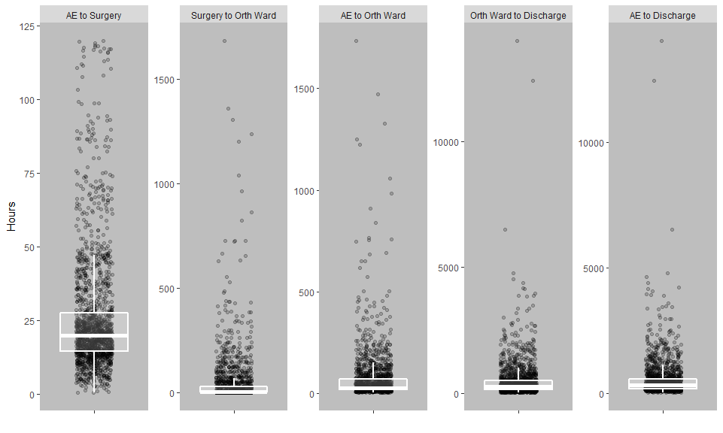

We know the overall dataset is heterogeneous with respect to how/why/when decisions were made for hip surgery. For example, there will be cases where a patient was admitted for something else and only then, perhaps much later, did the need for a hip surgery become necessary. So from this point, we will limit the dataset to those patients where the time between admission and surgery is < 5 days (n = 1694 (9.35% of the original dataset)).

## Table 1

| Variable | Missing | Mean SD or n (%) | Median [IQR] | (Min, Max) |
| --- | --- | --- | --- | --- |
| sex | 1694 |  |  |  |
| Male |  | 483 (28.5%) |  |  |
| Female |  | 1211 (71.5%) |  |  |
| age | 1694 | 80.6 ± 8.9 | 82 (74, 87) | (60, 104) |
| marr_status | 1694 |  |  |  |
| 1 |  | 303 (17.9%) |  |  |
| 2 |  | 616 (36.4%) |  |  |
| 3 |  | 634 (37.4%) |  |  |
| 4 |  | 52 (3.1%) |  |  |
| 5 |  | 73 (4.3%) |  |  |
| 6 |  | 16 (0.9%) |  |  |
| 7 |  | 0 (0%) |  |  |
| 8 |  | 0 (0%) |  |  |
| los | 1694 | 21.9 ± 30.7 | 13 (8, 24) | (1, 586) |
| has_med_card | 1690 |  |  |  |
| No |  | 576 (34.1%) |  |  |
| Yes |  | 1114 (65.9%) |  |  |
| adm_asa_grade | 1535 |  |  |  |
| 1 |  | 48 (3.1%) |  |  |
| 2 |  | 653 (42.5%) |  |  |
| 3 |  | 761 (49.6%) |  |  |
| 4 |  | 71 (4.6%) |  |  |
| 5 |  | 2 (0.1%) |  |  |
| ae_orth_diff | 1694 | 70.2 ± 122.4 | 29.1 (20, 73.7) | (3.8, 1733.4) |
| surg_orth_diff | 1694 | 44.4 ± 118.5 | 5.5 (3.7, 30) | (0, 1685.4) |
| orth_dis_diff | 1694 | 456.4 ± 725.4 | 246.8 (144.2, 485.3) | (2.5, 14021.6) |
| ae_surg_diff | 1694 | 25.9 ± 20.2 | 20.1 (14.6, 27.7) | (0.4, 120) |
| ae_dis_diff | 1694 | 526.6 ± 737.7 | 313.9 (186.7, 572.1) | (15.5, 14046) |
| mdro | 1694 |  |  |  |
| No |  | 1623 (95.8%) |  |  |
| Yes |  | 71 (4.2%) |  |  |
| anticoag | 1694 |  |  |  |
| No |  | 1599 (94.4%) |  |  |
| Yes |  | 95 (5.6%) |  |  |

## Time to event models

By MDRO status (unadjusted)

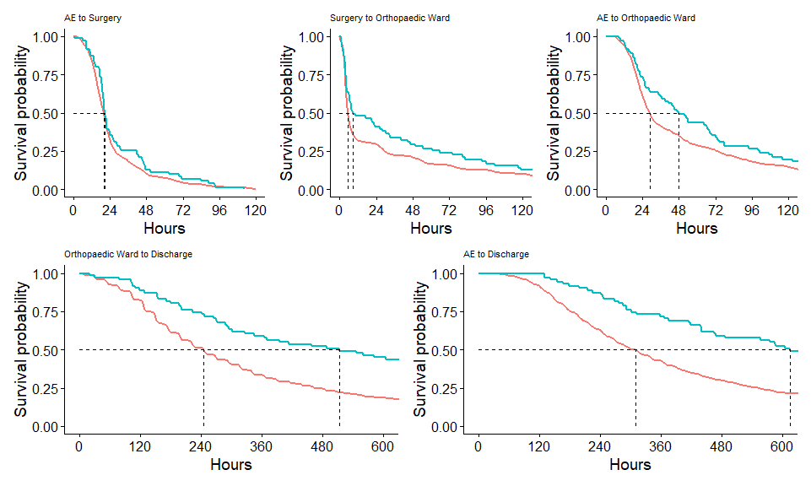

Proportion >= 48 hours (compare survival proportions)

## Call: survfit(formula = Surv(ae_surg_diff, out) ~ mdro, data = data_4_palt_5d)  
##   
## mdro=No   
## time n.risk n.event survival std.err lower 95% CI   
## 4.80e+01 1.64e+02 1.46e+03 1.00e-01 7.46e-03 8.68e-02   
## upper 95% CI   
## 1.16e-01   
##   
## mdro=Yes   
## time n.risk n.event survival std.err lower 95% CI   
## 48.0000 9.0000 62.0000 0.1268 0.0395 0.0688   
## upper 95% CI   
## 0.2334

Cox models

All the tables report HRs, so that values < 1 indicate *longer* times to surgery.

Times from AE (the total times)

AE to Surgery

AE to Surgery

Surgry to Orthopeadic Ward

Surgry to Orthopeadic Ward

AE to Orthopeadic Ward

AE to Orthopeadic Ward

Orthopeadic Ward to Discharge

Orthopeadic Ward to Discharge

AE to Discharge

AE to Discharge

Predictors

Estimates

CI

p

Estimates

CI

p

Estimates

CI

p

Estimates

CI

p

Estimates

CI

p

Estimates

CI

p

Estimates

CI

p

Estimates

CI

p

Estimates

CI

p

Estimates

CI

p

mdro [Yes]

0.84

0.66 – 1.07

0.159

1.20

0.91 – 1.56

0.193

0.72

0.57 – 0.91

0.007

0.89

0.68 – 1.17

0.421

0.71

0.56 – 0.91

0.006

0.99

0.75 – 1.30

0.942

0.51

0.40 – 0.65

<0.001

0.48

0.37 – 0.63

<0.001

0.49

0.39 – 0.62

<0.001

0.48

0.37 – 0.63

<0.001

anticoag [Yes]

0.70

0.56 – 0.87

0.002

0.76

0.61 – 0.95

0.014

0.70

0.56 – 0.87

0.001

0.83

0.67 – 1.04

0.101

0.81

0.65 – 1.01

0.064

rcs(age_z [ degree]

1.01

0.98 – 1.04

0.421

1.01

0.99 – 1.04

0.365

1.02

1.00 – 1.05

0.099

0.98

0.95 – 1.01

0.144

0.98

0.95 – 1.01

0.193

rcs(age_z [ degree]

0.99

0.89 – 1.10

0.867

0.93

0.84 – 1.03

0.174

0.91

0.82 – 1.01

0.076

1.00

0.91 – 1.11

0.955

0.99

0.90 – 1.10

0.859

rcs(age_z [ degree]

1.01

0.58 – 1.77

0.966

1.33

0.77 – 2.29

0.304

1.50

0.86 – 2.59

0.152

1.00

0.58 – 1.72

0.988

1.05

0.61 – 1.80

0.859

rcs(age_z [ degree]

1.03

0.30 – 3.51

0.964

0.82

0.25 – 2.71

0.748

0.63

0.19 – 2.13

0.461

1.04

0.32 – 3.42

0.950

1.03

0.31 – 3.39

0.960

sex [Female]

1.00

0.89 – 1.12

0.984

1.02

0.91 – 1.14

0.791

1.01

0.91 – 1.14

0.808

1.17

1.05 – 1.32

0.006

1.18

1.05 – 1.32

0.005

adm_asa_grade [linear]

0.65

0.26 – 1.62

0.356

0.87

0.35 – 2.16

0.770

1.06

0.43 – 2.63

0.896

0.59

0.24 – 1.46

0.255

0.56

0.23 – 1.39

0.211

adm_asa_grade [quadratic]

1.10

0.51 – 2.38

0.801

1.03

0.48 – 2.21

0.945

1.34

0.62 – 2.89

0.452

1.30

0.60 – 2.79

0.504

1.24

0.58 – 2.67

0.580

adm_asa_grade [cubic]

1.46

0.91 – 2.36

0.119

1.13

0.70 – 1.82

0.619

1.54

0.95 – 2.48

0.078

0.97

0.60 – 1.57

0.914

1.00

0.62 – 1.61

0.999

adm_asa_grade [4thdegree]

1.13

0.91 – 1.40

0.270

1.07

0.87 – 1.33

0.526

1.18

0.96 – 1.47

0.121

1.01

0.82 – 1.26

0.895

1.03

0.83 – 1.28

0.789

has_med_card [Yes]

0.89

0.79 – 0.99

0.040

0.97

0.87 – 1.09

0.634

0.93

0.83 – 1.04

0.193

1.07

0.96 – 1.19

0.246

1.05

0.94 – 1.17

0.431

hosp [Connolly Hospital]

4.19

2.71 – 6.49

<0.001

2.60

1.70 – 3.98

<0.001

3.46

2.26 – 5.30

<0.001

1.67

1.09 – 2.56

0.018

1.88

1.23 – 2.88

0.004

hosp [Midland regionalHospital Tullamore]

4.56

2.51 – 8.29

<0.001

1.52

0.84 – 2.74

0.162

1.86

1.03 – 3.35

0.038

1.72

0.96 – 3.11

0.071

1.91

1.06 – 3.44

0.032

hosp [University HospitalLimerick]

1.50

0.88 – 2.55

0.138

1.30

0.77 – 2.20

0.330

1.29

0.76 – 2.18

0.338

2.18

1.28 – 3.69

0.004

2.22

1.31 – 3.76

0.003

hosp [LetterkennyUniversity Hospital]

1.15

0.47 – 2.82

0.756

1.18

0.48 – 2.87

0.718

1.14

0.47 – 2.78

0.771

0.71

0.29 – 1.73

0.450

0.71

0.29 – 1.73

0.452

hosp [Sligo UniversityHospital]

1.34

0.79 – 2.27

0.283

0.87

0.51 – 1.47

0.596

1.00

0.59 – 1.69

1.000

1.81

1.07 – 3.06

0.028

1.73

1.02 – 2.93

0.042

hosp [Cork UniversityHospital]

1.36

0.89 – 2.09

0.154

0.87

0.58 – 1.32

0.517

0.96

0.63 – 1.45

0.848

1.36

0.89 – 2.06

0.151

1.30

0.86 – 1.97

0.221

hosp [University HospitalKerry]

1.49

0.87 – 2.55

0.147

1.54

0.91 – 2.61

0.110

1.26

0.74 – 2.13

0.391

1.27

0.75 – 2.16

0.378

1.30

0.77 – 2.22

0.326

hosp [Galway UniversityHospital]

2.34

1.51 – 3.63

<0.001

1.13

0.74 – 1.72

0.586

1.47

0.96 – 2.25

0.074

1.10

0.72 – 1.68

0.671

1.13

0.74 – 1.73

0.570

hosp [Mayo UniversityHospital]

2.07

0.72 – 6.01

0.179

1.89

0.66 – 5.44

0.239

2.17

0.75 – 6.24

0.152

1.63

0.57 – 4.70

0.365

1.87

0.65 – 5.39

0.247

hosp [St. James’sHospital, Dublin]

1.40

0.84 – 2.35

0.199

0.96

0.57 – 1.60

0.873

1.11

0.66 – 1.86

0.698

0.97

0.59 – 1.61

0.921

0.95

0.57 – 1.57

0.834

hosp [Mater Hospital]

1.31

0.85 – 2.02

0.220

0.44

0.29 – 0.68

<0.001

0.53

0.35 – 0.81

0.003

0.94

0.62 – 1.44

0.775

0.79

0.52 – 1.21

0.277

hosp [St. VincentsUniversity Hospital]

2.84

1.88 – 4.29

<0.001

0.82

0.55 – 1.22

0.335

1.17

0.78 – 1.73

0.451

1.02

0.68 – 1.52

0.919

1.00

0.67 – 1.49

0.996

hosp [OLOL Drogheda]

1.05

0.68 – 1.60

0.834

0.49

0.32 – 0.74

0.001

0.56

0.37 – 0.85

0.007

1.59

1.04 – 2.42

0.032

1.25

0.82 – 1.91

0.291

hosp [Beaumont]

1.61

0.93 – 2.78

0.086

1.02

0.59 – 1.75

0.948

1.11

0.65 – 1.91

0.702

0.77

0.44 – 1.33

0.344

0.75

0.43 – 1.31

0.313

hosp [Tallaght]

2.97

1.91 – 4.61

<0.001

1.02

0.67 – 1.56

0.929

1.55

1.01 – 2.38

0.044

1.01

0.65 – 1.55

0.978

1.02

0.66 – 1.57

0.931

Observations

1694

1532

1694

1532

1694

1532

1694

1532

1694

1532

R2 Nagelkerke

0.001

0.213

0.005

0.171

0.005

0.208

0.021

0.108

0.024

0.124

# Supplemental info

## Additional sample info

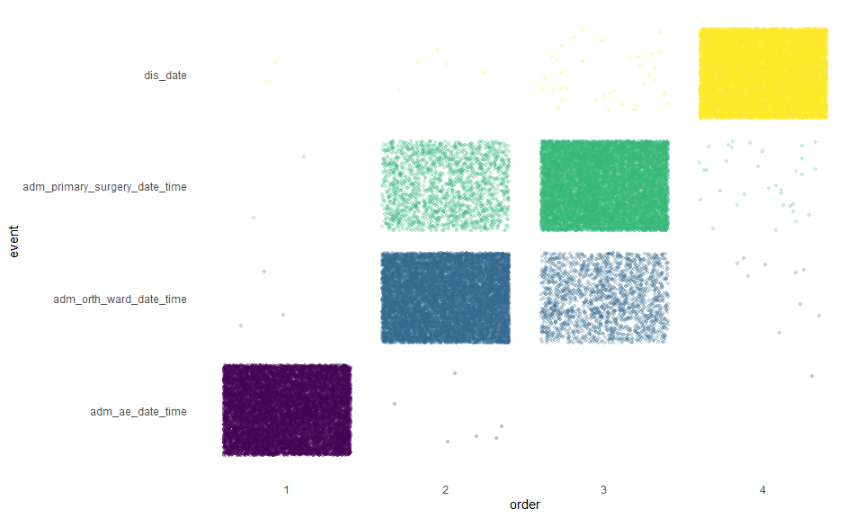

This plot tells us that for the vast majority of cases, arrival and discharge are, as expected, the first and last timepoint respectively; and that most patients are admitted to the orth ward prior to surgery, though a significant number are not.

I think we would expect there to be more MDRO patients, proportionately, in the alternative pathway, but this doesn’t seem to be the case.

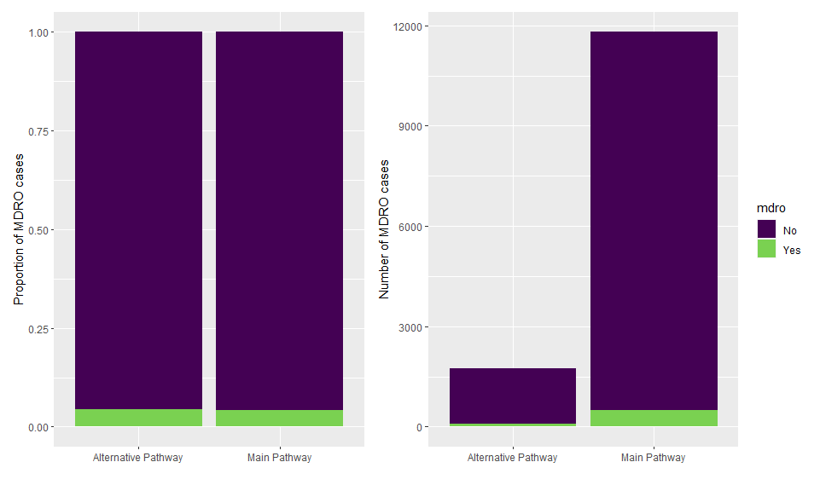

|  |  |  |
| --- | --- | --- |
|  | Alternative Pathway | Main Pathway |
| **No** | 1673 (0.955) | 11320 (0.959) |
| **Yes** | 78 (0.0445) | 489 (0.0414) |

(Mind the different y axis scales)

Now we can look at this by MDRO (3.84% of patients) and anticoag (6.35% of patients) statuses.

Logistic model for odds of surg > 48 hours

AE to Surgery > 48 hours

AE to Surgery > 48 hours

Predictors

Odds Ratios

CI

p

Odds Ratios

CI

p

(Intercept)

0.30

0.29 – 0.32

<0.001

0.38

0.23 – 0.62

<0.001

mdro [Yes]

1.66

1.35 – 2.03

<0.001

1.44

1.14 – 1.81

0.002

anticoag [Yes]

2.61

2.20 – 3.11

<0.001

rcs(age_z [ degree]

0.97

0.94 – 0.99

0.018

rcs(age_z [ degree]

1.15

1.04 – 1.27

0.007

rcs(age_z [ degree]

0.59

0.37 – 0.96

0.034

rcs(age_z [ degree]

1.70

0.60 – 4.81

0.314

sex [Female]

0.71

0.64 – 0.78

<0.001

adm_asa_grade [linear]

3.02

1.15 – 7.94

0.025

adm_asa_grade [quadratic]

0.86

0.38 – 1.94

0.713

adm_asa_grade [cubic]

0.62

0.38 – 1.02

0.062

adm_asa_grade [4thdegree]

1.00

0.81 – 1.23

0.973

has_med_card [Yes]

1.10

0.99 – 1.23

0.076

hosp [Connolly Hospital]

0.38

0.29 – 0.49

<0.001

hosp [Midland regionalHospital Tullamore]

0.75

0.61 – 0.93

0.008

hosp [University HospitalLimerick]

1.07

0.89 – 1.30

0.470

hosp [LetterkennyUniversity Hospital]

0.73

0.57 – 0.93

0.012

hosp [Sligo UniversityHospital]

0.41

0.31 – 0.54

<0.001

hosp [Cork UniversityHospital]

1.00

0.81 – 1.23

0.970

hosp [University HospitalKerry]

0.60

0.45 – 0.79

<0.001

hosp [Galway UniversityHospital]

0.36

0.28 – 0.47

<0.001

hosp [Mayo UniversityHospital]

0.15

0.09 – 0.25

<0.001

hosp [St. James’sHospital, Dublin]

0.42

0.32 – 0.56

<0.001

hosp [Mater Hospital]

0.93

0.68 – 1.25

0.614

hosp [St. VincentsUniversity Hospital]

0.18

0.14 – 0.25

<0.001

hosp [OLOL Drogheda]

0.79

0.64 – 0.98

0.031

hosp [Beaumont]

0.61

0.48 – 0.78

<0.001

hosp [Tallaght]

0.33

0.25 – 0.43

<0.001

Observations

11309

10295

R2 Tjur

0.002

0.094

Analysis of Deviance Table

|  |  |  |  |  |
| --- | --- | --- | --- | --- |
|  | Df | Deviance | Resid. Df | Resid. Dev |
| **NULL** | NA | NA | 10294 | 11324 |
| **mdro** | 1 | 20.55 | 10293 | 11304 |
| **anticoag** | 1 | 146 | 10292 | 11158 |
| **rcs(age_z, 5)** | 4 | 37.54 | 10288 | 11120 |
| **sex** | 1 | 60.66 | 10287 | 11059 |
| **adm_asa_grade** | 4 | 262.1 | 10283 | 10797 |
| **has_med_card** | 1 | 4.314 | 10282 | 10793 |
| **hosp** | 15 | 440.7 | 10267 | 10352 |

# Sensitivity

|  |  |  |  |  |  |
| --- | --- | --- | --- | --- | --- |
| Variable | Observations | Total | Out | In | Test p-value |
| sex | 17226 |  |  |  | 0 |
| Male | NA | 5036 (29.2%) | 1841 (31.1%) | 3195 (28.3%) |  |
| Female | NA | 12190 (70.8%) | 4076 (68.9%) | 8114 (71.7%) |  |
| age | 17226 | 82 [74, 87] | 81 [74, 87] | 82 [74, 87] | 0.1 |
| marr_status | 17226 |  |  |  | 0 |
| 1 | NA | 2987 (17.3%) | 1053 (17.8%) | 1934 (17.1%) |  |
| 2 | NA | 6506 (37.8%) | 2165 (36.6%) | 4341 (38.4%) |  |
| 3 | NA | 6343 (36.8%) | 2215 (37.4%) | 4128 (36.5%) |  |
| 4 | NA | 533 (3.1%) | 216 (3.7%) | 317 (2.8%) |  |
| 5 | NA | 687 (4%) | 207 (3.5%) | 480 (4.2%) |  |
| 6 | NA | 163 (0.9%) | 56 (0.9%) | 107 (0.9%) |  |
| 7 | NA | 2 (0%) | 2 (0%) | 0 (0%) |  |
| 8 | NA | 5 (0%) | 3 (0.1%) | 2 (0%) |  |
| los | 17226 | 13 [8, 21] | 14 [9, 25] | 12 [8, 20] | 0 |
| has_med_card | 17172 |  |  |  | 0 |
| No | NA | 5852 (34.1%) | 2181 (36.9%) | 3671 (32.6%) |  |
| Yes | NA | 11320 (65.9%) | 3722 (63.1%) | 7598 (67.4%) |  |
| adm_asa_grade | 15708 |  |  |  | 0 |
| 1 | NA | 623 (4%) | 277 (5.2%) | 346 (3.3%) |  |
| 2 | NA | 6201 (39.5%) | 1975 (36.7%) | 4226 (40.9%) |  |
| 3 | NA | 7963 (50.7%) | 2753 (51.2%) | 5210 (50.4%) |  |
| 4 | NA | 901 (5.7%) | 362 (6.7%) | 539 (5.2%) |  |
| 5 | NA | 20 (0.1%) | 11 (0.2%) | 9 (0.1%) |  |
| mdro | 17226 |  |  |  | 0 |
| No | NA | 16458 (95.5%) | 5583 (94.4%) | 10875 (96.2%) |  |
| Yes | NA | 768 (4.5%) | 334 (5.6%) | 434 (3.8%) |  |
| anticoag | 17226 |  |  |  | 0.33 |
| No | NA | 16109 (93.5%) | 5518 (93.3%) | 10591 (93.7%) |  |
| Yes | NA | 1117 (6.5%) | 399 (6.7%) | 718 (6.3%) |  |

##   
## Alternative Pathway Main Pathway   
## 1751 11809

## Ternary plots

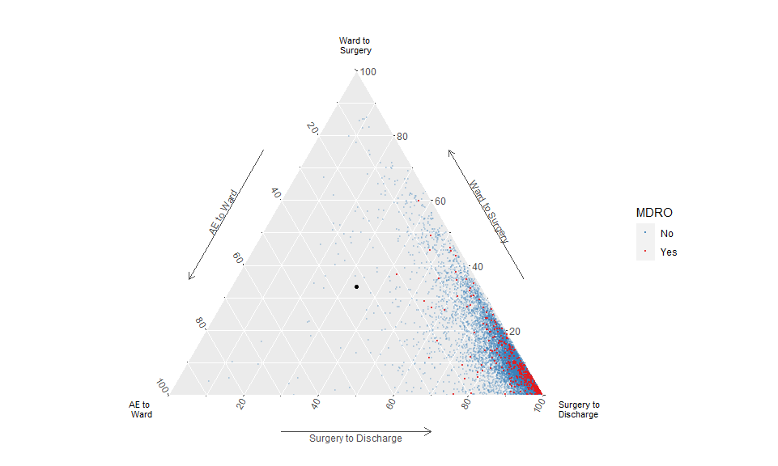

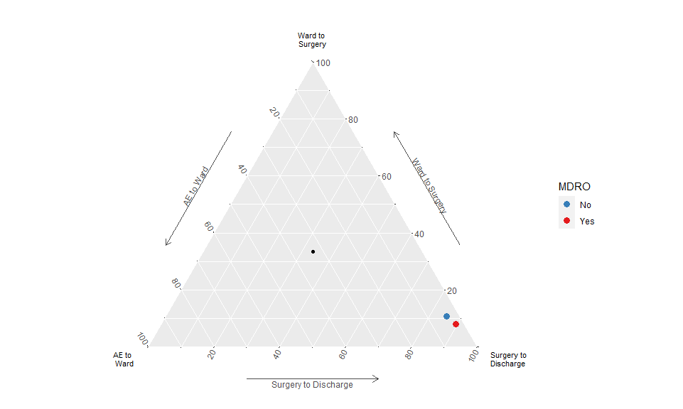

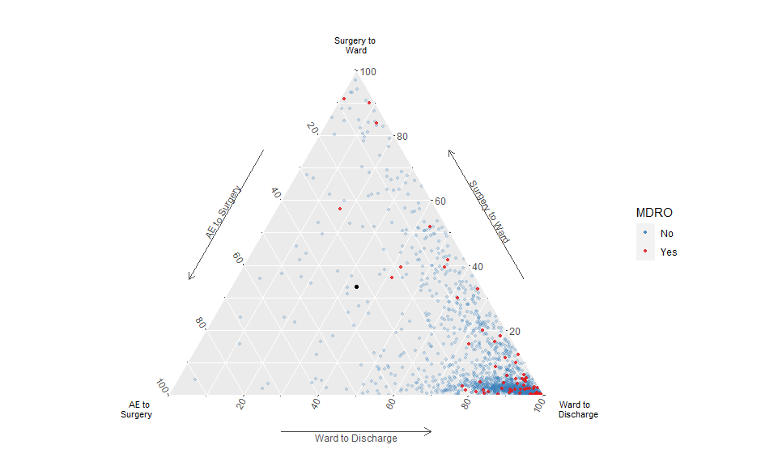

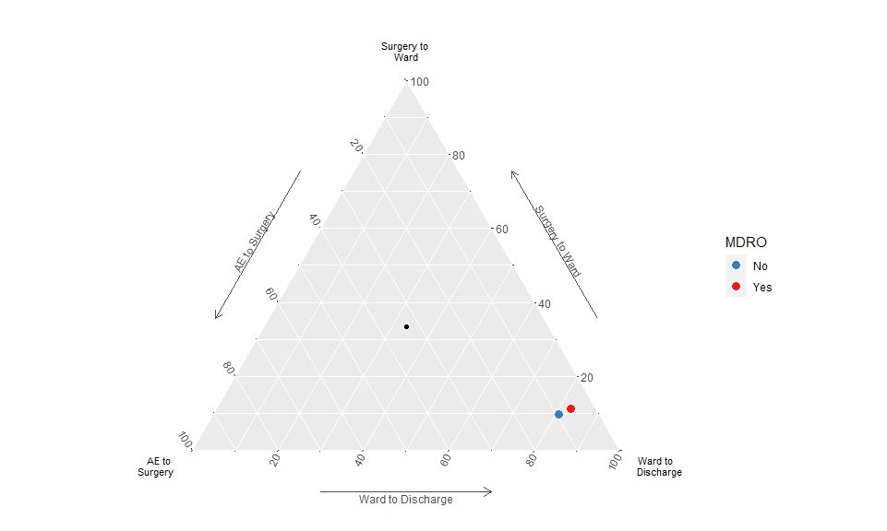

## Background

### Initial goals

TLDR: There are hip patients who are known carriers but not necessarily infected with a multi-drug resistant organism (MDRO). In order to prevent other patients from being colonized/cross contaminated by such organisms “MDRO patients” are isolated within the hospital. This really limits this cohort of patients’ access to basic care. Anecdotally they wait for much longer to get a bed on the ward and are left on trolleys in ED far longer and also have to wait much longer to get to theatre for their broken hip…..but nobody has shown this.

Primary outcomes: Time to theatre for hip fracture Fixation, Time to ward bed from emergency department

Secondary outcomes: Thirty day mortality, local cost analysis (we have more detailed data for waterford)

### Update

* Analyze time to ward and time to discharge in the same way. YES
* Try adjustment for age and ASA (comorbidities) YES
* Filter out those with > 5 or 10 days pre op (time to surgery). This is because some hips get diagnosed when in hospital for other problems. YES
* Target time to get people into surgery is 48 hours…important effects on later survival…so we can also calcuate % under 48 hours in each group.
* There might be a group that goes adm_ae_date_time -> surg -> orth -> dischange…these might be people that they want out of the ER because of mdro, but there isn’t a bed in the orth ward, so they get stuck in a private room on any other ward…and surg doesn’t happen until a orth bed is available, since other wards can’t take them post-op. Check this group. COMMENTS BELOW

### Key variables in the dataset

**adm_date**: admission date

**adm_first_pres_hosp_date_time**: Date and time of arrival at first presenting hospital (not all hospitals have orthopaedics e.g. if a patient presents to Kilkenny hospital and is subsequently transferred to Waterford for fixation -this time represents date/time of presentation to Kilkenny hospital)

**adm_ae_dis_date_time**: Date and time of leaving ED for operating hospital *(key data piece for this study as often MDROs patients are stuck in EDs waiting for isolation beds)*

**adm_ae_date_time**: Date and time of arrival to operating (orthopaedic) hospital

**adm_orth_ward_date_time**: Date & time admission to an orthopaedic ward *(Again a key piece of data here as often MDRO patients are delayed getting to ortho wards)*

**adm_primary_surgery_date_time**: Date & Time of primary surgery for hip fracture *this is one of our key outcomes (our hypothesis is that this is delayed in MDRO patients)*

**dis_date**: discharge date

Other times, less/not useful:

**adm_trauma_date_time**: Date & Time of Trauma causing Hip Fracture - Lots of missings, errors **adm_ger_acute_assess_date_time**: Date & Time of assessment by geriatrician during acute admission - Not really relevant. **adm_trauma_team_date_time**: Date & time seen by orthopaedic team in operating hospital - ~75% missing

##   
## System: Windows 10 x64 build 18363  
## Nodename: DESKTOP-JKQ7LTN, User: Darren  
## Total Memory: 16168 MB  
##   
## R version 3.6.3 (2020-02-29)   
## x86_64-w64-mingw32/x64 (64-bit)   
##   
## Loaded Packages:   
## ggtern (3.3.0), broom (0.7.0), survminer (0.4.8), ggpubr (0.4.0), patchwork (1.0.1), rms (6.0-1), SparseM (1.78), Hmisc (4.4-1), Formula (1.2-3), survival (3.2-3), lattice (0.20-38), sjPlot (2.8.4), pander (0.6.3), knitr (1.29), flextable (0.5.10), viridis (0.5.1), viridisLite (0.3.0), descr (1.1.4), forcats (0.5.0), stringr (1.4.0), dplyr (1.0.2), purrr (0.3.4), readr (1.3.1), tidyr (1.1.2), tibble (3.0.3), ggplot2 (3.3.2), tidyverse (1.3.0)