EPO/Hepcidin analysis

# Number of observations with EPO and hepcidin values at baseline and pre-op

In the ITT sample (n = 474), EPO (mIU/mL) was measured in 421 patients at baseline and 392 patients prior to their operation but after the intervention was administered (354 patients had EPO measured at both time points and 15 had it measured at neither).

Hepcidin (ng/mL) was measured in 313 patients at baseline and 318 patients prior to their operation but after the intervention was administered (237 patients had hepcidin measured at both time points and 80 had it measured at neither).

# Impact of iron (ITT) on EPO and hepcidin values

**Table: Distribution of EPO and hepcidin by study arm**

|  |  |  |  |  |
| --- | --- | --- | --- | --- |
| Variable | Observations | Total | Control | Active |
| Baseline EPO (mIU/mL) | 421 | 27 [19, 39.9] | 27.2 [18.4, 38.7] | 26.8 [20.3, 41.1] |
| Baseline EPO (log10(mIU/mL)) | 421 | 1.4 [1.3, 1.6] | 1.4 [1.3, 1.6] | 1.4 [1.3, 1.6] |
| Pre-op EPO (mIU/mL) | 392 | 20.5 [15.2, 29.9] | 23.8 [16.2, 37.6] | 19 [14.1, 24.7] |
| Pre-op EPO (log10(mIU/mL)) | 392 | 1.3 [1.2, 1.5] | 1.4 [1.2, 1.6] | 1.3 [1.1, 1.4] |
| Change in EPO (mmol/L) | 354 | -4.9 [-13.1, 0.9] | -2 [-10.7, 3.5] | -7.7 [-17.3, -3.1] |
| Baseline hepcidin (ng/mL) | 313 | 9.2 [1.7, 22.2] | 8.9 [2.5, 21] | 9.2 [1.1, 22.3] |
| Baseline hepcidin (ng/mL) | 313 | 1 [0.2, 1.3] | 0.9 [0.4, 1.3] | 1 [0, 1.3] |
| Pre-op hepcidin (ng/mL) | 318 | 18.8 [6.3, 41.6] | 8.3 [2.4, 19.5] | 36.9 [16.8, 56.2] |
| Pre-op hepcidin (ng/mL) | 318 | 1.3 [0.8, 1.6] | 0.9 [0.4, 1.3] | 1.6 [1.2, 1.7] |
| Change in hepcidin (ng/mL) | 237 | 4.9 [-0.6, 19.9] | -0.1 [-4, 4.4] | 19.9 [7, 34.6] |

*Note: values are medians[IQR]*

**Figure: Distributions of baseline and pre-operative EPO values (mIU/mL) by study arm.**

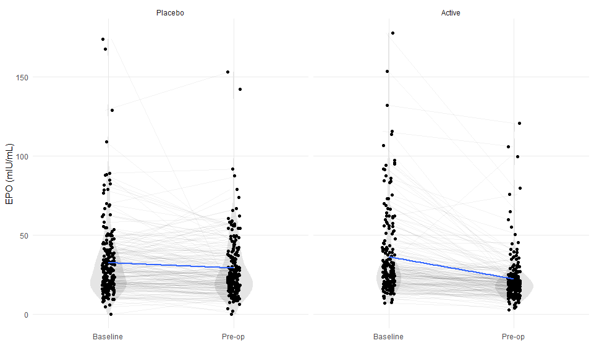

Baseline adjusted pre-operative EPO levels were 7.53 mIU/mL lower in the iron arm vs the placebo arm (-7.53; 95%CI-10.44 to -4.61; p = < 0.001).

**Table: Effect of iron on EPO levels (mIU/mL) estimated by linear regression with adjustment for baseline EPO**

|  |  |  |  |
| --- | --- | --- | --- |
|  | **Pre-op EPO (mIU/mL)** | | |
| *Predictors* | *Estimates* | *CI* | *p* |
| (Intercept) | 29.36 | 27.35 – 31.37 | **<0.001** |
| group [Active] | -7.53 | -10.45 – -4.60 | **<0.001** |
| Baseline EPO | 0.45 | 0.39 – 0.50 | **<0.001** |
| Observations | 354 | | |
| R2 / R2 adjusted | 0.403 / 0.400 | | |

**Figure: Distributions of baseline and pre-operative hepcidin values (ng/mL) by study arm.**

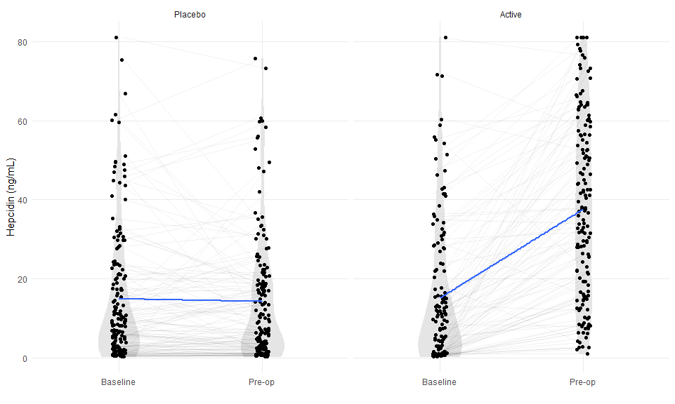

Pre-operative hepcidin levels were 23.11 ng/mL higher in the iron arm vs the placebo arm (23.11; 95%CI 19.14 to 27.08; p < 0.001).

**Table: Effect of iron on hepcidin levels (ng/mL) estimated by linear regression with adjustment for baseline hepcidin**

|  |  |  |  |
| --- | --- | --- | --- |
|  | **Pre-op hepcidin (ng/mL)** | | |
| *Predictors* | *Estimates* | *CI* | *p* |
| (Intercept) | 13.73 | 11.01 – 16.45 | **<0.001** |
| group [Active] | 23.11 | 19.12 – 27.10 | **<0.001** |
| Baseline hepcidin | 0.66 | 0.55 – 0.78 | **<0.001** |
| Observations | 237 | | |
| R2 / R2 adjusted | 0.528 / 0.524 | | |

# Associations between EPO, hepcidin and hemoglobin.

Here we will just relate the changes in EPO and hepcidin (baseline to pre-op) to corresponding changes in Hb, adjusted for trial arm.

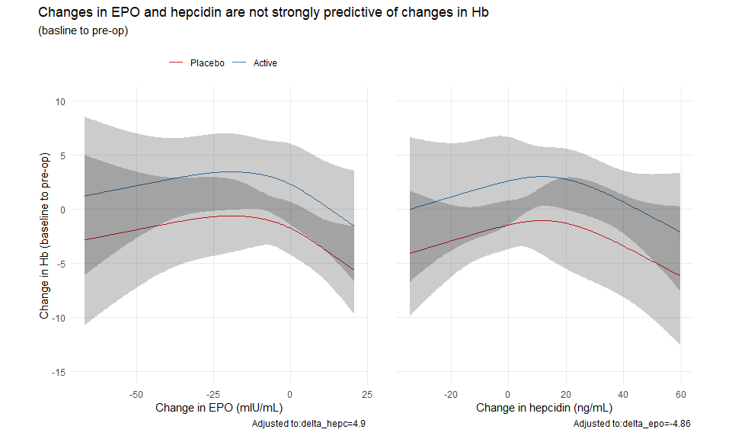

These plots show the model-adjusted relationships between changes in EPO and hepcidin with changes in Hb (baseline to pre-op). The EPO and hepcidin effects are adjusted for one another, as well as for study arm. Potential non-linear effects were accommodated for with restricted cubic splines. **Essentially what we see is that there is no relationship between changes in EPO or hepcidin with changes in Hb** (i.e. the red and blue lines move horizontally across the plot, and the 95% confidence regions overlap considerably). This is confirmed by the tests of these associations below.

## Analysis of Variance Response: tdl_hb_change   
##   
## Factor d.f. Partial SS MS F P   
## group 1 443.0000 443.0000 3.92 0.0490  
## delta_hepc 3 375.4616 125.1539 1.11 0.3471  
## Nonlinear 2 331.5404 165.7702 1.47 0.2330  
## delta_epo 3 545.2486 181.7495 1.61 0.1885  
## Nonlinear 2 398.1932 199.0966 1.76 0.1743  
## TOTAL NONLINEAR 4 828.4248 207.1062 1.83 0.1237  
## REGRESSION 7 1933.7145 276.2449 2.44 0.0198  
## ERROR 219 24759.4838 113.0570

##   
## System: Windows 10 x64 build 18363  
## Nodename: DESKTOP-JKQ7LTN, User: Darren  
## Total Memory: 16168 MB  
##   
## R version 4.0.3 (2020-10-10)   
## x86_64-w64-mingw32/x64 (64-bit)   
##   
## Loaded Packages:   
## broom (0.7.1), patchwork (1.0.1), ggfortify (0.4.11), sjPlot (2.8.5), rms (6.0-1), SparseM (1.78), Hmisc (4.4-1), Formula (1.2-3), survival (3.2-7), lattice (0.20-41), knitr (1.30), viridis (0.5.1), viridisLite (0.3.0), forcats (0.5.0), stringr (1.4.0), dplyr (1.0.2), purrr (0.3.4), readr (1.4.0), tidyr (1.1.2), tibble (3.0.4), ggplot2 (3.3.2), tidyverse (1.3.0), descr (1.1.4), MASS (7.3-53), logbin (2.0.4)