# Descriptive

Figure: Timing of key events for the 48 patients. 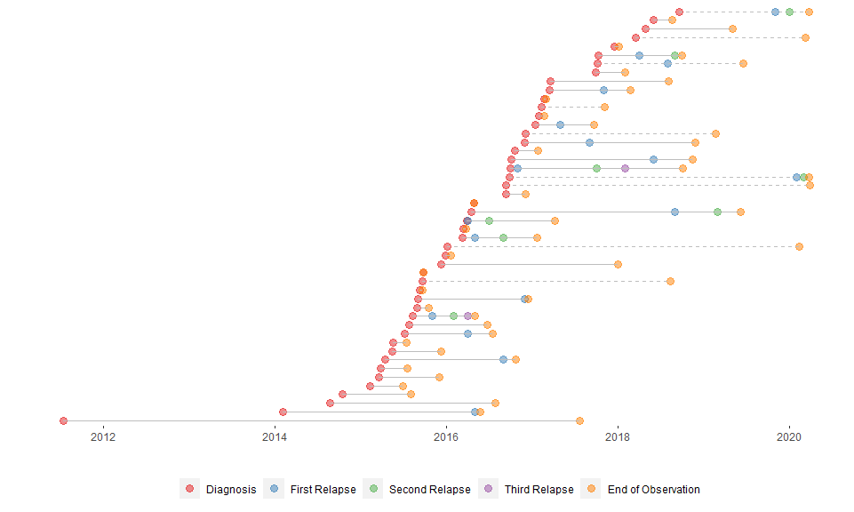

Dashed lines are patients that died; solid lines are patients that were alive at the last follow-up.

Note: it stands out somewhat that there is not follow-up for the living patients up to the same date.

Table 1. Sample characteristics (n = 48)

| Variable | n | Mean SD or n (%) | Median [IQR] | (Min, Max) |
| --- | --- | --- | --- | --- |
| Age (years) | 48 | 68.8 ± 10 | 68.5 (63, 76.2) | (37, 85) |
| Sex | 48 |  |  |  |
| Female |  | 19 (39.6%) |  |  |
| Male |  | 29 (60.4%) |  |  |
| P53 | 48 |  |  |  |
| Negative |  | 42 (87.5%) |  |  |
| Positive |  | 6 (12.5%) |  |  |
| BCL2 | 48 |  |  |  |
| Negative |  | 14 (29.2%) |  |  |
| Positive |  | 34 (70.8%) |  |  |
| OS | 48 |  |  |  |
| Alive |  | 9 (18.8%) |  |  |
| Died |  | 39 (81.2%) |  |  |
| Diagnosis to OS outcome (weeks) | 48 | 65.7 ± 66.2 | 48.4 (13.4, 103) | (0.1, 314.3) |
| PFS | 48 |  |  |  |
| Alive |  | 6 (12.5%) |  |  |
| Died |  | 25 (52.1%) |  |  |
| Remission |  | 17 (35.4%) |  |  |
| Diagnosis to PFS outcome (weeks) | 48 | 55.1 ± 66.1 | 35.1 (7.8, 75.6) | (0.1, 314.3) |

# 

# OS

## KM plots

### Empty

|  |  |  |  |  |  |  |
| --- | --- | --- | --- | --- | --- | --- |
| records | n.max | n.start | events | median | 0.95LCL | 0.95UCL |
| 48 | 48 | 48 | 39 | 49.29 | 37.29 | 100.6 |

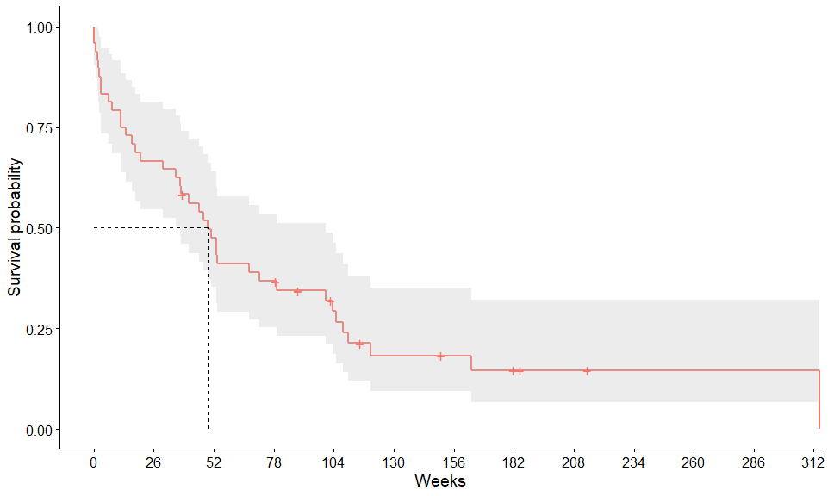

**BCL2**

Table continues below

|  |  |  |  |  |  |  |  |  |
| --- | --- | --- | --- | --- | --- | --- | --- | --- |
|  | records | | n.max | | n.start | | events | median |
| **bcl2_percent=Negative** | 14 | | 14 | | 14 | | 11 | 49.29 |
| **bcl2_percent=Positive** | 34 | | 34 | | 34 | | 28 | 49.29 |
|  | | 0.95LCL | | 0.95UCL | |
| **bcl2_percent=Negative** | | 16.43 | | NA | |
| **bcl2_percent=Positive** | | 37.29 | | 104.9 | |

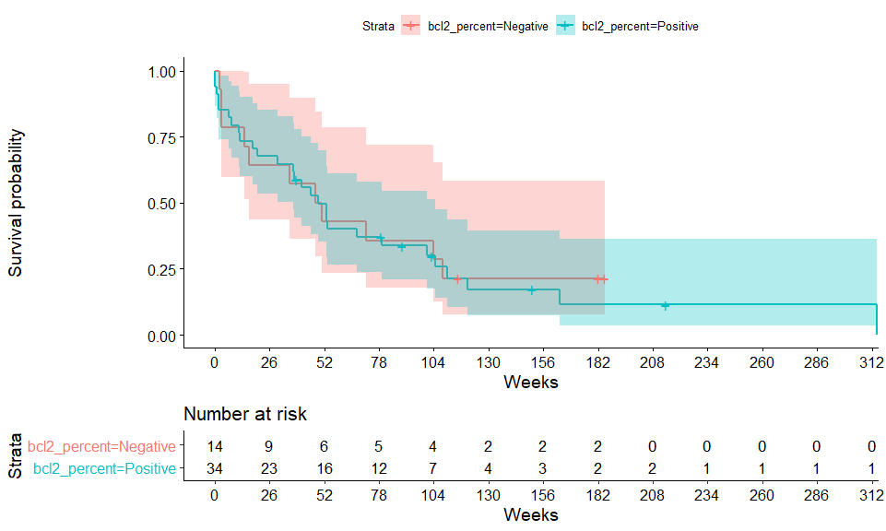

### P53

Table continues below

|  |  |  |  |  |  |  |  |  |
| --- | --- | --- | --- | --- | --- | --- | --- | --- |
|  | records | | n.max | | n.start | events | median | 0.95LCL |
| **p53_exp=Negative** | 42 | | 42 | | 42 | 33 | 49.29 | 37.29 |
| **p53_exp=Positive** | 6 | | 6 | | 6 | 6 | 32.43 | 3.143 |
|  | | 0.95UCL | |
| **p53_exp=Negative** | | 104.9 | |
| **p53_exp=Positive** | | NA | |

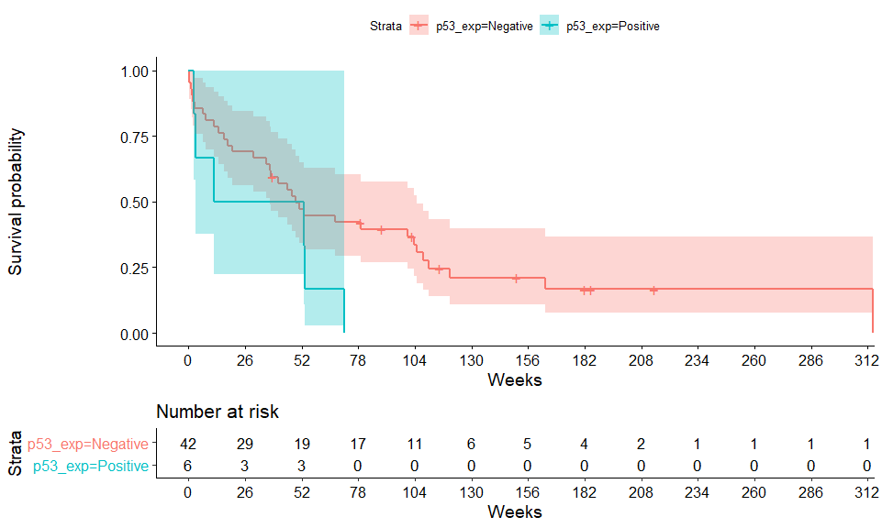

### Cox models

|  |  |  |  |  |  |  |  |  |  |  |  |  |
| --- | --- | --- | --- | --- | --- | --- | --- | --- | --- | --- | --- | --- |
|  | **BC12%** | | | **P53** | | | **Both** | | | **+Covariates** | | |
| *Predictors* | *Estimates* | *CI* | *p* | *Estimates* | *CI* | *p* | *Estimates* | *CI* | *p* | *Estimates* | *CI* | *p* |
| BCL2  [Positive vs Negative] | 1.10 | 0.54 – 2.22 | 0.796 |  |  |  | 1.14 | 0.56 – 2.31 | 0.715 | 1.23 | 0.60 – 2.52 | 0.581 |
| P53  [Positive vs Negative] |  |  |  | 2.05 | 0.83 – 5.03 | 0.118 | 2.08 | 0.84 – 5.12 | 0.112 | 2.58 | 0.97 – 6.90 | 0.059 |
| Sex  [Male vs Female] |  |  |  |  |  |  |  |  |  | 0.97 | 0.50 – 1.90 | 0.930 |
| Age (years) |  |  |  |  |  |  |  |  |  | 1.02 | 0.99 – 1.06 | 0.221 |
| Observations | 48 | | | 48 | | | 48 | | | 48 | | |
| R2 Nagelkerke | 0.002 | | | 0.053 | | | 0.056 | | | 0.093 | | |

# PFS (first remission)

## KM plots

### Empty

|  |  |  |  |  |  |  |
| --- | --- | --- | --- | --- | --- | --- |
| records | n.max | n.start | events | median | 0.95LCL | 0.95UCL |
| 48 | 48 | 48 | 42 | 35.14 | 16.43 | 58.29 |

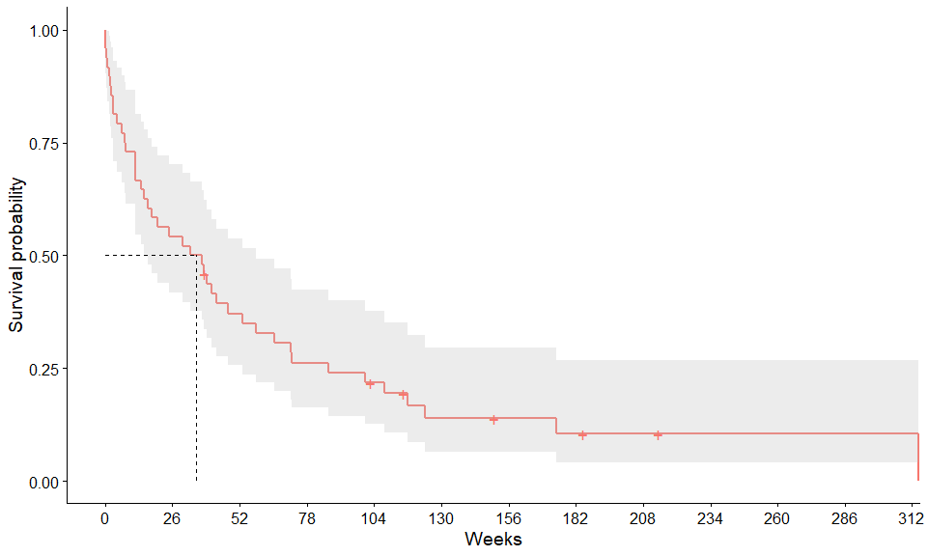

**BCL2**

Table continues below

|  |  |  |  |  |  |  |  |  |
| --- | --- | --- | --- | --- | --- | --- | --- | --- |
|  | records | | n.max | | n.start | | events | median |
| **bcl2_percent=Negative** | 14 | | 14 | | 14 | | 12 | 32.07 |
| **bcl2_percent=Positive** | 34 | | 34 | | 34 | | 30 | 35.14 |
|  | | 0.95LCL | | 0.95UCL | |
| **bcl2_percent=Negative** | | 15 | | NA | |
| **bcl2_percent=Positive** | | 11.71 | | 65.29 | |

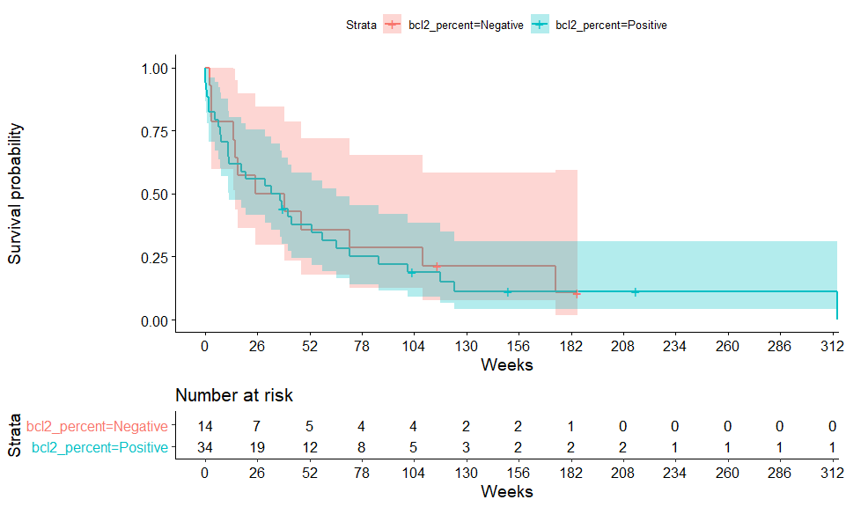

### P53

Table continues below

|  |  |  |  |  |  |  |  |  |
| --- | --- | --- | --- | --- | --- | --- | --- | --- |
|  | records | | n.max | | n.start | events | median | 0.95LCL |
| **p53_exp=Negative** | 42 | | 42 | | 42 | 36 | 38.29 | 18.14 |
| **p53_exp=Positive** | 6 | | 6 | | 6 | 6 | 7.429 | 2.429 |
|  | | 0.95UCL | |
| **p53_exp=Negative** | | 72 | |
| **p53_exp=Positive** | | NA | |

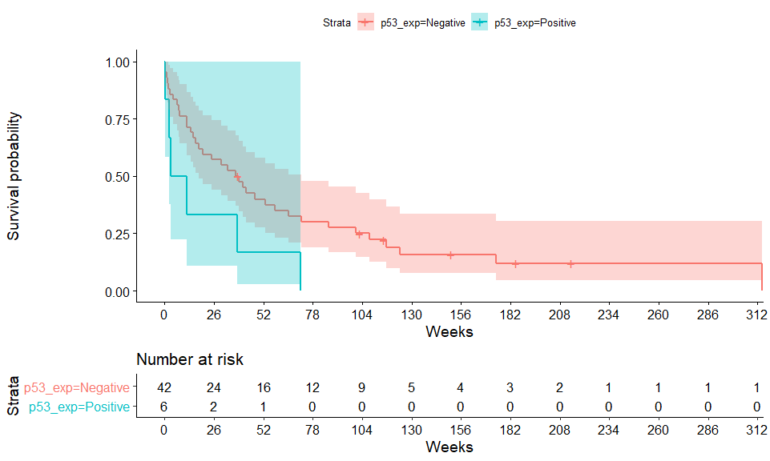

## Cox models

|  |  |  |  |  |  |  |  |  |  |  |  |  |
| --- | --- | --- | --- | --- | --- | --- | --- | --- | --- | --- | --- | --- |
|  | **BC12%** | | | **P53** | | | **Both** | | | **+Covariates** | | |
| *Predictors* | *Estimates* | *CI* | *p* | *Estimates* | *CI* | *p* | *Estimates* | *CI* | *p* | *Estimates* | *CI* | *p* |
| BCL2  [Positive vs Negative] | 1.13 | 0.58 – 2.22 | 0.721 |  |  |  | 1.26 | 0.63 – 2.52 | 0.508 | 1.39 | 0.67 – 2.87 | 0.376 |
| P53  [Positive vs Negative] |  |  |  | 2.38 | 0.98 – 5.79 | 0.055 | 2.55 | 1.03 – 6.31 | **0.044** | 3.33 | 1.20 – 9.21 | **0.021** |
| Sex  [Male vs Female] |  |  |  |  |  |  |  |  |  | 1.25 | 0.65 – 2.40 | 0.502 |
| Age (years) |  |  |  |  |  |  |  |  |  | 1.03 | 0.99 – 1.06 | 0.149 |
| Observations | 48 | | | 48 | | | 48 | | | 48 | | |
| R2 Nagelkerke | 0.003 | | | 0.070 | | | 0.080 | | | 0.138 | | |

|  |  |  |  |  |
| --- | --- | --- | --- | --- |
|  |  |  |  |  |

##   
## System: Windows 10 x64 build 18363  
## Nodename: DESKTOP-JKQ7LTN, User: Darren  
## Total Memory: 16168 MB  
##   
## R version 3.6.3 (2020-02-29)   
## x86_64-w64-mingw32/x64 (64-bit)   
##   
## Loaded Packages:   
## survminer (0.4.8), ggpubr (0.4.0), survival (3.2-3), patchwork (1.0.1), sjPlot (2.8.4), pander (0.6.3), knitr (1.29), flextable (0.5.10), RColorBrewer (1.1-2), viridis (0.5.1), viridisLite (0.3.0), descr (1.1.4), summarytools (0.9.6), testthat (2.3.2), janitor (2.0.1), forcats (0.5.0), stringr (1.4.0), dplyr (1.0.2), purrr (0.3.4), readr (1.3.1), tidyr (1.1.2), tibble (3.0.3), ggplot2 (3.3.2), tidyverse (1.3.0), readxl (1.3.1)