Running head: SESSION NUMBER AND SPACING EFFECTS ON SPONTANEOUS RECOVERY

The Number and Spacing of Conditioning Sessions
Positively Affect Spontaneous Recovery
Efstathios B. Papachristos*† and Charles R. Gallistel*
* Department of Psychology and Center for Cognitive Science, Rutgers, the State University of New Jersey
† Department of Neuroscience, Erasmus University Medical Center

Address correspondence to:
Efstathios B. Papachristos
Department of Neuroscience, Erasmus MC
Dr. Molewaterplein 50
3015GE Rotterdam
The Netherlands
Tel: +31-10-70 43751
Fax: +31-10-70 44734
E-mail: e.papachristos@erasmusmc.nl
The Number and Spacing of Conditioning Sessions
Positively Affect Spontaneous Recovery
Efstathios B. Papachristos* and Charles R. Gallistel

Abstract
The conditioning trial (and the number thereof) is assumed to be the primary acquisition variable that affects spontaneous recovery from extinction. However, growing evidence suggests that the conditioning session is a distinct experiential unit on its own. Using the conditioned magazine approach in mice we tested whether session manipulations affected spontaneous recovery. We found that distributing the same number of trials across more sessions or spacing the same sessions more widely enhanced spontaneous recovery. The importance of session number was corroborated by observing that when it was held constant, a four-fold decrease in the number of trials did not hurt spontaneous recovery. Moreover, having four times more sessions and four times fewer trials was, if anything, more effective than the reverse in promoting recovery. These results are better accounted for by models like the Temporal Weighting Rule, which postulates that the decision to reinvest in a recently failing CS is based upon consideration of all experiences with that CS, each one weighted by its recency. Sessions, rather than trials, seem to constitute this unit of experience in the mouse.

TEMPORAL WEIGHTING RULE NOSE POKE ACQUISITION EXTINCTION MOUSE

Responding to a well-trained conditioned stimulus (CS) that is repeatedly presented in the absence of the reward –or unconditioned stimulus (US) – declines progressively and ultimately ceases. This is the well-known extinction process and was first reported by Pavlov (1927). His theoretical interpretation of extinction was influenced by the interesting observation that the extinguished response recovered spontaneously with the passage of time. In the years that followed, spontaneous recovery was increasingly viewed as a phenomenon that shed light on the mechanisms operating in extinction (Robbins, 1990) and a wealth of interpretations has since been suggested (see, for example, Rescorla, 2004a; Robbins, 1990).
Most accounts of spontaneous recovery view the time after extinction as a critical period during which changes in learning-related psychological processes occur. For example, with time after extinction the activation threshold for the extinction memory rises making it harder to retrieve (Kraemer & Spear, 1993), the temporal context of extinction changes, which in turn results in the ‘renewal’ of the acquisition memory at the time of testing (Bouton, 1991, 1993), the inhibition that developed during extinction fades (Hull, 1943; Pavlov, 1927; Rescorla, 1979, 1993a; Wagner, 1981), or the conditioned and unconditioned CS elements are redistributed, so that a random sample drawn during testing maintains the relative proportion of the two subpopulations of elements and thus ensures that the unconditioned elements from extinction are outnumbered by the conditioned elements that were formed from the lengthier acquisition training (Estes, 1955b; Estes & Burke, 1953). Despite their differences, what all these interpretations have in common is that they all treat time as the medium for alterations in psychological processes but not as part of the content of learning.
The popularity of the time-as-medium view among these models reflects a traditional conceptualization of time as nothing more than just a dimension of the experiences that lead to the appearance of conditioned responding (Balsam & Gallistel, 2009).
The ability of animals to master discriminations based on stimulus duration and on the temporal order of events prompted Honig (1981) to propose the concept of the ‘temporal map’, that is, a psychological structure stored in long-term memory which, in analogy to the spatial cognitive map, reflects the stable parametric relationships among sequences of events in time. The current temporal location of a subject in combination with information accessed from the temporal map allows the subject to anticipate future events and to thereby organize behavior which is not under immediate stimulus control (Honig, 1981).
The idea that time plays an important role in Pavlovian conditioning has also been long recognized. Successful conditioning is considered to depend on the temporal duration of stimuli as well as their temporal relation (Pavlov, 1927). Nevertheless, the encoding of temporal information has had virtually no place within traditional theories of associative learning (e.g., Mackintosh, 1975; Pearce & Hall, 1980; Rescorla & Wagner, 1972). For these theories, temporal factors play only a facilitative role in the formation of associations, but the temporal information itself is not encoded (Savastano & Miller, 1998). Much recent research implies, however, that temporal information is encoded and plays a fundamental role in the emergence of anticipatory behavior (Balsam, Fairhurst, & Gallistel, 2006; Barnet, Arnold, & Miller, 1991; Barnet, Cole, & Miller, 1997; Cole, Barnet, & Miller, 1995; Gibbon, 1977; Gibbon & Balsam, 1981; Matzel, Held, & Miller, 1988; Miller & Barnet, 1993). Theories like the Scalar Expectancy Theory and the Temporal Coding Hypothesis have emerged, according to which the temporal relationship between the experienced events is represented as part of the association. Gallistel (1990; Gallistel & Gibbon, 2000), in his Rate Estimation Theory, has taken a more extreme position in which he abandons the construct of association altogether and relies only on time to explain learning.
The only theory of spontaneous recovery which treats encoded time as a critical determinant is Devenport’s Temporal Weighting Rule (TWR; Devenport, 1998; Devenport, Hill, Wilson, & Ogden, 1997). According to TWR, spontaneous recovery reflects the animal's decision to re-invest in a CS because on average, over the longer run, it has produced more than it has failed. Specifically, the animal computes an estimate of the value of a CS as a signal of reward. This estimate is a weighted average (V_{w}) of all experiences with the CS, with each experience (Q_{i}) being weighted by its recency (i.e., inverse of time, T_{i}, since that experience). Equation 1 shows the mathematical formulation of the model:
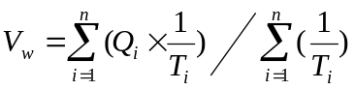 (1)
More recent experiences are weighted more heavily but their privileged weight is discounted in a hyperbolic fashion with the passage of time. Thus, soon after extinction responding is still depressed because the extinction experience (the quality of which is 0) carries a considerably heavier weight. After a longer delay, however, the extinction weight becomes more similar to the acquisition weight(s) (time makes the extinction experience look less and less more recent relative to acquisition) and the internal estimate regresses to the true (unweighted) mean, thereby causing the appearance of spontaneous recovery.
TWR’s treatment of time as an encoded part of the learning episode allows it to explain an interesting finding by Rescorla (2004b) that not just the extinction-test interval but also the training-test interval affects spontaneous recovery. Rescorla trained rats in a magazine approach procedure with two stimuli that differed only in the interval between their acquisition and extinction training. For one of the stimuli the two training regimes were separated by 8 days, while for the other that interval lasted only 1 day. Both stimuli were tested 2 days after extinction. Despite identical extinction curves, the stimulus with the shorter interval between acquisition and extinction showed greater spontaneous recovery during testing. Thus, the acquisition-extinction interval inversely affected spontaneous recovery.
Rescorla’s finding proves troublesome for the majority of the accounts of spontaneous recovery. Inhibition models (Hull, 1943; Pavlov, 1927; Rescorla, 1979, 1993a; Wagner, 1981) make the rather arbitrary assumption that the inhibition that developed during extinction fades with time causing the appearance of spontaneous recovery. Time does not impact the acquisition memory, so prolonging the interval between acquisition and extinction should be irrelevant for spontaneous recovery. Interference models encounter similar difficulties. For example, Bouton’s model treats only the extinction memory as context dependent. Only time after extinction can induce a functional change in the temporal context of extinction. Similarly, the Kraemer and Spear model claims that the asymmetrical affective nature of the two learning episodes causes an increase of the activation threshold of the less salient extinction memory over the retention interval. Again, there is no rule that governs any changes in the retrievability of the acquisition memory before extinction starts. Thus, the delay of the conflicting experience (extinction) has no place in this model. Indeed, the observation of identical extinction in both stimuli in Rescorla’s experiments attests to a perfect retrieval of the acquisition memory at the start of extinction. Finally, Estes’ stimulus sampling theory cannot predict this finding either. If acquisition were asymptotic, at the start of extinction the sample should consist of only conditioned elements, regardless of how much time has passed since training. If, on the other hand, acquisition were not asymptotic, then the longer the delay between the end of acquisition and the start of extinction, the more likely it is that extinction impacts (un-conditions) fewer conditioned elements overall. Thus, under the theory, the acquisition-extinction interval, should, if anything, positively affect the magnitude of recovery.
Rescorla’s finding can be accommodated by TWR because what is important in TWR is the relative distance (in time) of the two conflicting experiences (acquisition and extinction) from the time of test. Inserting an interval between acquisition and extinction makes extinction significantly more recent than acquisition. Its relative proximity endows it with a bigger weight (relative to the acquisition weight), which dominates the value of the stimulus as a predictor of reward. Thus, the relatively more recent extinction memory inhibits the appearance of spontaneous recovery.
According to TWR, animals need to remember two aspects of each encounter with the CS: its food-signaling quality and how long ago it occurred. Memory for the temporal characteristics of the learning event has been shown to include intervals lasting several days in birds (Clayton & Dickinson, 1998, 1999; Clayton, Yu, & Dickinson, 2003) and rats (Roberts et al., 2008). A question of theoretical importance is what counts as an experience with the CS. Do trials or sessions constitute the unit of experience that enters into the weighted averaging process? Put it otherwise, is it time since each trial or each session that is retained in memory? Sessions are important units of experience. Changes in conditioned responding usually occur at the beginning of a new session (Gallistel et al., 2007; Papachristos & Gallistel, 2006). Furthermore, distributing the same number of trials across more sessions speeds up acquisition, an effect known as the trials-per-session effect (Kehoe & Macrae, 1994; Levinthal, 1973; Papini & Dudley, 1993; Papini & Overmier, 1985), which indicates that the number of sessions is an important parameter of learning. Moreover, as long as the contingencies do not change within a session, it would be computationally advantageous for memory load purposes if the animal maintained in memory the time since each session, as opposed to each trial.
The question of whether trials or sessions are the important units of experience for spontaneous recovery can be addressed experimentally because TWR makes opposite predictions regarding these two possibilities. If at the time of testing the animal calculates the quality and time since each session, then the number of sessions becomes an important parameter for spontaneous recovery, while the number of trials within a session is irrelevant. Therefore, increasing the number of sessions, while keeping the total number of trials constant, should enhance spontaneous recovery from extinction.
Increasing the number of sessions results in an increase of the duration (in days) of acquisition. Such an increase may positively affect spontaneous recovery by a different mechanism than the one proposed by TWR. For example, it is possible that spontaneous recovery is due to the animal’s uncertainty about the current status of the CS-US relation (Gallistel & Gibbon, 2002; Papachristos & Gallistel, 2006). This predictive relation used to hold for an extended period of time (acquisition) before it failed (extinction). A single failure of a relatively stable process may be just a transient event. Among other factors, the readiness to treat the failure as a transient aberration may depend on how long the animal observed the relation to hold during acquisition. Thus, any manipulation that prolongs the acquisition regime should positively affect spontaneous recovery because it increases the evidence for long-term stationarity in the CS-US relation.
The extent to which various parameters of acquisition, such as the number of sessions, the spacing of sessions, and the number of trials within a session, affect spontaneous recovery remains unresolved. This research was designed to explore these issues. Experiment 1 found that prolonging the duration of acquisition, either by distributing the same number of trials across more sessions or by spacing the same number of sessions more widely, positively affected the magnitude of spontaneous recovery 4 weeks post extinction. Experiment 2 was a partial replication of Experiment 1 and confirmed the beneficial effect of increasing the number of sessions on spontaneous recovery 1 week after extinction. Experiment 3 used a within-subjects design to determine that of the two manipulations the session-number increase had a slightly stronger effect. Experiment 4 determined that the number of trials within an acquisition session is not an absolute determinant of the magnitude of spontaneous recovery. Experiment 5 provided a more direct test of whether the number of trials or the number of sessions is a more relevant parameter for spontaneous recovery and found that having four times more sessions and four times fewer trials is at least as effective as the reverse in promoting recovery.
Together the results suggest that the animals may keep track of the number of occasions and/or the duration of the period for which they experience a positive CS-US relationship in order to compute whether a single failure (extinction) is likely to be transient. The experimental session, as opposed to the trial, seems to be the memorable unit of experience that enters into this computation.
Experiment 1
This experiment investigated the relation between acquisition duration and spontaneous recovery. Duration was manipulated in two ways: while keeping the overall number of conditioning trials constant, we increased either the number of sessions or the spacing of sessions. Thus, we trained three groups of mice on a Pavlovian magazine approach procedure in which a 10-s white noise signaled food. The control group received 7 daily sessions of 40 trials each. Another group received the same 7 sessions spaced on average 4 days apart. The third group received 28 daily sessions of 10 trials each. Thus, all groups were equated for total trial number (280 trials) and context exposure (they received identical ITI sequences). The day after the last acquisition session, all mice went through a single extinction session. Finally, all mice were tested for spontaneous recovery 1 and 3 weeks later.
The only two models that make specific predictions regarding the two manipulations are Estes’ statistical theory (Estes, 1955b) and Devenport’s TWR (Devenport, 1998). Estes’ model predicts that both manipulations should increase the magnitude of spontaneous recovery because they both result in a wider distribution of conditioning trials. By inserting longer intervals between trials, more elements from the larger population have the opportunity to be sampled and become conditioned. Thus, at the time of testing, the proportion of conditioned elements in the sample will be greater for the two experimental groups with the prolonged acquisition duration compared to the control group.
TWR, on the other hand, makes a different prediction. Session spacing should, if anything, impair spontaneous recovery because it brings early acquisition experiences even farther away from the time of testing, thus diminishing their influence on the weighted average. Regarding the session number manipulation, TWR’s predictions depend on whether trials or sessions constitute the unit of experience with the CS that enter into the averaging process to determine the reward-signaling value of that CS. If at the time of testing the animal calculates the time since each session, then increasing the number of sessions should enhance spontaneous recovery. (By administering more conditioning sessions, the sum of their weights (that is, the recencies of those sessions) is added to both the numerator and denominator of Equation 1, bringing the value of the cluster closer to 1. Therefore, increasing the number of sessions should augment spontaneous recovery from extinction.) The opposite is true if it is time since each trial that enters into the computation. The rationale is similar to that applying to the session spacing manipulation; distributing the same trials across more sessions moves many of them to a greater distance from the time of the test, thus diminishing their positive influence on the weighted average.
Method
Subjects
The subjects were 18 male C57Bl/6 mice obtained from Harlan (Indianapolis, IN). They were about 9-11 weeks old and weighed between 16.3 and 20.9 g when the experiment started. They were housed individually in plastic tubs, and maintained on a 12:12 hr photoperiod, with lights on at 22:00 hr. Behavioral testing occurred during the dark phase of the photoperiod. Water was available ad lib in both the home cage and the experimental chambers, while food was restricted to keep body weight at approximately 85% of free-feeding weight. Standard rodent chow was given at the end of each session. Mice remained on their deprivation schedule until the first spontaneous recovery test, after which they received unrestricted food until 4 days prior to the second test, when they returned on their deprivation schedule.
Apparatus
Experimental sessions took place in modular operant chambers (Med Associates, Georgia, VT, model # ENV307W) measuring 21.6 cm x 17.8 cm x 12.7 cm, housed in individual ventilated, sound-attenuating boxes. Each chamber was equipped with a pellet dispenser connected to a feeding station on the center of one side. The station was a cubic hopper, 24 mm on a side, equipped with an infrared (IR) beam that detected nose pokes and a 5-watt light that illuminated the hopper when turned on. Mounted on the opposite wall were a clicker generator (80 dB, 10 Hz), a white noise generator (80dB, flat 10-25,000 Hz), and a house light (28 V DC, 100 mA). At the end of the feeding latency (10 s) a 20-mg precision pellet (TestDiet, 5TUM 1811143) was delivered in the feeding station. The experiment was controlled by computer software (Med-PC IV, Med Associates) that also logged and time-stamped the events—the onsets and offsets of interruptions of the IR beams in the station, the onsets and offsets of white noise, and the delivery of food pellets. Event times were recorded with a resolution of 20 ms.
Procedure
Body weights were recorded right before the start of each session. The house light remained illuminated throughout the experiment.
Acquisition. Sessions started with an intertrial interval (ITI) drawn from an exponential distribution with a mean of 180 s. This ITI was followed by a fixed, unsignaled 10-s interval (pre-CS period), at the end of which a trial started. A trial consisted of 10-s presentation of white noise, which ended with the delivery of a pellet in the feeding station. A 100-ms clicker also signaled pellet delivery. There were three groups of 6 mice each. The group given many daily trial-poor sessions received 28 sessions of 10 trials each, while the two groups given only a few trial-rich sessions received seven sessions of 40 trials each. One of the two latter groups got their few trial-rich sessions on successive days, while the other received a trial-rich session every 4 days on average (range 1-7 d).
The temporal extent of training was the same (28 days) for the group that got many trial-poor daily sessions and the group that got a few widely spaced trial-rich sessions, and all three groups got the same number of trials. The interval between sessions was the same (1 day) for the group that got many trial-poor daily sessions and the group that got a few trial-rich daily sessions. The amount of context exposure was the same for all three groups because session length covaried with the number of trials in a session. For the group that got a few daily trial-rich sessions, all of its acquisition trials were concentrated relatively close to the beginning of extinction and, hence, to the beginning of the tests for spontaneous recovery. For the other two groups, most of the trials occurred at a greater temporal remove from extinction, hence, also from the tests for spontaneous recovery.
Extinction. The day after their last acquisition session all mice received a single extinction session. There were no pellets or clickers delivered at the end of the white noise. In every other aspect, the extinction session was identical to an acquisition session. After the first 20 trials, an extinction criterion was employed. A mouse should make no responses during the CS for five consecutive trials. The session ended five trials after this criterion was met.
Spontaneous Recovery Tests. All mice were tested for spontaneous recovery 1 and 3 weeks post extinction. Each test included four presentations of the white noise in the absence of a reward.
Analysis
Our index of conditioned responding was the elevation score, that is, the difference in the number of pokes during the CS and the 10-s period (pre-CS) immediately preceding the onset of the CS.
Results and Discussion
Figure 1 shows the performance of the three groups during the first and last two-trial blocks of extinction, as well as the course of the two spontaneous recovery tests. Surprisingly, the groups did not respond at similar rates at the start of extinction. The mean elevation score for the first two extinction trials was 0.9 for the group that got many daily sessions, 4.6 for the group that got only a few daily sessions, and 7.6 for the group that got a few widely spaced sessions (F(2,15)= 3.72, p=.049). The source of this difference was the significantly lower performance of the group that got many daily sessions compared to the group that got a few widely spaced sessions, as determined by Tukey’s HSD post-hoc comparison (p=.04). This discrepancy was not due to a difference in baseline poking because the mean number of pokes during the pre-CS period of the first two extinction trials was comparable for all groups (F(2,15)=0.31, p=.74). The cause was most likely a coincidental reduction in conditioned responding in the mice of the group given many daily sessions. We have observed similar bi-directional fluctuations post acquisition before (Papachristos & Gallistel, 2006). Despite their different initial performance, all groups took approximately 30 trials to reach the extinction criterion and by the end of extinction conditioned responding was completely eliminated for all groups (none of these two differences approached significance).
<Figure 1 about here>
Spontaneous recovery was defined as greater responding during the first trial of the recovery test than during the last two-trial block of extinction. As can be seen in the figure, none of the groups showed robust recovery 1 week after extinction; a two-way Anova with Test (last extinction block vs. first trial of the 1-week test) treated as the within-subjects variable, and
Group as the between-subjects, confirmed this by showing no main effect of Test (F(1,15)=2.39, p=.14) and no Group x Test interaction (F(2,15)=0.32, p=.73).
Three weeks post extinction there was robust spontaneous recovery for all groups except for the group that received only a few daily sessions. The same mixed models Anova revealed significant main effects of Test (F(1,15)=48.4, p<.001), Group (F(2,15)=11.62, p=.001), and their interaction (F(2,15)=11.03, p=.001). The source of this interaction was the absence of any spontaneous recovery in the group with the few daily sessions (t(5)=0.27, p=.40, one-tailed), as opposed to the two other groups.
In summary, we observed that distributing the same number of signal-reward pairings across more sessions or spacing the same acquisition sessions along a wider interval augmented the chances for spontaneous recovery 3 weeks after extinction. This is a finding that many theories of spontaneous recovery cannot accommodate. Trial-based associated models usually attribute spontaneous recovery to the dissipation with time of an inhibitory process that developed during extinction, which counteracted the excitatory properties of the CS (Pearce & Hall, 1980; Wagner, 1981). Since all groups in this experiment received the same number of acquisition trials, and very similar number of extinction trials and exposure to the context, both associations (excitatory and inhibitory) should be of equal strength in both groups. Therefore, the time-dependent fading of the inhibition should progress at equal rates and no differences should be observed in spontaneous recovery testing after any delay. We will return to the evaluation of these models during the General Discussion.
Similarly, interference theories have difficulties accounting for this effect. Although stated in different terms, interference theories emphasize the role of extinction memory as the main contributor of spontaneous recovery. As the time passes, the extinction memory becomes harder to retrieve because its activation threshold rises with time (Kraemer & Spear, 1993), or its temporal context becomes increasingly dissimilar (Bouton, 1991, 1993, 2004), and thus spontaneous recovery appears. Since all groups in this experiment received identical extinction-testing delays, no differences should be anticipated.
Devenport’s Temporal Weighting Rule (Devenport, 1998) anticipates the finding that the group given many trial-poor sessions show more recovery than the group given a few trial-rich daily sessions, only if the session, as opposed to the trial, is the unit of experience that enters into the weighted averaging process. However, TWR wrongly predicts that spacing the same number of sessions should, if anything, hurt spontaneous recovery, since it moves the acquisition experiences farther into the past, thus diminishing their positive influence on the weighted average at the time of testing. Our data indicate that spacing the sessions enhances spontaneous recovery, in a similar way that spacing trials enhances conditioning.
Estes’ statistical theory of learning (Estes, 1955b) is the only model of spontaneous recovery that correctly anticipates the enhancing effects of both manipulations. Spacing acquisition trials or sessions allows more elements to become conditioned with the US. Both experimental groups showed enhanced recovery simply because at the time of testing a larger proportion of conditioned elements were sampled, compared to the control group.
It is rather surprising that 1 week post extinction none of the groups showed any spontaneous recovery. This rest interval is usually long enough to produce robust recovery in the same preparation in the rat (Rescorla, 2007). We speculate that the lack of recovery could be due to the fast extinction that we observed. Unpublished data in our laboratory by Alan Daniel indicated that the lever pressing response is considerably more resistant to extinction and shows much stronger spontaneous recovery as well. Nonetheless, a closer look at the data showed that at least in the group given many daily trial-poor sessions the absence of spontaneous recovery could be attributed to its unusually elevated baseline poking at the start of the first spontaneous recovery test. Figure 2 shows the mean number of pokes during the 10-s periods preceding the two extinction blocks and each test trial. Baseline poking remained equally low for all groups except for the first test trial 1 week after extinction (F(2,15)=4.66, p=.03); the number of pokes during the pre-CS period of that first trial was higher in the group with the many daily trial-poor sessions compared to the group with the few daily trial-rich sessions (p=.04) and the group with the few spaced trial-rich sessions (p=.05), as determined by Tukey’s HSD post-hoc tests.
<Figure 2 about here>
Whether this elevated base-rate is indicative of stronger contextual conditioning in group “many daily trial-poor sessions” as a result of manipulating the session number or simply a fluke cannot be determined. Regardless of the source of this finding, we decided to replicate it to ensure that the positive effect of the number of sessions on spontaneous recovery can be obtained 1 week after extinction without it being contingent on a recovery of contextual conditioning.
Experiment 2
The goal of this experiment was to investigate whether increasing the number of conditioning sessions could boost spontaneous recovery even 1 week after extinction. So far, this effect was only observed during the second test (3 weeks post-extinction). Although in Experiment 1 the group with the many daily trial-poor sessions showed a trend for more vigorous responding to the CS 1 week post-extinction, their contextual base-rate also recovered, decreasing their overall elevation score. To eliminate an elevated base-rate, we gave all mice a session of context extinction on each of the two days prior to the 1-week test.
Method
Subjects and Apparatus
The subjects were 12 male C57Bl/6 mice obtained from Harlan (Indianapolis, IN). They were about 10 weeks old and weighed between 21.2 and 24 g when the experiment started. They were maintained on the same manner as in Experiment 1. The apparatus was the same as in Experiment 1.
Procedure
The procedural details during all phases of training and testing were those of Experiment 1 except where noted. Mice were randomly assigned into two groups of 6 subjects. During conditioning, the group with the few trial-rich sessions received six daily sessions (one per day) of 40 rewarded trials with the white noise, while the group with the many trial-poor sessions received 24 daily sessions of 10 such trials. A single extinction session one day after the last day of conditioning employed the same criterion as in Experiment 1. On the 5th and 6th day following extinction, all mice were placed in the experimental chambers for 1 hr. No stimuli were presented during those sessions, with the exception of the house light, which remained on throughout. Finally, both groups were tested for spontaneous recovery 1 and 3 weeks post extinction, each test being identical to the tests of Experiment 1.
Results and Discussion
Figure 3 shows the performance at the beginning and end of extinction, and throughout the course of the two tests. The two groups responded at similar rates during the start (t(10)=0.34, p=.74) and end of extinction (t(10)=0.56, p=.59). Moreover, there was no difference in the mean number of trials to reach the extinction criterion (Group many trial-poor sessions: 28.5, Group few trial-rich sessions: 34.3, t(10)=1.53, p=.16).
<Figure 3 about here>
The results of most interest come from the test session given a week later. That day found robust recovery on the first test trial for the group given many trial-poor sessions (t(5)=3.38, p<.01, one-tailed), followed by a sharp drop to practically baseline levels. Moreover, on that first trial, the same group responded to the white noise more than the group with the few trial-rich sessions (t(10)=3, p=.01). The latter group failed to show any spontaneous recovery (t(5)=1.30, p=.12, one-tailed).
Three weeks after extinction the results look very similar. The group with the many trial-poor sessions exhibited spontaneous recovery during the first (t(5)=5.45, p=.001, one-tailed) and second trial (t(5)=2.37, p=.03, one-tailed). Moreover, a two-way Anova with group treated as the between-subjects factor and test trial (first vs. second) as the within-subjects factor found a main effect of group (F(1,10)=10.11, p=.01), indicating that during these two trials the group with the many trial-poor sessions responded more than the group with the few trial-rich sessions.
In summary, Experiment 2 replicated one of the main findings of Experiment 1 that distributing the same number of CS-US pairings across more sessions augments spontaneous recovery from extinction.
Experiment 3
Experiment 1 showed that spontaneous recovery is enhanced when acquisition has been prolonged by distributing trials across more sessions or by spacing trial-rich sessions more widely. The session number manipulation seemed to have a slightly bigger effect than the session spacing one, although this was not established statistically. One might assume it did given that there was a tendency for higher responding during the first CS presentation of the 1-wk test, which was though masked by an unusually elevated baseline. Similarly, responding throughout the second test was higher in the group that got many trial-poor daily sessions than in the group that got a few widely spaced trial-rich sessions, although again this difference was not statistically significant. The question of whether there is a difference in the size of the effect that the two manipulations have on spontaneous recovery has some theoretical importance. If the two manipulations have equal effects, then it is more likely that they both share the same mechanism of action (for example, they result in widely distributed trials, or they prolong the duration of the acquisition regime). If, on the other hand, the session number manipulation is more robust, this may indicate that whatever unique properties this manipulation possesses may be relevant parameters that a complete account of spontaneous recovery should encompass.
We tried to address this question in Experiment 3. It used a within-subjects design to compare spontaneous recovery to a stimulus that during acquisition had been presented on all training sessions with that to a stimulus presented on a random quarter of those sessions. The two stimuli had in common the total number of trials each was presented, and the span (in days) of acquisition training, while they differed on the number of sessions in which they had appeared.
Method
Subjects and Apparatus
The subjects were 6 mice of the same sex and type as in the previous experiments. They were about 11-12 weeks old and weighed between 17.9 and 18.9 g when the experiment started. They were maintained on the same manner as in previous experiments. The apparatus was that of Experiment 1.
Procedure
To improve stimulus discrimination, this experiment used three stimuli: white noise, flashing house-light (0.5-s on, 0.5-s off), and diffuse hopper light. Two of these stimuli served as conditioned stimuli, while the third one had always the opposite outcome, that is, it was not reinforced during conditioning, but it was during extinction. The role of the stimuli was counterbalanced across subjects. One role was that of what we will call the routinely present CS, that is the CS that occurred equally often in every session. The second role was that of what we will call the intermittently frequent CS. This only occurred in 25% of the sessions, but in those sessions, it occurred 4 times more frequently than the routine CS. The third role was that of the control CS. This CS occurred in every training session for one quarter of the number of trials of the other CS(s) (that is, it was presented once for every four trials with either of the other two CSs). In training sessions, it was never reinforced; in the extinction session, it was always reinforced. Its role was to prevent stimulus generalization between the other two CSs, that is, to prevent the subject from drawing the conclusion that whenever a stimulus came on, it predicted food regardless of its identity.
Acquisition. Initial training lasted for 28 sessions (1 session per day). Sessions started with a variable 180-s ITI, followed by an unsignaled fixed 10-s pre-CS interval, at the end of which a 10-s trial started. 75% of the sessions contained 8 trials with the routine CS and 2 trials with the control CS. The other 25% of the sessions contained 8 trials with the routine CS, 32 trials with the intermittently frequent CS, and 10 trials with the control CS. With the exception of the first and last conditioning session, which belonged to this type, the choice of the other 5 such sessions was individually randomized for each mouse. The order of trial type within all sessions was determined randomly for each mouse by the computer program that controlled the experiment, without any restrictions imposed.
Extinction. The day after acquisition ended, mice received a single extinction session, which contained 20 non-reinforced presentations of each of the two CSs, and 10 rewarded presentations of the control CS, with random order. This alternation in the latter stimulus’ outcome aimed to maintain some level of reinforcement and accelerate extinction.
Spontaneous Recovery Tests. All mice were tested for spontaneous recovery 1 and 4 weeks after extinction. Each test included two non-reinforced trials with each of the two extinguished CSs. During each test, for half of the mice the order of the stimuli followed an ABBA pattern while for the other half it was reversed (BAAB). Each mouse received both orders across the two tests. There were no presentations of the control CS in any of the tests.
Results and Discussion
Figure 4 shows responding to the two conditioned stimuli during the course of extinction and the two tests. Mice responded indistinguishably to the two stimuli at the onset of extinction. The curves remained superimposed almost throughout extinction, and at the end there was no difference in responding to the two stimuli (t(5)=0.55, p=.60).
<Figure 4 about here>
One week later responding to the two stimuli recovered slightly during the first trial and marginally exceeded that shown at the final extinction block for both stimuli (Routine CS: t(5)=2.02, p=.05; Intermittently frequent CS: t(5)=2.05, p=.05, one-tailed). Four weeks post extinction there was a trend for recovery only in the routine CS but it did not reach significance (t(5)=1.73, p=.07, one-tailed). Moreover, although the mice tended to respond to it more than they did to the intermittently frequent CS, the difference between the two stimuli at the first trial of the test did not approach significance either (t(5)=2, p=.1).
Figure 5 shows the distributions of elevation scores for the routine CS and the intermittently frequent CS. Five of the six mice did not respond at all to the intermittently frequent CS, whereas 4 of them did respond to the routine CS, at levels comparable to those seen in all mice 1 week after extinction. Elevation scores are plausibly regarded as coming from the 2-parameter Skellam distribution, which is the distribution of the differences between two Poisson distributed random variables. If one were to assume that the Skellam distribution for the routine CS was the same in all 6 mice and likewise for the intermittently frequent CS, then a relative maximum likelihood analysis gives strong odds in favor of a model in which the routine-CS distribution has a higher expectation than the intermittent-CS distribution. The assumption that the different subjects have the same distributions is, however, dubious. The most that can be said is that more likely than not the spontaneous recovery to the routine CS was greater than to the intermittently frequent CS when tested 4 weeks after extinction.
<Figure 5 about here>
Experiment 4
The previous experiments suggested that the number of sessions is an important parameter for spontaneous recovery. With total trial number held constant, more initial conditioning sessions augment spontaneous recovery. This property may partially be attributed to the resulting lengthening of acquisition, because spacing trial-rich sessions has almost the same effect. However, this might also mean that the session itself is an important unit of experience, perhaps even more important than the number of trials within a session. Experiment 4 was designed to evaluate this possibility. Two groups of mice received the same number of conditioning sessions but differed in the number of trials per session. Group Many Trials was trained with four times more trials per session than Group Few Trials. Both groups were given a single extinction session and subsequently tested for spontaneous recovery. If the number of sessions is the only determinant of spontaneous recovery, both groups should exhibit equivalent recovery, since they don’t differ on that regard. If on the other hand the number of trials within a session contributes to spontaneous recovery, then Group Many Trials should show higher recovery.
Method
Subjects and Apparatus
The subjects were 12 mice of the same sex and type as in Experiment 1. They were about 11 weeks old and weighed between 18.1 and 21 g when the experiment started. They were maintained on the same manner as in Experiment 1. The apparatus was that of Experiment 1.
Procedure
The procedural details during all phases of training and testing were those of Experiment 1 except where noted. Mice were randomly assigned into two groups of 6 subjects. During conditioning, Group Few Trials received eight daily sessions (one per day) of 10 rewarded trials with the white noise, while Group Many Trials received 8 daily sessions of 40 trials. Note that since the same 3-min average ITI was given to both groups, session durations differed also by a factor of four in these groups. A single extinction session one day after the last day of conditioning employed the same criterion as in Experiment 1. All mice were tested for spontaneous recovery 1 and 3 weeks post extinction. Both tests were the same as the respective tests of Experiment 1.
Results and Discussion
Figure 6 shows responding during the beginning and end of extinction, and the two spontaneous recovery tests. The groups responded at similar levels both at the start (t(10)=1.68, p=.12) and end (t(10)=1.83, p=.10) of extinction. Moreover, they did not differ in the number of trials to reach the extinction criterion (t(10)=0.07, p=.94).
<Figure 6 about here>
One week after extinction none of the groups showed any recovery, a result similar to that in Experiment 2. Three weeks after extinction conditioned responding in both groups recovered substantially on the first trial, but dropped sharply immediately after. On the first trial both Group Many Trials (t(5)=3.78, p<.01, one-tailed) and Group Few Trials (t(5)=3.27, p=.01, one-tailed) exceeded their performance shown at the end of extinction, and despite a trend for Group Few Trials to respond at a higher rate than Group Many Trials, the performance of the two groups did not differ (t(10)=1.88, p=.09).
The results of this experiment argue against the number of acquisition trials as a main determinant of spontaneous recovery: A four-fold difference in this parameter did not affect the magnitude of spontaneous recovery from extinction. The predictions of trial-based models are at odds with these findings. Such models emphasize the importance of trials for the formation and the strengthening or weakening of associations. Thus, they capitalize on the assumption that more conditioning trials should result in higher excitatory associative strength. The latter either should take longer to decline during extinction (Mackintosh, 1975; Rescorla & Wagner, 1972) or should require more time before it is cancelled out by an opposite (inhibitory) association that develops during extinction (Pearce & Hall, 1980; Wagner, 1981). In the absence of any differences on the number of extinction trials, these models would predict that at the end of extinction the group that received more conditioning trials should have a higher net associative strength which should cause higher recovery. Estes’ model (Estes, 1955b) similarly fails to predict the lack of a difference in spontaneous recovery between the two groups. Under similar trial spacing protocols, the model stipulates that spontaneous recovery is an increasing function of the number of reinforcements. Thus, it too expects Group Many Trials to produce more recovery.
It is possible that the 80 acquisition trials were enough to fully condition mice in Group Few Trials. Thus, the absence of any difference in spontaneous recovery might have been due to the fact that the excitatory associations for both groups were practically equal at the onset of extinction. Nonetheless, if trial number did contribute to spontaneous recovery, one should expect that Group Many Trials should show at least a trend for higher recovery especially 1 week post extinction, when performance was maintained at the low end of the scale. In the clear absence of such a trend, the current findings favor the hypothesis that the number of sessions and/or the duration of the pre-extinction phase of training (the duration of the phase during which the CS did predict the US) are more important parameters for spontaneous recovery than is the number of conditioning trials.
Experiment 5
Experiment 4 found no differences in spontaneous recovery between two groups that received the same number of sessions but differed by a factor of four on the total number of trials and context exposure. Although this finding argues against a role of trial number in spontaneous recovery, it would be premature to conclude that this parameter has no effect. If the number of conditioning trials within a session drops below a critical value, it may hurt not only conditioning, but also spontaneous recovery. The hypothesized superior role of session as an important unit of experience may be contingent on its containing more than some minimum number of trials. A direct evaluation of this hypothesis would entail a replication of Experiment 4, with the exception that Group Few Trials would receive only one or two trials per session. However, such a design is almost certainly doomed to fail, because, in the absence of an increased ITI in that group, their session duration would be too short to allow mice to obtain the reward in a timely manner during the first couple of sessions. If on the other hand the two groups were equated on context exposure (session duration), the results would be confounded by the trial-spacing effect (Barela, 1999; Barnet, Grahame, & Miller, 1995; Brelsford & Theios, 1965; Salafia & et al., 1973). To avoid these complications, Experiment 5 was designed to pit the number of sessions against the number of trials.
We trained two groups on the magazine approach procedure. The session-rich-trial-poor group received four times more sessions but also four times fewer total trials than the session-poor-trial-rich group. Both groups were subsequently put through extinction and then tested for spontaneous recovery. If the number of sessions and/or the acquisition duration is a more important parameter than the number of trials, then it should stimulate more recovery in the session-rich-trial-poor group.
Method
Subjects and Apparatus
The subjects were 12 mice of the same sex and type as in Experiment 1. They were about 10-12 weeks old and weighed between 19 and 21 g when the experiment started. They were maintained on the same manner as in Experiment 1. The apparatus was that of Experiment 1.
Procedure
The procedural details during all phases of training and testing were those of Experiment 1 except where noted. Mice were randomly assigned into two groups of 6 subjects. During conditioning, the session-rich-trial-poor group received 28 daily sessions (one per day), each containing 2.5 trials on average (2 or 3 trials alternating between adjacent sessions). The session-poor-trial-rich group received 7 daily sessions of 40 trials each. A single extinction session one day after the last day of conditioning employed the same criterion as in Experiment 1. All mice were tested for spontaneous recovery 3 and 18 days after extinction. Both tests were identical to the tests of Experiment 1.
Results and Discussion
Figure 7 shows responding during the beginning and end of extinction, and the two spontaneous recovery tests. The groups responded at similar levels both at the start (t(10)=0.51, p=.62) and end (t(10)=1.46, p=.18) of extinction, and they did not differ in the number of trials to reach the extinction criterion (t(10)=0.08, p=.94).
<Figure 7 about here>
The results of interest come from the two spontaneous recovery tests. Three days after extinction none of the groups showed any recovery. This interval was chosen to ensure that the session-poor-trial-rich group would respond at a low rate, so that any enhancing effect of the session number manipulation could be easily detected. However, this choice of delay proved unfortunate, since it was too short to allow any recovery in the session-rich-trial-poor group as well. As can be seen in the figure, only on the second trial did the mice of the session-rich-trial-poor group show a trend of higher responding than their controls, but this difference did not reach statistical significance (t(10)=2.07, p=.07).
Eighteen days after extinction responding recovered for both groups during the first (Session-rich-trial-poor group: t(5)=3.46, p<.01; Session-poor-trial-rich group: t(5)=2.27, p=.04, one-tailed) and second (t(5)= 3.02, p=.01; t(5)=2.92, p=.02, one-tailed) test trials. More importantly, the session-rich-trial-poor group responded at a higher rate than the session-poor-trial-rich group during the first three trials of that test. A two-way Anova with trial as the within-subjects factor and group as the between-subjects showed significant main effects of the trial (F(2,20)=4.41, p=.03) and the group (F(1,10)=7.57, p=.02) factors.
The results from this experiment suggest that session number may be a more important parameter for spontaneous recovery than trial number. Having four times more sessions and four times fewer trials was slightly more effective than the reverse in promoting spontaneous recovery. However, the magnitude of this effect was not as big as one would expect if the session were the only important unit of experience. Note that the session-rich-trial-poor group significantly outperformed the session-poor-trial-rich group only when the first three trials of the 18-d test were taken into account. However, this difference should be treated with caution because on the 3rd trial both groups had already returned to levels of responding comparable to those each had shown at the end of extinction. It was only during the first two trials that both groups’ recovery was maintained at a high level. The superior responding of the session-rich-trial-poor group during these first two trials approached but did not reach significance (F(1,10)=4.59, p=.06).
The results of this experiment strengthen the hypothesis that the session may be a more important parameter for spontaneous recovery than the trial. However, the evidence is not very robust. Until this finding is replicated, the results should be treated with caution. Future experiments should aim at remedying two drawbacks of this design. First, the extinction-test intervals should be chosen to ensure robust recovery of the session-rich-trial-poor group. Second, the number of trials in the same group should be kept at the minimum, possibly at just one trial per session, in order to avoid asymptotic conditioning of this group’s subjects. Such a design may be more appropriate for a direct and conclusive evaluation of this hypothesis.

General Discussion
The results of these experiments suggest a model of spontaneous recovery that shares some features with TWR (Papachristos & Gallistel, 2006). Spontaneous recovery may be best thought of as a behavioral indication of the animal’s expectations regarding the current status of the signal-reward relation. This relation held throughout acquisition until it failed in extinction. This failure could be either a transient aberration (noise) of a stable process or the marking of a long-lasting change (i.e. new contingency). At the time of test the choice between these two options is influenced among other factors by the duration of acquisition. As Experiments 1 and 2 showed, prolonging acquisition by spreading the same number of sessions across more days, or by distributing the same number of trials across more sessions, enhanced spontaneous recovery. Under our hypothesis, both manipulations increase the strength of the evidence for long-term stationarity of the signal-reward relation, thus favoring a decision to invest to the extinguished CS because it is more likely to yield again. Apart from the overall duration (in days) of acquisition, the number of rewarding CS experiences may be an additional factor favoring the decision to invest to a recently failing CS. As Experiment 3 showed (although not decisively so), when number of trials and span (in days) of acquisition training were equated for, spontaneous recovery to a stimulus that had been presented on all training sessions tended to be greater than that to a stimulus presented on a random quarter of those sessions. The session, as opposed to the trial, seems to be the unit of memorable experience that enters into the computations for the decision to respond or not. A four-fold increase in the number of trials did not augment spontaneous recovery, when number of sessions was equated for (Experiment 4). Moreover, having four times more sessions and four times fewer trials was at least as effective, if not more, as the reverse in promoting spontaneous recovery (Experiment 5).
These results are at odds with most accounts that rely on failing memory, or preferential retrieval of a certain memory, to explain spontaneous recovery. Specifically, the results obtained are inconsistent with generalization decrement accounts (e.g., Capaldi, 1967). These accounts attribute spontaneous recovery to the ambiguous state of the context at the time of testing. The observation of Experiments 1 and 2 that spontaneous recovery is enhanced in mice that receive the same number of trials across more sessions poses serious difficulties to this account. Since this manipulation did not affect the total exposure to the context, mice given many trial-poor or few trial-rich sessions should be equally (un)able to classify the test context as signaling reward or no reward. The same reasoning can be applied to explain the failure of this account to predict the enhancing effects of the session-spacing manipulation in Experiment 1.
Interference accounts (e.g., Bouton, 1991, 1993; Kraemer & Spear, 1993) have similar difficulties explaining these main findings. Such accounts emphasize the role of retrieval processes during testing to explain spontaneous recovery. However, both rely on a time-induced change in the extinction memory, but not the acquisition memory. The experimental manipulations of this study did not target extinction. Thus, the observed differences between the groups of Experiment 1 cannot be explained by a time-induced increase in the threshold for the activation of the extinction memory (Kraemer & Spear, 1993) or a time-induced change in the internal state of the animal since extinction (Bouton, 1991, 1993).
The early-session cue account of spontaneous recovery (Burstein, 1967; Skinner, 1950) can predict most of the findings in this study, with the exception of the session-spacing effect. With this account Skinner proposed that handling, transportational, and other cues present at the start of a training session can cause spontaneous recovery when they reappear at the beginning of a test session. In effect, the close temporal proximity of the early session CSs to these memorable cues makes them distinctively different than the CSs presented later in the session (Burstein, 1967). The incomplete extinction of these initial stimuli makes them partially effective in eliciting a CR at the beginning of the next session, when memory of these CSs is still recent. Thus, spontaneous recovery is simply due to incomplete extinction of the CSs that occur early in the session.
Regarding the session-number manipulation, the administration of more conditioning sessions could have resulted in better conditioning of the first CS(s), thereby causing stronger recovery during testing. For this account, the number of trials within a session is not important for spontaneous recovery because it is only the first few CSs that cause recovery. This is why Experiment 4 found no differences between two groups that received the same number of sessions but differed in the trial number. Using the same rationale, this account explains why session number may be a more important parameter for spontaneous recovery than trial number (Experiment 5).
However, Skinner’s hypothesis (1950) cannot account for the enhancing effects of the session-spacing manipulation (Experiment 1). Group Few Spaced Sessions received the exact same number of trials and sessions as the control group and thus should show equal recovery. Additionally, stronger evidence against this account has been obtained by studies which showed that recovery is not constrained to appear at the beginning of sessions (Robbins, 1990; Thomas & Sherman, 1986). In unpublished work in our laboratory, using the same procedure and species as in the reported experiments, we also observed recovery in the middle of a session, after three non-reinforced trials with another formerly trained and extinguished CS. Finally, perhaps the most serious objection to Skinner’s proposition comes from its inability to predict the main feature of spontaneous recovery that it increases with the passage of time after extinction (Mackintosh, 1974; Rescorla, 2004a; Thomas & Sherman, 1986). The current experiments showed this repeatedly: spontaneous recovery was always stronger on the second test, even though the intervening test constituted a brief extinction session.
The temporal weighting rule (Devenport, 1998; Devenport et al., 1997) is similarly challenged by the finding that session-spacing enhances spontaneous recovery (Experiment 1). This manipulation results in endowing all but the last acquisition sessions with smaller weights, thereby diminishing their influence on the weighted average and resulting in smaller, if anything, recovery. However, TWR can accommodate the remaining findings. Specifically, assuming that the session and not the trial is the important unit of experience that enters into the averaging process, this account predicts that the number of sessions, regardless of the number of trials within a session, affects spontaneous recovery positively. Thus it explains why Experiment 4 found no differences between two groups that received the same number of sessions, and also why in Experiment 5 the four-fold increase in the same variable tended to outperform the four-fold decrease in the number of trials.
Estes’ statistical theory of learning (Estes, 1955a, 1955b) shares the same success with TWR in accounting for most of our results. This model is unique among associative models in specifying the time-induced changes that occur throughout learning. Any trial-spacing manipulation, according to this model, results in a higher number of conditioned elements in the total population. During the single extinction session a small subset of these elements will become unconditioned. After extinction, the exchange of elements between the sample and the population that occurs, allows more conditioned elements to be included in the test sample, thus causing more recovery to the extinguished CS.
What Estes’ model fails to accommodate is the lack of a difference between two groups that received the same number of sessions differing only in the number of trials within that session (Experiment 4). Estes’s account predicts that under identical trial-spacing protocols, spontaneous recovery is a positive (exponential) function of the number of reinforcements (Estes, 1955b; Homme, 1956). Thus, a four-fold difference in that variable should if anything hurt spontaneous recovery, contrary to what we observed.
The picture is less clear when evaluating models that attribute extinction to the development of non-associative inhibition (Hull, 1943; Pavlov, 1927; Rescorla, 1979; Rescorla & Cunningham, 1978; Robbins, 1990) or associative inhibition between the CS and the conditioned response (Rescorla, 1993b, 1997). These models focus only on extinction, the part of the training protocol that was not manipulated in these experiments. Thus, without resorting to further assumptions, they would fail to capture the current findings.
The majority of the trial-based associative models are also seriously challenged by these data (e.g., Mackintosh, 1975; Rescorla & Wagner, 1972). In order to account for the effects of trial spacing on conditioning, they assume that the CS and the context compete for associative strength (Barela, 1999). Longer ITIs produce contextual extinction, thereby allowing the CS to acquire more associative strength than the one it would have accrued with massed ITIs. However, all the groups in Experiments 1 and 2 were equated for context exposure. Therefore, such models cannot explain the main findings about the enhancing effects of spreading trials out over more sessions or spreading sessions out over more time.
Trial-based associative models that have incorporated a CS-processing mechanism, such as the SOP model by Wagner (1981) seem to have a better fate. According to SOP a stimulus is represented by a number of elements that can be in any of three states: inactive, active, and refractory. When the CS occurs, some of its elements in the inactive state enter the active state. From there, there is a constant decay of elements to the refractory state, and from the refractory state back to the inactive, where they remain until the CS appears again. Excitatory conditioning takes place when elements of both CS and US representations happen to be in the active state. If the CS elements are in the active state but the US elements in the refractory state, conditioned inhibition occurs instead. A very dense trial protocol hurts learning because the US elements from the previous trials do not have enough time to decay to the inactive state but instead remain in the refractory state, where they can support inhibitory conditioning to the CS. By remaining in the refractory state, they also limit the number of US elements that can become active upon presentation of the US, thereby reducing the excitatory strength accumulated to the CS.
The mechanism proposed by SOP could be responsible for the session-number manipulation effect. The 24-hr intervals between successive sessions are long enough to allow the majority of the CS and US elements to be in the inactive state before conditioning starts. More such intervals, as the result of increasing the session number, are beneficial for learning and also augment the chances for spontaneous recovery. The same rationale could explain the results of Experiment 4, in which more trials per session almost hurt conditioning and spontaneous recovery. However, nothing could be said for the session-spacing manipulation. It is conceivable that even if the parameter for the probability of elements in the refractory state decaying in the inactive state is very small, it should still support conditioning at least during the first trial of each session. Thus, inserting a 4-d intersession interval should not have a better effect than a 1-d interval.
SOP is a fairly complex model with many free parameters, which endow it with high explanatory power. However, its value as an adequate account of these data is limited because it heavily depends on a particular subset of parameters. If the current findings hold across a number of procedures, which use different experimental parameters, it is unlikely that the same set of free parameters would suffice to explain all data. On the same grounds, the use of a high number of free parameters in any model of learning is discouraged because it allows the model to make unspecific and sometimes contradictory predictions. If, for example, Experiment 4 had found that the number of trials in a session positively correlated with spontaneous recovery, SOP would predict that by adjusting its parameters to allow the CS to recover its conditionability too quickly.
Finally, it is worth noting that the session-number manipulation’s effect on spontaneous recovery resembles the trials-per-session effect (TPSE). The TPSE refers to the observation that distributing the same number of trials across more sessions increases the rate of conditioning. It has been documented in rabbit eyeblink conditioning (Kehoe & Macrae, 1994) and in autoshaping experiments with rats (Papini & Dudley, 1993) and pigeons (Papini & Overmier, 1985). If the session number manipulation in this study resulted in higher associative strength between the CS and the US by means of the TPSE, it could explain why it also produced more recovery in Experiments 1 and 2. However, it would not explain why the session-spacing manipulation in Experiment 1 had also the same effect. Moreover, it would similarly fail to account for the results of Experiments 4 and 5, in which there was a four-fold difference in the total number of trials between the two groups.
The possibility that the session-number manipulation resulted in the TPSE is rather slim, but it cannot be excluded. If the TPSE had been obtained in our experiments, it would have expedited conditioning in the respective group(s), an effect that was not observed. Moreover, in Experiments 1 and 2, performance during the first two trials of extinction was equal for the group with the many trial-poor sessions and the group with the few daily trial-rich sessions. Particularly in Experiment 1, conditioned responding for the former group at the start of extinction was very low, arguing against the possibility that this group was better conditioned than its control. Nevertheless, these experiments were not designed to address the possibility of differential conditioning, and thus did not include proper common tests for group comparisons during acquisition. Therefore, it is still possible that the effect was present but not detected.

Number of Sessions and the Temporal Weighting Rule
Experiments 4 and 5 provided evidence that the number of trials within a session is not the primary determinant of spontaneous recovery. Instead, the number of sessions appeared to be a more important parameter. There is reason to believe that the session may be an important unit of experience. The observation of the TPSE (Kehoe & Macrae, 1994; Levinthal, 1973; Papini & Dudley, 1993; Papini & Overmier, 1985) supports this argument. Moreover, changes in conditioned responding usually occur at the beginning of a new session (Gallistel et al., 2007; Papachristos & Gallistel, 2006). Finally, using the conditioned approach procedure with rats and mice, Gottlieb (2008) found that an eight-fold increase of the number of acquisition trials had no effect on conditioned responding, when cumulative ITI and number of sessions were equated. His results were better accounted for by time-centered models of conditioning (e.g., Gallistel & Gibbon, 2000), for which the number of trials within a session is not a meaningful parameter.
Of the models of spontaneous recovery that have been presented, only TWR can account for all the findings obtained from manipulating the number of sessions (but not their spacing). Moreover, TWR is unique in anticipating that lengthening the temporal distance between acquisition and extinction hurts spontaneous recovery (Rescorla, 2004b). Similar findings that the interval between two antithetical learning episodes affects subsequent performance have been obtained in verbal learning studies with humans (Underwood & Freund, 1968), animal studies of counter-conditioning (Gordon & Spear, 1973) and in matching (Mazur, 1996). Additionally, TWR’s use of no free parameters maximizes its parsimony. Therefore a fully successful account of spontaneous recovery should perhaps incorporate some of the features of TWR.
Perhaps its most attractive feature is that it is time-scale invariant: if one multiplies all the temporal intervals (i.e., trials and ITIs) in a protocol by the same factor, the result does not change (Gallistel, 2000), because what is relevant is the unitless proportion between intervals. Time-scale invariance has been obtained in many aspects of conditioning, ranging from the timing of the conditioned response (Gibbon, Baldock, Locurto, Gold, & Terrace, 1977) to the rate of acquisition (the inverse of the number of reinforcements to acquisition) (Balsam & Gallistel, 2009; Gallistel & Gibbon, 2002). TWR is time-scale invariant because what matters is not the absolute but the relative time distance of the two experiences (acquisition and extinction) from testing. Any model of spontaneous recovery that invokes a single time-changing process (i.e., fading of inhibition, change in temporal context, rise of activation threshold, etc.) is not time-scale invariant, because the intrinsic dynamics of the process impose a time scale. In other words, such a process subjects the appearance of spontaneous recovery to a fixed delay. For example, if an inhibitory process dissipates with time, the rate at which it does so imposes a time scale. Suppose that after observing some behavioral data one finds that a delay t is sufficient to produce spontaneous recovery. A subsequent change (e.g., lengthening) in the interval between acquisition and extinction, if adequately big, could hurt the appearance of spontaneous recovery, as Rescorla (2004b) showed. Thus, the same delay t from extinction that once was sufficient to cause a change in the temporal context now is unable to produce the same effect.

Summary
The experiments described in this study measured the effects of trial-distributing manipulations on spontaneous recovery from extinction. Using a magazine approach procedure with mice we observed that distributing the same number of trials across more sessions or spacing the same number of sessions more widely increased spontaneous recovery. The effect of the session number manipulation appeared to be, if anything, stronger than the session-spacing manipulation. Subsequent experiments showed that the number of sessions, as opposed to number of trials, might be a more important parameter for spontaneous recovery. When number of sessions was equated for, a four-fold decrease in the number of trials did not hurt spontaneous recovery. Having four times more sessions and four times fewer trials was more effective than the reverse in promoting spontaneous recovery, although the effect was not as strong as when the total number of trials was equated for. These results are better accounted for by models like the Temporal Weighting Rule, which view spontaneous recovery as the animal’s decision to invest in a CS because on average it has produced more than it has failed. This decision is assumed to be made upon consideration of all past experiences with the particular CS. Conditioning sessions, rather than trials, seem to constitute the unit of experience in the laboratory mouse.

References
Balsam, P. D., Fairhurst, S., & Gallistel, C. R. (2006). Pavlovian contingencies and temporal information. Journal of Experimental Psychology: Animal Behavior Processes, 32, 284-294.
Balsam, P. D., & Gallistel, C. R. (2009). Temporal maps and informativeness in associative learning. Trends in Neurosciences, 32, 73-78.
Barela, P. B. (1999). Theoretical mechanisms underlying the trial-spacing effect in Pavlovian fear conditioning. Journal of Experimental Psychology: Animal Behavior Processes, 25, 177-193.
Barnet, R. C., Arnold, H. M., & Miller, R. R. (1991). Simultaneous conditioning demonstrated in second-order conditioning: Evidence for similar associative structure in forward and simultaneous conditioning. Learning and Motivation, 22, 253-268.
Barnet, R. C., Cole, R. P., & Miller, R. R. (1997). Temporal integration in second-order conditioning and sensory preconditioning. Animal Learning & Behavior, 25, 221-233.
Barnet, R. C., Grahame, N. J., & Miller, R. R. (1995). Trial spacing effects in Pavlovian conditioning: A role for local context. Animal Learning & Behavior, 23, 340-348.
Bouton, M. E. (1991). Context and retrieval in extinction and in other examples of interference in simple associative learning. In L. Dachowski & C. F. Flaherty (Eds.), Current topics in animal learning: Brain, emotion, and cognition (pp. 25-53). Hillsdale, NJ: Erlbaum.
Bouton, M. E. (1993). Context, time, and memory retrieval in the interference paradigms of Pavlovian learning. Psychological Bulletin, 114, 80-99.
Bouton, M. E. (2004). Context and Behavioral Processes in Extinction. Learn. Mem., 11, 485-494.
Brelsford, J., & Theios, J. (1965). Single session conditioning of the nictitating membrane in the rabbit: Effect of intertrial interval. Psychonomice Science, 2, 81-82.
Burstein, K. R. (1967). Spontaneous Recovery: a (Hullian) Non-Inhibition Interpretation. Psychonomic Science, 7, 389-390.
Capaldi, E. J. (1967). A sequential hypothesis of instrumental learning. In K. W. Spence & J. T. Spence (Eds.), The psychology of learning and motivation (pp. 67-156). New York: Academic Press.
Clayton, N. S., & Dickinson, A. (1998). Episodic-like memory during cache recovery by scrub jays. Nature, 395, 272-274.
Clayton, N. S., & Dickinson, A. (1999). Scrub jays (Aphelocoma coerulescens) remember the relative time of caching as well as the location and content of their caches. Journal of Comparative Psychology, 113, 403-416.
Clayton, N. S., Yu, K. S., & Dickinson, A. (2003). Interacting cache memories: Evidence for flexible memory use by Western scrub-jays (Aphelocoma californica). Journal of Experimental Psychology: Animal Behavior Processes, 29, 14-22.
Cole, R. P., Barnet, R. C., & Miller, R. R. (1995). Temporal encoding in trace conditioning. Animal Learning & Behavior, 23, 144-153.
Devenport, L. D. (1998). Spontaneous recovery without interference: Why remembering is adaptive. Animal Learning & Behavior, 26, 172-181.
Devenport, L. D., Hill, T., Wilson, M., & Ogden, E. (1997). Tracking and averaging in variable environments: A transition rule. Journal of Experimental Psychology: Animal Behavior Processes, 23, 450-460.
Estes, W. K. (1955a). Statistical theory of distributional phenomena in learning. Psychological Review, 62, 369-377.
Estes, W. K. (1955b). Statistical theory of spontaneous recovery and regression. Psychological Review, 62, 145-154.
Estes, W. K., & Burke, C. J. (1953). A theory of stimulus variability in learning. Psychological Review, 60, 276-286.
Gallistel, C. R. (1990). The organization of learning. Cambridge, MA: The MIT Press.
Gallistel, C. R. (2000). The replacement of general-purpose learning models with adaptively specialized learning modules. In M. S. Gazzaniga (Ed.), The Cognitive Neurosciences (2nd ed., pp. 1179-1191). Cambridge, MA: MIT Press.
Gallistel, C. R., & Gibbon, J. (2000). Time, rate, and conditioning. Psychological Review, 107, 289-344.
Gallistel, C. R., & Gibbon, J. (2002). The symbolic foundations of conditioned behavior. Mahwah, NJ: Lawrence Erlbaum Associates.
Gallistel, C. R., King, A. P., Gottlieb, D., Balci, F., Papachristos, E. B., Szalecki, M., et al. (2007). Is matching innate? Journal of the Experimental Analysis of Behavior, 87, 161-199.
Gibbon, J. (1977). Scalar expectancy theory and Weber's law in animal timing. Psychological Review 84, 279-325.
Gibbon, J., Baldock, M. D., Locurto, C. M., Gold, L., & Terrace, H. S. (1977). Trial and intertrial durations in autoshaping. Journal of Experimental Psychology: Animal Behavior Processes, 3, 264-284.
Gibbon, J., & Balsam, P. D. (1981). The spread of association in time. In C. Locurto, H. S. Terrace & J. Gibbon (Eds.), Autoshaping and conditioning theory (pp. 219–253). New York: Academic Press.
Gordon, W. C., & Spear, N. E. (1973). Effect of reactivation of a previously acquired memory on the interaction between memories in the rat. Journal of Experimental Psychology, 99, 349-355.
Gottlieb, D. A. (2008). Is the number of trials a primary determinant of conditioned responding? Journal of Experimental Psychology: Animal Behavior Processes, 34, 185-201.
Homme, L. E. (1956). Spontaneous recovery and statistical learning theory. Journal of Experimental Psychology, 51, 205-212.
Honig, W. K. (1981). Working memory and the temporal map. In N. E. Spear & R. R. Miller (Eds.), Information processing in animals: Memory mechanisms (pp. 167-197). Hillsdale, NJ: Erlbaum.
Hull, C. L. (1943). Principles of behavior: an introduction to behavior theory. Oxford, England: Appleton-Century.
Kehoe, E. J., & Macrae, M. (1994). Classical conditioning of the rabbit nictitating membrane response can be fast or slow: Implications for Lennartz and Weinberger's (1992) two-factor theory. Psychobiology, 22, 1-4.
Kraemer, P. J., & Spear, N. E. (1993). Retrieval processes and conditioning. In T. R. Zentall (Ed.), Animal cognition: A tribute to Donald A. Riley (pp. 87-107). Hillsdale, NJ: Erlbaum.
Levinthal, C. F. (1973). The CS-US interval function in rabbit nictitating membrane response conditioning: Single vs multiple trials per conditioning session. Learning and Motivation, 4, 259-267.
Mackintosh, N. J. (1974). The psychology of animal learning. Oxford, England: Academic Press.
Mackintosh, N. J. (1975). A theory of attention: Variations in the associability of stimuli with reinforcement. Psychological Review, 82, 276-298.
Matzel, L. D., Held, F. P., & Miller, R. R. (1988). Information and expression of simultaneous and backward associations: Implications for contiguity theory. Learning and Motivation, 19, 317-344.
Mazur, J. E. (1996). Past experience, recency, and spontaneous recovery in choice behavior. Animal Learning & Behavior, 24, 1-10.
Miller, R. R., & Barnet, R. C. (1993). The role of time in elementary associations. Current Directions in Psychological Science, 2, 106-111.
Papachristos, E. B., & Gallistel, C. R. (2006). Autoshaped head poking in the mouse: A quantitative analysis of the learning curve. Journal of the Experimental Analysis of Behavior, 85, 293-308.
Papini, M. R., & Dudley, R. T. (1993). Effects of the number of trials per session on autoshaping in rats. Learning and Motivation, 24, 175-193.
Papini, M. R., & Overmier, J. B. (1985). Partial reinforcement and autoshaping of the pigeon's key-peck behavior. Learning and Motivation, 16, 109-123.
Pavlov, I. (1927). Conditioned reflexes: an investigation of the physiological activity of the cerebral cortex. London: Oxford University Press.
Pearce, J. M., & Hall, G. (1980). A model for Pavlovian learning: Variation in the effectiveness of conditioned but not of unconditioned stimuli. Psychological Review, 87, 532-552.
Rescorla, R. A. (1979). Conditioned inhibition and extinction. In A. Dickinson & R. A. Boakes (Eds.), Mechanisms of learning and motivation: A memorial volume for Jerzy Konorski (pp. 83-110). Hillsdale, NJ: Erlbaum.
Rescorla, R. A. (1993a). Inhibitory associations between S and R in extinction. Animal Learning & Behavior, 21, 327-336.
Rescorla, R. A. (1993b). Preservation of response-outcome associations through extinction. Animal Learning & Behavior, 21, 238-245.
Rescorla, R. A. (1997). Response-inhibition in extinction. Quarterly Journal of Experimental Psychology B: Comparative and Physiological Psychology, 50B, 238-252.
Rescorla, R. A. (2004a). Spontaneous recovery. Learning & Memory, 11, 501-509.
Rescorla, R. A. (2004b). Spontaneous recovery varies inversely with the training-extinction interval. Learning & Behavior, 32, 401-408.
Rescorla, R. A. (2007). Spontaneous recovery after reversal and partial reinforcement. Learning & Behavior, 35, 191-200.
Rescorla, R. A., & Cunningham, C. L. (1978). Recovery of the US representation over time during extinction. 9, 373-391.
Rescorla, R. A., & Wagner, A. R. (1972). A theory of Pavlovian conditioning: Variations in the effectiveness of reinforcement and nonreinforcement. In A. H. Black & W. F. Prokasy (Eds.), Classical conditioning II (Vol. 2, pp. 64-99). New York: Appleton-Century-Crofts.
Robbins, S. J. (1990). Mechanisms underlying spontaneous recovery in autoshaping. Journal of Experimental Psychology: Animal Behavior Processes, 16, 235-249.
Roberts, W. A., Feeney, M. C., Macpherson, K., Petter, M., McMillan, N., & Musolino, E. (2008). Episodic-like memory in rats: is it based on when or how long ago? Science, 320, 113-115.
Salafia, W., & et al. (1973). Conditioning of the nictitating membrane response of the rabbit (Oryctolagus cuniculus) as a function of length and degree of variation of intertrial interval. Animal Learning & Behavior, 1, 109-115.
Savastano, H. I., & Miller, R. R. (1998). Time as content in Pavlovian conditioning. Behavioural Processes, 44, 147-162.
Skinner, B. F. (1950). Are theories of learning necessary? Psychological Review, 57, 193-216.
Thomas, D. R., & Sherman, L. (1986). An assessment of the role of handling cues in "spontaneous recovery" after extinction. Journal of the Experimental Analysis of Behavior, 46, 305-314.
Underwood, B. J., & Freund, J. S. (1968). Effect of Temporal Separation of Two Tasks on Proactive Inhibition. Journal of Experimental Psychology, 78, 50-54.
Wagner, A. R. (1981). SOP: a model of automatic memory processing in animal behavior. In N. E. Spear & R. R. Miller (Eds.), Information Processing in Animals: Memory Mechanisms (pp. 5-47). Hillsdale, NJ: Erlbaum.

Author Notes
The work reported here comprised a portion of a dissertation submitted to Rutgers University in partial fulfillment of the requirements for the doctoral degree. The research was supported by National Institutes of Health Grant R21 MH 63866 to Charles R. Gallistel, and Fulbright, Alexander S. Onassis Public Benefit Foundation, and Gerondelis Foundation scholarships to Efstathios B. Papachristos.
Many thanks are due my advisor, Charles R. Gallistel, for his advice and support throughout the project. I am also grateful to Peter Balsam, Louis Matzel, and Tim Otto for serving on my dissertation committee and for providing helpful suggestions and comments. Finally, I thank Dan Gottlieb for his stimulating discussions and his influence on the experimental design of pitting the number of trials against the number of sessions (Experiment 5).
Parts of these data have been presented at the Society for the Quantitative Analysis of Behavior (2007) and the Pavlovian Society (2007) conferences.
Correspondence concerning this article should be addressed to Efstathios B. Papachristos, Department of Neuroscience, Erasmus MC, Dr. Molewaterplein 50, 3015GE Rotterdam, The Netherlands.

Figure Captions
Figure 1. Mean elevation scores during the first and last two-trial extinction blocks and on each trial of the two spontaneous recovery tests, for Experiment 1. The error bars indicate one standard error of the mean (SEM).
Figure 2. Mean number of pokes during the pre-CS periods of the first and last two-trial extinction blocks, as well as on each trial of the two spontaneous recovery tests, for the groups of Experiment 1. The error bars indicate one SEM.
Figure 3. Mean elevation scores during the first and last two-trial extinction blocks and on each trial of the two spontaneous recovery tests, for Experiment 2. The error bars indicate one SEM.
Figure 4. Mean elevation scores during extinction and each trial of the two spontaneous recovery tests, for the two stimuli of Experiment 3.
Figure 5. Cumulative distributions of elevation scores during the first trial of the 4-wk test with the CS that had been presented 8 times on every conditioning session (Routine CS) and the CS that had been presented 32 times on only a quarter of the conditioning sessions (Intermittently Frequent CS). At any datum on the x-axis, the distributions show the number of mice with an elevation score less than or equal to that particular datum.
Figure 6. Mean elevation scores during the first and last two-trial extinction blocks, and on each trial of the two spontaneous recovery tests, for Experiment 4. The error bars indicate one SEM.
Figure 7. Mean elevation scores during the first and last two-trial extinction blocks, and each trial of the two spontaneous recovery tests, for Experiment 5. The error bars indicate one SEM.
Figure 1

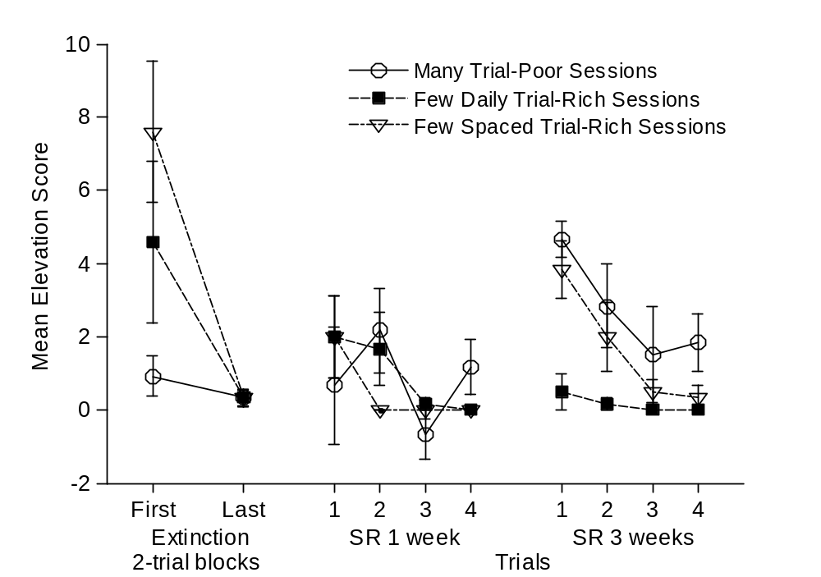

Figure 2

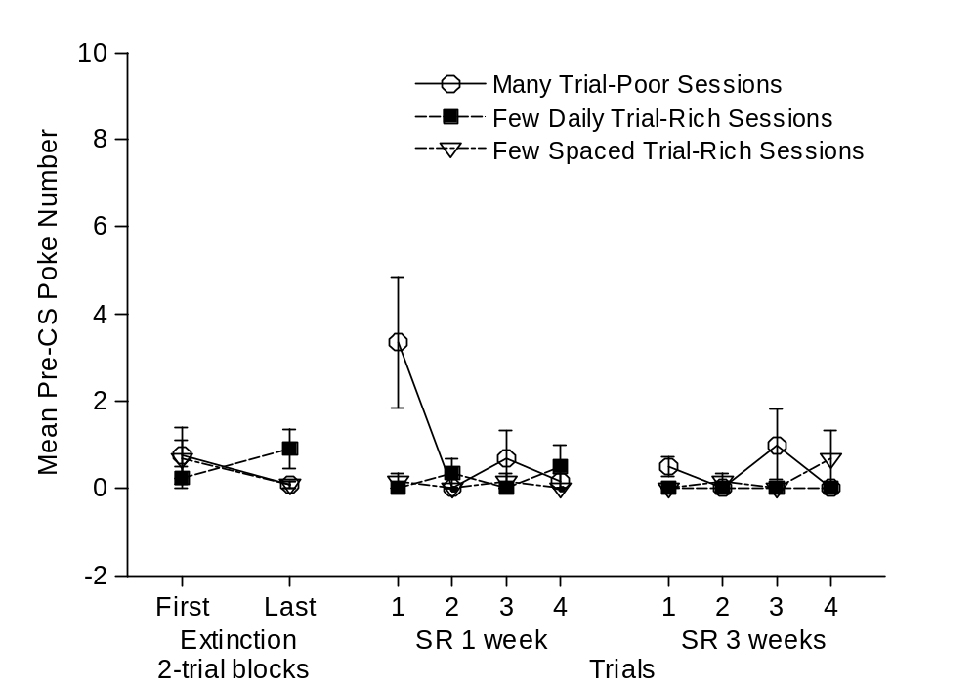

Figure 3

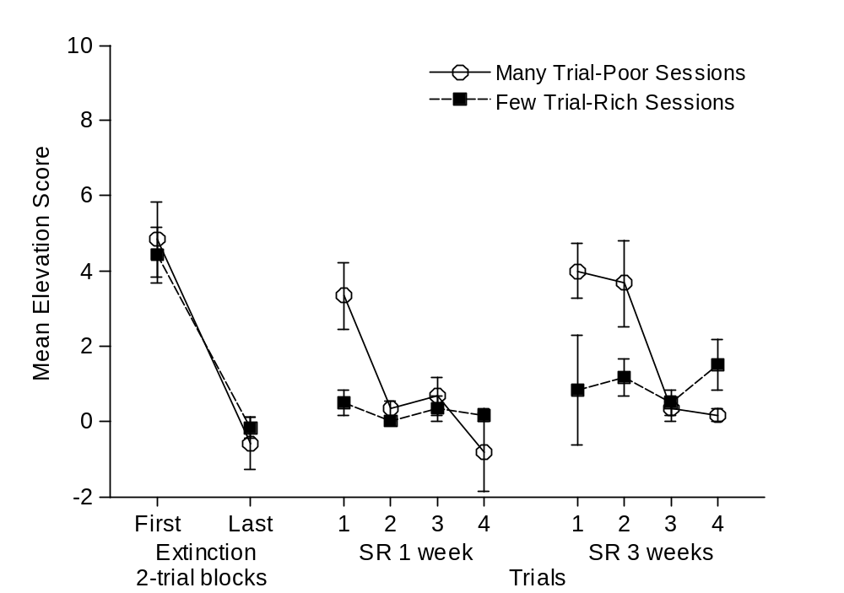

Figure 4

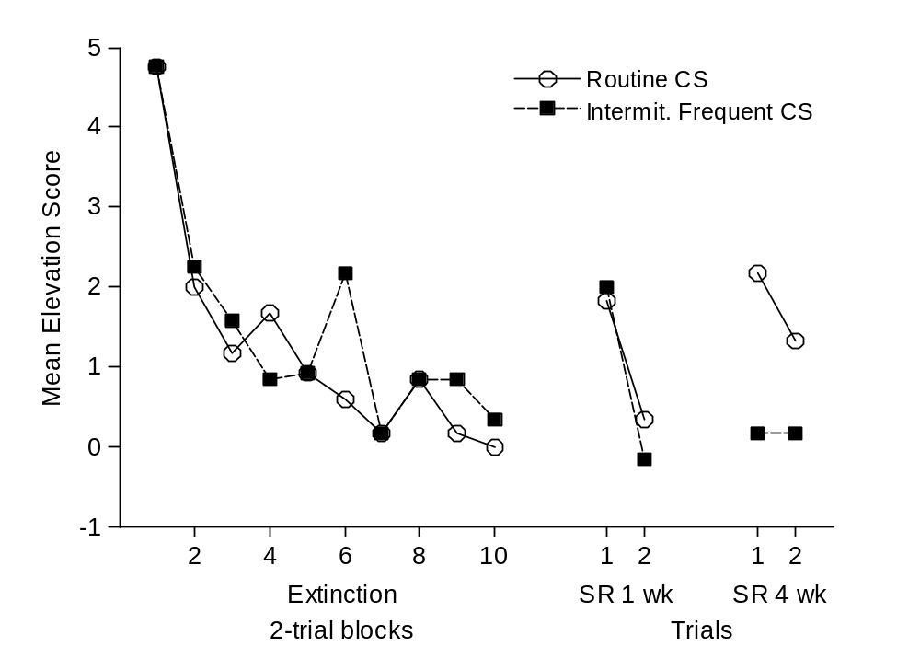

Figure 5

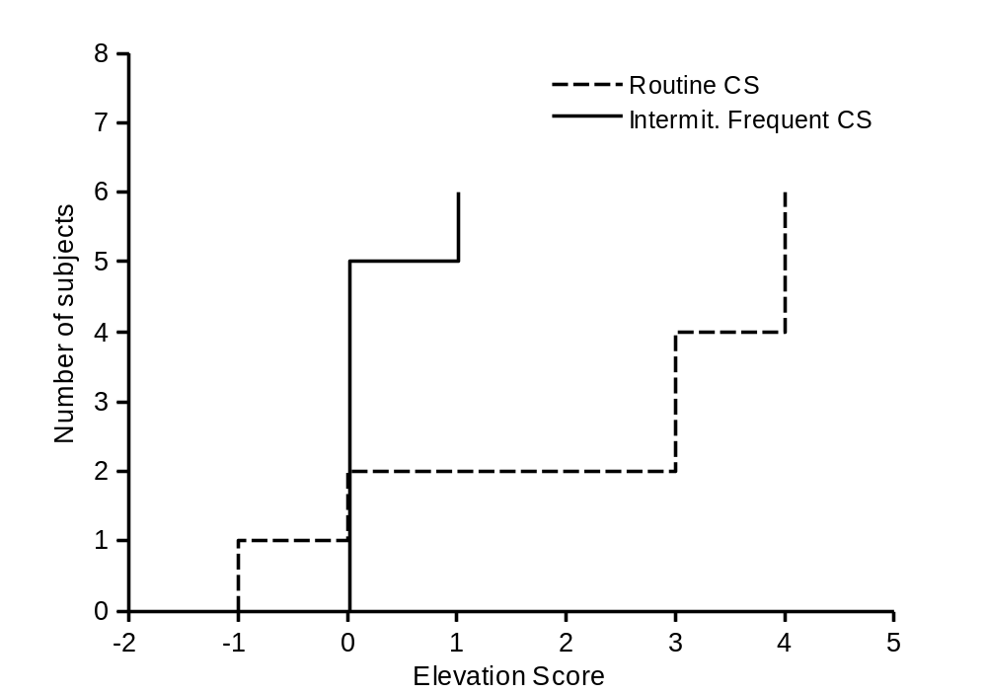

Figure 6

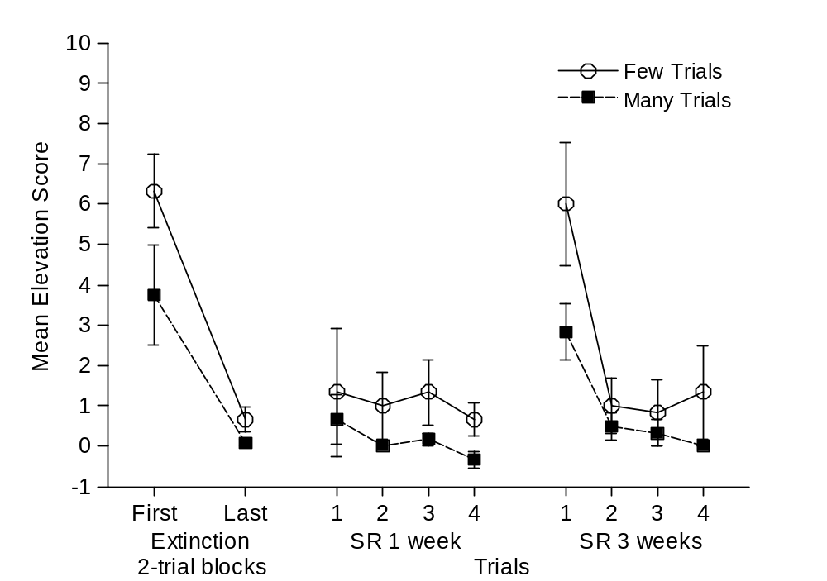

Figure 7

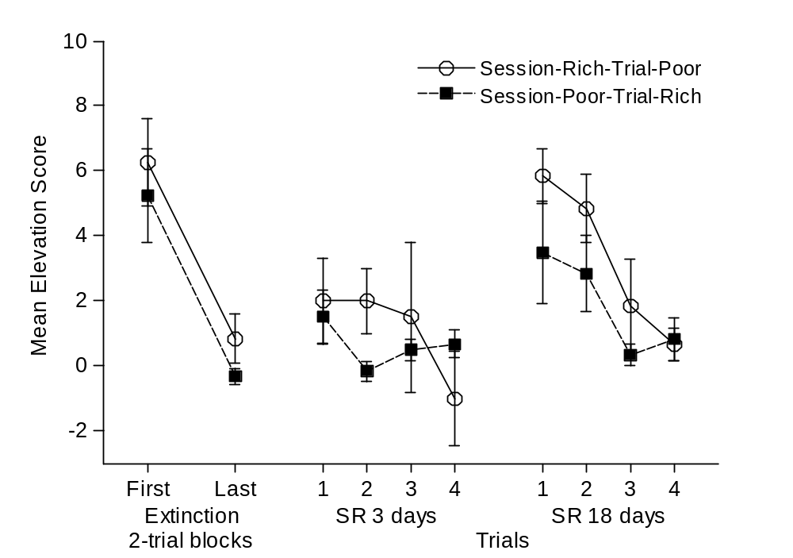

The effect of hyperbolic discounting will be better exemplified by considering the following example. Suppose an animal receives acquisition training during day 1, followed by extinction training on day 2. On day 3 the extinction experience is twice more recent (1/1d) than the acquisition experience (1/2d). However, 11 days after extinction both experiences are almost equally recent (extinction recency = 1/11d, acquisition recency = 1/12d).

