Cris Lawrence L. Parcon
Narra Street, Lantana Subdivision
Barangay Cannery Site, Polomolok, South Cotabato

April 30, 2025

Elon Mayer
Hiring Manager
Pioneer Avenue
General Santos City

Dear Mr. Mayer:

I am writing to express my enthusiastic interest in the Web Developer position at Google Inc., as advertised on the television and referred by Jon Lou. I believe my experience as a Web Developer for 6 years will be perfectly fit in your available position.

I graduated as a Summa Cum Laude at Ramon Magsaysay Memorial Colleges. I believed that my expertise in this IT field for 6 years will help your company to grow. I have also received varans awards:
- Best in Web Development
- Best Employee of the Year
- Most Punctual
- Service Award
Should you consider me applicant, you can reach me through this email and contact number, crisparcon@gmail.com, 09950579382.
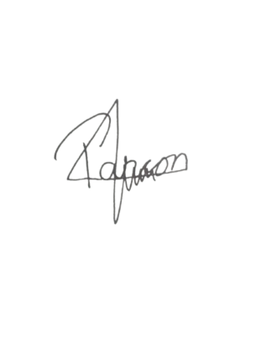
I am willing to come for an interview at your most convenient time.

Sincerely,

Cris Lawrence L. Parcon
Applicant

