Ma. Jasmin L. Enrico

1. Analyze the scenario and determine the entities, attributes, and relationships.
- Customer
Name
ContactNumber
Email
Address

- Cake
CakeID
CakeType
IcingFlavor
BasePrice

- Topping
ToppingID
ToppingType
AdditionalPrice

- Order
OrderID
CustomerID
OrderDate
OrderType
DeliveryMethod
OrderStatus
TotalAmount

- Cake Ordered
CakeOrderID
CakeTypeID
IcingFlavor
PersonalizedMessage

- OrderTopping
OrderCakeID
ToppingID

- Billing
BillingID
OrderID
PaymentMethod
PaymentDate
AmountPaid

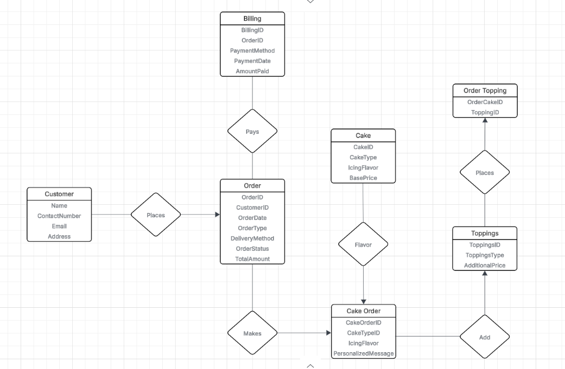
2. Create an ERD (Entity Relationship Diagram) for the system.

Relationship Notes:
Customer to Order → 1:M (One customer can have many orders)
Order to Cake Order → 1:M (One order can have multiple cakes/customizations)
Cake Order to Toppings → M:N via OrderTopping (A cake can have many toppings, and a topping can be on many cakes)
Order to Billing → 1:1 (One order has one billing transaction)
Cake to Cake Order→ 1:M (One cake type can appear in many orders)

3. Add cardinalities and constraints based on your understanding of the business process.
Cardinalities and Constraints
Customer–Order: 1:M → A customer must place at least one order (but system can allow “guest” customers for walk-ins).
Order–Billing: 1:1 → Each order has exactly one billing record.
Order–Cake Order: 1:M → One order can contain multiple cakes.
Cake Order–Toppings: M:N → Implemented with a junction table (OrderTopping).

4. Propose a database schema (tables with attributes and primary keys).
customer(customerID, name, contact_number, email,address)
cake(cakeID,cake_type,icing_flavor,base_price)
order(orderID,customerID,order_date,order_type,delivery_method,order_status,total_amount)
cake_order(cakeorderID, caketypeID,icing_flavor,personalized_message)
toppings(toppingsID,toppings_type,additional_price)
ordertopping(ordertoppingID,toppingID)
billing(billingID, orderID, payment_method, payment_date, amount_paid)

