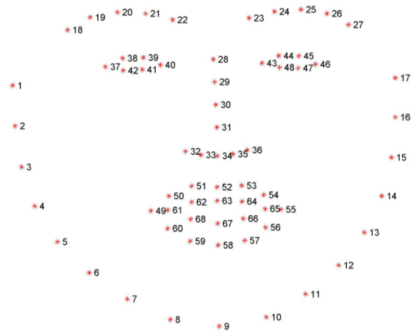As the name implies, EAR is a measure used on the eye to determine how open or closed the eye is, based on predetermined landmarks. A common algorithm used for this purpose includes dlib (cite). The first step of the process would be to map keypoints, or landmarks onto the face in question. Depending on the algorithm and its complexity, the number of landmarks may vary. In terms of the dlib library, there are 68 landmarks marked for a human face.

From studying the above representation of the landmarks, we can see that points 37 to 42 and points 43 to 48 represent landmarks plotted for the right and left human eye respectively. With these points, the next step is to calculate the ratio of openness of the eyes by applying a ratio for the height of each eye and the length of each eye. For each eye, each landmark corresponds to a point in the formula, such as;

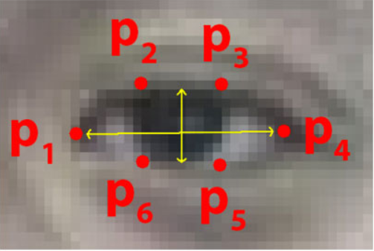

The formula for calculating the ear are as follows;

$$EAR=\frac{\left|\left|p_{2}-p_{6}\right|\right|+|\left|p_{3}-p_{5}\right||}{2|\left|p_{1}-p_{4}\right||}$$

When plotted onto a graph, we see the values of EAR correlate to the behaviour of human eyes when blinking

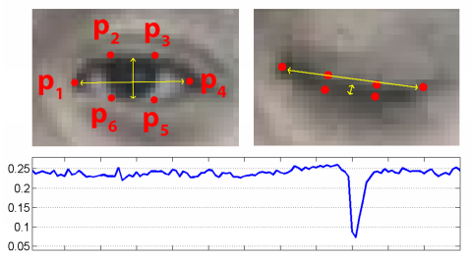

With this idea in mind, we can determine the state of the eye based on the EAR measure recorded by comparing it to a preset constant, where any value above it is considered as the eye to be open, and any value below it is considered as the eye to be closed