Driver Drowsiness Detection

JOSHUAA CHALES ROY

FACULTY OF COMPUTING AND INFORMATICS

MULTIMEDIA UNIVERSITY

# Abstract

Driver drowsiness is an issue faced by the average road user. Not only does it jeopardize the driver itself, but as well as other road users. The creation of a detection system to detect drowsiness and to warn the users will be able to mitigate this problem. In this study, drowsiness detection will be looked at as a whole, and a prototype system will be proposed. Experiments will also be carried out to test and analyze the components of this prototype in order to fully understand its functionality and to increase its performance.

**Index Terms** – drowsiness detection, CNN

# Introduction

Driver drowsiness or driver fatigue, is a condition where the driver begins to lose attention on driving due to a lack of rest or from an array of untreated sleep disorders, such as obstructive sleep apnea, insomnia, and narcolepsy [1]. This condition can not only endanger the driver, but other drivers may become collateral to the situation. This also means that a road user could be a victim to driver drowsiness without suffering its effects for themselves.

Accidents caused by driver drowsiness are not uncommon. Reports show that drowsiness while driving have been the root cause in situations where an individual woke up late for work [2] and even family causalities due to a drowsy road user [3]. Driver drowsiness does not stem from any bad or illegal influence such as drug and alcohol abuse. It is a condition that can happen at any time a driver is at the wheel.

Driver sleepiness is a common cause for road accidents globally. It can happen to the best of drivers at the most unexpected moments of a journey. It can however be tackled by notifying the driver in time regarding their drowsy state, in hopes of them deciding to take the necessary precautions. Therefore, by developing a feature for a monitoring system that can detect when the driver is sleepy, it could be used as a potential security feature for many modern automobiles to reduce the rate of road accidents caused by driver drowsiness.

# BACKGROUND STUDY

Current implementations of driver drowsiness detection systems can be generalized into three categories, which are vehicular metrics, physiological metrics, and behavioral metrics. Each of these categories observe inputs from different focus areas, such as the driver or the vehicle. The input data is then analyzed for patterns which can be used to detect driver drowsiness, which will trigger a response to alert the driver on their current state.

Studies regarding the vehicular metric can be found dating back as far as 1994 [4]. It represents some of the earliest interests and implementations of driver drowsiness detection. Detection in this form of metric commonly includes sensors within the vehicle itself to monitor the driver performance to detect the state of the driver and to execute counter-measures if possible. Current studies and implementations focus on a range of vehicle-based signals that include, but are not limited to, steering wheel activity, monitoring for lane drifting, and pedal states [5]. Steering-wheel movement (SWM) is a common indicator in most vehicle-based driver drowsiness detection systems and studies. Due to the understanding that fatigued drivers would make lesser micro corrections and more erratic and obvious macro corrections [6], SWM can be applied to detect these observations. The data obtained can be used to detect the current state of the driver at the wheel. A detector that monitors lane drifting has been implemented by observing standard deviations of the position of the cars in their respective lanes [7]. Features such as these are then collected and weighted accordingly, before being applied with machine learning techniques, specifically classifiers. Common classifiers used in studies include Support Vector Machines (SVM) and Back Propagation Neural Network (BPNN) [5]. The perks of implementing a system with these metrics are they are not influenced by the physical cosmetics of the driver [8]. The monitoring system would also be non-intrusive, meaning that the data obtained by the system can, and will, only be used for detecting the state of the driver. The downsides to this system are that they are prone to causing high occurrences of false positives or false negatives. For example, micro-corrections or macro-corrections could occur due to the driver driving on unfamiliar roads [9] or even random road events such as potholes and debris on the road.

This form of metric is considered to be accurate [10] as it represents biological signals from the driver itself. By observing the driver through the use of this metric, driver drowsiness can be detected. Currently, the most reliable method in this metric is Electroencephalography (EEG) [10], a test that measures one’s brain activity by its electrical signals. The raw signals are obtained by EEG electrodes attached to the scalp, which is then studied by dividing them into different frequency bands, which is then studied to observe the current activity of the brain. Electrocardiogram (ECG) is another test that is commonly to monitor electrical signals from the specimen’s heart. The signals, which are displayed as waves, can be observed to detect fatigue. According to [11], aside from the brain, different organs in the human body that show obvious signs of alertness or drowsiness of the driver can be observed for drowsiness detection. These modes of measurements include, but are not limited to, electrooculography (EOG); which observes the activity of the eyes, electromyography; which observes the activity and condition of the muscles and nerves of the body, and electrocardiography and blood pressure signals; which observe the current state of a person’s cardiac activity. A major advantage physiological metrics may have compared to the other metrics, is its accuracy, as this form of metric is observing biological signals from the driver itself. The flaw of this metric stems from the expensive and complex equipment needed to conduct these tests [12]. This form of metric is also sensitive to external variables such as driver conditions [8].

Most people who are fatigued while driving show noticeable visual behaviors, particularly observable from their facial reactions. A typical form of response from a person who is drowsy while driving may include swaying of the head, slow eyelid movement and a longer blink duration. An implementation with the behavioral metric studies these facial behaviors of the driver to determine the level of drowsiness. Most available studies have been conducted by studying the eye of the driver for features such as rapid blinking, or slow closure of the eyelids (drooping). PERCLOS is the percentage of eyelid closure over the pupil over time and reflects drooping, rather than blinks [13]. This form of the metric was deemed reliable in many studies to accurately predict drowsiness. Multiple other facial behaviors have been used by researchers, some of them include eyebrow rises, lip stretching and jaw drops. One implementation of this work studied the tracking of the head and eye of the driver using two cameras [14]. In this implementation Matsumoto and Zelinsky used an image processing board, specifically an IP5000, which houses a wide array of fast image processing functions. Connected to an external camera and a video output monitor, it represented the hardware that they used. A field multiplexing technique was then used on the video feed to create a multiplexed video stream from the analogue phase. With the stereo video feed, an initialization phase is conducted, where the algorithm searches the video feed for a face using a 2-dimensional template. Once detected, the algorithm begins its head pose tracking function where a 3-dimensional template is applied to determine head pose. If successful in tracking the head pose, the algorithm calculates the 3D gaze vector, and returns to the face tracking phase and repeats the process. If the system fails to detect a phase in the face tracking phase, the system reverts back to the initialization phase where it once again attempts to detect a face. Template matching is a method which attempts to match parts of the live data being received to available templates in the system. These templates are available images taken and readily classified to their respective states (i.e. open eyes, closed eyes, etc.) [15]. The templates are then constantly filtered over the input data to find matches in states with the templates and uses these as key points. From this, details such as eye closure times can be calculated and compared to a predefined threshold of values, for which then periods of drowsiness can be detected. A perk of applying this form of metric is that it is non-intrusive as well as most natural as compared to the other metrics as it studies the movement of selected facial features of the driver [16]. It has a disadvantage when it comes to lighting. To save costs on equipment, normal and relatively cheaper cameras are used as the driver dashboard cameras for the implementations. These types of cameras do not particularly excel at recording in low-lit areas, which causes the recorded data to be noisy and unclear, reducing the ability of an algorithm to observe the facial behaviors of the driver

# approach

The proposed system utilizes the behavioral metric to construct a prototype model of a drowsiness detector. The approach is tackled by using the template matching method as discussed in the background study. A Convolution Neural Network is constructed to detect the opening and closure of the eyes to construct a basic blink detector, which will be coupled with a scoring system to turn it into a drowsiness detector. The core hardware specifications that the prototype was created on are as follows;

CPU: Intel(R) Core i5-8400 CPU @ 2.80GHz

GPU: NVIDIA GeForce RTX 2060 SUPER

RAM: 24GB

Video Input: Drive-Free USB Webcam

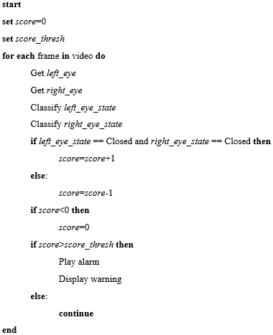The model is trained on data that comprises of approximately 84000 samples of both open and closed eye states. The model is then fitted into the program which uses it as an eye state classifier, to analyse how long the eyes are open or closed. If the eyes are closed, for each frame a score is added by 1. Consequently, if the eyes are opened, the score is reduced by. If the score threshold is achieved, the program will then play an alert sound as well as provide visual cues for the user to warn them that they are drowsy. An example of the flow of the program can be in the pseudocode shown below;

Figure 1 Pseudocode of CNN drowsiness detector

# Experiment

## Dataset

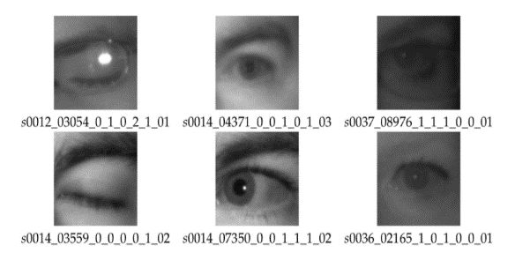The dataset that will be used in this study for model training is the MRL Eye Dataset [17]. It in itself is a large-scale dataset filled with human eye images. The dataset was created as the team behind it has been involved in solving tasks in the behavior of driver behavior. These tasks do not exclude eye detection, gaze estimation and eye-blinking frequency. These images were used primarily to train the eye state classifier for a basic blink detector, which is then modified into a prototype drowsiness detector.

Figure 2 Sample of eye images from the dataset

The data had to be processed first before it could be ingested by the model. The first step was to segregate the eye images to its two distinct classes; which were either open or close. The data was then loaded onto Python, resized to 50x50 images, and segregated to its respective columns, with the images being under the attributes column and the classes which will be represented by numbers (0= Open, 1=Close) is added to the label columns. The images in the attribute column were normalized by dividing the images by 255

## Experiments

A total of 3 experiments were planned to test the characteristics of a prototype drowsiness detector. To do this, tests were conducted on its core functioning component, which was a blink detection system.

### Experiment 1

A CNN based blink detector will be compared to the performance of an EAR (Eye Aspect Ratio) based blink detector. The two applications will be tested on a video that has a pre-determined number of blinks to observe its performance at detecting blinks. This experiment will be tested by placing the camera at a higher angle

### Experiment 2

The next experiment pits the two versions of the blink detector against each other at different camera angles, one which is higher, and another which is lower. This is done to observe the performance of the detectors when the angle of vision of the human face is altered.

### Experiment 3

This experiment tests the accuracy of the eye state classifier from the CNN blink detector by manipulating the size of the dataset fed into it for training. This is done so that an “elbow point” could be observed for a possible sign of slowing down in the rate of gain of accuracy.

## Evaluation Metrics

### Accuracy

The accuracy metric is simply the ratio of correct predictions made. This metric will not be applied to the confusion matrix results as the data lacks true negative values. This is due to the fact that the negative states (Closed eyes), can be potentially infinite. The metric will be used when comparing the accuracy of the trained model, which will be extracted from the code itself.

### Precision

Precision metric displays the portion of TP among positive predictions. It describes the ratio of correct positive predictions among positive predictions made by the model

$$Precision=\frac{TP}{TP+FP}$$

### Recall

The Recall metric displays the ratio of TP to the sum of TP and FN. Since TP and FN are generally positive instances, recall can also be understood as the ratio of correct positive predictions among positive instances

$$Recall=\frac{TP}{TP+FN}$$

### Loss

Loss is another metric that will be used to evaluate the results of the experiments. Loss translates to the penalty the model receives for a bad prediction. It is represented as a number that indicates how bad the model’s classification was on an example-by-example basis. The greater the number, the greater the penalty is. The closer the number is to 0, the better the model is at classifying, with a loss of 0 indicating a perfect classification.

## Results and Discussion

Table 1 CNN Blink Detection Metrics

|  |  |  |
| --- | --- | --- |
| **Angle** | **Precision** | **Recall** |
| Upper | 0.800 | 0.727 |
| Lower | 0.333 | 0.909 |

Table 2 EAR Blink Detector Metrics

|  |  |  |
| --- | --- | --- |
| **Angle** | **Precision** | **Recall** |
| Upper | 0.700 | 0.808 |
| Lower | 0.400 | 1.000 |

Table 3 Dataset Size Variation Metrics

|  |  |  |
| --- | --- | --- |
| **Dataset Size** | **Loss** | **Accuracy** |
| 80 | 0.678238 | 0.532043 |
| 800 | 0.273736 | 0.896171 |
| 8000 | 0.145054 | 0.950895 |
| 80000 | 0.059834 | 0.979609 |

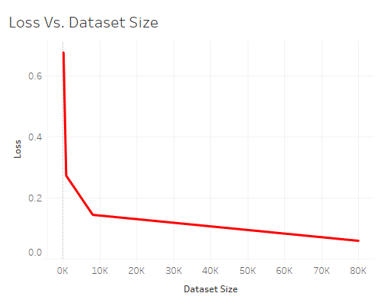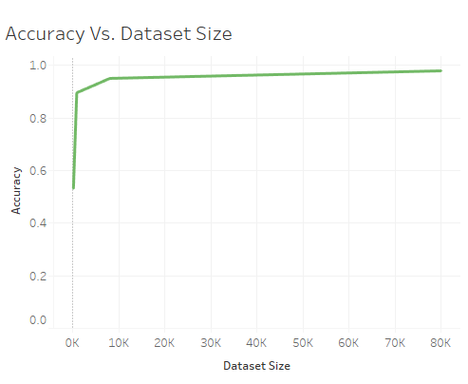

Figure 3 Accuracy Vs. Dataset Size

From *Experiment 1*, we can see that the CNN blink detector has a higher precision at 0.8 (80%) compared to its EAR counterpart at 0.7 (70%). This shows that the CNN blink detector is able to detect actual states of blinking approximately 10% better than the EAR blink detector. Consequently, in terms of recall, the EAR blink detector has a higher value at 0.808 (80.8%) whereas the CNN blink detector has a lower value at 0.727 (72.7%). *Experiment 2* shows both applications of the blink detectors performed better at elevated angles, compared to that of a lower angle, such as one representing the angle of a camera placed on a dashboard. Precision values of the CNN application drop from 0.8 (80%) to 0.333 (33.3%), as well as for the EAR application, where the values drop from 0.7 (70%) to 0.4 (40%). This suggest that the current calibrations for the blink detectors, and subsequently, the drowsiness detector that applies it, would perform better at elevated angles, such as on the sun visor. In *Experiment 3*, it is observed that the increase in data begins to slow down at approximately 8000 samples in the data. This is also reflected in observing the loss of the model, where the drastic decrease in value slows at around 8000 samples in the data. From this experiment, the minimal size of data that should be used should be 8000 samples for better performance. More data can be used; however, the performance of the model would not be affected by much. To compensate for a lack of data beyond 8000 samples, one can improve the performance of the model by conducting parameter tuning on the model itself to increase its performance

# conclusion

In completion of this study, the idea of a drowsiness detector is understood with greater clarity. The technology no longer seems as a figment of science fiction, but more of a practical implementation that can potentially save lives, as well as provide a deeper understanding of human behavior. The objectives that were set out for this study were also achieved. By conducting a background study on the current achievements of drowsiness detectors as well as studying their applications, characteristics, and limitations, relevant information was gained in order to construct a prototype form of a drowsiness detector that can be potentially applied with further development. The facial features that was focused in this study was the eyes of the driver, which was studied in forms of classification methods. By understanding these methods, the core function of the drowsiness detector which was a blink detector, was created and analyzed.

The main limitations of the applications of driver drowsiness detectors are that they are not dynamic. Both applications function-based on a rudimentary idea of drowsiness based on length of blinks. Although it attends to the base idea of monitoring the length of blinks to determine signs of drowsiness, the application of these idea is considered a static approach as it has a pre-determined set of constants for its scoring system for the drowsiness detection, such as specified number of frames (length of blink) and EAR threshold in terms of the EAR. These constants could limit the capability of the prototypes to perform in various different scenarios under different influences, such as different types of drivers with different resting EAR.

Figure 4 Loss Vs. Dataset Size

Current works on the driver drowsiness detector are not near groundbreaking work. There is still a plethora of improvements that can be made to further solidify this idea of a safety measure. For starters, the same set of studies could be made for other parts of the human face to study for relevance to drowsiness. For example, the mouth can be observed for signs of yawning which could contribute to signs of drowsiness. To take it a step further, higher performing applications could study major facial muscle points, such as the cheeks or the forehead, to study its relaxation and contraction rates in order to detect drowsiness.

**REFERENCES**

|  |  |
| --- | --- |
| [1] | "Drowsy Driving," 4 October 2020. [Online]. Available: https://www.uclahealth.org/sleepcenter/drowsy-driving#:~:text=Some%20drowsy%20drivers%20may%20actually,grumpy%20on%20a%20daily%20basis.. |
| [2] | J. Richards, "Parowan Canyon rollover caused by driver’s drowsiness, police say," 7 October 2020. [Online]. Available: https://www.stgeorgeutah.com/news/archive/2020/10/07/jmr-parowan-canyon-rollover-caused-by-drivers-drowsiness-police-say/#.X4yHRtAzaUk. |
| [3] | "Thailand: Broken railway signal, lack of gate blamed for deadly accident in Chachoengsao," 12 October 2020. [Online]. Available: https://www.thestar.com.my/aseanplus/aseanplus-news/2020/10/12/thailand-broken-railway-signal-lack-of-gate-blamed-for-deadly-accident-in-chachoengsao. |
| [4] | R. R. Knipling and W. W. Wierwille, "Vehicle-Based Drowsy Driver Detection: Current Status and Future Prospects," IVHS America Fourth Annual Meeting, Atlanta, 1994. |
| [5] | S. Yang, J. Xi and W. Wang, "Driver Drowsiness Detection through a Vehicle’s Active Probe Action," 2019. |
| [6] | G. Borghini, L. Astolfi, G. Vecchiato, D. Mattia and F. Babilonii, "Measuring neurophysiological signals in aircraft pilots and car drivers for theassessment of mental workload, fatigue and drowsiness," *Neuroscience and Biobehavioral Reviews,* 2012. |
| [7] | A. Anund, G. Kecklund, A. Vadeby, M. Hjalmdahl and T. Akerstedt, "The alerting effect of hitting a rumble strip—A simulator study withsleepy drivers," *Accident Analysis and Prevention,* 2008. |
| [8] | D. Haupt, P. Honzik, P. Raso and O. Hyncica, "Steering Wheel Motion Analysis for Detection of The Driver's Drowsiness," 2011. |
| [9] | E. Vural, "Video Based Detection of Driver Fatigue," Sabanci University, 2009. |
| [10] | M. Awais, N. Badruuddin and M. Drieberg, "A Hybrid Approach to Detect Driver Drowsiness Utilizing Physiological Signals to Improve System Performance and Wearability," *Sensors,* 2017. |
| [11] | M. Doudou, A. Bouabdallah and . V. Cherfaoui, "A Light on Physiological Sensors for Efficient Driver Drowsiness Detection System," *Sensors & Transducers Journal,* 2018. |
| [12] | S. Sheng Yang, T. Wen Zhong and W. Yan Yang, "A Review on Fatigue Driving Detection," *ITM Web of Conferences,* 2017. |
| [13] | D. Dinges and R. Grace, "PERCLOS: A Valid Psychophysiological Measure of Alertness As Assessed by Psychomotor Vigilance," Federal Highway Administration,Office of Motor Carrier Research and Standards, Washington, 1998. |
| [14] | Y. Matsumoto and A. Zelinsky, "An Algorithm for Real-time Stereo Vision Implementation," in *Proceedings Fourth IEEE International Conference on Automatic Face and Gesture Recognition*, 2000. |
| [15] | M. R. Ullah, M. Aslam, M. I. Ullah and A. M. Martinez-Enriquez, "Driver’s Drowsiness Detection Through Computer Vision: A Review," *Lecture Notes in Computer Science,* 2018. |
| [16] | P. M. X. S. Y. Z. Yong Du, "Driver Fatigue Detection based on Eye State Analysis," *Proceedings of the 11th Joint Conference on Information Sciences (2008),* 2008. |
| [17] | B. S. Omarov, A. B. Altayeva and Y. I. Cho, "Exploring Image Processing and Image Restoration Techniques," *The International Journal of Fuzzy Logic and Intelligent System,* pp. 172-179, 2015. |
| [18] | K. Moez, R. Aboulaich, A. Habbal and M. Moakher, "A Nash-game approach to joint image restoration andsegmentation," *Applied Mathematical Modelling,* pp. 3038-3053, 2014. |
| [19] | P. Singh and R. Pandey, "A Comparative Study to Noise Models and Image Restoration Techniques," *International Journal of Computer Applications,* pp. 18-27, 2016. |
| [20] | R. Mishra, N. Mittal and S. K. Khatri, "Digital Image Restoration using Image Filtering Techniques," in *2019 International Conference on Automation, Computational and Technology Management*, 2019. |
| [21] | S. A. Ali, "Image Enhancement Techniques for Images at Blur Motion and Different Noises," *Al-Rafidain Journal of Computer Sciences and Mathematics,* pp. 48-60, 2019. |
| [22] | R. Chandel and G. Gupta, "Image Filtering Algorithms and Techniques: A Review," *International Journal of Advanced Research in Computer Science and Software Engineering,* pp. 198-202, 2013. |
| [23] | G. Sanchez, V. Vincente, G. Verdu, P. Mayo and F. Rodenas, "Medical Image Restoration with Different Types of Noise," in *34th Annual International Conference of the IEEE EMBS*, 2012. |
| [24] | R. Molina, J. Nunez, F. J. Cortijo and J. Mateos, "Image Restoration In Astronomy: A Bayesian Perspective," *IEEE SIGNAL PROCESSING MAGAZINE,* pp. 11-29, 2001. |
| [25] | R. Gonzalez and R. Woods, Digital Image Processing, Pearson Educational International, 2002. |
| [26] | S. S. Al-amri, N. Kalyankar and K. D., "A Comparative Study of Removal Noise from Remote Sensing Image," *International Journal of Computer Science Issues,* pp. 32-36, 2010. |
| [27] | A. M. Selami and A. F. Fadhil, "A Study of the Effects of Gaussian Noise on Image Features," *Kirkuk University Journal /Scientific Studies,* pp. 152-169, 2016. |
| [28] | J. Al-Azzeh, B. Zahran and Z. Alqadi, "Salt and Pepper Noise: Effects and Removal," *International Journal on Informatics Visualization,* 2018. |
| [29] | C. Tomasi and R. Manduchi, "Bilateral filtering for gray and color images," in *Sixth International Conference on Computer Vision (ICCV)*, 1998. |
| [30] | "skimage.util," 16 October 2020. [Online]. Available: https://scikit-image.org/docs/dev/api/skimage.util.html. |
| [31] | "MRL Eye Dataset," January 2021. [Online]. Available: http://mrl.cs.vsb.cz/eyedataset. |