Setting up a development on Windows Machine:

*Setting the MySql local database:*

1. Install MySQL database 5.6 or above.
2. Install MySQL Workbench. log in as root following command. These steps would create a database called "crl" and database user called "crl" with password "crl".

create database crl;

CREATE USER 'crl'@'localhost' IDENTIFIED BY 'crl';

GRANT ALL ON crl.* TO 'crl'@'%' IDENTIFIED BY 'crl';

-- make sure you can log as crl user.

*Setting the java project:*

1. Install jdk 1.7, if not already installed.
2. Open the Issue.zip file (source code) into a directory.
3. Run the sql from scripts folders from MySQL Workbench. The scripts would create the tables and populate the code tables. *It also create an "admin" user with password "password"*

Step_01_ddl.sql ( create tables)

Step_02_seed_data.sql ( populate code tables)

1. Open the application.conf under conf folder. Make sure following the database entries have the right parameters.

db.default.driver=com.mysql.jdbc.Driver

db.default.url="jdbc:mysql://localhost/crl"

db.default.user=crl

db.default.pass="crl"

1. Open powershell and go to the project root directory. Issue following commands. First command would download all the necessary library from the internet and compile the project. The second command would start the application in debug mode and start listening on port 9000.

.\activator clean compile

.\activator -jvm-debug 9999 run

1. Open a browser and go to the following and log in as admin/password

http://localhost:9000

*Setting the java project:*

1. Open Eclipse and import the project form the file system.

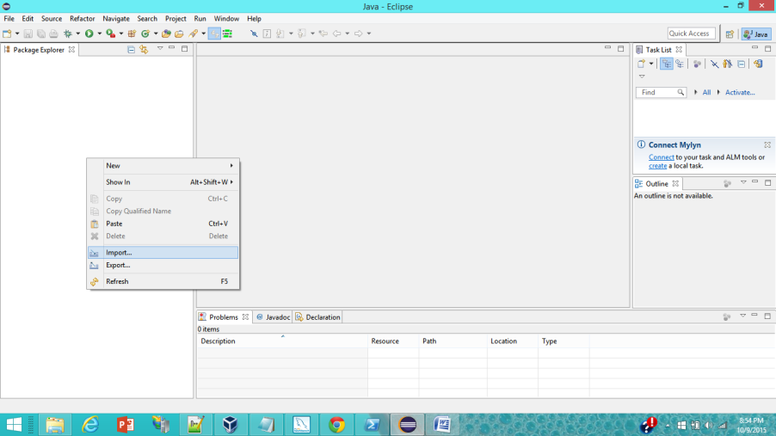

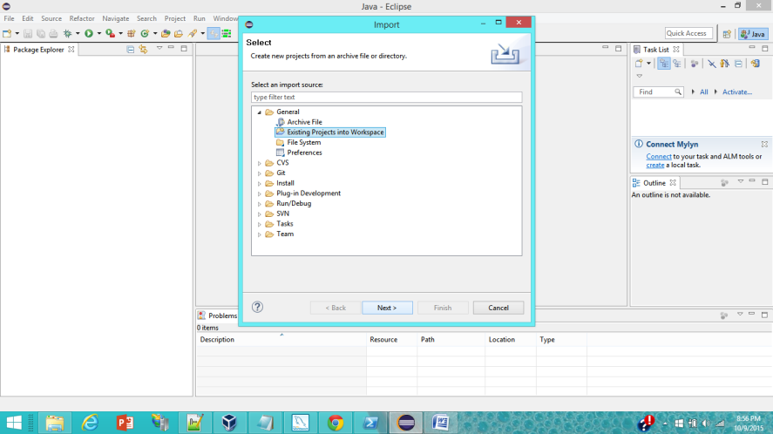

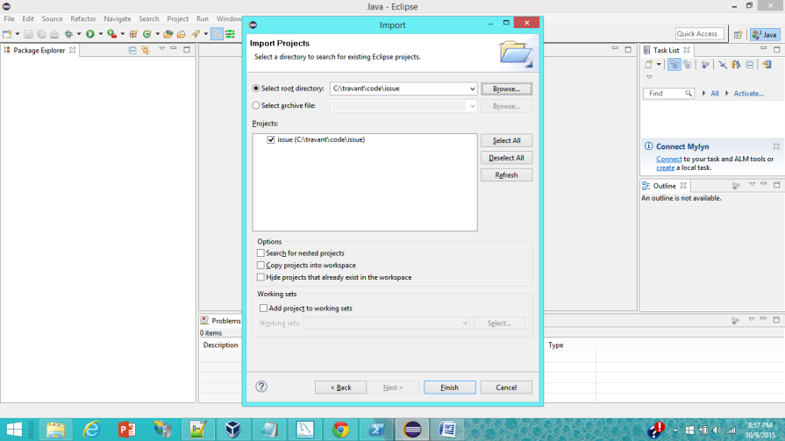

1. Setting up a remote debugger

