

9210B Datalogger
Iridium Based Glacier Monitoring System User Manual

Part No. 8800-xxxx

Version 1.2
July 14, 2016

Sutron Corporation
22400 Davis Drive
Sterling, Virginia 20164
TEL: (703) 406-2800
FAX: (703) 406-2801
WEB: http://www.sutron.com/
Table of Contents

Introduction 3
Equipment 4
Installation 5
Setup and Operations 8
Wiring 8
Startup and Configuration 9
Operating the Xpert 12

Introduction
In order to monitor glaciers in the Arctic, Sutron has prepared a series of BASIC programs for the Sutron 9210B Data Recorder to facilitate capturing images from a FLIR A300 infrared camera, and one or two StarDot NetCam SC optical camera(s). The images are transferred using FTP to a server on the internet with the aid of an Iridium modem either an NAL Research A3LA-RM Iridium modem or BEAM RST 600B.
The following topics are discussed:
- Equipment
- How to install the programs
- Setup and Operations
- Wiring
- Startup and Configuration
- Issuing Commands
- Transferring files
- Performing a complete system upgrade

EQUIPMENT
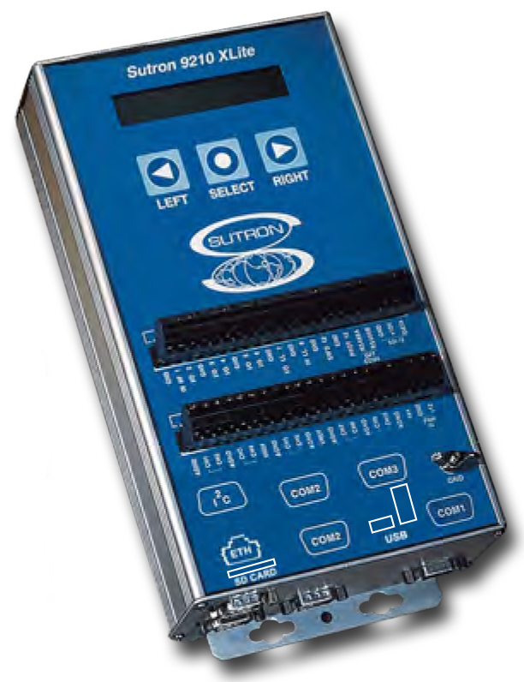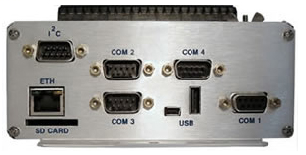
Sutron 9210B Data Recorder (firmware version 3.13.0.15 or later)
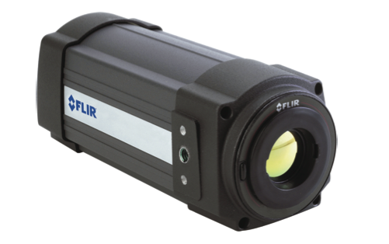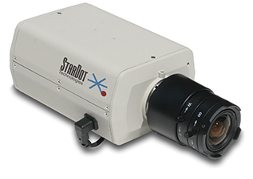
FLIR A300 Infrared Camera StarDot NetCam SC Visual Camera
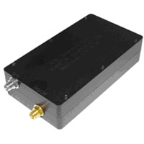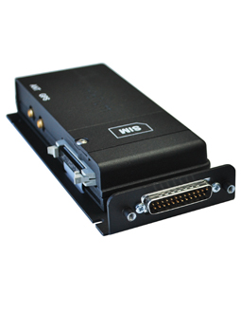
NAL Research A3LA-RM (Left) or Beam RST 600b (right) Iridium Modem

SETUP Notes based on user input
SIM CARDS
The Iridium SIM cards are provisioned by the Department of Defense (DoD) and are authorized for use on the DoD gateway. The following are required for the SIM card to work properly with the system for direct connection to the internet.

SIM Pin
By default the SIM cards from the DoD come with a pin lock activated. The default pin code is 1111 and is required every time you access the SIM. This pin needs to be disabled by the user using a modem or a handheld satellite phone. When using a handheld satellite phone select the following:
- Menu → Security
- Security → Pin Lock
- Disable Pin – will be required to enter the pin to do so.
The pin will then be disabled and not required on use.

SIM card provisioning
When the cards are ordered/activated it will be required for them to have RUDICS or PPP provisioned on them which enables them to access the internet through a direct access number which the cameras use to access a network connection. It has been found that if even if you ask for this provisioning when you order the cards you sometimes have to go in and ask them to activate it. This can be done using a DISA website form.

The following URL has all of the information for doing so along with the most recent information about access numbers and configurations.
http://inah.pac.disa.mil/info.shtml

SD CARD
The setup requires an SD card to be installed in the logger. The SD card can be no larger than 2GB and has to be a standard SD not an SDHC or SDXC. We have tested numerous cards and the WinTec industrial cards will not recognize in the logger. Transcend and others have been shown to work.

FIELD SETUP NOTES

Station Name:
Location:
Installation Date:
GPS Coordinates:
Installed By:
Mount type:

LOGGER
Logger Make:
Logger Model:
Logger Firmware:
Logger Serial Number:
Logger Barcode:
Logger IP Address:
LOGGER CONNECTIONS
Camera Power I/O (def. IO6):
Modem Power I/O (def. IO5):
Modem COM port (def. COM2):
Light Sensor I/O (def. CH6):

Logger Subnet:

MODEM
Modem Model:
Modem Serial Number:

SIM CARD
SIM Card IMEI:
SIM Card Unlocked (Yes/No):

CAMERA(S)
Camera 1 Make:
Camera 1 Model:
Camera 1 Firmware:
Camera 1 Serial Number:
Camera 1 IP Address:
Camera 1 Subnet:
Camera Time:

Camera 2 Make:
Camera 2 Model:
Camera 2 Firmware:
Camera 2 Serial Number:
Camera 2 IP Address:
Camera 2 Subnet:
Camera Time:

SD CARD
Make:
Formatted FAT/FAT32:

SOFTWARE CONFIGURATION SETTINGS
Manager:
TakeStardotPicture1:
TakeStardotPicture2:
TransferStardotPicture:
CheckForCommand:
CheckForUpgrade:
Installing the programs into a 9210B
This section describes installation of the BASIC programs.

Installation
To install the programs, copy the following Basic files to the “\Flash Disk” subdirectory of your Xpert using Xterm. For more information on performing this file transfer, please refer to chapter 6 of the Xpert or 9210 user manual.
Manager.bas
FLIR.bas
StarDotNetCamSC.bas
A3LA.BAS
FtpOps.bas

No additional SLLs are needed, and while the A3LA modem communicates using PPP, the PPP.SLL is not used nor required. Instead a Basic interface called the RAS/PPP API is used. Another Basic interface called the FTP API is used for communicating with FTP Servers. These two interfaces require that Xpert2 V3.13 firmware (or later) be used with the system. The latest Xpert2/9210B firmware is available at http://www.sutron.com/downloads/software.htm
You may check the current version by issuing the “ABOUT” command at the Flash Disk prompt, or with Xterm by clicking the button on the Status tab of the main screen.
Once the files have been transferred, setup is performed from the Setup tab of the main screen. Click the [+] next to the Basic entry to expand it, and then click the [+] next to Scheduled Subroutines to expand that. Select [Add Schedule] and press the button. You should then select the name Manager and then you may select how often you want the system to operate, and click OK to save the setting.

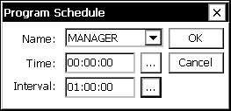

There are several other subroutines that you may schedule as well, and what they determine is what actions the Manager subroutine will perform when it’s run. The actions are performed in serial order.
Here are the actions that the Manager subroutine will be perform if the appropriate action subroutine is run at the same time or in advance of when the Manager runs:

Action | Description
TakeFLIRPicture | Take a picture from the FLIR and archive it to the SD Card
TakeStarDotPicture1 | Take a picture from the first StarDot camera and archive it to the SD Card.
TakeStarDotPicture2 | Take a picture from the second StarDot camera and archive it to the SD Card. If only camera #1 is installed, then the only thing you need to do is not schedule this subroutine.
TransferFLIRPicture | Transfer the FLIR picture to the FTP server
TransferStarDotPicture | Transfer the StarDot picture(s) to the FTP server
CheckForCommand | Check for a remote command
CheckForUpgrade | Check for a remote upgrade. Upgrade checks may be scheduled more frequently than command checks, because a command must be issued first to initiate an upgrade. The transfer of upgrade files may take quite a while and server attempts, and it’s the CheckForUpgrade interval that determines how often retries are attempted.
ArchiveMaintenance | Perform maintenance tasks

The system is configured by scheduling the BASIC subroutines to run at the time you wish. For each action you wish to occur, schedule that subroutine to run and enter the desired time and interval.
Basic Run Always mode should be enabled. This is especially important to allow the execution of Remote commands which may turn off recording. This option is accessed by selecting the Basic entry in the Setup tab and pressing Edit. You should see the following screen where Run Always Mode may be enabled:
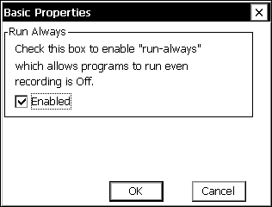
After the system is configured as you wish, you may start operations by turning recording ON. If there are any errors in the BASIC program they will be displayed at this time and recorded in the system log.

Here’s a more detailed look at the sequence of events (assuming all actions are enabled):
- Camera tasks:
  - Turn on LAN
  - Power on the FLIR camera using DIO-4 (if installed and requestes)
  - Power on the StarDot camera(s) using DIO-6
  - Wait 2 minutes for the cameras to power up (interval can be changed)
  - Using Telnet communications (port 23) to the FLIR:
    - Tell the camera to take a picture (NUC)
    - Remove any old pictures (del \image.jpg)
    - Create a new image (store -j \image.jpg)
  - Transfer image to the Xpert's flash disk folder using FTP GET (port 21)
  - Using TCP/IP communications to the StarDot:
    - Perform an HTTP GET on /image.jpg (port 80)
    - Store the image in the Xpert's flash disk folder
  - Power off the camera
  - Turn off LAN
  - Copy the FLIR image to the SD Card in to the \SD Card\FLIR folder
  - Append the name of the file to \SD Card\ArchiveList.dat
  - Copy the StarDot image to the SD Card in to the \SD Card\StarDot folder
  - Append the name of the file to \SD Card\ArchiveList.dat
  - (repeat for the 2nd StarDot camera if enabled)
- Transfer tasks:
  - Power on the A3LA-RM Iridium Modem using DIO-5
  - Initiate a PPP connection on A3LA using RAS API
  - Wait for Connect
  - Ftp the FLIR image to the Server's /FLIR folder
  - Ftp the StarDot image to the Server's /StarDot folder
  - Check for a remote command file (command.txt) and execute it
  - Check for an upgrade (if the ENABLEUPGRADE command has been issued)
  - Install an upgrade (if an upgrade has transferred and the UPGRADENOW command has been issued)
  - Disconnect PPP
  - Power off A3LA
- Maintenance tasks:
  - If the available disk space on the SD Card should fall below 10 million bytes:
    - Retrieve the position of the name of the next file to delete from \SD Card\ArchivePos.dat
    - Read the name of the next file to delete from \SD Card\ArchiveList.dat (using the position)
    - Remove the indicated file from the \SD Card
    - Update the ArchivePos.dat file with the position of the next file to delete
    - Repeat until the free disk space is over 10 million bytes or 10,000 attempts have been made
  - If the amount of memory in use should exceed 90% then reboot the station

Setup and Operations
This section gives an overview of the overall setup and operations of the 9210B configured to operate as a Glacier imaging system. It is written assuming that you are familiar with the 9210B and its operation. Be sure to refer to the 9210B Operation and Maintenance manual before using this manual.

Equipment
- Ethernet Switch (low-power, wide temperature, 12V compatible) for connecting the Ethernet devices
- FLIR A300 Infrared Camera connected to the switch using a standard Ethernet patch cable
- 1 or 2 StarDot NetCam SC Visible Light Camera(s) connected to the switch using a standard Ethernet patch cable
- Sutron 9210B with 3.13.0.15 firmware (or later)
  - Connected to the switch using a standard Ethernet patch cable
  - Insert 2GB SD Card formatted with FAT32. SDHC cards are not supported by the Xpert. NTFS format is not supported.
  - Connect DIO-4 to a relay that controls power to the FLIR A300
The DIO will ground (open-collector output) the signal when enabled so it would normally be wired to the (-) side of the relay's input and protected 12V from the Xpert may be wired to both the (+) side of the relay's input, and jumpered to the (+) side of the relay's output. Use as short of a cable/wire as possible with thick wires as reasonable, otherwise significant power will be lost due to wire resistance. One option is to run the PROT+12V and GND wires separately with thicker wires, or double up smaller wires.
  - Connect DIO-5 to a relay that controls power to the Iridium modem (see notes for DIO-4)
  - Connect DIO-6 to a relay that controls power to the StarDot NetCAM SC camera(s) (see notes for DIO-4)
- Iridium Modem connected to 9210B via RS232 cable from COM2:
  - The jumper settings for COM2: must be configured to connect PIN 9 to RI (J901, 1-2, 5-6, 9-10)
  - This should be the default for COM2:, but COM3: has PIN 9 wired to 5V
- Logger IP settings
  - IP address: 192.168.50.120
  - Subnet: 255.255.255.0
  - Gateway: 0.0.0.0

Wiring Diagram

Connection | Color | Module, Position | Description
FLIR
Relay+ |  | PROT 12 | Input to FLIR relay
Relay- |  | IO 4 | Open collector signal to FLIR relay
A3LA-RM
Relay+ |  | PROT 12 | Input to A3LA relay
Relay- |  | IO 5 | Open collector signal to A3LA relay
Serial |  | COM 2 | DB-9 Serial Cable to A3LA
StarDot NetCam
Relay+ |  | PROT 12 | Input to FLIR relay
Relay- |  | IO 6 | Open collector signal to StarDot relay

Startup and Configuration
The configuration for a station to operate automatically is contained in a setup file and Basic program files. When the 9210B starts it first looks for a setup file with a name that matches the station name. For example, if the station is named “SITE01” the software will look for a setup named “SITE01.ssf” to load. If it doesn’t find a setup file with a matching name it will then look for a file named “default.ssf” to load and run. The file is actually just an ASCII file (XML format) containing all the settings for the different fields in the Xpert. The startup sequence takes about 1-2 minutes. During this time, the 9210B also runs tests and initializes devices before loading and running the setup, initializing Basic, and scheduling Basic subroutines.
The Basic programs supervise everything, and the beginning of each Basic file generally contains some constant declarations that may be modified to adapt the software to your system.
Here’s a list of the Basic programs that make up the project, and settings which can be edited (with a text editor such as “Notepad”) in the programs to customize the behavior:

A3LA.bas
A3LA.bas uses the RAS/PPP API to create a PPP connection between the 9210B and the Iridium DOD Gateway using the A3LA-RM modem. There isn’t anything in this file that would need to be changed, unless perhaps if the type of modem being used was changed. In that case the constant “DefaultModemInit” may need to be modified to accommodate differences.

FLIR.bas
FLIR.bas is responsible for communicating with the FLIR A300 camera. The following constants may be customized as desired:
Variable | Default | Usage
CameraIP | "192.168.50.12" | IP address of the FLIR. The camera should be configured with this address as its static IP.
CameraFtpUser | "anonymous" | By default the FLIR should support FTP access via anonymous logins. If this is changed in the camera it will need to be changed here.
CameraFtpPassword | "xpert@sutron.com" | With an anonymous FTP login, the password is just a string meant to identify who’s accessing the server.
TakePicture | "NUC" | This is the command the Xpert issues to take a picture.
CameraImagePath | "\image.jpg" | This is a path to the image on the Camera.
RemovePicture | "del " & CameraImagePath | This command is used to remove an old picture from the camera before a new one is stored.
StorePicture | "store -j " & CameraImagePath | This command is sent to the camera in order to store the current image to storage in the camera.
LocalFLIRImageFile | "\Flash Disk\flir.jpg" | This is where the image is placed in the 9210B after retrieving it from the Camera.

FtpApi.bas
FtpApi.bas is included as a reference to the FTP API, and contains no executable code. It does not need to be transferred to the 9210B.

FtpOps.bas
FtpOps.bas contains various functions (FtpPut, FtpGet, FtpAppend, FtpUpgrade, etc) used to support FTP and makes extensive use of the FTP API. It’s a support library of subroutines and does not contain any constants that need to be configured.

Manager.bas
Manager.bas is the “main” program and contains the latest comments regarding operations of the system and also contains most of the constants that are used to configure the system.

Variable | Default | Usage
FLIRDIGIO | 4 | The digital I/O channel used to control the power relay for the FLIR A300 camera.
StarDotDIGIO | 6 | The digital I/O channel used to control the power relay for the StarDot NetCam SC camera.
CameraWarmupDelay | 120.0 | The number of seconds to wait after turning power on the camers before taking a picture. Both cameras are powered on at the same time, so the warmup time applies to both.
ServerIP | "12.189.158.76" | URL of the FTP Server to be used to store images, and retrieve commands, and upgrades from.
ServerFLIRImagePath | "/home/iridiumcam/station/FLIR/" | Where to place the FLIR A300 images on the FTP Server
ServerStarDotImagePath1  ServerStarDotImagePath2 | "/home/iridiumcam/station/StarDot1/"  "/home/iridiumcam/station/StarDot2/" | Where to place the StarDot images on the FTP Server
ServerFtpUser | (see code) | User name for logging in to the FTP Server
ServerFtpPassword | (see code) | Password for logging in to the FTP Server
ModemPort | "COM2:" | The serial port of the 9210B that the A3LA-RM is connected to. Typically COM2: is used, as by default COM3: is configured for Sutron modems that can receive power on pin 9.
ModemDIGIO | 5 | The digital I/O channel used to control the power relay for the A3LA-RM modem.
ModemWarmupDelay | 60.0 | Number of seconds to allow the A3LA-RM to warm up before trying to make a connection.
ArchiveFLIRPath | "\SD Card\FLIR" | Where to place FLIR images when archiving them to the SD Card.
ArchiveStarDotPath1  ArchiveStarDotPath2 | "\SD Card\StarDot1"  "\SD Card\StarDot2" | Where to place StarDot images when archiving them to the SD Card.
ArchiveListFile | "\SD Card\ArchiveList.dat" | This file tracks every image archived to the SD Card, so if necessary, old ones may be removed to make more space
ArchivePosFile | "\SD Card\ArchivePos.dat" | The file contains a number which points to the position of the next file to remove in the ArchiveListFile and is updated every time a file is removed.
ArchiveSpace | 10000000 | If the number of bytes available on the SD Card should fall below this amount, the oldest remaining image will be removed from the SD Card archive until enough space is freed up
RemoteCommandFile | "/home/iridiumcam/station/command.txt" | Where to look on the FTP Server for a remote command to issue
LocalCommandFile | "\Flash Disk\command.bat" | Where to place a remote command on the local system before trying to run it (must be a .bat file or the command prompt will not be able to run it)
RemoteResultsFile | "/home/iridiumcam/station/results.txt" | Where the results of a remote operation will be placed on the FTP Server
RemoteCommandUser | "" | Used to authenticate remote commands on the 9210B, and hence must be a valid user name that can be used to login to the RTU with (or "" if no users are defined)
RemoteCommandPassword | "" | Used to authenticate remote commands on the 9210B, and hence must be a valid password that can be used to login to the RTU with (or "" if a password is not required)
RemoteUpgradePath | "/home/iridiumcam/station/Upgrade" | The folder on the FTP Server where upgrade files will be placed
LocalUpgradePath | "\Flash Disk\Upgrade" | The folder on the 9210B where the upgrade files will be temporarily transferred before they are installed.
SIMULATE | False | Set this to TRUE in order to test without the A3LA modem hardware (uses LAN instead)
DirectIridiumInit | "+DS=0,0,2048,20;+CBST=71,0,1" | A3LA modem init string used when connecting to the DOD gateway
DialUpModemInit | "+DS=3,0,512,6;+CBST=7,0,1" | A3LA modem init string used when connecting to a dialup ISP.
ISP_ModemInit | DirectIridiumInit | Selects whether the Direct Iridium/DOD Gateway is used or a dialup ISP
ISP_PhoneNumber | "008816000022" | The phone number to dial to connect to the ISP. The Direct Iridium service uses various numbers intended for different operating systems. We’ve had success with 008816000022 and sometimes with 008816000023.
ISP_UserName | "" | User name for authenticating with the ISP
ISP_Password | "" | Password for authenticating with the ISP

StarDotNetCamSC.bas
StartDotNetCamSC.bas is responsible for communicating with the StarDot NetCam SC camera. The following constants may be customized as desired:

Variable | Default | Usage
StarDotIPAddress1 | "192.168.50.130:80" | IP address of the first StarDot. The camera should be configured with this address as its static IP.
StarDotIPAddress2 | "192.168.50.131:80" | IP address of the second StarDot. The camera should be configured with this address as its static IP.
LocalStarDotImageFile1 | "\Flash Disk\stardot1.jpg" | This is where the image is placed in the 9210B after retrieving it from camera #1.
LocalStarDotImageFile2 | "\Flash Disk\stardot2.jpg" | This is where the image is placed in the 9210B after retrieving it from camera #2.

Operating the Xpert
Given that most of the functionality is being performed by Basic programs, the primary means for interacting with the program is by observing the output of status messages. They can be viewed in real time by issuing the “report high” command at the Flash Disk prompt, or an archive of these messages may be examining the system.log. This can be done by accessing the Log tab of the UI using Xterm, or even interactively at the Flash Disk prompt with a command such as “get /f system /newest /reverse”.
Here are some typical messages you may see during normal operation:
- Manager: Waiting for Camera to power up
- Manager: Powering Cameras OFF
- Manager: Copying \Flash Disk\flir.jpg to \SD Card\FLIR\SITE01_20130906_120000.jpg
- Manager: Copy FLIR image to archive worked
- Manager: Copying \Flash Disk\stardot.jpg to \SD Card\StarDot\SITE01_20130906_120000.jpg
- Manager: Copy StarDot image to archive worked
- Manager: Powering A3LA-RM modem ON (1/5)
- Manager: Waiting for modem to power up
- Manager: Connected to ISP
- Manager: Uploading picture with FTP using PutImage
- Manager: PutImage FLIR did not complete (1/5)
- Manager: Closing ISP connection
- Manager: Powering A3LA-RM modem ON (2/5)
- Manager: Waiting for modem to power up
- Manager: Connected to ISP
- Manager: Uploading picture with FTP using PutImage
- Manager: PutImage FLIR worked (2/5)
- Manager: Uploading picture with FTP using PutImage
- Manager: PutImage StarDot worked (1/5)
- Manager: Checking for Command (1/5)
- Manager: Checking for Upgrade (1/5)
- Manager: Checking for upgrade files (1/5)
- Manager: Closing ISP connection
- Manager: Powering A3LA-RM modem OFF

System Operations
When the system is operating, image files should be transferred to the FTP server at the rate you selected. You should be able to observe the files arrive in the various folders. When setting up a new station, you will need to create folders for each station on the FTP Server.
For instance, if the station was named SITE01, you would need to create the following folders on the FTP server:
- /SITE01/FLIR FLIR camera images
- /SITE01/StarDot1 StarDot camera #1 images
- /SITE01/StarDot2 StarDot camera #2 images
- /SITE01 Remote commands and results
- /SITE01/Upgrade Remote upgrade files
As image files are transferred you may observe files appearing in the image folders with a “.partial” extension. This is used while the files are being transferred. If the transfer completes successfully the extension will be removed. It’s possible that everything except the rename operation complete, and in such a case, you may try renaming a “.partial” file and checking to see if the image is usable.

Remote Commands
Remote commands are placed in a file called "command.txt" in the folder named after the station on the FTP Server. It’s a good idea to test new commands on a test station to verify the syntax is correct. Another good practice is to prepare the command in a file on your PC and then copy it over to the FTP Server at a time when the station isn’t accessing the FTP Server (some period outside the CheckForCommand interval).
Command.txt file can issue any command that can be run from the command line as well as Batch and some additional project related commands. For any command that might respond with many lines, you’ll want to add a “/C” (or “/c”) at the end to prevent it from stopping and prompting for “-More-“.
So, a very simple command.txt might contain this to display current status:
info /c
Or display the current value of the tag BV (if you had one):
show BV /tag

Or do both of those:
info /c
show BV /tag
Or display the last hour of the log:
get /hour /c
Some things to note:
- Command.txt may contain multiple commands to issue
- It’s just a standard text file that you can create with notepad on a Windows PC.
- Be sure to press Enter after every line even if it’s just one line (adds a necessary carriage return character).
- You can see a list of commands by issuing HELP at the Flash Disk prompt of the logger.
- A quick way to test a command.txt file is to copy the file to “command.bat”, transfer it to an Xpert, and run it at the Flash Disk prompt by typing
\Flash Disk> command
This will not be able to test enhanced commands that are processed by the Manager program rather than the command prompt.
This file is detected by the Xpert and transferred in to the "\Flash Disk" folder where it is run as a batch file. In order for this to work, a user name and password must be supplied to grant access rights. The variables RemoteCommandUser and RemoteCommandPassword contain the values which will be used.
The results of a remote command are appended to the file "results.txt" and command.txt will be removed.
The batch language used by the Xpert is a simplified version of the MS-DOS batch language and supports the following commands:
@ECHO OFF Suppresses echo of the command being run
ECHO ON Re-enables the echo of commands
ECHO string Displays string
Command Runs the command as-if entered at the Flash Disk prompt.
@command Runs the command but suppresses echo
DEBUG ON Allows debug commands to be issued
EXIT Stops processing the batch file – avoid if possible
A “Logout” automatically appended to the batch file to speed up detection of the end of execution. Use of the “EXIT” command will prevent this LOGOUT from being executed, and will cause a delay in processing the command.
There are a few special commands which are processed separately if they are detected at the start of the command.txt file:
- ENABLEUPGRADE | Allows upgrade detection and transfers to begin
- DISABLEUPGRADE | Disables upgrade detection and transfers
- UPGRADENOW | Powers an upgrade after it's been transferred and may be placed after an ENABLEUPGRADE to install the upgrade immediately after downloading it without intervention.
- CONNECT url:port [/XTERM] [/TELNET] | Connects to the specified URL and port, and presents an SSP/CL (CL stands for Command Line) session. This may be used to communicate with XTerm or Telnet, but only if a redirector is used to "glue" the two clients together.  The optional /XTERM flag may be used to indicate that a raw TCPIP session is desired (such as XTerm uses).  The optional /TELNET flag may be use to indicate that the telnet protocol is desired (such as HyperTerminal uses).  If neither /XTERM nor /TELNET are selected then the SSP/CL session will attempt to auto-detect the connection, but if the latency is too long, it will tend to end up not detecting TELNET and defaulting to XTERM.

Remote Upgrades
Remote upgrades are placed in an "Upgrade" folder placed inside the station folder on the FTP Server. An upgrade is started by issuing the command ENABLEUPGRADE, and then at each interval, the system will try to FTP more and more of the upgrade files from the FTP Server to the Xpert until everything has been transferred.
As each file/folder is transferred, it is removed from the FTP Server and placed in an Upgrade folder in the Flash Disk of the Xpert. A Cleanup.bat file is automatically generated to remember which files should be deleted after the upgrade has been installed. Once the files have been transferred a message is appended to the "results.txt" file to indicate the status.
The UPGRADENOW command may be issued when you're ready to complete the upgrade.
The upgrade process will look for an Xpert2____.upg file. This is used to direct the upgrade process and is always included with an Xpert upgrade package. Always use an upgrade package meant for installation from a Storage Card (_SC).
Before copying any files to the FTP Server, you should prepare the upgrade in a folder with only the files that will be needed, and an edited version of the supplied .upg file that will only install the files which are needed. For instance, you do not need to transfer all the Extra SLL files or perhaps any of the speech files.
The upgrade files from Sutron are typically compressed with PKZIP. You will need to Unzip the upgrade file and place different parts of it in to an Upgrade folder. In the root of the Upgrade folder you may wish to include the Xpert2.ker and Xpert2.fil files. These are necessary if you want to perform a Kernel upgrade. The hand edited Xpert2____.upg file must be placed in the root of the Upgrade folder you're preparing. Next take any files or sub-folders you may require from the Upgrade folder in the PKZIP image and copy them in to the root of the Upgrade folder you are preparing.
The final result should look something like this:
[Upgrade]
Xpert2 v3.14.0.0 SC.upg
Xpert2.ker
Xpert2.fil
Autoexec.bat
Basic.sll
Coms.sll
Xpert.exe
...
[Extra SLLs]
IMD.sll <- This is just an example (the project
is not currently using any Extra SLL files)
Modbus.sll
...

Be sure to edit the .upg file to include only the files you need to upgrade. Copy the Upgrade folder structure you've created to the Station folder on the FTP Server at a time when the station should not be contacting the FTP Server, and issue the remote command ENABLEUPGRADE.
Periodically examine the Results.txt file, and when the station informs you that it has completed transferring the upgrade, you may issue the command UPGRADENOW to complete the process.

Transferring a File
It's possible to create an upgrade that will only upgrade a Basic program or even a data file, here are the steps:
- Create an Xpert2.upg file to copy each file to where it belongs. It will typically look something like this:
s "Upgrade\Manager.bas" "\Flash Disk\Manager.bas"
s "Upgrade\FtpOps.bas" "\Flash Disk\FtpOps.bas"
…

- Place the files to be updated in the Upgrade folder on the FTP Server under the Station you wish to update:
[Upgrade]
Manager.bas
FtpOps.bas
Xpert2.upg
- Issue the ENABLEUPGRADE command, and once the files have been copied down issue the UPGRADENOW command to complete.
The Xpert will reboot, copy the files to their new location, startup the application, and cleanup the old upgrade files.

System Notifications
The following notifications may automatically appended in the results.txt (when appropriate):
- Remote upgrade has completed transfer, you may install it now.
- The station was restarted at 9/9/2013 07:45:00 - upgrade files have been removed.
- Upgrade cannot be installed because either the last transfer failed, or one is in progress
- Upgrade cannot be installed because no files were transferred on the last attempt
- Neither a \Flash Disk\Xpert2.key, nor a " & \Flash Disk\Upgrade\Xpert2_v3.14.0.5.upg file were detected, so nothing to install
- Kernel upgrade has been installed, system will be rebooted shortly to complete the App upgrade
- Kernel upgrade has been installed, system will be rebooted shortly to complete
- App upgrade has been prepared, system will be rebooted shortly to complete

