# Tradewind Turbines:

# Business Understanding Report

Tradewind Turbines (TT) is a small start-up company that is developing a novel Vertical-Axis Wind Turbine (VAWT). The turbine uses sailing technology to generate power at lower wind-speeds than conventional turbines to allow siting in marginal-wind sites, close to where the power is required. The turbine has quiet operation to enable operation close to homes and businesses, and operates slower than the wind speed minimising its impact on local fauna. The company is currently building its third prototype turbine (TT18 v1.3, ~500W rated power, ~6,000kWh annual production), which will be the design that is taken to market. The company is also developing a small, man portable turbine for deployment in a hybrid energy system with the MoD (TT1).

## The Company

The Tradewind Turbines was conceived by Tim Crocker of Scimar Engineering. TT was then set up to develop and commercialise the turbine. The company consists of a turbine design arm (Tradewind Turbines), and an engineering manufacturing division (Tradewind Engineering (TE)). While TT is solely focussed on the wind turbine, TE engages in contract work for a limited number of external clients in addition to manufacturing turbine parts.

The combination of the design function and an engineering manufacturing facility allows a two-way design process, where minor modifications suggested by the engineering team enable more efficient design, reducing manufacturing cost and time. This also allows the turbine to be designed so that it can be assembled with a basic set of tools in remote locations in developing countries.

## The Turbine

The Tradewind Turbine is a Vertical-Axis Wind Turbine with three sail arms to provide power from the wind. The sails are positioned 120o apart on radial spars (Fig 1), which rotate clockwise about a central mast. The sails themselves rotate anti-clockwise about their centre-line at the end of the radial spars, at half the rate of the rotating spars. The sails rotate so that they are perpendicular to the wind when they are travelling in the same direction as the wind (downwind) to obtain the full drag force, and parallel when travelling in the opposite direction (upwind) to minimise the drag in the opposite (angular) direction.

The turbine begins generating power at lower wind speeds than conventional turbines (2m/s compared to 4m/s) with a maximum power output of 4.5kW which is limited by electrical components. To reduce the loads on the turbine structure under strong winds, the sails begin to furl at a given wind speed to reduce the sail area, giving a proportional reduction in power. The furling mechanism is the most innovative part of the design, and is covered by a worldwide patent. The tradewind turbine will generate more power than a conventional turbine for 96% of the time in UK wind conditions.

As the turbine has been designed to give most of its power from drag forces, it operates slower than the wind speed. This means that the turbine is very quiet during operation and has no characteristic noise signatures that would make it more noticeable to humans. This characteristic of the turbine also means that it has a low impact on local fauna such as bats and birds.

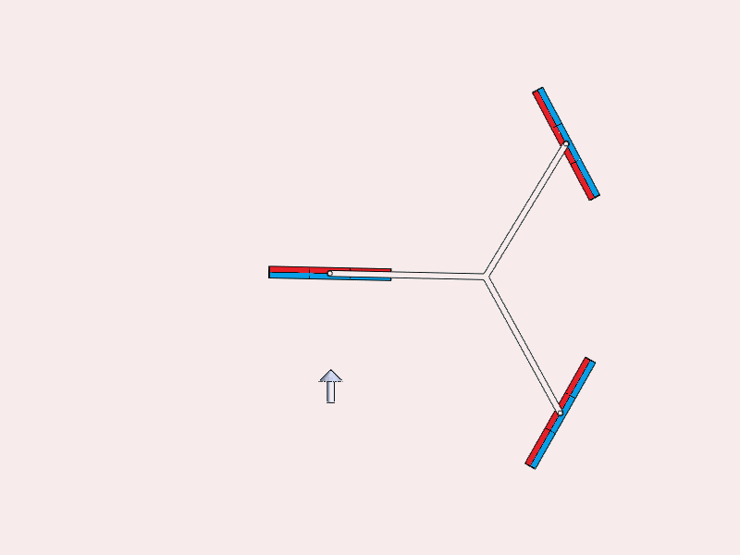

Figure 1: Turbine Sail Positions

In addition, the sail cloth can be printed on, which allows the turbine to be camouflaged to reduce its environmental impact further. On the flip side, logos or messages can be printed on the sails for corporate promotion or as public information. Although the sails do furl, and this would reduce the visibility of the message, this would only be a concern for approximately 4% of the time in average UK wind conditions.

The fact that the turbine is low noise and that it operates at low wind speeds means that it can be sited close to where the power is required. This is an advantage over conventional turbines as it means that short electrical cable can be used, reducing losses, but also that the turbine can be installed with a Power Take Off (PTO) system providing mechanical energy for a variety of uses such as water pumping or grinding crops.

Due to the simplicity and design of the turbine, the generic turbine design can be modified very easily for the various different applications such as electricity generation (on-grid or off-grid, d.c. or a.c.,) and the PTO system, and can be incorporated easily into a hybrid power system.

## Vision, Strategy & Collaborations

The aim for the wind turbine is to have it certified to BS EN 61400 to allow it to be connected to the grid and generate income for its owner via the Feed-In Tariffs (FIT) in developed countries. However, the certification process is lengthy and expensive, taking at least 6 months and costing approximately £100,000. It is therefore only financially viable to undertake certification once the turbine design has been finalised. In order to generate turnover in the mean-time, and to build up in-field experience on a range of sites, the company plans to see the turbine for off-grid applications in the UK, but also to emerging markets such as India and Africa where there are fewer legislative barriers to market.

To aid the marketing of the turbine worldwide, TT has a number of partnerships in place with partners who specialise in different markets across the world. Some of these partners include Pegasus (for North America), Aeolus Power (for the UK) and Wren/ARC for Africa. In addition, TT has an agreement with Moxx to promote the turbine to humanitarian organisations.

## Conclusions

Tradewind Turbines is a small start-up company that is developing a novel vertical-axis wind turbines. The product is different from current wind turbines as it uses sailing technology to generate power. This enables it to operate slower than the wind speed, reducing the noise produced, allowing it to be sited close to where the power is required. The power can either be in the form of electricity (a.c. or d.c.), or mechanical power (water pumping, grinding grain etc).

The aim for the turbine is to gain certification to EN61400 to allow the turbine to qualify for Feed-In-Tariffs. However due to the cost and time required for certification, the company is currently pursuing emerging markets and other applications which do not require certification to generate income while certification is achieved.