FAKE CURRENCY DETECTION

Software Requirements Specifications (SRS) Documentation

EML - PBL

Essentials Of Machine Learning

Project Based learning

Team Members

D. Jeevitesh Reddy - 23EG106C13
C. R V Praney Teja - 23EG106C10
P. Sai Varun - 23EG106C50
D. Bhanu Prakash - 23EG106C14

Faculty Incharge:
Mr.Tejavath Bala Krishna

Abstract

The rise in counterfeit currency circulation has become a major concern for the global economy. Detecting fake notes using traditional manual or hardware-based techniques often proves to be inefficient, time-consuming, and costly.
To address these challenges, this project introduces an automated Fake Currency Detection System using Convolutional Neural Networks (CNNs) — a deep learning approach known for its high performance in image classification tasks.

The proposed model is trained on a dataset consisting of real and counterfeit currency note images. Through multiple convolutional and pooling layers, the CNN automatically learns the visual features that distinguish genuine notes from fake ones, eliminating the need for manual feature extraction.

A Graphical User Interface (GUI) developed using Tkinter enables users to upload an image of a currency note and instantly receive a prediction indicating whether it is real or fake. The system demonstrates strong classification accuracy and is designed to be scalable and affordable for deployment in banks, ATMs, and retail sectors.

This work highlights the potential of combining deep learning with computer vision to achieve an efficient, accurate, and practical solution for counterfeit currency detection.

Introduction
The circulation of counterfeit currency is a serious issue that affects the stability of a country’s economy. It leads to financial losses, decreases public confidence, and increases inflationary pressure. Traditional methods of detecting fake currency — such as manual verification and hardware-based machines like UV scanners or watermark detectors — are slow, costly, and often inaccurate, especially with the rise of high-quality counterfeiting technologies.

With advancements in Artificial Intelligence (AI) and Deep Learning (DL), it has become possible to build systems that can automatically identify counterfeit notes through image analysis. Among various AI models, Convolutional Neural Networks (CNNs) have proven to be highly efficient in image classification tasks because they can automatically extract detailed visual features from input images.

In this project, a CNN-based model is developed to detect fake currency by analyzing images of banknotes. The model is trained on a dataset containing both real and counterfeit note images, enabling it to learn patterns such as texture, color, and symbol variations. The trained model can then predict whether an uploaded note is Real or Fake.
To make the system more accessible, a Graphical User Interface (GUI) is designed using Tkinter, allowing users to upload a note image and view instant results. The system is fully automated, eliminating manual feature extraction and reducing human error.

The overall aim of this project is to create a cost-effective, accurate, and scalable solution that helps individuals, retailers, and banking institutions detect counterfeit currency efficiently using deep learning technology.

3. Research Gap

Several research efforts have been made to detect fake currency using image processing and machine learning. However, most of these approaches face significant limitations:

- Hardware Dependence: Many existing systems rely on costly devices such as UV detectors or magnetic sensors, making them impractical for small retailers or ATMs.
- Manual Inspection Errors: Visual inspection by humans is inconsistent and prone to fatigue, leading to inaccurate results.
- Limited Scalability: Traditional systems are designed for specific denominations or currencies and cannot adapt to new designs.
- Feature Extraction Challenges: Conventional machine learning models (like SVM or Random Forest) depend on manual feature engineering, which fails to capture the intricate details of currency patterns.
- Dataset Limitations: Most previous systems lack large, diverse, and well-labeled datasets required for robust model training.

The proposed CNN-based approach addresses these gaps by:
- Automating feature extraction through convolutional layers.
- Supporting multiple denominations with retrainable models.
- Offering a purely software-based, cost-effective solution that can scale across various currency types.

4. Objective

The core objective of this project is to develop a deep learning-driven system that can automatically detect counterfeit currency using image classification techniques.

Specific Objectives

- To construct a dataset of genuine and counterfeit currency note images for model training and testing.
- To preprocess images through resizing, normalization, and augmentation to ensure consistency and improve model generalization.
- To design and train a Convolutional Neural Network (CNN) model for binary classification (Real or Fake).
- To develop a Graphical User Interface (GUI) using Tkinter for real-time user interaction.
- To evaluate the system using metrics such as Accuracy, Precision, Recall, and F1-score.
- To provide a scalable and cost-effective detection mechanism adaptable for different currencies and environments.
- To minimize human intervention while maintaining high accuracy and speed.

This project ultimately aims to combine computer vision, deep learning, and user-centered design to deliver a reliable solution for counterfeit detection.

5. Design
The proposed system design is structured into several modules to ensure smooth workflow, maintainability, and high performance.

5.1 System Architecture

Modules:
- Dataset Module:
  - Contains images of real and fake currency notes categorized into labeled folders.
  - Supports multiple denominations and file formats (JPG, PNG).
- Preprocessing Module:
  - Converts images to RGB format.
  - Resizes all images to 64×64 pixels.
  - Normalizes pixel values between 0 and 1 for efficient CNN learning.
  - Handles image augmentation for increased dataset variety.
- Model Training Module (CNN):
  - Consists of convolutional, pooling, flattening, and dense layers.
  - Uses the ReLU activation function for non-linearity and Softmax for output classification.
  - Optimized using Adam Optimizer and Categorical Cross-Entropy Loss.
  - Incorporates Early Stopping to avoid overfitting.
- Evaluation Module:
  - Evaluates the model using standard metrics such as Accuracy, Precision, Recall, and F1-score.
  - Stores results and training history for visualization and comparison.
- User Interface Module:
  - Developed using Tkinter for real-time testing.
  - Allows users to upload currency images and view classification results instantly.
  - Displays confidence percentage along with classification output.
- Model Deployment:
  - The trained CNN model is saved in .keras format and can be reloaded for later use.
  - Designed for potential integration with web or mobile platforms.

5.2 Workflow Diagram
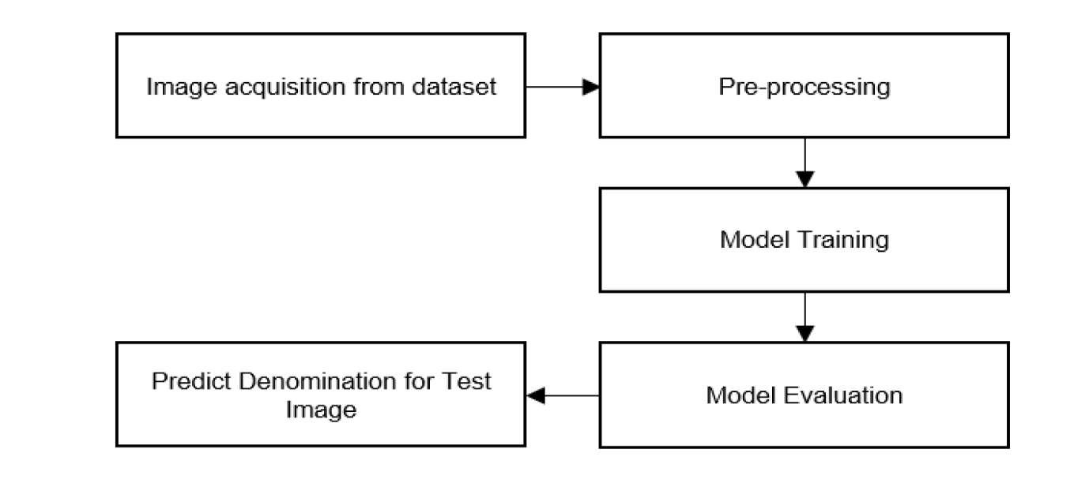
Dataset → Preprocessing → CNN Model Training →
Evaluation → GUI Prediction → Output

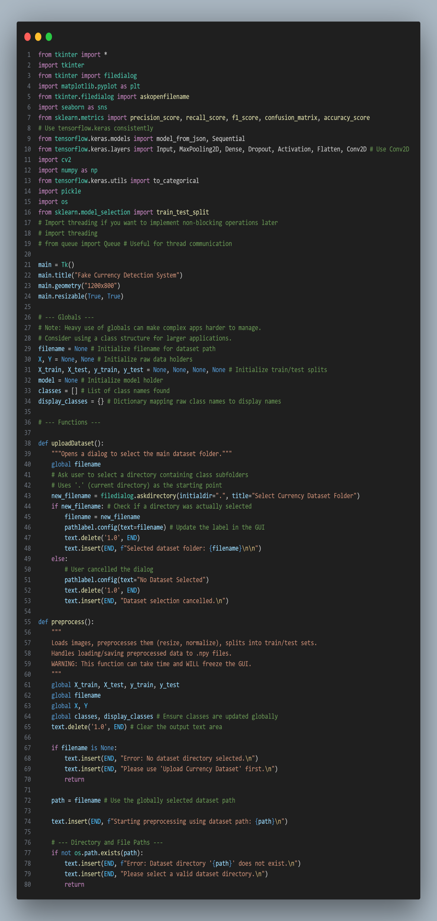
6. Coding
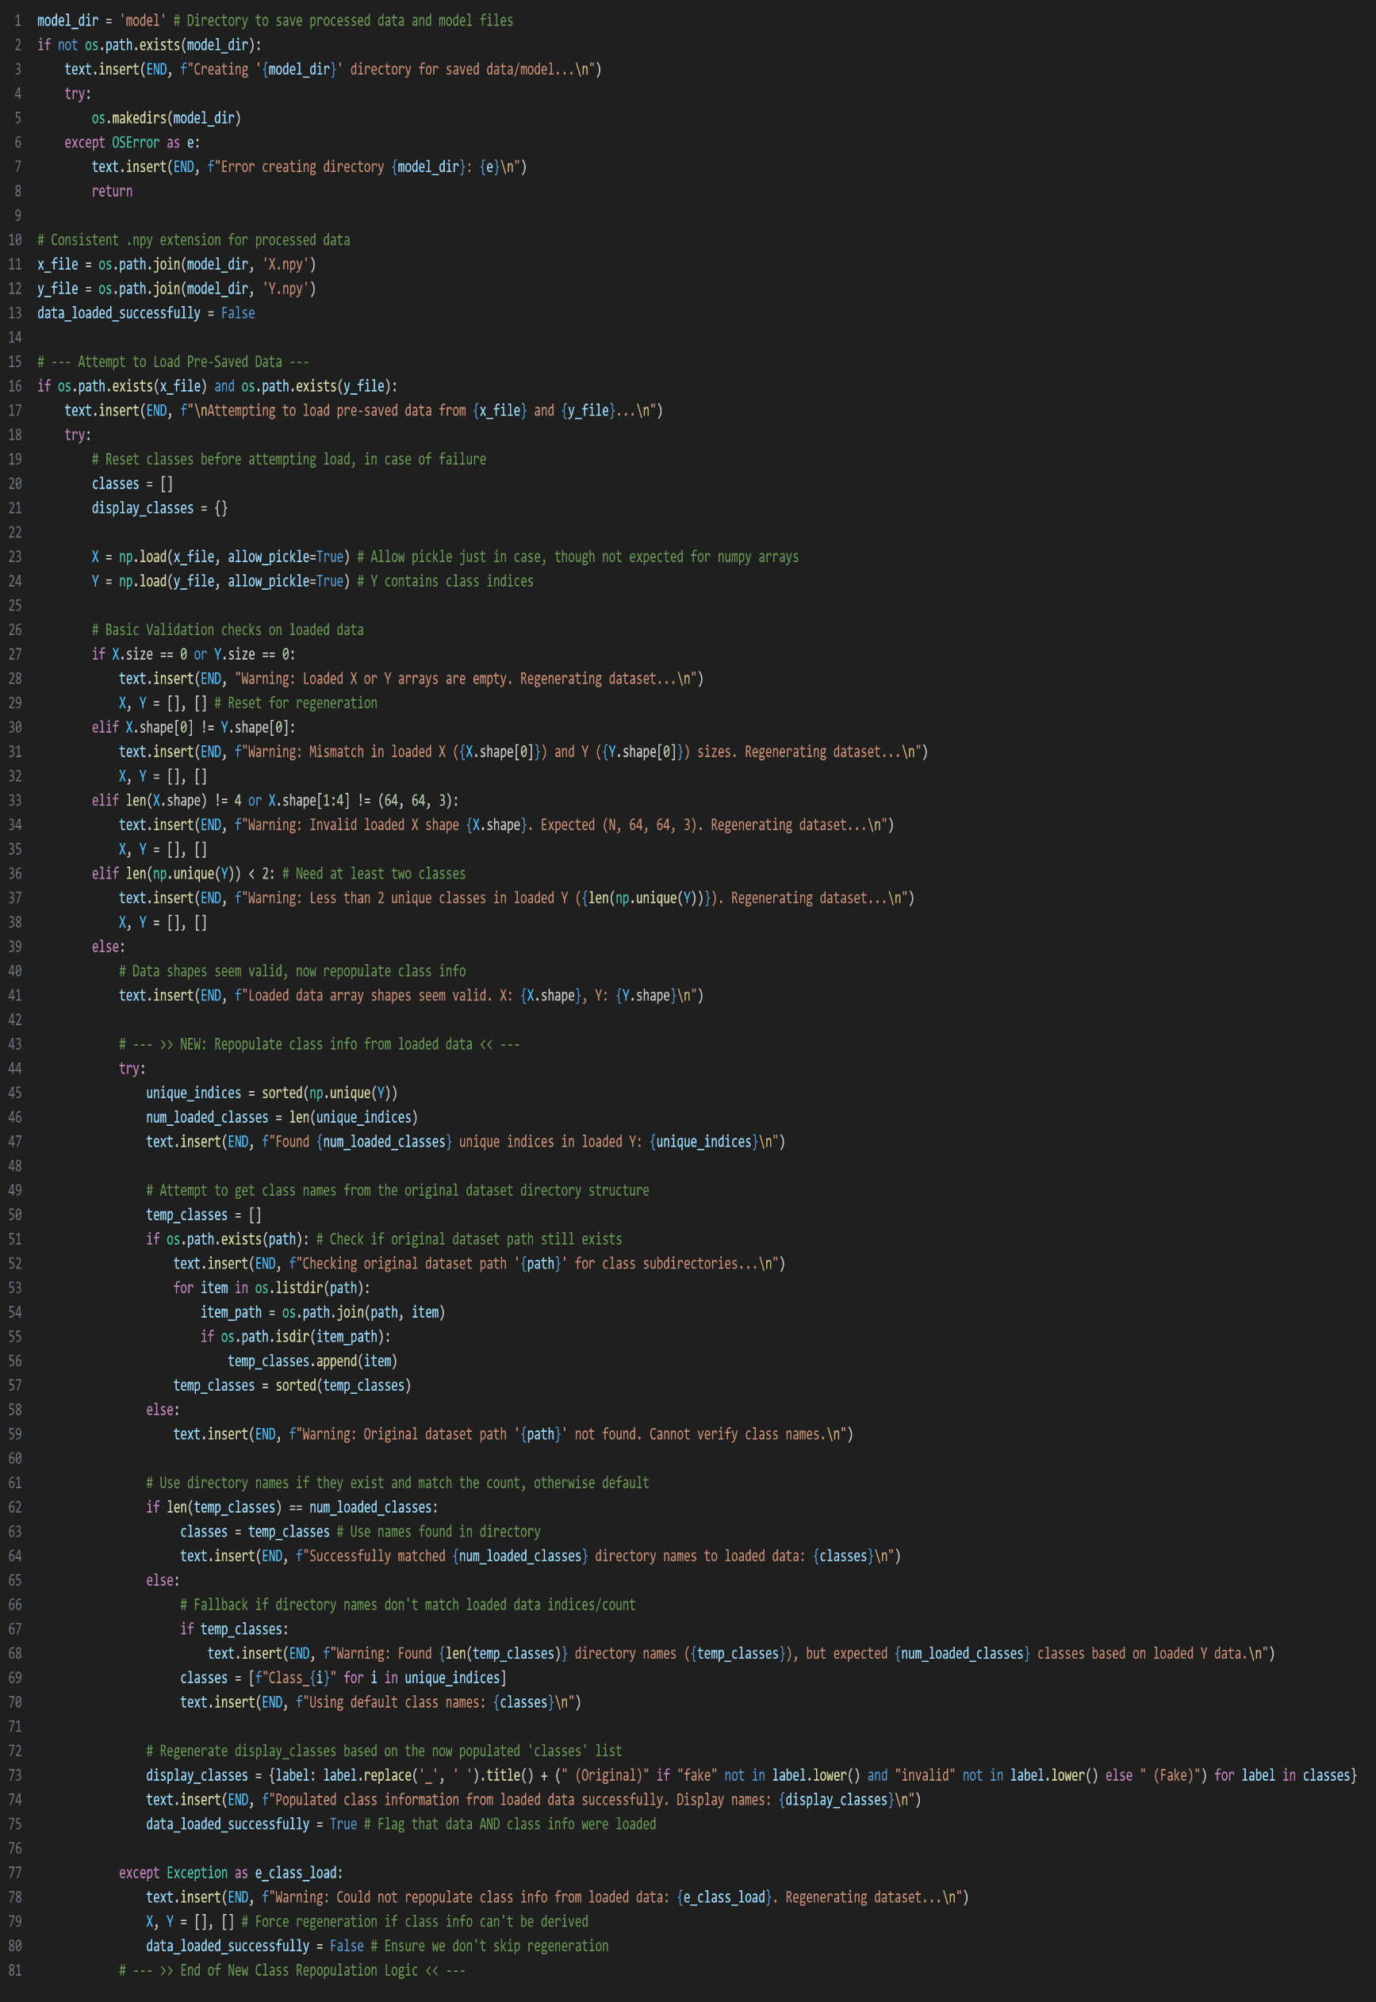
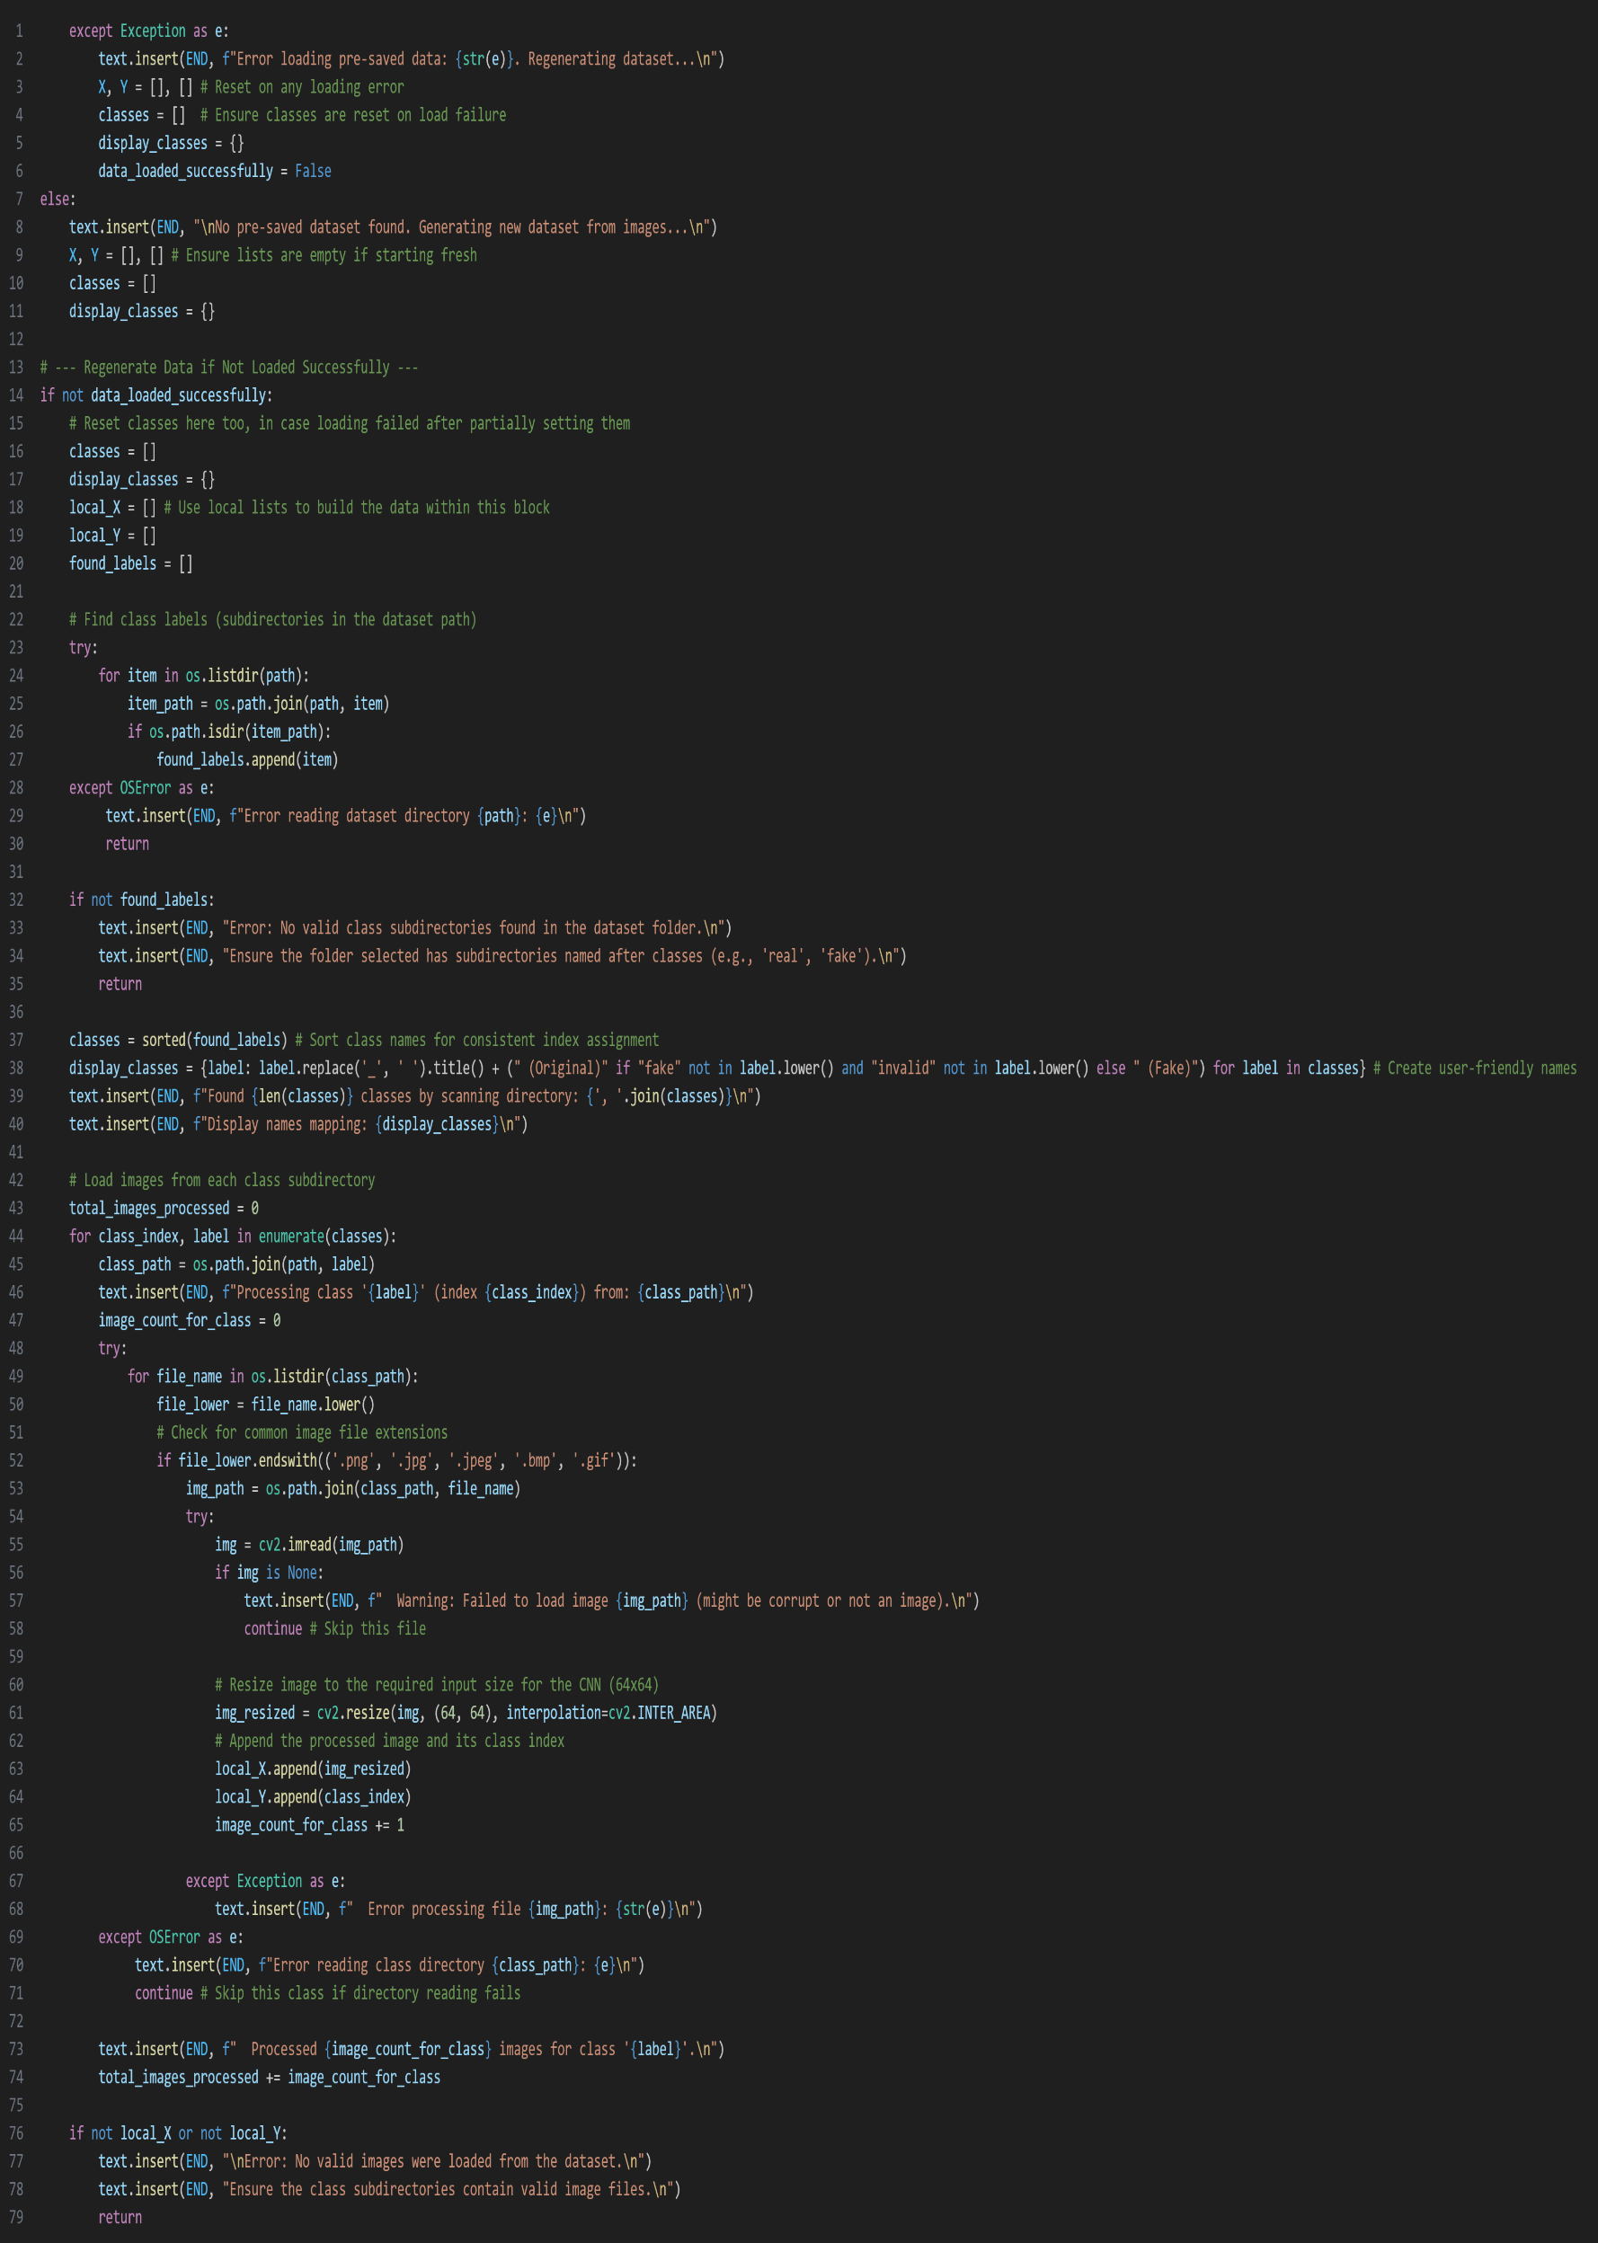
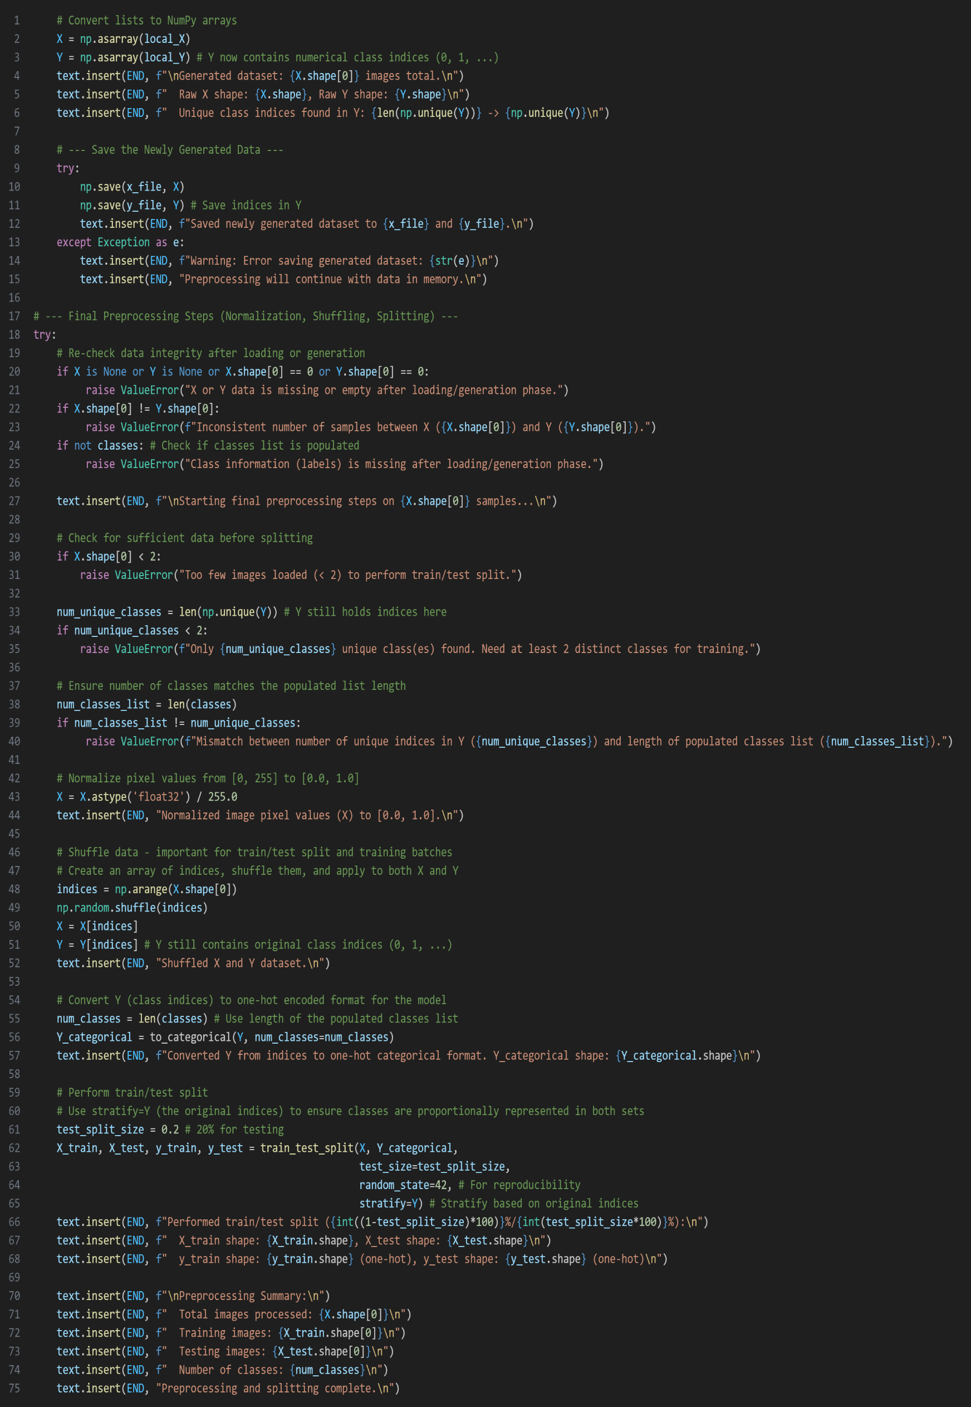
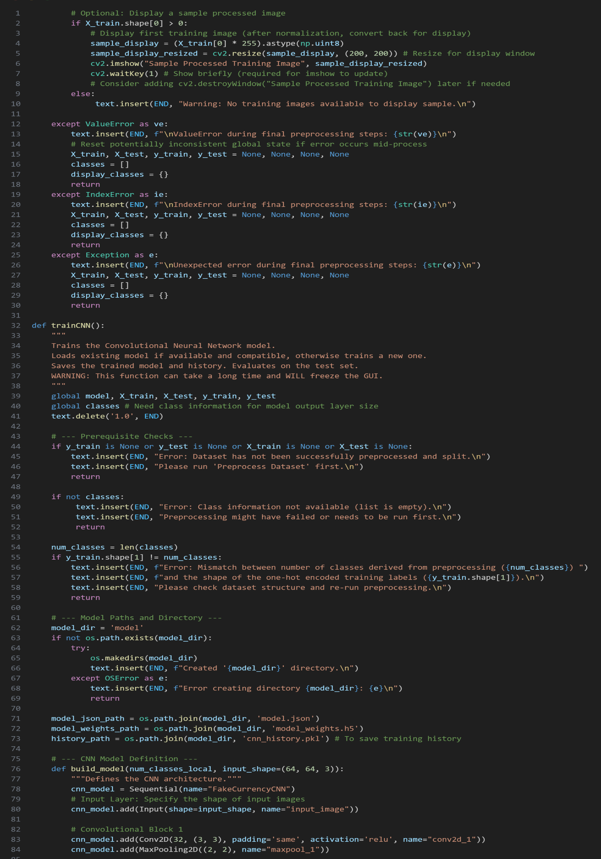
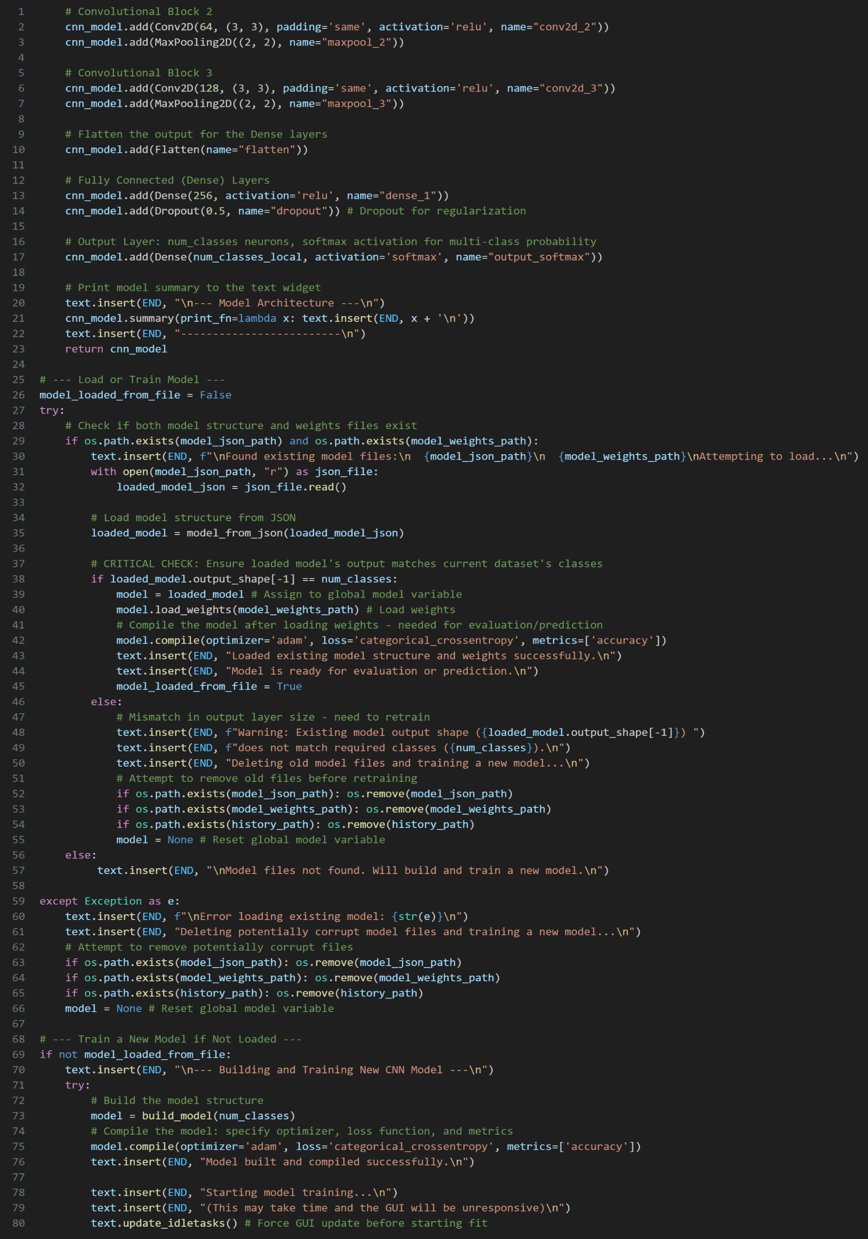
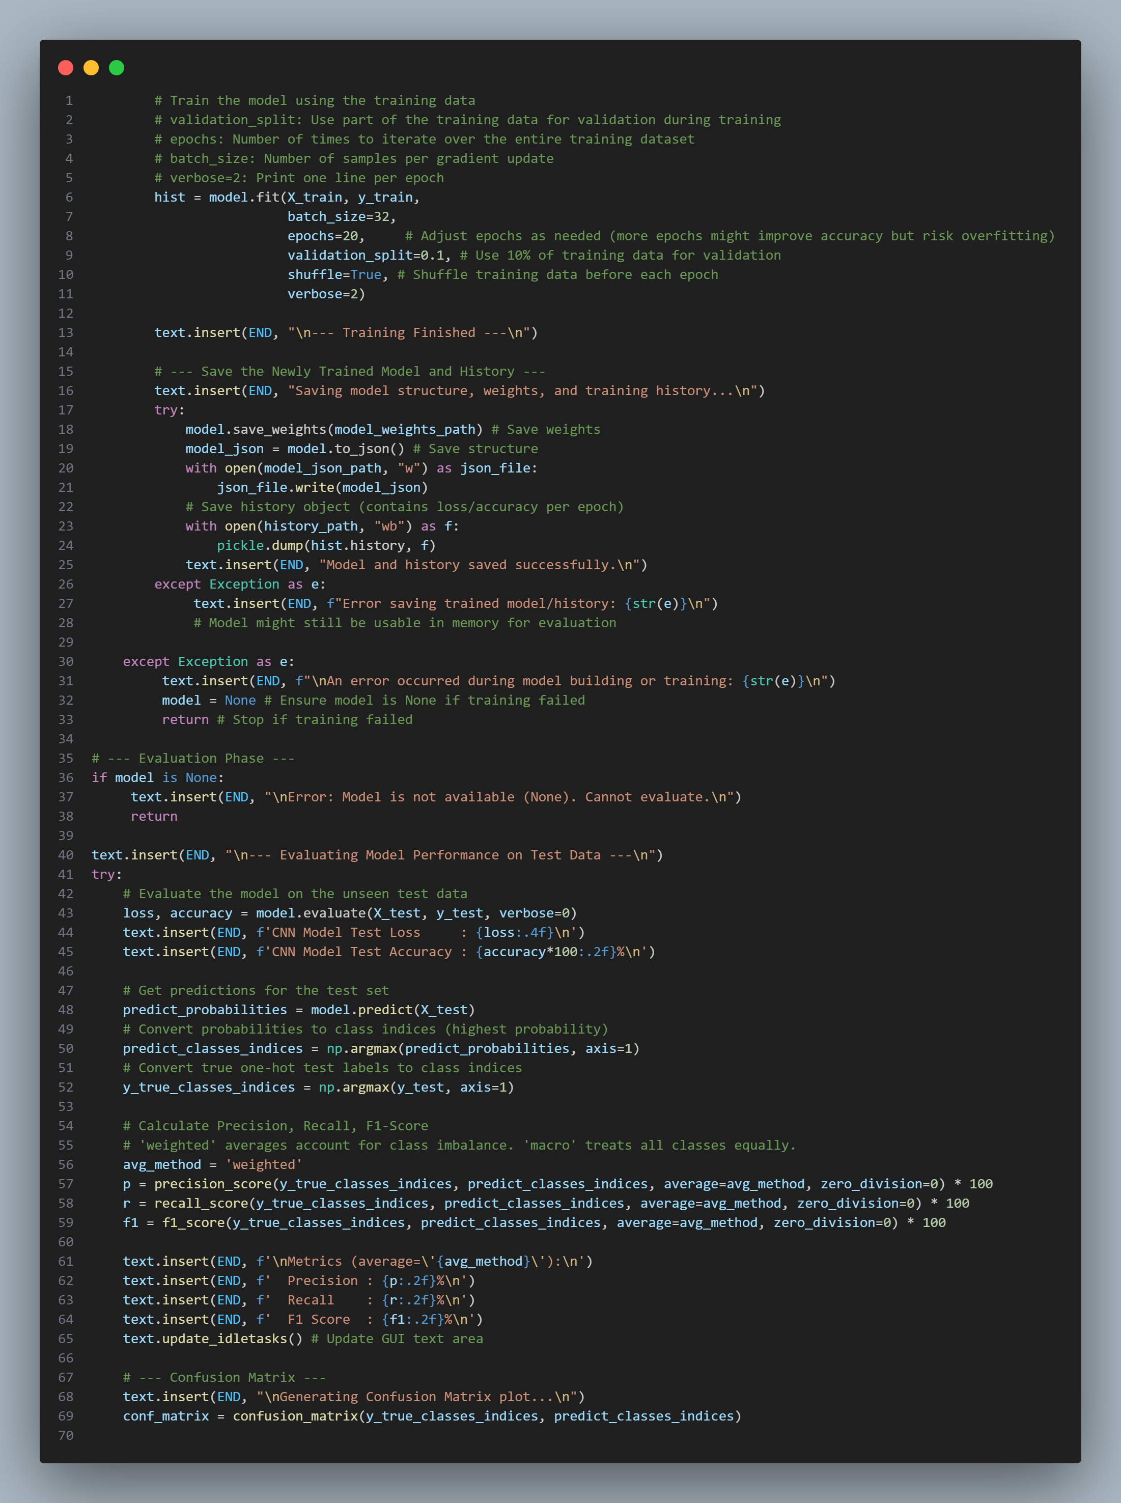
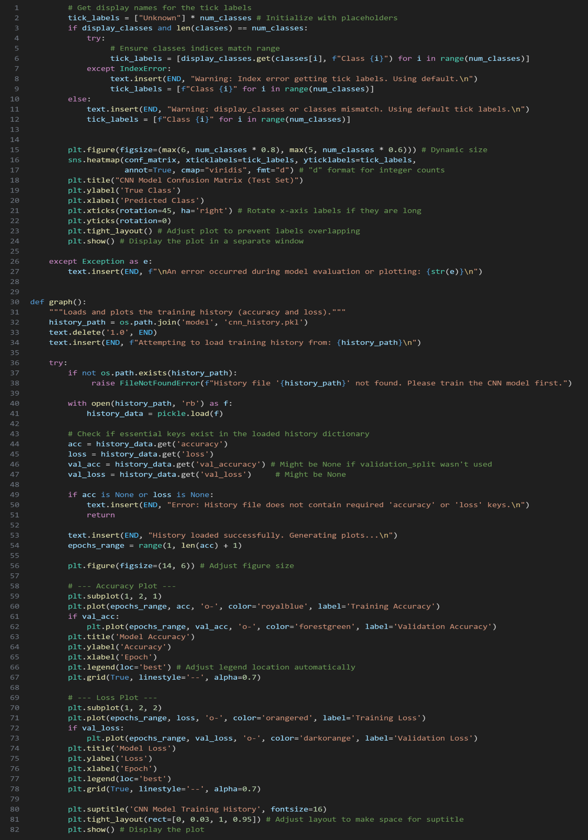
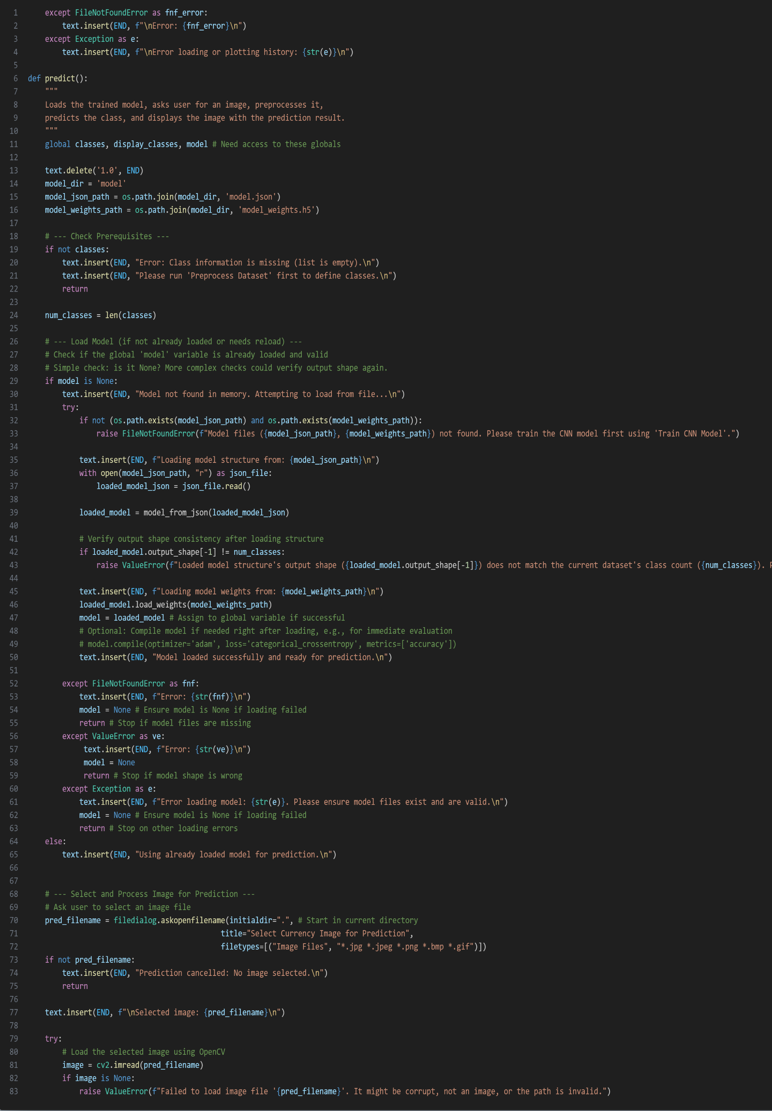
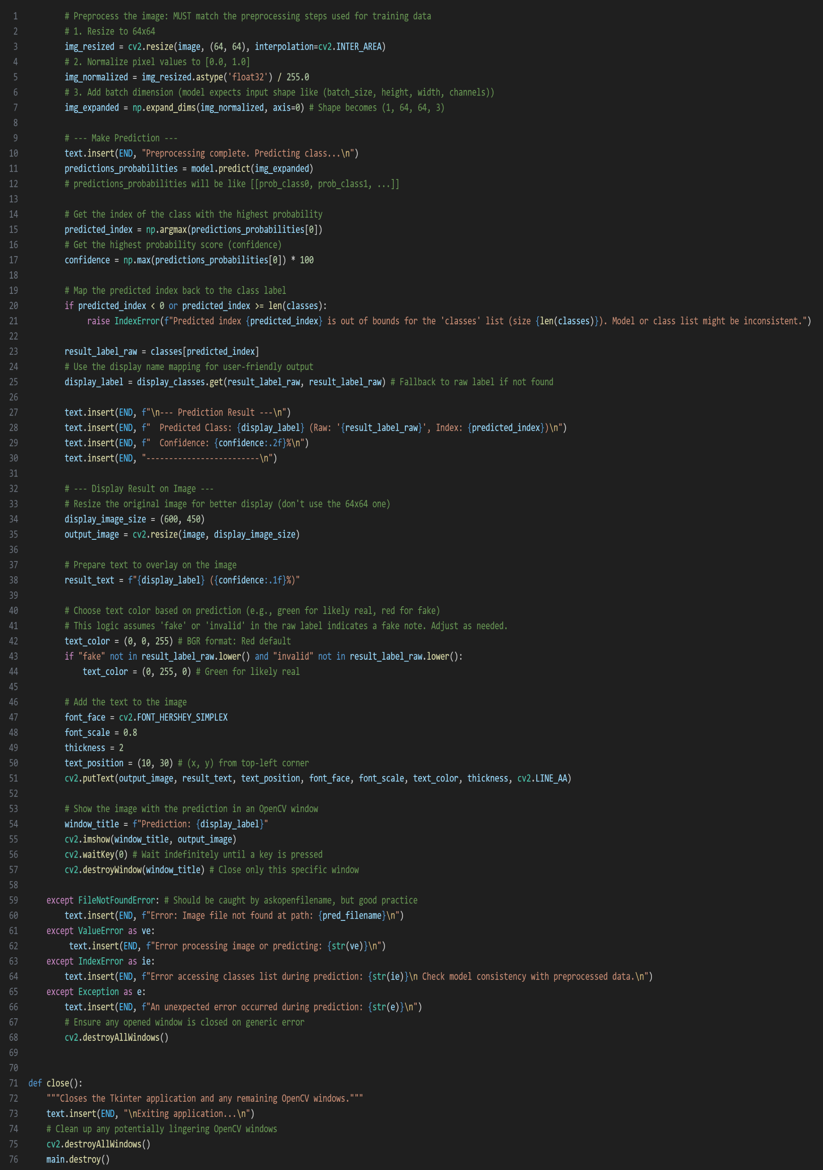
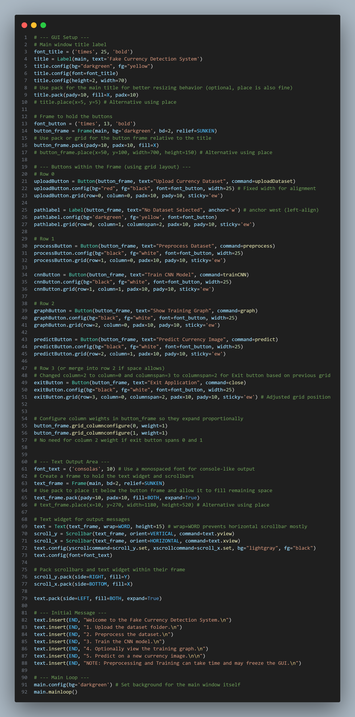

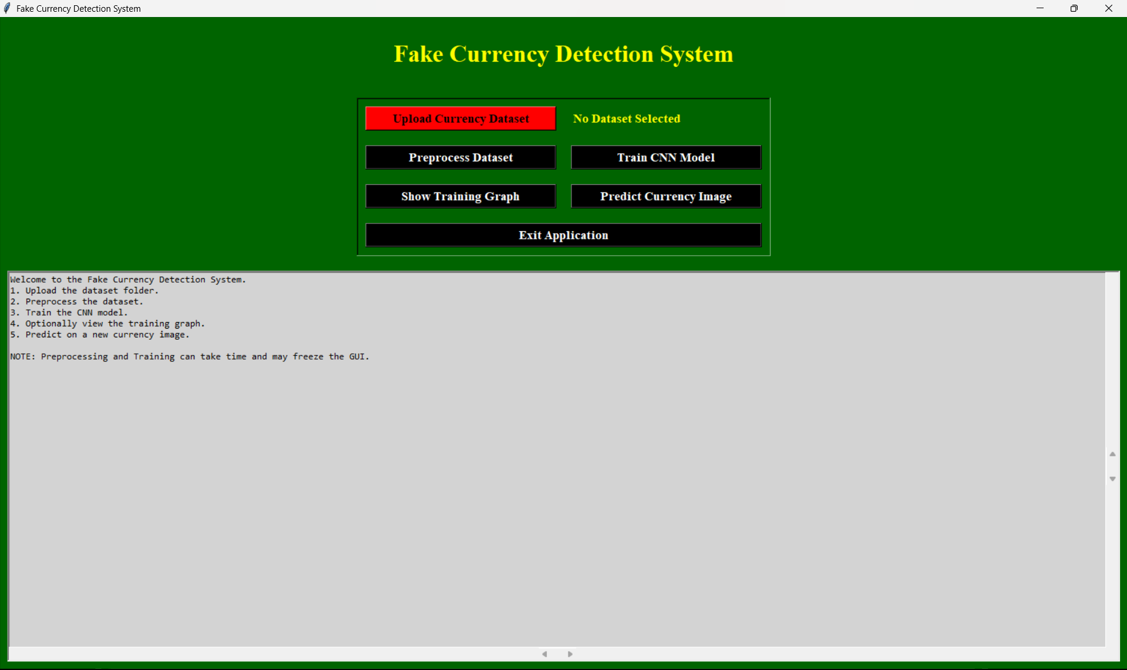
7. Outputs
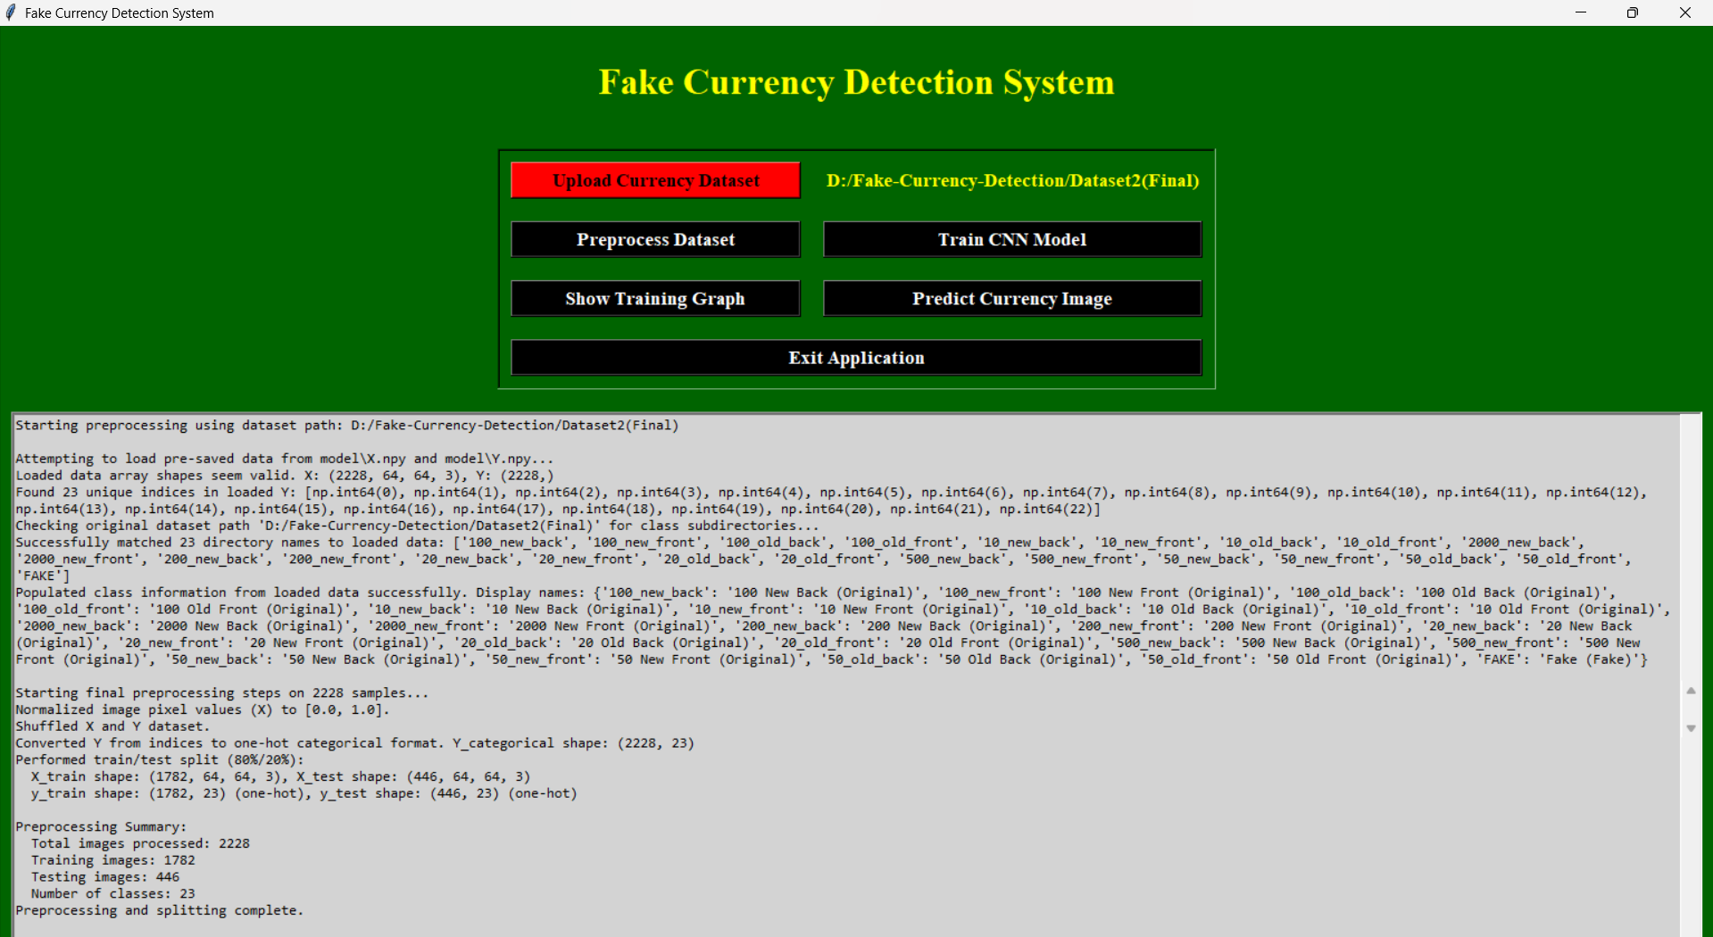
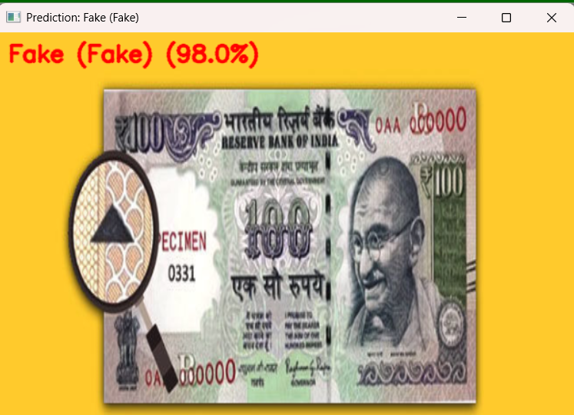
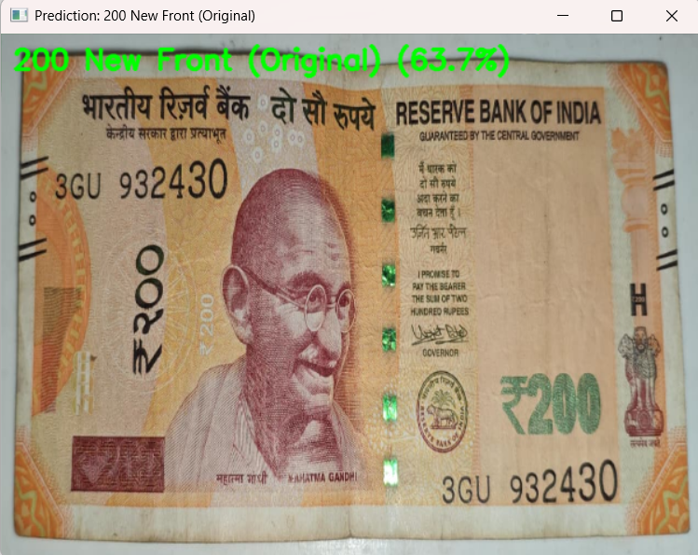
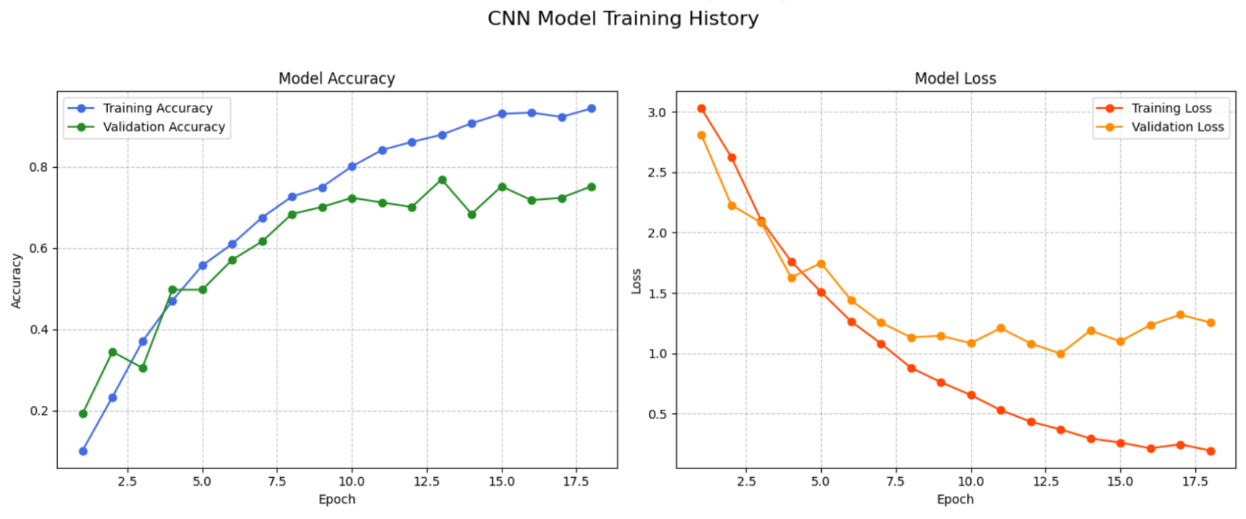
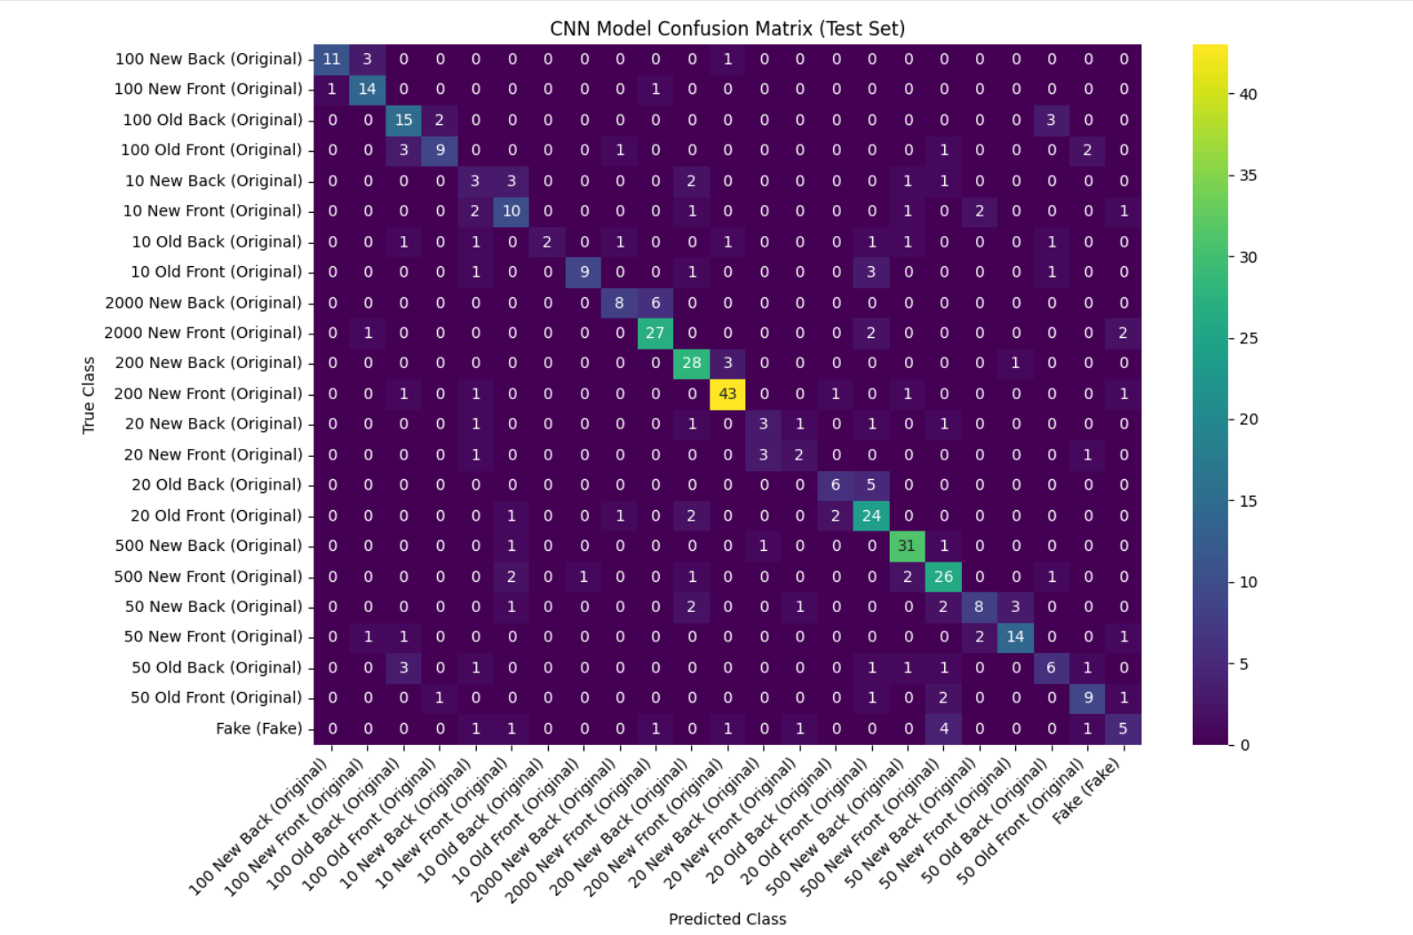

8. Future Enhancements
Although the system achieves reliable detection performance, several future improvements can enhance its functionality, scalability, and real-world applicability:
- Multi-Currency and Multi-Denomination Detection:
Expand the model to detect counterfeit notes for other currencies like USD, EUR, and GBP.
- Mobile and Web Deployment:
Convert the application into a cross-platform mobile app or web application for global access.
- Integration with Banking and Retail Systems:
Integrate directly with ATMs, POS machines, or banking software for automatic currency validation.
- Adoption of Advanced CNN Architectures:
Implement deep transfer learning models such as VGG16, ResNet, or MobileNet to achieve higher accuracy and faster inference.
- Real-time Camera Integration:
Enable live detection via camera feed instead of static image upload.
- Continuous Learning:
Implement model retraining mechanisms to adapt to new currency note designs over time.
- Cloud Storage and Model Hosting:
Use cloud platforms (like AWS, Google Cloud) to host models and process large datasets efficiently.
Through these enhancements, the system can evolve into a real-world deployable solution capable of supporting governments, banks, and consumers in combating counterfeit money circulation.

