E-LEARNING SCHEMA

**ER DIAGRAM**

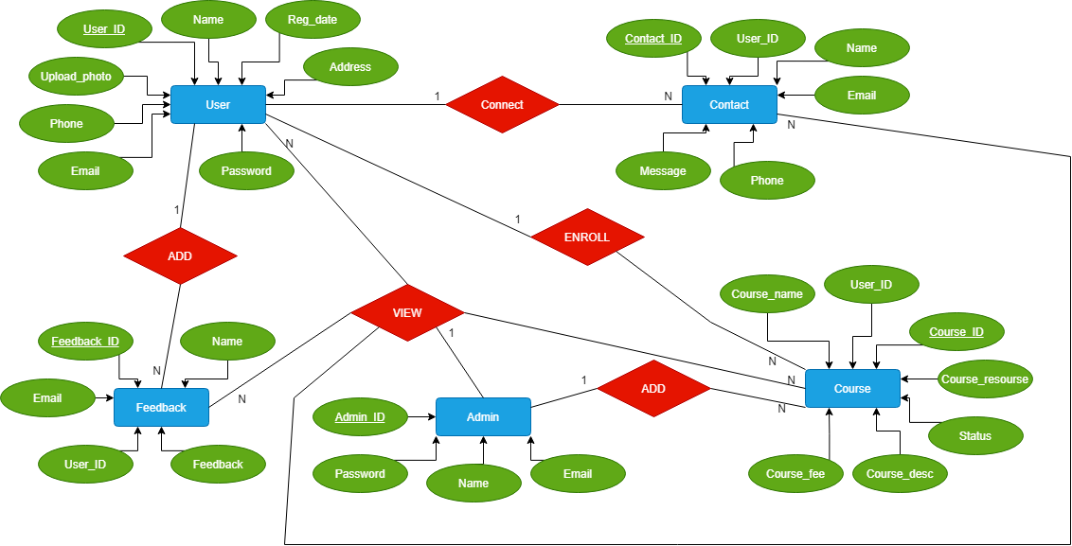

**CREATING E-LEARNING SCHEMA**

**Step 1: Connect to database**

conn system/password

**Step 2: Create tablespace**

CREATE **TABLESPACE** tbs_register DATAFILE 'tbs_register.dat' SIZE 1M AUTOEXTEND ON;

**Step 3: Create a new user in Oracle**

CREATE **USER** elearning IDENTIFIED BY learning123 DEFAULT TABLESPACE tbs_register QUOTA unlimited on tbs_register;

**Step 4: Grant permissions**

GRANT create session TO register;

GRANT create table TO register;

GRANT create sequence TO register;

**Step 6: Create ADMIN table**

create table admin ( admin_id number primary key, name varchar2(100),email varchar2(100), password varchar2(100);

insert into admin values (1,’rahul’,’rahul@gmail.com’,’pass’);

insert into admin values (2,’ankit’,’ankit@gmail.com’,’pass’);

insert into admin values (3,’gowthami’,’gowthami@gmail.com’,’pass’);

insert into admin values (4,’aishwarya’,’aishwarya@gmail.com’,’pass’);

insert into admin values (5,’harshitha’,’harshitha@gmail.com’,’pass’);

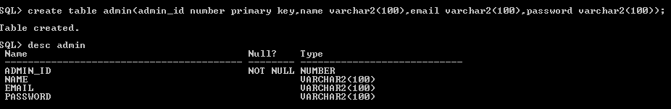

Select * from admin;

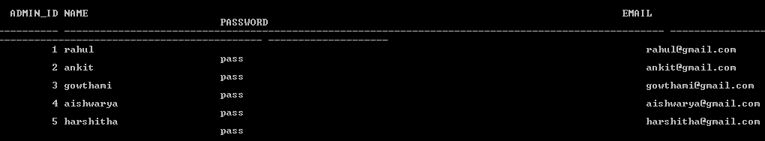

**Step 6: Create COURSE table**

create table course ( course_id number primary key, c_name varchar2(100),c_desp varchar2(100), c_fees varchar2(100), user_id number ,c_resource varchar2(100) , status varchar2(20);

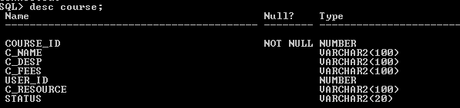

Select * from course;

create table contact(user_id number references user1 , name varchar2(30), Email varchar2(20), Phone_no number, Messege varchar2(20), contact_id number primary key);

insert into contact values (101, 'Ankit', 'ankit@gmail.com', 1234, 'Message',1);insert into contact values (102, 'Rahul', 'rahul@gmail.com', 1235, 'Message',2);insert into contact values (103, 'Gouthami', 'Gouthami@gmail.com', 1236, 'Message',3);insert into contact values (104, 'Ishwarya', 'Ishwarya@gmail.com', 1237, 'Message',4);insert into contact values (105, 'Harshitha', 'Harshitha@gmail.com', 1238, 'Message',5);

create table feedback(user_id number references user1,name varchar2(100),email varchar2(100),f_id number primary key,feedback varchar2(100));

insert into feedback(user_id,name,email,f_id,feedback)values(1,'anil','anil@gmail.com',100,'good'); insert into feedback(user_id,name,email,f_id,feedback)values(1,'anil','anil@gmail.com',100,'good');