BML MUNJAL UNIVERSITY
School of Engineering and Technology
Course: MTH2802 – Linear Algebra & Differential Equations
B.Tech Computer Science & Engineering, Semester III
Project Report
Predicting Population Movement Using Transition Matrices
A Markov-chain model of movement between Delhi, Gurugram, Noida and Faridabad
Group 14
Name | Roll No.
Mansi Awasthi | 250450
Prince Kumar Yadav | 250500
Shobhit Rai | 250557
Ishank Chauhan (Group Representative) | 250406
Instructor: Dr. Luckshay Batra
November 2026

Abstract
In this project we model how people move between four regions of the Delhi–NCR area (Delhi, Gurugram, Noida and Faridabad) using a column-stochastic transition matrix P, with one time step equal to one year and the update rule x_{k+1} = P x_k. The starting populations are approximate Census 2011 figures, while the transition probabilities are simulated because public inter-city annual flow data are not available at this level. We verify that P is regular, compute future distributions through matrix powers, and find the long-term (steady-state) distribution in three independent ways: the eigenvector for λ = 1, Gaussian elimination on (P − I)π = 0, and a high matrix power. All three agree to within 10⁻⁸. The model gives the steady state Delhi 55.5%, Gurugram 17.5%, Noida 16.7% and Faridabad 10.3%. All eigenvalues are real and distinct (1, 0.8862, 0.8638, 0.8600), so P can be diagonalised, and the second-largest eigenvalue 0.8862 explains the convergence speed (about 32 years to come within 1%). We also study two what-if scenarios and a 1000-run sensitivity test, and we discuss the limits of the model honestly.

1 Introduction and Problem Statement
People in a metropolitan region keep moving between cities for work, housing and family reasons. If, each year, a fixed fraction of the people living in one city move to another, then the future population of every city can be predicted with simple matrix multiplication. This is the idea of a transition matrix, and it is a good first application of the linear algebra we study in MTH2802.
The official brief for this project is: construct a transition matrix representing movement of people between selected regions using simulated or publicly available data; use matrix powers to estimate future population distributions and study the long-term behaviour of the model. We choose four regions of the National Capital Region (NCR): Delhi, Gurugram, Noida and Faridabad.

1.1 Objectives
- Construct a 4 × 4 column-stochastic transition matrix P for the four regions and verify its properties.
- Use repeated multiplication and matrix powers P^{k} to project the population for k = 0 to 30 years.
- Find the long-term steady state in three independent ways and check that they agree.
- Diagonalise P (P = V D V⁻¹) and use the eigenvalues, especially |λ₂|, to explain how fast the model converges.
- Study scenarios (what-if changes) and the sensitivity of the answer to small errors in P.
- State the limitations of the model, including what happens when P is not regular.

1.2 Convention used
We follow the textbook of Poole and use column-stochastic matrices. The entry P[i][j] is the probability that a person living in region j this year lives in region i next year, so every column sums to 1. If x_{k} is the population vector after k years, then x_{k+1} = P x_{k}. The order of regions is always Delhi, Gurugram, Noida, Faridabad.

2 Mathematical Background

2.1 Stochastic matrices and Markov chains
A square matrix P is column-stochastic if all its entries are non-negative and every column sums to 1. A Markov chain is a process that moves between a finite number of states where the probability of the next state depends only on the present state (the *memoryless* property). Here the states are the four regions and the transition probabilities are stored in P.
Why columns sum to 1. Column j lists what happens to a person living in region j: they must live somewhere next year, either in the same region or in one of the others. The probabilities of all these possibilities add up to 1. Consequently the total population is unchanged by x_{k+1} = P x_{k} (our model is a closed system: nobody is born, dies, enters or leaves the four regions).

2.2 Why λ = 1 is always an eigenvalue
Let 1 be the vector of all ones. Since each column of P sums to 1, we have 1^{T}P = 1^{T}, which means P^{T}1 = 1. So 1 is an eigenvalue of P^{T}. A matrix and its transpose have the same characteristic polynomial because det(P − λI) = det(P^{T} − λI), so 1 is also an eigenvalue of P. Moreover, every eigenvalue λ of a stochastic matrix satisfies |λ| ≤ 1.
A useful by-product: if v is an eigenvector of P for an eigenvalue λ ≠ 1, then 1^{T}Pv = 1^{T}v gives (1 − λ)(1^{T}v) = 0, so the entries of v add up to 0. Eigenvectors for λ ≠ 1 therefore describe *redistributions* of population, not population itself.

2.3 Regular chains and the steady-state theorem
P is regular if some power P^{k} has all entries strictly positive (i.e. after k steps it is possible to get from any region to any other). Steady-state theorem (stated, not proved): if P is regular, then (i) λ = 1 is a simple eigenvalue and all other eigenvalues satisfy |λ| < 1; (ii) there is a unique probability vector π with Pπ = π; and (iii) for any starting distribution x₀ with total 1, x_{k} = P^{k}x₀ → π as k → ∞. Moreover P^{k} approaches the matrix whose every column is π.
Intuition: if every region can reach every other region, the process keeps mixing the population. Memory of the starting point fades and only the balance between inflow and outflow remains. At the steady state, the number leaving each region equals the number arriving, so the shares stop changing.

2.4 Diagonalisation and P^{n} = V D^{n} V^{-1}
If P has n linearly independent eigenvectors v₁, …, v_{n} with eigenvalues λ₁, …, λ_{n}, put them as columns of V and the eigenvalues on the diagonal of D. Then P = V D V⁻¹. Since the inner V⁻¹V cancel, P^{n} = V D^{n} V⁻¹, and D^{n} is easy because we only raise each diagonal entry to the power n. Distinct eigenvalues guarantee that P is diagonalisable, which is why we arranged the matrix so that all eigenvalues are real and distinct.
Write the starting vector as x₀ = c₁v₁ + c₂v₂ + … + c_{n}v_{n}, where c = V⁻¹x₀. Then
x_{k} = c₁(1)^{k}v₁ + c₂λ₂^{k}v₂ + c₃λ₃^{k}v₃ + …
The terms with |λ_{j}| < 1 die out as k grows, so only c₁v₁ survives, and that is the steady state. The speed of convergence is controlled by the largest of the remaining |λ_{j}|, namely |λ₂|: the closer it is to 1, the slower the convergence, and the distance to the steady state shrinks roughly like |λ₂|^{k}.

2.5 A worked 2 × 2 example
Let T = [[0.9, 0.2],[0.1, 0.8]] (two cities; 10% of city 1 move to city 2 each year and 20% of city 2 move to city 1). Columns sum to 1.
- Eigenvalues: the characteristic equation is λ² − (trace)λ + det = λ² − 1.7λ + 0.70 = 0, so λ = 1 and λ = 0.7.
- λ = 1: (T − I)v = 0 gives −0.1a + 0.2b = 0, so a = 2b and v₁ = (2, 1). Normalising to sum 1 gives the steady state π = (2/3, 1/3).
- λ = 0.7: (T − 0.7I)v = 0 gives 0.2a + 0.2b = 0, so v₂ = (1, −1) (entries sum to 0, as predicted).
- Diagonalisation: V = [[2, 1],[1, −1]], D = diag(1, 0.7). Hence T^{n} = V D^{n} V⁻¹ → [[2/3, 2/3],[1/3, 1/3]] as n → ∞ because 0.7^{n} → 0.
- Check: starting from (0.5, 0.5) the code gives (0.5000, 0.5000) → (0.5500, 0.4500) → (0.5850, 0.4150) → (0.6095, 0.3905), moving towards (0.6667, 0.3333).

2.6 Open systems: births, deaths and migration
A closed model keeps the total population fixed for ever. To let people be born, die, leave the NCR or arrive from the rest of India we use the affine model xk+1 = A xk + m, with A = diag(1 + g) P diag(1 − e). Here ej is the share of region j that leaves the NCR each year, gi is the natural growth rate (birth rate minus death rate) and m is the yearly number of arrivals. The columns of A no longer sum to 1, so A is not stochastic.
Homogeneous coordinates. Writing the state as (xk, 1) turns the affine step into a linear one: (xk+1, 1) = B (xk, 1) with B = [[A, m],[0, 1]], the same trick used in computer graphics. B is block upper-triangular, so its eigenvalues are those of A together with 1.
Closed form. If 1 is not an eigenvalue of A, put x* = (I − A)⁻¹m. Then xk = A^{k}(x0 − x*) + x*. If every |λ(A)| < 1 the population settles at x*; otherwise A^{k} dominates and the population keeps growing.
Perron–Frobenius. A has only positive entries, so its largest eigenvalue ρ(A) is real, simple and has a positive eigenvector. In the long run the total grows by a factor ρ(A) per year and the shares approach that eigenvector (normalised to sum 1). This replaces the steady state π of the closed model.
Scaling mobility. For 0 < α ≤ 1 let Pα = I + α(P − I). Its columns still sum to 1 and Pαπ = π, so the steady state is unchanged, but every eigenvalue moves to 1 + α(λ − 1): fewer movers give the same destination, reached more slowly. We use α to fit the model to the census in Section 7.1.

3 Data and Assumptions

3.1 Regions and initial population
We use four regions at district level. The initial populations in Table 1 are the official district totals from the Census of India 2011 (Gurugram = Gurgaon district, Noida = Gautam Buddha Nagar district). The total is 21,760,221. An earlier draft used approximate values for Gurugram (1,514,085) and Noida (1,674,714); both were wrong and have been corrected. All code inputs are in one module (inputs.py), so changing a figure needs one edit and a re-run.
Table 1: Initial populations (Census of India 2011, district totals)
Region | Unit used | Population (Census 2011) | Initial share
Delhi | NCT of Delhi | 16,787,941 | 77.15%
Gurugram | Gurgaon district | 1,514,432 | 6.96%
Noida | Gautam Buddha Nagar district | 1,648,115 | 7.57%
Faridabad | Faridabad district | 1,809,733 | 8.32%

3.2 Simulated transition probabilities
The transition probabilities in this project are simulated. Public data on yearly movement between individual NCR cities, in the form of a complete origin–destination matrix, are not available at this granularity (Census migration tables are collected only occasionally, by state or district, and use different time windows). We therefore designed P by hand using plain-language reasoning about how the four places behave, and we kept it within the rules we set ourselves: retention between 0.88 and 0.96, all entries strictly positive, columns summing to 1, and real distinct eigenvalues. Table 2 explains each column.
Table 2: Justification of each column of P (simulated)
Column (from) | Stay | Where the movers go | Plain-language reasoning
Delhi | 0.950 | Gurugram 0.020, Noida 0.020, Faridabad 0.010 | Highest retention: the largest job market, established housing and family ties. Movers prefer Gurugram and Noida (IT and corporate jobs) over Faridabad.
Gurugram | 0.890 | Delhi 0.060, Noida 0.030, Faridabad 0.020 | Many workers are recent arrivals with weaker roots; some return to Delhi for housing cost, family or education. Few move to Faridabad.
Noida | 0.890 | Delhi 0.060, Gurugram 0.030, Faridabad 0.020 | Similar to Gurugram (IT and job-driven residents). Slightly more movement back to Delhi, which is adjacent.
Faridabad | 0.880 | Delhi 0.070, Gurugram 0.030, Noida 0.020 | Lowest retention: some residents move to Delhi (closest large job market) and Gurugram (jobs along the same corridor), fewer to Noida.

3.3 Assumptions
- Time step is one year and P is constant in time (the same every year).
- The system is closed: only the four regions exist; no births, deaths, or movement to or from the rest of India.
- The process is memoryless: where a person goes next depends only on where they live now.
- Each person in a region has the same probabilities (no age, income or occupation differences).
- Populations are Census 2011 district totals; the year 2011 is only the starting point of the simulation, and the closed model does not claim real forecasts (the open model in Section 7 is a first step towards that).
- In the sensitivity study, ‘±2%’ means each entry of P is multiplied by a random factor in [0.98, 1.02] and each column is then renormalised to sum to 1.

3.4 Extra data for the open model (Section 7)
The open model needs three more inputs per region (Table 1b). The 2001 populations are Census 2001 totals; Faridabad's 2001 district still included Palwal (split off in 2008), so we back-compute its comparable value from the official 2001–2011 growth of 32.54%. Natural growth is the Sample Registration System (SRS) 2020 birth rate minus death rate for the state (Delhi, Haryana, Uttar Pradesh), applied to each district. The emigration rates are simulated.
Table 1b: Inputs of the open model
Region | Census 2001 | Natural growth per year (SRS 2020) | Leave the NCR per year (simulated)
Delhi | 13,850,507 | 1.06% (14.2 − 3.6 per 1000) | 0.6%
Gurugram | 870,539 | 1.38% (Haryana) | 0.8%
Noida | 1,202,030 | 1.86% (Uttar Pradesh) | 0.8%
Faridabad | 1,365,424 (comparable) | 1.38% (Haryana) | 0.7%

4 Model Construction
The final transition matrix (rows = region next year, columns = region this year) is shown in Table 3 and as a heat map in Figure 1.
Table 3: Final transition matrix P (simulated), x_{k+1} = P x_{k}
to \ from | Delhi | Gurugram | Noida | Faridabad
Delhi | 0.950 | 0.060 | 0.060 | 0.070
Gurugram | 0.020 | 0.890 | 0.030 | 0.030
Noida | 0.020 | 0.030 | 0.890 | 0.020
Faridabad | 0.010 | 0.020 | 0.020 | 0.880

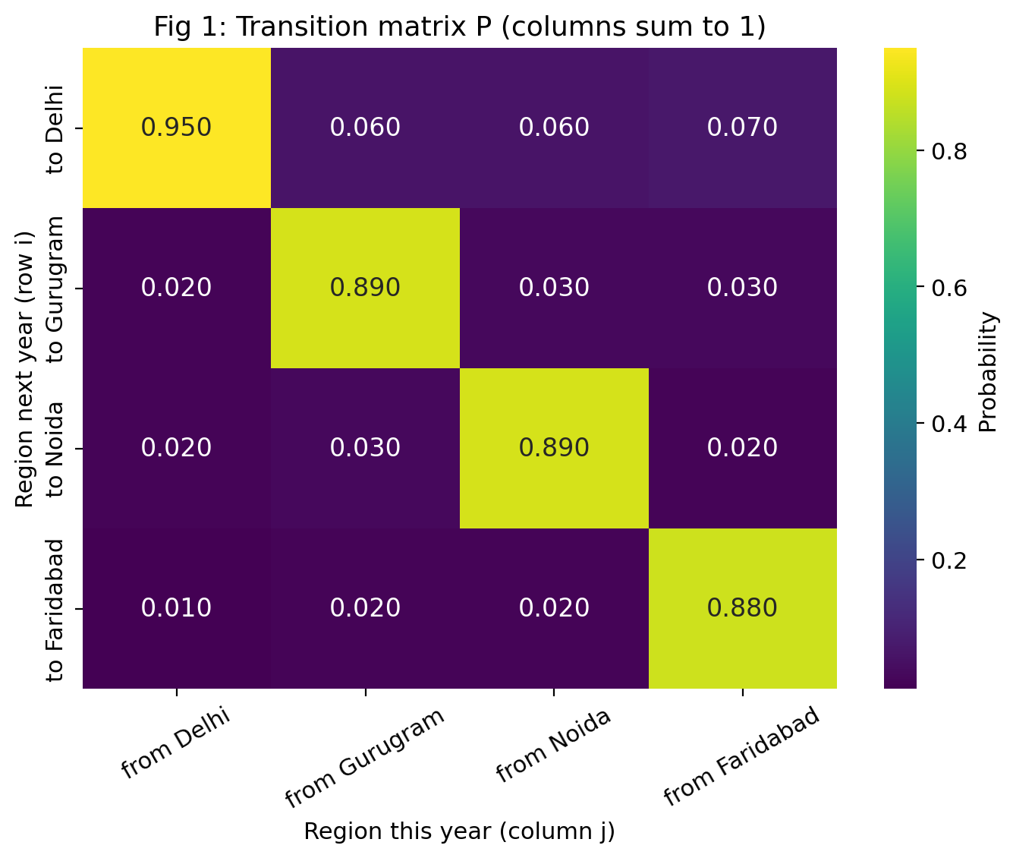
Figure 1: Heat map of the transition matrix P. Large diagonal values show that most people stay where they are.
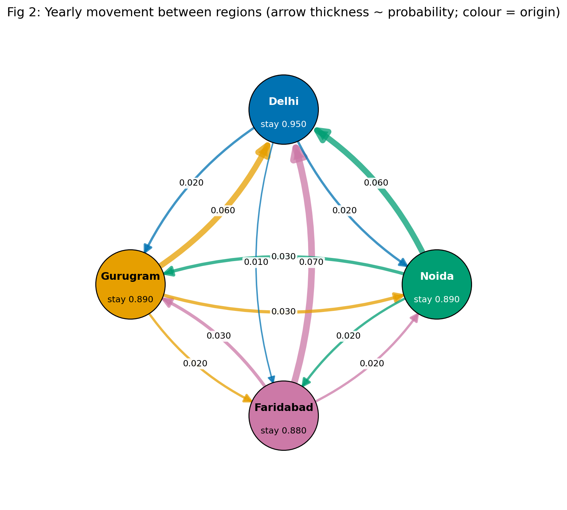
Figure 2: Flow diagram of the four regions. Arrow thickness is proportional to the transition probability.

4.1 Verification of properties
Table 4: Properties of P checked by the program (43 checks passed, 0 design warnings)
Property | Result
Every column sums to 1 | Yes (column sums = 1.000, 1.000, 1.000, 1.000)
All entries non-negative | Yes
Retention (diagonal) between 0.88 and 0.96 | k = 1 (P itself is strictly positive); the program searches up to Wielandt's bound (n − 1)² + 1 = 10, so a 'not regular' answer would be a proof
Regular: smallest k with P^{k} > 0 | k = 1 (already P itself is strictly positive)
Eigenvalues real and distinct | Yes (1.0000, 0.8862, 0.8638, 0.8600)
No region below 5% in steady state | Yes (smallest share 10.32%)
The program separates two kinds of check. Mathematical facts (columns sum to 1, Pπ = π, the three methods agree, P = VDV⁻¹) must always hold; a failure stops the program. Design choices (retention between 0.88 and 0.96, every steady share above 5%, distinct eigenvalues) are properties of our particular P; if someone edits P and one of them fails, the program prints a warning instead of crashing.

5 Results

5.1 Population projections
Starting from the Census 2011 populations x₀, we computed x_{k+1} = P x_{k} repeatedly for 30 years. Table 5 gives the population counts and Table 6 the shares for selected years.
Table 5: Projected population (persons) after k years
k | Delhi | Gurugram | Noida | Faridabad
0 | 16,787,941 | 1,514,432 | 1,648,115 | 1,809,733
1 | 16,264,978 | 1,787,339 | 1,884,209 | 1,823,695
2 | 15,799,681 | 2,027,268 | 2,092,339 | 1,840,933
5 | 14,690,023 | 2,587,145 | 2,580,106 | 1,902,947
10 | 13,522,696 | 3,153,225 | 3,076,056 | 2,008,244
20 | 12,515,807 | 3,613,964 | 3,480,205 | 2,150,245
30 | 12,207,751 | 3,746,048 | 3,594,629 | 2,211,793
Table 6: Projected share of total population after k years
k | Delhi | Gurugram | Noida | Faridabad
0 | 77.15% | 6.96% | 7.57% | 8.32%
1 | 74.75% | 8.21% | 8.66% | 8.38%
2 | 72.61% | 9.32% | 9.62% | 8.46%
5 | 67.51% | 11.89% | 11.86% | 8.75%
10 | 62.14% | 14.49% | 14.14% | 9.23%
20 | 57.52% | 16.61% | 15.99% | 9.88%
30 | 56.10% | 17.22% | 16.52% | 10.16%

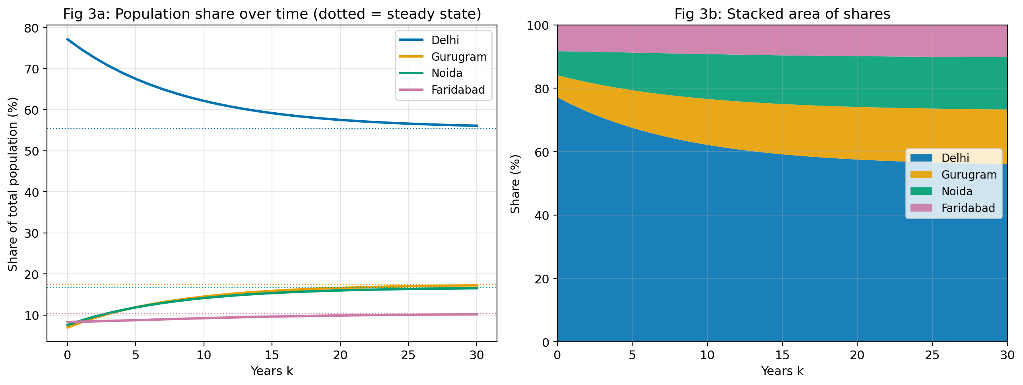
Figure 3: Population shares over 30 years (left: lines with dotted steady-state levels; right: stacked area).
The total stays at 21,760,221 in every year because P is column-stochastic. Delhi's share falls from 77.1% to 56.1% after 30 years, while Gurugram, Noida and Faridabad grow. A hand calculation for one entry is shown in Appendix B.

5.2 Matrix powers
Instead of repeating the step, we can compute P^{k} directly. Table 7 shows P¹⁰ and P⁵⁰. In P¹⁰ the columns are still different, but in P⁵⁰ each row is nearly constant: all four columns have become almost the same vector. The largest gap between columns in any row is 0.310 for P¹⁰ and 0.0027 for P⁵⁰. That common column is the steady state.
Table 7: Selected matrix powers
Power | Delhi col | Gurugram col | Noida col | Faridabad col
P¹⁰ Delhi | 0.6898 | 0.3796 | 0.3796 | 0.4097
Gurugram | 0.1227 | 0.3742 | 0.1529 | 0.1514
Noida | 0.1203 | 0.1490 | 0.3703 | 0.1218
Faridabad | 0.0671 | 0.0972 | 0.0972 | 0.3171
P⁵⁰ Delhi | 0.5559 | 0.5533 | 0.5533 | 0.5540
Gurugram | 0.1742 | 0.1755 | 0.1750 | 0.1748
Noida | 0.1670 | 0.1676 | 0.1681 | 0.1671
Faridabad | 0.1028 | 0.1036 | 0.1036 | 0.1040

5.3 Steady state: three independent methods
- (a) Eigenvector for λ = 1, normalised so its entries sum to 1.
- (b) Linear system. We solve (P − I)π = 0 together with π₁+π₂+π₃+π₄ = 1 by Gaussian elimination: the last row of P − I is replaced by a row of ones and the right-hand side by (0, 0, 0, 1).
- (c) High power. Every column of P²⁰⁰ is the steady state.
Table 8: Steady state from the three methods
Method | Delhi | Gurugram | Noida | Faridabad
(a) Eigenvector | 0.55483871 | 0.17465438 | 0.16728111 | 0.10322581
(b) Linear system | 0.55483871 | 0.17465438 | 0.16728111 | 0.10322581
(c) Column of P²⁰⁰ | 0.55483871 | 0.17465438 | 0.16728111 | 0.10322581
Steady state (%) | 55.48% | 17.47% | 16.73% | 10.32%
The largest difference between the methods is 1.52e-11, far below the tolerance 10⁻⁸ that we required. The steady-state counts are Delhi 12,073,413, Gurugram 3,800,518, Noida 3,640,074, Faridabad 2,246,216. As a check of the balance idea, at the steady state the share leaving Delhi each year (0.05 × 0.5548 = 0.0277) equals the share arriving in Delhi (0.06×0.1747 + 0.06×0.1673 + 0.07×0.1032 = 0.0277).
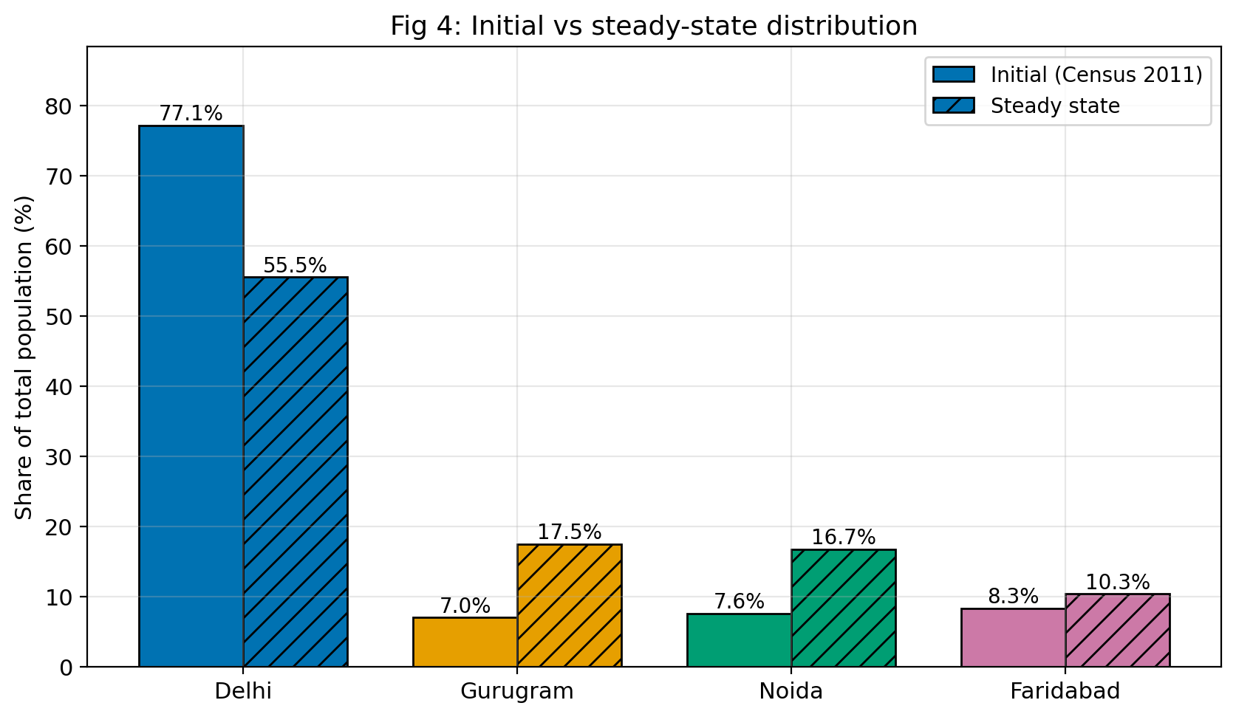
Figure 4: Initial (Census 2011) and steady-state shares.

5.4 Eigen-analysis and diagonalisation
The eigenvalues of P are all real and distinct: λ₁ = 1.000000, λ₂ = 0.886180, λ₃ = 0.863820, λ₄ = 0.860000 (Figure 9, now drawn in the complex plane so that complex or negative eigenvalues would also be visible). Hence P is diagonalisable: P = V D V⁻¹ with D = diag(λ₁, …, λ₄) and V holding the eigenvectors (Table 9). The reconstruction error max|V D V⁻¹ − P| is 5.6e-16. For n = 10, the matrix V D¹⁰ V⁻¹ agrees with the direct power P¹⁰ to within 2.0e-15.
Table 9: Eigenvector matrix V (first column normalised to sum 1; the others to length 1)
 | v₁ (λ=1) | v₂ | v₃ | v₄
Delhi | 0.5548 | 0.8615 | 0.1750 | 0.0000
Gurugram | 0.1747 | -0.3290 | -0.4582 | 0.7071
Noida | 0.1673 | -0.2034 | 0.7413 | -0.7071
Faridabad | 0.1032 | -0.3290 | -0.4582 | 0.0000

Writing the starting share vector as x₀ = c₁v₁ + c₂v₂ + c₃v₃ + c₄v₄ gives c₁ = 1.0000, c₂ = 0.2841, c₃ = -0.1602, c₄ = -0.1202. The coefficient c₁ equals 1 because the other eigenvectors sum to 0 and x₀ sums to 1. After 30 years the factors λ_{j}³⁰ are 1.00e+0, 2.66e-2, 1.24e-2, 1.08e-2: the λ = 1 component stays at full strength, while the others have shrunk to about 1–3% of their start. This is the algebraic reason for convergence.
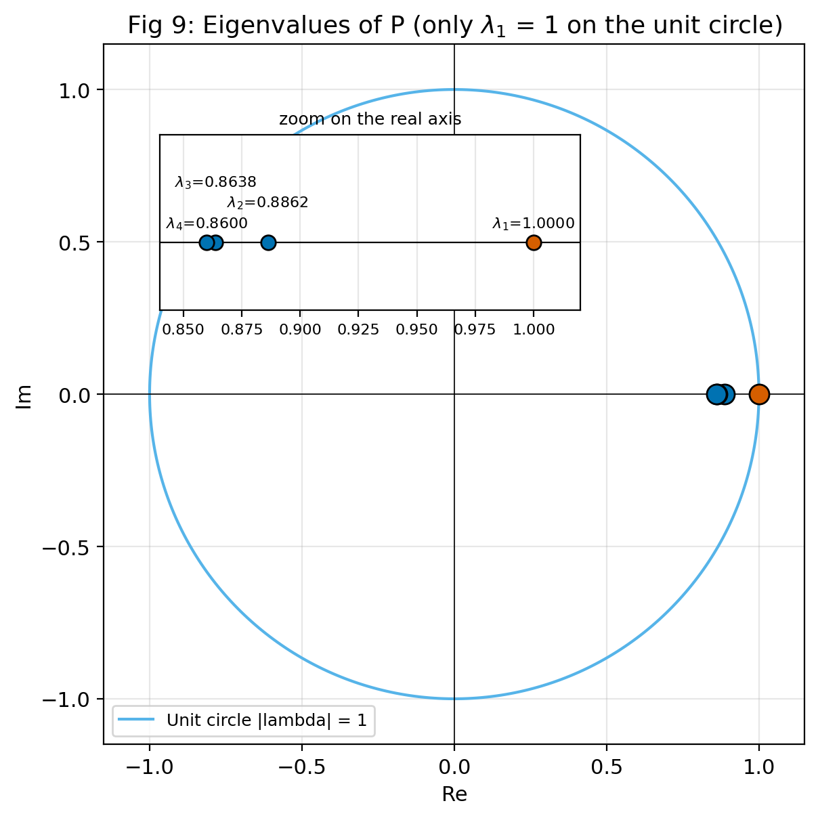
Figure 9: Eigenvalues of P in the complex plane with the unit circle (inset: zoom on the real axis). Only λ1 = 1 lies on the circle; the other three are inside it.

5.5 Convergence speed
We measure the distance to the steady state by d_{k} = Σ|x_{k,i} − π_{i}| using shares. Because d_{k} ≈ C|λ₂|^{k}, taking logarithms gives the estimate k ≈ ln(ε/C)/ln|λ₂| for the years needed to reach distance ε. With |λ₂| = 0.8862 and C = ‖c₂v₂‖₁ = 0.4894, taken from the eigen-decomposition (c = V⁻¹x₀), we get Table 10. An earlier draft fitted C from the simulated curve itself (C = d₂₀/|λ₂|²⁰ = 0.4558), which made the ‘theory’ column partly circular. The slowest mode loses half of its size every 5.7 years.
Table 10: Years until the distance to the steady state drops below a threshold
Threshold | Actual (simulation) | Theory from |λ₂|^{k}
1% (d_{k} < 0.01) | 32 | 33
0.1% (d_{k} < 0.001) | 51 | 52
Theory over-estimates by one year because the faster modes (λ₃ = 0.8638, λ₄ = 0.8600) have coefficients of opposite sign to c₂, so they slightly cancel the slowest mode during the first decades.

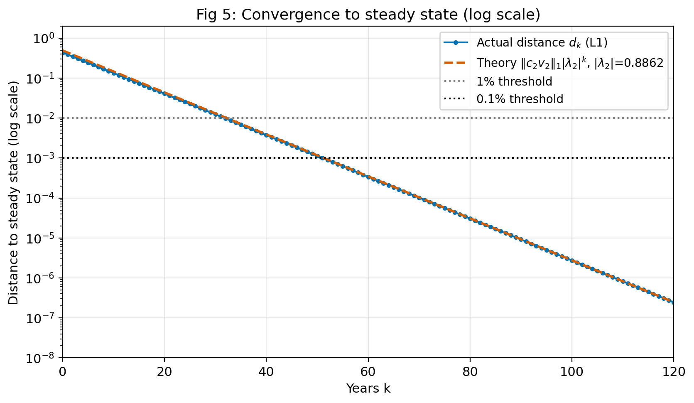
Figure 5: Distance to the steady state on a log scale. The straight line shows geometric decay at rate |λ₂|.
Different starting points. Figure 6 starts the system from four very different distributions (the Census-based one, everyone in Delhi, uniform, everyone in Faridabad). All of them end at the same steady state, as the theorem predicts: the long-term result depends on P, not on the starting point.
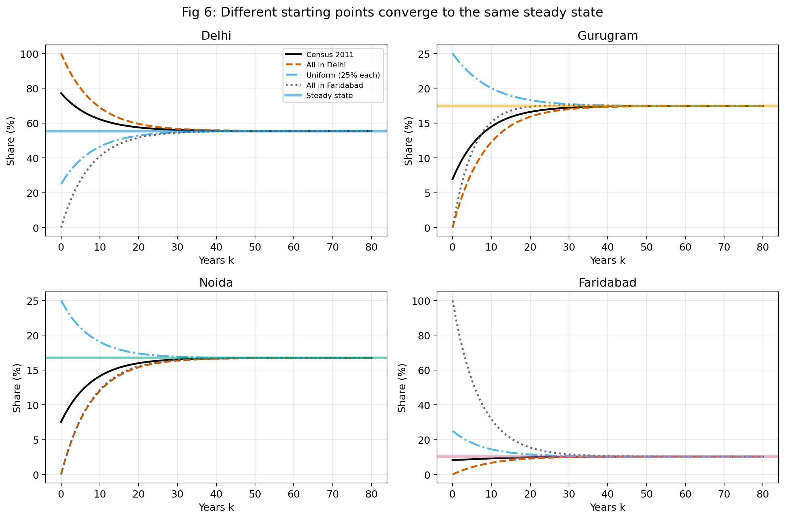
Figure 6: Four different starting distributions converge to the same steady state.

6 Scenario and Sensitivity Analysis

6.1 Scenarios (simulated what-if changes)
- Scenario A – Faridabad improves infrastructure. Faridabad's retention rises from 0.880 to 0.920, and the flows into Faridabad increase (from Delhi 0.010 → 0.015, from Gurugram 0.020 → 0.030, from Noida 0.020 → 0.030). The other columns are rebalanced so that every column still sums to 1.
- Scenario B – Job boom in Gurugram and Noida. Delhi's movers to Gurugram and Noida rise from 0.020 and 0.020 to 0.035 each (Delhi's retention drops to 0.920), and Gurugram and Noida each retain more people (0.920). Columns are rebalanced.
Table 11: Steady-state shares and |λ₂| under each scenario
Scenario | Delhi | Gurugram | Noida | Faridabad | |λ₂|
Baseline | 55.48% | 17.47% | 16.73% | 10.32% | 0.8862
A: Faridabad | 46.62% | 16.60% | 15.86% | 20.91% | 0.9015
B: Job boom | 34.15% | 28.47% | 27.53% | 9.85% | 0.8950
Change A (pp) | -8.86 | -0.86 | -0.87 | +10.59 | 0.0153
Change B (pp) | -21.33 | +11.00 | +10.80 | -0.48 | 0.0088

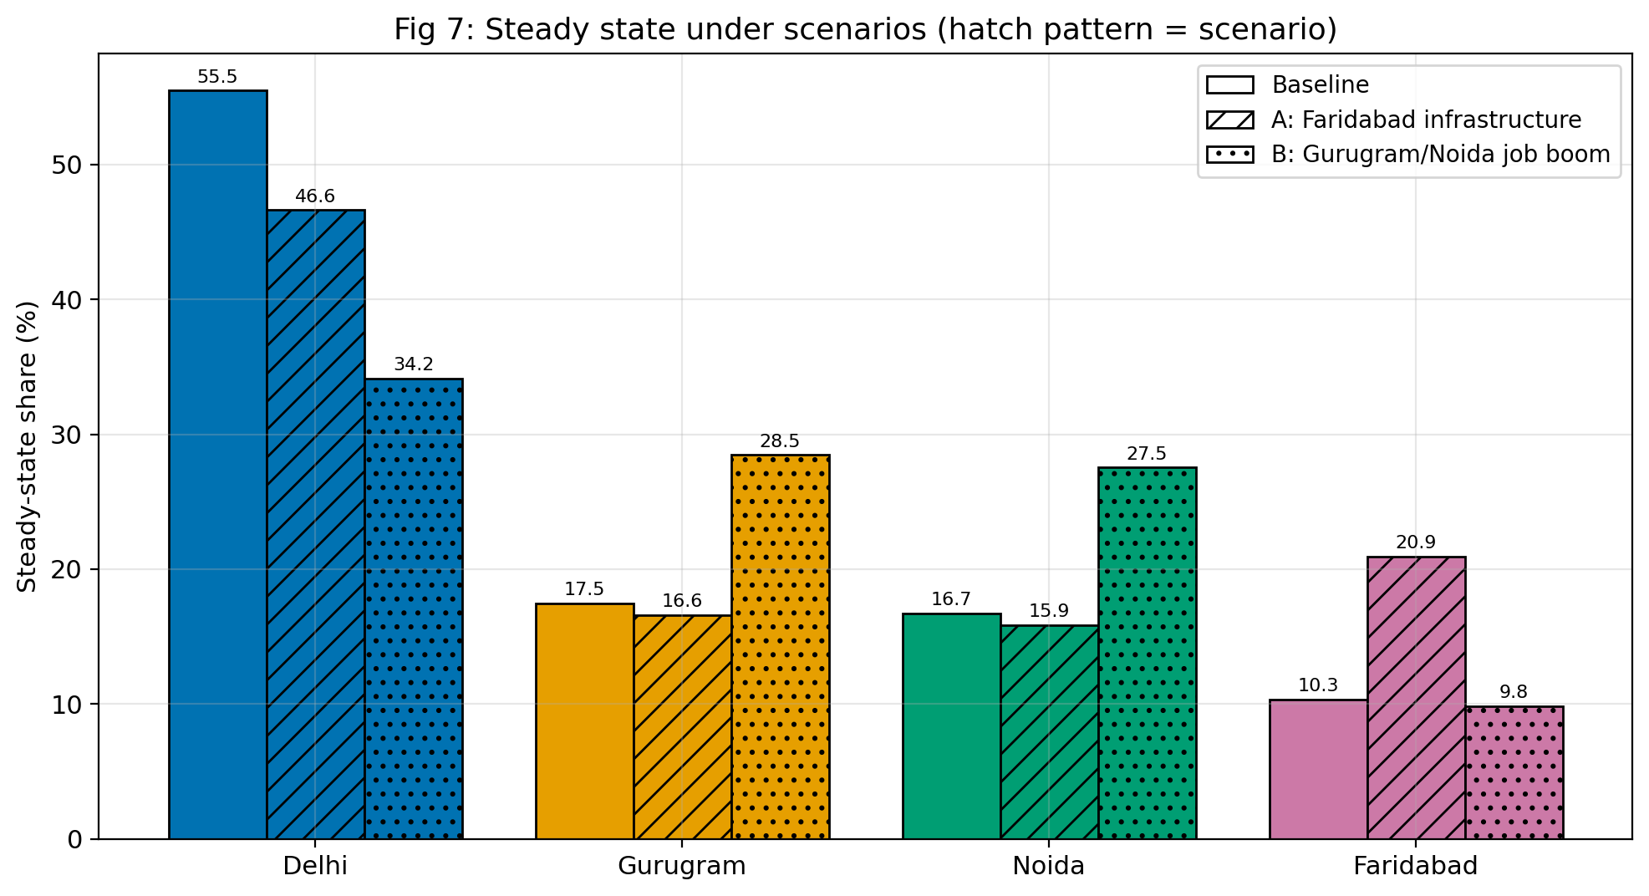
Figure 7: Steady-state shares under the baseline and the two scenarios.
In scenario A Faridabad's long-term share rises from 10.3% to 20.9%, mostly at the expense of Delhi (55.5% → 46.6%). In scenario B Gurugram and Noida jump to 28.5% and 27.5%, while Delhi falls to 34.2%. In both scenarios |λ₂| rises slightly (0.8862 → 0.9015 and 0.8950), so the new steady state would be approached a little more slowly. Small changes in yearly probabilities therefore produce large changes in the long-run shares.

6.2 Sensitivity analysis
To test how much our conclusions depend on the exact numbers in P, we ran 1000 random experiments. In each run every entry of P was multiplied by a random factor between 0.98 and 1.02, the columns were renormalised, and the steady state was recomputed (random seed 42).
Table 12: Steady-state share (%) over 1000 perturbed matrices
Region | Baseline | Mean | Std. dev. | Min | Max
Delhi | 55.48 | 55.47 | 0.39 | 54.36 | 56.68
Gurugram | 17.47 | 17.48 | 0.24 | 16.74 | 18.20
Noida | 16.73 | 16.73 | 0.23 | 15.94 | 17.49
Faridabad | 10.32 | 10.33 | 0.14 | 9.95 | 10.74

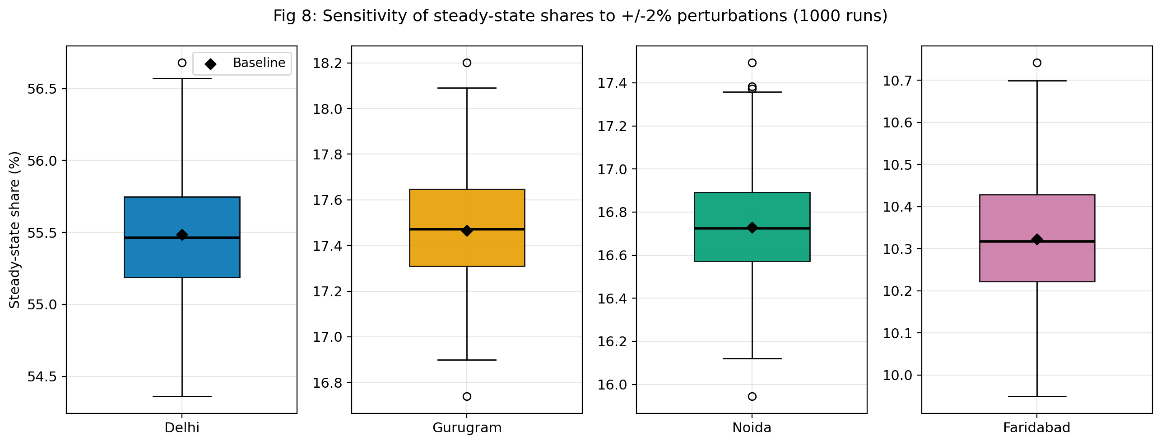
Figure 8: Distribution of the steady-state shares over 1000 perturbations (diamond = baseline).
Conclusion on robustness. The standard deviation of each share is at most 0.39 percentage points, and the largest deviation from the baseline over all runs is 1.20 percentage points. |λ₂| stays between 0.8835 and 0.8894. So the qualitative picture (Delhi largest, Faridabad smallest, convergence in several decades) is robust to ±2% errors in P. It is, however, not robust to the larger structural changes of the scenarios, which is why accurate data on retention would matter.

7 Open-System Extension
Sections 4–6 used a closed system. Here we let people be born, die, leave the NCR and arrive from outside (Section 2.6), and we check the simulated P against two real censuses.

7.1 Can the simulated P explain the census?
Over 10 years the model gives x2011 = A¹⁰x2001 + S10m with S10 = I + A + … + A⁹. Since the censuses fix x2001 and x2011, the yearly arrivals m solve the 4 × 4 linear system S10m = x2011 − A¹⁰x2001, which we solve with the same Gaussian elimination as in Section 5.3.
Finding. With P at full strength the solution needs negative arrivals: −210,414 people a year into Gurugram and −192,075 into Noida (Figure 12a). That is impossible, so our simulated P moves too many people. For example, 2% of Delhi moving to Gurugram is about 335,000 people a year, which would add 22% to Gurugram in a single year, while the census shows +74% over ten years. Scaling mobility with Pα = I + α(P − I), the largest α that gives non-negative arrivals everywhere is α = 0.137: the census supports only about 14% of the simulated movement. The calibrated arrivals are Delhi 293,386, Gurugram 21,143, Noida 0 and Faridabad 31,852 people a year (346,381 in total).
The steady state π does not change with α, so every result of Sections 5–6 about the long-run shares still holds. What changes is the speed: |λ₂| becomes 1 + 0.137(0.8862 − 1) = 0.984, so convergence is about 7.7 times slower. Note that this is an exact fit (four equations, four unknowns), not an independent test of the model.
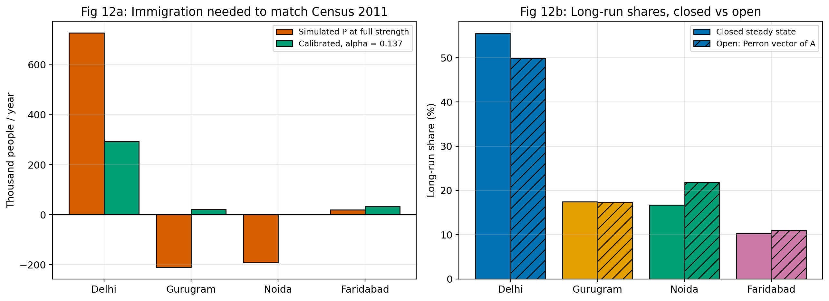
Figure 12: (a) Yearly arrivals needed to reproduce Census 2011, with P at full strength and with α = 0.137. (b) Long-run shares of the closed model (steady state) and the open model (Perron vector of A).

7.2 Forecast 2011–2041
Starting from Census 2011 with α = 0.137 and the calibrated arrivals, the four districts grow from 21.76 million to about 36.8 million in 2041 (Table 13, Figure 10). Unlike the closed model, Delhi grows too. Writing x₃₀ = A³⁰x₀ + S₃₀m splits the 2041 population into 25.6 million descendants of the 2011 residents and 11.2 million people who arrived after 2011, with their children (Figure 11).
Table 13: Open-model forecast (millions of people)
Year | Delhi | Gurugram | Noida | Faridabad | Total
2011 | 16.79 | 1.51 | 1.65 | 1.81 | 21.76
2021 | 19.80 | 2.22 | 2.19 | 2.28 | 26.49
2031 | 22.89 | 2.98 | 2.84 | 2.78 | 31.49
2041 | 26.08 | 3.80 | 3.59 | 3.32 | 36.78
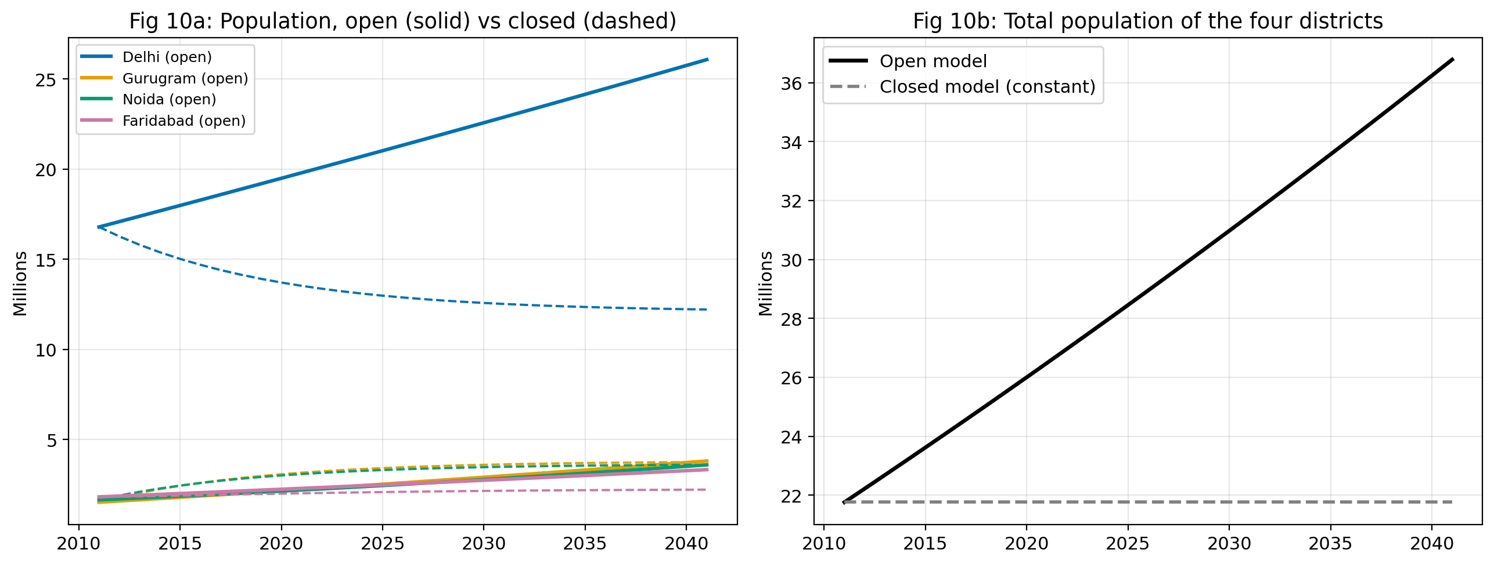
Figure 10: Open model (solid) against the closed model (dashed). Left: each region. Right: total population.
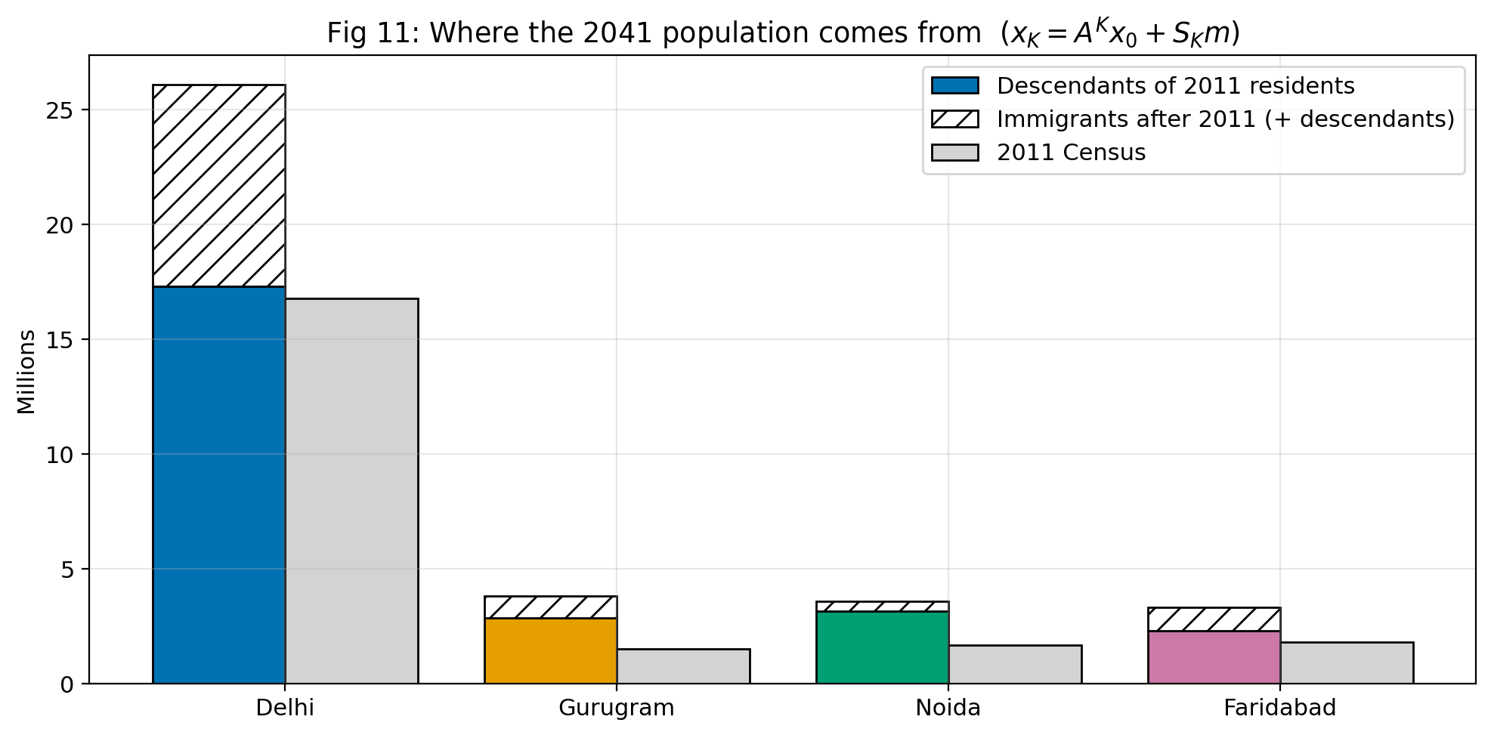
Figure 11: Where the 2041 population comes from: descendants of 2011 residents (A³⁰x₀) and later arrivals (S₃₀m).

7.3 Long-run behaviour
The dominant eigenvalue of A is ρ(A) = 1.00626, so in the long run the population grows by 0.63% a year. ρ(A) > 1, so x* = (I − A)⁻¹m is not an attractor (its entries are even negative); the shares instead approach the Perron vector of A: Delhi 49.8%, Gurugram 17.4%, Noida 21.8%, Faridabad 11.0% (Figure 12b). Noida ends higher than in the closed model (16.7%) because Uttar Pradesh has the highest natural growth. Because α is small, this limit is approached very slowly: in 2041 Delhi still holds 70.9%.

7.4 What-if cases
Table 14: Total population of the four districts in 2041 under different assumptions
Case | Total 2041 (million) | Delhi share | Change vs baseline
Baseline | 36.78 | 70.9% | –
Emigration x2 | 31.23 | 71.9% | -5.56 M
Natural growth -30% | 33.64 | 71.6% | -3.14 M
Immigration +50% | 42.37 | 71.9% | +5.59 M
Immigration stops | 25.60 | 67.6% | -11.18 M
Arrivals matter most: without them the four districts would hold 25.6 million people in 2041 instead of 36.8 million. Doubling emigration removes about 5.6 million. These numbers rest on simulated emigration and on α fitted to one decade, so they show sensitivities, not an official forecast.

8 Discussion

8.1 What the numbers mean in plain English
Every year about 5% of Delhi's residents move to the other three regions, but Delhi receives 6–7% of the residents of each of the others. Because Delhi starts with 77% of the people, the movers going into Delhi are few in absolute terms compared with the many movers going out, so Delhi's share falls steadily until outflow equals inflow at 55.5%. The other three regions grow towards 17.5%, 16.7% and 10.3%. After about 32 years the distribution is within 1% (in total distance) of the steady state, so the long-term picture is reached within a generation or two.
We must be careful: in this model the number of people living in Delhi falls from 16,787,941 to 12,207,751 after 30 years. Real Delhi has not behaved this way, because births and migration from other states more than compensate. This is an artefact of the closed-system assumption and the simulated probabilities, not a prediction. Section 7 removes the closed-system assumption.

8.2 Limitations
- Closed system: no births, deaths, or movement into or out of the four regions.
- Constant P: real movement probabilities change with the economy, policy and infrastructure.
- Memoryless: a person's next move is assumed to depend only on where they live now, not on how long they have lived there.
- Simulated data: the transition probabilities are not measured; our conclusions are about the model, not about reality.
- Constant retention and identical people: all residents of a region are treated the same.
- Approximate populations: Census 2011 figures at district level, which are now old.

8.3 What if P is not regular?
The steady-state theorem needs regularity. If a region has retention 1 (an absorbing state), people who enter it never leave. In our 3-state example with such a state, starting from state 1 the population after 200 steps is (0.000003, 0.000004, 0.999993): everybody ends in the absorbing state, and the steady state is not driven by inflow–outflow balance. A periodic chain such as P = [[0, 1],[1, 0]] has eigenvalues 1 and −1; starting from (1, 0) the vector flips between (1, 0) and (0, 1) forever and has no limit. For these chains the |λ₂| < 1 argument fails, so the result of Section 2.3 cannot be used. Our matrix is strictly positive, so it is regular.

8.4 What real data would change
With real data (for example yearly origin–destination counts from administrative or survey sources), the diagonal entries would probably be much closer to 1 and the off-diagonal entries smaller and less symmetric. We would also be able to add rows and columns for ‘rest of India’, births and deaths (making the matrix non-stochastic or adding an input vector), and let P change with time. The mathematical tools (matrix powers, eigenvalues, steady state) would remain the same.

9 Conclusion
We built a regular, column-stochastic transition matrix for four NCR regions, projected the population by matrix multiplication and found the steady state (Delhi 55.48%, Gurugram 17.47%, Noida 16.73%, Faridabad 10.32%) by three independent methods that agree. Diagonalisation shows that the λ = 1 eigenvector survives while the other components decay at the rates 0.8862^{k}, 0.8638^{k} and 0.8600^{k}, and |λ₂| predicts the convergence time well. The scenarios show that small changes in yearly probabilities shift the long-run shares considerably, whereas ±2% random errors change them by at most 1.2 percentage points. The main limitation is that the transition probabilities are simulated; the project demonstrates the method, and real migration data would be needed for real predictions.

10 References
- D. Poole, Linear Algebra: A Modern Introduction (course textbook; chapter on Markov chains).
- D. G. Zill, Advanced Engineering Mathematics (for matrices and eigenvalue methods).
- Census of India 2011, Office of the Registrar General & Census Commissioner, India: district totals for NCT of Delhi, Gurgaon, Gautam Buddha Nagar and Faridabad (also the 2001 totals used for calibration in Section 7).
- Python 3, NumPy, Matplotlib, pandas and seaborn software documentation (used for all computations and figures).

Individual contribution (placeholder – edit before submission)
Member | Roll No. | Contribution (edit)
Mansi Awasthi | 250450 | e.g. Mathematical background and 2 × 2 example
Prince Kumar Yadav | 250500 | e.g. Python code, figures and results
Shobhit Rai | 250557 | e.g. Scenario and sensitivity analysis
Ishank Chauhan | 250406 | e.g. Report editing, data and coordination

Appendix A: Full Code Listing (project_code.py)
#!/usr/bin/env python3
"""
Group 14 - MTH2802 Linear Algebra & Differential Equations (BML Munjal University)
Project : Predicting Population Movement Using Transition Matrices
Convention (Poole): P is COLUMN-stochastic, x_{k+1} = P x_k,
P[i][j] = Prob(person in region j this year lives in region i next year).
Run : python project_code.py (creates figures/, results.json, results.txt next to this file)
NOTE : Transition probabilities are SIMULATED. Populations are APPROXIMATE (Census 2011).
"""
import json, math, warnings
from pathlib import Path
import numpy as np
import pandas as pd
import matplotlib
matplotlib.use("Agg")
import matplotlib.pyplot as plt
from matplotlib.patches import FancyArrowPatch
try:
import seaborn as sns
except ImportError: # graceful fallback: heatmap drawn with matplotlib only
sns = None
warnings.filterwarnings("ignore")
np.random.seed(42) # reproducibility
rng = np.random.default_rng(42)

OUT = Path(__file__).resolve().parent
FIG = OUT / "figures"; FIG.mkdir(exist_ok=True)
DPI = 200

# ----------------------------------------------------------------------------------
# 0. EDITABLE INPUTS
# ----------------------------------------------------------------------------------
# APPROXIMATE populations, from Census of India 2011 (district level), TO BE VERIFIED BY THE GROUP.
INITIAL_POPULATION = {
"Delhi": 16_787_941, # NCT of Delhi (approx., Census 2011)
"Gurugram": 1_514_085, # Gurgaon district (approx., Census 2011)
"Noida": 1_674_714, # Gautam Buddha Nagar district (approx., Census 2011)
"Faridabad": 1_809_733, # Faridabad district (approx., Census 2011)
}
REGIONS = list(INITIAL_POPULATION)
n = len(REGIONS)
COLORS = {"Delhi": "#0072B2", "Gurugram": "#E69F00", "Noida": "#009E73", "Faridabad": "#CC79A7"} # Okabe-Ito (colour-blind safe)
REG_COL = [COLORS[r] for r in REGIONS]

# SIMULATED transition matrix (column j = where people living in region j go next year). Columns sum to 1.
# from: Delhi Gurugram Noida Faridabad
P = np.array([[0.950, 0.060, 0.060, 0.070], # to Delhi
[0.020, 0.890, 0.030, 0.030], # to Gurugram
[0.020, 0.030, 0.890, 0.020], # to Noida
[0.010, 0.020, 0.020, 0.880]]) # to Faridabad

R = {} # everything that goes in results.json
LOG = [] # lines for results.txt
PASSED = [] # assertion log
def out(s=""):
print(s); LOG.append(str(s))
def check(cond, msg):
assert cond, "FAILED: " + msg
PASSED.append(msg); out(f"[PASS] {msg}")
def L(a, d=6): return np.round(np.asarray(a, dtype=float), d).tolist()
def savefig(name):
plt.tight_layout(); plt.savefig(FIG / name, dpi=DPI, bbox_inches="tight"); plt.close()
def pct(v): return 100 * np.asarray(v)

plt.rcParams.update({"font.size": 11, "axes.titlesize": 13, "axes.labelsize": 11, "legend.fontsize": 10,
"axes.grid": True, "grid.alpha": 0.3})

def steady_eig(M):
"""Steady state via eigenvector for lambda = 1, normalised to sum 1."""
w, V = np.linalg.eig(M)
i = np.argmin(abs(w - 1)); v = np.real(V[:, i]); return v / v.sum()

def gauss_solve(A, b, verbose=False):
"""Gaussian elimination with partial pivoting + back substitution (course-style)."""
A = A.astype(float).copy(); b = b.astype(float).copy(); m = len(b)
for c in range(m):
p = c + np.argmax(abs(A[c:, c])); A[[c, p]] = A[[p, c]]; b[[c, p]] = b[[p, c]]
for r in range(c + 1, m):
f = A[r, c] / A[c, c]; A[r, c:] -= f * A[c, c:]; b[r] -= f * b[c]
if verbose:
out("Row-echelon form [A | b] after forward elimination:")
for r in range(m): out(" " + " ".join(f"{A[r, j]:9.5f}" for j in range(m)) + " | " + f"{b[r]:9.5f}")
x = np.zeros(m)
for r in range(m - 1, -1, -1): x[r] = (b[r] - A[r, r + 1:] @ x[r + 1:]) / A[r, r]
return x

def second_eig(M):
ev = np.linalg.eigvals(M); ev = ev[np.argsort(-abs(ev))]; return abs(ev[1])

# ----------------------------------------------------------------------------------
# 1. BUILD P AND VERIFY BASIC PROPERTIES
# ----------------------------------------------------------------------------------
out("=" * 78); out("1. TRANSITION MATRIX P (SIMULATED, column-stochastic)"); out("=" * 78)
out(pd.DataFrame(P, index=["to " + r for r in REGIONS], columns=["from " + r for r in REGIONS]).to_string())
check(np.allclose(P.sum(axis=0), 1, atol=1e-12), "Every column of P sums to 1")
check(all(round(float(c), 3) == 1.0 for c in P.sum(axis=0)), "Column sums equal 1 when rounded to 3 decimals")
check((P >= 0).all(), "All entries of P are non-negative")
check((P > 0).all(), "All entries of P strictly positive (so P^1 > 0)")
check(all(0.88 <= P[i, i] <= 0.96 for i in range(n)), "Retention (diagonal) lies in [0.88, 0.96]")
k_reg = next(k for k in range(1, 50) if (np.linalg.matrix_power(P, k) > 0).all())
check(k_reg == 1, f"Regularity: smallest k with P^k > 0 is k = {k_reg}")
R["P"] = L(P, 3); R["regions"] = REGIONS; R["retention"] = {r: float(P[i, i]) for i, r in enumerate(REGIONS)}
R["column_sums"] = L(P.sum(axis=0), 12); R["smallest_k_regular"] = k_reg
R["initial_population_approx_census2011"] = INITIAL_POPULATION

x0 = np.array(list(INITIAL_POPULATION.values()), dtype=float); N0 = x0.sum()
s0 = x0 / N0
R["total_population"] = int(N0); R["initial_share"] = L(s0)
out(f"\nTotal initial population (approx.) = {int(N0):,}; initial shares = {np.round(s0, 4)}")

# ----------------------------------------------------------------------------------
# 9a. HAND-CHECKABLE EXAMPLE: x_1 for Gurugram, step by step
# ----------------------------------------------------------------------------------
out("\n" + "=" * 78); out("HAND-CHECKABLE EXAMPLE: population of Gurugram after 1 year"); out("=" * 78)
row = 1
terms = [P[row, j] * x0[j] for j in range(n)]
out("x_1[Gurugram] = sum_j P[Gurugram][j] * x_0[j]")
for j in range(n): out(f" from {REGIONS[j]:<10}: {P[row, j]:.3f} x {x0[j]:>12,.0f} = {terms[j]:>14,.1f}")
out(f" TOTAL = {sum(terms):,.1f} (people in Gurugram after 1 year)")
R["hand_example"] = {"region": REGIONS[row], "row_of_P": L(P[row], 3), "x0": x0.tolist(),
"terms": L(terms, 1), "x1_value": round(float(sum(terms)), 1)}
x1_check = P @ x0
check(abs(x1_check[row] - sum(terms)) < 1e-6, "Hand-calculation of x_1[Gurugram] matches P @ x_0")
check(abs(x1_check.sum() - N0) < 1e-6, "Total population conserved after 1 step (closed system)")

# ----------------------------------------------------------------------------------
# 2. PROJECTIONS x_0 ... x_30 AND MATRIX POWERS
# ----------------------------------------------------------------------------------
out("\n" + "=" * 78); out("2. PROJECTIONS x_{k+1} = P x_k"); out("=" * 78)
K = 30
X = np.zeros((K + 1, n)); X[0] = x0
for k in range(K): X[k + 1] = P @ X[k]
S = X / X.sum(axis=1, keepdims=True)
show = [0, 1, 2, 5, 10, 20, 30]
tab = pd.DataFrame({"k (years)": show})
for i, r in enumerate(REGIONS): tab[r + " (persons)"] = [round(X[k, i]) for k in show]
out(tab.to_string(index=False))
tab2 = pd.DataFrame({"k (years)": show})
for i, r in enumerate(REGIONS): tab2[r + " (%)"] = [round(100 * S[k, i], 2) for k in show]
out("\nShares in percent:"); out(tab2.to_string(index=False))
R["projection_k"] = show
R["projection_counts"] = {str(k): [round(float(v)) for v in X[k]] for k in show}
R["projection_shares"] = {str(k): L(S[k], 6) for k in show}
check(np.allclose(X.sum(axis=1), N0), "Total population constant for all k = 0..30")
check(np.allclose(S.sum(axis=1), 1), "Shares sum to 1 for all k")

out("\nMATRIX POWERS (columns converge to the same vector):")
R["matrix_powers"] = {}; R["power_column_spread"] = {}
for p_ in [2, 5, 10, 50]:
Pp = np.linalg.matrix_power(P, p_)
out(f"\nP^{p_} =\n{np.round(Pp, 4)}")
spread = float(np.max(Pp.max(axis=1) - Pp.min(axis=1)))
out(f" largest difference between columns in any row = {spread:.2e}")
R["matrix_powers"][f"P^{p_}"] = L(Pp, 6); R["power_column_spread"][f"P^{p_}"] = spread
check(R["power_column_spread"]["P^50"] < 1e-2, "Columns of P^50 are (almost) identical")

# ----------------------------------------------------------------------------------
# 3. STEADY STATE - THREE INDEPENDENT METHODS
# ----------------------------------------------------------------------------------
out("\n" + "=" * 78); out("3. STEADY STATE (three methods)"); out("=" * 78)
pi_a = steady_eig(P)
A = P - np.eye(n); A_c = A.copy(); A_c[-1, :] = 1.0; b_c = np.zeros(n); b_c[-1] = 1.0
out("Method (b): replace the last equation of (P-I)pi = 0 by pi1+pi2+pi3+pi4 = 1.")
out("Augmented matrix [A | b] BEFORE elimination:")
for r in range(n): out(" " + " ".join(f"{A_c[r, j]:9.4f}" for j in range(n)) + " | " + f"{b_c[r]:6.1f}")
pi_b = gauss_solve(A_c, b_c, verbose=True)
pi_c = np.linalg.matrix_power(P, 200)[:, 0]
for nm, v in zip(["(a) eigenvector", "(b) linear system", "(c) P^200 column"], [pi_a, pi_b, pi_c]):
out(f" {nm:<20}: " + " ".join(f"{REGIONS[i]} {v[i]:.8f}" for i in range(n)))
check(np.max(abs(pi_a - pi_b)) < 1e-8, "Steady state: eigenvector method == linear-system method (<1e-8)")
check(np.max(abs(pi_a - pi_c)) < 1e-8, "Steady state: eigenvector method == P^200 method (<1e-8)")
check(np.max(abs(pi_b - pi_c)) < 1e-8, "Steady state: linear-system method == P^200 method (<1e-8)")
pi = pi_a
check(np.allclose(P @ pi, pi, atol=1e-12), "P pi = pi holds")
check(pi.min() > 0.05, f"No region collapses below 5% (smallest share = {100 * pi.min():.2f}%)")
R["steady_state"] = {"eigenvector": L(pi_a, 10), "linear_system": L(pi_b, 10), "P200": L(pi_c, 10),
"max_abs_difference": float(max(abs(pi_a - pi_b).max(), abs(pi_a - pi_c).max()))}
R["steady_state_counts"] = [round(float(v)) for v in pi * N0]

# ----------------------------------------------------------------------------------
# 4. EIGEN-DECOMPOSITION
# ----------------------------------------------------------------------------------
out("\n" + "=" * 78); out("4. EIGEN-DECOMPOSITION P = V D V^-1"); out("=" * 78)
w, V = np.linalg.eig(P)
check(np.allclose(w.imag, 0), "All eigenvalues are real")
w = w.real; V = V.real
order = np.argsort(-w); w = w[order]; V = V[:, order]
check(len(set(np.round(w, 8))) == n, "All eigenvalues are distinct")
check(np.min(np.diff(np.sort(w))) > 1e-3, "Eigenvalues separated by more than 1e-3")
for j in range(n): # normalisation: v1 sums to 1 (= steady state); others unit length, first nonzero entry > 0
if j == 0: V[:, j] = V[:, j] / V[:, j].sum()
else:
V[:, j] = V[:, j] / np.linalg.norm(V[:, j])
if V[np.argmax(abs(V[:, j]) > 1e-12), j] < 0: V[:, j] *= -1
D = np.diag(w); Vinv = np.linalg.inv(V)
rec_err = np.max(abs(V @ D @ Vinv - P))
out("Eigenvalues: " + ", ".join(f"{x:.6f}" for x in w))
out("Eigenvectors (columns of V):\n" + str(np.round(V, 5)))
out(f"Reconstruction error max|V D V^-1 - P| = {rec_err:.2e}")
check(rec_err < 1e-12, "P = V D V^-1 reconstruction error < 1e-12")
check(abs(w[0] - 1) < 1e-12, "Largest eigenvalue is exactly 1 (lambda_1 = 1)")
check(abs(V[:, 0] - pi).max() < 1e-10, "Eigenvector for lambda = 1 equals the steady state")
check(all(abs(V[:, j].sum()) < 1e-10 for j in range(1, n)), "Other eigenvectors have components summing to 0")
P10_dir = np.linalg.matrix_power(P, 10); P10_diag = V @ np.diag(w ** 10) @ Vinv
err10 = np.max(abs(P10_dir - P10_diag)); out(f"P^10 via V D^10 V^-1 vs matrix_power: max error = {err10:.2e}")
check(err10 < 1e-12, "P^10 = V D^10 V^-1 matches np.linalg.matrix_power(P,10)")
c = Vinv @ s0 # coefficients of x_0 (shares)
out("\nDecomposition of the initial SHARE vector: x_0 = c1 v1 + c2 v2 + c3 v3 + c4 v4")
for j in range(n): out(f" c{j + 1} = {c[j]: .6f} (lambda_{j + 1} = {w[j]:.6f}, lambda^30 = {w[j] ** 30:.3e})")
check(np.allclose(V @ c, s0), "x_0 = sum c_j v_j reconstruction")
check(abs(c[0] - 1) < 1e-10, "c1 = 1 for a share vector (total population share)")
out("Why: x_k = c1 (1)^k v1 + c2 (l2)^k v2 + ...; since |l2|,|l3|,|l4| < 1 those terms -> 0, only c1 v1 = steady state survives.")
R["eigenvalues"] = L(w, 8); R["eigenvectors_V"] = L(V, 6); R["V_inverse"] = L(Vinv, 6)
R["D"] = L(D, 8); R["reconstruction_error"] = float(rec_err); R["P10_error"] = float(err10)
R["x0_coefficients"] = L(c, 6); R["eigenvalue_powers_k30"] = [float(v ** 30) for v in w]
R["P10_direct"] = L(P10_dir, 6)
lam2 = abs(w[1]); R["lambda2_abs"] = float(lam2); R["slowest_mode_halflife_years"] = float(math.log(0.5) / math.log(lam2))

# ----------------------------------------------------------------------------------
# 5. CONVERGENCE SPEED
# ----------------------------------------------------------------------------------
out("\n" + "=" * 78); out("5. CONVERGENCE SPEED"); out("=" * 78)
def dist_curve(start_share, kmax=120):
x = np.array(start_share, float); d = []
for k in range(kmax + 1): d.append(np.abs(x - pi).sum()); x = P @ x
return np.array(d) # L1 distance (total variation x2) between shares and steady state
dist = dist_curve(s0)
first = lambda thr: int(np.argmax(dist < thr))
k1, k01 = first(0.01), first(0.001)
Cfit = dist[20] / lam2 ** 20 # asymptotic constant: d_k ~ C |lambda_2|^k
th = lambda thr: math.ceil(math.log(thr / Cfit) / math.log(lam2))
out(f"|lambda_2| = {lam2:.6f}; L1 distance d_k = sum_i |x_k,i - pi_i| (shares)")
out(f"d_0 = {dist[0]:.5f}; fitted constant C = d_20/|l2|^20 = {Cfit:.5f}")
out(f"Years until d_k < 1% : actual {k1}, theoretical ceil(ln(0.01/C)/ln|l2|) = {th(0.01)}")
out(f"Years until d_k < 0.1% : actual {k01}, theoretical ceil(ln(0.001/C)/ln|l2|) = {th(0.001)}")
check(abs(k1 - th(0.01)) <= 2 and abs(k01 - th(0.001)) <= 2, "Actual convergence times agree with |lambda_2|^k theory (within 2 years)")
R["convergence"] = {"d0": float(dist[0]), "C_fit": float(Cfit), "years_to_1pct_actual": k1, "years_to_0.1pct_actual": k01,
"years_to_1pct_theory": th(0.01), "years_to_0.1pct_theory": th(0.001),
"d_at_k": {str(k): float(dist[k]) for k in [0, 1, 2, 5, 10, 20, 30]}}

# ----------------------------------------------------------------------------------
# 6. MULTIPLE INITIAL DISTRIBUTIONS
# ----------------------------------------------------------------------------------
starts = {"Census-based (approx.)": s0, "All in Delhi": np.array([1., 0, 0, 0]), "Uniform (25% each)": np.ones(4) / 4,
"All in Faridabad": np.array([0, 0, 0, 1.])}
out("\n" + "=" * 78); out("6. DIFFERENT STARTING POINTS -> SAME LIMIT"); out("=" * 78)
traj = {}; R["multi_start"] = {}
for nm, s in starts.items():
xs = [s];
for k in range(120): xs.append(P @ xs[-1])
traj[nm] = np.array(xs)
out(f" {nm:<22} share after 120 yrs: {np.round(xs[-1], 6)}")
check(np.abs(xs[-1] - pi).max() < 1e-5, f"Start '{nm}' converges to the steady state")
R["multi_start"][nm] = {"start": L(s), "after_120": L(xs[-1], 8)}

# ----------------------------------------------------------------------------------
# 7. SCENARIOS
# ----------------------------------------------------------------------------------
out("\n" + "=" * 78); out("7. SCENARIO ANALYSIS (all SIMULATED what-if changes)"); out("=" * 78)
def set_col(M, col, new): # replace a column (dict region->prob) and check it sums to 1
M = M.copy(); M[:, col] = [new[r] for r in REGIONS]; assert abs(M[:, col].sum() - 1) < 1e-12; return M
# Scenario A: Faridabad improves infrastructure -> retention 0.880 -> 0.920 and inflow rises (columns re-balanced by hand).
PA = P.copy()
PA = set_col(PA, 0, {"Delhi": 0.945, "Gurugram": 0.020, "Noida": 0.020, "Faridabad": 0.015}) # Delhi -> Faridabad 0.010 -> 0.015
PA = set_col(PA, 1, {"Delhi": 0.050, "Gurugram": 0.890, "Noida": 0.030, "Faridabad": 0.030}) # Gurugram -> Faridabad 0.020 -> 0.030
PA = set_col(PA, 2, {"Delhi": 0.050, "Gurugram": 0.030, "Noida": 0.890, "Faridabad": 0.030}) # Noida -> Faridabad 0.020 -> 0.030
PA = set_col(PA, 3, {"Delhi": 0.045, "Gurugram": 0.020, "Noida": 0.015, "Faridabad": 0.920}) # Faridabad keeps more people
# Scenario B: job boom in Gurugram and Noida -> more movers from Delhi go there, and both retain more people.
PB = P.copy()
PB = set_col(PB, 0, {"Delhi": 0.920, "Gurugram": 0.035, "Noida": 0.035, "Faridabad": 0.010})
PB = set_col(PB, 1, {"Delhi": 0.040, "Gurugram": 0.920, "Noida": 0.025, "Faridabad": 0.015})
PB = set_col(PB, 2, {"Delhi": 0.040, "Gurugram": 0.025, "Noida": 0.920, "Faridabad": 0.015})
PB = set_col(PB, 3, {"Delhi": 0.050, "Gurugram": 0.040, "Noida": 0.030, "Faridabad": 0.880})
scen = {"Baseline": P, "A: Faridabad infrastructure": PA, "B: Gurugram/Noida job boom": PB}
R["scenarios"] = {}; rows = []
for nm, M in scen.items():
check(np.allclose(M.sum(0), 1) and (M > 0).all() and all(0.88 <= M[i, i] <= 0.96 for i in range(n)), f"Scenario '{nm}': valid column-stochastic, positive, retention in range")
ev = np.linalg.eigvals(M); check(np.allclose(ev.imag, 0), f"Scenario '{nm}': eigenvalues real")
ps = steady_eig(M); l2 = second_eig(M)
check(ps.min() > 0.05, f"Scenario '{nm}': smallest steady share {100 * ps.min():.2f}% > 5%")
R["scenarios"][nm] = {"P": L(M, 3), "steady_state": L(ps, 6), "lambda2_abs": float(l2),
"eigenvalues": L(np.sort(ev.real)[::-1], 6),
"change_vs_baseline_pct_points": L(100 * (ps - pi), 4)}
rows.append([nm] + [f"{100 * v:.2f}" for v in ps] + [f"{l2:.4f}"])
out(f"\n{nm}: P =\n{np.round(M, 3)}")
out("\n" + pd.DataFrame(rows, columns=["Scenario"] + [r + " (%)" for r in REGIONS] + ["|lambda_2|"]).to_string(index=False))

# ----------------------------------------------------------------------------------
# 8. SENSITIVITY: 1000 random perturbations (each entry multiplied by U[0.98, 1.02], then columns renormalised)
# ----------------------------------------------------------------------------------
out("\n" + "=" * 78); out("8. SENSITIVITY ANALYSIS (1000 random +/-2% perturbations)"); out("=" * 78)
NSIM = 1000; sens = np.zeros((NSIM, n)); sens_l2 = np.zeros(NSIM)
for t in range(NSIM):
Q = P * rng.uniform(0.98, 1.02, size=P.shape); Q = Q / Q.sum(axis=0, keepdims=True)
sens[t] = steady_eig(Q); sens_l2[t] = second_eig(Q)
sm = pd.DataFrame({"Region": REGIONS, "Baseline %": 100 * pi, "Mean %": 100 * sens.mean(0), "Std %": 100 * sens.std(0, ddof=1),
"Min %": 100 * sens.min(0), "Max %": 100 * sens.max(0)})
out(sm.round(3).to_string(index=False))
max_dev = float(np.max(100 * np.abs(sens - pi)))
out(f"Largest deviation of any share from baseline over all 1000 runs = {max_dev:.3f} percentage points")
out(f"|lambda_2| over runs: mean {sens_l2.mean():.4f}, min {sens_l2.min():.4f}, max {sens_l2.max():.4f}")
check(max_dev < 3.0, "Steady-state shares stay within 3 percentage points of baseline under +/-2% perturbations (robust)")
R["sensitivity"] = {"n_runs": NSIM, "perturbation": "each entry multiplied by U[0.98,1.02], columns renormalised",
"per_region": {REGIONS[i]: {"baseline_pct": float(100 * pi[i]), "mean_pct": float(100 * sens[:, i].mean()),
"std_pct": float(100 * sens[:, i].std(ddof=1)), "min_pct": float(100 * sens[:, i].min()),
"max_pct": float(100 * sens[:, i].max())} for i in range(n)},
"max_deviation_pct_points": max_dev,
"lambda2_mean": float(sens_l2.mean()), "lambda2_min": float(sens_l2.min()), "lambda2_max": float(sens_l2.max())}

# ----------------------------------------------------------------------------------
# 9b. 2x2 TOY EXAMPLE (by hand)
# ----------------------------------------------------------------------------------
out("\n" + "=" * 78); out("9b. 2x2 TOY EXAMPLE T = [[0.9, 0.2],[0.1, 0.8]]"); out("=" * 78)
T = np.array([[0.9, 0.2], [0.1, 0.8]]); tr = T.trace(); det = np.linalg.det(T)
disc = tr ** 2 - 4 * det; l_1 = (tr + math.sqrt(disc)) / 2; l_2 = (tr - math.sqrt(disc)) / 2
out(f"Characteristic equation: lambda^2 - (trace) lambda + det = lambda^2 - {tr:.1f} lambda + {det:.2f} = 0")
out(f" => lambda = {l_1:.1f} and {l_2:.1f}")
out("lambda = 1: (T - I)v = 0 -> -0.1 a + 0.2 b = 0 -> a = 2b -> v1 = (2,1) -> normalised (2/3, 1/3)")
out("lambda = 0.7: (T - 0.7I)v = 0 -> 0.2 a + 0.2 b = 0 -> b = -a -> v2 = (1,-1)")
Tw, Tv = np.linalg.eig(T); pT = steady_eig(T)
check(np.allclose(sorted(Tw), [0.7, 1.0]), "Toy 2x2: eigenvalues are 1 and 0.7")
check(np.allclose(pT, [2 / 3, 1 / 3]), "Toy 2x2: steady state is (2/3, 1/3)")
xt = np.array([0.5, 0.5]); toy_seq = [xt.tolist()]
for k in range(3): xt = T @ xt; toy_seq.append(xt.tolist())
out("Start (0.5,0.5): " + " -> ".join(str(np.round(v, 4)) for v in toy_seq))
R["toy_2x2"] = {"T": T.tolist(), "eigenvalues": [l_1, l_2], "steady_state": pT.tolist(), "sequence_from_(0.5,0.5)": toy_seq,
"v1": [2, 1], "v2": [1, -1]}

# ----------------------------------------------------------------------------------
# 10. LIMITATIONS: NON-REGULAR / ABSORBING / PERIODIC
# ----------------------------------------------------------------------------------
out("\n" + "=" * 78); out("10. WHAT IF P IS NOT REGULAR?"); out("=" * 78)
Pabs = np.array([[0.8, 0.1, 0.0], [0.2, 0.8, 0.0], [0.0, 0.1, 1.0]]) # state 3 has retention 1 (absorbing)
check(np.allclose(Pabs.sum(0), 1), "Absorbing example is column-stochastic")
reg_abs = any((np.linalg.matrix_power(Pabs, k) > 0).all() for k in range(1, 200))
check(not reg_abs, "Absorbing example is NOT regular (no power of it is strictly positive)")
xa = np.array([1., 0, 0]); xa = np.linalg.matrix_power(Pabs, 200) @ xa
out(f"Absorbing chain, start in state 1, after 200 steps: {np.round(xa, 6)} -> everybody ends in the absorbing state 3")
Pper = np.array([[0., 1.], [1., 0.]])
out("Periodic chain [[0,1],[1,0]]: eigenvalues " + str(np.linalg.eigvals(Pper)) + "; start (1,0) -> " +
" , ".join(str((np.linalg.matrix_power(Pper, k) @ np.array([1., 0])).tolist()) for k in range(1, 5)) + " (flips forever, no limit)")
R["non_regular"] = {"absorbing_P": Pabs.tolist(), "absorbing_limit_from_state1": L(xa, 6),
"absorbing_eigenvalues": L(np.sort(np.linalg.eigvals(Pabs).real)[::-1], 6),
"periodic_P": Pper.tolist(), "periodic_eigenvalues": [1.0, -1.0]}

# ----------------------------------------------------------------------------------
# FIGURES
# ----------------------------------------------------------------------------------
# fig1 heatmap
fig, ax = plt.subplots(figsize=(7, 5.8))
lab_f = ["from " + r for r in REGIONS]; lab_t = ["to " + r for r in REGIONS]
if sns is not None:
sns.heatmap(P, annot=True, fmt=".3f", cmap="viridis", xticklabels=lab_f, yticklabels=lab_t, ax=ax, cbar_kws={"label": "Probability"}, annot_kws={"size": 12})
else:
im = ax.imshow(P, cmap="viridis"); plt.colorbar(im, label="Probability"); ax.set_xticks(range(n)); ax.set_yticks(range(n))
ax.set_xticklabels(lab_f); ax.set_yticklabels(lab_t)
for i in range(n):
for j in range(n): ax.text(j, i, f"{P[i, j]:.3f}", ha="center", va="center", color="w")
ax.set_title("Fig 1: Transition matrix P (columns sum to 1)"); ax.set_xlabel("Region this year (column j)"); ax.set_ylabel("Region next year (row i)")
ax.grid(False); plt.xticks(rotation=30); savefig("fig1_transition_heatmap.png")

# fig2 flow diagram (matplotlib only)
pos = {"Delhi": (0, 1), "Gurugram": (-1.4, -0.6), "Noida": (1.4, -0.6), "Faridabad": (0, -1.8)}
fig, ax = plt.subplots(figsize=(8.5, 7.5)); ax.set_aspect("equal"); ax.axis("off"); ax.grid(False)
for i, ri in enumerate(REGIONS): # arrow from j (source) to i (target), width ~ P[i,j]
for j, rj in enumerate(REGIONS):
if i == j: continue
(xa_, ya_), (xb_, yb_) = pos[rj], pos[ri]
ar = FancyArrowPatch((xa_, ya_), (xb_, yb_), connectionstyle="arc3,rad=0.18", arrowstyle="-|>", mutation_scale=14 + 220 * P[i, j],
lw=0.6 + 90 * P[i, j], color=COLORS[rj], alpha=0.75, shrinkA=34, shrinkB=34)
ax.add_patch(ar)
dx, dy = xb_ - xa_, yb_ - ya_; mx, my = (xa_ + xb_) / 2 + 0.5 * 0.18 * dy, (ya_ + yb_) / 2 - 0.5 * 0.18 * dx # midpoint of the curved arrow
ax.text(mx, my, f"{P[i, j]:.3f}", fontsize=9, color="k", ha="center", va="center", zorder=7,
bbox=dict(boxstyle="round,pad=0.15", fc="white", ec="none", alpha=0.9))
for r, (px, py) in pos.items():
ax.scatter([px], [py], s=5200, color=COLORS[r], edgecolor="k", zorder=5)
ax.text(px, py + 0.07, r, ha="center", va="center", fontsize=11, fontweight="bold", color="white" if r in ("Delhi", "Noida") else "black", zorder=6)
ax.text(px, py - 0.14, f"stay {P[REGIONS.index(r), REGIONS.index(r)]:.3f}", ha="center", va="center", fontsize=9, color="white" if r in ("Delhi", "Noida") else "black", zorder=6)
ax.set_xlim(-2.4, 2.4); ax.set_ylim(-2.6, 1.8)
ax.set_title("Fig 2: Yearly movement between regions (arrow thickness ~ probability; colour = origin)"); savefig("fig2_flow_diagram.png")

# fig3 shares over time
fig, axs = plt.subplots(1, 2, figsize=(13, 5)); yrs = np.arange(K + 1)
for i, r in enumerate(REGIONS):
axs[0].plot(yrs, 100 * S[:, i], color=COLORS[r], lw=2.2, label=r); axs[0].axhline(100 * pi[i], color=COLORS[r], ls=":", lw=1)
axs[0].set_title("Fig 3a: Population share over time (dotted = steady state)"); axs[0].set_xlabel("Years k"); axs[0].set_ylabel("Share of total population (%)"); axs[0].legend()
axs[1].stackplot(yrs, 100 * S.T, labels=REGIONS, colors=REG_COL, alpha=0.9)
axs[1].set_title("Fig 3b: Stacked area of shares"); axs[1].set_xlabel("Years k"); axs[1].set_ylabel("Share (%)"); axs[1].set_xlim(0, K); axs[1].set_ylim(0, 100); axs[1].legend(loc="center right")
savefig("fig3_population_over_time.png")

# fig4 initial vs steady
fig, ax = plt.subplots(figsize=(8.5, 5)); xx = np.arange(n); wd = 0.38
b1 = ax.bar(xx - wd / 2, 100 * s0, wd, color=REG_COL, edgecolor="k", label="Initial (Census-based)")
b2 = ax.bar(xx + wd / 2, 100 * pi, wd, color=REG_COL, edgecolor="k", hatch="//", label="Steady state")
for bars in (b1, b2):
for b in bars: ax.text(b.get_x() + b.get_width() / 2, b.get_height() + 0.8, f"{b.get_height():.1f}%", ha="center", fontsize=10)
ax.set_xticks(xx); ax.set_xticklabels(REGIONS); ax.set_ylabel("Share of total population (%)"); ax.set_title("Fig 4: Initial vs steady-state distribution")
ax.legend(); ax.set_ylim(0, 85); savefig("fig4_initial_vs_steady.png")

# fig5 convergence
fig, ax = plt.subplots(figsize=(8.5, 5)); kk = np.arange(len(dist))
ax.semilogy(kk, dist, "o-", ms=3, color="#0072B2", label="Actual distance $d_k$ (L1)")
ax.semilogy(kk, Cfit * lam2 ** kk, "--", color="#D55E00", lw=2, label=f"Theory $C|\\lambda_2|^k$, $|\\lambda_2|$={lam2:.4f}")
ax.axhline(0.01, color="gray", ls=":", label="1% threshold"); ax.axhline(0.001, color="k", ls=":", label="0.1% threshold")
ax.set_ylim(1e-8, 2); ax.set_xlim(0, 120); ax.set_xlabel("Years k"); ax.set_ylabel("Distance to steady state (log scale)")
ax.set_title("Fig 5: Convergence to steady state (log scale)"); ax.legend(); savefig("fig5_convergence.png")

# fig6 several starts
fig, axs = plt.subplots(2, 2, figsize=(12, 8)); mk = ["-", "--", "-.", ":"]; scol = ["#000000", "#D55E00", "#56B4E9", "#666666"]
for i, r in enumerate(REGIONS):
ax = axs.flat[i]
for (nm, tr_), ls, cc in zip(traj.items(), mk, scol): ax.plot(100 * tr_[:81, i], ls=ls, color=cc, lw=2, label=nm)
ax.axhline(100 * pi[i], color=COLORS[r], lw=3, alpha=0.5, label="Steady state")
ax.set_title(f"{r}"); ax.set_xlabel("Years k"); ax.set_ylabel("Share (%)")
axs.flat[0].legend(fontsize=8); fig.suptitle("Fig 6: Different starting points converge to the same steady state", fontsize=14); savefig("fig6_multiple_starts.png")

# fig7 scenarios
fig, ax = plt.subplots(figsize=(10, 5.5)); wd = 0.26; hat = ["", "//", ".."]
for s_i, (nm, M) in enumerate(scen.items()):
ps = steady_eig(M)
bars = ax.bar(xx + (s_i - 1) * wd, 100 * ps, wd, color=REG_COL, edgecolor="k", hatch=hat[s_i], label=nm)
for b in bars: ax.text(b.get_x() + b.get_width() / 2, b.get_height() + 0.6, f"{b.get_height():.1f}", ha="center", fontsize=8)
ax.set_xticks(xx); ax.set_xticklabels(REGIONS); ax.set_ylabel("Steady-state share (%)"); ax.set_title("Fig 7: Steady state under scenarios (hatch pattern = scenario)")
from matplotlib.patches import Patch
ax.legend(handles=[Patch(fc="white", ec="k", hatch=hat[i], label=nm) for i, nm in enumerate(scen)]); savefig("fig7_scenarios.png")

# fig8 sensitivity box plot (one panel per region so each has its own readable scale)
fig, axs = plt.subplots(1, n, figsize=(13, 5))
for i, r in enumerate(REGIONS):
ax = axs[i]; bp = ax.boxplot([100 * sens[:, i]], patch_artist=True, widths=0.5, medianprops=dict(color="k", lw=2))
bp["boxes"][0].set_facecolor(COLORS[r]); bp["boxes"][0].set_alpha(0.9)
ax.scatter([1], [100 * pi[i]], marker="D", color="k", zorder=5, label="Baseline")
ax.set_xticks([1]); ax.set_xticklabels([r]); ax.set_ylabel("Steady-state share (%)" if i == 0 else "")
if i == 0: ax.legend()
fig.suptitle("Fig 8: Sensitivity of steady-state shares to +/-2% perturbations (1000 runs)", fontsize=13); savefig("fig8_sensitivity_boxplot.png")

# fig9 eigenvalues on real line
fig, ax = plt.subplots(figsize=(9, 3.2)); ax.axhline(0, color="k", lw=1); ax.axvspan(-1, 1, color="#56B4E9", alpha=0.15, label="Unit interval (-1, 1)")
for j in range(n):
ax.scatter(w[j], 0, s=140, color="#D55E00" if j == 0 else "#0072B2", zorder=5, edgecolor="k")
ax.annotate(f"$\\lambda_{j + 1}$={w[j]:.4f}", (w[j], 0), xytext=(0, 18 + 16 * (j % 2)), textcoords="offset points", ha="center", fontsize=10)
ax.set_xlim(0.84, 1.03); ax.set_ylim(-0.5, 0.8); ax.set_yticks([]); ax.set_xlabel("Real axis"); ax.set_title("Fig 9: Eigenvalues of P on the real line (only $\\lambda_1$ = 1 touches the boundary)"); ax.legend(loc="lower left")
savefig("fig9_eigenvalues.png")

# ----------------------------------------------------------------------------------
# WRITE OUTPUTS
# ----------------------------------------------------------------------------------
R["assertions_passed"] = PASSED; R["note"] = "Transition probabilities are SIMULATED; populations are APPROXIMATE (Census 2011, to be verified)."
R["scenario_table_rows"] = rows
(OUT / "results.json").write_text(json.dumps(R, indent=2))
out("\n" + "=" * 78); out(f"ASSERTIONS PASSED: {len(PASSED)}"); out("Figures saved in: " + str(FIG))
(OUT / "results.txt").write_text("\n".join(LOG))

Appendix B: Hand-Calculation Sheet

B.1 Population of Gurugram after one year (use a calculator)
x₁[Gurugram] = Σ_{j} P[Gurugram][j] · x₀[j] (row 2 of P times the initial vector).
From region j | P[Gurugram][j] | x₀[j] | Product
Delhi | 0.020 | 16,787,941 | 335,758.8
Gurugram | 0.890 | 1,514,432 | 1,347,844.5
Noida | 0.030 | 1,648,115 | 49,443.4
Faridabad | 0.030 | 1,809,733 | 54,292.0
Total |  |  | 1,787,338.7

Check: the same row sum is the second entry of P x₀ in Python.

B.2 Eigenvalues of P using trace and structure
The trace of P is 3.610, and the eigenvalues add up to the trace: 1.0000 + 0.8862 + 0.8638 + 0.8600 = 3.610. This is a quick check that the printed eigenvalues are right.

B.3 The 2 × 2 example in full
- T = [[0.9, 0.2],[0.1, 0.8]]. Trace = 1.7 and determinant = 0.9×0.8 − 0.2×0.1 = 0.70.
- Characteristic equation: λ² − 1.7λ + 0.70 = 0, i.e. (λ − 1)(λ − 0.7) = 0.
- λ = 1: solve (T − I)v = 0. Row 1: −0.1a + 0.2b = 0 ⇒ a = 2b. Take v₁ = (2, 1); divide by the sum 3 to get π = (2/3, 1/3).
- λ = 0.7: (T − 0.7I)v = 0. Row 1: 0.2a + 0.2b = 0 ⇒ b = −a. Take v₂ = (1, −1).
- V = [[2, 1],[1, −1]], det V = −3, V⁻¹ = [[1/3, 1/3],[1/3, −2/3]], D = diag(1, 0.7).
- T^{n} = V D^{n} V⁻¹. As n → ∞, D^{n} → diag(1, 0), so T^{n} → [[2/3, 2/3],[1/3, 1/3]]: every column is π.
- Start x₀ = (0.5, 0.5): x₁ = (0.9×0.5 + 0.2×0.5, 0.1×0.5 + 0.8×0.5) = (0.55, 0.45). Then x₂ = (0.585, 0.415) and x₃ = (0.6095, 0.3905), approaching (0.6667, 0.3333).

B.4 Steady state of P by hand (outline)
Solve (P − I)π = 0 with π₁ + π₂ + π₃ + π₄ = 1: write the augmented matrix, replace the last equation by the row of ones, and apply row operations (forward elimination, then back-substitution). The program prints the row-echelon form it obtains in results.txt (Section 3), so each row operation can be checked against it.

