PAX 1391 Block 9 Coding Walkthrough
SCH-1024 / Repair Building 1024, Armory Expansion and Admin Conversion
Camp Schwab, Okinawa, Japan / FY 2026 Special Projects Program / MCIPAC G-F PPE

Project facts
Project Number BU26PPE70M. PAX ID 387356. iNFADS RPUID 148675. Building 1024 is an 83,732 SF four-story multipurpose facility built in 1991. Primary use category is Small Arms Storage. The first floor (26,488 SF) is being converted under this project. The form lists Category Code 14346 in the header and CCN 14345 in the building description. That one-digit difference needs to be checked against iNFADS at entry so both fields match.
This walkthrough was put together after sitting in the PAX 1391 Processor and looking at the Block 9 Data screen, the Associated Costs dialog, and the printed FY 2026 Special Projects Program form for SCH-1024 (signed by Bil Hawkins on 09 April 2026 and by Justus OConnor on 21 April 2026). Every number and every line item below comes straight off those screens.

How PAX organizes Block 9
PAX splits Block 9 into two operator-controlled inputs and one rendered output.
Block 9 Data items table.
This is the line-item list. Columns are ID, Description, Classification of Work, Work Type, UM, Quantity, Unit Cost, and Total Cost ($000). The toolbar above the table has buttons for Add, Delete, Dollar item, and Percent item. The first row is the iNFADS-supplied building line. PAX populates Description, Classification of Work, Work Type, UM, and Quantity from the iNFADS property record and that row cannot be edited by the operator. Below it the operator adds rows.
Associated Costs dialog.
This dialog opens from a button on the Block 9 Data screen. It has four named percent fields: Contingency, Supervision Inspection and Overhead, Design Build (required), and Planning and Design. Each field accepts a percentage. PAX applies the rate to its own internal base when it renders the printed form.
Printed FY 2026 Special Projects Program form.
PAX renders the printed form from the items table plus the Associated Costs dialog. The items table fills the line-item section near the top of the form. The Subtotal at the bottom of that section equals the sum of the items table rows. Below the Subtotal, PAX prints rows for Contingency, SIOH, Total Funded Cost, Total Project Cost, and Planning and Design (NON ADD). Each rollup row shows its rate from Associated Costs and the dollar amount PAX computed.

Current SCH-1024 entry
The items table holds 18 rows. The first is the iNFADS-locked building line. The next eleven are scope rows entered as dollar items, each starting with a UNIFORMAT II Level 2 prefix (B20, C10, C30, D20, D30, D40, D50, E20, F20, G10, G20). The last six are the cost rollup adders, also entered as dollar items: Contingency, LSH, Design (Planning and Design), SIOH, CM, and DB Design.
All four percent fields in the Associated Costs dialog are set to 0.00 percent.
Because every adder is already absorbed as a dollar line item and the percent fields are zero, the printed form shows Subtotal $10,412K, Contingency (0.0 percent) $0, SIOH (0.0 percent) $0, Total Funded Cost $10,412K, Total Project Cost $10,412K, and Planning and Design (0 percent) (NON ADD) ($0).

Proposed coding change
The proposed change does two things. The eleven UNIFORMAT prefixes come off the scope rows. The descriptions read in plain English without the codes. Dollar values do not change.
The six cost rollup adders move out of the items table and into the Associated Costs dialog as percentages.
After the change, the Associated Costs dialog reads:
Contingency: 10.00 percent
Supervision, Inspection, and Overhead: 8.00 percent
Design Build: 4.00 percent
Planning and Design: 10.00 percent
The 10 percent in the Planning and Design slot covers the NAVFAC 6 percent Design plus the 4 percent Construction Management combined. PAX does not have a CM percent slot, so CM rides under Planning and Design and the breakout is disclosed in the Block 10 narrative.

LSH
The Marine Corps 2.5 percent of PRV Life Safety and Health allowance for SCH-1024 is $2,413K (2.5 percent of iNFADS PRV $96,523,347 per NAVFAC 11010.44E CH-1 and MCO 11000.12). PAX does not have an LSH slot in the Associated Costs dialog. Two options preserve the dollar value.
Option A keeps LSH as a single dollar line item in the items table. The line reads: Life Safety and Health Allowance, 2.5 percent of iNFADS PRV $96,523,347 per NAVFAC 11010.44E CH-1 and MCO 11000.12. The items table holds 13 rows under this option. This is the simplest path because it matches how LSH is recorded today.
Option B bakes the $2,413K into the scope total. Allocate proportionally across the eleven scope rows or to the building line. The Block 10 narrative discloses the LSH share and the authority. The items table holds 12 rows under this option.
The methodology call goes to the team before PAX entry.

Data flow and BEFORE / AFTER
The diagram below has two parts. The top half shows where each piece of data comes from, where the operator enters it in PAX, and where it lands on the printed form. The bottom half shows the SCH-1024 entry side by side, before and after the proposed change.
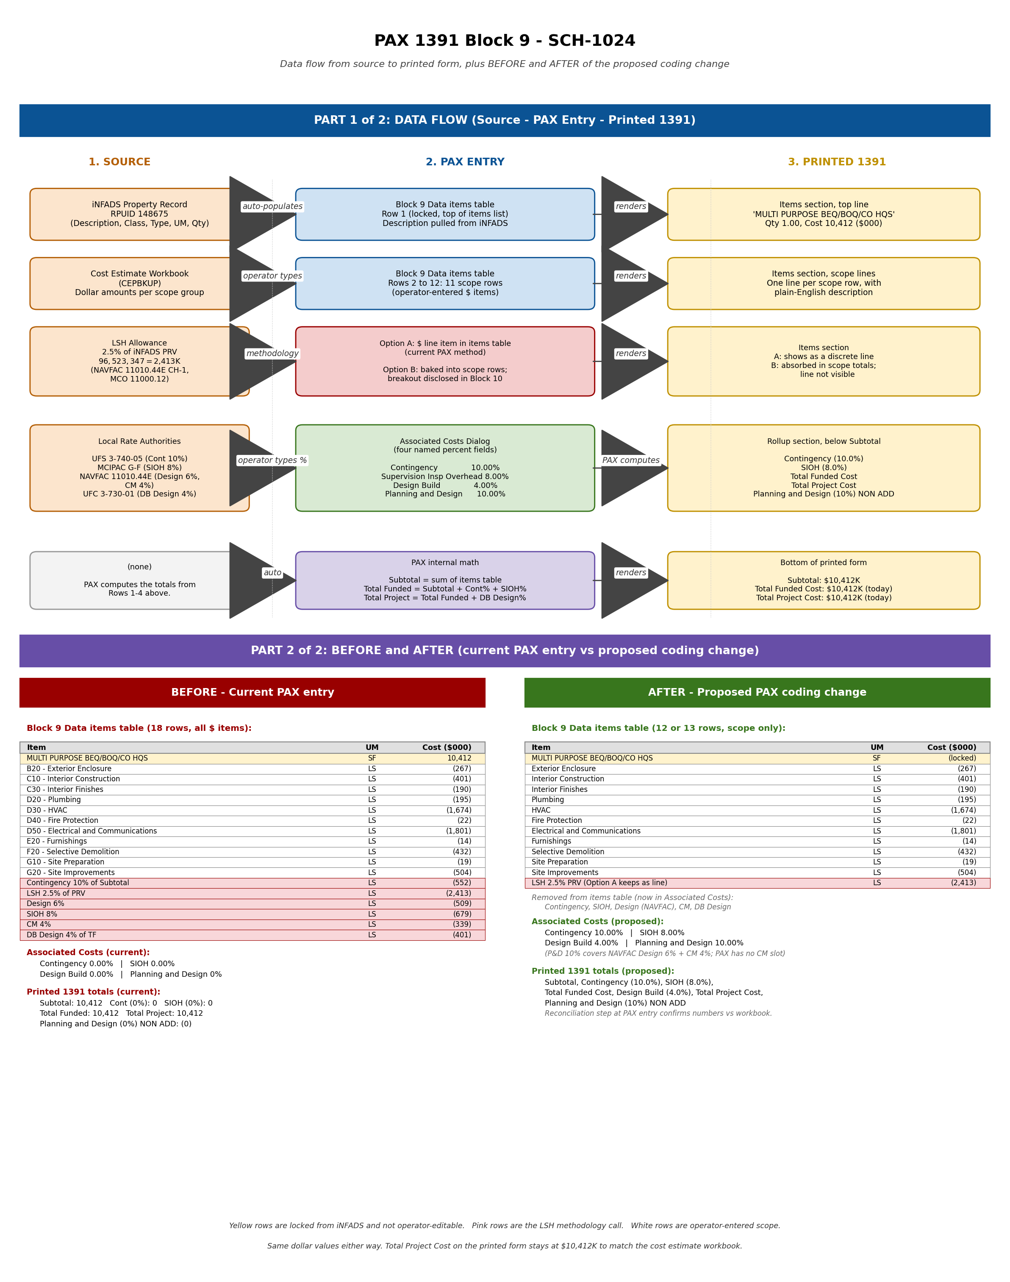

Renamed scope lines (descriptions only, dollar values unchanged)
The current line items use UNIFORMAT II Level 2 prefixes. The proposed renamed descriptions remove the prefix and lead with the work being done in plain English. The dollar values come straight off the printed 1391.
Row | Current line item | Proposed renamed line item | Cost ($000)
1 | B20 - Exterior Enclosure: CMU infill and weapons port windows, 28 openings total - Construction | Exterior Enclosure: CMU infill and weapons port windows, 28 openings total | 267
2 | C10 - Interior Construction: vault doors, structural walls, partitions, COMM room, OSS entrance - Construction | Interior Construction: vault doors, structural walls, partitions, COMM room, OSS entrance | 401
3 | C30 - Interior Finishes: paint, VCT, CT tile, bathroom and OSS finishes, armory spaces - Construction | Interior Finishes: paint, VCT, ceiling tile, bathroom and OSS finishes, armory spaces | 190
4 | D20 - Plumbing: fixture capping, removal, new water fountains, OSS plumbing removal - Construction | Plumbing: fixture capping, removal, new water fountains, OSS plumbing removal | 195
5 | D30 - HVAC: ceiling realign, exhaust, split A/C, DX multi-zone, chillers, TAB - Construction | HVAC: ceiling realign, exhaust, split A/C, DX multi-zone, chillers, TAB | 1,674
6 | D40 - Fire Protection: fire hose cabinet replacement, 4 EA per NFPA 10 - Construction | Fire Protection: fire hose cabinet replacement, 4 EA per NFPA 10 | 22
7 | D50 - Electrical and Communications: IDS/ESS, WAOs, SIPR network, TR, OSP/ISP, lighting mods - Construction | Electrical and Communications: IDS/ESS, WAOs, SIPR network, TR, OSP/ISP, lighting mods | 1,801
8 | E20 - Furnishings: stainless steel shelves at weapons issue port windows, 11 EA - Construction | Furnishings: stainless steel shelves at weapons issue port windows, 11 EA | 14
9 | F20 - Selective Demolition: window/door removal, ceiling, OSS gut, ACM mastic per Bhate 2001 - Construction | Selective Demolition: window/door removal, ceiling, OSS gut, ACM mastic per Bhate 2001 | 432
10 | G10 - Site Preparation: tree removal, 6 EA at new exterior pad locations - Construction | Site Preparation: tree removal, 6 EA at new exterior pad locations | 19
11 | G20 - Site Improvements: walkways, landings, concrete pads, covered overhangs, pavilion - Construction | Site Improvements: walkways, landings, concrete pads, covered overhangs, pavilion | 504

Sum of the eleven scope rows: 267 + 401 + 190 + 195 + 1,674 + 22 + 1,801 + 14 + 432 + 19 + 504 = 5,519. The cost estimate workbook subtotal is $5,520.182, a one $K rounding difference consistent with the $000 rounding on the printed form.

Reconciliation step at PAX entry
The exact Total Project Cost on the printed form after the change cannot be predicted without rendering it. PAX has not been observed running these percentages against the items table outside of the all-zero state. The cost estimate workbook target is $10,413K rounded ($10,012K Total Funded). The check at PAX entry has five steps.
Step one. Make the change in PAX. Delete the six adder dollar items. Enter the four Associated Costs percentages.
Step two. Save the entry and re-render the printed FY 2026 Special Projects Program form.
Step three. Compare the printed Subtotal, Contingency line, SIOH line, Total Funded Cost, Total Project Cost, and Planning and Design (NON ADD) line against the cost estimate workbook target values.
Step four. If the numbers do not match, the resolution is one of three. Switch the LSH option from A to B (or B to A). Adjust the percentage rates to match what PAX computes against its base. Adjust the cost estimate workbook to match PAX's calculation method.
Step five. Document the chosen reconciliation in CEPBKUP ESTIMATE Section F-11.

Portfolio mirror
Once the SCH-1024 approach is concurred, the same coding mirrors across SCH-3270, SCH-3213, SCH-3237, and SCH-3314. The percentage rates are identical for all five buildings. Contingency 10 percent. SIOH 8 percent. Design Build 4 percent. Planning and Design 10 percent. The LSH option chosen for SCH-1024 applies to the other four. Per-building renamed-line tables live in the project repository.

