Fuel Route Planner API
Spotter – Backend Django Engineer coding assessment
Candidate: Akshat Sachan
Item | Link / value
GitHub repository | https://github.com/CRYPTOcoderAS/route-planner
Loom walkthrough | <paste Loom URL here>
Live demo (map) | https://route-planner-ivory.vercel.app/map/
Live API | https://route-planner-ivory.vercel.app/api/v1/route/?start=Chicago, IL&finish=Houston, TX
Stack | Python 3.13, Django 6.1.2 (latest stable), Django REST Framework 3.18
Routing / map API | OSRM public API (free, no key, OpenStreetMap). Map: Leaflet + OSM tiles
Routing API calls per trip | 1 (0 on repeat requests, served from cache)
Response time | ~0.3–0.8 s uncached (almost entirely the OSRM call; planning itself is 15–60 ms); ~1–10 ms cached

1. Requirements and how each one is met
Requirement | How it is met
Input start & finish within the USA | GET or POST /api/v1/route/ takes 'City, ST', 'City, State' or 'lat,lon'. Inputs are resolved offline against the US Census Gazetteer; anything outside the USA is rejected with a 400.
Return a map of the route | Every response includes map.geojson (the route LineString, start/finish and fuel-stop points) and map.url, an interactive Leaflet map page (/map/).
Optimal (cost-effective) fuel stops | An exact dynamic-programming optimiser (Khuller et al., 'To fill or not to fill'). Stations within 5 mi of the route are candidates. mode=cheapest gives the minimum fuel cost; mode=balanced (the default) adds $5 per stop to avoid micro-stops.
500-mile range, multiple stops | The tank holds 50 gal (500 mi at 10 MPG). The optimiser plans as many stops as needed and never runs dry or overfills; the tests check this.
Total money spent at 10 MPG | summary.total_fuel_cost is the money spent at the stops. summary.trip_fuel_cost is all fuel burned, valued at the average price paid. Gallons are also given per stop.
Use the provided fuel price file | 6,626 unique US stations; 6,452 (97.4%) geocoded offline. Duplicate rows keep the cheapest price, and Canadian rows are dropped.
Free map/routing API | OSRM public server (router.project-osrm.org) and OpenStreetMap tiles.
Latest stable Django | Django 6.1.2 on Python 3.13.
Fast results | Data is held in memory as numpy arrays, corridor matching uses a KD-tree, and the optimiser is vectorised. Routes and plans are cached, responses are gzipped, and the route line is thinned to 1 point per mile.
Minimal calls to the routing API | Exactly 1 OSRM call per unique trip. Geocoding makes 0 calls because it is offline. Repeat requests make 0.

2. Screenshots
All screenshots come from the running application at http://127.0.0.1:8000. In the API screenshots the long route coordinate list is cut short for display only; the real response contains every point.

2.1 Map UI – New York, NY → Los Angeles, CA
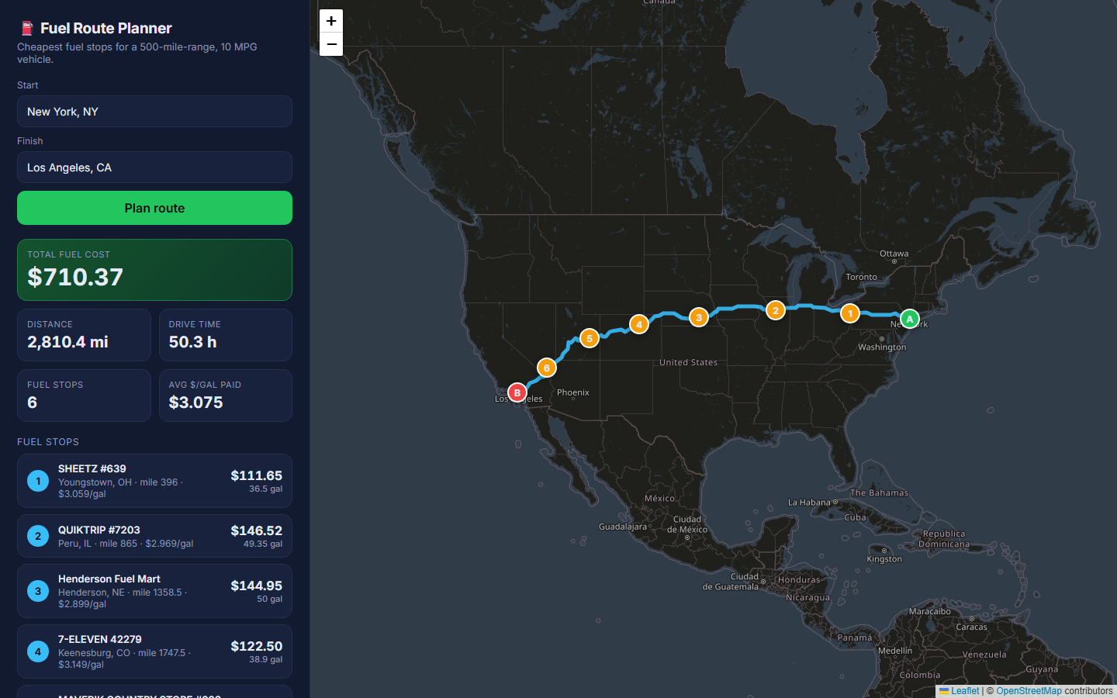
Figure 1 – 2,810 mi, 6 fuel stops, total fuel cost $710.37. Numbered markers are fuel stops; the sidebar lists the station, price, gallons and cost for each one.

2.2 More routes
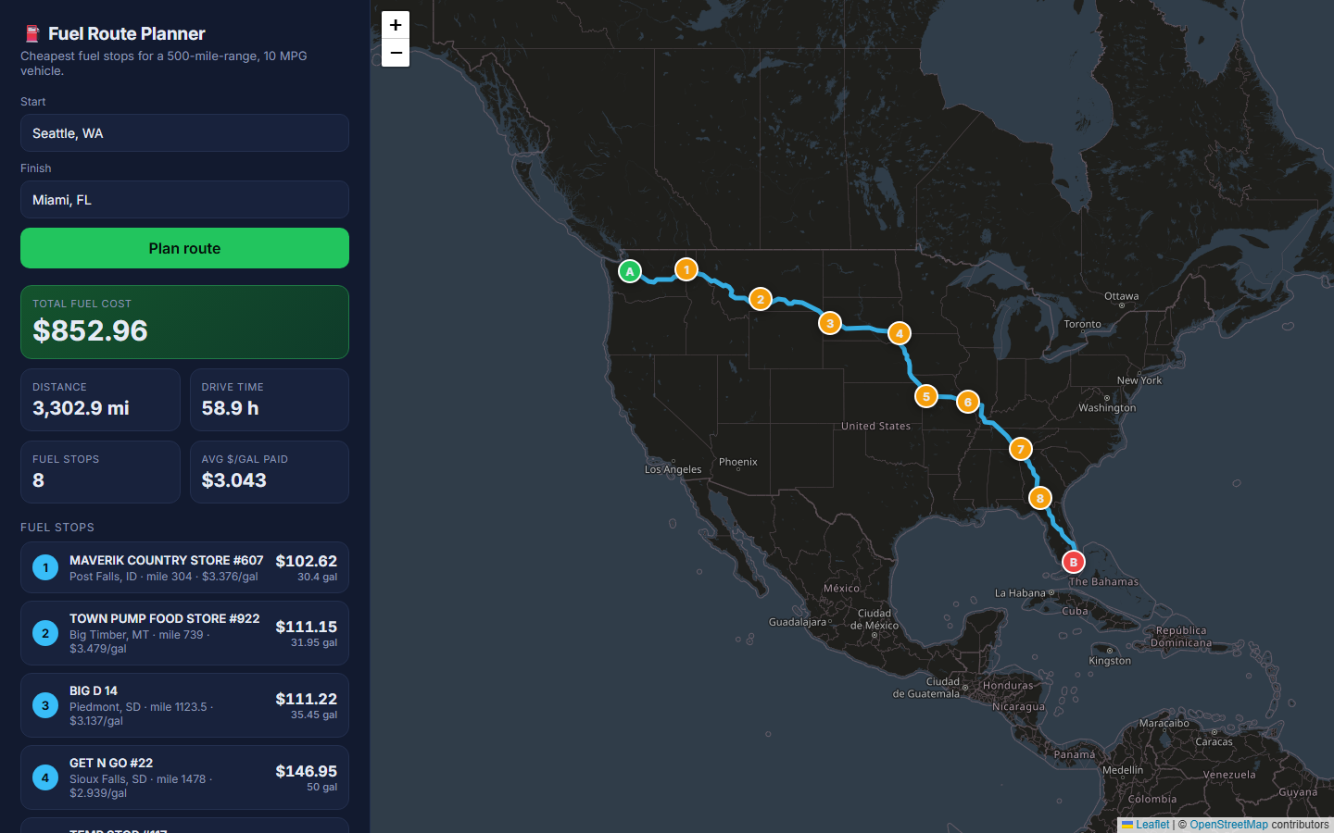
Figure 2 – Seattle, WA → Miami, FL (3,303 mi): 8 stops, $852.96.
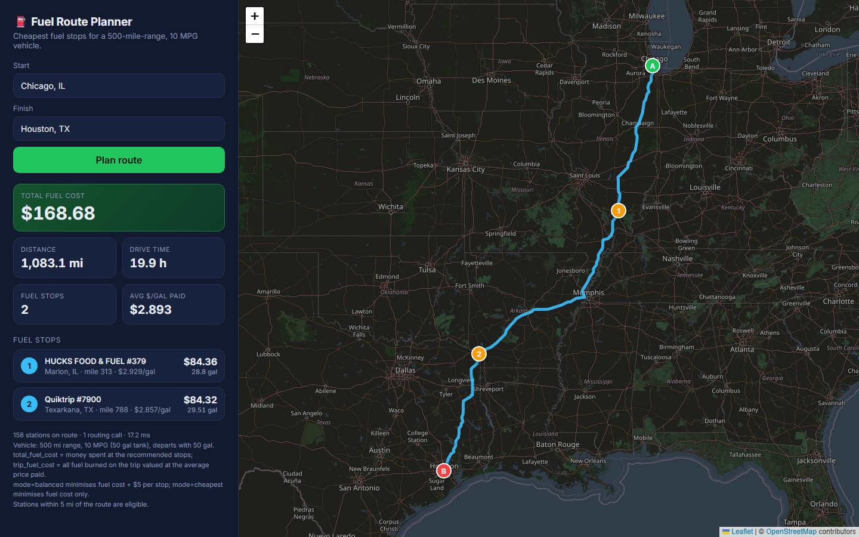
Figure 3 – Chicago, IL → Houston, TX (1,083 mi).

2.3 API – GET, first call (1 routing call)
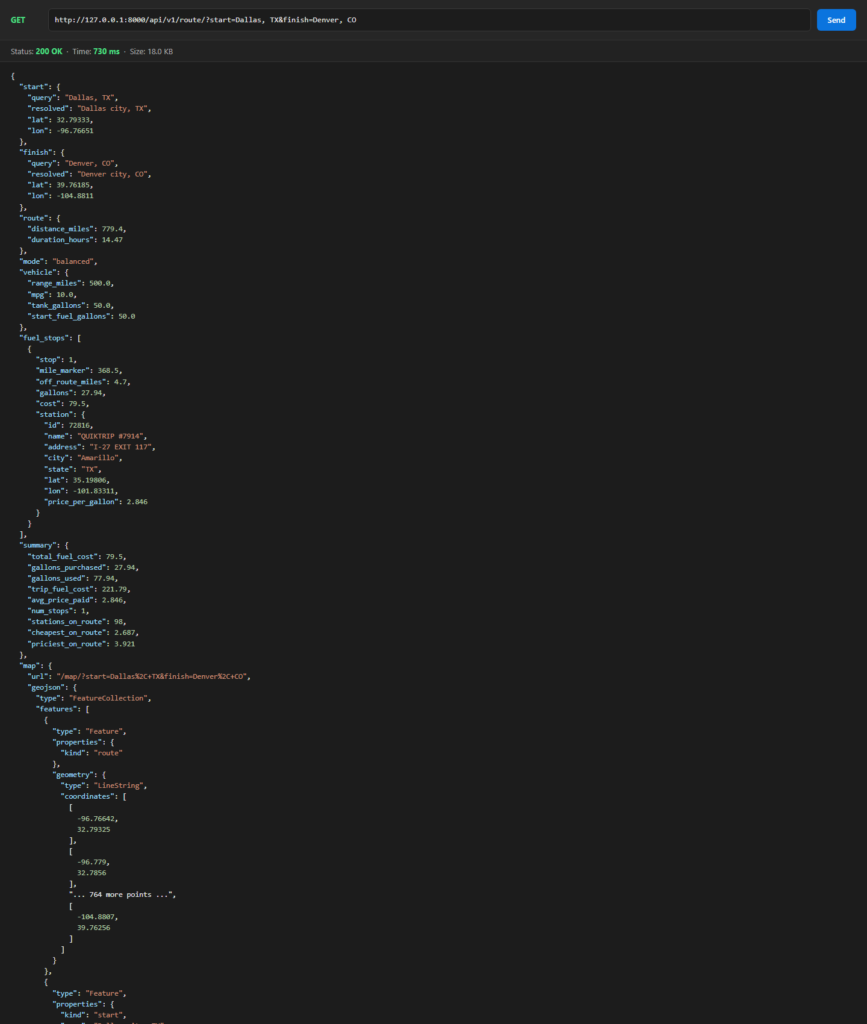
Figure 4 – GET /api/v1/route/?start=Dallas, TX&finish=Denver, CO. 1 fuel stop (QuikTrip, Amarillo TX at $2.846/gal).

2.4 API – same request again (served from cache)
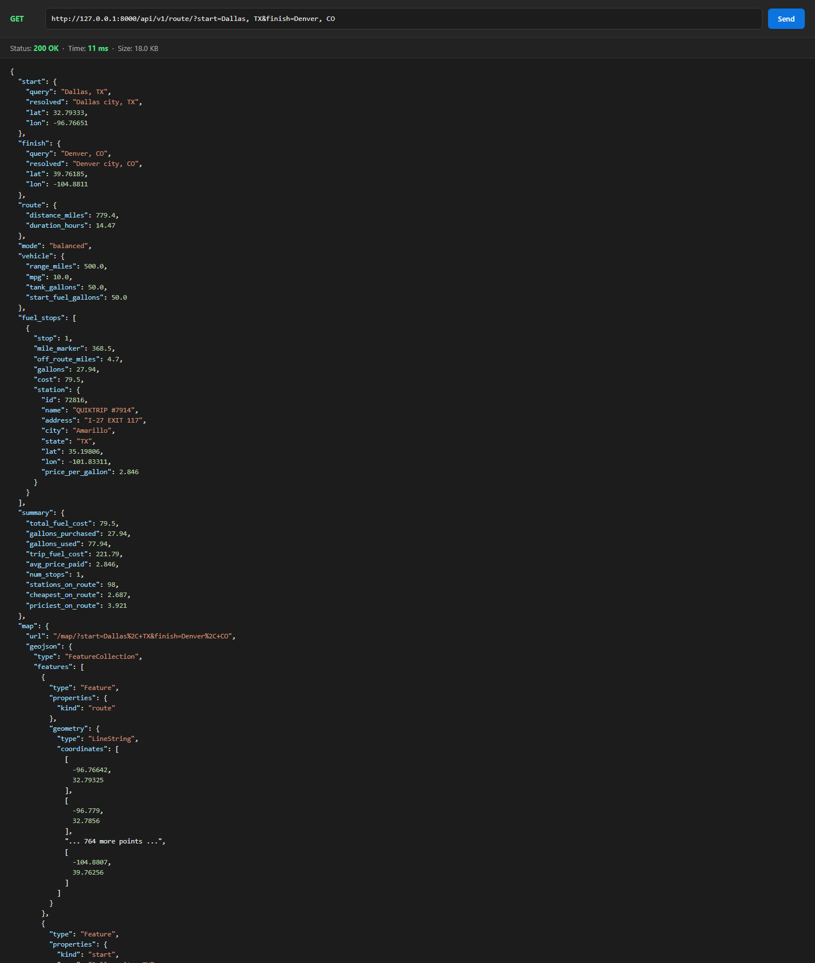
Figure 5 – The repeat request is answered from cache in a few ms. meta.routing_api_calls = 0.

2.5 API – POST, coast to coast
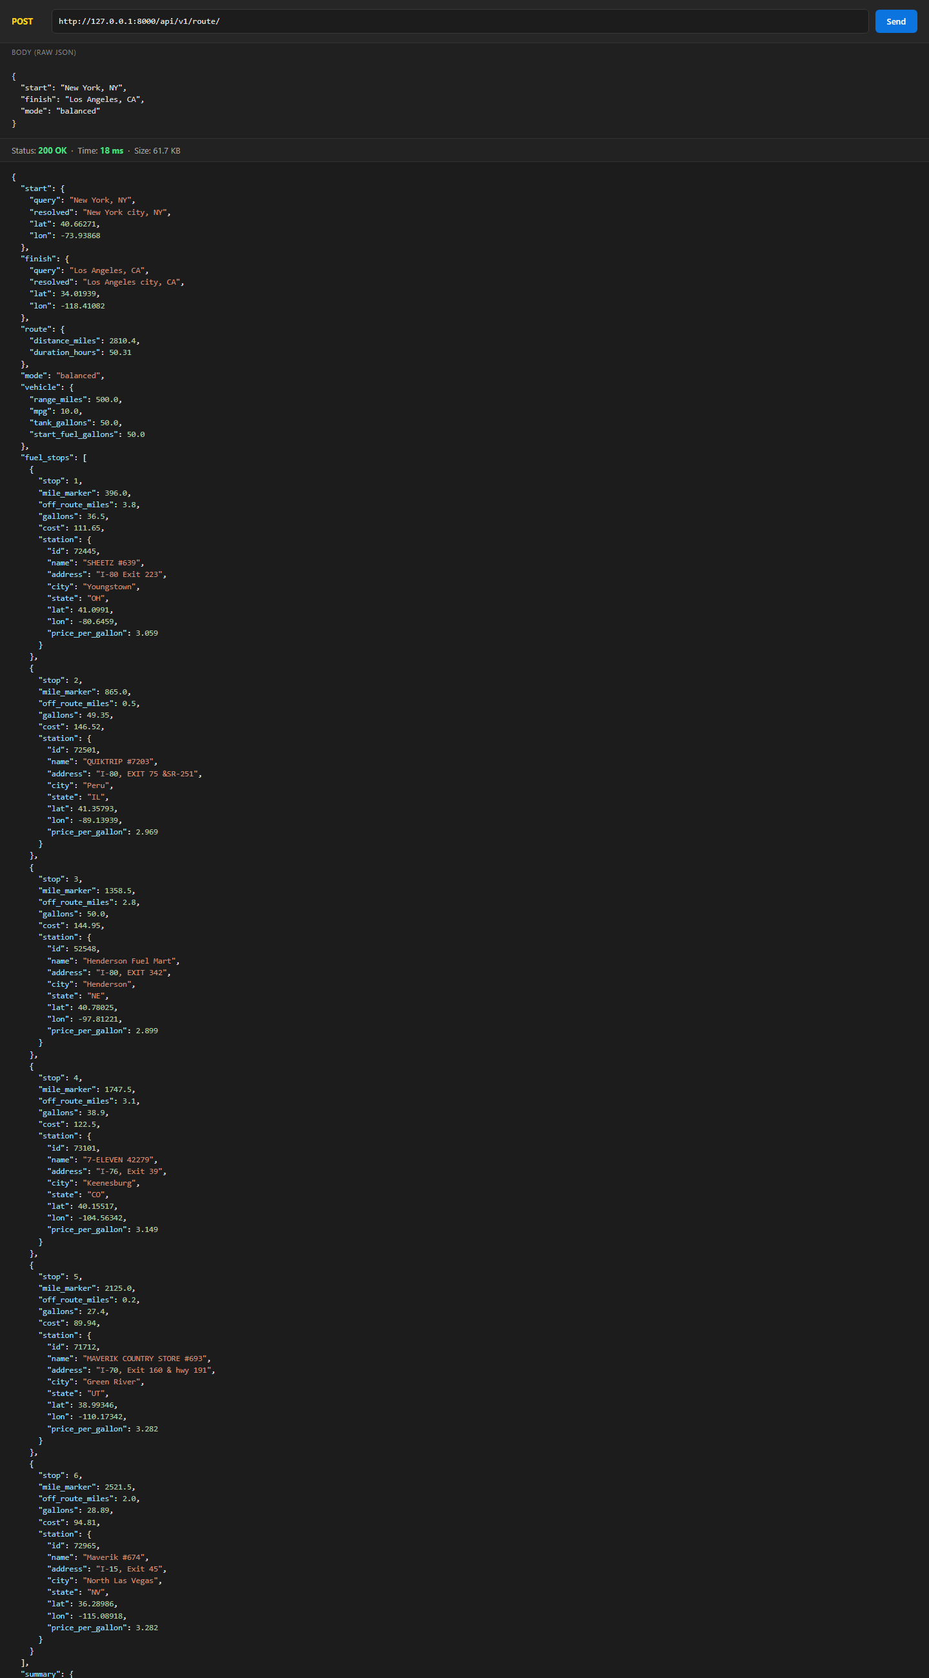
Figure 6 – POST with JSON body {start: 'New York, NY', finish: 'Los Angeles, CA'}.

2.6 API – lat,lon input, half tank, cheapest mode
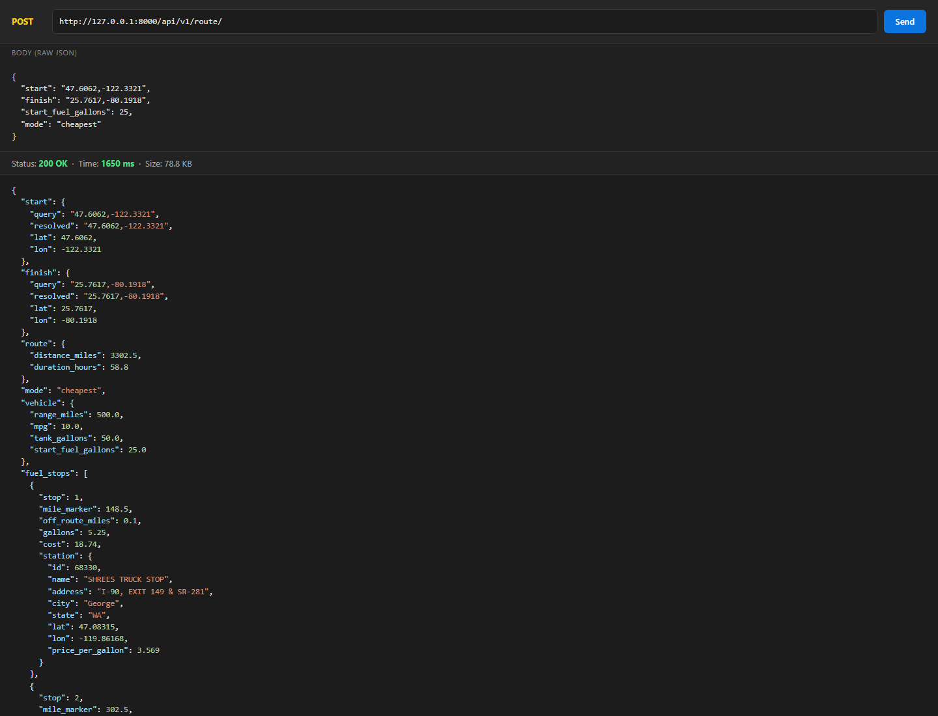
Figure 7 – Coordinates as input, start_fuel_gallons=25, mode=cheapest.

2.7 API – error handling
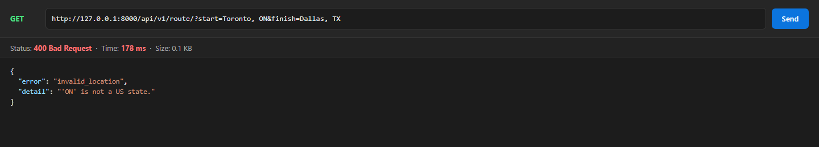
Figure 8 – A non-US location is rejected with 400 invalid_location.
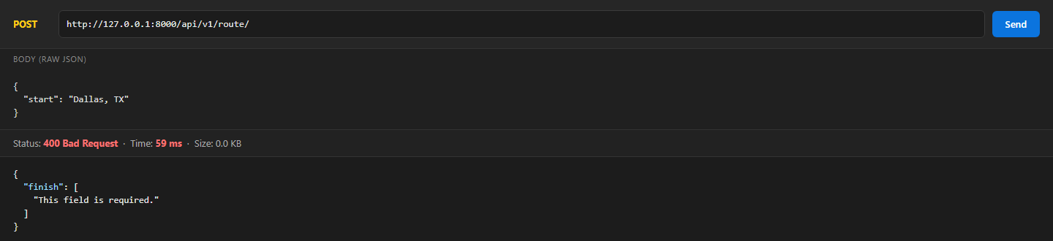
Figure 9 – A missing field returns a 400 with a field-level validation error.

2.8 Automated tests
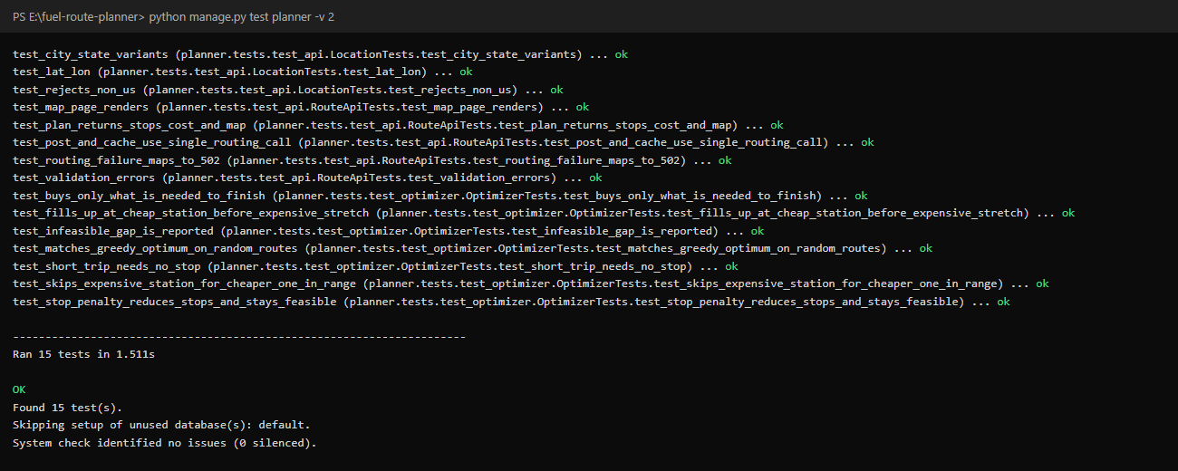
Figure 10 – All 15 tests pass: optimiser property tests and API tests with OSRM mocked.

3. API reference
Endpoint: GET or POST /api/v1/route/
Field | Type | Required | Description
start | string | yes | 'City, ST', 'City, State' or 'lat,lon'
finish | string | yes | same formats as start
mode | balanced | cheapest | no | default balanced: fuel cost plus $5 per stop; cheapest: fuel cost only
start_fuel_gallons | number 0–50 | no | fuel in the tank at departure (default: full, 50 gal)

Main response fields:
- fuel_stops[] – stop number, mile_marker, off_route_miles, gallons, cost, and the station (name, address, city, state, lat/lon, price).
- summary.total_fuel_cost – total money spent on fuel at the recommended stops.
- summary.trip_fuel_cost – every gallon burned on the trip (distance ÷ 10 MPG) × the average price paid.
- route – distance_miles and duration_hours from OSRM.
- map.geojson / map.url – the route and stops as GeoJSON, plus a link to the interactive map.
- meta – cached, routing_api_calls, elapsed_ms, routing_ms, compute_ms.
Error responses use the shape {error, detail}: 400 for invalid input or a location outside the USA, 422 when a stretch of the route is longer than 500 mi with no station, and 502 when the routing service is down.
Try it live: the same endpoints are deployed at https://route-planner-ivory.vercel.app (Vercel free tier, so the first request after an idle period can take a few seconds).
Run locally:
python -m venv .venv
.venv\Scripts\activate
pip install -r requirements.txt
python manage.py runserver
python manage.py test planner

Postman: import postman_collection.json from the repository root (5 ready-made requests).

4. How it works
request -> resolve start/finish offline (Census gazetteer, in memory) 0 API calls
-> OSRM /route (overview=full, GeoJSON) 1 API call (cached 24h)
-> corridor match: stations within 5 mi of the route KD-tree, ~1 ms
-> optimise fuel stops (dynamic programming) ~10-60 ms
-> JSON + GeoJSON response (result cached)

4.1 Offline data preparation
The fuel price sheet has only City and State, with no coordinates. Calling a geocoding API for 6,000+ stations at request time would be slow and rate-limited. Instead, scripts/build_datasets.py geocodes each station once against the public-domain US Census Gazetteer (places and county subdivisions) and writes data/stations.csv. The same gazetteer resolves the user's start and finish, so the only external call at runtime is the single routing request.

4.2 Corridor matching
The OSRM polyline is resampled every 0.5 miles and indexed in a scipy KD-tree on unit-sphere coordinates. Stations inside the route's bounding box are matched to their nearest route point in one vectorised query. That gives each station a mile marker along the route and its distance from the route.

4.3 Choosing the fuel stops (the optimiser)
This is the classic 'gas station problem'. A key result (Khuller, Malekian & Mestre, ACM TALG 2011) says that, for a fixed set of stops, the best purchase at each stop is either 'buy just enough to reach the next stop' (when the next stop is not more expensive) or 'fill the tank' (when it is). The fuel level on arrival at a stop can therefore take only a few values, and a dynamic program over those states finds the exact optimum. Running time is O(n·w²), vectorised with numpy.
- mode=cheapest – minimises fuel cost only. Its result matches the provably optimal greedy algorithm on 200 random routes in the tests.
- mode=balanced (default) – minimises fuel cost plus $5 per stop. A pure cost optimiser will stop to buy 1 gallon to save 1 cent; the small penalty removes those stops. New York → Los Angeles drops from 15 stops to 6 for about $5 more ($705 → $710).

4.4 Performance
Trip | Distance | Stops | Fuel cost | Uncached | Cached
New York → Los Angeles | 2,810 mi | 6 | $710.37 | ~0.4–0.7 s | ~2 ms
Seattle → Miami | 3,303 mi | 8 | $852.96 | ~0.77 s (compute 28 ms) | ~7 ms
Chicago → Houston (cheapest) | 1,083 mi | 5 | $167.83 | ~0.70 s (compute 14 ms) | ~5 ms
Dallas → Denver | 779 mi | 1 | $79.50 | ~0.73 s | ~5 ms

Almost all of the uncached time is the network round trip to the free OSRM server. Planning itself takes 15–60 ms.

4.5 Code structure
File | Responsibility
planner/datasets.py | Loads stations and places into memory once (AppConfig.ready); offline geocoder
planner/routing.py | OSRM client: one call, timeouts, retries, keep-alive session, 24h cache
planner/geo.py | Vectorised geometry (haversine, unit-sphere KD-tree helpers, line thinning)
planner/optimizer.py | Pure, framework-free DP optimiser (easy to unit test)
planner/services.py | Orchestration: geocode → route → corridor → optimise → JSON/GeoJSON
planner/serializers.py, views.py | Validation, HTTP layer, error mapping (400/422/502), map page
planner/tests/ | Optimiser property tests (vs. greedy oracle) and API tests with OSRM mocked
scripts/build_datasets.py | One-time geocoding of the fuel price sheet

5. Assumptions and trade-offs
- The vehicle starts with a full tank (50 gal) by default; start_fuel_gallons changes this. total_fuel_cost is the money spent at stops; trip_fuel_cost also values the fuel already in the tank.
- Stations are placed at their city's centroid, because the sheet has no coordinates. Each stop reports how far it is from the route. Stations up to 5 mi off the route are allowed (configurable).
- 97.4% of US stations are geocoded. The remaining 174 are very small unincorporated places that are not in the Census gazetteer.
- No database is needed: the data is static and read-only, so in-memory numpy arrays are faster and simpler. For multiple workers or production, use Redis for the cache and a self-hosted or paid routing provider.

6. Loom walkthrough script (≈5 minutes)
- 0:00–0:30 Intro – A Django 6 API: start and finish in the USA in; route map, cheapest fuel stops and total fuel cost out. 1 routing call per trip.
- 0:30–2:00 Postman – Run GET New York → Los Angeles and show fuel_stops, summary.total_fuel_cost, map.geojson and meta.routing_api_calls = 1. Send it again and show cached: true and a few ms. Run the POST Chicago → Houston with mode=cheapest, then the Toronto error case.
- 2:00–2:40 Map – Open map.url in the browser and click a stop in the list to zoom to it.
- 2:40–4:30 Code – build_datasets.py (offline geocoding, so no geocoding API at runtime) → routing.py (single cached OSRM call) → services.py (KD-tree corridor) → optimizer.py (the DP and why balanced mode exists) → tests (DP matches the greedy oracle).
- 4:30–5:00 Wrap-up – Speed numbers, and the production next steps: Redis cache, self-hosted OSRM.

