# Terminology and General Notes:

* RADAR_NAME should be replaced with the radar name (e.g. “accum”, “rds”, or “snow”)
* SEASON_NAME should be replaced with the season name (e.g. 2018_Antarctica_Ground)
* Each radar digital system version has a difference name and file version. For example:
  + “mcords3” is the cresis designation for the OIB radar depth sounder.
  + “snow8” is the cresis designation for the OIB snow radar.
  + “mcords6” is the cresis designation for the Dome Fuji ground based radar depth sounder
* In the toolbox, there is a single GPS file for each day, but it may be created from multiple flights or ground traverses which may each contain multiple GPS files.
* Data from each day are broken into data “segments”. Data segments are named “YYYYMMDD_SS”. A single data segment is created each time the radar recording is stopped and started.
* Data segments are broken down into contiguous data “frames” for convenient data handling. Data frames are named “YYYYMMDD_SS_FFF”. For the snow radar, these are generally automatically created and are 5 km long. For the radar depth sounder, these are usually automatically generated, but are sometimes manually generated so that frame boundaries are put in convenient placed (e.g. turns) and we usually aim for 50 km long segments unless a small grid is done in which case the frames are usually made to match the grid lines.
* Segments and frames start at “1” and are monotonically increasing with time and names cannot be repeated. In other words, for segment (or frame) M and N where N>M, the ordering implies that segment (or frame) N was collected *after* segment (or frame) M.
* **Parameter spreadsheets must be saved in “Microsoft Excel 5.0/95 Workbook” format using Microsoft Excel.** Newer formats are often not read in properly by Matlab. Also, only Microsoft Excel from Windows and Macintosh has been used reliably to save files. Open Office or Libre Office can also save the files in Excel format, but occasionally Matlab cannot read these files properly and the file must be moved to Windows Excel and resaved in the 5.0/95 format before it can be used again. The problem seems to be when certain features are exercised that Matlab’s reader does not support (certain characters and long strings maybe the culprit).
* **There are two categories of digital systems “CReSIS-based” and “Arena-based”.** There are small differences between the outputs and debug information for these two categories which are noted in the guide.

# File System Structure:

Here is the list of directories used for processing and an indication of whether or not the directory should be backed up. The locations of these directories are stored in the global gRadar variable which is set in the startup.m file. The startup.m file is usually in the Documents/MATLAB directory in the home directory.

|  |  |  |
| --- | --- | --- |
| **Folder** | **Contents** | **Backup** |
| /scratch/csarp_support | gps, records, and frames files | Yes |
| /scratch/ct_tmp | cresis-toolbox shared temporary files | No |
| /scratch/mdce_tmp | cresis-toolbox user temporary files | No |
| /scratch/metadata | raw GPS files, raw LIDAR files, notes, special measurements | Yes |
| /scratch/accum | Accumulation Radar data products | Only CSARP_post |
| /scratch/rds | MCoRDS data products | Only CSARP_post |
| /scratch/snow | Snow Radar data products | Only CSARP_post |
| /scratch/scripts/cresis-toolbox | Git repository of cresis toolbox | Push changes |
| /scratch/scripts/ct_params | Git repository of parameter spreadsheets | Push changes |
| /scratch/scripts/ct_docs | Git repository of documentation | Push changes |
| /scratch/scripts/matlab | Matlab scripts that are not to be committed | Yes |
| /scratch/GIS_data | geotiffs of surface velocity, optical imagery, and DEMs, KML placename files | No |

# Quick Look Processing Steps

1. Read headers of all the “raw” radar data
   1. Ensure that run_preprocess.m is pointed to the correct setup script:
      1. From Matlab, run “edit run_preprocess.m”
      2. Ensure that the line containing the comment: “% REPLACE THIS LINE WITH CORRECT SETUP SCRIPT” is correct. For OIB it is:  
         run_preprocess_OIB; % REPLACE THIS LINE WITH CORRECT SETUP SCRIPT
   2. From Matlab, update the run preprocess setup script. For OIB, run “edit run_preprocess_OIB.m” to do this.
   3. Modify each “SINGLE DAY” radar section to point to the current date. Comment out radars that were not used for that day. For example, on the P-3, if only the radar depth sounder and snow radar are run, the section would look like this for 20180322:

%% MCORDS3 SINGLE DAY

cur_idx = length(param.config.default)+1;

param.config.default{cur_idx} = default_radar_params_2018_Greenland_P3_rds();

param.config.base_dir{cur_idx} = '/N/dcwan/projects/cresis/2018_Greenland_P3/';

param.config.config_folder_names{cur_idx} = '20180405/mcords';

param.config.board_folder_names{cur_idx} = '20180405/mcords/%b';

param.config.date_strs{cur_idx} = '20180405';

%% SNOW8 SINGLE DAY

cur_idx = length(param.config.default)+1;

param.config.default{cur_idx} = default_radar_params_2018_Greenland_P3_snow();

param.config.base_dir{cur_idx} = '/N/dcwan/projects/cresis/2018_Greenland_P3/';

param.config.config_folder_names{cur_idx} = '20180405/fmcw/snow';

param.config.board_folder_names{cur_idx} = '20180405/fmcw/snow';

param.config.date_strs{cur_idx} = '20180405';

%% MCORDS5-ACCUM SINGLE DAY

%cur_idx = length(param.config.default)+1;

%param.config.default{cur_idx} = default_radar_params_2018_Greenland_P3_accum();

%param.config.base_dir{cur_idx} = '/N/dcwan/projects/cresis/2018_Greenland_P3/';

%param.config.config_folder_names{cur_idx} = '20180405/accum';

%param.config.board_folder_names{cur_idx} = '20180405/accum/%b';

%param.config.date_strs{cur_idx} = '20180405';

* 1. Run the script (F5). The script will run “preprocess.m” which will generate a set of tasks to run on the cluster.
  2. Using the mouse, select the commands printed out by “preprocess.m” and evaluate these by pressing F9. The commands look like this:  
       
     If a mex file error occurs, the mex file probably needs to be recompiled for your specific version of Matlab. For example, if the arena_packet_strip_mex.cpp failed the error message and steps to recompile are:

[ctrl_chain,chain_fn] = cluster_load_chain(28);

ctrl_chain = cluster_run(ctrl_chain);

Invalid MEX-file '/users/paden/scripts/cresis-toolbox/cresis-toolbox/rss/arena_packet_strip_mex.mexa64': /lib64/libc.so.6: version `GLIBC_2.14' not found (required by

/users/paden/scripts/cresis-toolbox/cresis-toolbox/rss/arena_packet_strip_mex.mexa64)

…

>> cd /users/paden/scripts/cresis-toolbox/cresis-toolbox/rss/

>> mex -v -largeArrayDims arena_packet_strip_mex.cpp

…

MEX completed successfully.

* 1. Once all the tasks are completed, for CReSIS-based digital acquisition systems, review the outputs in ct_tmp/headers/RADAR_NAME/SEASON_NAME/SEGMENT.  
     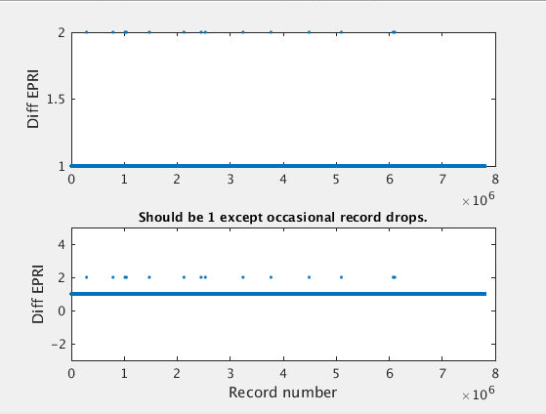  
     The EPRI counts by one for each recorded record. Therefore the difference of EPRI should be one always. If there are dropped records, then the EPRI will be larger. If there are corrupt headers, then the EPRI could take on any value. The above plots shows a typical radar depth sounder result with a few dropped records (when the diff(epri) == 2). This shows an acceptable number of dropped records.  
     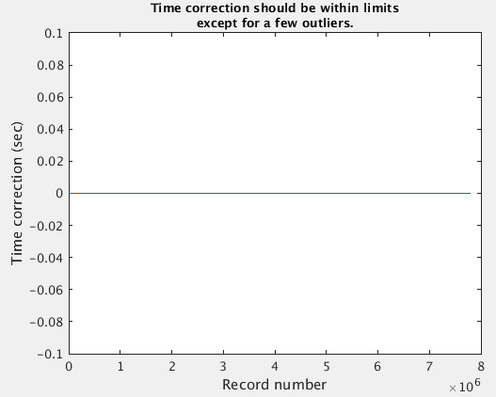  
     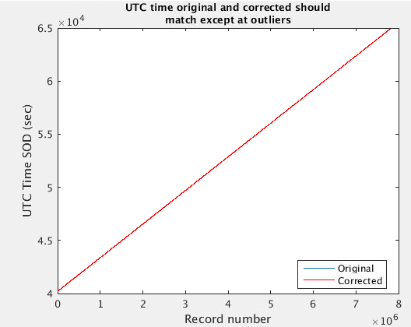  
     The above plots show a typical result for rds. Note there are not time errors found. As long as the corrected (red) version looks correct, it is okay for the original to have errors.
  2. Once the figures are reviewed, open the parameter text files in ct_tmp/param/RADAR_NAME/SEASON_NAME and copy and paste these into the respective spreadsheets.  
     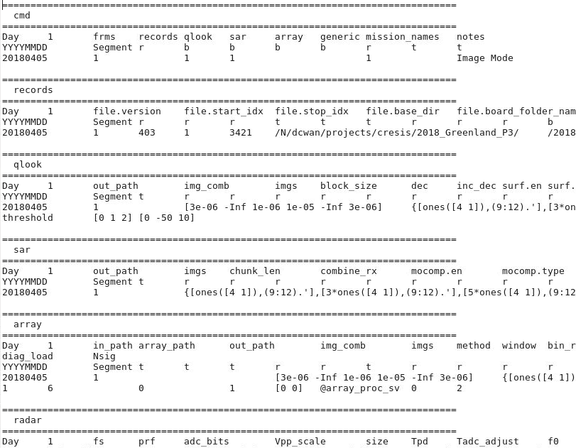

1. While run_preprocess.m is running, update make_gps_SEASON_NAME.m to make the “gps” file
   1. This first step can be skipped for Arena-based digital acquisition systems since the preprocess step already copies the files. For CReSIS-based digital acquisition systems: Copy GPS files from accum or mcords (but not both) to the “metadata/SEASON_NAME/YYYYMMDD” directory (in others create a new directory for each day of data).
   2. From Matlab run “edit make_gps_SEASON_NAME.m”
   3. Ensure that gps_source_to_use = 'NMEA' for CReSIS-based and ‘ARENA’ for Arena-based.
   4. Copy and paste the following section of code into the NMEA section and update the year/month/day to match the date of the folder where the GPS files are stored.

year = 2017; month = 3; day = 31;

file_idx = file_idx + 1;

in_fns{file_idx} = get_filenames(fullfile(in_base_path,sprintf('%04d%02d%02d',year,month,day)),'GPS','','.txt');

out_fns{file_idx} = sprintf('gps_%04d%02d%02d.mat', year, month, day);

file_type{file_idx} = 'NMEA';

params{file_idx} = struct('year',year,'month',month,'day',day,'format',3,'time_reference','utc');

gps_source{file_idx} = 'nmea-field';

sync_flag{file_idx} = 0;

* 1. Run the function (F5) after ensuring the GPS files have been copied to the metadata directory (either by run_preprocess.m or manually). Output below shows two flights being combined into one GPS file.

>> make_gps_2016_greenland_Polar6

Input files (0.1 sec)

/home/administrator/Scratch/metadata/2016_Greenland_Polar6/GPS_R_L1_20160426T112011_132911.nc

/home/administrator/Scratch/metadata/2016_Greenland_Polar6/GPS_R_L1_20160426T140329_154829.nc

Output file /home/administrator/Scratch/csarp_support/gps/2016_Greenland_Polar6/gps_20160426.mat

INS file /home/administrator/Scratch/metadata/2016_Greenland_Polar6/INS_L1_20160426T112012_132939.nc

INS file /home/administrator/Scratch/metadata/2016_Greenland_Polar6/INS_L1_20160426T140330_154933.nc

Found 52242 bad records based on heading == 0

Inserting 281 level flight records due to missing INS data

Inserting 2767 level flight records due to missing INS data

* 1. To check the GPS file, you may run the “plot_gps” function with the output GPS file as an argument:

>> plot_gps('/home/administrator/Scratch/csarp_support/gps/2016_Greenland_Polar6/gps_20160426.mat')

Approx. number of skips: 3831

Approx. number of repeats: 0

Start: 26-Apr-2016 11:20:28 GPS

Stop: 26-Apr-2016 15:48:46 GPS

Start: 26-Apr-2016 11:20:11 UTC

Stop: 26-Apr-2016 15:48:29 UTC

1. When step 1 and 2 are done, you can create “records” files for the respective radar. Records files contain all the header information for the raw data and time and position information for each record of data.
   1. Put a “1” in the “records” column in the “cmd” worksheet for each segment to be processed. Make sure all other spots are empty.
   2. Run the run_create_records script for each radar that collected data. Ensure this script is loading the correct parameter file and no other parameter files. For example, to run rds_param_2018_Antarctica_Ground.xls:

% params = read_param_xls(ct_filename_param('accum_param_2018_Antarctica_TObas.xls'));

params = read_param_xls(ct_filename_param('rds_param_2018_Antarctica_Ground.xls'));

* 1. For CReSIS-based digital acquisition systems: If there is a GPS time problem in the header, a debug prompt will show up with 3 figures. Verify figure 3 that the UTC seconds of day measured and expected are within the view of the ylimits. If they are it is safe to dbcont. If not, GPS time will have to be hand corrected in the records file and run_update_records.m run to synchronize the trajectory and attitude.  
     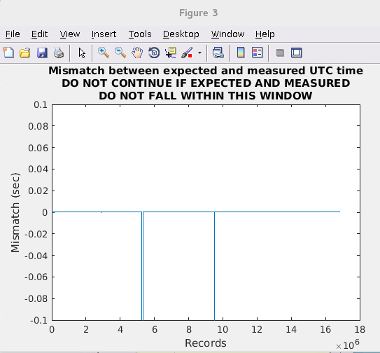

1. After step 3, create quick look images and track the surface. This step is called “qlook” and creates the radar echograms stored in the data products directory.
   1. Put a “1” in the “qlook” column in the “cmd” worksheet for each segment to be processed. Make sure all other spots are empty.
   2. Run the run_qlook script for each radar that collected data. Ensure this script is pointing to the correct parameter file.
2. After step 4, create the posting files (jpg images and kml files for the snow radar and jpg images, pdf, and kml files for mcords and accum)
   1. Put a “1” in the “generic” column in the “cmd” worksheet for each segment to be processed. Make sure all other spots are empty.
   2. Adjust the echo.depth variable in the post spreadsheet as follows. These are just recommendations. This field controls the y-axis limits of the images:  
      Snow Land Ice: [min(Surface_Depth)-4 max(Surface_Depth)+20 ]  
      Snow Sea Ice: [min(Surface_Depth)-4 max(Surface_Depth)+4 ]  
      Accum Land Ice: [min(Surface_Depth)-50 max(Surface_Depth)+1100 ]  
      Accum Sea Ice: [min(Surface_Depth)-20 max(Surface_Depth)+20 ]  
      MCoRDS Greenland: [min(Surface_Depth)-50 max(Surface_Depth)+3500 ]   
      MCoRDS Antarctica: [min(Surface_Depth)-50 max(Surface_Depth)+4500 ]
   3. Run the run_create_posting script for each radar that collected data. Ensure this script is pointing to the correct parameter file.
   4. Check the results in the RADAR_NAME/SEASON_NAME/CSARP_post/images directory for each radar.
3. If uploading data to CReSIS, upload files in CSARP_post for each radar using the “data” user account to /cresis/snfs1/dataproducts/public/data/OUTPUT_DIR/SEASON_NAME/ where OUTPUT_DIR is “accum”, “rds”, or “snow”.