**Software Design  
Document**

for

<Flame Army: Chess 1.0>

Version 1.0 approved

Prepared by <author>

<organization>

<date created>

# Contents

Revisions ii

1 Introduction 1

1.1 Purpose 1

1.2 System Overview 1

1.3 Definitions, Acronyms and Abbreviations 1

1.4 Supporting Materials 1

1.5 Document Overview 1

2 Architecture 2

2.1 Overview 2

2.2 Component 1..n 2

3 High-Level Design 3

4 Low-Level Design 4

4.1 Modules Overview 4

4.2 Module Specifications 4

4.2.1 Module X1 4

4.2.2 Module X2 5

Appendix A – Group Log 6

# Revisions

| Version | Primary Author(s) | Description of Version | Date Completed |
| --- | --- | --- | --- |
| Draft Type and Number | Full Name | Information about the revision. This table does not need to be filled in whenever a document is touched, only when the version is being upgraded. | 00/00/00 |

<This template serves as a basis for a Software Design Specification. As in the SRS document, all italics refer to the “comment” style. Comments in blue are general and apply to any SDS, these that are in black are applicable specifically for this course. This template is based on the work by Karl. E Wiegers, Steve McConnel of CXOne group and the IEEE standards.>

# Introduction

## Purpose

## System Overview

<Brief high-level description of system structure, functionality, interactions with external systems, system issues, etc.

## Definitions, Acronyms and Abbreviations

< List any project definitions and acronyms introduced to the project by this design.

## Supporting Materials

<Note any references or related materials here.

## Document Overview

# Architecture

<The architecture provides the top level design view of a system and provides a basis for more detailed design work. This is the section where you should include your High-Level design Component Diagram.

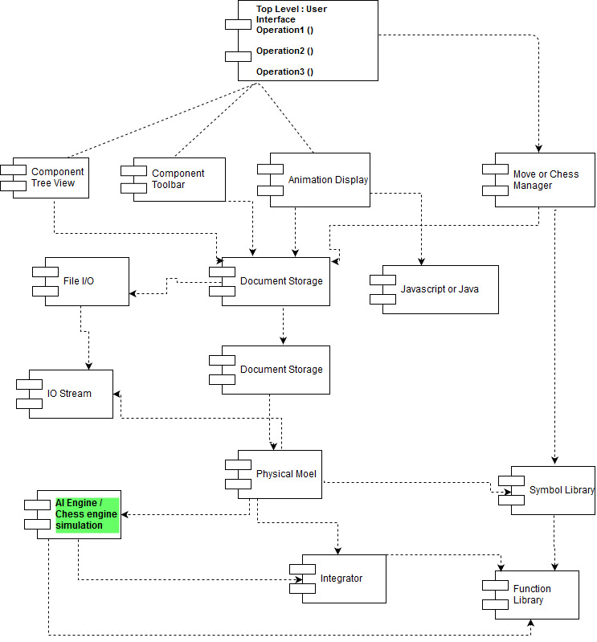

# Overview

<This section provides a high level overview of the structural and functional decomposition of the system. Focus on how and why the system was decomposed in a particular way rather than on details of the particular components. Include information on the major responsibilities and roles that the system (or portions of it) must play.

**From our HDD we can understand that Top Level : User Interface has 3 important methods component tree view, component toolbar and animation display/user view.**

1] Component Tree View

2] Component Toolbar

3] Animation Display / User view

4] Move or Chess Manager (separate entity from above 3 components)

All these components are having dependencies and hierarchical relationship between all of the components is shown above.

Document storage stores all the information coming from user, chess manager, and stores the result as well.

Animation is dependent on the platform or the programming language we use like Java or Javascript.

Chess manager has relationship with symbols, objects of the chess board and communicates with Symbol library.

File I/O component handles input/ output operations. Once the physical model is prepared, it will redirect information to AI/Chess Engine and I/O stream.

Integrator component integrates the game operations and works directly with Function library.

# Component 1..n

<Describe an element (subsystem, component, etc...) from architecture in further detail. When appropriate, include information on how the element is further broken down and the interactions and relationships between these subcomponents.

# High-Level Design

<This section describes in further detail elements discussed in the Architecture. Normally this section would be split into separate documents for different areas of the design.

High-level designs are most effective if they attempt to model groups of system elements from a number of different views.

## View / Model Component 1..n

<Provide a description and diagramsof a system component or set of components that describes a clearly defined view or model of the entire system or a subset of the system.