Software Requirements Specification
for
<Project>
Version 1.0 approved
Prepared by <author>
<organization>
<date created>
Table of Contents
Table of Contents ii
Revision History ii
1. Introduction 1
1.1 Purpose 1
1.2 Document Conventions 1
1.3 Intended Audience and Reading Suggestions 1
1.4 Product Scope 1
1.5 References 1
2. Overall Description 2
2.1 Product Perspective 2
2.2 Product Functions 2
2.3 User Classes and Characteristics 2
2.4 Operating Environment 2
2.5 Design and Implementation Constraints 2
2.6 User Documentation 2
2.7 Assumptions and Dependencies 3
3. External Interface Requirements 3
3.1 User Interfaces 3
3.2 Hardware Interfaces 3
3.3 Software Interfaces 3
3.4 Communications Interfaces 3
4. System Features 4
4.1 System Feature 1 4
4.2 System Feature 2 (and so on) 4
5. Other Nonfunctional Requirements 4
5.1 Performance Requirements 4
5.2 Safety Requirements 5
5.3 Security Requirements 5
5.4 Software Quality Attributes 5
5.5 Business Rules 5
6. Other Requirements 5
Appendix A: Glossary 5
Appendix B: Analysis Models 5
Appendix C: To Be Determined List 6

Revision History
Name | Date | Reason For Changes | Version

Introduction

Purpose
The purpose of this document is to present a detailed description of a a chess game. It will explain the features of the system, the interfaces of the system, how the system performs the actions, and how the system will interact with the end user.

Product Scope
The software is intented to allow a user to play a traditional chess game with another player on the same interface or to play against a randomize ai. This system will be designed to allow the user to move chess board pieces with a mouse until the player checkmates the opponent.

Glossary
King | The main piece of the game, checkmating this piece is the object of the game. It can move 1 space in any direction.
Queen | This piece can move in any number of spaces in any direction as long as no other piece is in its way.
Knight | This piece can move 1 space vertically and 2 spaces horizontally or 2 spaces vertically and 1 space horizontally. This piece looks like a horse. This piece can also jump over other pieces.
Rook | one of two pieces of the same color that may be moved any number squares horizontally or vertically, as long as no other piece blocks its way.
Pawn | One of eight men of one color and of the lowest value usually moved one square at a time vertically and capturing diagonally.
Bishop | one of two pieces of the same color that may be moved any number squares diagonally, as long as no other piece blocks its way. One piece always remains on White squares and the other always on Black.
Chess Board | A board you need to play Chess. Have 64 black and white square.
Chess | A game played by 2 people on a chessboard with 16 pieces each.
En Passant | a method by which a pawn that is moved two squares can be captured by an opponent's pawn commanding the square that was passed
Castling | to move the king two squares horizontally and bring the appropriate rook to the square the king has passed over.
Check | To make a move that puts the opponents King under direct attack.
Checkmate | a situation in which an opponent’s king is in check and it cannot avoid being captured. This then brings the game to a victorious result.
Player or User | A user or a player will be the person that is playing the chess game.
Stalemate | A situation in which a player’s king is not in check, but that player can make no move. This then results is a stalemate, which is a draw.

Overall Description

Product Perspective
This program will be the first version of a chess game.

Product Functions
endTheGame: Will allow the user to end the game at anytime
saveGame: Shall allow the user to save the game state.
newGame: Shall allow the user to start a new game.
movePiece: Will allow the user to move a chess piece with the mouse.

User Classes and Characteristics
Intermideate Chess Player: The user must be an experience chess player. The user must know how to play chess before attempting to play the game since it will not provide user hints to making moves.

Operating Environment
The program will operate under Java Language.

Design and Implementation Constraints

User Documentation
https://help.gnome.org/users/glchess/stable/
https://www.youtube.com/watch?v=SM2fcenx7KU

External Interface Requirements

User Interfaces

<Describe the logical characteristics of each interface between the software product and the users. This may include sample screen images, any GUI standards or product family style guides that are to be followed, screen layout constraints, standard buttons and functions (e.g., help) that will appear on every screen, keyboard shortcuts, error message display standards, and so on. Define the software components for which a user interface is needed. Details of the user interface design should be documented in a separate user interface specification.>

Hardware Interfaces
<Describe the logical and physical characteristics of each interface between the software product and the hardware components of the system. This may include the supported device types, the nature of the data and control interactions between the software and the hardware, and communication protocols to be used.>

Software Interfaces
<Describe the connections between this product and other specific software components (name and version), including databases, operating systems, tools, libraries, and integrated commercial components. Identify the data items or messages coming into the system and going out and describe the purpose of each. Describe the services needed and the nature of communications. Refer to documents that describe detailed application programming interface protocols. Identify data that will be shared across software components. If the data sharing mechanism must be implemented in a specific way (for example, use of a global data area in a multitasking operating system), specify this as an implementation constraint.>

Communications Interfaces
<Describe the requirements associated with any communications functions required by this product, including e-mail, web browser, network server communications protocols, electronic forms, and so on. Define any pertinent message formatting. Identify any communication standards that will be used, such as FTP or HTTP. Specify any communication security or encryption issues, data transfer rates, and synchronization mechanisms.>

System Features
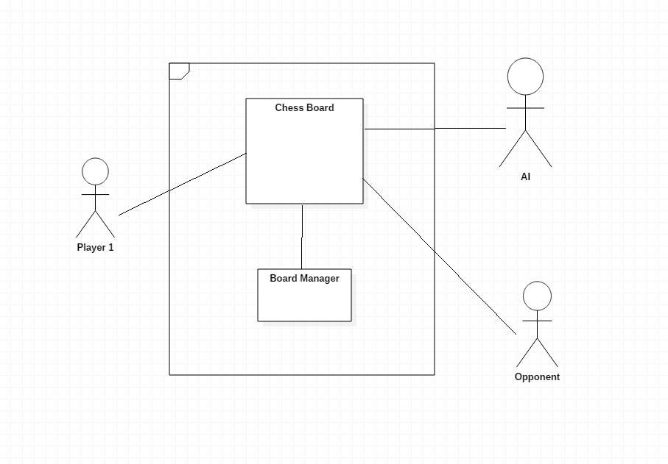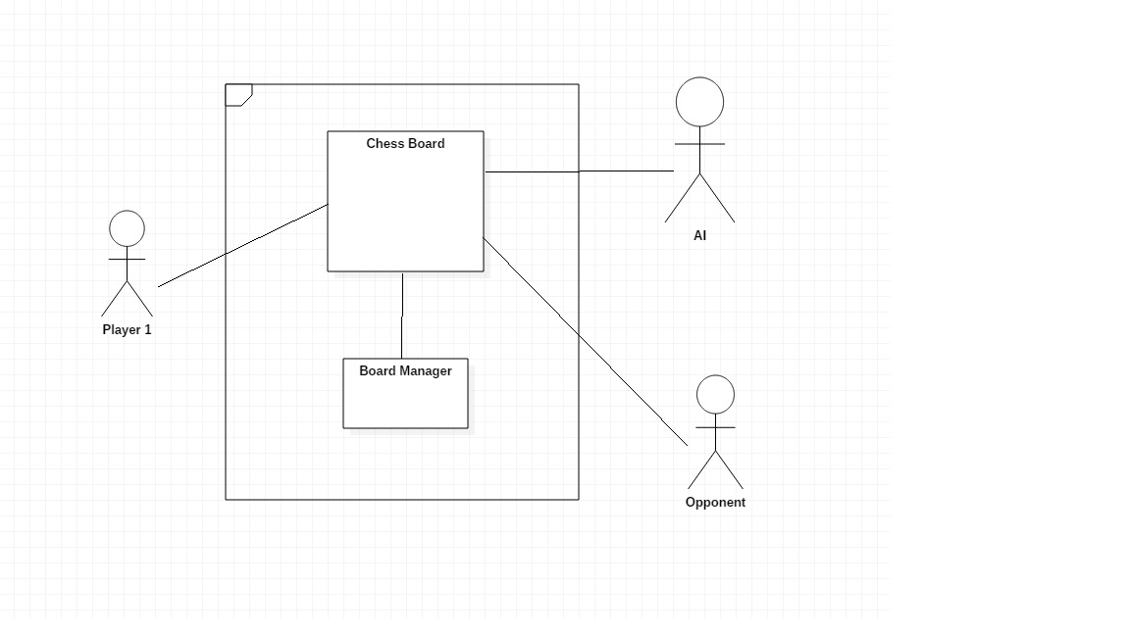

<This template illustrates organizing the functional requirements for the product by system features, the major services provided by the product. You may prefer to organize this section by use case, mode of operation, user class, object class, functional hierarchy, or combinations of these, whatever makes the most logical sense for your product.>

System Feature 1
<Don’t really say “System Feature 1.” State the feature name in just a few words.>
4.1.1 Description and Priority
<Provide a short description of the feature and indicate whether it is of High, Medium, or Low priority. You could also include specific priority component ratings, such as benefit, penalty, cost, and risk (each rated on a relative scale from a low of 1 to a high of 9).>
4.1.2 Stimulus/Response Sequences
<List the sequences of user actions and system responses that stimulate the behavior defined for this feature. These will correspond to the dialog elements associated with use cases.>
4.1.3 Functional Requirements
<Itemize the detailed functional requirements associated with this feature. These are the software capabilities that must be present in order for the user to carry out the services provided by the feature, or to execute the use case. Include how the product should respond to anticipated error conditions or invalid inputs. Requirements should be concise, complete, unambiguous, verifiable, and necessary. Use “TBD” as a placeholder to indicate when necessary information is not yet available.>

<Each requirement should be uniquely identified with a sequence number or a meaningful tag of some kind.>

REQ-1:
REQ-2:

System Feature 2 (and so on)

Other Nonfunctional Requirements

Other Requirements
<Define any other requirements not covered elsewhere in the SRS. This might include database requirements, internationalization requirements, legal requirements, reuse objectives for the project, and so on. Add any new sections that are pertinent to the project.>
Appendix A: Glossary
<Define all the terms necessary to properly interpret the SRS, including acronyms and abbreviations. You may wish to build a separate glossary that spans multiple projects or the entire organization, and just include terms specific to a single project in each SRS.>
Appendix B: Analysis Models
<Optionally, include any pertinent analysis models, such as data flow diagrams, class diagrams, state-transition diagrams, or entity-relationship diagrams.>
Appendix C: To Be Determined List
<Collect a numbered list of the TBD (to be determined) references that remain in the SRS so they can be tracked to closure.>

