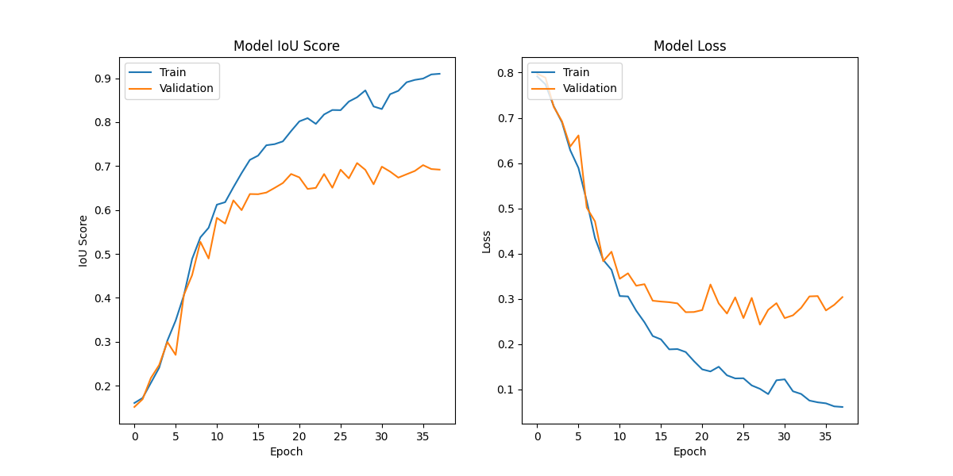Patched images to 200x200  
  
loss: 0.0614 - iou_score: 0.9101 - val_loss: 0.3040 - val_iou_score: 0.6919  
  
  
the val iou is poor.  
  
I want to boost it.  
imma get a first 16 filter layer line  
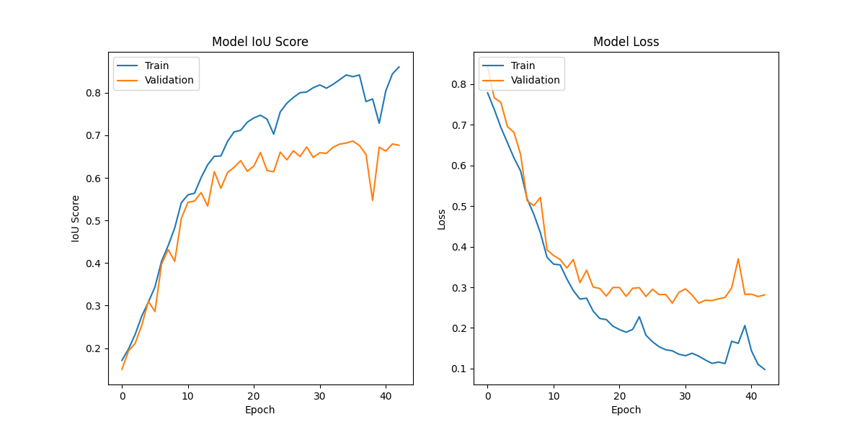

31ms/step - loss: 0.0981 - iou_score: 0.8605 - val_loss: 0.2813 - val_iou_score: 0.6767  
  
  
which iis much faster but actually less precise.  
  
  
maybe the size is too small.  
  
lets try with the original 400 images, but keep the num filters reduced  
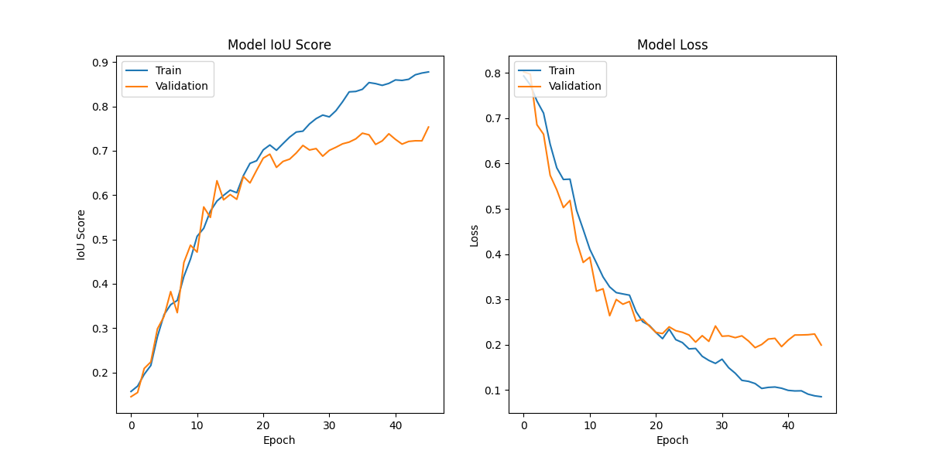  
  
  
loss: 0.0852 - iou_score: 0.8779 - val_loss: 0.1993 - val_iou_score: 0.7535  
  
  
much better !

IoU= True Positive (TP)​ / True Positive (TP)+False Positive (FP)+False Negative (FN)

lets try to change the unet a bit (play with num of layers and num filters  
  
  
going from 32 to 256 is worse. Dropping the iou by 3 points  
  
  
  
  
Ok I figured out the output images are 608x608  
  
1rst experiement was to train on 400x400, then resize the test image before and after the predicitons.  
  
F1 score : 0695 : Accuracy : 0.848  
  
  
2nd experiment will involve using a patching technique.  
Images to be predicted will be 256 then 320 and 192  
  
  
3rd will be to use best case and try to reduce the unet depth