# Connecting to Chapman IS&T RTS Clusters (Windows version)

2020-03-27  
jakelly@chapman.edu

version .05

# Introduction

This document covers:

1. Connecting and authenticating to Chapman RTS clusters in text/shell mode (SSH) from Windows clients.
2. Connecting and authenticating to Chapman RTS clusters in graphical/GUI mode (X2Go) from Windows clients.

# Network Connectivity Notes:

On campus, you will need to be connected through a physical ethernet cable or EduRoam wireless. Depending on your location on campus, you may also need to be connected through the campus VPN server, vpn.chapman.edu.

Off campus, or on-campus but connected to ChapmanOpen wireless, you will always need to connect through the campus VPN server.

# Connecting to RTS Clusters Using SSH

An SSH client provides network-optimized, cryptographically-secure text-mode access to remote hosts and devices running SSH server software. All SSH communication is securely encrypted. No credentials, commands, or data are ever communicated in plaintext.

On a computer running Windows, RTS recommends the free SSH client [MobaXTerm](https://mobaxterm.mobatek.net/). Other free clients that work, with some limitations, are [Kitty](http://kitty.9bis.com/), [Putty](https://www.chiark.greenend.org.uk/~sgtatham/putty/), and [Windows Subsystem for Linux](https://docs.microsoft.com/en-us/windows/wsl/install-win10). RTS recommends [MobaXTerm](https://mobaxterm.mobatek.net/) because it includes:

* built-in graphical display redirection, which displays graphical applications running on the remote server as though they were running locally
* a tabbed interface for managing multiple connections
* easy-to-use secure file transfer (sftp) functionality

When using other free SSH clients, additional software must be installed to get these features.

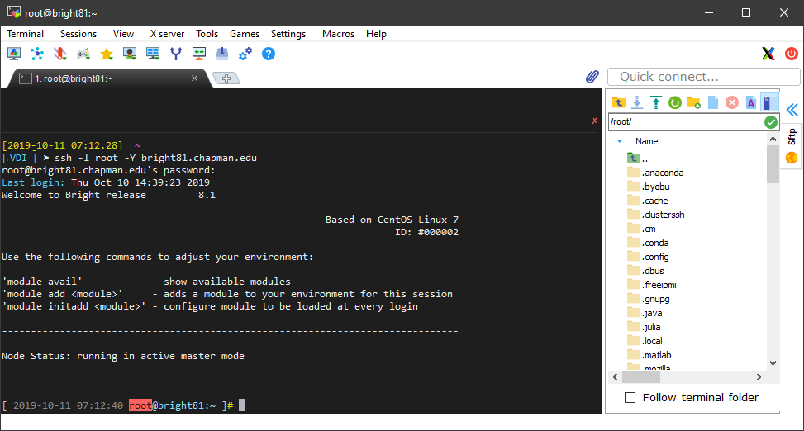  
A typical MobaXTerm window, with its file-transfer panel open

## Connecting to an RTS cluster using SSH:

Once the local ssh client is running, use the command ssh -Y {username}@chapman.edu@{hostname}.chapman.edu to connect to the server.

[user@localhost]# ssh -Y {username}@chapman.edu@{hostname}.chapman.edu

All Chapman RTS clusters are integrated into the campus **single-sign-on** environment. Your login name will be your **full Chapman email address**, including @chapman.edu or @mail.chapman.edu. Your password will be your email password.

*[Don’t include the curly braces. In this document curly braces identify variables to be replaced in input.]*

Replace {username}@chapman.edu with your login name (your full Chapman email address), and {hostname}.chapman.edu with the DNS name for the cluster login node. The login node for the Keck cluster is keckcluster.chapman.edu.

[user@localhost]# ssh -Y tysmith@chapman.edu@keckcluster.chapman.edu

Accept any ssh warnings by entering yes or y, then enter your password for the server. For security reasons, the password will not be visible as you enter it. The -Y parameter tells the server to enable remote graphical redirection.

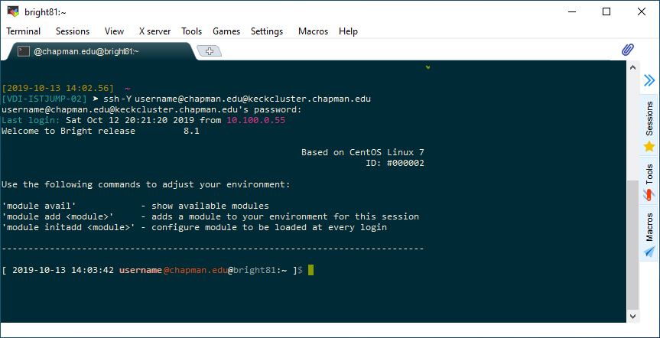  
MobaXTerm window, showing the login process for keckcluster.chapman.edu

## Running programs through SSH on the server:

Once connected, any text-mode (“shell”) programs you run will show their output in the terminal window. You can connect as many terminal tabs or windows concurrently as you need. When your interactive programs are all finished, use the command exit to disconnect, or just close the terminal window.

Closing the SSH client application without exiting first will disconnect all logged-in terminal windows, abruptly terminating any running programs. (Both shell and graphical programs.) The failure of a network connection or VPN tunnel will also terminate all sessions. Server-side “connection manager” utilities (like [tmux](https://www.hamvocke.com/blog/a-quick-and-easy-guide-to-tmux/), [screen](https://linuxize.com/post/how-to-use-linux-screen/), or [byobu](http://byobu.co/)) can be used to keep sessions open across disconnections, avoiding lost work and corrupted data.

If you are running a local X server application (like [MobaXTerm](https://mobaxterm.mobatek.net/)’s), the windows of any graphical programs you start on the server (firefox, jupyter, MATLAB, RStudio, etc.) from your terminal will be redirected back to your local computer. They will look very much like they are running locally, except for slowness caused by network lag. Any file locations shown in their dialogs will refer to storage locations on the remote server.

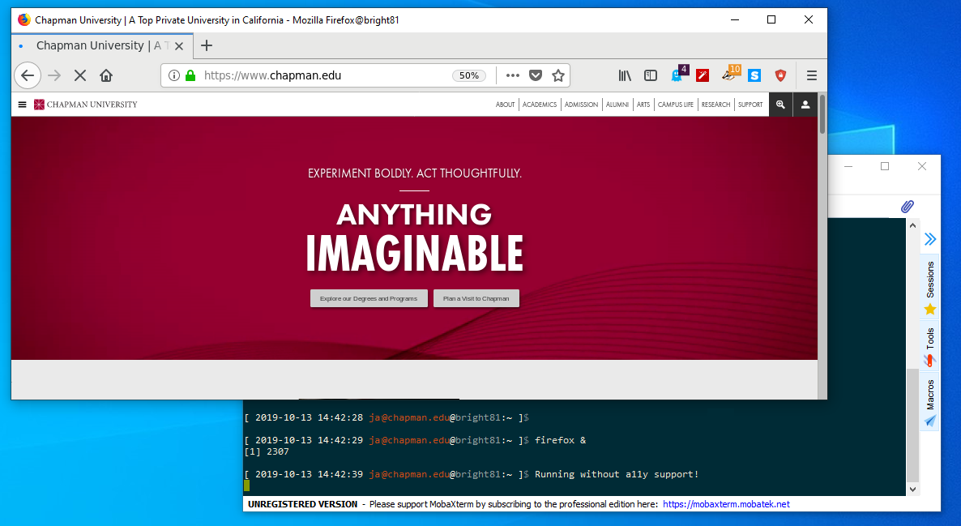  
A logged-on SSH session, with a remote firefox window displayed locally though graphical display redirection

# Connecting to RTS Clusters Using X2Go

Unlike an SSH client, which uses a terminal window to run remote applications, redirecting applications separately back to your local display, the X2Go graphical remote-access client relays the entire desktop, including menus, icons, toolbars, and background.

The main advantage of X2Go is responsiveness. Redirecting the entire remote display results in much faster graphical access to the remote server, tunable for different speeds of network connection.

Some users also like having fewer windows to manage, or having all of the work associated with a particular server or project organized into a single window.

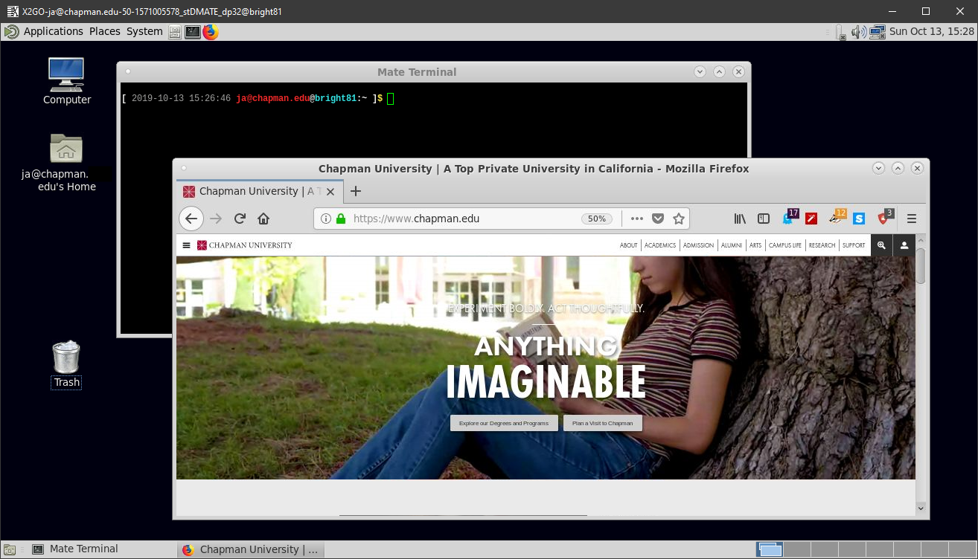  
X2Go remote graphical client window, showing the full keckcluster.chapman.edu [MATE](https://mate-desktop.org/) desktop

The download link and installation instructions for the X2Go client are available [here](https://wiki.x2go.org/doku.php/doc:installation:x2goclient). It can be installed without administrative rights, if necessary (a slightly more complex install).

Once installed, running the client displays the main window:

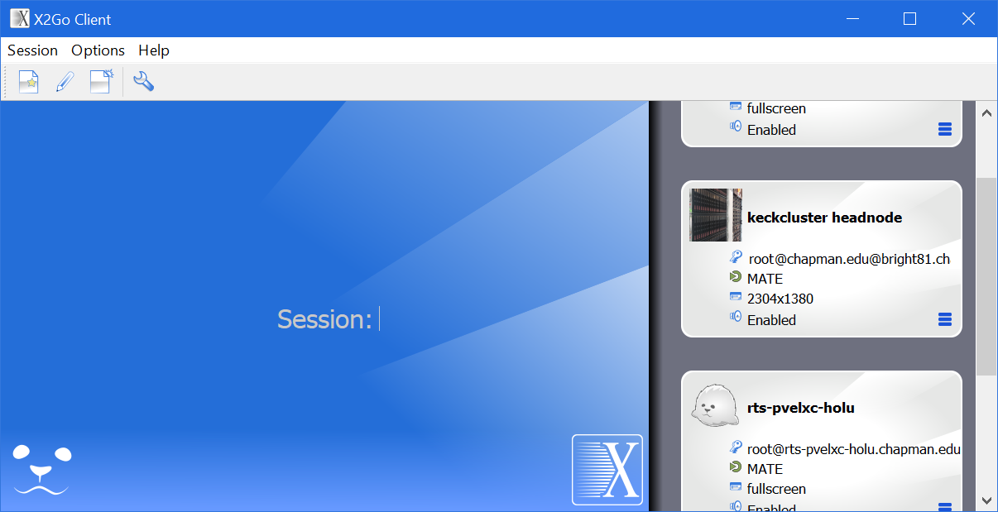  
X2Go Client main window, showing several Saved Session entries with different icons

The first task is to create a new Saved Session entry.

## Create a new Saved Session entry:

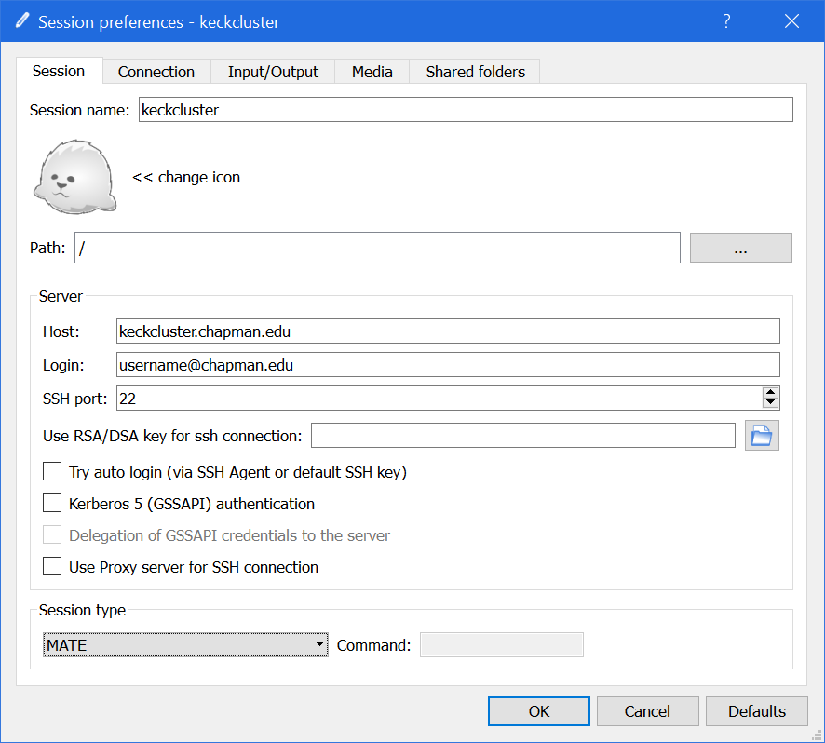

To create a new Saved Session entry, either click the New Session button, or use the menu items, Session --> New Session.

On the Session tab, set:

Session name: to any name you want to give the saved session.

Host: to the DNS name or IP address of the cluster login node you want to connect to. For the Keck cluster, use keckcluster.chapman.edu.

Login: to your full Chapman email address, including @chapman.edu or @mail.chapman.edu.

Session type: to MATE.

(Later, when you open these settings again, the drop-down menu will say Custom desktop and MATE will appear in the Command: text-box. You do not need to do anything. That is normal.)

[*X2Go will not save your password. You will need to enter your password each time you log in.]*

Feel free to click the “<< change icon” button. Most types of graphics file can be used as a Saved Session icon.

Then click the Input/Output tab.

## Create a new Saved Session entry (continued):

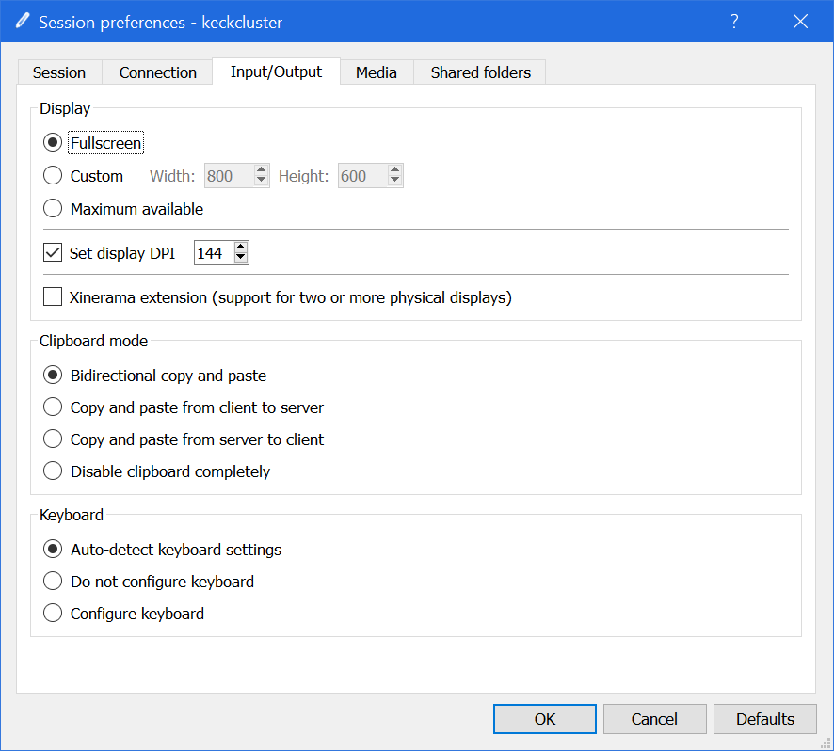

On the Input/Output tab, set:

Display: to Fullscreen. (Fullscreen is simplest to start with. Please feel free to experiment with the other choices later to find what works best for you.)

Set display DPI: Leave this at its current value, for now.

After you successfully log in once, experiment with this setting. The higher you set it, the smaller it makes the graphical elements on the remote server appear. This adjustment can be very useful when working from very small or very large local screens.

Then click the Shared folders tab.

## Create a new Saved Session entry (continued):

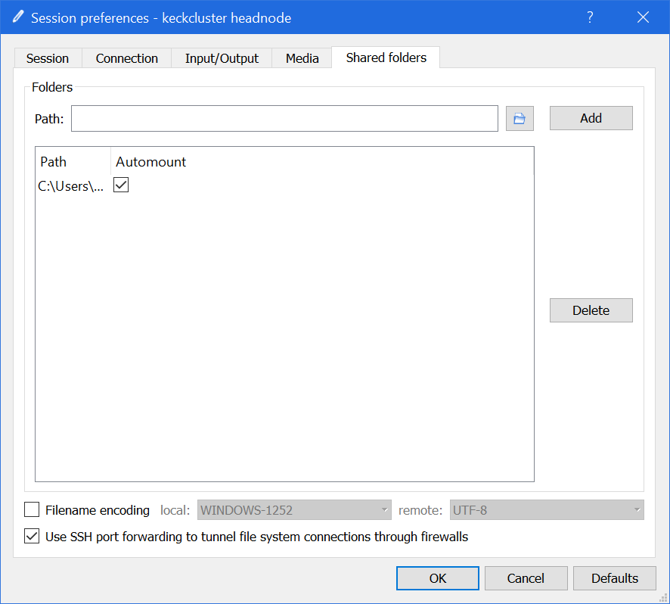

On the Shared folders tab, set:

Path: Set this to a local computer storage path that you want to be connected on the remote server. You can also click the small Browse button next to the text-box to select the folder you want mounted.

Once you have entered or selected a folder, click the Add button to make the folder appear in the Path column of the Folders list.

Check the Automount check-box to have it mounted automatically when you log in.

You can add as many local folders as you would like.

When you log in, a virtual alias to the local folders will be mounted in your cluster home-directory at the path:

{REMOTE_HOMEDIRECTORY}/media/disk/{local_foldername}

Then click the OK button to save the new Saved Session entry.

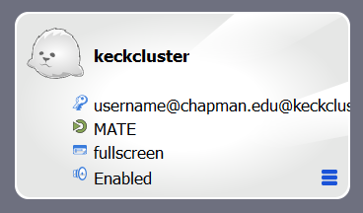

The new Saved Session entry will appear in the list in the main X2Go window.

## Connect to the RTS cluster using X2Go:

Double-click the new Saved Session entry to start the connection process. A login window will appear in the middle of the X2Go main window:

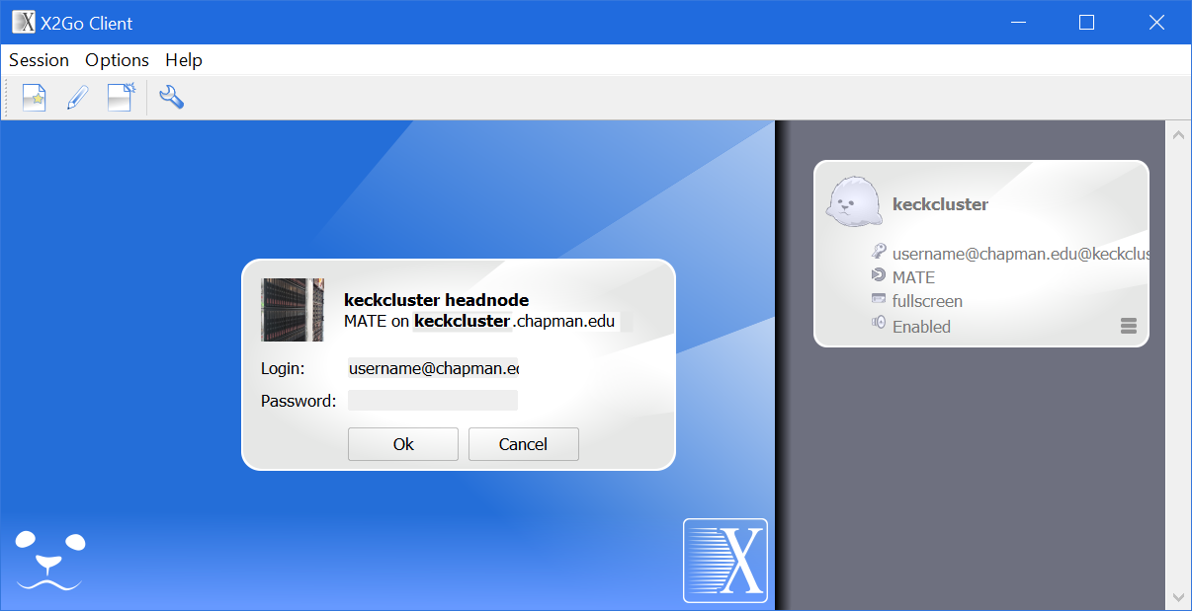

Enter your Chapman single-sign-on (email) password. Click the Ok button to connect.

## Using the RTS cluster login-node remote desktop:

If the connection and login are successful, the login node’s desktop will appear in a single local window.

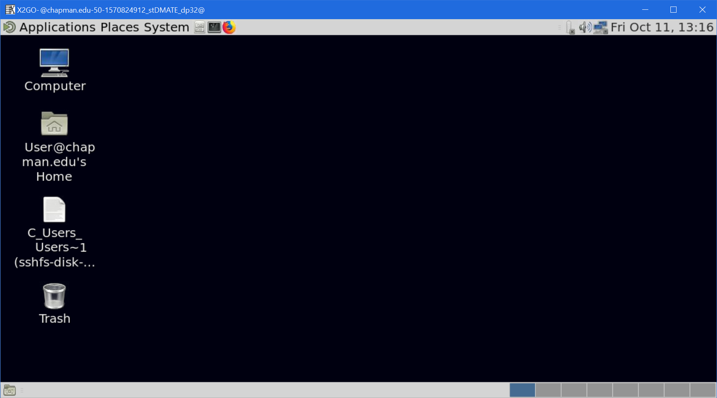  
X2Go remote graphical client window, showing full keckcluster.chapman.edu MATE desktop

The Linux MATE desktop is similar to the Macintosh and Windows desktops. Most elements are self-explanatory. Most cluster research applications are started using a terminal window, rather than menu items.

The X2Go client allows graphical programs to run much more responsively compared to SSH and graphical display redirection.

*[Please note, the C_Users_Users~1-sshfs-disk… desktop shortcut will not work for security reasons.   
Your local folders are mounted at the path noted above in the Shared folders tab configuration.]*

## Ending a remote desktop session:

To exit the remote desktop session, in the menus, select System --> Log Out {user}@chapman.edu.

The remote desktop session will close and you will be logged out of the remote server. Any running processes will be terminated, unless protected by a session manager utility.

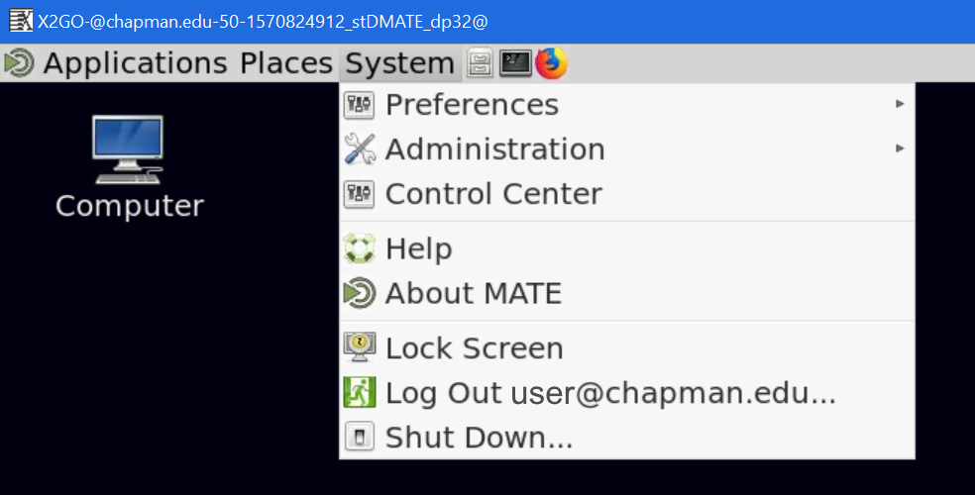  
Part of an X2Go Client remote desktop window, showing the System menu.