**Report - Q5**

Images without Gaussian noise:

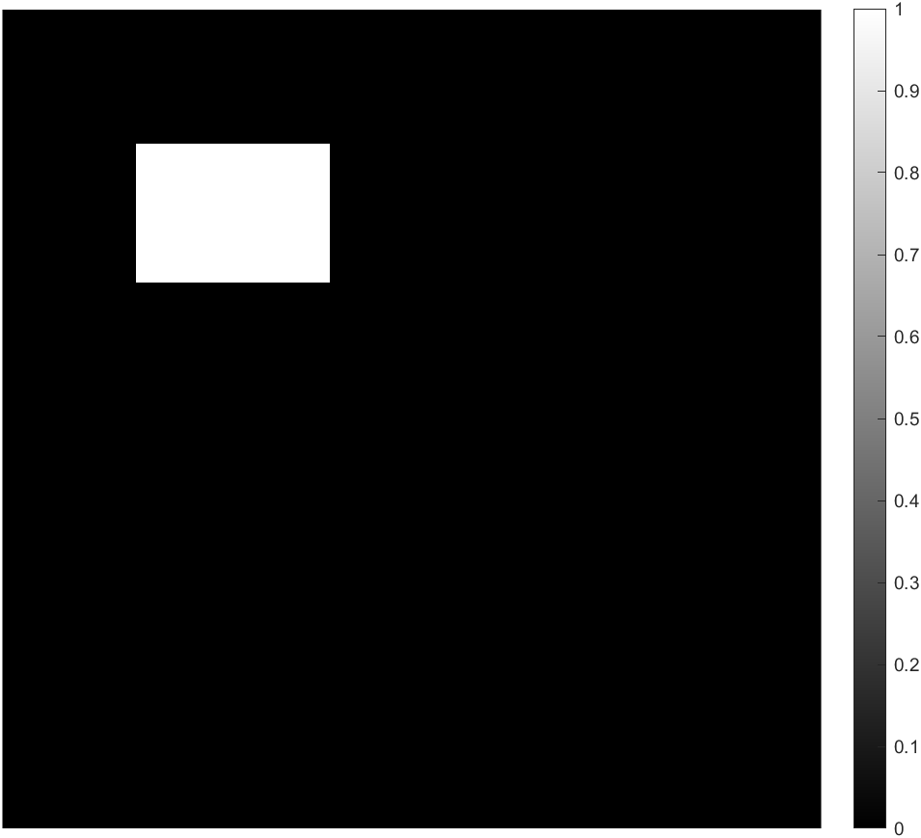 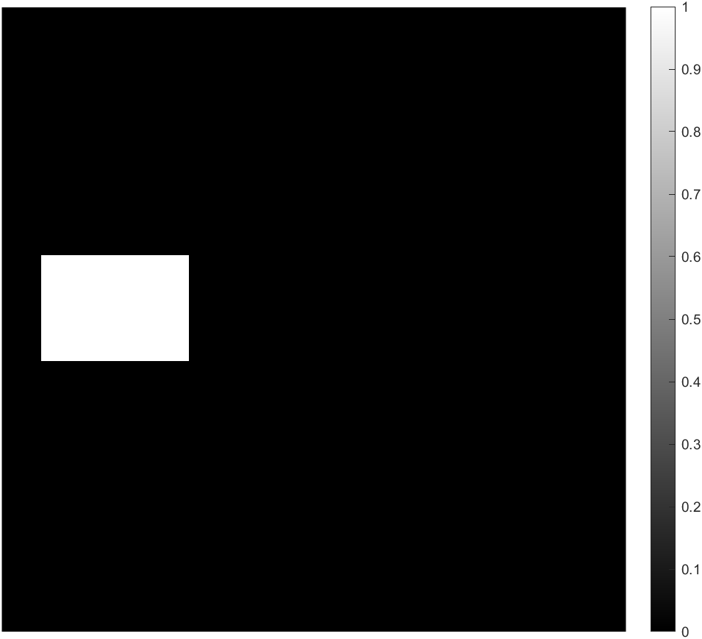

Figure 1 Left: Image I , Right: Image J

Logarithm of the Fourier magnitude of the cross-power spectrum:

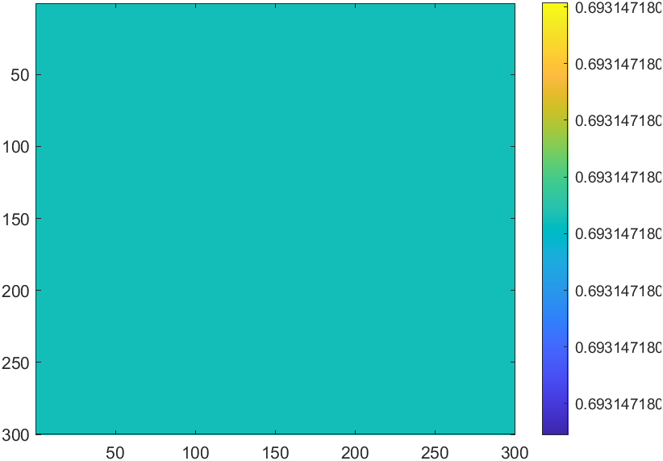

Translation needed for restoration for images without noise:

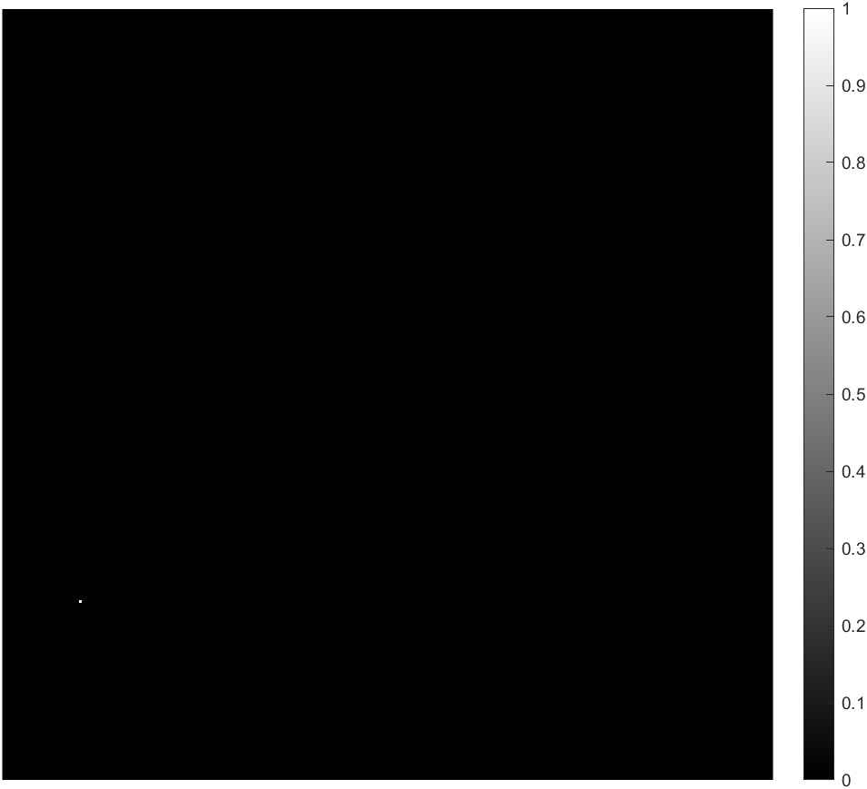

Images with Gaussian noise:

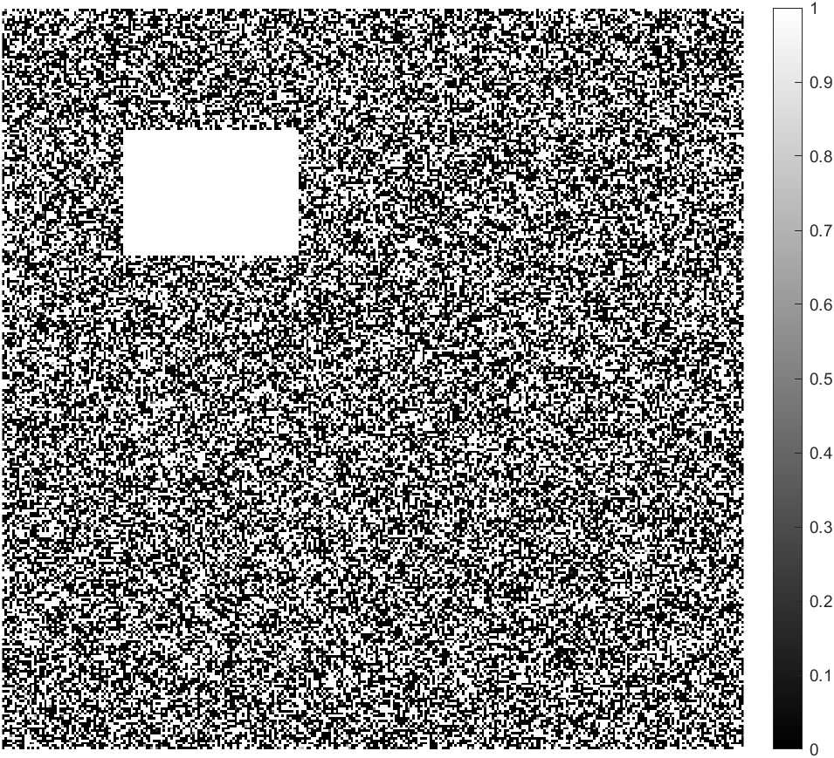 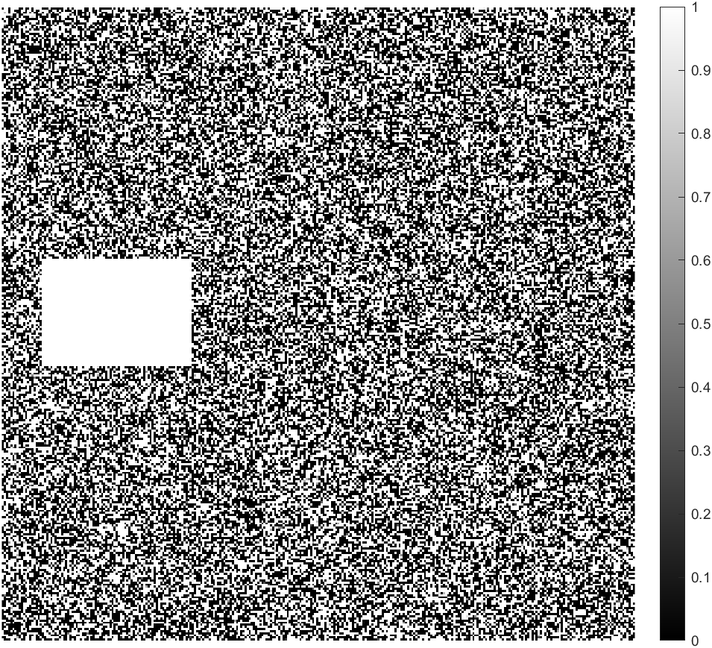

Figure : Left: Image I with noise , Right: Image J with noise

Logarithm of the Fourier magnitude of the cross-power spectrum:

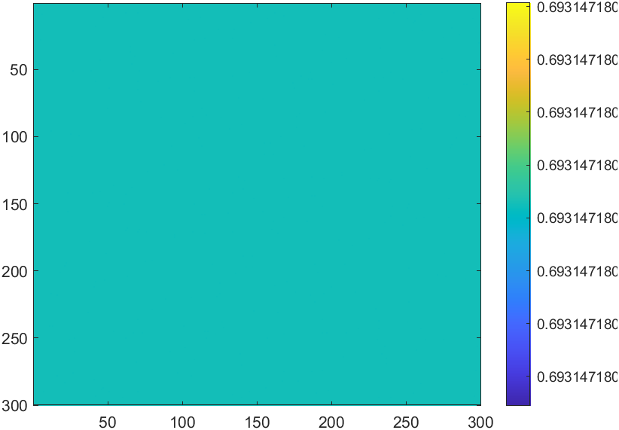

Translation needed for restoration for images with noise:

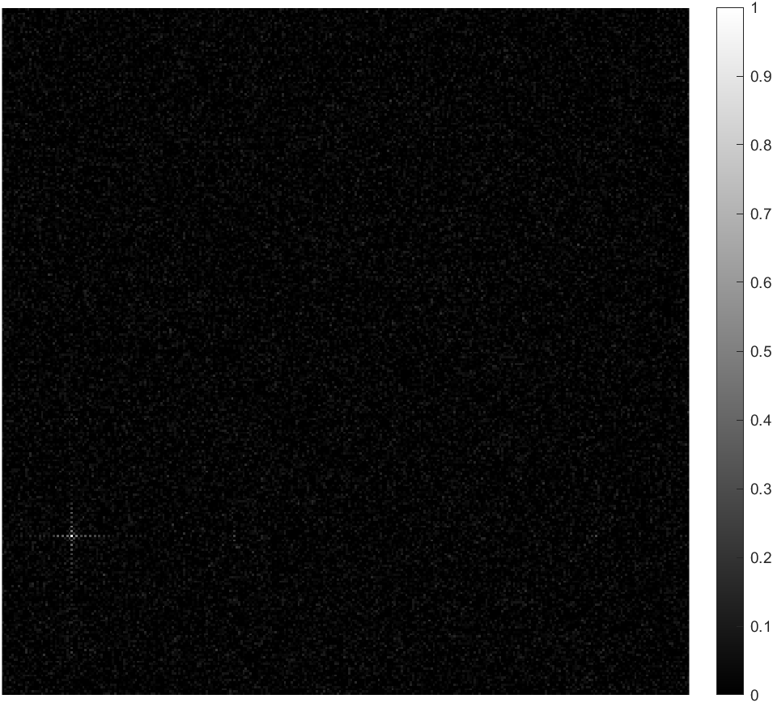

**Verification between predicted values and ground truth values:**

For images I and J without noise we can see that the required translation is shown as (31, 231) as a spike in values but as MATLAB is indexed from 1 we can take this to be as (30, 230) which can be considered as (30,-70) considering wraparound which is the exact translation required as the initial translation we applied was (-30,70) .

For image I and J with noise we can see that the required translation is shown around (31, 231) as a spike in values but as MATLAB is indexed from 1 we can take this to be as (30, 230) which can we considered as (30, -70) considering wraparound. Here we observe that that spike is not as sharp as the first case because of noise. There are values on around the spike because of noise added to the image.

**Comparison of Complexities:**

For the current method used (NxN image):

* Complexity of FFT: O(N2*log(N))
* Complexity of Conjugate: O(N2)
* Vectorized multiplication and division: O(1)
* Total Complexity: O(N2*log(N))

For the pixel-wise image comparison (NxN image):

* Complexity: O(N4)

We can see here that the complexity for pixel-wise comparison is much higher than the current method used.

**Correction for rotation between two images:**

Let f2(x,y) be a be a rotated version of f1(x,y) rotated by a angle θo,

f2(x,y) = f1(x*cos(θo) + y*sin(θo), -x*sin(θo) + y*cos(θo))

From Fourier rotation property the Fourier transforms of f1 and f2 are related by,

F2(u,v) = F1(u*cos(θo) + v*sin(θo), -u*sin(θo) + v*cos(θo))

Here as we can calculate cross-power spectrum by converting the magnitudes of F1 and F2 to polar coordinates,

M1 = M2(ρ, θ-θo)

From this we can get both the translation and rotation of the image as we would be able to calculate both ρ and θ.