**Q6 Report**

Formula for N, N-point Discrete Fourier Transform for Laplacian kernel k1:

G(u, v) = (-4)*F(u, v) + F(u, v) $\left(e^{-\frac{j*2*pi*U}{N}}+ e^{\frac{j*2*pi*U}{N}}+ e^{-\frac{j*2*pi*V}{N}}+ e^{\frac{j*2*pi*V}{N}}\right)$

*

Formula for N, N-point Discrete Fourier Transform for Laplacian kernel k2:

G(u, v) = 8*F(u, v) - F(u, v)*

DFT plot for kernel k1 with N=201:

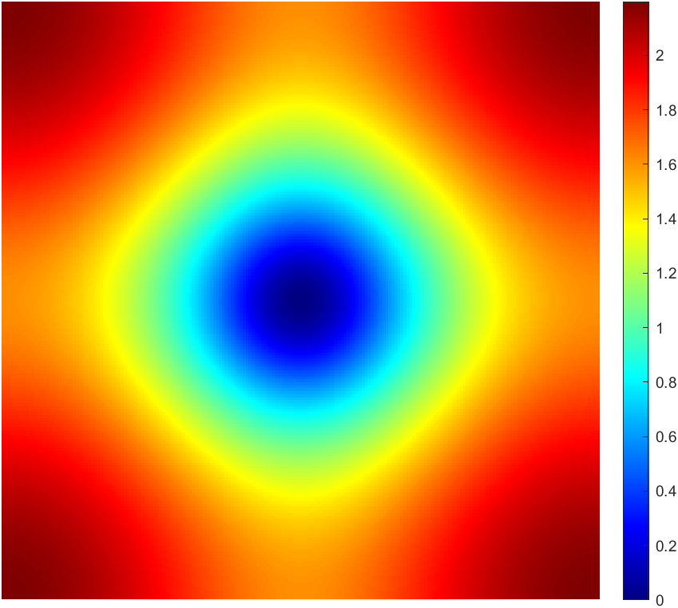

DFT surface plot for kernel k1 with N=201:

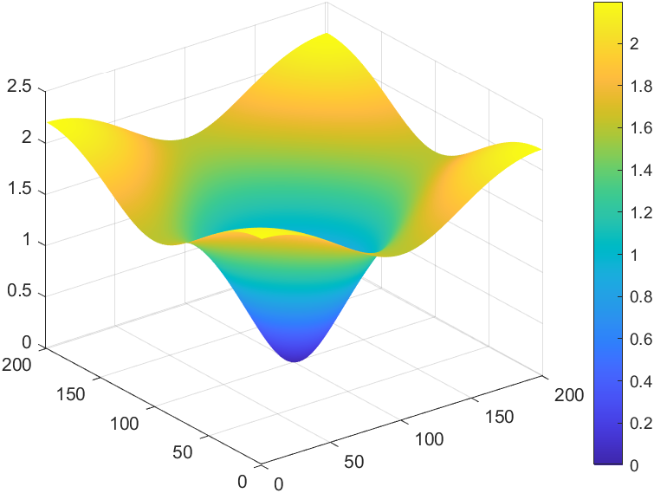

Code snippet for the DFT computation:



DFT plot for kernel k2 with N=201:

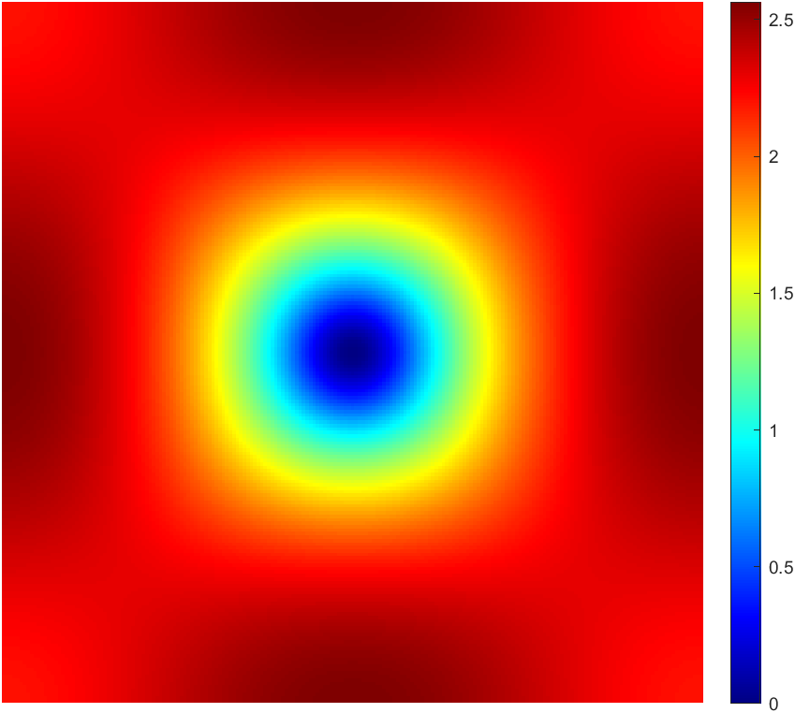

DFT surface plot for kernel k2 with N=201:

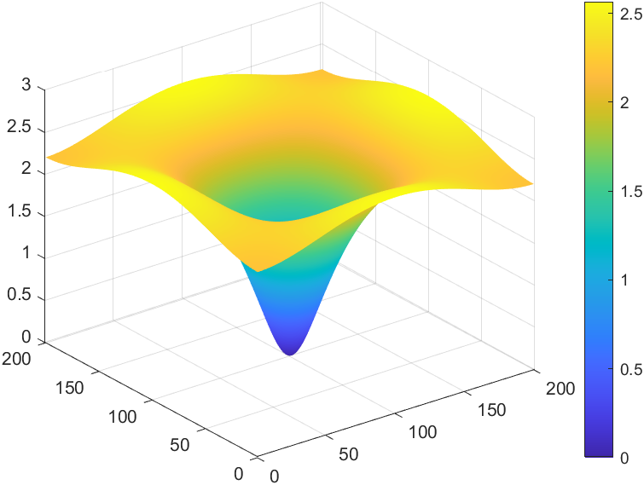

Code snippet for the DFT computation:



**Comment’s on the difference in the Fourier transforms:**

The Fourier transform for the kernel k2 is much more uniform in all directions because of weighting factors in the corners of the filter. This results in the DFT being more circular for the kernel k2 and for kernel k1 the DFT is more like a rhombus.

But for DFT of kernel k2 there is a dip in the values at the edges compared to constant increase in values from centre to corners for kernel k1.