

**National University OF Computer and Emerging Sciences**



**Web Project**

**Project Name: HOSTELYTE**

**Members**:

Ali Haider Rizvi 16L-4267

Ali Haider Butt 16L-6305

Ali Akber 16L-4081

MSZ 16L-4103

# Introductory Page

**Mobile : 0334-4646825**

**E-mail: hostelyte.inc@gmail.com**

**Logo:**

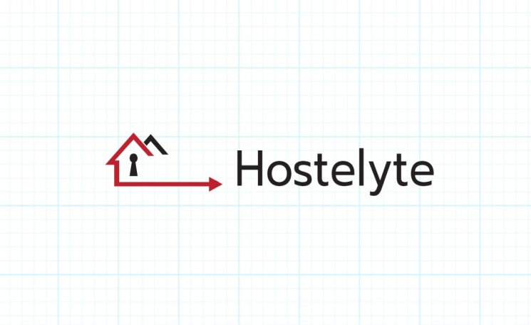

**Company name : Hostelyte**

**Address : 32-B Milaad street**

**Website :** [**www.hostelyte.com**](http://www.hostelyte.com/)

**Facebook :** [**www.facebook.com/hostelyte**](http://www.facebook.com/hostelyte)**(WORKING)**

**Instagram :** [**www.instagram.com/hostelyte**](http://www.instagram.com/hostelyte) **(WORKING)**

**Nature**

The nature of the business is to provide an online platform to search and manage hotel related tasks efficiently**.**

# Executive Summary

**Introduction**

Hostelyte is a new online venture that allows the students coming from distant places, to find and book hostels in an efficient and easy way, through its advanced search engine and distinctive features. It also provides the hostellers with some premium features.

**Industry analysis and competitor analysis**

Hostelyte falls in the category of accommodation industry. The size of accommodation industry is massive in Pakistan. Due to the importance of education in Pakistan, everyday more and more students migrate from one place to another, and they need an advanced and easy search engine to find hostels, hence growth rate of industry is also high. Industry is fragmented rather than concentrated. Profit margins are also high because of the use of technological advances cost of the business is greatly reduced. Our direct competitors are **pakistanyouthhostels.co.**

Our indirect competitors are **booking.com** and **hostels.com**

**Company Description**

Our mission is to provide a platform to help students in finding hostels in an efficient way and to allow hostellers to manage hostel related tasks in better and effective way. Hostelyte will provide an online website and a Google play store app to accomplish these tasks. We currently have a complete online website that is ready to be launched in the market. Currently we are not associated with any partners i.e. founders are working on their own.

**The economics of business**

Hostelyte will drive revenue from Online Ads and some premium features which the hostellers can avail. Operating leverage is low as we donot have fixed cost of production relative to variable cost.Our startup cost is approximately 297,000 Rs. Our Business will not take longer to break even.

Marketing Plan

Hostelyte will charge the hostellers and other advertisers for advertising their hostels and content respectively. The range of pricing for these services vary as per the extent of service. The hostellers that have subscribed their premium features will be charged a monthly fee. Our place of business is internet. Most of our promotion is through social media.

**Operation plan**

Our Application will be accessible on App Stores and we will have Website as well. We will generate revenue from the traffic and there will be Premium Version for Hostellers from which we will generate revenue too.

Since, it’s an online business so we will have Website and Smartphone Applications on their respective App Stores.

**Management Team**

1. Ali Haider (Founder)
2. Ali Haider(Founder)
3. Ali akbar (Founder)
4. MSZ (Founder)

**Financial Projections**

1. **Net Sales**

We are expecting 10,000 sales per year.

Our net sales per year will be Rs.9, 800,000/-

1. **Cost of Sales**

Our cost of sales for the first year will be Rs.1, 017,000.

Our cost of sales for the first year will be Rs.1, 164,000.

Our cost of sales for the first year will be Rs.1, 244,400.

# Industry Analysis:

**Hostelyte** falls in the category of **Accommodation Industry**. Let us focus on some aspects of this industry.

* **Industry size**

The size of accommodation industry is massive in Pakistan.

* **Growth rate**

The growth rate of the industry is very high in Pakistan. Because of education and business explosion, everyday more and more people migrate from one place to another, and there they need accommodation.

* **Industry structure**

The accommodation industry is fragmented rather than concentrated. Any new entrant ,who maintains a fine balance between the services they provide and the cost of those services can easily earn some good profit.

* **Nature of Participants**

The participants in the industry only deal with searching the hostels online. They do not have a healthy interaction environment. The services they provide are only uni-directional whereas if we talk about hostelyte it acts as middleware between two parties. You can book the hostels online. Hostel owners are linked to the website through their account and in this way security is also ensured.

* **Key success factors**

Since the importance of education is increasing radically in Pakistan the need for accommodation is also increasing, which is one of the key success factors. Moreover, hostels owners also need something to keep and maintain records online, which is also a key success factor.

* **Industry trends**

People usually have enough money to spend on their accommodation, even if they do not have they will somehow manage to fulfill this basic requirement. The use of the technological devices in accommodation industry is increasing day by day because the people prefer ease, hence the entrepreneurs are trying to shift their businesses online. Profit margins in the accommodation industry are increasing because of the increase in demand and use of better equipment.

* **Long term prospects**

The industry has enough space for new venture to enter and earn

Sufficient profit. The industry has the potential to last a long time.

# Company Description:

* **Company history**

The idea for the company appeared when our founders realized the difficulties the students faced in finding and managing the tasks related to hostels. Since our founders experienced the hostel life themselves in their student life they were well aware of the scope of the business and things which needed to be better.

* **Mission statement**

To help students and hostel owners in finding and managing hostel related tasks in better and efficient way.

* **Vision statement**

To create a platform that can reduce the process of degeneration for prospective hostelites in the future.

* **Products and Services**

**Hostelyte** provides an online website for students to find hostels which suits best to their requirement. It also provides a separate portal to the hostel owners to manage hostel tasks and to keep records in a much better way.

* **Current Status**

We are currently in the process of building our website and negotiating with hostel owners and students to avail our services.

* **Legal status and Ownership**

Hostelyte is a partnership firm with following profit ratio:

Ali Haider Rizvi 25%

Ali Haider 25%

Ali akbar 25%

MSZ 25%

* **Key partnerships**

Currently we are not associated with any partners but in the future we are planning to partner with the institutions which do not have their own hostels.

# Market Analysis:

* **Market Segmentation**

Hostelyte segments the market on the basis of lifestyle.

* **Target Market**

Initially since it’s a new venture, our target market will be limited to only students looking for hostels coming from distant areas and the hostellers. But we will increase the scope with time.

* **Buyer Behavior**

Buyer behavior is positive because as we conducted a focused group, they were all interested in our business plan and are anxiously waiting for this Application.

* **Competitor Analysis**

**Pakistanyouthhostels.co** is our direct competitor which provides searching the hostel easily but what Hostelyte provides is, in addition to searching the hostels efficiently, Hostelyte provides a separate portal for hostellersi.e. They can sign up and post ads about their hostels and also maintain a database about their hostel, this feature is not available in any of the competitor. Also the hostellers and the hostelites can directly interact with each other through online messaging, this features is helpful for hostelites in case anything is out of order they can contact the owners directly.

There are also a number of other indirect competitors like hostels.com (not popular in Pakistan) and booking.com.

# **The Economics of the business**

* **Revenue driver:**

Hostelyte will drive revenue from Online Ads which will be shown on Application and Website. Moreover, Premium Version for Hostellers will also add up to revenue and mainly commission based earning.

* **Profit margins:**
* We have very low fixed cost.
* We have high profit margins.
* **Fixed cost:**

Our fixed cost includes:

* Domain Renewal(Rs 2,000)
* Server (Rs 20,000/Year)
* Apple Store (Rs 3,000)
* Desks (Rs 8,000)
* Flexes (Rs 4,000)
* Furniture (Rs 30,000)
* Laptop (Rs 30,000)
* **Variable cost:**

Variable cost includes:

* Rent
* Advertisement
* **One time cost:**

One time cost includes:

* Domain Renewal (Rs 2,000)
* Server (Rs 20,000/Year)
* Apple Store (Rs 3,000)
* Desks (Rs 8,000)
* Flexes (Rs 4,000)
* Furniture (Rs 30,000)
* Laptop (Rs 30,000)
* **Operating leverages and its implications:**

Operating leverage is low in Hostelyte as we do not have Fixed Cost of production relative to Variable Cost. Our service with a low operating leverage will not take longer time to breakeven.

* **Startup cost:**

Total startup cost will be around 297,000 Rupees (approximately).

* **Break even and calculations:**

1050 sales * 900 (commission) + 84,000(commission on mess by 40 % of 1050 sales)=Rs. 1,029,000/-

# **Marketing Plan**

* **Overall marketing strategy:**

Overall marketing strategy will be Differentiation strategy as Hostelyte will provide Search facility around pined location and details about each Hostel. Moreover, Hostelyte will provide database to Hostellers.

* **Price:**

Hostelyte will not charge any price for Visitors except for the Premium version for Hostellers.

The featured adverts will cost RS 1000 for the 7 days, Rs 2,000 for the 14 days and Rs 3500 for 30 days. The hostellers with premium services will be charged with 500-1000 Rs per month.

* **Products:**

Hostelyte App is a platform for general public to get the Reliable Details of a Hostel which incorporates Virtual Tours and Specific Hostel Details. This will be the first app in the country providing Prospective Hostellers to showcase their Hostels through Images and 3D virtual Tour. Moreover, the gap in the market will be the edge for this Application.

* **Place:**

Since, Hostelyte is an internet based Startup so, its application will be available at Smartphone’s Play Stores/App Stores and likewise, it will have a web rendition.

* **Promotions:**

According to the current trends, most of the promotions are done using electronic media i.e. social media. We will post ads on Facebook and Instagram through their promotional facilities. These facilities will allow us to target almost 85-90% of our desired customers.

* **Sale tactics:**

We will use Social Media to promote Hostelyte and generate Traffic.

# Design and Development Plan

As it’s not a new service that we are providing so this section is not included.

# Operational plan

* **General Approach to Operations**

Our Application will be accessible on App Stores and we will have Website as well. There is no fee for visitor for using this app. We will generate revenue from the traffic and there will be Premium Version for Hostellers from which we will generate revenue too.

* **Business Location**

Since, it’s an online business so we will have Website and Smartphone Applications on their respective App Stores.

* **Facilities and Equipment**
* Customized Search engine Facility.
* We will provide Database for Records of hostelites to Hostellers.