

**DIP-Project-1(c)**

______________________________________________

**Course Instructor:**

Dr. Usman Sadiq

**Submitted By:**

NAME: **Hamza Mansoor**

ROLL NUMBER: **14L-4204**

National University of Computer and Emerging Sciences

Department of Computer Sciences

**P3.1: Mathematical Derivation**

**Step1: take first pixel value (px1) of the image (fn1)**

**Step2: take first pixel value (px2) of the image (fn2)**

**Step3: sum the pixel values and divide by 2**

**Average = (px1+px2)/2;**

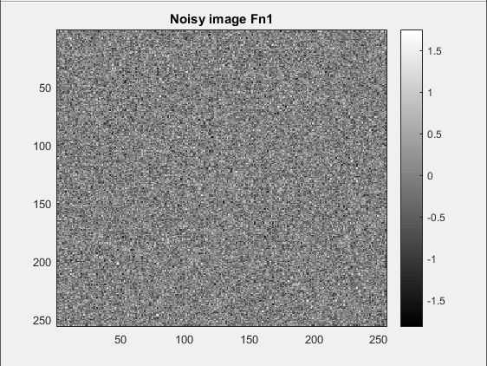 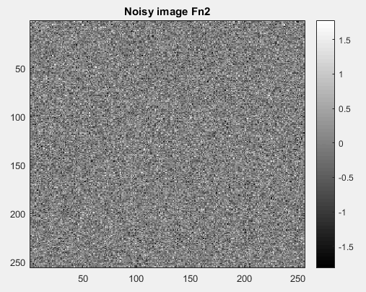

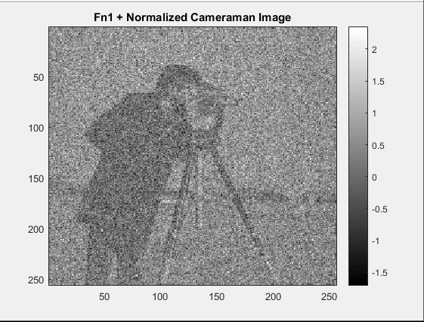 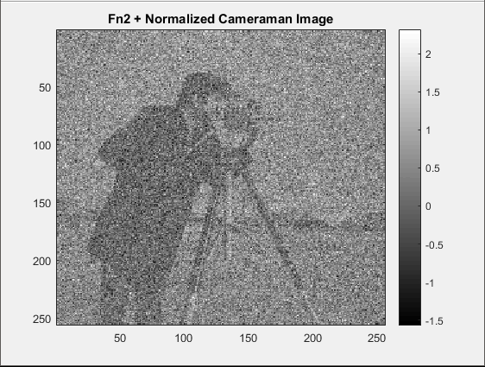

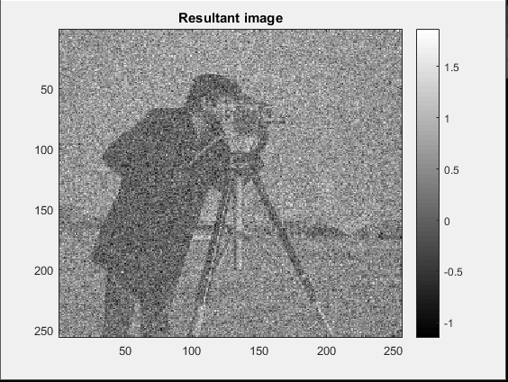

**P3.2:**

CODE PROVIDED IN THE FILE **part32.m**

**EXECUTION INSTRUCTIONS**

1. **Unzip folder 14L4204.zip**
2. **Set the folder as the current working directory in matlab**
3. **Execute each file separately**