**MonogDb vs Mongoose**

[**MongoDB**](https://www.mongodb.com/) is an Open Source, NoSQL database management system. **While, MongooseJS** is an Object Document Mapper (ODM) that makes using MongoDB easier by translating documents in a MongoDB database to objects in the program.   
  
Basically, it is a set of high-level APIs for interaction with MongoDB, using JS as a language.

MongoDB **creating** a new document:

* [db.collection.insertOne()](https://docs.mongodb.com/manual/reference/method/db.collection.insertOne/#db.collection.insertOne)
* [db.collection.insertMany()](https://docs.mongodb.com/manual/reference/method/db.collection.insertMany/#db.collection.insertMany)

**Example code:**

db.inventory.insertOne(

{ item: "canvas", qty: 100, tags: ["cotton"], size: { h: 28, w: 35.5}

}

)

MongoDB **reading** a new document:

* [db.collection.find()](https://docs.mongodb.com/manual/reference/method/db.collection.find/#db.collection.find)

**Example code:**

db.inventory.find( {} )

MongoDB **updating** a new document:

* [db.collection.updateOne()](https://docs.mongodb.com/manual/reference/method/db.collection.updateOne/#db.collection.updateOne)
* [db.collection.updateMany()](https://docs.mongodb.com/manual/reference/method/db.collection.updateMany/#db.collection.updateMany)
* [db.collection.replaceOne()](https://docs.mongodb.com/manual/reference/method/db.collection.replaceOne/#db.collection.replaceOne)

**Example code:**

db.inventory.updateOne(

{ item: "paper" },

{

$set: { "size.uom": "cm", status: "P" },

$currentDate: { lastModified: **true** }

}

)

MongoDB **deleting** a new document:

* [db.collection.deleteOne()](https://docs.mongodb.com/manual/reference/method/db.collection.deleteOne/#db.collection.deleteOne)
* [db.collection.deleteMany()](https://docs.mongodb.com/manual/reference/method/db.collection.deleteMany/#db.collection.deleteMany)

**Example code:**

db.inventory.deleteOne( { status: "D" } )

**POST vs PUT**

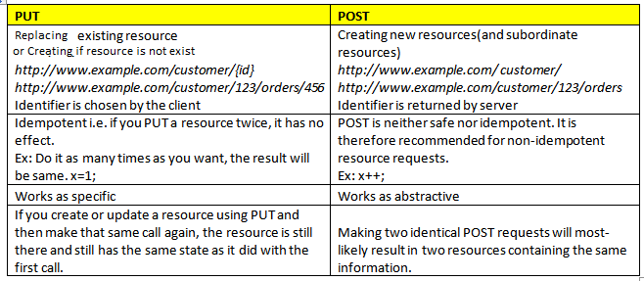

**HTML form doesn’t support put request. So maybe that’s why we used post instead of put. But we can always use URL encoder to go with put request.**

**Well! PUT will be helpful in updating a document. For that, document information must be known. Like if we want to update a book we need to provide its id in the URL.**

**PUT vs PATCH**

Put is used to update as mentioned above. One can updates multiple fields simultaneously. While using Patch one can update only one field of a record at one time.  
Both can be used, to update name.

**Angular JS vs React**

**Angular is a TypeScript-based, open-source front-end web application platform. It is an MVC framework created by Google. MVC is an architecture type for frameworks that develop user interfaces. It translates to Model View Controller.** Angular allows two-way data binding.

**React is a JavaScript library for building user interfaces**. React allows one-way data binding.

**Vue.js**

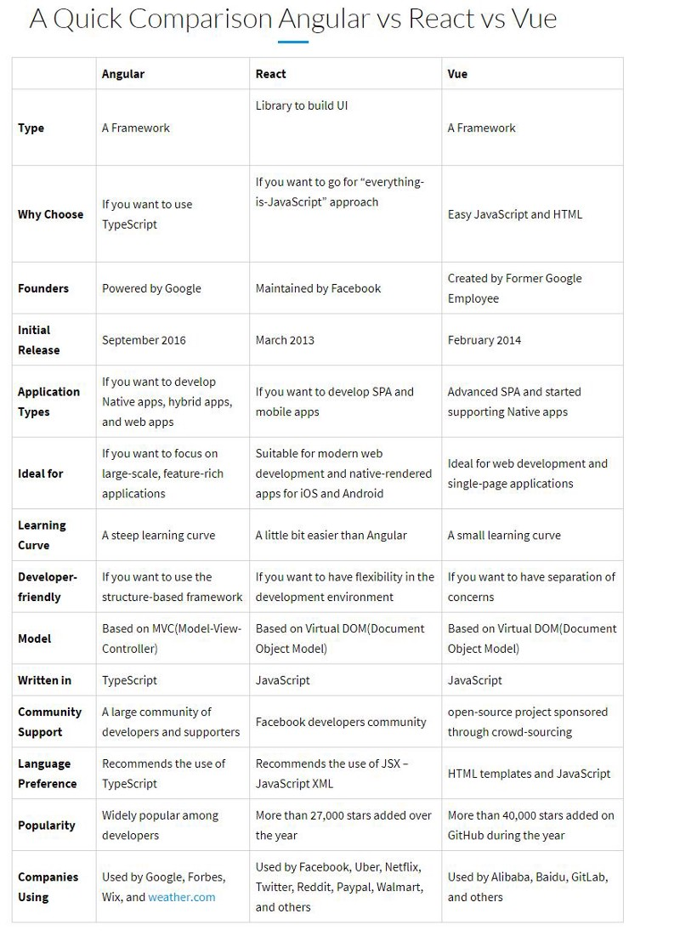

**Example code in Vue:**

<div id="app">  
<h1>{{ message }}</h1>  
</div>  
  
<script>

var myObject = new Vue({  
    el: '#app',  
    data: {message: 'Hello Vue!'}  
})

</script>

**Example code in Angular:**

<div ng-app="" ng-init="message='Hello AngularJS!'">  
  <h1>{{ message }}</h1>  
</div>

**Example code in React:**

<!DOCTYPE html>  
<html lang="en">  
<title>Test React</title>  
  
**<!-- Load React API -->**<script src= "https://unpkg.com/react@16/umd/react.production.min.js"></script>  
**<!-- Load React DOM-->**<script src= "https://unpkg.com/react-dom@16/umd/react-dom.production.min.js"></script>  
**<!-- Load Babel Compiler -->**<script src="https://unpkg.com/babel-standalone@6.15.0/babel.min.js"></script>  
  
<body>  
  
<script type="text/babel">  
**//  JSX Babel code goes here**</script>  
  
</body>  
</html>

**Angular and Ajax**

AngularJS is a framework for developing Frontend MVC application whereas Ajax is a Javascript method to get data from urls without reloading the page.  
So I will be using angular when developing an application from scratch using a specific framework. I will use Ajax when a small functionality in the application needs to be loaded dynamically without reloading.

**Angular and Anglar.io**

* AngularJS is an open-source, JavaScript-based, front-end web application framework for dynamic web app development. It utilizes HTML as a template language. By extending HTML attributes with directives and binding data to HTML with expressions, AngularJS creates an environment that is readable, extraordinarily expressive and quick to develop.

**The newer version of Angular are off course better in every aspect.** [Here’](https://www.simplilearn.com/angularjs-vs-angular-2-vs-angular-4-differences-article)**s a website explaining about difference in a good way.**

**Linting**

**Linting** is the process of checking the source code for Programmatic as well as Stylistic errors. This is most helpful in identifying some common and uncommon mistakes that are made during coding.

A Lint or a Linter is a program that supports linting (verifying code quality). They are available for most languages like JavaScript, CSS, HTML, Python, etc.

**Example:**  
Some of the useful linters are JSLint, CSSLint, JSHint, Pylint.