*Muhammad**Hassan Tariq (L16-4177)*

*WEB PROGRAMMING (CS-A)*

*Assignment 2*

**Q1: MongoDB vs Mongoose. Why are we using Mongoose package instead of MongoDB package? How would we perform CRUD operations using the MongoDB package? Give code examples for creating, retrieving, updating and deleting MongoDB documents. (8)**

**Mongoose** is built upon the MongoDB driver to provide programmers with a way to model their data. Using it, a user can define the schema for the documents in a particular collection. Mongoose is chosen over MongoDB because it provides a lot of convenience in the creation and management of data. However, a few drawbacks are:

* Learning Mongoose can be time-consuming
* It has complex schema-related limitations.

**MongoDB** is used, if your collection schema is unpredictable, or you want a Mongo-shell like experience inside Node.js. It is the simplest to pick up. Its downside is:

* You will have to write larger amounts of code for the purpose of data validation
* The risk of errors is higher.

**Insert Operation:**

db.users.insertOne (

{ name:”sue”,

age:26,

status:”pending”

})

**Read Operation:**

db.users.find(

{{age:{$gt:18}},

{name:1,address:1}

).limit(5)

**Update Operation:**

db.users.updateMany(

{ age:{$lt:18}},

{$set:{status:”reject”}}

)

**Delete Operation:**

db.users.deleteMany(

{status:”reject”} )

**Q2: POST vs PUT. Why was POST used to update employee data in the Employees sample**

**AJAX application? What happens if you replace POST with PUT? What difference**

**does it make? (2)**

**ANS. PUT: create or update**

**POST: create**

Both PUT and POST can be used for creating, so either can be used.

You have to ask "what are you performing the action to?" to distinguish what you should be using. Which is used is your decision, depending on what object you are referencing in the request.

A few factors to consider:

* Do you name your URL objects you create explicitly, or let the server decide? If you name them then use PUT. If you let the server decide then use POST.
* PUT is idempotent, so if you PUT an object twice, it has no effect. This is a nice property, so I would use PUT when possible.
* You can update or create a resource with PUT with the same object URL
* With POST you can have 2 requests coming in at the same time making modifications to a URL, and they may update different parts of the object.

**Q3: PUT vs PATCH. Can PUT be used for partial updates e.g. in case of updating your**

**name in an online university application form what method should be used? PUT or**

**PATCH or anyone? Why? (2)**

**ANS:** PUT: The http PUT method only allows a complete replacement of the document.

It is used when user knows all the fields, or answers.

PATCH: Used to modify an existing http resource i.e. for updating little bits at a time.

Partial Update: If PUT is used, by sending the entire resource with updated values, there is a chance of unnecessary bandwidth being consumed. PATCH is the preferred option here.

Similarly, PATCH should be used to update name in an online university application. Here, a single field is being updated and not the entire document. PATCH will speed up this process.

**Q4. Where does React lie in comparison to AngularJS? Compare with respect to   
 advantages and disadvantages. (4)**

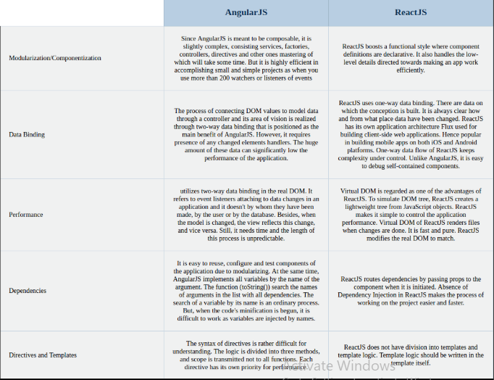

**Q5. What is Vue.js? Where does Vue lie in comparison to React and AngularJS? Give examples. (4)**

Vue is a **progressive framework** for building user interfaces. The core library is focused on the view layer only, and is easy to pick up and integrate with other libraries or existing projects.

* **History of each framework**  
  React is a JavaScript library for building UI components for web applications. React is used by Facebook, Uber, Netflix, Twitter, Paypal, Reddit, Tumblr, WalMart and many more.  
  Angular is a TypeScript-based JvaScript framework backed by Google. It is an enormously popular framework for front-end development. Angular is used by Google, Forbes, WhatsApp, Instagram and many more.   
  Vue.js can be used to build attractive UIs using HTML, CSS and JavaScript. Vue is used by Alibab, GitLab, Baidu, and appreciated by developers and designers globally.
* **Popularity and Market Trends**  
  According to the 2017 Stackoverflow survey, Angular is loved by 51.7% of developers and React is embraced by 66.9% of surveyed developers. React and Angular have almost the same level of users in the category of front-end frameworks. Vue hasn’t occupied a place in any of the above lists but has an ability to participate in this battle.
* **Community Support and Growth**  
  As React is powered by Facebook and Angular is maintained by Google, there’s no doubt on the growth of both of these frameworks. In both frameworks, updates and release are published frequently but they are well maintained when it comes to migrations.   
  If we consider Vue.js in this way, there’s a migration helper tool which makes migration easier. But in the large app, it might cause a problem as there is no proper roadmap which focuses on versioning and their plans.
* **Is it easy to find developers**

You can easily find Angular developers and it has a well-established community with lots of projects, updates, resources and a sustainable future.

React involves more JavaScript and sometimes that’s the reason people sometimes do not choose it over the other two.

* **Framework? Library? What’s the difference?**

With React, you can do multiple integrations as you can pair, exchange, and integrate libraries with other great tools out there. At this point, React works out of the box due to its flexibility to offer seamless integration but, with this, there are more chances of to wrong and it requires more dependencies.

Angular is a framework because it provides you with a good start to build an application with the complete setup. You don’t need to look into libraries, routing solutions, and the structure. React and Vue, on the other hand, are more flexible and universal than Angular.

Vue is the cleanest because it not only helps you keep your code efficient with the perfect balance of internal dependencies and flexibility but is also a very easy and straightforward JavaScript framework which aims to simplify web development.

Summing up:

* If you like flexibility more than other features, use **React**.
* If you love coding in TypeScript, go for **Angular**.
* If you are a JavaScript lover, use **React**.
* If you are a fan of clean code, use **Vue.**
* **Vue** provides the easiest learning curve and it’s an ideal option for beginners.
* If you want separation of concerns in your application, use **Vue**.
* If you are a fond of object-oriented programming, use **Angular**.
* Vue is ideal for a small team and a small project. If your app seems to be large, pick **React** or **Angular**.

**Q6. How is AngularIO different from AngularJS? Give examples. (4**)

AngularIO is a platform that makes it easy to build applications with the web. Angular combines declarative templates, dependency injection, end to end tooling, and integrated best practices to solve development challenges. Angular empowers developers to build applications that live on the web, mobile, or the desktop. Angular, on the other, hand has a component-based architecture. Every Angular application has at least one component known as the root component.

Whereas, AngularJs a different framework, which is the ancestor of Angular. AngularJS is the first version of Angular. It works with JavaScript and it is still getting supported but it is not compatible with Angular. AngularJS is a client side framework of JavaScript which is based on MVC Architecture and provides a Single-page application solution for dynamic websites.

**Q7. What is Linting? What is the use of JSLint? What is the use of ESLint?**

**Give examples. (4)**

**Linting** is the process of running a program that will analyze code for potential errors. Lint was the name originally given to a particular program that flagged some suspicious and non-portable constructs (likely to be bugs) in C language source code.

**JSLint** is a JavaScript program that looks for problems in JavaScript programs. It is a **static code analysis** tool used in software development for checking if JavaScript source code complies with coding rules.

**ESLint** is a tool for identifying and reporting on patterns found in ECMAScript/JavaScript code, with the goal of making code more consistent and avoiding bugs. In many ways, it is similar to JSLint and JSHint with a few exceptions such as ESLint uses Espree for JavaScript parsing, ESLint uses an AST to evaluate patterns in code and ESLint is completely pluggable, every single rule is a plugin and you can add more at runtime.

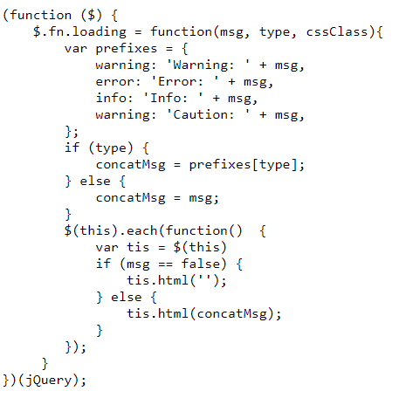

**Q8. Give an example where you would prefer to use AngularJS over AJAX and vice versa. (2)**

AJAX is a JavaScript concept for fetching data from server. There are predefined methods both in Angular as well as jQuery for implementing AJAX.

Similar to the jQuery, angularJS is also based on JavaScript. But it's scope in terms of web development is much broader than jQuery. It is actually a complete framework which would change the way you write your code (both html as well as JavaScript part).

Both the concepts are used in different conditions when I have to retrieve data from a web server without reloading the entire web page then I will use AJAX and when I have to build single page applications, that is webpages that act like an application I will use AngularJS.