Web Research Assignment:

# **Question: 1**

**Mongo DB vs Mongoose. Why are we using Mongoose package instead of Mongo DB package? How would we perform CRUD operations using the Mongo DB package? Give code examples for creating, retrieving, updating and deleting Mongo DB documents?**

## **Answer:**

**MongoDB** is a schema-less NoSQL document database. It means you can store JSON documents in it, and the structure of these documents can differ as it is not obligatory like SQL databases. This is one of the benefits of using NoSQL as it speeds up application development and lessens the complexity of deployments.

**Mongoose** is an Object Data Modeling (ODM) library for MongoDB and Node.js. It manages relationships between data, provides schema validation, and is used to translate between objects in code and the representation of those objects in MongoDB.

The reason we chose mongoose package over mongodb is that we have to write larger amounts of code for validating the data and risks of errors are high. Mongoose play a role of abstraction over your database model, so its queries are understandable easily. Mongodb is the database itself, while Mongoose is an object modeling tool for Mongodb.

### Examples:

1. The code for creating MongoDB document is given below:

db.inventory.insertOne (

{Item: "canvas", qty: 100, tags: ["cotton"], size: {h: 28, w: 35.5, uom: "cm”}}

)

1. The code for deleting MongoDB document is given below:

try {

db.orders.deleteOne ({“_id”: ObjectId ("563237a41a4d68582c2509da")});

} catch (e) {

print(e);

}

1. The code for updating MongoDB document is given below:

try {

db.restaurant.updateOne (

{“name”: "Central Perk Cafe”},

{$set: {“violations”: 3}}

);

} catch (e) {

print(e);

}

1. The code for retrieving MongoDB document is given below:

db.collection.find ({qty: {$gt: 4}})

# **Question: 2**

## **POST vs PUT. Why was POST used to update employee data in the Employees sample**

## **AJAX application? What happens if you replace POST with PUT? What difference does it make?**

## **Answer:**

**PUT** implies putting a resource - completely replacing whatever is available at the given URL with a different thing. By definition, a PUT is idempotent. Do it as many times as you like, and the result is the same. x=5 is idempotent. You can PUT a resource whether it previously exists, or not (e.g., to Create, or to Update).

**POST** updates a resource, adds a subsidiary resource, or causes a change. A POST is not idempotent, in the way that x++ is not idempotent.

Put allows us to change or update a value only once whereas post allows us to change a value as many times we want so this is the reason we used post method for employee data update in a sample Ajax application. If we use put instead of post, all updates to a particular employee will be done only once and can never be modified again.

# **Question: 3**

## **PUT vs PATCH. Can PUT be used for partial updates e.g. in case of updating your name in an online university application form what method should be used? PUT or PATCH or anyone? Why?**

## **Answer:**

In a **PUT request**, the enclosed entity is considered to be a modified version of the resource stored on the origin server, and the client is requesting that the stored version be replaced.

With **PATCH**, however, the enclosed entity contains a set of instructions describing how a resource currently residing on the origin server should be modified to produce a new version.

Another difference is that when you want to update a resource with PUT request, you have to send the full payload as the request whereas with PATCH, you only send the parameters which you want to update.

As asked in case of updating name in an online university form, if we use put we have to send whole parameters with it in the request. For example, we have to send last-name, father-name etc. Whereas if we use patch, we don’t need to send last-name or any other parameter. It will just change the name from its record.

# **Question: 4**

## **Where does React lie in comparison to AngularJS? Compare with respect to advantages and disadvantages?**

## **Answer:**

**Angular** is a Typescript-based, open-source front-end web application platform. It is an MVC framework created by Google.

**React** is a JavaScript library for building user interfaces. Created by Facebook, Instagram, and the community, React is evolving at an impressively increasing rate.

**Differences:**

1. ReactJS is an Open Source JS type, on the other hand AngularJS is fully-featured MCV work.
2. AngularJS use JavaScript, HTML and ReactJS use JSX language.
3. The app architecture of ReactJS is none, combined with Flux and Angular has MCV structure.
4. Whereas data binding is concerned, ReactJS flows in unidirectional and AngularJS flows in bidirectional.
5. All the credit goes to AngularJS simple and unique design as well as a solid CLI. While, React is provable that it is reliable and efficient for better workflow. Hence, this framework is very scalable comparatively.
6. React is quite simple and easy-to-learn, but it consumes time while setting up a project in React. On the other hand, Angular is not at all easy in any aspects and its natural intricacy creates turmoil as Angular specifically creates third party syntax and stores.

**Conclusions:**

In case if you are building dynamic applications, single page app, and native app, React is the ideal choice and if you are building cross-platform mobile apps, enterprise software and progressive web apps or hybrid mobile apps, Angular is the best of all.

# **Question: 5**

## **What is Vue.js? Where does Vue lie in comparison to React and AngularJS? Give Examples**

## **Answer:**

**Vue.js** is one of those new software technologies that are being widely used across the world for web development. Vue.js is actually a JavaScript framework with various optional tools for building user interfaces.

**Advantages:**

1. One of the greatest advantages of Vue.js is its small size. The size of this framework is 18–21KB and it takes no time for the user to download and use it.
2. The user can easily add Vue.js to his web project because of its simple structure.
3. Vue.js is also popular among the web developers because it facilitates them to integrate with the existing applications.
4. A great deal of flexibility is another advantage of Vue.js. It allows the user to write his template in HTML file, JavaScript file, and pure JavaScript file using virtual nodes.
5. Vue.js also facilitates two way communications because of its MVVM architecture which makes it quite easy to handle HTML blocks. In this respect, it seems very close to Angular.js which also speeds up HTML blocks.

Vue.js has clear advantages over all the earlier frameworks like Angular.js and React.js. In short, it combines the peculiar features of all the older frameworks.

A hello World **example** is given:

How code is written in ReactJS:

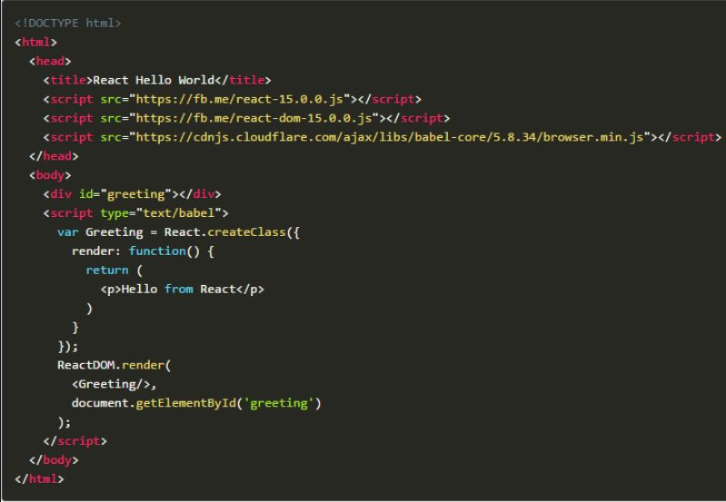

How code is written in vue.js: 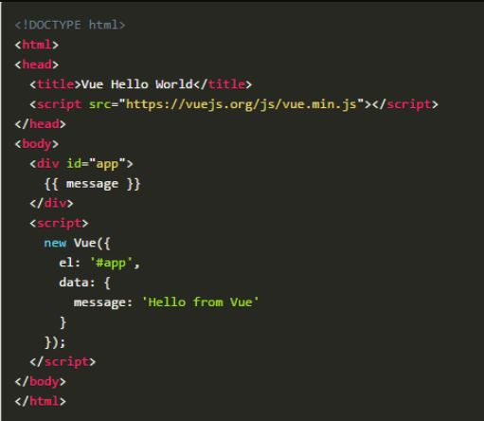

# **Question: 6**

## **How is AngularIO different from AngularJS? Give examples.**

## **Answer:**

AngularJS is a JavaScript-based open-source front-end web application framework mainly maintained by Google and by a community of individuals and corporations to address many of the challenges encountered in developing single-page applications.

Angular is the blanket term used to refer to Angular 2, Angular 4 and all other versions that come after AngularJS. Both Angular 2 and 4 are open-source, Typescript-based front-end web application platforms.

1. The architecture of AngularJS is based on MVC. Whereas Angular 2 is based on a Components structure, like what we see in React.js.
2. AngularJS applications are built using JavaScript. Whereas Angular 2 applications are built on Typescript, which is a superset of JavaScript.
3. $scope, which was featured in AngularJS, was removed from Angular 2. In the newer versions of Angular, instance developers can add new directives and controls. Additionally, various component splitting features have increased code reusability.
4. AngularJS was made for responsive UI and two-way binding of applications. But it didn't support mobile. Angular 2 was made with a mobile-oriented architecture. Native Script helped make Angular 2 mobile development faster and more effective.

**Example:**

function ($scope)

{

$scope. Comparison =”Angular vs Angular 2”

}

//is replaced by

constructor ()

{

this. Comparison =”Angular vs Angular 2”

}

# **Question: 7**

## **What is Linting? What is the use of JSLint? What is the use of ESLint? Give examples.**

## **Answer:**

A **linter** or lint refers to tools that analyze source code to flag programming errors, bugs, stylistic errors, and suspicious constructs.

**ESLint** is an open source JavaScript linting utility originally created by Nicholas C. Zakas in June 2013. Code linting is a type of static analysis that is frequently used to find problematic patterns or code that doesn't adhere to certain style guidelines.

**JSLint** is a static code analysis tool used in software development for checking if JavaScript source code complies with coding rules.

**Example:**

ESLint error:

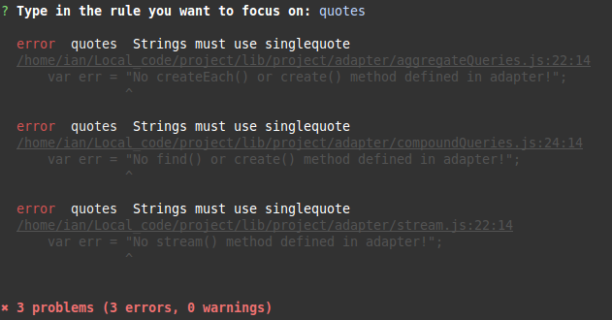

JSLint error:

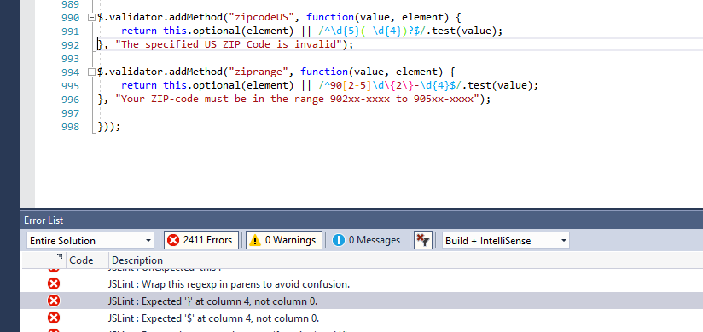

# **Question: 8**

## **Give an example where you would prefer to use AngularJS over AJAX and vice versa.**

## **Answer:**

Ajax is the feature which allows you to update the part of the page without update or refresh the page while AngularJS is one of the JavaScript framework (to be specific) client side MVC framework (most says MVW, where W is whatever that is MVC/MVVM).

Ajax is preferred to be used when client request to server for data. Also for displaying results on same page without refreshing the page. Whereas angular is used to develop single page application. Also to bind the data bidirectional.