**Name: Maham Masood (16L-4072)**

**Course: Web Programming**

**Section: CS – A**

**Assignment 2 – Research Assignment**

**Q1: MongoDB vs Mongoose. Why are we using Mongoose package instead of MongoDB package? How would we perform CRUD operations using the MongoDB package? Give code examples for creating, retrieving, updating and deleting MongoDB documents. (8)**

Mongoose:

It is a library built upon the MongoDB driver to provide programmers with a way to model their data. Using Mongoose, a user can define the schema for the documents in a particular collection.

Mongoose is preferred over MongoDB because it makes creating and managing data in MongoDB much more convenient. However, a disadvantage is that it takes time to learn Mongoose, and it has some complex limitations in handling schemas.

MongoDB:

If the collection schema is unpredictable, or the user wants a Mongo-shell like experience inside Node.js, then it is recommended to use MongoDB driver. It is the simplest to pick up. The one disadvantage it has is that the user has to write significantly larger pieces of code to validate the data, and hence, the risk of errors becomes higher.

CRUD OPERATIONS:

* **Insert Operation:**   
  db.collection.insertOne()  
  db.collection.insertMany()

db.users.insertOne (

{ name:”sue”,

age:26,

status:”pending”

})

* **Read Operation:**

db.collection.find()

db.users.find(

{{age:{$gt:18}},

{name:1,address:1}

).limit(5)

* **Update Operation:**

db.collection.updateOne()  
db.collection.updateMany()  
db.collection.replaceOne()

db.users.updateMany(

{ age:{$lt:18}},

{$set:{status:”reject”}}

)

* **Delete Operation:**

db.collection.deleteOne()  
db.collection.deleteMany()

db.users.deleteMany(

{status:”reject”} )

**Q2: POST vs PUT. Why was POST used to update employee data in the Employees sample**

**AJAX application? What happens if you replace POST with PUT? What difference**

**does it make? (2)**

The POST method is used to **create** i.e. requests that the origin server accept the entity enclosed in the request as a new subordinate of the resource.

The PUT method is used to **create or update** i.e. requests that the enclosed entity be stored under the supplied Request-URI.

PUT can do what POST can do, and hence it makes no difference in using either. However, the following are a few things to consider while choosing **POST vs PUT**:

* Do you name your URL objects you create explicitly, or let the server decide? If you name them, then use PUT. If you let the server decide, then use POST.
* With POST you can have 2 requests coming in at the same time making modifications to a URL, and they may update different parts of the object.
* You can update or create a resource with PUT with the same object URL.
* PUT is idempotent, so if you PUT an object twice, it has no effect. This is a nice property, so use PUT when possible.

*(Reference: https://stackoverflow.com/questions/630453/put-vs-post-in-rest)*

**Q3: PUT vs PATCH. Can PUT be used for partial updates e.g. in case of updating your**

**name in an online university application form what method should be used? PUT or**

**PATCH or anyone? Why? (2)**

**PUT** request is similar to creating a new object. It allows a complete replacement of the document. On the other hand, **PATCH** requests modify an existing http resource by only sending the **changed properties**.

**Patch vs Put for partial updates?**

**HTTP PATCH** requests are usually more efficient, easier and safer. While a resource can be updated “partially” using HTTP PUT (send the whole resource with updated values), you might end up consuming more network bandwidth than necessary.

To update your name in an online university application, use PATCH. This will not only make the performance quicker, but also allow you to update only the required field.

*(Reference:* [*https://futurestud.io/tutorials/retrofit-2-how-to-update-objects-on-the-server-put-vs-patch*](https://futurestud.io/tutorials/retrofit-2-how-to-update-objects-on-the-server-put-vs-patch)*)*

**Q4. Where does React lie in comparison to AngularJS? Compare with respect to   
 advantages and disadvantages. (4)**

### Advantages of AngularJS:

1. Angular offers new features like enhanced RXJS, really fast compilation, and a new HttpClient launch.
2. Detailed documentation that allows effective communication and collaboration.
3. Two-way data binding that enables singular behavior for the app minimizes risks of possible errors.
4. MVVM (Model-View-ViewModel) allows developers to work separately on the same app section using the same set of data.

### Disadvantages of AngularJS:

1. The complex syntax that comes from the first version of Angular.
2. Migration issues which can appear while moving from the older version to the latest ones.

Companies that use Angular 5: Upwork, Freelancer, Udemy, YouTube, Paypal, Nike, Google.

### Advantages of ReactJS:

1. Easy to learn. With their HTML writing skills, developers can easily write in React. No need to learn TypeScript deeply like in Angular.
2. Extremely responsive and flexible.
3. Combined with ES6/7, ReactJS can work with heavy loads with relative ease.
4. 100% open-source JavaScript library with a highly engaged contributor community, resulting in speedy updates and solutions.
5. Extremely lightweight because the data performing on the user side can be easily represented on the server side simultaneously.
6. Migrating between versions is generally very easy.

### Disadvantages of ReactJS:

1. Lack of official documentation - a bit chaotic now as many developers contribute it individually without any systematic approach.
2. React is unopinionated — meaning that developers sometimes have too much choice.
3. Long time to master which means that React JS requires deep knowledge of how to integrate user interface into MVC framework.

Companies that use ReactJS: Facebook, Instagram, Netflix, New York Times, Yahoo, Khan   
 Academy, Whatsapp, Codecademy, Dropbox, Airbnb, Microsoft.

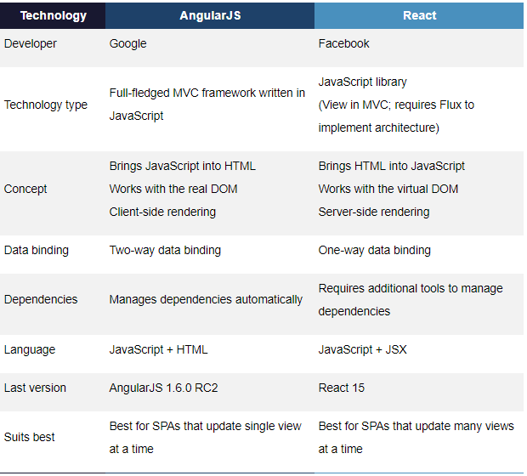

*(Referencess:* [*https://www.moveoapps.com/blog/reactjs-vs-angularjs/*](https://www.moveoapps.com/blog/reactjs-vs-angularjs/)*,   
 https://rubygarage.org/blog/react-vs-angularjs)*

**Q5. What is Vue.js? Where does Vue lie in comparison to React and AngularJS? Give   
 examples. (4)**

What is Vue.js?

Vue is a **progressive framework** for building user interfaces. The core library is focused on the view layer only, and is easy to pick up and integrate with other libraries or existing projects. Vue is also perfectly capable of powering sophisticated Single-Page Applications when used in combination with [**modern tooling**](https://vuejs.org/v2/guide/single-file-components.html) and [**supporting libraries**](https://github.com/vuejs/awesome-vue#components--libraries).

Vue.js comparison with AngularJS and React:

* History:

1. React is a JS library for building UI components for web applications. It is maintained by Facebook and used by Uber, NetFlix, Twitter, Tumblr, Walmart, etc.
2. Angular is a TyeScript-based JS framework for front-end development. It is used by Google, WhatsApp, Instagram, etc.
3. Vue,js is one of the most rapidly growing frameworks for building attractive UIs. It is used by Alibaba, GitLab, Baidu, etc.

* Popularity:

According to the 2017 Stack overflow survey, Angular is loved by 51.7% of developers and React is embraced by 66.9% of surveyed developers. On GitHub, Vue has **108,086**stars, React gained **106, 807**stars, and Angular received **38,654** stars.

### Is it easy to find developers?

React involves more JavaScript and sometimes that’s the reason people geared towards Angular or Vue.

Angular is a pretty good option in such cases. You can easily find Angular developers and it has a well-established community with lots of projects, updates, resources, and it has a sustainable future.

### Framework? Library? What’s the Difference?

1. Angular is a framework because it provides you with a good start to build an application with the complete setup. React and Vue, on the other hand, are more flexible and universal than Angular.
2. With React, you can do multiple integrations as you can pair, exchange, and integrate libraries with other great tools out there. However, there are more chances of wrong and it requires more dependencies.
3. **Vue is the cleanest in comparison to these three frameworks. It helps you keep your code efficient and is a very simple, straightforward, and easy-to-use JavaScript framework which aims to simplify web development.**

Code example:

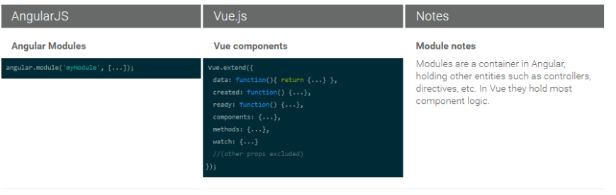

A few considerations:

* If you like **flexibility** more than other features, use **React**.
* If you love coding in **TypeScript**, go for **Angular**.
* If you are a **JavaScript lover**, use **React**.
* If you are a fan of **clean code**, use **Vue.**
* **Vue** provides the easiest learning curve and it’s an ideal option for beginners.
* If you want **separation of concerns** in your application, use **Vue**.
* If you are a fond of **object-oriented programming**, use **Angular**.
* Vue is ideal for a **small team** and a small project. If your app seems to be large and has significant future expansion plan, pick **React** or **Angular**.

*(References:*

[*https://dzone.com/articles/react-vs-angular-vs-vuejs-a-complete-comparison-gu*](https://dzone.com/articles/react-vs-angular-vs-vuejs-a-complete-comparison-gu)*,*

[*https://medium.com/front-end-hacking/react-vs-angular-vs-vue-js-a-complete-comparison-guide-d16faa185d61*](https://medium.com/front-end-hacking/react-vs-angular-vs-vue-js-a-complete-comparison-guide-d16faa185d61)*)*

**Q6. How is AngularIO different from AngularJS? Give examples. (4**)

#### Architecture

* Version 1.0 vs. Version 2.0 : The architecture of AngularJS is based on MVC whereas the architecture of Angular 2 is based on service/controller.
* Version 2.0 vs. Version 4.0: Upgrade of the version from 2.0 to 4.0 has reduced it’s bundled file size by 60%. The code generated is reduced and has accelerated the application development.
* JavaScript and TypeScript
* Version 1.0 vs. v 2.0: Angular JS uses JavaScript to build the application while from Angular v2.0, the angular team introduced the typescript to write the application. TypeScript is a superset of JavaScript which helps to build more robust and structured code.
* Version 2.0 vs. v 4.0: Angular v4.0 is compatible with newer versions TypeScript 2.1 and TypeScript 2.2. This helps with better type checking and also enhanced IDE features for Visual Studio Code.

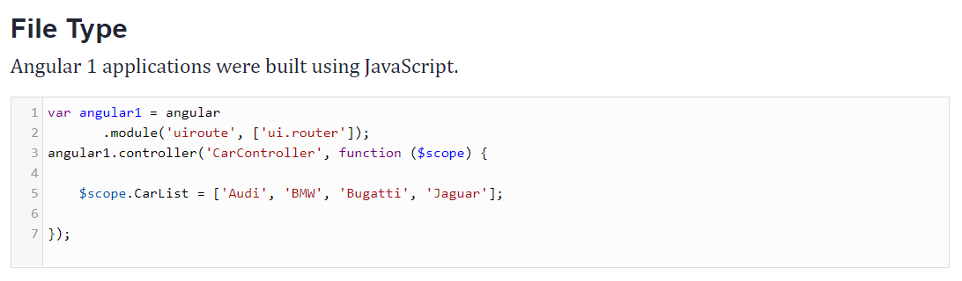

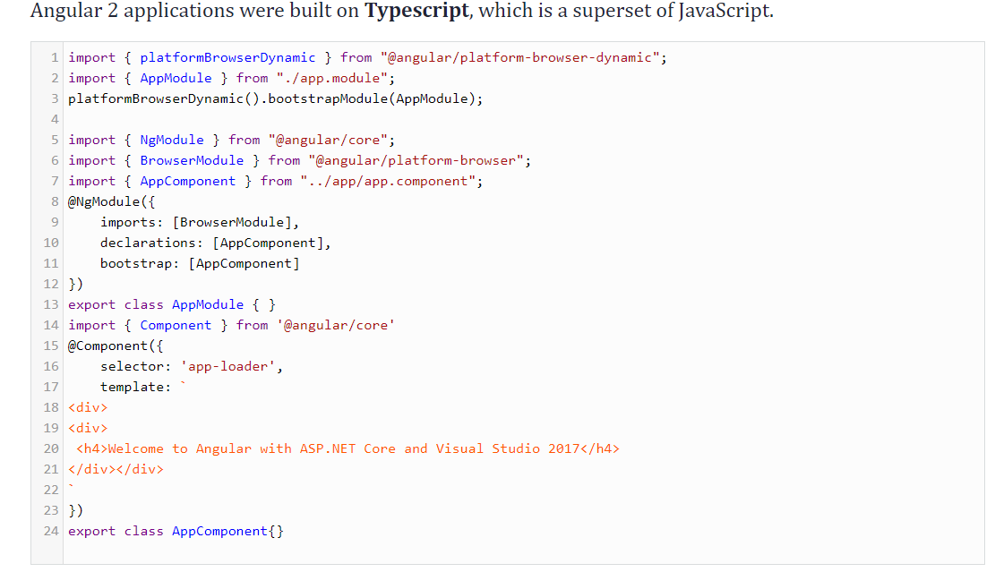

* Mobile Support

Angular 2.0 has made it possible to accomplish the native applications for a mobile platform like React Native. Angular 2.0 provides application layer and the rendering layer. As need, any view can be rendered in runtime for the required component.

* Component-based UI

Version 1.0 vs. 2.0: The controller concept which was present in Angular v1.0 is eliminated in Angular v2.0, changing it to component based UI. This helps a developer to divide the applications in terms of components with desired features and enable to call required UI. These have helped to improve the flexibility and reusability as compared to Angular v1.0.

### **Code Reuse**

**$scope**,which was featured in Angular 1, was removed from Angular 2 and Angular 4. In the newer versions of Angular, instance developers can add new directives and controls. Additionally, various component splitting features have increased code reusability.

*(References:* [*https://dzone.com/articles/learn-different-about-angular-1-angular-2-amp-angu*](https://dzone.com/articles/learn-different-about-angular-1-angular-2-amp-angu)*, https://medium.com/@angularminds/comparison-between-angular-1-vs-angular-2-vs-angular-4-62fe79c379e3)*

**Q7. What is Linting? What is the use of JSLint? What is the use of ESLint?**

**Give examples. (4)**

**Linting** is the process of running a program that will analyze code for potential errors. Lint was the name originally given to a particular program that flagged some suspicious and non-portable constructs (likely to be bugs) in C language source code.

Linting will find in your code formatting discrepancy, non-adherence to coding standards and conventions, pinpoint possible logical errors in your program, etc.

* **JSLint** is a JavaScript program that looks for problems in JavaScript programs. It is a **static code analysis** tool used in software development for checking if JavaScript source code complies with coding rules.

Code with errors:

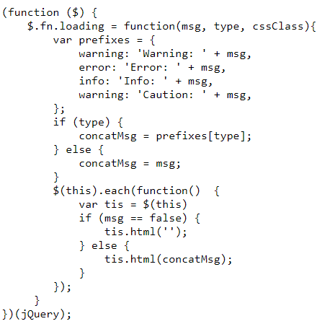

Part of JSLint output:

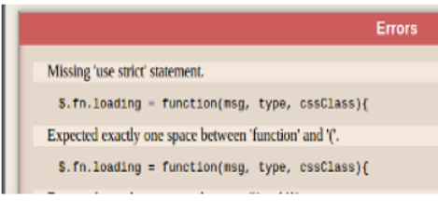

* **ESLint** is a tool for identifying and reporting on patterns found in ECMAScript/JavaScript code, with the goal of making code more consistent and avoiding bugs. In many ways, it is similar to JSLint and JSHint with a few exceptions:
* ESLint uses [Espree](https://github.com/eslint/espree) for JavaScript parsing.
* ESLint uses an AST to evaluate patterns in code.
* ESLint is completely pluggable, every single rule is a plugin and you can add more at runtime.

Example:

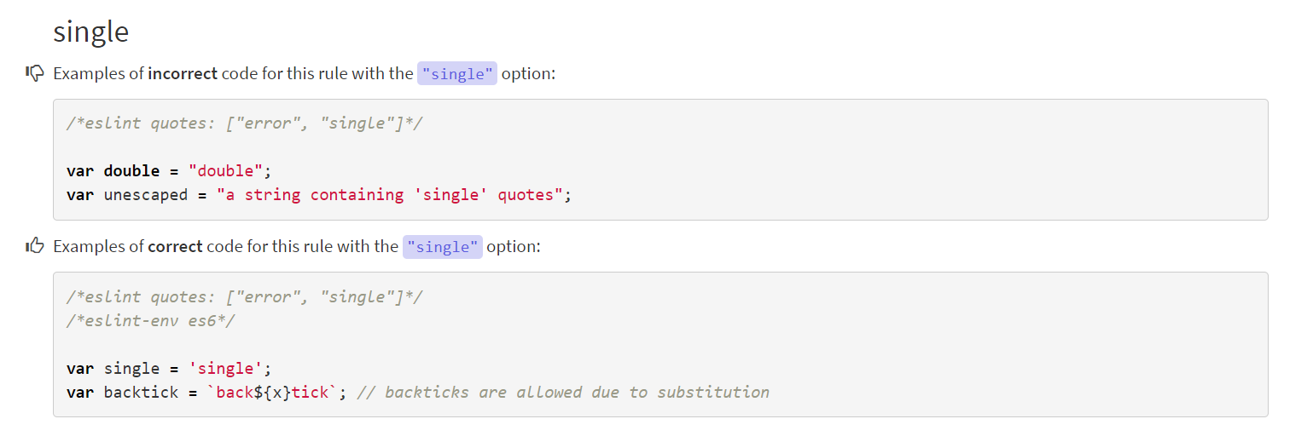

*(References:* [*https://www.sitepoint.com/using-jslint-to-refine-your-code/*](https://www.sitepoint.com/using-jslint-to-refine-your-code/)*, https://eslint.org/docs/rules/quotes)*

**Q8.** Give an example where you would prefer to use AngularJS over AJAX and vice versa. (2)

**AJAX:** Asynchronous JavaScript and XML. A system for sending and receiving data from a server without a page refresh. It is based on JavaScript and is similar to jquery, but its scope is much broader in terms of web development.

**AngularJS**: A client side MV framework. **It** is a hip JavaScript framework which is made for building large, single-page web applications.

Both angular and AJAX do almost the same thing, but ANGULAR makes development easier and faster.

Preference of each framework over the other:

AJAX: When data from the web server needs to be reloaded without reloading the entire web   
 page.

AngularJS: When single page applications need to be built (i.e. web pages that act like an   
 application).

*(Reference: https://teamtreehouse.com/community/whats-the-difference-between-ajax-and-angular-js)*