**Name: Shafin Salim**

**Roll No # 16L-4298**

**Section: A**

**Q7.**

Linting is the process of running a program that will analyse code for potential errors.

**ES Lint**

[ESLint](https://github.com/eslint/eslint) is completely plug-able, every single rule is a plugin and we can add more rules at run-time. It is the most recent out of the three libraries. It is designed to be easily extensible, comes with a large number of custom rules, and it’s easy to install more rules in the form of plugins. It gives concise output, and also includes the rule name by default so you always know which rules are causing the error messages.

**Pros**

* Completely configurable — we can configure/enable/disable any rule
* Extensible — We can create our own rules
* Has a rich set of existing rules as per best practices
* Completely supports ES6 and React
* Easy to understand output with rule names
* Rules are very well documented with examples
* Configured through a configuration file (json/yaml/js) — Easy to share configuration across team members
* Easy integration with IDE

**Cons**

* Needs initial configuration to get started
* A bit slow

### **JS Lint**

[JS Lint](http://www.jslint.com/help.html) is one of the oldest JavaScript linting tool available.

#### Pros

* It comes pre-configured and is ready to go

#### Cons

* It is not user configurable
* It is not extensible — we cannot add custom rules
* It does not very good documentation
* Difficult to identify the rule which is failing
* No support for ES6 or React

**Q8.**

AJAX is a way for JavaScript to request data from a server without refreshing the page or blocking the application. jQuery is a JavaScript library built to automate and simplify common web tasks like AJAX or animation. Angular is a hip JavaScript framework which is made for building large, single-page web applications.

**Q2.**

PUT is used for updating an entity whereas POST is used for creation of an entity. First an entity is created in DB using POST and then it can be updated with PUT. However, both PUT and POST can be used for creating.

**Q3.**

PUT handles an entity by replacing the entire entity, while PATCH only updates the fields that were supplied, leaving the others alone. PUT can be used for partial updates but one will be overwriting the fields with the same data they already have whereas by using PATCH we will be able to update the name only without touching the other fields.

**Q5.**

Angular is a framework because it provides you with a good start to build an application with the complete setup. You don’t need to look into libraries, routing solutions, and the structure. You can simply start building. React and Vue, on the other side, are more flexible and universal than Angular.

With React, you can do multiple integrations as you can pair, exchange, and integrate libraries with other great tools out there. At this point, React works out of the box due to its flexibility to offer seamless integration but with this, there are chances of wrong decisions and dependencies.

Vue is the cleanest in comparison to these three frameworks. It helps you keep your code efficient with the perfect balance of internal dependencies and flexibilities. It is very simple, straightforward, and easy-to-use JavaScript framework which aims to simplify web development.

**Q4.Comparison of ReactJS with AngularJS**

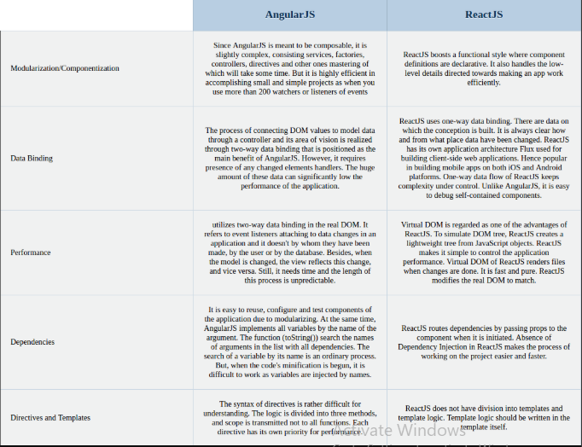

**Q6. AngularIO vs AngularJS**

AngularIO is a platform that makes it easy to build applications with the web. Angular combines declarative templates, dependency injection, end to end tooling, and integrated best practices to solve development challenges. Angular empowers developers to build applications that live on the web, mobile, or the desktop. Angular, on the other, hand has a component-based architecture. Every Angular application has at least one component known as the root component. Whereas, AngularJs a different framework, which is the ancestor of Angular. AngularJS is the first version of Angular. It works with JavaScript and it is still getting supported but it is not compatible with Angular. AngularJS is a client side framework of JavaScript which is based on MVC Architecture and provides a Single-page application solution for dynamic websites.

**Q1.MONGOOSE VS MONGODB**

Mongoose is built upon the MongoDB driver to provide programmers with a way to model their data. Using Mongoose, a user can define the schema for the documents in a particular collection. It provides a lot of convenience in the creation and management of data in MongoDB.

**Insert operation:**

db.users.insertOne (

{ name:”Hello”,

age:26,

status:”rejected”

})

**Read Operation:**

db.users.find(

{{age: 18},

{name: Hello,address:World}

).limit(5)

**Update Operation:**

db.users.update (

{ age: 18},

{$set:{status:”accept”}}

)

**Delete Operation:**

db.users.delete (

{status:”accept”} )