Faculty of Computers and Artificial Intelligence

Information Systems Department

Software Engineering-2

Spring semester 2023-2024

**Online Library System**

**Project Number: 5**

***Team Members***

|  |  |  |  |
| --- | --- | --- | --- |
|  | **Name** | **ID** | **Grade** |
| **1** | **علي علاءالدين السيد** | **20210579** |  |
| **2** | **عمر أسامة رأفت عثمان** | **20210596** |  |
| **3** | **عبدالرحمن مصطفى محمود** | **20210533** |  |
| **4** | **عبدالرحمن ياسر حامد** | **20210536** |  |
| **5** | **صلاح محمد صلاح** | **20210477** |  |
| **6** | **شهاب وليد عبدالمعبود** | **20210463** |  |

***Grading criteria***

|  |  |  |
| --- | --- | --- |
|  | **Name** | **ID** |
| **1** | SRS (Use Case Diagram, Activity Diagram, Sequence Diagram, Class Diagram, ERD) | **10%** |
| **2** | SDD (Project detailed documentation) | **10%** |
| **3** | Validation | **15%** |
| **4** | OCL | **20%** |
| **5** | ASOP (Aspect Oriented programming) | **20%** |
| **6** | Microservices | **5%** |

1. ***Introduction***

The Online Library System is an application designed for library management, catering specifically to small and medium-sized libraries. It serves as a computerized tool utilized by librarians to efficiently oversee library operations. The system's development aimed to provide librarians with a comprehensive solution for recording every book transaction, mitigating issues such as file or record loss. Additionally, it facilitates the generation of reports detailing the status of all bookshelves.

Member users also can benefit from this computerized system because it helps them to register to the library system and search for books and request a book to borrow in addition to showing a list of books borrowed books.

All the previous advantages of this system have been developed for the user in highly modern technologies all for the sake of user satisfaction.

* 1. ***Purpose***

The primary objective of this project is to effectively manage the information pertaining to books and library members. It endeavors to establish a seamless circulation system between library patrons and staff, facilitating the issuance of books and enabling effortless access to a wide array of available titles. Furthermore, users will have the convenience of accessing specific features from the comfort of their own homes.

* 1. ***Scope***

The transformation of the library system from manual to web-based facilitates several key functionalities for users:

* Accessing comprehensive information about available books and borrowing limits conveniently from their computers or smartphones.
* Enjoying services such as updating book details, adding new books, removing books, and setting limits on book issuance.
* Generating detailed reports regarding borrowed books and the availability of books in the library's collection.

1. ***Overall Description***

***2.1 Product Perspective***

The envisioned Library Management System is designed to seamlessly handle real-time updates of book details. Whether it's issuing a book or returning it, the system will automatically update the relevant book details, ensuring that users always have access to the most up-to-date information regarding the library's inventory.

***2.2 Software Requirements***

* Front-end: React Framework.
* Backend: SpringBoot Framework and MySQL Database.

***2.3 Hardware Requirements***

* 1GB Ram
* 1.2 GHz Processor
* Intel core i5
* Window 8/10/11

***2.4 Functional Requirements***

**R.1: Register**

▪ Description: First the user will have to register/sign up. There are two different type of users.

▪ The library manager/head: The manager must provide details about his/her name, role, and password.

▪ Member: The user must provide details about his/her name , UserName, and password.

**R.2: Login**

▪ Input: Enter the role, UserName, and password provided in the registration stage.

▪ Output: User will be able to use the features of software restricted to his/her role.

**R.3: Manage books by user.**

**R.3.1: Search**

▪ Input: Enter the name of author's name of the books to be issued.

▪ Output: List of books related to the keyword.

**R.3.2: Borrow Book**

▪ State: Searched the book user wants to borrow.

▪ Input: click the book user wants.

▪ Output: conformation for book issue and apology for failure in issue.

▪ Processing: if selected book is available then book will be issued else error will be displayed.

**R.3.3: Return Book**

▪ Input: Return the book to the library.

▪ Output: The issued list will be updated and the returned book will be listed out.

**R.3.4: Show Borrowed Books**

▪ Description: List of books that had been borrowed before.

**R.4 Manage book by librarian**

**R.4.1 Update details of books**

**R.4.2 Add Books**

▪ Input: Enter the details of the books such as names, author, ISBN, quantity, etc.

▪ Output: confirmation of addition.

**R.4.3 Remove Books**

▪ Input: Enter the id of the book.

▪ Output: Update the list of the books available.

**R.5 Generate reports of shelf status**

***2.5 Non-Functional Requirements***

**Usability Requirement**

The system shall allow the users to access the system from the phone using any web browser. The system uses a web-based interface. There is no special training is required. The system is user friendly which makes the system easy.

• **Availability Requirement**

The system is available 100% for the user and is used 24 hours a day and 365 days a year. The system shall be operational 24 hours a day and 7 days a week.

• **Accuracy**

The system should accurately provide real time information taking into consideration various concurrency issues. The system shall provide 100% access reliability.

• **Performance Requirement**

The information is refreshed depending upon whether some updates have occurred or not in the application. The system shall respond to the member in not less than two seconds from the time of the request submittal. The system shall be allowed to take more time when doing large processing jobs. Responses to view information shall take no longer than 5 seconds to appear on the screen.

• **Reliability Requirement**

The system must be 100% reliable due to the importance of data and the damages that can be caused by incorrect or incomplete data. The system will run 7 days a week, 24 hours a day.

***2.6 Users Characteristics***

we have two levels of users.

* ***Librarian user***
* Login/logout
* Manage books (CURD)
* Generate requests about borrowed and available books.
* ***Normal user***
* Register
* Login/logout
* Search for book.
* Borrow a book.
* Return a book.
* Show list of borrowed book.

1. ***UML Diagrams***

***3.1 Use-Case Diagram***

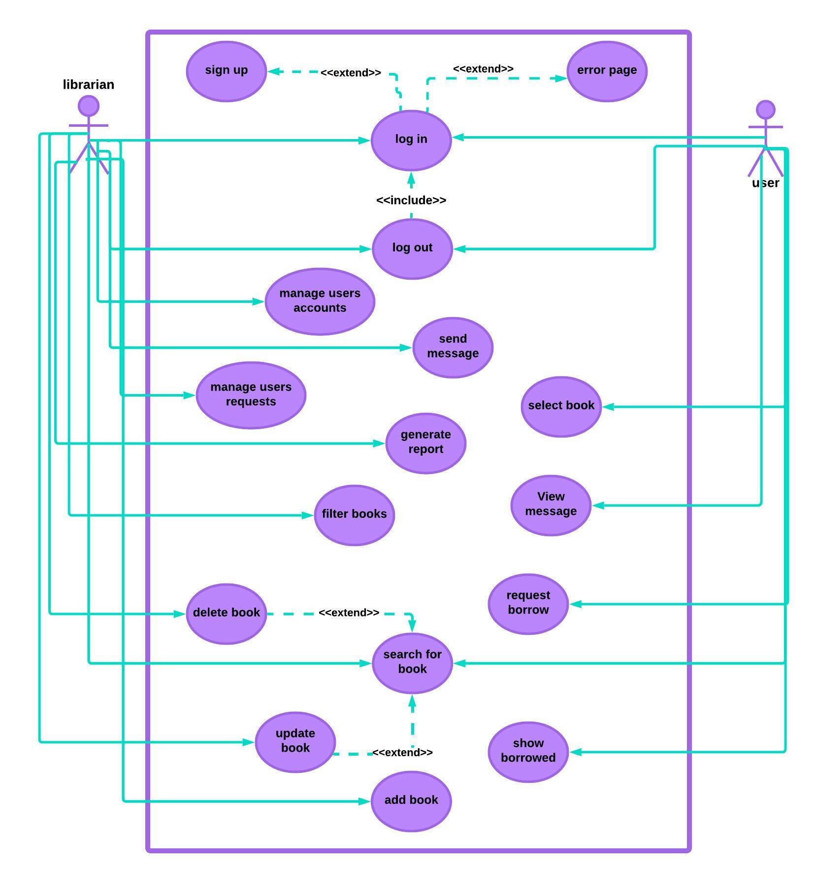

***3.2 General Activity Diagram***

***3.3 sequence Diagram***

***For login and registration***

***3.4 Class Diagram***

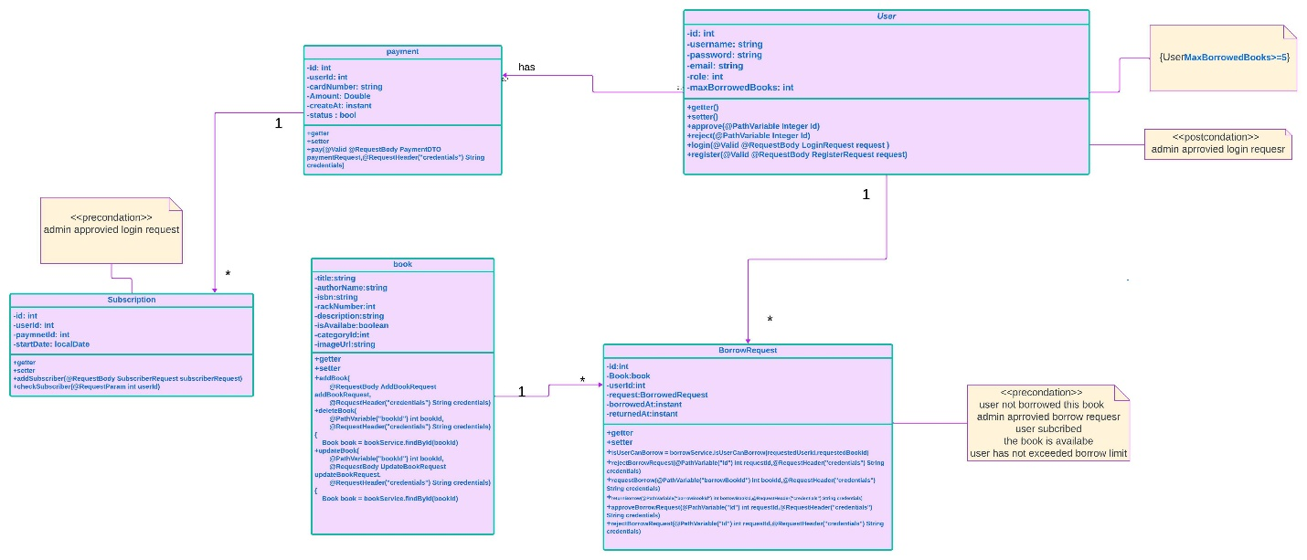

* 1. ***ER Digram***

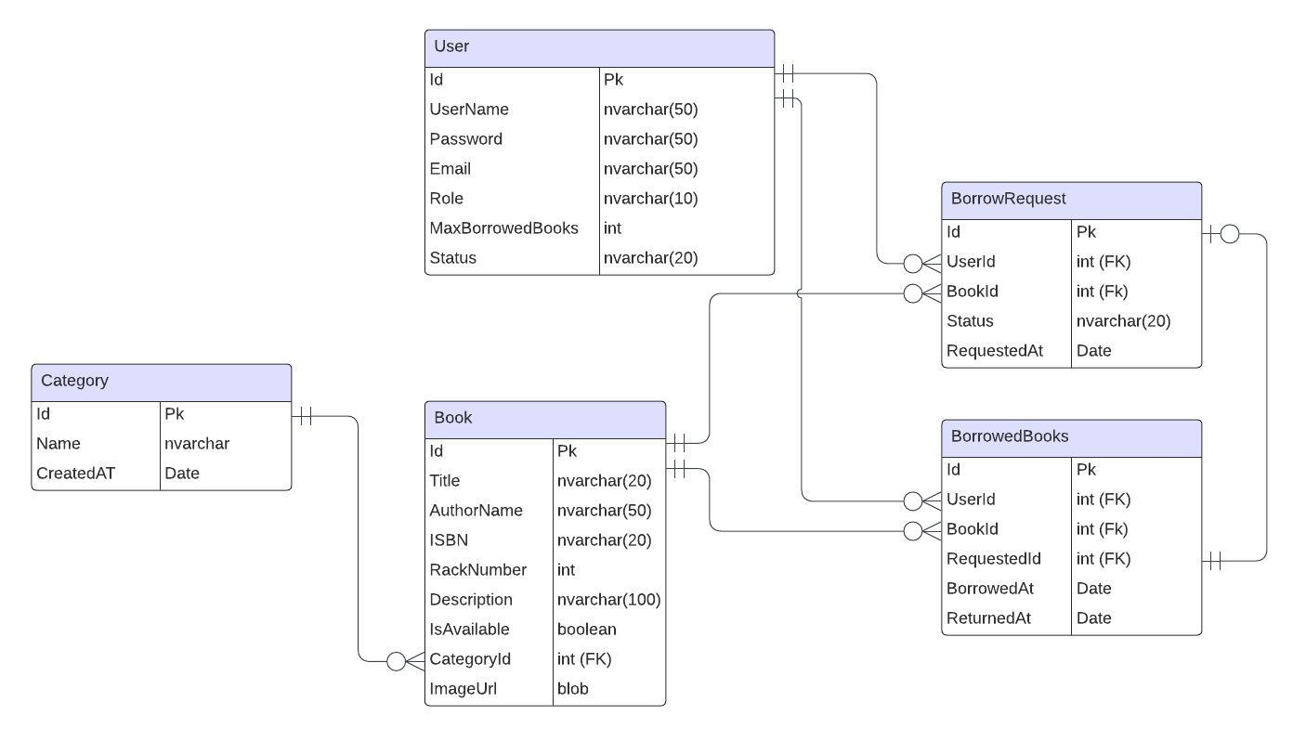

1. ***Conclusion***

From a proper analysis of positive points and constraints on the system, it can be safely concluded that the product is a highly efficient and this application is working properly and meeting to all user requirements.in addition that it can be easily plugged in any organization that needs its services.