DriverPass Business Requirements Document
Ehigie Ekata | CS 255 | Project One
Prepared for Jennifer, project lead. This document translates the DriverPass interview into requirements for design and acceptance. Client requests come from Southern New Hampshire University (SNHU, n.d.); proposed controls and assumptions are identified separately.

System Components and Design

Purpose
- Design a web-based system for DriverPass that supports driver education through online classes, practice tests, and reservations for on-the-road training.
- Give customers convenient access to training and scheduling while giving Liam, Ian, and the secretary the information and controls needed to operate the business.

System Background
- Liam wants to address inadequate preparation for DMV driving tests. DriverPass combines online learning with instructor-led training instead of relying only on previously published tests.
- The system needs account and role management, package enrollment, a shared reservation calendar, online learning and test tracking, driver notes, reporting, and a connection for DMV updates.
- Use a central database behind a cloud-hosted web application. Customers, the secretary, and authorized employees work with the same current records. A managed hosting service is the proposed means of providing backup and infrastructure support.
- DriverPass initially has 10 cars, each associated with a driver. A reservation connects a customer to a driver, car, date, and two-hour time slot.

Objectives and Goals
- Allow a customer or secretary to create, modify, and cancel reservations. Acceptance checks should include competing requests for the same driver or car and changes made through different booking channels.
- Support three packages: Package One provides six driving hours (three sessions); Package Two provides eight hours (four sessions) plus an in-person DMV lesson; Package Three provides twelve hours (six sessions), the in-person lesson, and online classes and practice tests.
- Show test name, time taken, score, and status; record lesson times and driver comments; and identify the employee or customer responsible for each reservation change.
- Let Liam print activity reports and download reports usable in Excel. Let Ian reset accounts and block access. Notify DriverPass when DMV learning content changes.

Requirements

Nonfunctional Requirements

Performance Requirements
- Provide browser access from computers and mobile devices. Booking and record changes require an internet connection; downloaded reports remain available for offline viewing.
- Proposed acceptance targets: 95% of routine page requests should complete within three seconds, and reservation submissions within five seconds, under an agreed test load. Concurrent-user volume and network conditions need client approval before testing.
- Apply DMV content updates after notification and review. Agree on an update deadline with Liam; the interview does not specify one. Schedule application maintenance to reduce disruption to lessons and tests.

Platform Constraints
- Use a cloud-hosted web application and central database, as the client prefers. Support current desktop and mobile browsers without requiring a separate installed customer application.
- The transcript does not select a server operating system, database product, hosting provider, or programming language. Choose these during technical design; Excel-compatible report export is required.

Accuracy and Precision
- Proposed design: use unique IDs for accounts, reservations, vehicles, and test attempts. Validate required contact fields and store appointment dates, times, and the business time zone consistently.
- Enforce two-hour sessions and purchased driving-hour limits. Save a reservation and its audit entry together, and reject overlapping reservations for the same customer, driver, or car.
- Proposed credential policy: passwords are case-sensitive; login identifiers are normalized consistently. Names retain their entered capitalization. Confirm this policy and test pass thresholds with Ian and Liam.
- Show users validation or booking conflicts immediately. Proposed monitoring should alert Ian to repeated login failures, unsuccessful backups, failed DMV updates, and errors that prevent transactions from saving.

Adaptability
- Let Ian manage accounts and permissions without editing source code. Let Liam disable a package for new enrollments. Existing enrollment treatment must be confirmed before disabling a package.
- Separate accounts, scheduling, learning content, and reporting so developers can update a module with limited effects on other functions. New or redesigned package modules are deferred to a future release.
- Proposed maintenance process: test browser, database, and cloud-platform updates before deployment and retain a rollback option. Ian needs administrative access, while provider responsibilities must be documented.

Security
- Authenticate users before account access and enforce role permissions on the server. Ian must be able to reset and block accounts. Provide automatic password recovery; the proposed method uses an expiring, single-use reset link to a verified contact address.
- Proposed controls include HTTPS for data exchange, protected database storage and backups, salted password hashes, and restricted access to audit records. Ian’s account authority does not require access to customers’ passwords or full payment details.
- Proposed response to brute-force attempts: rate-limit sign-ins and temporarily lock an account after five failed attempts within fifteen minutes. Notify Ian of repeated suspicious activity and verify identity before unlocking. Confirm the thresholds with the client.
- Record who created, canceled, or last modified a reservation and when. Limit report exports to authorized users, and protect downloaded reports because they leave the managed application.
- The interview requests card number, expiration date, and security code during registration. Proposed design: collect payment details through a payment provider and retain a transaction reference and masked card details. Do not retain the security code after authorization; PCI SSC prohibits that storage (PCI Security Standards Council, n.d.). Confirm the payment workflow with Liam.
- Use managed backups and monitoring to reduce DriverPass’s maintenance burden. Proposed daily backups, restoration testing, recovery targets, and division of security responsibilities require agreement with Ian and the provider.

Functional Requirements
- The system shall authenticate customers and employees and apply the permissions assigned to their roles.
- The system shall let Ian reset accounts, manage permissions, and block access for a departing or unauthorized user.
- The system shall provide automatic password recovery for customers who forget their passwords.
- The system shall let customers or the secretary enter customer first name, last name, address, state, phone number, and the contact information shown in the client’s interface sketch.
- The system shall present the three training packages and grant the driving hours and learning access included in the selected package.
- The system shall let Liam disable a package to prevent new registrations for it.
- The system shall let customers make, modify, and cancel their own driving appointments online and let the secretary do so for customers who call or visit.
- The system shall schedule each driving appointment for two hours and associate it with a customer, driver, car, date, start time, and end time.

Functional Requirements Continued
- The system shall capture a pickup location and use the same location for drop-off, as requested by Liam.
- The system shall check available driving hours and scheduling conflicts before confirming a reservation. This is a derived rule needed to enforce the package and resource limits.
- The system shall record the identity of the user who creates, cancels, or modifies each reservation, along with the action and timestamp.
- The system shall provide authorized users with a printable activity report showing reservation changes and their responsible users.
- The system shall provide downloadable reports usable in Excel for offline work and require an online connection for changes to central records.
- The system shall provide online classes and practice tests to customers whose selected package includes them.
- The system shall display test name, time taken, score, and a status of not taken, in progress, failed, or passed.
- The system shall record and display driver comments and lesson times, including start and end hours. Direct entry by drivers is the proposed workflow and requires confirmation.
- The system shall receive available DMV rules, policies, or sample-question updates through an agreed connection and notify DriverPass when updates are available.
- The system shall provide a contact page and a way for authorized staff to contact a student.
- The system shall support collection of payment details during registration through the proposed provider workflow and record the resulting payment reference without retaining the card security code.

User Interface
- Customers need registration, sign-in, password recovery, package selection, and appointment forms that work with a mouse, keyboard, or touch screen. Show available lesson times, confirmations, and clear validation messages.
- Use Liam’s dashboard sketch as the starting point: business logo, customer information, online test progress, driver notes, special needs, and driver and student photos. Confirm photo consent, optional fields, and who may view special-needs information.
- The secretary needs a customer search and appointment calendar for telephone and office bookings. The interface should show the selected customer clearly while preserving the secretary’s identity in the audit trail.
- Liam needs report filters, print/export controls, training-progress views, and package-disable controls. Ian needs account, permission, access-blocking, and system-monitoring screens.
- Proposed driver access is limited to assigned lessons and relevant student information, with a form for lesson comments. Use labeled inputs, keyboard navigation, readable contrast, and responsive layouts across all roles.

Assumptions
- Customers and staff have an internet-capable device and supported browser. A verified email address is assumed for the proposed reset-link workflow; the interview sketch includes email but does not define verification.
- A DMV data feed, API, or other authorized exchange is available. Ian must confirm its format, permissions, cost, and notification mechanism. If no direct integration exists, an approved manual update workflow will be needed.
- Driver availability, vehicle availability, business hours, and the business time zone will be supplied before scheduling is implemented. A car’s usual driver pairing may need reassignment rules.
- Liam will provide package prices, cancellation and refund rules, test pass thresholds, and content. Treatment of canceled sessions and disabled packages for existing customers needs clarification.
- The proposed payment provider supports both customer self-service and staff-assisted registration. DriverPass and the provider will agree on the handling of payment details and failed transactions.
- The final schedule table in the transcript is the planning baseline where it differs from the spoken estimates. The chart uses 2026 only as a display year; the source specifies month/day dates without a year. Durations below are inclusive calendar spans, not verified staff effort.

Limitations
- Offline users can view or work with downloaded reports, but cannot synchronize edits or change reservations. Exported information becomes a snapshot and may become outdated.
- Training capacity depends on the ten cars, driver schedules, and two-hour sessions. Software cannot create additional vehicle or instructor capacity.
- The first release supports the three stated packages and package disabling. Creating or removing modules requires developer or analyst involvement and is outside the current release.
- Internet outages, hosting problems, or unavailable DMV services can interrupt parts of the system. Cloud hosting reduces local maintenance but does not eliminate account administration or vendor oversight.
- No budget, staffing capacity, peak demand, or service-level commitments are supplied. Response-time, backup, and security thresholds in this document are proposed targets rather than client-approved commitments.
- The baseline runs January 22 through May 10 and has limited contingency. John cannot start the class diagram before March 1. Design changes after customer review or unresolved integrations could move later milestones.

Schedule Planning
- Prioritize requirements and models before customer approval, then build the interface, database connection, and business logic. Test the complete system before delivery and acceptance.
- UI research can proceed independently of use case modeling. Activity diagrams may begin as individual use cases become available. Same-day transitions require completed portions to be handed off before dependent work begins.
- The April 27 testing overlap assumes a testable business-logic increment is available that day. May 9 sign-off begins after delivery checks. If these handoffs are not feasible, Jennifer should revise the dates before approving the baseline.

Gantt Chart
Figure 1. DriverPass project schedule created in Lucidchart from the interview’s final schedule table (SNHU, n.d.).
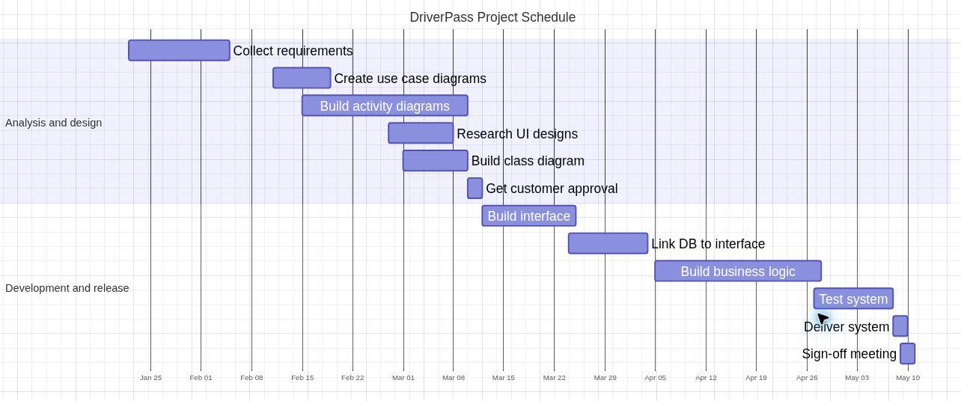
The chart covers each task’s full end date. The year is a display assumption; no weekend exclusions are applied. The following table provides exact dates and the proposed dependency interpretation.

Schedule Dates and Dependencies
Dates reproduce the transcript’s final table. Durations are inclusive calendar days in the assumed non-leap display year. Dependencies explain sequencing; they are not additional client-supplied dates.
ID | Task | Dates | Days | Dependency or constraint
1 | Collect requirements | Jan 22–Feb 4 | 14 | Project kickoff
2 | Create use case diagrams | Feb 11–18 | 8 | 1; planned holiday gap
3 | Build activity diagrams | Feb 15–Mar 9 | 23 | 2, as use cases become ready
4 | Research UI designs | Feb 27–Mar 7 | 9 | 1; independent of 2 and 3
5 | Build class diagram | Mar 1–9 | 9 | 1; John returns Mar 1
6 | Get customer approval | Mar 10–11 | 2 | 2, 3, 4, and 5 complete
7 | Build interface | Mar 12–24 | 13 | 6 approved
8 | Link DB to interface | Mar 24–Apr 3 | 11 | 7; same-day handoff
9 | Build business logic | Apr 5–27 | 23 | 8 complete
10 | Test system | Apr 27–May 7 | 11 | 9; testable increment ready
11 | Deliver system | May 8–9 | 2 | 10 passes acceptance checks
12 | Sign-off meeting | May 9–10 | 2 | 11; delivery checks complete

References
PCI Security Standards Council. (n.d.). Can card verification codes/values be stored for card-on-file or recurring transactions? https://www.pcisecuritystandards.org/faqs/1280/
Southern New Hampshire University. (n.d.). CS 255 DriverPass interview transcript [Course handout].

