DriverPass
System Design Document
CS 255 • Project Two
Ehigie Ekata
October 21, 2026

Design purpose
DriverPass needs a web-based system that combines driver-training enrollment, driving-lesson reservations, online learning, and progress reporting. This document translates the business requirements into UML models and technical requirements for Jennifer and the development team. The DriverPass interview is the primary client source (Southern New Hampshire University [SNHU], n.d.-a).

UML Diagrams
The following five diagrams describe complementary views of the same system. The use case diagram defines user goals and external interactions. The activity diagrams detail lesson booking and practice-test completion. The sequence diagram shows how the booking interface, service, and database collaborate. The class diagram defines the main data objects and their relationships.
The models were developed in Lucidchart. Readable companion diagram images are embedded on dedicated larger pages; the remaining document uses standard letter-size pages. Diagram captions explain the modeled scope and important constraints.

Requirement status
Client requirements are distinguished from proposed implementation choices. Specific technologies, performance targets, cancellation rules, and integration details require confirmation where identified. These diagrams are design specifications; they do not indicate that the software has already been implemented.

System boundary
DriverPass includes account and enrollment management, reservations, learning records, reporting, and staff administration. Banking/payment authorization and DMV information originate outside this boundary. Payment processing and an instructor login are proposed design features, while the actual provider, permissions, and interfaces remain subject to approval.

UML Use Case Diagram
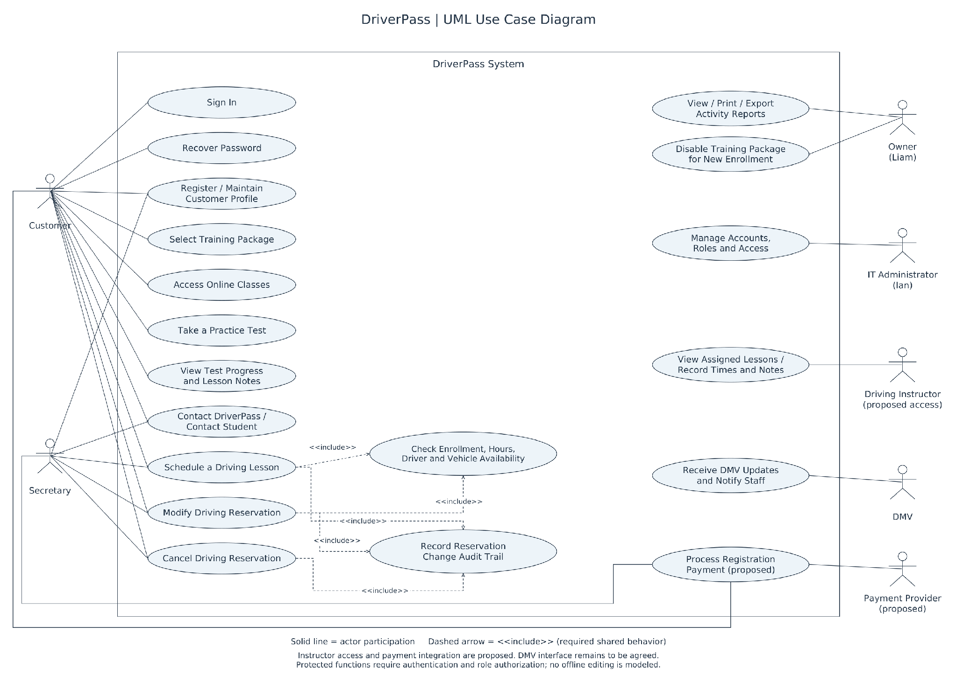
Figure 1. DriverPass user goals and external systems. Customers manage their training and reservations; secretaries can book for customers; the owner reviews reports and reservation activity; the IT administrator controls accounts and permissions. Protected actions require authorization. Instructor access and the payment-provider interface are proposed. Scheduling and modifying reservations include eligibility and availability checks; reservation changes produce an audit record.

UML Activity Diagrams — Schedule a Driving Lesson
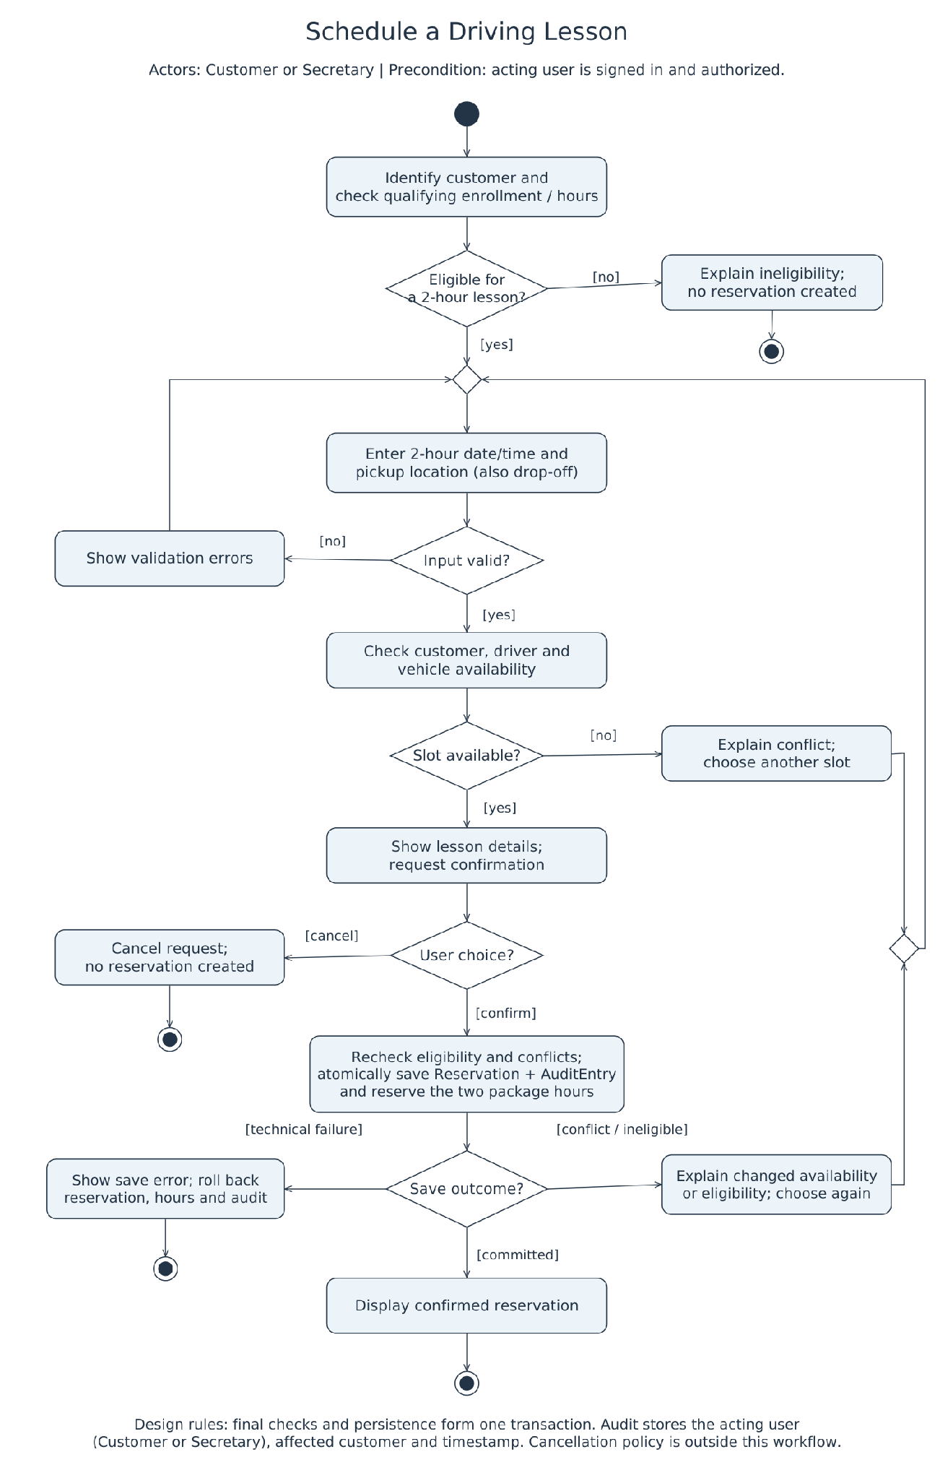
Figure 2. Customer or secretary booking workflow. A reservation uses a two-hour session from an eligible enrollment. Before confirmation, the system rechecks the customer, driver, vehicle, and remaining hours and commits the reservation, reserved hours, and audit entry together. A failed transaction rolls back. The acting user is recorded separately from the customer; cancellation credit rules still require client approval.

UML Activity Diagrams — Complete a Practice Test
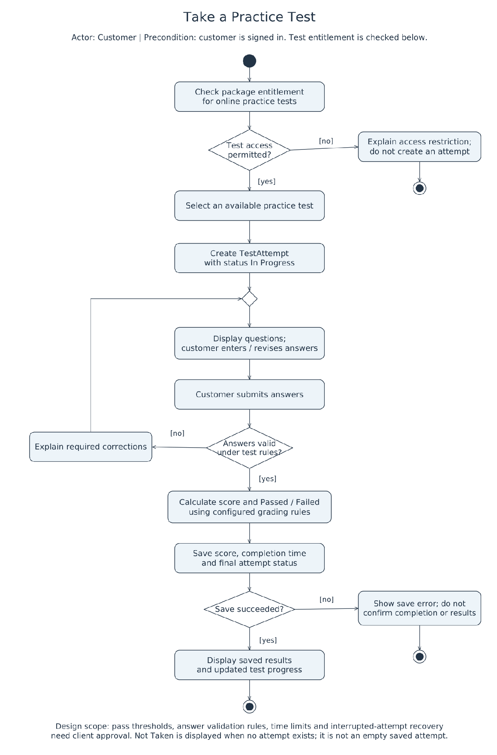
Figure 3. Online practice-test workflow. The system verifies online access, records an in-progress attempt, collects answers, validates submission, calculates a score, and persists the completed result. A save failure must not be displayed as confirmed completion. Not Taken is derived from the absence of an attempt. Passing thresholds and pause/resume behavior require confirmation.

UML Sequence Diagram
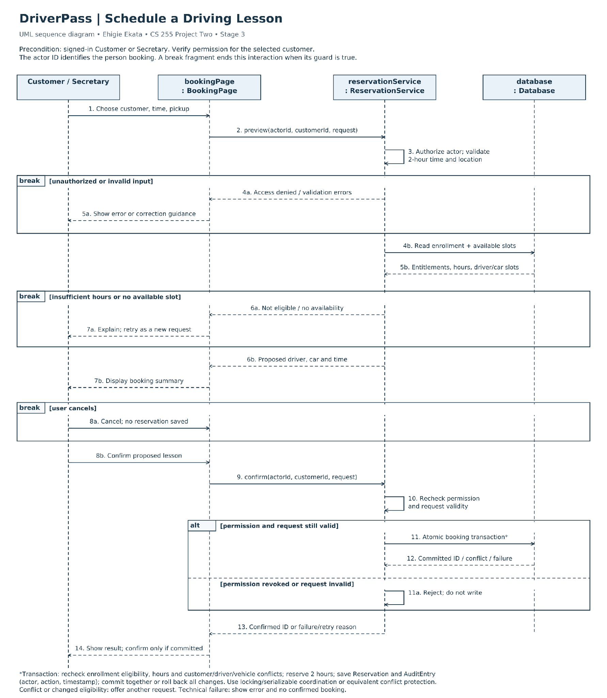
Figure 4. Schedule a driving lesson. Customer/Secretary, BookingPage, ReservationService, and Database exchange requests and results. Early exits cover invalid input, denied access, no available slot, and cancellation. Final authorization and an atomic database transaction protect the booking. A confirmed reservation ID is returned only after commit; failed or conflicting requests return an error or retry outcome.

UML Class Diagram
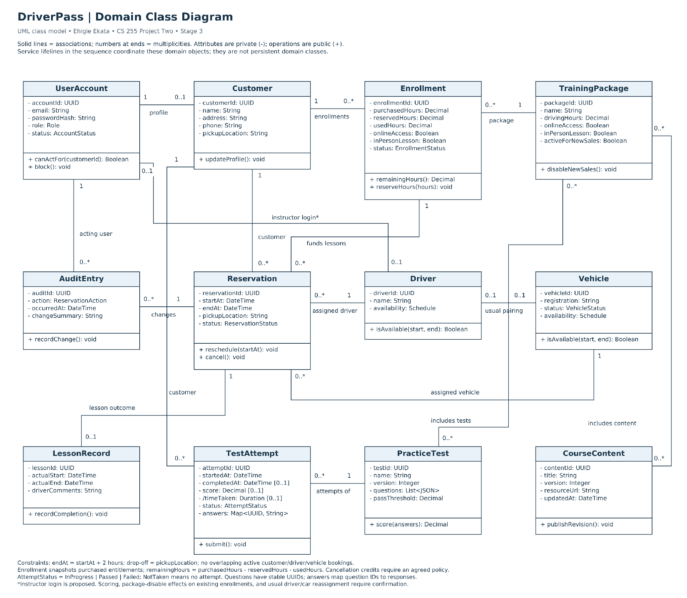
Figure 5. DriverPass domain model. Enrollment preserves purchased entitlements; Reservation links one customer, enrollment, driver, and vehicle; AuditEntry identifies the acting account. TestAttempt belongs to a customer and a versioned PracticeTest. LessonRecord holds actual lesson times and comments. Reports are derived from these records. Payment, password recovery, contact delivery, and DMV integration are service concerns beyond this domain diagram.

Technical Requirements

Architecture, hardware, and infrastructure
The client requires cloud access from computers and mobile devices. A responsive browser interface will communicate with an application service over HTTPS; that service will validate requests and access a managed relational database. Database access must remain private to authorized services. This is a proposed architecture, not a vendor selection. Users need an internet-connected device with a supported browser; staff also need a printer or PDF printing for reports. No dedicated customer hardware or local server is required.
Component | Requirement and purpose
Application hosting | Managed cloud application hosting with separate development, test, and production environments. Select compute and storage capacity after measuring expected peak users and data growth.
Database | A relational database with foreign keys, transactions, constrained status values, and coordinated concurrent updates. Store accounts, enrollments, reservations, audits, lesson records, and learning attempts.
Files and reports | Controlled storage for learning materials and generated reports. Deliver authorized downloads through the application rather than exposing customer files publicly.
Connectivity | Reliable internet access and an HTTPS endpoint with a trusted certificate. Configure domain/DNS, restricted service access, operational logging, and monitored backups.
Client equipment | Desktop/laptop browsers and mobile browsers with layouts suitable for forms, schedules, and practice tests. Test keyboard operation, clear labels, and readable status/error messages.

Software and development tools
Lucidchart maintains the UML models. The development team needs an IDE, a version-control repository, a web framework, a relational database engine, database migration tooling, and a repeatable build process. Automated unit, service, integration, and browser tests will check behavior. Dependency scanning and code review will help identify vulnerable libraries and implementation defects before release. Exact products and supported versions should be selected during implementation planning.

Access and reporting
Owner and staff reports must support printing and Excel export. Exported files are offline snapshots; the design does not provide offline editing or synchronization. Customer changes require an online connection. The owner can review who created, modified, or canceled a reservation and when. Report contents must follow the user’s permissions.

Technical Requirements — Application and Data

Enrollment and package rules
TrainingPackage stores configurable offerings rather than separate subclasses. Package One provides six driving hours in three two-hour sessions. Package Two provides eight hours in four sessions plus an in-person DMV lesson. Package Three provides twelve hours in six sessions, an in-person DMV lesson, online classes, and practice tests. Enrollment snapshots the purchased hours and access rights so later package edits do not silently change a customer’s purchase (SNHU, n.d.-a).
The owner can disable a package for new enrollment. Treatment of existing enrollments requires confirmation. Adding new modules is a future development task. Prices, refunds, and expiration rules are not established by this design.

Reservations and concurrent updates
Each reservation must identify its customer, qualifying enrollment, driver, vehicle, start/end time, and pickup location. Drop-off is the same location as pickup. The reservation’s customer must match the enrollment’s customer. The system must prevent overlapping bookings for a customer, driver, or vehicle and prevent reserved plus used hours from exceeding purchased hours. Initially, DriverPass has ten cars with assigned drivers; reassignment rules need confirmation.
Availability displayed in the browser is provisional. On confirmation, the service must recheck permissions, enrollment eligibility, hours, and conflicts within a coordinated transaction. It must reserve the hours and save the reservation and audit entry together, or roll back all changes. PostgreSQL serializable transactions are one implementation option; serialization failures require retrying the transaction. The database and concurrency strategy remain a design choice (PostgreSQL Global Development Group, n.d.).
Modify and cancel operations also require authorization, consistent hour accounting, and an audit entry. Cancellation windows, no-show treatment, and whether hours are credited back require client decisions. Store timestamps consistently and display the agreed business time zone; retain actual lesson times and driver comments in LessonRecord.

Learning and progress
Online classes and practice tests are limited to entitled customers. A TestAttempt records its customer, versioned test, answers, start/end time, score, and status. Score and completion time remain unset until completion. Publish a new test version rather than overwrite questions used by historical attempts. The interface must show meaningful progress, including not taken, in progress, passed, and failed states; test thresholds and interrupted-attempt recovery remain open.

Technical Requirements — Security and Interfaces

Account and data protection
Customer registration collects the contact and pickup information required to provide training, including name, address/state, and telephone number. Store password hashes rather than plaintext passwords. Protect browser traffic with HTTPS and restrict database, backup, and administrative access. Avoid recording credentials or payment details in application logs.
Apply least privilege and deny access unless explicitly allowed. Check permissions on every server request, including ownership of the requested customer record. Customers access their own records; secretaries manage authorized customer bookings; the owner accesses business reports; the IT administrator can reset or block accounts and manage permissions. Instructor login and its exact access scope are proposed. Authorization tests should cover attempts to access another customer’s data (OWASP Foundation, n.d.-a).
Provide automatic password recovery using a verified communication channel and securely generated, expiring, single-use reset tokens. Use consistent responses that do not reveal whether an account exists, and rate-limit requests. The channel and account-verification process require agreement with the client (OWASP Foundation, n.d.-b).

External interfaces
Interface | Required behavior / proposed approach
DMV updates | DriverPass requests a DMV connection and notices when rules/content change. Confirm the available feed/API, access terms, and update frequency. A proposed adapter can import approved updates and notify staff; a manual review/import process is a fallback requiring client approval.
Payments | Use a proposed payment-provider integration for authorization. Retain payment references and masked details only, rather than full card numbers or card security codes. Confirm payment timing, provider, refunds, and reconciliation before implementation.
Contact and notifications | Provide the requested contact page and a way for staff to contact students. Agree on email/SMS or other delivery channels, delivery-failure handling, and which events generate messages.
Exports | Generate authorized printable and Excel reports from current stored data. Clearly identify the export time. Downloads must not bypass account permissions.

Audit integrity
AuditEntry links a reservation to the account that performed the action, action type, timestamp, and change summary. A secretary booking for a student must be recorded as the actor. Restrict audit modification and define retention with the client. Logs support investigation but must not unnecessarily expose personal data.

Technical Requirements — Operations and Validation

Performance, reliability, and recovery
Proposed acceptance targets are a response within three seconds for 95% of routine requests and five seconds for 95% of booking confirmations under an agreed test load. These are not client-approved commitments. Confirm peak concurrency, data volume, business hours, availability needs, and recovery objectives before sizing the system or selecting a service agreement.
Use monitored application/database health checks, error alerts, managed backups, and tested restoration procedures. A daily backup is a starting proposal; retention, acceptable data loss, and recovery time remain open. Deploy changes through a tested release process with a rollback plan. Network or persistence failures must produce clear error states without falsely confirming bookings or completed tests.

Verification tied to the models
Acceptance check | Expected result
Competing reservations | Two simultaneous requests for the same customer, driver, or car cannot both commit. No booking can overspend the final available two hours.
Failure during booking | An injected persistence failure leaves no partial reservation, hour deduction/reservation, or misleading success message.
Delegated booking and access | A secretary’s booking records the secretary as actor and the student as customer. Unauthorized customer or staff actions are rejected server-side.
Learning and progress | Only entitled users open online content. Scoring follows the configured test version; failed result storage does not appear as completed progress.
Reports and recovery | Authorized reports match stored records and export correctly. Password recovery tokens expire and cannot be reused; restored backups preserve related records.

Decisions to confirm with DriverPass
Before implementation, confirm package prices and existing-customer effects of disabling a package; cancellation/refund/no-show rules; business hours and time zone; driver/vehicle reassignment; test passing scores and pause/resume rules; instructor permissions; DMV and payment interfaces; notification channels; data retention; expected load; and service/recovery targets. These decisions may refine the models and acceptance criteria.

References
OWASP Foundation. (n.d.-a). Authorization cheat sheet. OWASP Cheat Sheet Series. https://cheatsheetseries.owasp.org/cheatsheets/Authorization_Cheat_Sheet.html
OWASP Foundation. (n.d.-b). Forgot password cheat sheet. OWASP Cheat Sheet Series. https://cheatsheetseries.owasp.org/cheatsheets/Forgot_Password_Cheat_Sheet.html
PostgreSQL Global Development Group. (n.d.). Transaction isolation. PostgreSQL 18 documentation. https://www.postgresql.org/docs/18/transaction-iso.html
Southern New Hampshire University. (n.d.-a). CS 255 DriverPass interview transcript [Course handout].
Southern New Hampshire University. (n.d.-b). CS 255 Project Two guidelines and rubric [Course handout].
Southern New Hampshire University. (n.d.-c). CS 255 system design document template [Course template].

