Practices for Secure Software Report
CS 305 Project Two · Artemis Financial

Document Revision History
Version | Date | Author | Comments
1.0 | October 25, 2026 | Ehigie Ekata | Final refactor and verification

Client
Artemis Financial, supported by Global Rain

Developer
Ehigie Ekata
The refactored application demonstrates SHA-256 checksum verification over HTTPS. The final build passed all 11 automated tests, and its dependency scan found zero known vulnerabilities within the documented coverage. This report explains the implementation, certificate setup, and supporting evidence. The endpoint uses a fixed demonstration string; a production financial file-transfer service would also need authenticated users, authorization, and verification of actual uploaded files.

Algorithm Cipher
I recommend AES-256 in Galois/Counter Mode (GCM) for protecting financial data in transit through TLS. AES is a symmetric block cipher: both sides use shared secret key material for encryption and decryption. AES supports 128-, 192-, and 256-bit keys with a 128-bit block size. GCM adds authentication of the encrypted records, helping detect tampering as well as protecting confidentiality (National Institute of Standards and Technology [NIST], 2023, 2007).
SHA-256 supplies the application checksum. It produces a 256-bit digest represented by 64 hexadecimal characters, allowing the application to compare data against a trusted expected value (NIST, 2015). AES encryption and SHA-256 hashing serve different purposes: the hash does not conceal the data or identify its sender. A changed file and an attacker-replaced checksum would require an authenticated reference, a digital signature, or a keyed integrity mechanism to detect reliably.
The certificate uses an asymmetric RSA-3072 key pair: the private key stays with the server and the public key is exported in the certificate. TLS uses certificate authentication and ephemeral key agreement to establish symmetric traffic keys. The TLS library manages cryptographically secure randomness and unique record nonces; application code does not invent keys or reuse fixed GCM nonces (Rescorla, 2018).
AES was standardized in 2001, and its 2023 standard update did not change the algorithm. TLS 1.3 was standardized in 2018, advancing encrypted communications beyond older protocol designs. For this application, TLS 1.3 and TLS 1.2 with AES-GCM are enabled; older SSL/TLS versions are excluded in line with OWASP guidance (NIST, 2023; Rescorla, 2018; OWASP Foundation, n.d.).

Certificate Generation
Java Keytool was run through Eclipse’s External Tools configuration to generate the local certificate and export certs/localhost.cer. The generation script uses -genkeypair and -exportcert, consistent with Oracle’s key-management documentation (Oracle, n.d.). The PKCS12 keystore uses alias artemis-localhost and contains a 3,072-bit RSA key pair with a SHA256withRSA self-signed certificate valid for 365 days.
The subject is CN=localhost, OU=CS 305 - Ehigie Ekata, O=Artemis Financial Demo, C=US. Subject Alternative Names include localhost and 127.0.0.1 so hostname verification can succeed. The certificate is marked for server authentication and is not a certificate authority. The public CER can be inspected or imported without disclosing the private key.
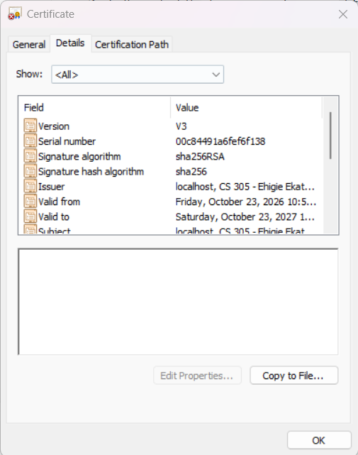
Figure 1. Exported localhost certificate opened in Windows on October 23, 2026. The details show the student organization unit, SHA-256/RSA signature, and 2026–2027 validity. This capture precedes installation of local trust.
The certificate was subsequently imported into the Windows Current User trusted root store for this local exercise. Figure 3 records Chrome’s secure-connection status after that step. This establishes trust on the test machine only; Artemis Financial’s public service would require a properly managed certificate from a trusted issuer. The submission omits the private keystore and its password.

Deploy Cipher
ChecksumService.java computes SHA-256 through Java’s MessageDigest API over explicit UTF-8 bytes. Each call creates its own digest object, which avoids shared mutable hashing state. The matches method validates a 64-character hexadecimal reference and compares parsed digest bytes using MessageDigest.isEqual. HashController.java exposes GET /hash, calculates the digest, compares it with an independently calculated reference, and displays MATCH or MISMATCH.
The unique input is shown below. It contains no trailing newline; even an added newline changes the digest.
Ehigie Ekata | Artemis Financial | CS 305 Project Two | Verification ID: EKATA-P2-20261021-A7C9
Expected SHA-256:
fe3c134a96a5e96a5a6c5b8db1d792d68f47167ad1e288ef0a7c9303850a6e0a
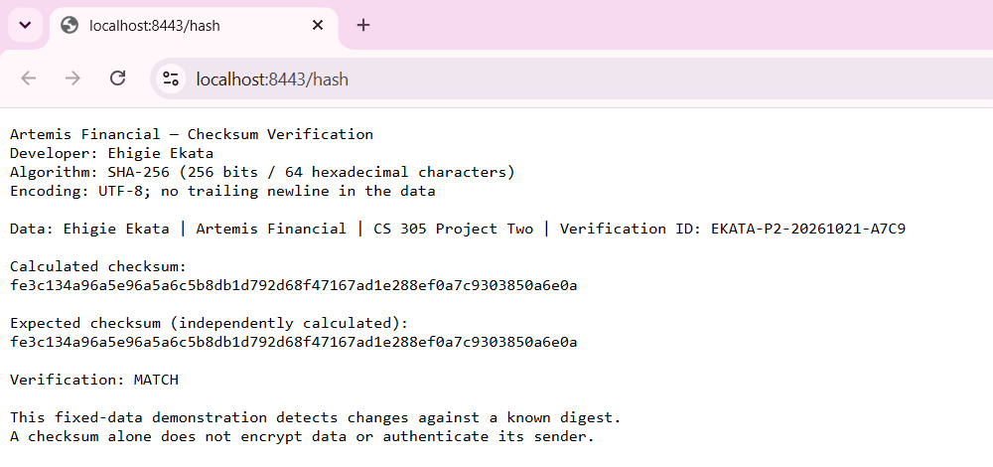
Figure 2. Final application in Chrome on October 25, 2026. The student name, unique input, calculated and expected checksums, and MATCH result are visible.
The expected value was calculated separately with Python hashlib and checked again during the packaged HTTPS test. The controller returns HTTP 200 for a match and HTTP 500 for a mismatch. It sends plain UTF-8 text with Cache-Control: no-store and X-Content-Type-Options: nosniff. Query parameters are not inserted into the output. The page demonstrates integrity verification without adding a third-party cryptography dependency.

Secure Communications
The application.properties file enables SSL, sets port 8443, and binds the demonstration server to 127.0.0.1. It loads the external PKCS12 keystore with alias artemis-localhost. ARTEMIS_KEYSTORE_PASSWORD supplies the password at runtime; the value is not stored in source control or the executable JAR. RUN_HTTPS.cmd prompts locally and starts the packaged application.
TLS 1.2 and TLS 1.3 are explicitly enabled. The allowed suites use AES-GCM with 128- or 256-bit keys, including TLS_AES_256_GCM_SHA384 and the TLS 1.2 ECDHE-RSA AES-GCM suites. There is no additional HTTP connector. Error responses exclude exception messages and stack traces. These settings apply OWASP’s guidance to use secure TLS versions and protect certificate keys (OWASP Foundation, n.d.).
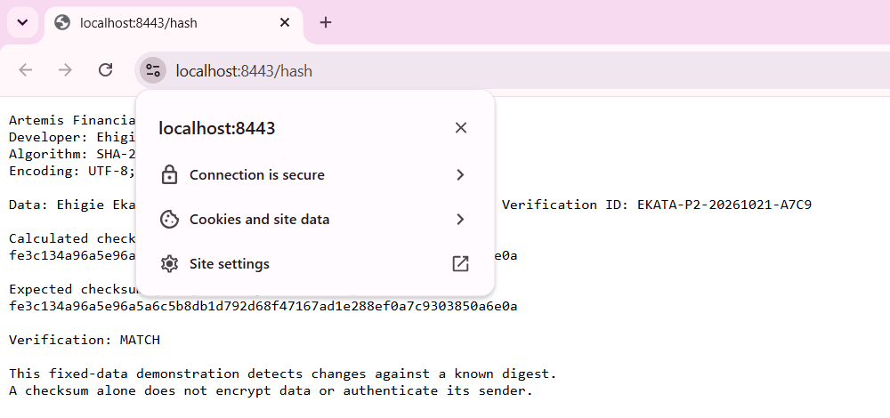
Figure 3. Chrome reports “Connection is secure” after local certificate trust was established on October 23, 2026. The final October 25 build reuses this certificate; its refreshed checksum page appears in Figure 2.
The final packaged application also passed a separate automated HTTPS check on Java 17. Certificate and hostname validation remained enabled. TLS 1.3 negotiated TLS_AES_256_GCM_SHA384, while TLS 1.2 negotiated ECDHE-RSA-AES256-GCM-SHA384. GET /hash returned HTTP 200 and the expected digest. An untrusted certificate and an incorrect hostname were rejected; plaintext traffic on port 8443 was rejected, and port 8080 was closed.
The automated check used its own temporary test certificate, separate from the Windows certificate in Figure 1. Figure 5 shows the final application starting successfully on the student’s Windows machine with Java 25.0.2. Both sets of evidence concern the same final executable, with the automated results retained in verification/evidence/https-verification.json.

Secondary Testing
OWASP Dependency-Check 13.0.0 scanned the final runtime and test dependencies after the refactor. This software composition analysis checks libraries against known vulnerability information; it does not replace review of custom Java code (OWASP Dependency-Check, n.d.). No external hashing library was introduced. The unused data REST dependency was removed, and the Spring Boot parent was updated to 4.0.9 with patched managed dependencies.
Scan | Unique records | Vulnerable records | Distinct CVEs
Original starter dependencies | 50 | 15 | 150
Final refactored dependencies | 41 | 0 | 0

Both comparisons used the same vulnerability snapshot and a current scanner. The final report lists 68 scanned entries, including 41 unique dependencies. It reports zero vulnerabilities and zero suppressed vulnerabilities. The successful final execution shown in Figure 5 supports both secondary and functional testing.
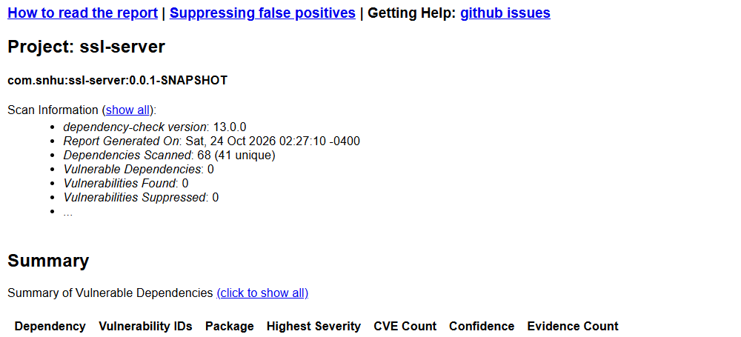
Figure 4. Final Dependency-Check report opened by the student on October 25. The report was generated October 24, 2026; all vulnerability totals are zero.
NVD and CISA checks ran. NVD feed snapshots were last modified October 23, 2026; downloaded feeds from NIST and the documented Dependency-Check mirror were verified against their published SHA-256 metadata. The package records source URLs and timestamps. The POM retains public feed URLs, failOnError=true, inclusion of test dependencies, and a CVSS failure threshold of 7.
Coverage limits: Sonatype OSS Index did not run because separate credentials were unavailable. The .NET Assembly Analyzer was disabled because the two bundled Byte Buddy DLLs were native Windows libraries, not managed .NET assemblies; their containing Java dependency remained in the scan. No CVE suppression file was used. Zero findings means no known matches in this scan’s data and scope, not proof that undiscovered vulnerabilities cannot exist.

Functional Testing
Manual review examined the controller, checksum service, application configuration, certificate scripts, and Maven dependencies. The review checked syntax and imports, followed the success and failure paths, and examined security assumptions. Null data is rejected, malformed expected digests fail verification, and a mismatch cannot be reported as a successful match. Digest state is method-local, while the injected service reference is private and final.
The endpoint accepts no uploaded files, customer records, SQL, or shell commands. It returns fixed plain text, does not reflect query input, rejects POST, and hides stack traces on errors. Missing keystore configuration prevents a successful HTTPS startup. The complete review is attached as verification/MANUAL_CODE_REVIEW.md.
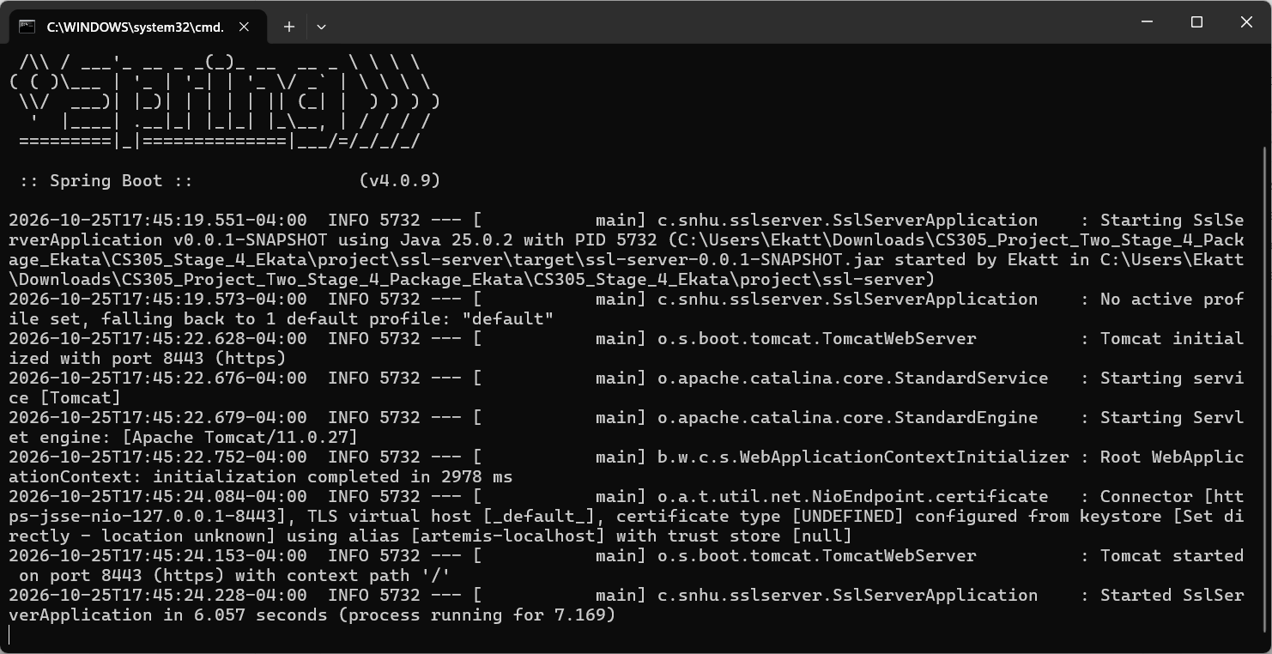
Figure 5. Final refactored application starts without an error on October 25, 2026. The student’s terminal shows Spring Boot 4.0.9, Tomcat 11.0.27, HTTPS port 8443, and “Started SslServerApplication.” This execution evidence also supports Secondary Testing.
Executed tests | Result
7 checksum tests: known vectors, UTF-8, changed data, malformed references, null input, concurrent calls | 7 passed
4 HTTP integration tests: output/headers, query handling, unsupported method, safe 404 | 4 passed
Total failures / errors / skipped | 0 / 0 / 0

The automated build completed with BUILD SUCCESS. HTTP integration tests use an isolated test profile; the separate packaged-server test verifies actual HTTPS settings. The final JAR in the ZIP is the exact executable used for the successful HTTPS probe. Build logs, individual test results, and the HTTPS verification record are included with the code.

Summary
The refactor adds a checksum service and controller, enables encrypted HTTPS communication, moves certificate secrets outside the code, and updates dependencies. It follows the course vulnerability assessment process by reviewing architecture first, checking each applicable security area, and recording findings with mitigations (Southern New Hampshire University, n.d.).
Architecture review established a small controller/service design and removed an unused dependency. Input validation rejects invalid digest references. API review checks the GET route, response type, headers, and method restrictions. Cryptography review checks SHA-256, UTF-8, certificate generation, and TLS configuration. Client/server review verifies hostname and certificate trust, encrypted transport, and the absence of a plaintext listener. Code-error review checks safe failure behavior. Code quality and encapsulation review check constructor injection, immutable references, and per-call digest state.
The flow diagram then directs manual reviews toward relevant components. For this application, those components are the controller, service, API, configuration, and plug-ins. It has no database layer or separate HTML view to review. Findings were recorded in the manual review, vulnerable library versions were replaced, and tests were repeated on the final build. The final scan and successful endpoint execution document the results of those changes.
These controls provide several layers of protection. HTTPS protects traffic, certificate validation supports server identity, the checksum detects changes against a trusted reference, and dependency updates address known library weaknesses. Input handling and safe error responses reduce avoidable exposure in the endpoint. Functional tests and manual review check behaviors that a dependency scanner cannot establish.

Industry Standard Best Practices
The implementation uses Java’s maintained cryptographic API and the TLS stack instead of custom encryption. Explicit encoding makes checksums reproducible. Private keys and passwords are excluded from the submission, supported TLS versions are configured, and response headers prevent caching and content sniffing. The fixed-data endpoint is limited to loopback access. These choices preserve the checksum behavior while adding transport protection and reducing unnecessary exposure.
Dependency updates were followed by regression tests and a new scan so that a security change did not silently break the application. Scan errors remain fatal, and the full results are retained rather than hidden through suppressions. Continued maintenance should repeat these checks after dependency changes, refresh vulnerability data, renew certificates before expiration, and review new functionality before deployment.
For Artemis Financial, these practices help reduce the risk of exposed financial information, corrupted transfers, and service interruptions. Clear evidence also helps developers reproduce problems and evaluate future changes. Before a public production launch, the company would still need user authentication, per-file authorization, a trusted reference for real file verification, managed public certificates, and operational monitoring. The submitted fixed-string demonstration does not claim to implement those additional business controls.

Code Attachments
The accompanying CS305_Project_Two_Refactored_Code_Ekata.zip contains one project folder. Its ssl-server subfolder includes the source, configuration, Maven wrapper, tests, certificate-generation and startup scripts, and the verified executable JAR. The verification subfolder contains the supporting reports and logs.
File or folder | Purpose
ssl-server/src/main/java/com/snhu/sslserver/ | Application entry point, HashController, and ChecksumService
ssl-server/src/main/resources/application.properties | HTTPS, external keystore, protocols, and safe error settings
ssl-server/src/test/ and pom.xml | 11 tests, dependency versions, and scanner configuration
ssl-server/GENERATE_CERTIFICATE.cmd and RUN_HTTPS.cmd | Local certificate creation/export and HTTPS startup
verification/evidence/ | Final and baseline scan reports, build/test logs, HTTPS checks, and feed provenance

The public certificate is documented in Figure 1. Its private keystore stays on the student’s machine; a new reviewer can generate a separate local certificate using the included instructions. The README explains how to run the existing JAR or rebuild the project.

References
National Institute of Standards and Technology. (2007). Recommendation for block cipher modes of operation: Galois/Counter Mode (GCM) and GMAC (SP 800-38D). https://csrc.nist.gov/pubs/sp/800/38/d/final
National Institute of Standards and Technology. (2015). Secure hash standard (SHS) (FIPS PUB 180-4). https://csrc.nist.gov/pubs/fips/180-4/upd1/final
National Institute of Standards and Technology. (2023). Advanced encryption standard (AES) (FIPS PUB 197). https://csrc.nist.gov/pubs/fips/197/final
Oracle. (n.d.). The keytool command. Java Platform, Standard Edition 17. https://docs.oracle.com/en/java/javase/17/docs/specs/man/keytool.html
OWASP Dependency-Check. (n.d.). dependency-check:check. https://dependency-check.github.io/DependencyCheck/dependency-check-maven/check-mojo.html
OWASP Foundation. (n.d.). Transport layer security cheat sheet. https://cheatsheetseries.owasp.org/cheatsheets/Transport_Layer_Security_Cheat_Sheet.html
Rescorla, E. (2018). The Transport Layer Security (TLS) protocol version 1.3 (RFC 8446). RFC Editor. https://doi.org/10.17487/RFC8446
Southern New Hampshire University. (n.d.). CS 305 vulnerability assessment process flow diagram, text-only version [Course handout].

