Before making the actual website there were many stages it had to go through such as the planning processes and creating the object design prototypes to see how the website should look like. Below there is a picture of both the before and after of the design prototypes.

Before:

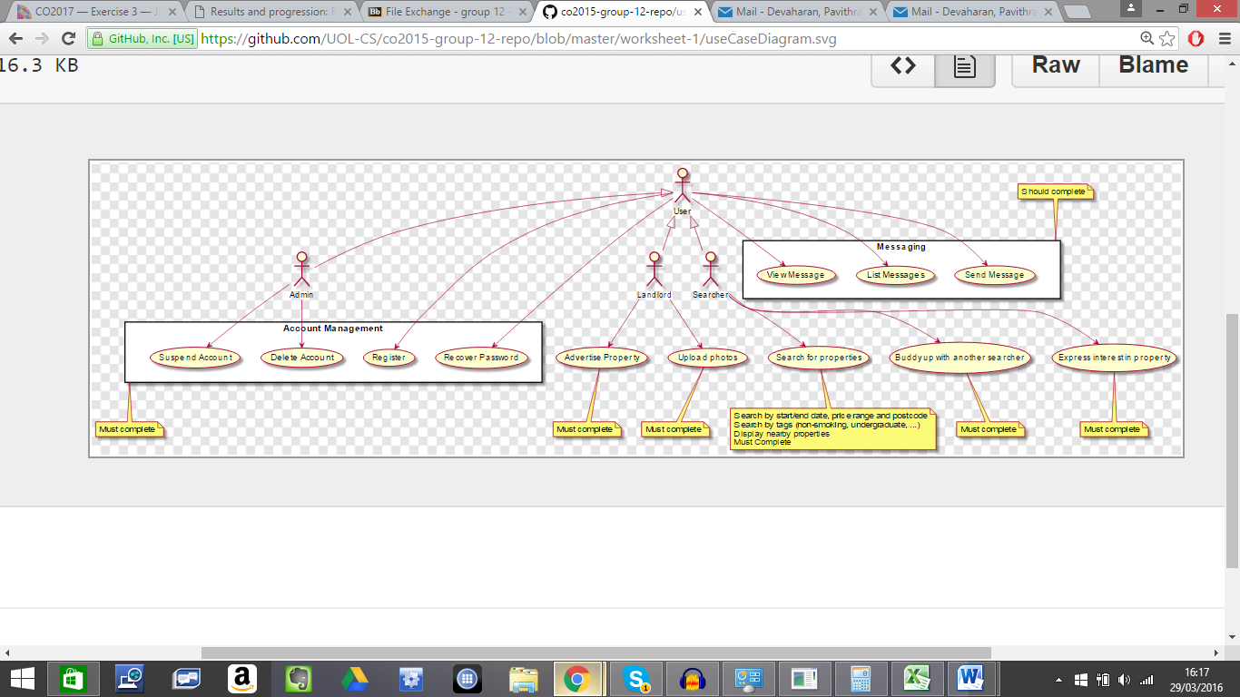

After:

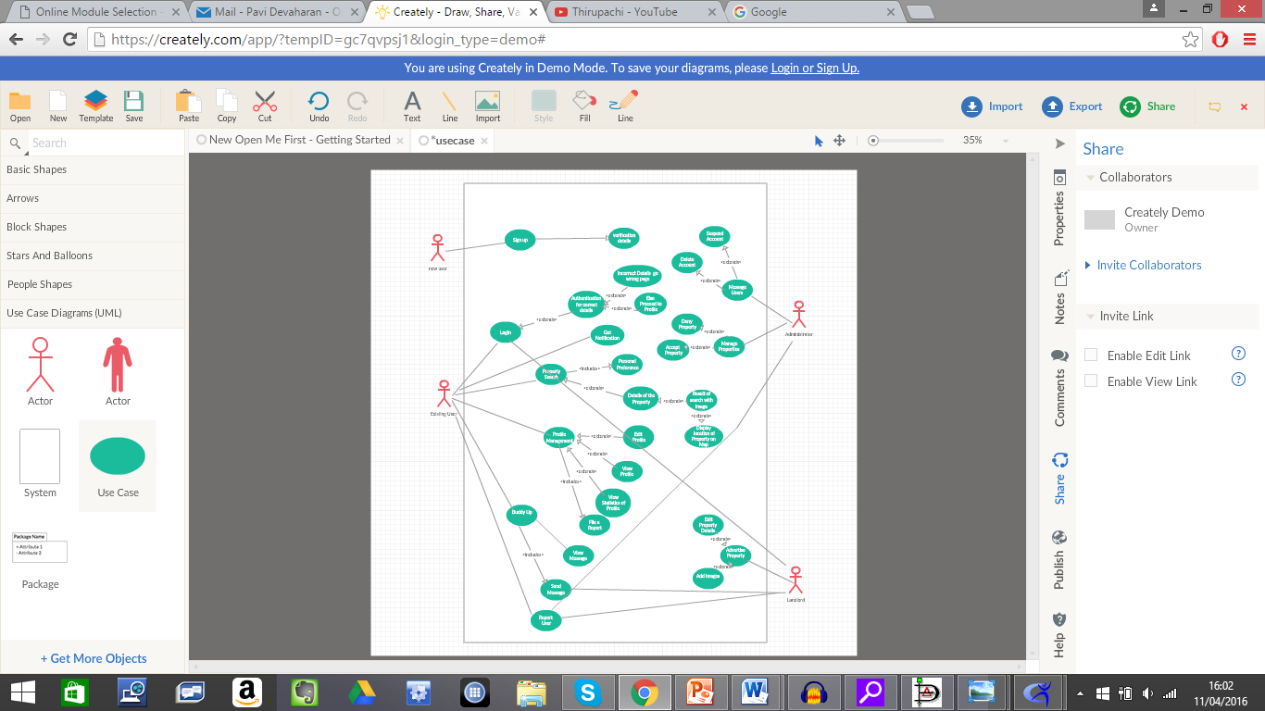

As you can see there has been several features added to the new use case diagram. A use case diagram is used in system analysis in order to identify and organize system requirements. This diagram is composed by implying the possible sequence of interactions between the system and the user. A use case can be assumed as a group of possible scenarios related to a specific goal.

The initial use case was very vague; it described the basic functions of the website but did not go in depth of what the website should do. The key points discussed in our group were the individual functions the website should be able to do. These functions include: report problems, authentication of user, profile management and displaying locations of properties on the map. The CSS of the website on the whole has many features included in it such as changing graphics as you scroll down the page as well changing the color of the font. The website is easy to maneuver around as it has hyperlinks which link to the user’s desired area of the website (e.g. homepage). Another key feature which is included in the new diagram is receiving new notifications. This will alert the user instantly to any changes made.

The second diagram which helped create the website was the component diagram. Below I have illustrated both the before and after of the component diagram.

Before:

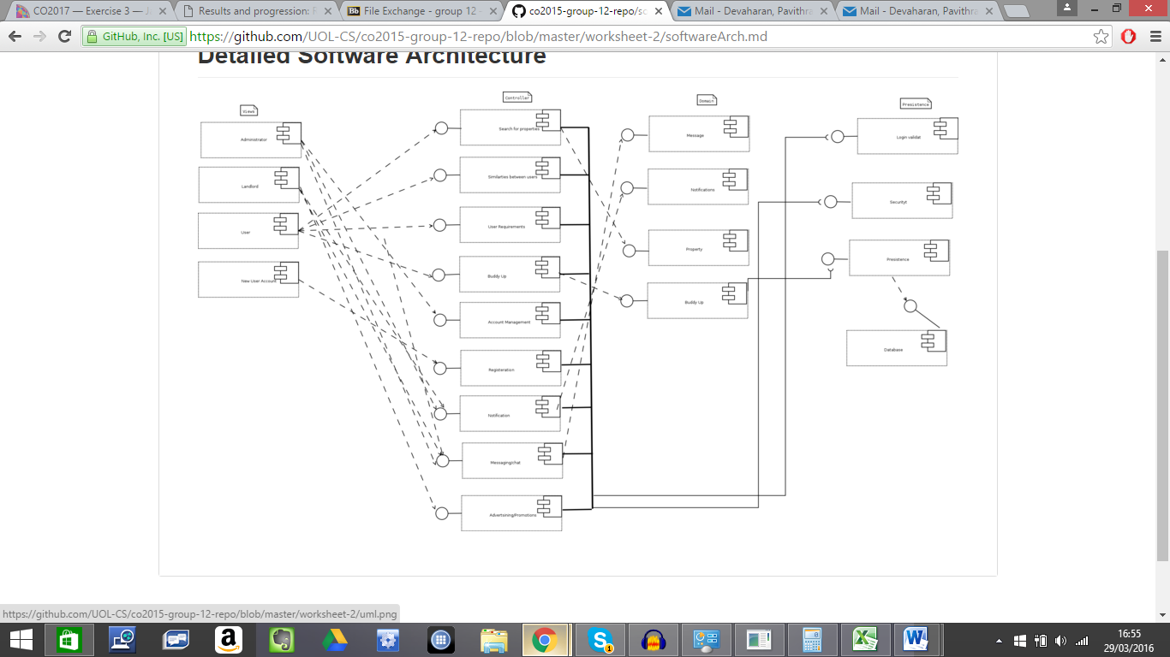

After:

The main function of a component diagram is to assist the model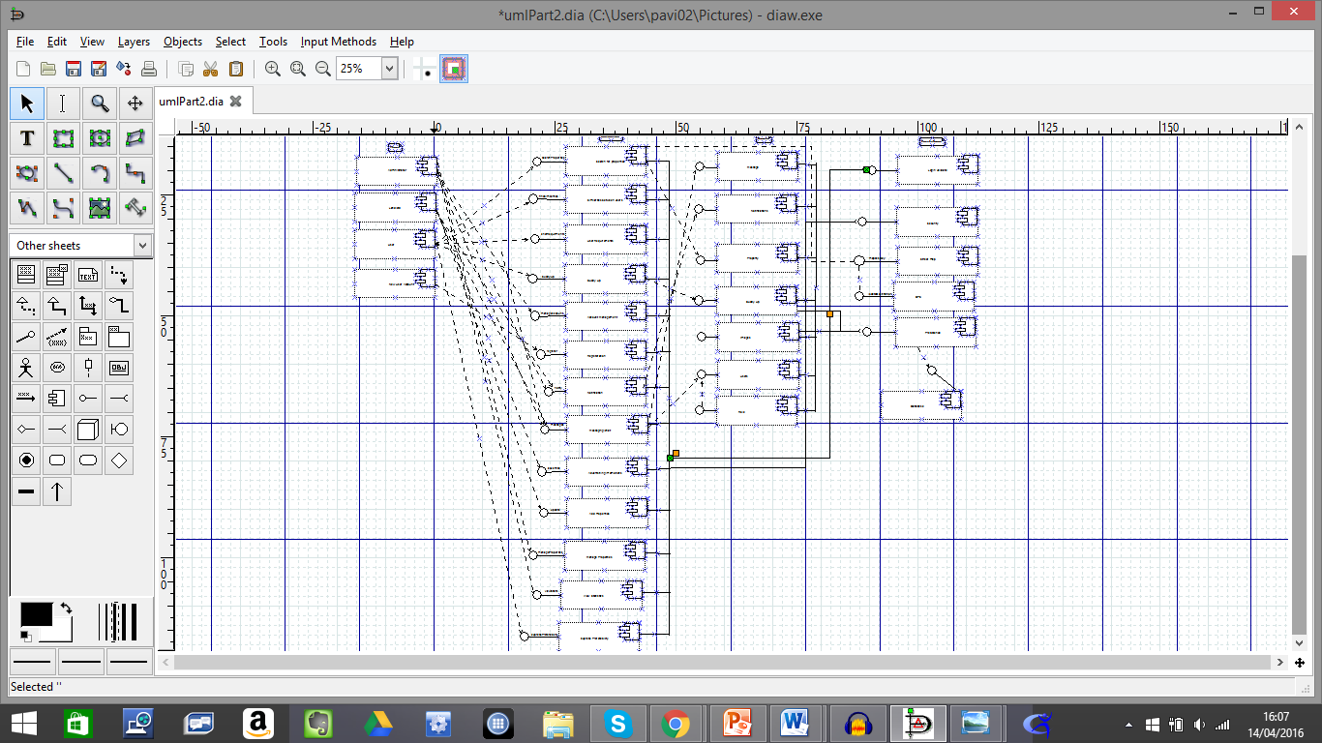ling of the physical aspect of an object oriented software system. It demonstrates the architectures of each software component and states the dependencies between them.

The updated diagram has more additional features in it. The initial component diagram has the basic concept of the website functions such as the buddy-up system and creating a user profile. The updated version focuses more towards the additional functions such as the GPS and the presentation (e.g. images of the property)

|  |
| --- |
|  |

What could have been done better?

The security of a website should take priority especially if it requires personal information of the user. Applying a time-out session once the account details have been typed incorrectly for a certain amount of times (e.g. 3 times) and sending the user account an email will help to make sure they are aware of this and take actions if necessary. Having a password secure scale will be beneficial. This scale will state how strong or weak the password is, and only accept a password if it’s at least medium. Keeping old administrators account would potentially be beneficial if that user is called upon again however this only gives someone else the opportunity to gain access to the website. Deleting the users which are not required will prevent that; they can be re-added later if needed.