**USER MANUAL**

**STARTING THE GAME**

1. Login/signup to [chess.com](https://www.chess.com/login)
2. Set the board’s coordinates to “Outside Board” under

Settings > Board and Pieces > Coordinates

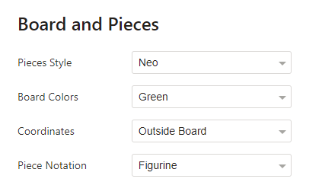

1. Navigate to the “Play” tab and start a game



1. Run “Hands-Free Chess”

**INSERT IMAGE HERE**

1. Make the chess.com window full screen

**PLAYING THE GAME**

Hands-Free Chess supports a few different formats for inputting chess moves. To move a rook to the position H4, simply say “Rook H4.”

Occasionally, two or more pieces of the same type could be moved to the same destination (ex: you say “Knight E5” but both knights could legally be moved to E5). To resolve the ambiguity, the program asks you to repeat your command, but this time, specifying the original location of the piece you want to move (ex: “C4 knight E5”).

Please note that there is still a lot of bug-fixing to do. If the software claims that your move is illegal or if it does not pick up on the microphone audio, just try again. The program will usually work after a few tries.

All valid chess move command formats are listed below:

|  |  |
| --- | --- |
| FORMAT | EXAMPLE |
| [NAME] + [DESTINATION] | “Pawn G4” |
| [NAME] + “to” + [DESTINATION] | “Pawn to G4” |
| [ORIGIN] + [NAME] + [DESTINATION] | “G3 pawn G4” |
| [ORIGIN] + [NAME] + “to” + [DESTINATION] | “G3 pawn to G4” |

Other voice commands:

|  |  |
| --- | --- |
| Command | Description |
| Pause | Pause all voice-recognition activity.  The microphone turns off. |
| EXIT | Exit Hands-Free Chess |
| cancel | Cancel a move that you are in the process of saying.  Ex: “Bishop… to… *cancel*. Queen to E4." |
| HELP | Display the user manual |