**JJJ MARKETING**

**(SALES AND INVENTORY SYSTEM)**

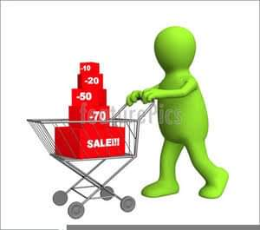

The **JJJ Marketing** is a company that promoting, selling

and distributing products to our potential Customers and Clients.

Because we want to promote our products to our clients

and to establish leadership.

Deliver/Pick up

Invoice

**JJJ MARKETING**

(SALES AND INVENTORY SYSTEM)

Purchase Order

Inventory

Sell

Distribute

Stock