ASSIGNMENT 1 | VERSION 5
Obstacle Avoidance: Bug Algorithm Scenario 1
Current instruction and proposed clearer student-facing revision
Review status: Draft only. No assignment configuration, grader, starter code, image, or application behavior has been changed.

Part 1 - Current instruction
Source: backend/assignments/assignment_1.json, version 5. Formatting is normalized for review; wording is unchanged.
Scenario
A cleaning robot starts at S(2,1) and travels toward G(8,9). The straight start-to-goal line is the Bug2 m-line. A rectangular obstacle spans 4 <= x <= 7 and 3 <= y <= 6.
Valid Bug2 intersections
The m-line first meets the obstacle's left edge at hit point H(4, 11/3). Following the boundary clockwise, the robot moves from H to the top-left corner T(4,6) and then along the top edge to leave point L(23/4, 6). H and L both lie on the m-line, and L is closer to G than H, so Bug2 permits the robot to leave the boundary at L.
Your task
- Calculate distance_to_hit from S to H.
- Calculate distance_along_obstacle as H-to-T plus T-to-L.
- Calculate distance_leave_to_goal from L to G.
- Set total_distance to the sum of those three traveled components.
Use Euclidean distance for straight segments. Treat the given fractional coordinates as exact values.

Part 2 - Proposed improved instruction

Purpose
Practice dividing a valid Bug2 path into approach, boundary-following, and departure distances.

Scenario and fixed route
A cleaning robot starts at S = (2, 1) and travels toward G = (8, 9). The straight start-to-goal line is the Bug2 m-line. A rectangular obstacle occupies 4 <= x <= 7 and 3 <= y <= 6.
- Hit point: H = (4, 11/3), where the m-line first reaches the obstacle.
- Clockwise boundary waypoint: T = (4, 6), the top-left corner.
- Leave point: L = (23/4, 6), where the boundary meets the m-line again.
- Required route: S -> H -> T -> L -> G.
H and L are on the m-line, and L is closer to G than H. Therefore, the robot may leave the boundary at L.
Reviewer note: The historical file backend/static/image1.png is no longer embedded and does not clearly match this corrected geometry. Use the proposed coordinate-accurate diagram or replace the old image before implementation.
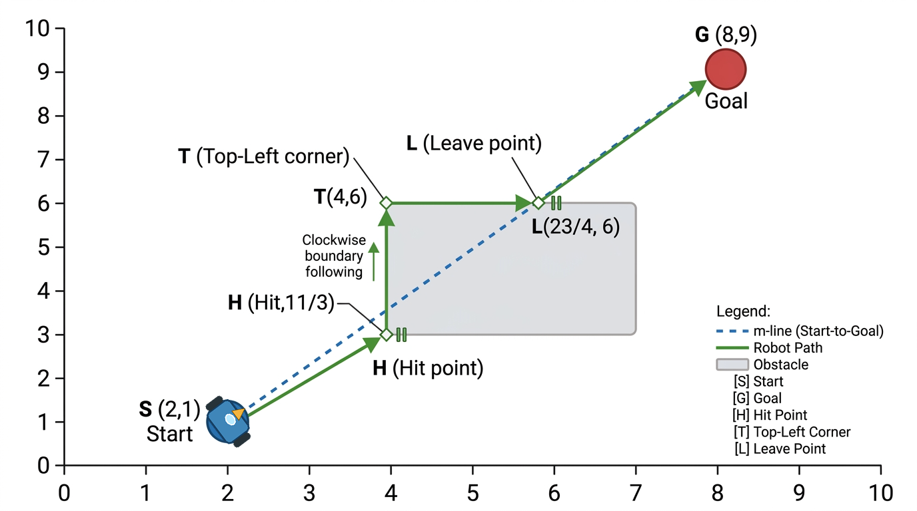
Proposed coordinate-accurate Bug2 diagram for Assignment 1.

Your task
- Set distance_to_hit to the Euclidean distance from S to H.
- Set distance_along_obstacle to H-to-T plus T-to-L.
- Set distance_leave_to_goal to the Euclidean distance from L to G.
- Set total_distance to the sum of those three traveled components exactly once.
distance = sqrt((x2 - x1)^2 + (y2 - y1)^2)

Rules and required outputs
- Treat the fractional coordinates as exact values.
- Follow only H -> T -> L; do not use the full obstacle perimeter.
- Do not change the supplied coordinates or required variable names.
- Required numeric variables: distance_to_hit, distance_along_obstacle, distance_leave_to_goal, and total_distance.

Before you run the tests
- Confirm that each variable is numeric and defined at module level.
- Confirm that total_distance equals the other three values added once.

What this revision improves
- Makes the exact Bug2 route and all point roles explicit.
- Separates traveled boundary segments from the unused obstacle perimeter.
- Defines a coordinate-accurate replacement for the missing instruction image.
Decision requested: Approve, revise, or reject this proposed wording before any application implementation.

