ASSIGNMENT 2 | VERSION 4
Obstacle Avoidance: Bug Algorithm Scenario 2
Current instruction and proposed clearer student-facing revision
Review status: Draft only. No assignment configuration, grader, starter code, image, or application behavior has been changed.

Part 1 - Current instruction
Source: backend/assignments/assignment_2.json, version 4. Formatting is normalized for review; wording is unchanged.
Scenario
A robot travels east along the Bug2 m-line from O(0,0) toward G(10,0). A rectangle blocks the m-line, with corners A(4,-1), B(6,-1), C(6,1), and D(4,1).
Specified Bug2 route
The robot reaches the obstacle at hit point H(4,0). A right turn from its eastward heading sends it toward the lower boundary. It follows H -> A -> B -> L, where the leave point is L(6,0). Point L is back on the m-line and is closer to the goal than H, so the robot leaves the boundary and continues straight to G.
Your task
- Calculate distance_to_obstacle from O to H.
- Calculate distance_along_obstacle as the sum of H-to-A, A-to-B, and B-to-L. Do not use the full rectangle perimeter.
- Calculate distance_from_obstacle_to_goal from L to G.
- Set total_path_length to the sum of those three traveled components.
Use Euclidean distance for each segment. The robot turns at exact points and its size and turning radius are ignored.

Part 2 - Proposed improved instruction

Purpose
Translate a specified Bug2 detour into distance calculations without using the full rectangle perimeter.

Scenario and fixed route
A robot starts at O = (0, 0) and travels east toward G = (10, 0) along the Bug2 m-line. A rectangular obstacle has corners A = (4, -1), B = (6, -1), C = (6, 1), and D = (4, 1).
- Hit point: H = (4, 0).
- Leave point: L = (6, 0).
- Required right-turn route: O -> H -> A -> B -> L -> G.
L is on the m-line and is closer to G than H, so the robot leaves the boundary at L.
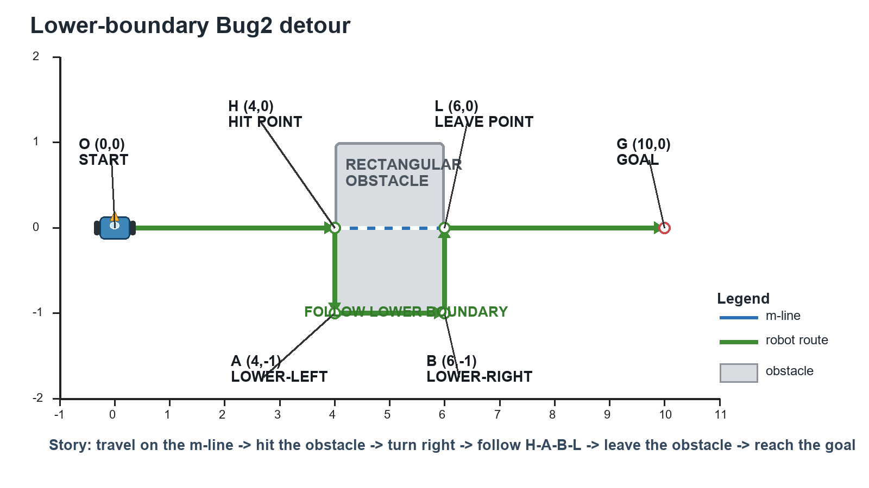
Specified lower-boundary Bug2 route for Assignment 2.

Your task
- Set distance_to_obstacle to the Euclidean distance from O to H.
- Set distance_along_obstacle to H-to-A plus A-to-B plus B-to-L.
- Set distance_from_obstacle_to_goal to the Euclidean distance from L to G.
- Set total_path_length to the sum of those three traveled components exactly once.
distance = sqrt((x2 - x1)^2 + (y2 - y1)^2)

Rules and required outputs
- Follow exactly H -> A -> B -> L. Do not use C, D, the upper boundary, or the full perimeter.
- Treat the robot as a point and ignore its width and turning radius.
- Required numeric variables: distance_to_obstacle, distance_along_obstacle, distance_from_obstacle_to_goal, and total_path_length.

Before you run the tests
- Confirm that the boundary distance contains exactly three segments.
- Confirm that total_path_length contains the approach, boundary, and departure components once each.

What this revision improves
- Uses one unambiguous coordinate layout and route direction.
- Clearly distinguishes the traveled lower boundary from the full perimeter.
- Names every graded variable and its intended path segment.
Decision requested: Approve, revise, or reject this proposed wording before any application implementation.

