ASSIGNMENT 3 | VERSION 5
Autonomous Robot Navigation in a Dynamic Office Environment
Current instruction and proposed clearer student-facing revision
Review status: Draft only. No assignment configuration, grader, starter code, image, or application behavior has been changed.

Part 1 - Current instruction
Source: backend/assignments/assignment_3.json, version 5. Formatting is normalized for review; wording is unchanged.
Scenario
A delivery robot starts at S(5,5) on floor 5 and must reach G(25,30) on floor 10. The main elevator shaft is at E_m(10,5) and the service elevator shaft is at E_s(6,15) on both floors. The robot moves horizontally at 1 meter per second.
Floor 5 routes
- A vertical construction barrier blocks the direct main-elevator route. The required 0.5-meter-clearance detour is explicitly represented by waypoints M1(7.5,4.5) and M2(8.5,4.5). Calculate the main entry path along S -> M1 -> M2 -> E_m.
- The service-elevator base path is the straight segment from S to E_s. A movable obstacle lies on that route, so add a half-circle detour of radius 1 meter: pi * radius.
Elevator and floor 10 routes
- Main elevator: 30-second wait and 15 seconds per floor.
- Service elevator: 10-second wait and 20 seconds per floor.
- Both elevators travel 5 floors.
- After exiting on floor 10, calculate a straight path from that elevator's shaft coordinate to G.
Your task
- Calculate path_to_E_m and path_to_E_s on floor 5.
- Calculate path_from_E_m_to_goal and path_from_E_s_to_goal on floor 10.
- Calculate total_time_via_E_m and total_time_via_E_s. Each total must include floor-5 travel, elevator wait, elevator ride, and floor-10 travel.
- Set best_option to Main Elevator or Service Elevator and set best_time to the corresponding smaller total.
Use Euclidean distance for straight segments. Do not add any obstacle behavior beyond the two specified detours.

Part 2 - Proposed improved instruction

Purpose
Compare two complete multi-floor routes using the same time model for walking, waiting, elevator travel, and destination-floor travel.

Scenario
A delivery robot starts at S = (5, 5) on floor 5 and must reach G = (25, 30) on floor 10. Coordinates are floor positions in meters. The robot travels across each floor at 1 meter per second.
- Main elevator shaft: E_m = (10, 5) on both floors.
- Service elevator shaft: E_s = (6, 15) on both floors.
- Both elevators travel 5 floors.

Two route options
- Main: floor-5 route S -> M1 -> M2 -> E_m, where M1 = (7.5, 4.5) and M2 = (8.5, 4.5); wait 30 seconds; ride 15 seconds per floor; then travel from E_m to G on floor 10.
- Service: straight floor-5 route S -> E_s plus one half-circle detour of radius 1 meter; wait 10 seconds; ride 20 seconds per floor; then travel from E_s to G on floor 10.
half-circle detour = pi * radius
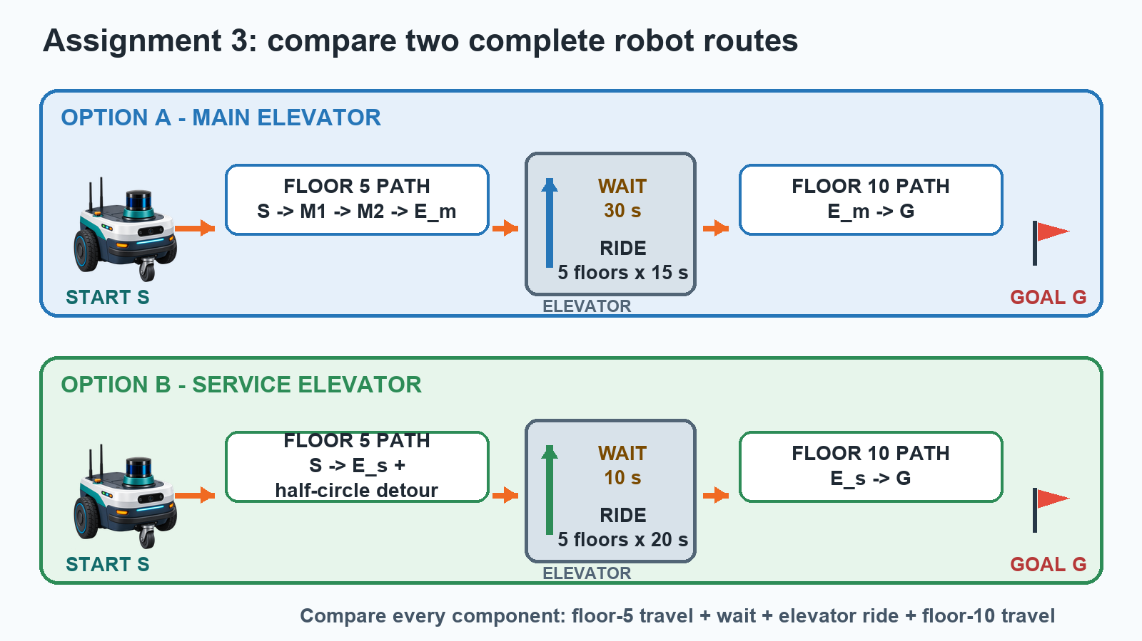
Complete components that must be included in each route comparison.

Your task
- Calculate path_to_E_m using S -> M1 -> M2 -> E_m.
- Calculate path_to_E_s as distance(S, E_s) plus the half-circle detour.
- Calculate path_from_E_m_to_goal and path_from_E_s_to_goal on floor 10.
- Calculate total_time_via_E_m and total_time_via_E_s using every route component.
- Set best_option to the exact label "Main Elevator" or "Service Elevator" for the smaller complete time.
- Set best_time to that same smaller complete time.
total time = floor-5 path / speed + wait + floors * seconds per floor + floor-10 path / speed

Rules and required outputs
- Use Euclidean distance for straight segments and the required waypoints for the main route.
- Add exactly one stated half-circle detour to the service route; do not invent other obstacles.
- Required numeric path and time variables are the six names above; best_option is text and best_time is numeric.

Before you run the tests
- Verify that both totals include floor-5 travel, wait, five-floor ride, and floor-10 travel.
- Verify that best_option and best_time refer to the same route.

What this revision improves
- Defines a single complete time equation for both alternatives.
- Clarifies that elevator coordinates are reused on floor 10.
- Prevents comparison of incomplete route totals.
Decision requested: Approve, revise, or reject this proposed wording before any application implementation.

