ASSIGNMENT 4 | VERSION 4
Calculating Safe Trajectory using Vector Field Histogram (VFH)
Current instruction and proposed clearer student-facing revision
Review status: Draft only. No assignment configuration, grader, starter code, image, or application behavior has been changed.

Part 1 - Current instruction
Source: backend/assignments/assignment_4.json, version 4. Formatting is normalized for review; wording is unchanged.
Scenario
A mobile robot has a 360-degree LIDAR that reports one distance for every integer sector from 0 through 359 degrees. This exercise uses a simplified Vector Field Histogram (VFH): each reading affects only its matching one-degree sector.
Complete LIDAR dataset
The starter code provides the readings for sectors 0, 1, 2, 358, and 359. For every sector angle from 3 through 357, calculate the deterministic simulated distance with 10 + 2 * sin(angle in degrees). In NumPy, use 10 + 2 * np.sin(np.radians(angle)).
Your task
- Complete all missing LIDAR readings using the stated formula.
- For every sector, calculate obstacle density as 1 / distance**2. A smaller density represents a clearer direction.
- The local goal direction is sector 90 degrees. Search the inclusive candidate range from 80 through 100 degrees.
- Set optimal_sector_angle to the candidate with the smallest density and set optimal_sector_value to that sector's density.
Assumptions
- All distances are positive arbitrary units.
- Robot width, safety inflation, smoothing, and dynamic obstacles are outside this simplified exercise.
- The deterministic formula produces a unique minimum-density candidate in the required range, so no tie-break rule is needed.

Part 2 - Proposed improved instruction

Purpose
Generate a complete deterministic LIDAR dataset, convert it to inverse-square obstacle density, and select the clearest sector near the goal direction.

Data model and candidate window
The simplified 360-degree LIDAR contains one distance for each integer sector from 0 through 359 degrees. Each reading affects only its matching one-degree sector.
- Keep the supplied readings for 0, 1, 2, 358, and 359 unchanged.
- Generate every missing integer sector from 3 through 357, inclusive.
distance = 10 + 2 * np.sin(np.radians(angle))
density = 1 / distance**2
A smaller density represents a clearer direction because it corresponds to a larger measured distance.
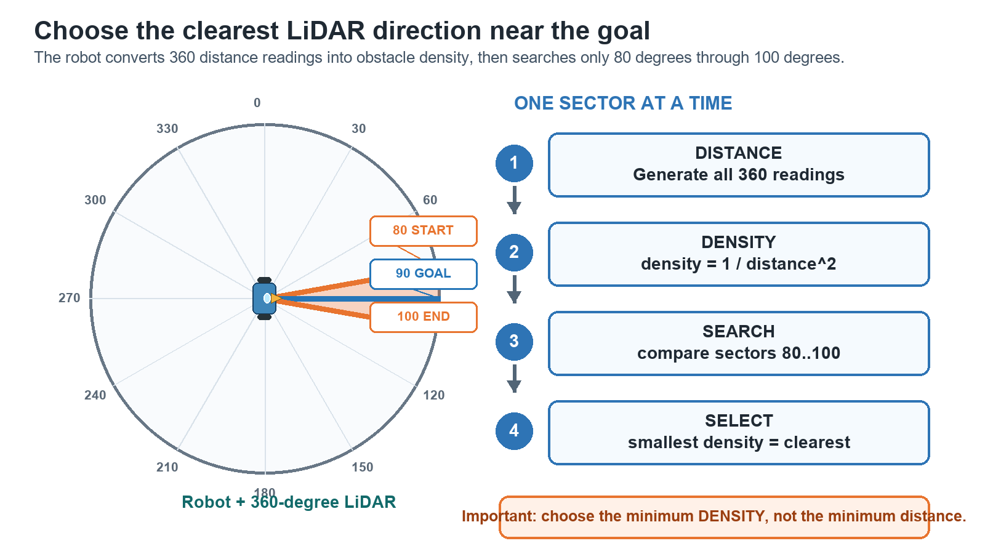
The simplified VFH workflow and inclusive 80-to-100-degree search window.

Your task
- Complete lidar_readings so it contains all 360 integer sectors.
- Build primary_polar_histogram with one inverse-square density for every sector.
- Search every candidate from 80 through 100 degrees, including both endpoints, around the 90-degree goal direction.
- Set optimal_sector_angle to the candidate with the smallest density.
- Set optimal_sector_value to the density stored for that same candidate.

Rules and required outputs
- Select the smallest density, not the smallest distance.
- Do not add smoothing, robot-width inflation, dynamic obstacles, or another VFH stage.
- The deterministic data has one unique best candidate; no tie-break rule is needed.
- Required outputs: optimal_sector_angle as an integer and optimal_sector_value as its numeric density.

Before you run the tests
- Confirm that both dictionaries contain 360 sectors.
- Confirm that optimal_sector_value comes from optimal_sector_angle, not a different sector.

What this revision improves
- Explains why minimum density means the clearest direction.
- Makes all inclusive ranges and unchanged seed readings explicit.
- Separates the selected angle from its associated density value.
Decision requested: Approve, revise, or reject this proposed wording before any application implementation.

