ASSIGNMENT 5 | VERSION 1
Drive Forward and Stop with ROS 2
Current instruction and proposed clearer student-facing revision
Review status: Draft only. No assignment configuration, grader, starter code, image, or application behavior has been changed.

Part 1 - Current instruction
Source: backend/assignments/assignment_5.json, version 1. Formatting is normalized for review; wording is unchanged.
Scenario
You are programming a mobile robot in ROS 2. The robot receives movement commands from the /cmd_vel topic.
Your task
- Create a Twist publisher on /cmd_vel.
- Move forward at 0.20 m/s without rotating.
- Stop after approximately five seconds.
- Continue publishing a zero-velocity command after stopping.
What to edit
Read every file in the project tree, but edit only robot_motion/controller.py and complete the four TODO sections.
Run Tests
The grader builds the ROS package, starts your node, monitors /cmd_vel, and checks its observable behavior. Simulation is not used in this assignment.

Part 2 - Proposed improved instruction

Purpose
Create a ROS 2 node that moves a robot straight forward for a fixed time and then continuously commands a safe stop.

Files and editing rule
Read the complete project tree, but edit only the following file:
src/robot_motion/robot_motion/controller.py
- Do not rename the package, node, executable, topic, class, methods, or starter variables.

Required behavior
- Create a geometry_msgs/msg/Twist publisher on /cmd_vel with queue depth 10.
- On each 0.1-second timer callback, create and publish one Twist command.
- While elapsed_time is less than 5.0 seconds, set linear.x to 0.20 m/s and angular.z to 0.0 rad/s.
- At and after 5.0 seconds, publish zero linear and angular velocity.
- Keep the node running and continue publishing zero velocity after stopping.
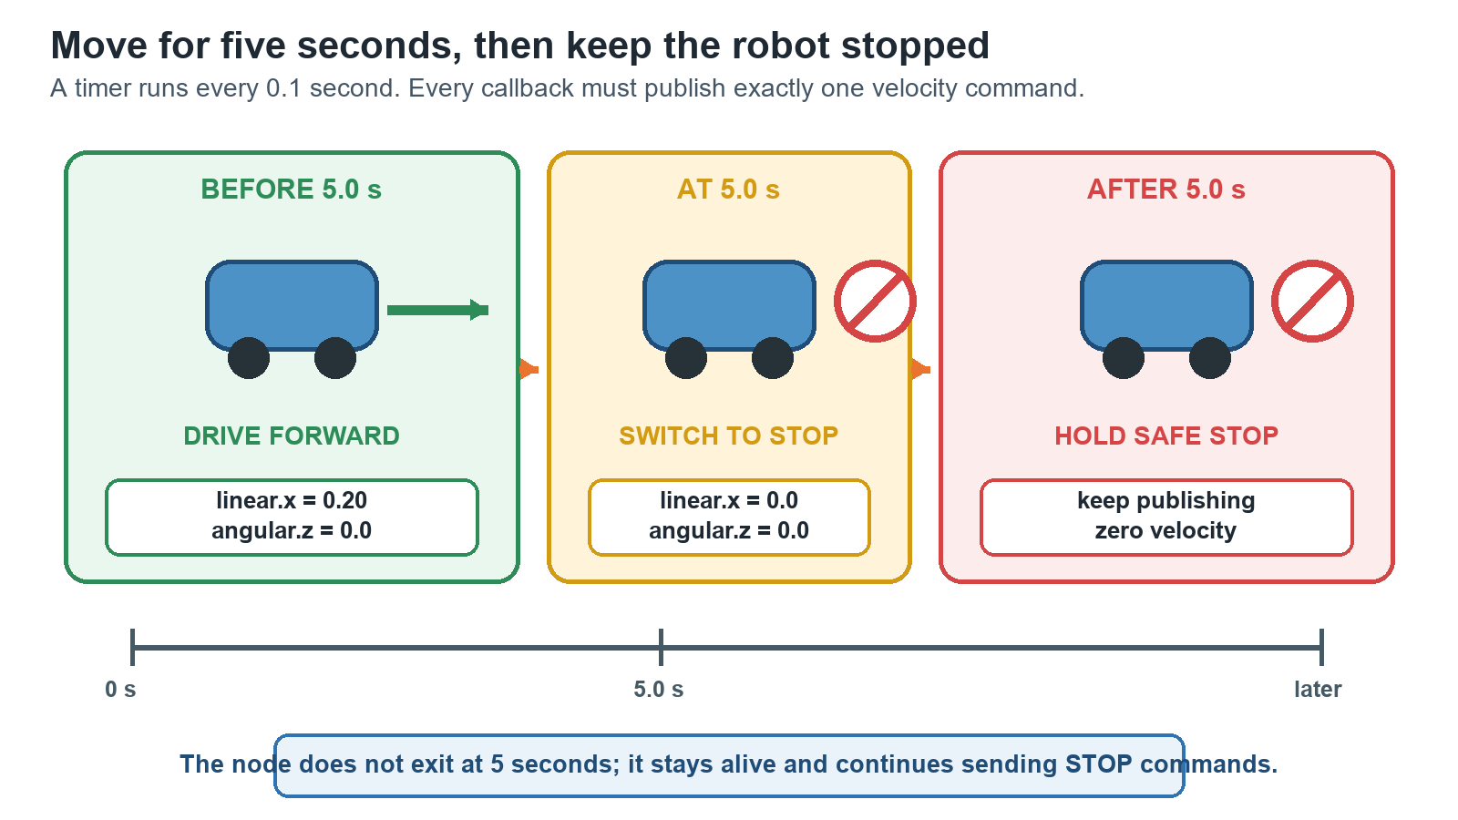
Timer-driven command flow for forward motion followed by a held stop.

Safety requirements
- The robot must move forward without turning.
- Ending the program is not a safe stop; the node must explicitly publish zero velocity.
- Every timer callback must publish exactly one command.

What Run Tests checks
- The package builds and the node starts.
- Twist messages are published on /cmd_vel at a sufficient rate.
- Forward and angular speeds match the required behavior.
- The robot stops after approximately five seconds and remains stopped.
No robot simulator is used in this assignment.

What this revision improves
- Corrects the editable file path to the full ROS package path.
- Defines what a safe, continuously held stop means.
- Connects each TODO to observable ROS topic behavior.
Decision requested: Approve, revise, or reject this proposed wording before any application implementation.

