ASSIGNMENT 6 | VERSION 1
Stop for an Obstacle with ROS 2
Current instruction and proposed clearer student-facing revision
Review status: Draft only. No assignment configuration, grader, starter code, image, or application behavior has been changed.

Part 1 - Current instruction
Source: backend/assignments/assignment_6.json, version 1. Formatting is normalized for review; wording is unchanged.
Scenario
You are programming a mobile robot that receives laser-range readings on /scan and velocity commands on /cmd_vel.
Your task
- Subscribe to sensor_msgs/LaserScan messages on /scan.
- Create a Twist publisher on /cmd_vel.
- Drive straight at 0.20 m/s when the nearest valid scan distance is greater than 0.75 m.
- Publish zero velocity when an obstacle is at or within 0.75 m, or when the scan contains no valid positive distance.
- Resume forward motion when the path becomes clear again.
What to edit
Read every file in the project tree, but edit only reactive_navigation/controller.py and complete the TODO sections.
Run Tests
The grader builds the ROS package, publishes synthetic LaserScan messages, and observes the resulting Twist commands. Simulation is not used in this assignment.

Part 2 - Proposed improved instruction

Purpose
Use LIDAR data to move when the path is clear, stop for a nearby obstacle or invalid data, and resume when the path clears.

Files and editing rule
Read the complete project tree, but edit only the following file:
src/reactive_navigation/reactive_navigation/controller.py
- Do not rename the package, node, executable, topics, class, methods, or starter variables.

Required behavior
- Create a Twist publisher on /cmd_vel with queue depth 10.
- Subscribe to sensor_msgs/msg/LaserScan on /scan and use handle_scan as the callback.
- Keep only scan ranges that are finite and greater than zero; reject NaN, positive or negative infinity, zero, and negative values.
- Find the nearest valid distance. If no valid distance exists, use the fail-safe stop behavior.
- If the nearest valid distance is greater than 0.75 m, publish linear.x = 0.20 m/s.
- If it is 0.75 m or less, or no valid distance exists, publish linear.x = 0.0 m/s.
- Always publish angular.z = 0.0 rad/s and publish one Twist decision for every scan.
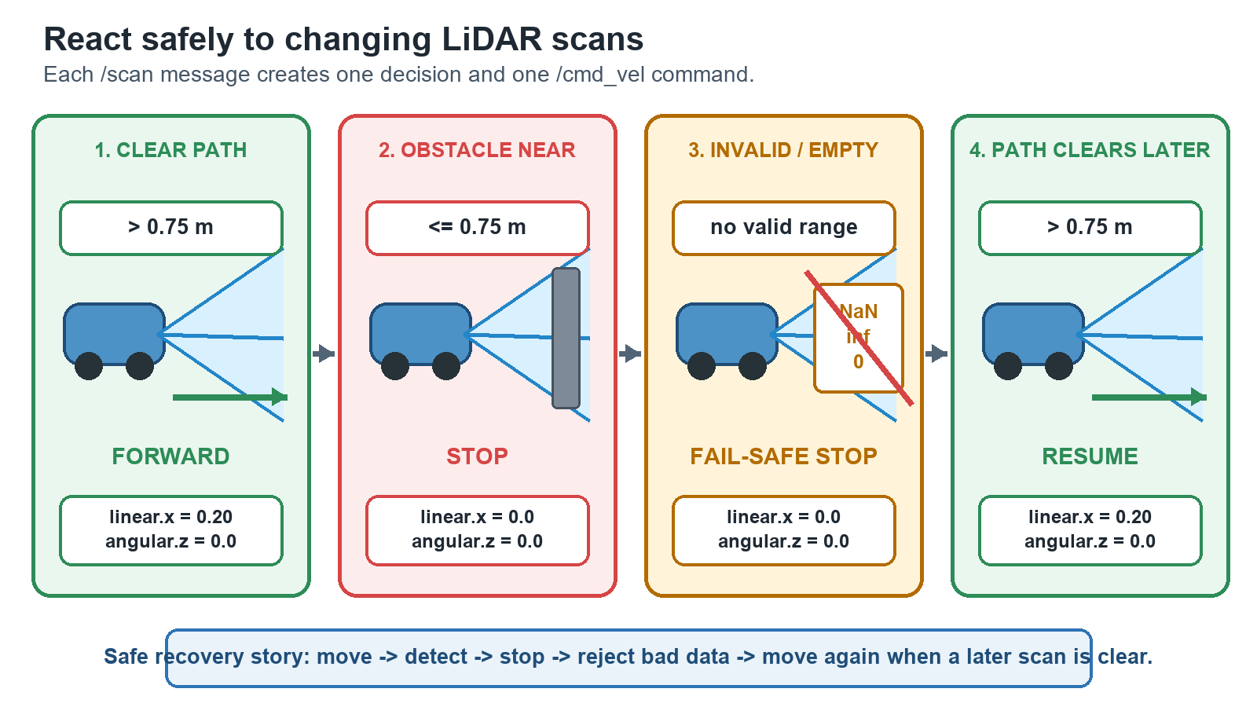
Fail-safe scan-to-velocity decision flow for Assignment 6.

Safety and recovery requirements
- The threshold is inclusive: exactly 0.75 m must stop the robot.
- Invalid sensor data must never cause forward motion.
- A later valid clear scan must automatically resume forward motion.

What Run Tests checks
- The package builds, the node starts, and it responds to /scan.
- Twist messages appear on /cmd_vel.
- Clear, near-obstacle, invalid-scan, straight-motion, and resume behaviors are correct.
The grader publishes synthetic scans and observes velocity commands. No robot simulator is used.

What this revision improves
- Corrects the editable file path to the full ROS package path.
- Defines every invalid LaserScan value and the inclusive stop boundary.
- Makes fail-safe stopping and automatic recovery equally explicit.
Decision requested: Approve, revise, or reject this proposed wording before any application implementation.

