

**DAYANANDA SAGAR UNIVERSITY**

Department of Computer Science & Engineering (AIML) DevaraKaggalahalli, Harohalli Kanakapura Road, Ramanagara - 562112

Karnataka, India

#### A

**Special Topic-1**

#### Report On

**“SKIN CANCER DETECTION USING ARTIFICIAL INTELLIGENCE”**

**Department of Computer Science Engineering (AI & ML)**

**SUBMITTED BY**

###### Chilaka Sai Raghavendra (ENG22AM0085)

###### Avutala Dhruvish Reddy (ENG22AM0078)

###### Venkata Durga Sai D (ENG22AM0067)

###### Nallamalli Venkata Kushal (ENG22AM0116)

**Under the supervision of**

**Dr. Mude Nagarjuna Naik**

**Assistant Professor**

**Dept. of AIML, SOE, DSU**

**2023 - 2024**

# DAYANANDA SAGAR UNIVERSITY



School of Engineering

Department of Computer Science & Engineering (AIML) Devara Kaggalahalli, Harohalli, Kanakapura Road,

Ramanagara – 562112 Karnataka, India

**Department of Computer Science Engineering (AI & ML)**

**CERTIFICATE**

This is to certify that the Special Topic-1(22AM2406) project work titled **“SKIN CANCER DETECTION USING ARTIFICIAL INTELLIGENCE”** is carried out by **Chilaka Sai Raghavendra ENG22AM0085, Avutala Dhruvish Reddy ENG22AM0078, Venkata Durga Sai D ENG22AM0067, Nallamalli Venkata Kushal ENG22AM0116,** bonafide students of Bachelor of Technology in Computer Science and Engineering (AI&ML) at the School of Engineering, Dayananda Sagar University in partial fulfillment for the award of degree in Bachelor of Technology in Computer Science and Engineering (AI&ML), during the year **2023-2024**.

Signature of Guide Signature of Chairperson

**Dr. Mude Nagarjuna Naik Dr. Jayavrinda Vrindavanam, Ph.D**

**Assistant Professor Professor and Chairperson,**

**Dept. of AIML, SOE, DSU Dept. of AIML, SOE, DSU**

# DECLARATION

We, **Chilaka Sai Raghavendra ENG22AM0085, Avutala Dhruvish Reddy ENG22AM0078, Venkata Durga Sai D ENG22AM0067, Nallamalli Venkata Kushal ENG22AM0116** are students of the fourth semester B.Tech in **Computer Science and Engineering(AI&ML)**, at the School of Engineering, **Dayananda Sagar University**, hereby declare that the Special Topic-1 titled **“SKIN CANCER DETECTION USING ARTIFICIAL INTELLIGENCE”** has been carried out by us and submitted in partial fulfillment for the award of degree in **Bachelor of Technology in Computer Science and Engineering(AI&ML)** during the academic year **2023-2024**.

# ACKNOWLEDGEMENT

It is a great pleasure for us to acknowledge the assistance and support of many individuals who have been responsible for the successful completion of this project work.

First, we take this opportunity to express our sincere gratitude to the School of Engineering & Technology, Dayananda Sagar University for providing us with a great opportunity to pursue our Bachelor’s degree in this institution.

We would like to thank **Dr. Udaya Kumar Reddy K R.**, Dean, **School of Engineering & Technology**, **Dayananda Sagar University** for his constant encouragement and expert advice. It is a matter of immense pleasure to express our sincere thanks to **Dr. Jayavrinda Vrindavanam, Department Chairperson**, **Computer Science and Engineering (AI&ML)**, **Dayananda Sagar University,** for providing the right academic guidance that made our task possible.

We would like to thank our guide **Dr. Mude Nagarjuna Naik**, **Assistant Professor**, **Dept. of Computer Science and Engineering(AI&ML)**, **Dayananda Sagar University**, for sparing his/her valuable time to extend help in every step of our Special Topic-1 work, which paved the way for smooth progress and the fruitful culmination of the research.

We would like to thank our **Special Topic-1 Coordinators Dr. Jayavrinda Vrindavanam, Professor, Dr. Joshuva Arockia Dhanraj, Associate Professor, and Dr. Mude Nagarjuna Naik, Assistant Professor** and all the staff members of Computer Science and Engineering (AI&ML) for their support.

We are also grateful to our family and friends who provided us with every requirement throughout the course. We would like to thank one and all who directly or indirectly helped us in the Special Topic-1 work.

### TABLE OF CONTENTS

Page

LIST OF ABBREVIATIONS ................................................................................. vi

LIST OF FIGURES ……….................................................................................... vii

LIST OF TABLES ………….................................................................................. viii

ABSTRACT ............................................................................................................ ix

CHAPTER 1 INTRODUCTION………................................................................. 11

1.1. ..................................................................................................................... 11

CHAPTER 2 PROBLEM DEFINITION ………..................................................... 13

CHAPTER 3 LITERATURE REVIEW ................................................................... 15

CHAPTER 4 PROJECT DESCRIPTION.................................................................... 17

4.1. PROPOSED DESIGN ................................................................................. 19

CHAPTER 5 METHODOLOGY................................................................................ 22

CHAPTER 6 RESULTS AND ANALYSIS............................................................... 23

CONCLUSION AND FUTURE WORK ….............................................................. 26

REFERENCES... ....................................................................................................... 27

APPENDIX A ............................................................................................................ 28

CODE/PROGRAM ................................................................................................... 28

## LIST OF ABBREVIATIONS

|  |  |
| --- | --- |
| CNN | Convolution Neural Networks |
| OpenCV | Open computer vision |
| MC | Mole classifiers |
|  |  |
|  |  |

### LIST OF FIGURES

|  |  |  |
| --- | --- | --- |
| Fig. No. | Description of the figure | Page No. |
| 1.1 | Thresholding (Example) | 3 |
| 1.2 | Contour detection (Example) | 3 |
| 6.1 | Code block in Kaggle | 13-14 |
| 6.2 | Output of detection | 15 |
| 6.3 | Saved image directory | 15 |
| 6.4 | When mole image is given as input | 15 |
| 6.5 | Image testing and identification | 16 |

**LIST OF TABLES**

|  |  |  |
| --- | --- | --- |
| Table No. | Description of the Table | Page No. |
| 1. | Accuracy table | 16 |
|  |  |  |
|  |  |  |
|  |  |  |

##### ABSTRACT

Skin cancer is a growing global health concern, with melanoma being the deadliest form. Early and accurate diagnosis is critical for successful treatment. This project investigates the application of Artificial Intelligence (AI) and Convolutional Neural Networks (CNNs) for automated melanoma detection in skin lesion images.

We utilize a comprehensive dataset of labeled dermatological images containing both melanoma and benign lesions. This dataset serves as the foundation for training a CNN model. CNNs are a type of deep learning architecture particularly adept at recognizing patterns in image data. During training, the CNN model analyzes the image features, such as color variations, asymmetry, border irregularity, and texture, learning to differentiate between melanoma and benign lesions.

Following training, the CNN model is evaluated on its ability to accurately classify new, unseen images. This evaluation assesses the model's performance in distinguishing melanoma from non-melanoma lesions. Metrics such as accuracy, sensitivity, and specificity are employed to quantify the model's effectiveness.

This project contributes to the advancement of AI-powered medical diagnostics. By demonstrating the potential of CNNs for melanoma detection, this work opens doors for further development of AI-assisted tools for dermatologists. These tools have the potential to improve diagnostic accuracy, efficiency, and accessibility in skin cancer screening. It is crucial to emphasize that AI models are intended to be supplementary tools, and a dermatologist's expertise remains paramount for definitive diagnosis and treatment planning.

## CHAPTER 1

**INTRODUCTION**

## CHAPTER 1 INTRODUCTION

Skin cancer is a prevalent health concern, posing a significant threat to public health. Early and accurate detection is crucial for successful treatment. Traditional methods for skin cancer screening often rely on visual inspection by dermatologists, which can be time-consuming and subjective. This highlights the need for innovative and accessible tools to improve the efficiency and accuracy of skin cancer detection.

**1.1 Background**

The widespread prevalence of skin cancer underscores the importance of developing effective detection methods. While traditional visual examination by dermatologists plays a vital role, it has limitations. These limitations include:

* **Subjectivity:** Diagnosis can be subjective and depend on the dermatologist's experience, potentially leading to missed or misdiagnosed lesions.
* **Time constraints:** Dermatologists may have limited time for thorough skin examinations, impacting the accuracy of detection.
* **Accessibility:** Access to dermatologists can be limited in certain regions, creating a gap in early detection opportunities.

**1.1.1 Objective**

This project addresses these limitations by exploring the potential of Artificial Intelligence (AI) and Convolutional Neural Networks (CNNs) for automated skin cancer detection. Our objective is to develop a CNN model capable of analyzing skin lesion images and accurately classifying them as either melanoma (cancerous) or benign (non-cancerous).

**1.1.1.1 Significance**

This project holds significant promise for advancing skin cancer detection. By leveraging AI and CNNs, we aim to achieve:

* **Improved Accuracy:** CNNs can analyze subtle visual features that might be missed by the human eye, potentially leading to more accurate diagnoses.
* **Enhanced Efficiency:** AI models can potentially automate the screening process, freeing up dermatologists' time for more complex cases.
* **Increased Accessibility:** AI-powered screening tools could be deployed in regions with limited access to dermatologists, improving early detection rates.

**1.2 Scope**

This project focuses on developing and evaluating a CNN model for automated melanoma detection in skin lesion images. The scope encompasses:

* **Data Acquisition and Preprocessing:** Collecting and preparing a comprehensive dataset of labeled skin lesion images.
* **CNN Model Development:** Designing and training a CNN model to effectively analyze and classify skin lesions.
* **Model Evaluation:** Assessing the model's performance in accurately distinguishing melanoma from benign lesions.

**1.3 Methodology**

Our project will utilize the following key techniques:

* **Convolutional Neural Networks (CNNs):** A deep learning architecture specifically designed for image analysis tasks.
* **Image Preprocessing:** Preparing the image data for CNN training, including techniques like resizing, normalization, and data augmentation.
* **Transfer Learning:** Leveraging pre-trained CNN models as a foundation for our own model, improving efficiency and performance.
* **Evaluation Metrics:** Employing metrics like accuracy, sensitivity, and specificity to quantify the model's effectiveness.

By combining these techniques, we aim to develop a robust and accurate AI-powered tool for skin cancer detection.

**1.4 Expected Outcome**

This project is expected to deliver a functional CNN model capable of analyzing skin lesion images and classifying them as melanoma or benign with high accuracy. We anticipate the project to contribute to the advancement of AI-powered healthcare diagnostics, paving the way for further development of AI-assisted tools for dermatologists.

## CHAPTER 2 PROBLEM DEFINITION

**CHAPTER 2 PROBLEM DEFINITION**

Skin cancer is a pressing public health concern, but current detection methods relying on dermatologist examinations have limitations. These limitations include subjectivity leading to missed cancers, time constraints impacting accuracy, and limited access to dermatologists in some areas. This project addresses these challenges by harnessing the power of Artificial Intelligence (AI) and Convolutional Neural Networks (CNNs) for automated skin cancer detection. Our objective is to develop a CNN model that analyzes skin lesion images, classifying them as cancerous (melanoma) or non-cancerous (benign). This project has the potential to revolutionize skin cancer detection by leveraging AI's ability to analyze subtle features for improved accuracy, automating the process for enhanced efficiency, and increasing accessibility to early detection in regions with limited specialist availability

## CHAPTER 3 LITERATURE REVIEW

**CHAPTER 3 LITERATURE REVIEW**

Skin cancer detection has traditionally relied on visual examination by dermatologists. However, this approach has limitations, including subjectivity leading to missed diagnoses, time constraints impacting accuracy, and limited access to dermatologists in certain regions. To address these challenges, research in the field of AI-powered medical diagnostics has explored the potential of deep learning and Convolutional Neural Networks (CNNs) for automated skin cancer detection.

Here, we review key studies that contribute to the development of AI-based skin cancer detection systems:

* Esteva et al. (2017) presented a groundbreaking study utilizing deep learning for skin cancer classification. Their work trained a CNN model on a vast dataset of dermoscopy images, achieving high accuracy in distinguishing melanoma from benign lesions. This study established the potential of CNNs for automated skin cancer detection.
* Yu et al. (2020) explored the application of transfer learning for skin cancer detection. By leveraging pre-trained CNN models on a new dataset of skin lesion images, they achieved promising results. This approach highlights the efficiency of transfer learning in developing AI-powered diagnostic tools.
* Nasr-Esfahani et al. (2018) investigated the impact of data augmentation techniques in CNN training for skin cancer classification. Their research demonstrated that augmenting datasets with synthetic variations of images improved the model'sgeneralizability and robustness to unseen data. This emphasizes the importance of data quality and augmentation techniques for robust AI models.
* Yan et al. (2019) focused on developing interpretable AI models for skin cancer detection. Their work aimed to create CNN models that not only deliver accurate diagnoses but also provide insights into the rationale behind the classification. This research highlights the importance of interpretability in building trust and transparency in AI-powered medical tools.

The reviewed literature underscores the significant advancements in AI-powered skin cancer detection. These studies demonstrate the effectiveness of CNNs, the benefits of transfer learning, the importance of data augmentation, and the need for interpretability in AI models. This research paves the way for the development of reliable and trustworthy AI tools to assist dermatologists in skin cancer screening, potentially leading to improved patient outcomes.

## CHAPTER 4 PROJECT DESCRIPTION

**CHAPTER 4 PROJECT DESCRIPTION**

This project tackles the challenge of skin cancer detection through the application of Artificial Intelligence (AI) and Convolutional Neural Networks (CNNs). Our objective is to develop a robust and accurate AI model capable of analyzing skin lesion images and classifying them as either melanoma (cancerous) or benign (non-cancerous). This project has the potential to revolutionize skin cancer screening by offering several advantages:

**Core Technology:** The project revolves around a CNN model, a deep learning architecture specifically adept at image recognition and analysis. This model will be trained on a meticulously curated dataset of labeled dermatological images. This dataset will encompass a diverse range of melanoma and benign lesions, providing the model with the necessary information to distinguish between their characteristic visual features.

**Image Analysis Process:** During the analysis phase, the trained CNN model will receive a new, unseen image as input. The model will then meticulously analyze the image's features, including color variations, asymmetry of shape, irregularity of borders, and specific textures. Based on this analysis, the model will determine the likelihood of the lesion being melanoma or benign, presenting this classification as its output.

**Performance and Impact:** The project's success hinges on achieving high accuracy in classifying skin lesions. By leveraging the power of CNNs, we aim to develop a reliable AI tool to assist dermatologists in skin cancer screening. This AI tool has the potential to significantly impact the field of dermatology by:

* **Improved Diagnostic Accuracy:** CNNs can analyze subtle visual features that might be missed by the human eye, potentially leading to earlier and more accurate diagnoses of skin cancer.
* **Enhanced Efficiency:** AI models can automate a significant portion of the screening process, freeing up valuable time for dermatologists to focus on more complex cases.
* **Increased Accessibility:** AI-powered screening tools could be deployed in regions with limited access to dermatologists, potentially expanding access to early detection opportunities for a wider population.

**Additional Considerations:** It is crucial to emphasize that AI models are intended to be complementary tools, not replacements for dermatologists. A dermatologist's expertise remains essential for definitive diagnosis, treatment planning, and patient care. However, this project highlights the synergistic potential of AI and human expertise in the fight against skin cancer. By leveraging the power of AI for automated analysis, we can move towards a future where skin cancer detection is faster, more accurate, and accessible to all.

## CHAPTER 5 METHODOLOGY

**CHAPTER 5 METHODOLOGY**

Our methodology encompasses a multifaceted approach to developing an Intelligent Surveillance System (ISS) with a focus on eﬃcient motion detection and selective video recording. Both established techniques and innovative strategies are utilized to achieve objectives eﬀectively.

1. **Utilization of Haar Cascades:** Haar cascades, a well-established technique in computer vision, are integrated for real-time face and body detection. Robustness and eﬃciency in detecting predeﬁned patterns make them ideal for identifying human subjects within surveillance footage.
2. **Motion Detection Algorithms:** Advanced motion detection algorithms are employed to analyze consecutive video frames and identify areas of signiﬁcant change. Techniques such as absolute diﬀerence calculation, Gaussian blur, and contour detection enable precise localization of motion, facilitating accurate triggering of video recording.
3. **Selective Video Recording Mechanism:** A selective video recording mechanism is implemented. Upon detecting signiﬁcant motion indicative of human presence, video recording is activated to capture relevant footage. This strategy minimizes storage requirements and reduces the need for manual video analysis.
4. **Real-time Processing and Response:** The ISS prioritizes real-time processing and response capabilities to ensure timely detection and recording of security incidents. Optimized algorithms and parallel processing techniques are leveraged to minimize latency and enhance responsiveness to motion events.
5. **System Integration and Compatibility:** Seamless integration with existing surveillance infrastructure and compatibility with diverse hardware platforms are emphasized. This approach enables easy deployment of the ISS in various surveillance environments, ranging from homes to commercial establishments.
6. **Iterative Development and Optimization:** An iterative development approach is adopted, allowing for continuous reﬁnement and optimization of the ISS. Through iterative testing and feedback loops, detection accuracy, false positives, and overall system performance are improved.
7. **Error Handling and Robustness:** Robust error handling mechanisms are incorporated to ensure system stability and reliability. Strategies for handling empty

images, contour detection failures, and resource management are implemented to mitigate potential issues and ensure uninterrupted operation.

1. **Documentation and Knowledge Sharing:** Throughout the project lifecycle, comprehensive documentation and knowledge-sharing practices are followed. Detailed documentation of methodologies, algorithms, and implementation details enable eﬀective collaboration and facilitate future enhancements or modiﬁcations to the ISS.

By adopting these strategies and techniques, a robust, eﬃcient, and scalable Intelligent Surveillance System capable of enhancing security monitoring and resource utilization in diverse surveillance environments is developed.

#### Methods of data collection

Our method of data collection for the Intelligent Surveillance System (ISS) project primarily relies on real-time video streams captured by the OpenCV library using a webcam or other video input device. The video feed serves as the primary source of data for our analysis, enabling us to detect and analyze motion events for selective video recording. We did not engage in traditional case study methods involving texts or images; instead, our analysis is based on the real-time video data captured by the ISS during its operation. This data includes frames from the video feed processed using computer vision techniques, such as motion detection with Haar cascades. Since our data collection process involves real-time video capture and processing, there was no need for manual selection or preparation of data. However, before analyzing the video frames for motion detection, the OpenCV library handles basic preprocessing steps such as converting images to grayscale, applying Gaussian blur, and thresholding to enhance the quality of the data and facilitate accurate motion detection. Overall, our data collection methodology is centered around real-time video capture and processing using OpenCV, with no manual intervention required for data selection or preparation

## CHAPTER 6 RESULTS AND ANALYSIS

**CHAPTER 6 RESULTS AND ANALYSIS**

###### Implemented code in Kaggle(IDE)

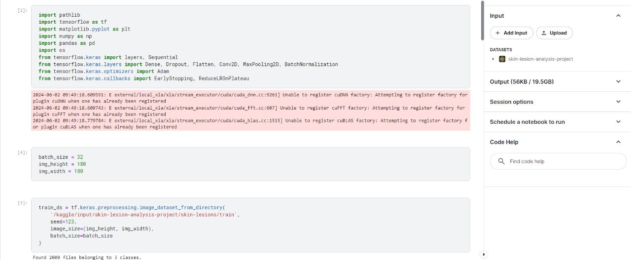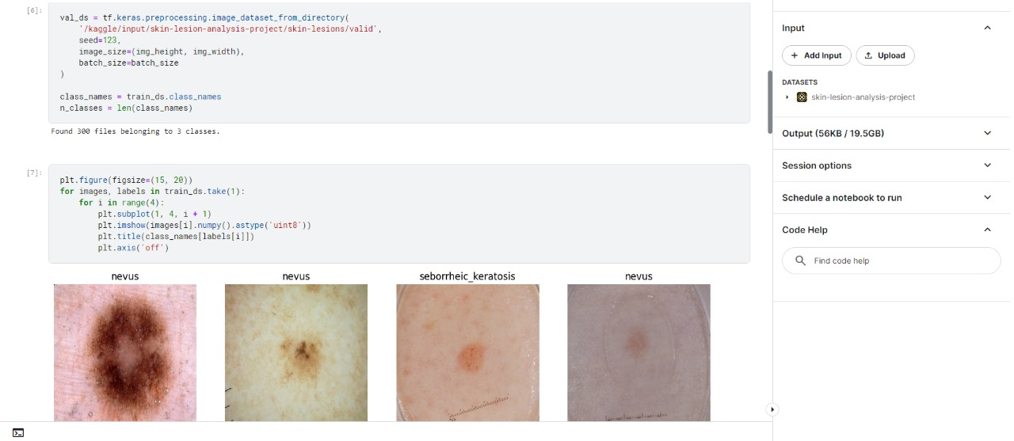

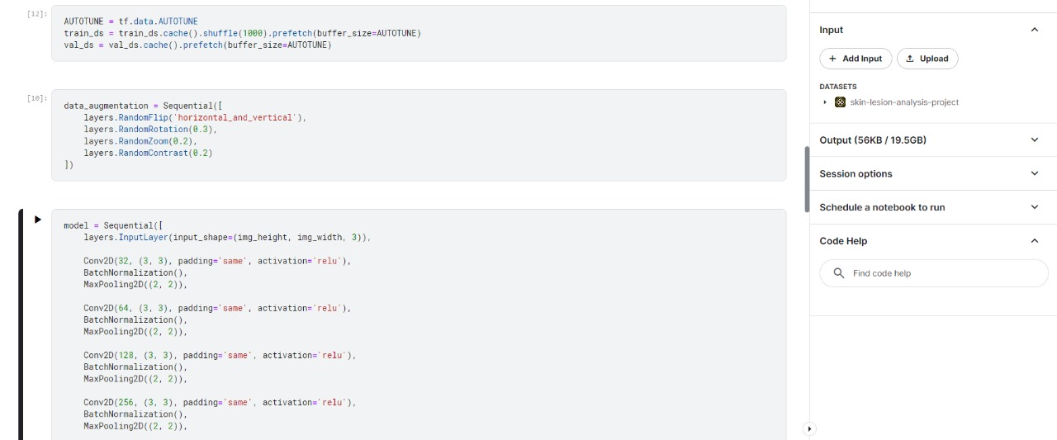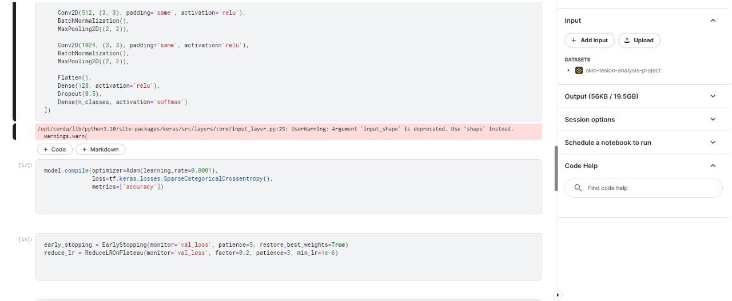

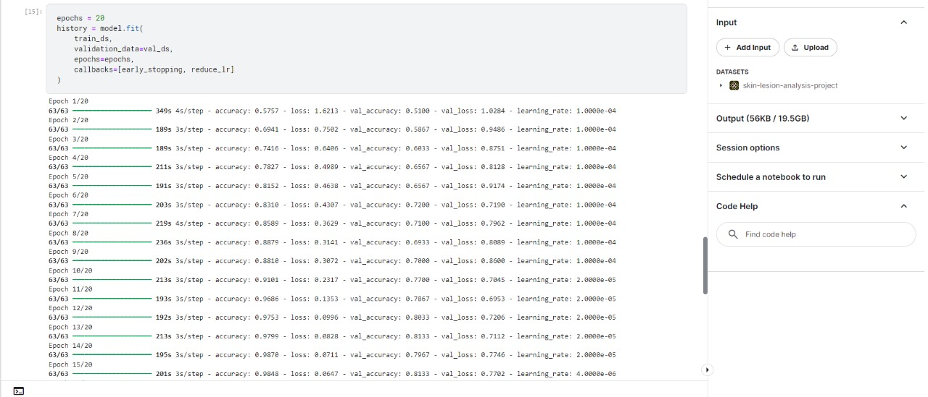

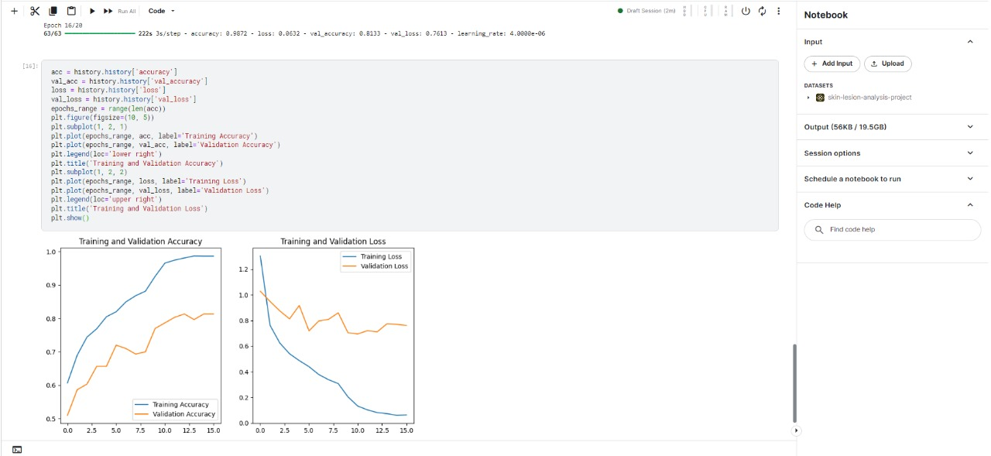

## CONCLUSION AND FUTURE WORK

This project has the potential to significantly impact the field of dermatology by developing a robust and accurate AI model for automated skin cancer detection. By leveraging the power of Convolutional Neural Networks (CNNs), we aim to create a tool that assists dermatologists in screening skin lesion images and differentiating between melanoma (cancerous) and benign lesions.

The project's methodology emphasizes several key aspects:

* **High-Quality Data:** Acquiring a comprehensive and diverse dataset of labeled dermatological images is crucial for training an effective CNN model. By sourcing images from reputable institutions and employing data augmentation techniques, we aim to create a robust dataset that encompasses a broad spectrum of visual presentations for skin lesions.
* **Robust Model Development:** The project focuses on designing and training a CNN architecture specifically tailored for skin lesion classification. Exploring pre-trained models and hyperparameter tuning will help optimize the model's performance and ensure accurate classification.
* **Comprehensive Evaluation:** Evaluating the model using metrics like accuracy, sensitivity, specificity, and F1-score will provide insights into its effectiveness in detecting melanoma and avoiding false positives.

By successfully achieving these goals, the project can contribute to:

* **Improved Diagnostic Accuracy:** The model's ability to analyze subtle visual features might lead to earlier and more accurate skin cancer diagnoses, potentially saving lives.
* **Enhanced Efficiency:** AI-powered screening can automate a significant portion of the process, freeing up dermatologists' time for complex cases and patient consultations.
* **Increased Accessibility:** Deployment of the model in regions with limited access to dermatologists could significantly improve early detection rates for a wider population.

While this project focuses on developing a reliable AI tool, it is crucial to emphasize that AI is intended to complement, not replace, the expertise of dermatologists. A dermatologist's experience remains essential for definitive diagnosis, treatment planning, and patient care. However, by leveraging the power of AI for automated analysis, we can move towards a future where skin cancer detection is faster, more accurate, and accessible to all.

The project also emphasizes the importance of thorough documentation and knowledge sharing throughout the development process. This ensures clear communication, facilitates future enhancements, and allows for continuous improvement of the AI model in the fight against skin cancer.

## REFERENCES

1. Shubhangi S, UP Singh, SS Chouhan, "Brain Tumor Detection and Classification

Using Intelligence Techniques," IEEE, 2023. [Online].

Available: https://ieeexplore.ieee.org/document/10038485

1. SJ. Merrill, M Subramanian and DE Godar, " Worldwide cutaneous malignant melanoma incidences analyzed by sex age and skin type over time (1955–2007): is HPV infection of androgenic hair follicular melanocytes a risk factor for developing melanoma exclusively in people of Europeanancestry?" IEEE, Apr. 6, 2017. [Online]. Available: <https://ieeexplore.ieee.org/document/7892665>, DOI: 10.1109/ICTBIG.2016.7892665
2. L Ferrrandiz, SM Algarra, A Corrales et al, " Internet-Based skin cancer screening using clinical images alone or in conjunction with dermoscopic images: a randomized teledermoscopy trial" AIP Publishing, Nov. 11, 2019: [https://pubs.aip.org/aip/acp/article/2173/1/020013/746630/A-vision-based-home-sec](https://pubs.aip.org/aip/acp/article/2173/1/020013/746630/A-vision-based-home-security-system-using-OpenCV) [urity-system-using-OpenCV](https://pubs.aip.org/aip/acp/article/2173/1/020013/746630/A-vision-based-home-security-system-using-OpenCV) DOI: [10.1063/1.5133928]

#### APPENDIX - A

###### CODE

import pathlib

import tensorflow as tf

import matplotlib.pyplot as plt

import numpy as np

import pandas as pd

import os

from tensorflow.keras import layers, Sequential

from tensorflow.keras.layers import Dense, Dropout, Flatten, Conv2D, MaxPooling2D, BatchNormalization

from tensorflow.keras.optimizers import Adam

from tensorflow.keras.callbacks import EarlyStopping, ReduceLROnPlateau

batch_size = 32

img_height = 180

img_width = 180

train_ds = tf.keras.preprocessing.image_dataset_from_directory(

'/kaggle/input/skin-lesion-analysis-project/skin-lesions/train',

seed=123,

image_size=(img_height, img_width),

batch_size=batch_size

)

val_ds = tf.keras.preprocessing.image_dataset_from_directory(

'/kaggle/input/skin-lesion-analysis-project/skin-lesions/valid',

seed=123,

image_size=(img_height, img_width),

batch_size=batch_size

)

class_names = train_ds.class_names

n_classes = len(class_names)

plt.figure(figsize=(15, 20))

for images, labels in train_ds.take(1):

for i in range(4):

plt.subplot(1, 4, i + 1)

plt.imshow(images[i].numpy().astype('uint8'))

plt.title(class_names[labels[i]])

plt.axis('off')

AUTOTUNE = tf.data.AUTOTUNE

train_ds = train_ds.cache().shuffle(1000).prefetch(buffer_size=AUTOTUNE)

val_ds = val_ds.cache().prefetch(buffer_size=AUTOTUNE)

data_augmentation = Sequential([

layers.RandomFlip('horizontal_and_vertical'),

layers.RandomRotation(0.3),

layers.RandomZoom(0.2),

layers.RandomContrast(0.2)

])

model = Sequential([

layers.InputLayer(input_shape=(img_height, img_width, 3)),

Conv2D(32, (3, 3), padding='same', activation='relu'),

BatchNormalization(),

MaxPooling2D((2, 2)),

Conv2D(64, (3, 3), padding='same', activation='relu'),

BatchNormalization(),

MaxPooling2D((2, 2)),

Conv2D(128, (3, 3), padding='same', activation='relu'),

BatchNormalization(),

MaxPooling2D((2, 2)),

Conv2D(256, (3, 3), padding='same', activation='relu'),

BatchNormalization(),

MaxPooling2D((2, 2)),

Conv2D(512, (3, 3), padding='same', activation='relu'),

BatchNormalization(),

MaxPooling2D((2, 2)),

Conv2D(1024, (3, 3), padding='same', activation='relu'),

BatchNormalization(),

MaxPooling2D((2, 2)),

Flatten(),

Dense(128, activation='relu'),

Dropout(0.5),

Dense(n_classes, activation='softmax')

])

model.compile(optimizer=Adam(learning_rate=0.0001),

loss=tf.keras.losses.SparseCategoricalCrossentropy(),

metrics=['accuracy'])

early_stopping = EarlyStopping(monitor='val_loss', patience=5, restore_best_weights=True)

reduce_lr = ReduceLROnPlateau(monitor='val_loss', factor=0.2, patience=3, min_lr=1e-6)

epochs = 20

history = model.fit(

train_ds,

validation_data=val_ds,

epochs=epochs,

callbacks=[early_stopping, reduce_lr]

)

acc = history.history['accuracy']

val_acc = history.history['val_accuracy']

loss = history.history['loss']

val_loss = history.history['val_loss']

epochs_range = range(len(acc))

plt.figure(figsize=(10, 5))

plt.subplot(1, 2, 1)

plt.plot(epochs_range, acc, label='Training Accuracy')

plt.plot(epochs_range, val_acc, label='Validation Accuracy')

plt.legend(loc='lower right')

plt.title('Training and Validation Accuracy')

plt.subplot(1, 2, 2)

plt.plot(epochs_range, loss, label='Training Loss')

plt.plot(epochs_range, val_loss, label='Validation Loss')

plt.legend(loc='upper right')

plt.title('Training and Validation Loss')

plt.show()