À / To : Frédéric Andraud, Frédéric Alfonsi, Aude Espesset
DE / From : Luc Maisonobe
COPIE / Copy : Nicolas Frouvelle, Régis Patrier
DATE / Date : 2014-06-10
RÉF. / Ref. : CSSI / 111-1/LM/14.188
OBJET / Subject : Computing contribution of Digital Elevation Model to sensor swath

Context
This memo is a preliminary design document for a new Orekit add-on. The new feature lies at the boundary between space flight dynamics (which is traditional Orekit scope) and observing mission products processing.
As an observing spacecraft is orbiting a roughly ellipsoidal celestial body, the pixels of its optical sensors observe different points on the body surface. As of Orekit version 6.1, the locations of these points can only be computed considering the body shape as a perfect one axis ellipsoid, defined by its equatorial radius and flattening. An example of such an ellipsoid is the WGS-84 ellipsoid, widely used today. However, the exact physical surface is not a true ellipsoid but has topographic features like mountains or valleys, which have some latitude and longitude dependent elevation above the geoid. The geoid itself also has a latitude and longitude dependent elevation above (or below) the reference ellipsoid.
Depending on location on Earth, the height differences between physical surface and geoid can be from a few hundreds negative offset (Dead Sea shore) to a few thousand meters positive offset for mountains.
Depending on location on Earth, the height differences between geoid and ellipsoid can be from about -106m to about +85m. The order of magnitudes of these height differences are far larger than the order of magnitude of Earth projected pixels sizes, which are of meter or tens of meters size as of 2014. This implies that computing the mapping between surface features and pixels must take these height differences (geoid and topography) into account. Computing the mapping using only a simple ellipsoidal model is not sufficient for modern observing missions.

Architecture
The architecture of the feature is tailored in order to be consistent with Orekit scope: a general library without any mission-specific parts. As the accurate geometric correction requires mission-specific data (like calibration of all pixels line of sight), some parts of the correction will remain out of scope, but some other low level algorithms are general enough to be included in a reusable library. As such a library is not pure space flight dynamics, it is set up as an intermediate level library that depends on Orekit.
The global architecture is therefore to have a top level image processing dealing only with lines and pixels, an interface layer that will load the mission specific data (sensors orientation, digital elevation model …), the mission independent Rugged library computing the mapping between pixels and ground surface, and the existing pair of libraries Orekit and Apache Commons Math for raw computation. Figure 1 shows the global architecture of the various layers and how they call each other.
This architecture allows both the image processing application and the mission specific interface to be as independent as possible from space flight dynamics and geometry. These parts can therefore be implemented by image processing specialists. The application itself can even be written in a programming language as C++, there is no need for the Java language at this level. It is expected that the mission specific interface is written using the Java language to simplify data exchanges with the lower layers and avoid complex data conversion. Data conversion is performed only between the image processing application and the interface layer, and is limited to very few high level functions with few primitive types (raw arrays for pixels or ground coordinates).
Figure 1: Libraries architecture
The Rugged library is developed in the Java language and has full access to the Orekit and Apache Commons Math libraries. It is designed and developed by space flight dynamics and geometry specialists, with support from the image processing specialists for the API definition.
The following table sorts out the various topics between the various layers.
Topic | Layer | Comment
Sensor to ground mapping | Rugged | Direct localization is the base feature provided
Ground to sensor mapping | Rugged | Inverse localization is another base feature provided
Individual pixels | Rugged | The API supports any number of pixels, defined by their individual line of sight provided by caller
Optical path | Interface | The folded optical path inside the spacecraft is taken into account by computing an overall transform combining all inside reflections, so each pixel position and line of sight can be computed later on by a single translation and rotation with respect to spacecraft center of mass
Line  time-stamping | Interface/Rugged | The caller must provide a simple time-stamping model (typically linear) that will be applied
Orbit and attitude interpolation | Orekit | Both simple interpolation from timestamped position samples and full orbit propagation are available, thanks to Orekit streamlined propagator architecture
CCSDS Orbit/Attitude file parsing | Orekit | This is supported as long as standard CCSDS Orbit Data Message (CCSDS 502.0-B-2) and CCSDS Attitude Data Messages (CCSDS 504.0-B-1) are used
Custom Orbit/Attitude file parsing | Interface | Custom files can be loaded by mission specific readers, and the list or orbit/attitude states can be provided to Orekit which is able to handle interpolation from these sample data
Frames transforms | Orekit | Full support to all classical reference inertial and Earth frames is already provided by Orekit (including the legacy EME2000, MOD, TOD, but also the more modern GCRF, ICRF, TIRF or exotic frames like TEME or Veis1950, as well as several versions of ITRF)
IERS data correction | Orekit | All frame transforms support the full set of IERS Earth Orientation Parameters corrections, including of course the large DUT1 time correction, but also the smaller corrections to older IAU-76/80 or newer IAU-2000/2006 precession nutation models as well as the polar wander. The frames level accuracy is at sub-millimeter level
Grid-post elevation model | Rugged | Only raster elevation models are supported
Triangulated Irregular Network elevation model | Not supported | If vector elevation models are needed, they must be converted to raster form in order to be used
Geoid computation | Not in version 1 | The first version only supports Digital Elevation Models computed with respect to a reference ellipsoid. If needed, this feature could be added after version 1, either at Rugged or Orekit level, using Orekit gravity fields
Time-dependent deformations | Interface/Rugged | The caller must supply a simple line-of-sight model (typically polynomial) that will be applied
Calibration | Image processing or interface | The calibration phase remains at the mission-specific caller level (pixels geometry, clock synchronization …), the caller is required to provide the already calibrated line of sights
DEM file parsing | Interface | The elevation models are dedicated to the mission and there are several formats (DTED, GeoTIFF, raw data …).  Rugged only deals with raw elevation on small latitude/longitude cells

Technical choices

Earth frames
As Rugged is built on top of Orekit and Apache Commons Math, all the flight dynamics and mathematical computation are delegated to these two libraries and the full accuracy available is used. This implies for example that when computing frames conversions between the inertial frame and the Earth frame, the complete set of IERS Earth Orientation Parameters (EOP) corrections is applied if the IERS files are available. This may lead to results slightly different from the one produced by some other geometry correction libraries that are limited to the older equinox-based paradigm (Mean Of Date and True Of Date), apply only DUT1 and pole wander corrections and ignore the other Earth Orientation Parameters corrections. The expected difference with such libraries is due to the missing corrections (δΔε and δΔψ for equinox-based paradigm) to the IAU-1980 precession (Lieske) and nutation (Wahr) models used in the legacy MOD and TOD frames. The error is a combination of an offset, a global drift and several periodic terms. This error was small in the 80's but is much higher now as it has reached the 3 meters level since mid-2013. The error is steadily increasing, as the old precession and nutation models are not accurate enough for current needs and are drifting with respect to real Earth motion.
These legacy models are very old and not recommended anymore by IERS since 2003. IERS also currently still provides the correction for these models, but there is no guarantee they will do so indefinitely, as they are now providing corrections with respect to newer and more accurate models. The newer frames are based on a non-rotating origin paradigm and on different precession and nutation models (IAU-2000/2006), which are much more accurate. The corresponding corrections (δx/δy, not to be confused with the x_{p}/y_{p} pole wander) are smaller because the precession and nutation models are better than the former ones.
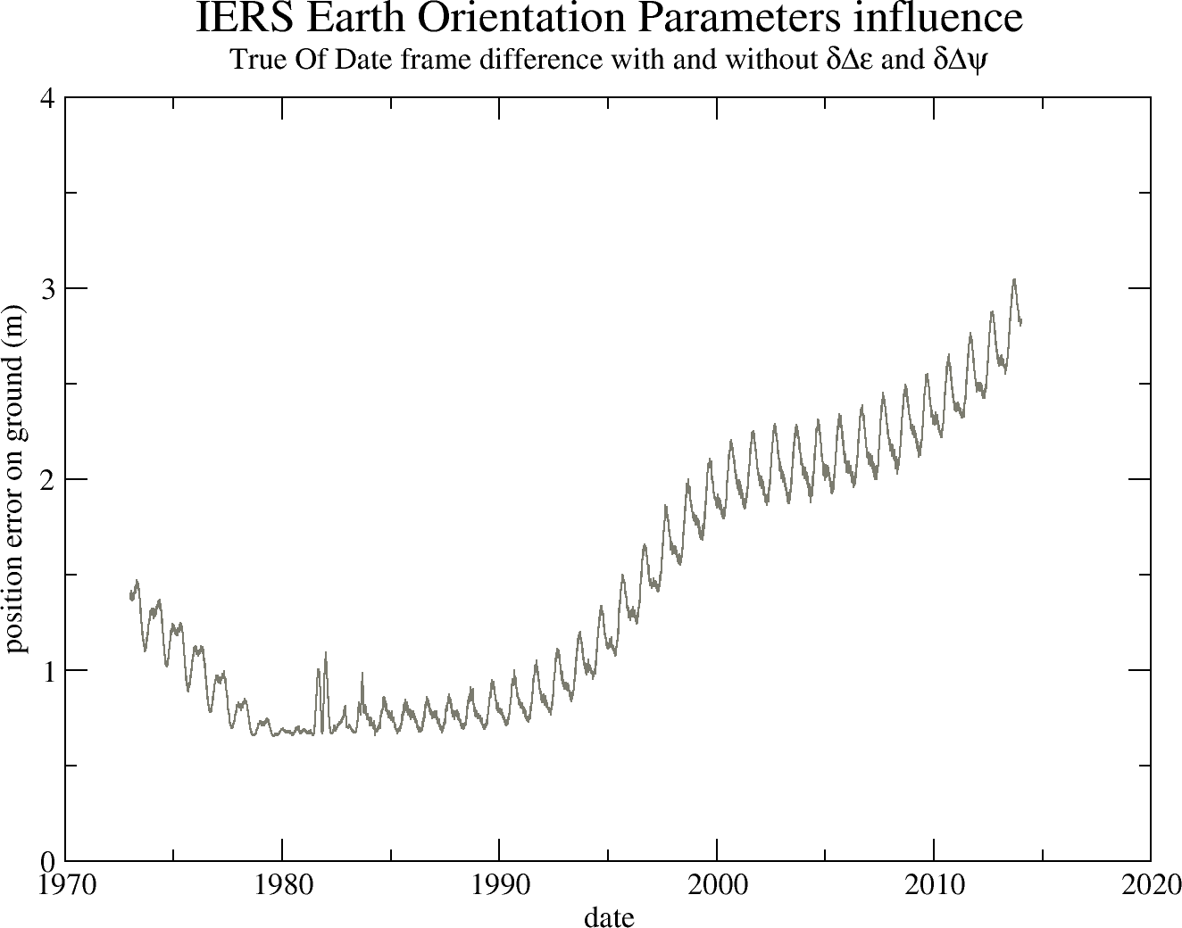Figure 2: Error introduced by ignoring δΔε and δΔψ corrections
As Rugged delegates computation to Orekit, the full set of corrections (DUT1, pole wander, lod, δΔε/δΔψ or δx/δy) are automatically loaded and applied. The final accuracy obtained when all EOP are considered is at sub-millimeter level in position, and the expected difference with libraries ignoring δΔε and δΔψ is at a few meters level, Rugged being the more accurate one.
Rugged is not limited to the legacy MOD and TOD frames and can use the newer IERS recommended frames as well. From a user perspective, this is completely unnoticeable as user simply selects an Earth frame as an existing predefined object by name, and doesn't have to care about the transforms and corrections. In fact at Rugged level there is not even a notion of precession, nutation or EOP corrections. The only interfaces used are the inertial and Earth frames and the date. From these three elements, Orekit computes all geometrical transform, including both the theoretical motion models and the IERS corrections, thus greatly leveraging the computation.
As a summary, the solution we propose may give results slightly more accurate than other geometric correction libraries, and is compatible with both the legacy frames and the newer frames.

Position and attitude
The global geometry of the image depends on the spacecraft position and attitude. Both are obtained using any Orekit provided propagators. Thanks to the architecture of the Orekit propagation framework, propagation can be either a true propagation from an initial state (which is interesting in mission analysis and simulation use cases) or can be an interpolation from a loaded ephemeris. From the caller point of view, there are no differences between the two cases, as an ephemeris is a special case of propagator, using interpolation from its loaded sample. Support for CCSDS-based ephemerides is already provided by Orekit, and it is possible to build ephemerides from lists of states if a dedicated loader is developed to parse mission-specific files.
When ephemeris interpolation is selected as the underlying propagator, the number of points used for the interpolation is specified by the user, so simple linear model is possible but higher degree interpolation is available. The interpolation retains the raw state format, so if an ephemeris contains circular orbital parameters, interpolation will be done using these parameters whereas if ephemeris contains position and velocity, interpolation will be done using position and velocity.
Dedicated algorithms are implemented in Orekit to deal with quaternions interpolation. Direct polynomial interpolation of the four quaternion components does not work reliably, and even less if only linear interpolation is performed, even if normalization is used afterwards. Orekit uses a method based on Sergeï Tanygin's paper “Attitude interpolation” with slight changes to use modified Rodrigues vectors as defined in Malcolm D Shuster's “A Survey of Attitude Representations”, despite attitude is still represented by quaternions in Orekit (Rodrigues vectors are used only for interpolation). These changes avoid a singularity at π. Some other refinements have been added to also avoid another singularity at 2π, but these refinements are mostly useful for either spin-stabilized spacecrafts with high rotation rate or for interpolation over large time spans when the attitude spans over more than a full turn, so they will probably not be triggered in the context of Earth observation spacecrafts.
The different interpolation scheme is however expected to lead to only very small differences in numerical accuracy in the traditional cases, because the step size used for the quaternion are often very small. The bad behavior of linear interpolation of quaternion components appears only for step sizes above one minute.
As a summary, the solution we propose relies on either propagation or interpolation at user choice, and attitude interpolation is much more sophisticated than linear interpolation of quaternion components, but no differences are expect at this level, except for simpler development and validation as everything is readily implemented and validated in Orekit.

Optical path

Inside spacecraft
At spacecraft level, the optical path is folded due to the various reflections and positions of the sensors with respect to the spacecraft center of mass. This path is considered fixed in spacecraft frame, i.e. no time-dependent or thermal deformation effects are considered. Following this assumption, the path can be virtually unfolded using the laws of optical geometry and replaced by a straight line in spacecraft vicinity, with virtual pixels locations and lines of sights defined by simple vectors with respect to the center of mass. As both position and orientation are considered, this implies that the pixels are not considered exactly co-located with the spacecraft center of mass, the offset is typically of meter order of magnitude. If for example we consider a 3m long spacecraft with an instrument is on the front (+X), the offset would be about 1.5m if center of mass were at spacecraft mid-length.
This path unfolding is done once at geometry loading by the interface layer above the Rugged library, so all further computation are done with simple straight lines. Of course, if the spacecraft definition file does not include position informations, only the various reflections are taken into account and the location of the sensor is co-located with spacecraft center of mass.

Free space travel
As pixel/ground mapping is computed, all intermediate geometric computation (attitude, orbit, precession, nutation, EOP corrections, Earth rotation, pole wander) are combined into a couple of accurate Transform instances. These transforms are then applied a few thousand times to convert every pixels line-of-sight in Earth frame. The reason for this computation scheduling is that the transform between inertial frame and Earth frame is computing intensive and only depends on date, so factoring it out of the pixels loop is a huge speed-up. As Orekit provides a way to combine several Transform instances together first and apply them to positions and directions later, a lot of computation steps can be saved by also including all conversions up to spacecraft frame.
As observation satellites are about 800km above ground, the light coming from the ground points they look at left Earth about 2.7ms before arriving on the sensors. This implies that the exact position of the ground point must be computed at an earlier time than the position of the spacecraft. The expected difference can be predicted as the rotation of Earth during the 2.7ms light travel time, it is about 1.2m at equator, in the East-West direction. This effect is compensated by applying the so-called light-time correction.
Figure 3: Light-time correction
The delay is computed for each pixel as the travel time is shorter for pixels looking in the nadir direction than for pixels looking at the edge of field of view. As Orekit frame transforms automatically include a local Taylor expansion of the transform, compensating the differential Earth rotation during this 2.7ms delay is done without recomputing the full precession/nutation model, so the computation savings explained in the paragraphs above are still available when this compensation is applied.
Aberration of light is another phenomenon that must be considered. Aberration of light is the apparent shift in direction of an incoming light when seen from a sensor that is itself moving. This shift is independent of the motion of the source of the light, it depends only on the current velocity of the sensor at time of arrival. It is a composition of two velocities, the velocity of light and the velocity of sensor. This composition can be computed simply in classical mechanics or with a slightly more complex equation with relativistic effects. As spacecraft velocities are limited, classical mechanics is sufficient for accurate correction. This effect is a large one and can correspond to up to a 20m shift once projected on ground for classical Earth observing missions.
As shown in figure 4, from spacecraft point of view, the light incoming from the ground point seems to come from a fictitious point “ahead” of the real point.
As a side note, aberration of light and light time correction can be linked or considered to be two aspects of a similar phenomenon, even in classical (non-relativistic) physics. It depends on the frame in which we look at the various elements. If the source is moving and the observer is at rest (i.e. we do the computation in the observer frame), then there is only light time correction and aberration of light is zero. If the source is at rest and the observer is moving (i.e. we do the computation in source frame), then there is only aberration of light (this is how aberration of light was first experimentally identified, in the context of astronomy, considering the motion of Earth from where astronomers observe stars) and light time correction is zero. In the Rugged context, both source and observer move with respect to the inertial frame into which we do the correction computation: the source moves due to Earth rotation, the observer moves due to spacecraft orbit. So in Rugged context, both phenomenoms exist and should be compensated. Some other systems may consider only one of the two phenomena and produce accurate results, simply by computing the correction in either Earth or spacecraft frame and considering the motion of the other part as a relative motion combining both Earth and spacecraft: it is really only a matter of point of view.
Figure 4: Aberration of light
Both light-time correction and aberration of light correction are applied in the Rugged library for greater accuracy, but both can be ignored (independently) at user choice. One use case for ignoring these important correction is for validation purposes and comparison with other libraries that do not take this correction into account. This use case is by definition restricted to validation phases and should not apply to operational systems. Another use case for ignoring light-time correction and aberration of light correction occurs when the effect is explicitely expected to be compensated at a later stage in the image processing chain, most probably using a posteriori polynomial models. This use case can occur in operational products. It seems however better to compensate these effects early as they can be computed to full accuracy with a neglectible computation overhead.

Arrival on ellipsoid
Once a pixel line-of-sight is known in Earth frame, computing its intersection with a reference ellipsoid is straightforward using an instance of OneAxisEllipsoid. The Orekit library computes this intersection as a GeodeticPoint instance on the ellipsoid surface.
The line-of-sight is a straight line in the Cartesian 3D space, and once converted to geodetic coordinates (latitude, longitude, altitude), it is not a straight line anymore. Assuming line-of-sight remains a straight line in this space and can be defined by computing only two points introduces yet another error, which is transverse to line-of-sight and reaches its maximum value roughly at middle point. This assumption is a flat-body assumption, i.e. it correspond to locally approximating the ellipsoid to its tangential plane. The error is the sagitta due to the bending of the real line-of-sight in the geodetic space.
This error depends on the diving angle of the line-of-sight with respect to local vertical. It is zero for a diving angle of 90 degrees (i.e. a pure nadir line-of-sight) and increases as the diving angle decreases. It can reach tremendous values (hundreds of meters or more) for almost tangential observations. Figure 5 shows the amplitude of the error as a function of both the diving angle and the azimuth of the observation. It was computed for a ground point at intermediate latitude (about 54 degrees North, in Poland), and using the two base points for the line-of-sight segment at 8000 meters altitude and -400 meters altitude.
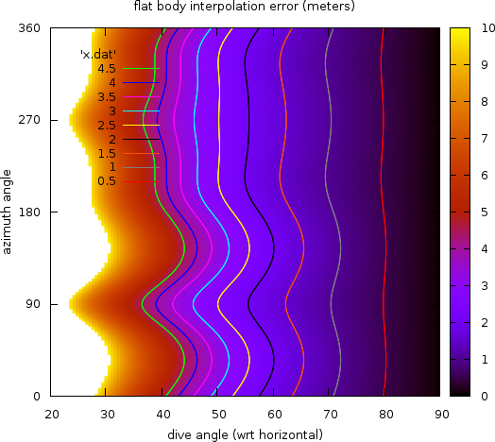Figure 5: Straight line-of-sight error
The Rugged library fully computes the shape of the line-of-sight throughout its traversal of the Digital Elevation Model when the Duvenhage algorithm (see next section) is used for DEM intersection. For testing purposes, another version of the algorithm assuming flat-body hypothesis is also available (i.e. it consider the line-of-sight is a straight line in latitude/longitude/altitude coordinates) but its use is not recommended. The computing overhead due to properly using ellipsoid shape is of the order of magnitude of 3%, so ignoring this on the sake of performances is irrelevant.

Errors compensation summary
The following table summarizes the error compensations performed in the Rugged library which are not present in some other geometry correction libraries:
origin | amplitude | location | comment
δΔε and δΔψ corrections for precession and nutation models | > 3m | horizontal shift | up-to-date precession and nutation models are also available
quaternion interpolation | negligible | line-of-sight direction | the effect is important for step sizes above 1 minute
instrument position | 1.5m | along track | coupled with attitude
light time correction | 1.2m | East-West | pixel-dependent
aberration of light | 20m | along track | depends on spacecraft velocity
flat-body | 0.8m | across  line-of-sight | error increases a lot for large fields of view

DEM intersection
The previous section explained how Rugged goes from an on-board pixel line-of-sight to a ground-based line-of-sight arrival in the vicinity of the ellipsoid entry point. At this step, we have a 3D line defined near the surface and want to compute where it exactly traverses the Digital Elevation Model surface. There is no support for this computation at Orekit library level, everything is done at Rugged library level.
As this part of the algorithm represents an inner loop, it is one that must use fast algorithms. Depending on the conditions (line-of-sight skimming over the terrain near field of view edges or diving directly in a nadir view), some algorithms are more suitable than others. This computation is isolated in the smallest programming unit possible in the Rugged library and an interface is defined with several different implementations among which user can select.
Three different algorithms are predefined in Rugged:
- a recursive algorithm based on Bernardt Duvenhage's 2009 paper “Using An Implicit Min/Max KD-Tree for Doing Efficient Terrain Line of Sight Calculations ”,
- an alternate version od Duvenhage algorithm using flat-body hypothesis,
- a basic scan algorithm sequentially checking all pixels in the rectangular array defined by Digital Elevation Model entry and exit points,
- a no-operation algorithm that ignores the Digital Elevation Model and uses only the ellipsoid.
It is expected that other algorithms like line-stepping (perhaps using Bresenham line algorithm) will be added afterwards.
The Duvenhage algorithm with full consideration of the ellipsoid shape is the baseline approach for operational computation. The alternate version of Duvenhage algorithm with flat-body hypothesis does not really save anything meaningful in terms of computation, so it should only be used for testing purposes. The basic scan algorithm is only intended as a basic reference that can be used for validation and tests. The no-operation algorithm can be used for low accuracy fast computation needs without changing the complete data product work-flow.

DEM loading
As the min/max KD-tree structure is specific to the Duvenhage algorithm, and as the algorithm is hidden behind a generic interface, the tree remains an implementation detail the user should not see. The min/max KD-tree structure is therefore built directly at Rugged level, only when the Duvenhage algorithm has been selected to perform localization computation.
On the other hand, Rugged is not expected to parsed DEM files, so the algorithm relies on the raw data being passed by the upper layer. In order to pass these data, a specific callback function is implemented in the mission specific interface layer and registered to Rugged, which can call it to retrieve parts of the DEM, in the form of small cells. The implicit KD-tree is then built from leafs to root and cached.

Preliminary design

Overview
The top level design describes the various libraries and their interactions. The lowest level corresponding to the Apache Commons Math library is not shown here for clarity.
The following sequence and class diagrams show the three most important functions: initialization of the libraries, direct localization and inverse localization.
The user of the Rugged library is responsible to provide its main program and a mission specific Digital Elevation Model loader, in the form of a class implementing Rugged TileUpdater interface. He also creates a LineSensor containing the geometry of the pixels line-of-sights. He then creates an instance of the top-level Rugged class and provides it the created objects as well as its selection of options for algorithm, ellipsoid and frame choices.
The Rugged instance will store everything and create the various objects defining the configuration (creating the algorithm, ellipsoid and frames from the identifiers provided by the user. Using simple enumerates for frames or ellipsoid allow a simpler interface for regular users who are not space flight dynamics experts. For expert use, the user can also create these objects directly and pass them to Rugged if the predefined identifiers do not cover his needs. As shown in figure 7, several line sensors can be added to a single Rugged instance, this is intended to compute correlation grid, when images coming from two different sensors are expected to be accurately combined.
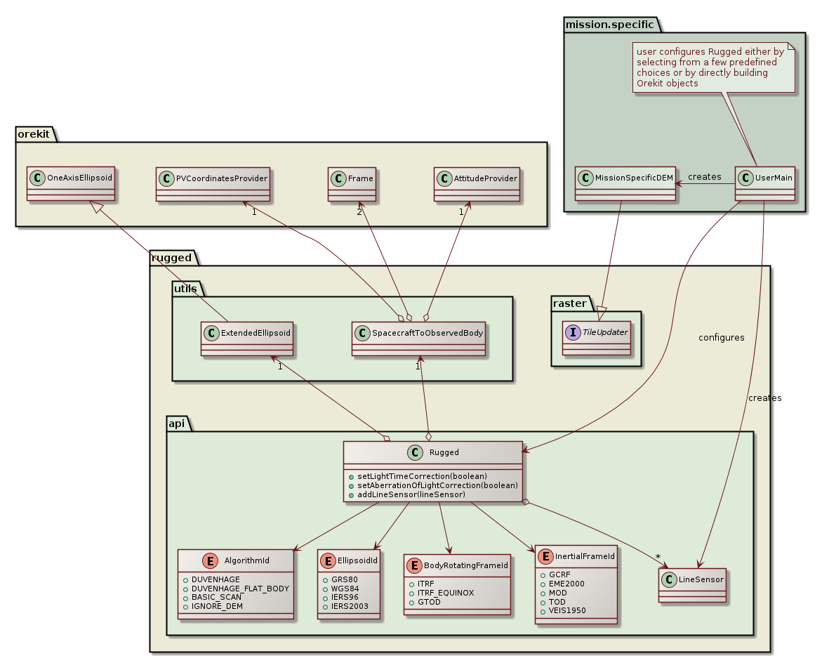Figure 6: Initialization class diagram
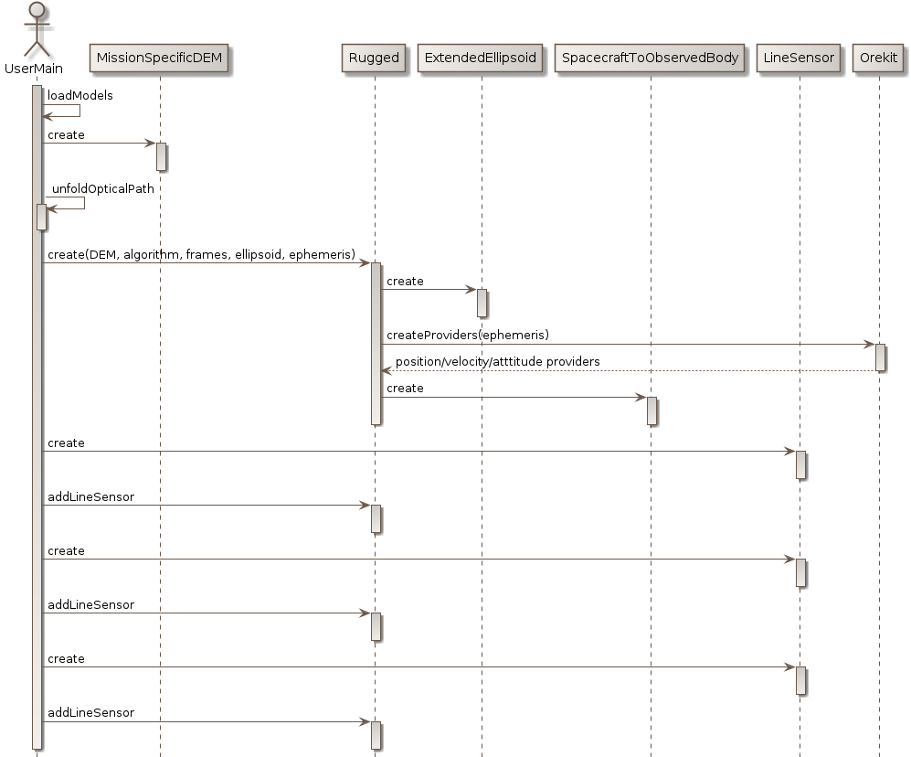Figure 7: Initialization sequence diagram
Direct localization is called a large number of times by the application, once for each sensor line. The application only provides image processing related data to the configured Rugged instance, i.e. the line number, and it expects the geodetic coordinates of the ground points corresponding to each pixels in the sensor line. The Rugged instance will delegate conversions between frames to an internal SpacecraftToObservedBody converter, the conversions between Cartesian coordinates and geodetic coordinates to an internal ExtendedEllipsoid object, and the computation of the intersection with the Digital Elevation Model to the algorithm that was selected by user at configuration time.
The pixels independent computation (orbit and attitude interpolation, Earth frame to inertial frame transforms, transforms composition) are performed only once per date inside the caching combined transform provider set up at initialization time and the resulting transform is applied for all pixels in the line, thus saving lot of computing power.
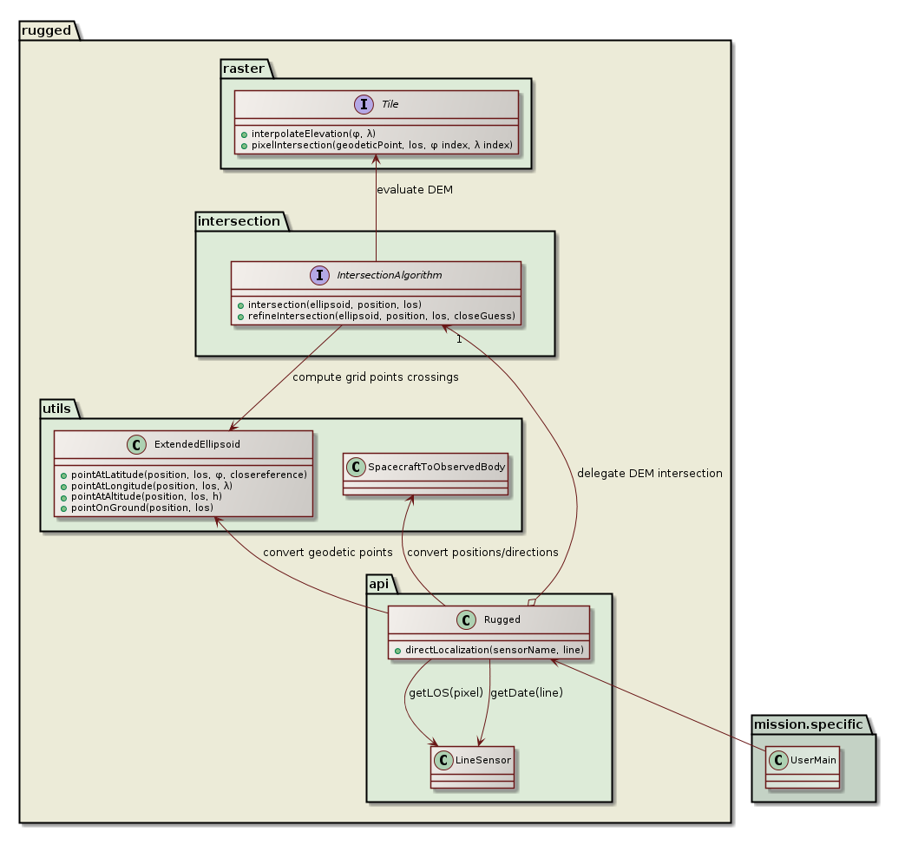Figure 8: Direct localization class diagram
The innermost loop is the correction of each pixel, which is split in the line-of-sight to ellipsoid intersection, and followed by the Digital Elevation Model intersection. The callback to the mission specific interface to retrieve DEM raw data is called from the inner loop but is expected to be triggered only infrequently thanks to a caching feature done at Rugged library level.
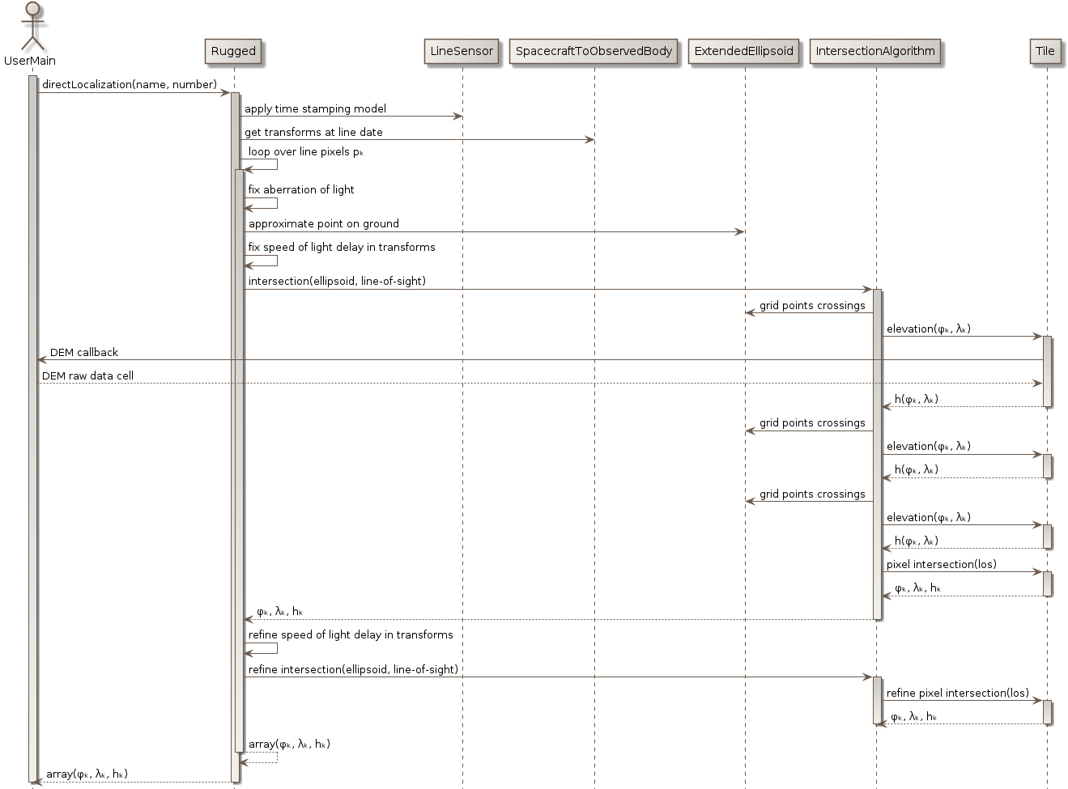Figure 9: Direct localization sequence diagram
Figure 10 describes the algorithm used for tile selection and how the underlying intersection algorithm (Duvenhage in this example) is called for one tile:
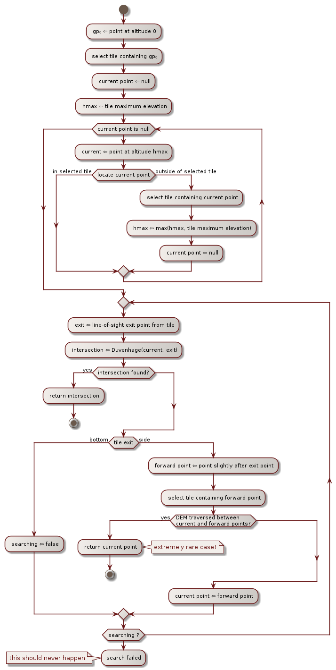Figure 10: Tile selection and intersection call

The recommended Digital Elevation Model intersection algorithm is the Duvenhage algorithm. Figure 11describes how it is implemented in the Rugged library.
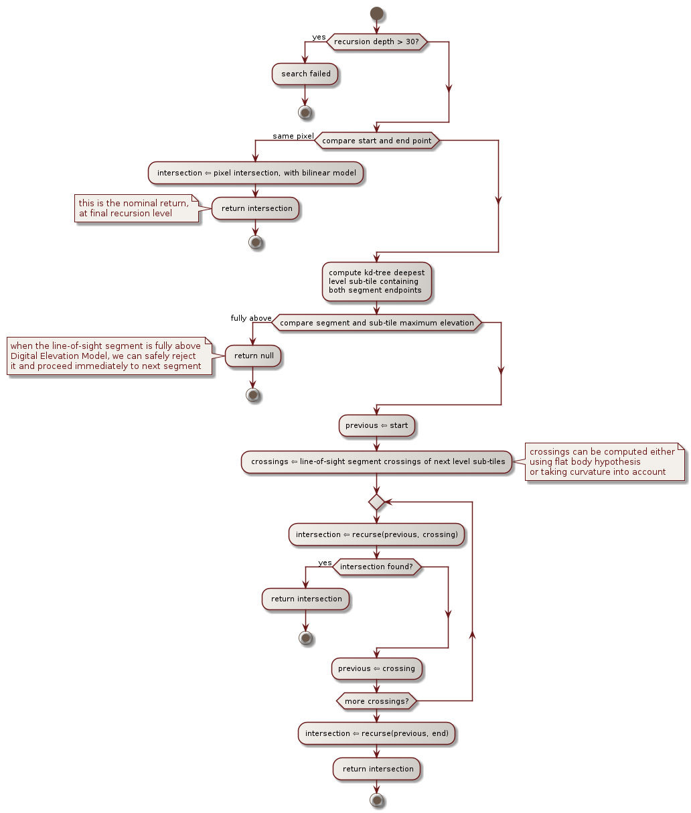Figure 11: Recursive Duvenhage algorithm
Inverse localization is called a large number of times by the application, typically on a regular grid in some geographic reference like UTM. The application only provides image processing related data, i.e. the geodetic coordinates of the ground points and expects the coordinates of the corresponding pixel (both line number of pixel number). The pixels independent computation (orbit and attitude interpolation, Earth frame to inertial frame transforms, transforms composition) are performed only once per line and cached across successive calls to inverse localization, thus greatly improving performances.
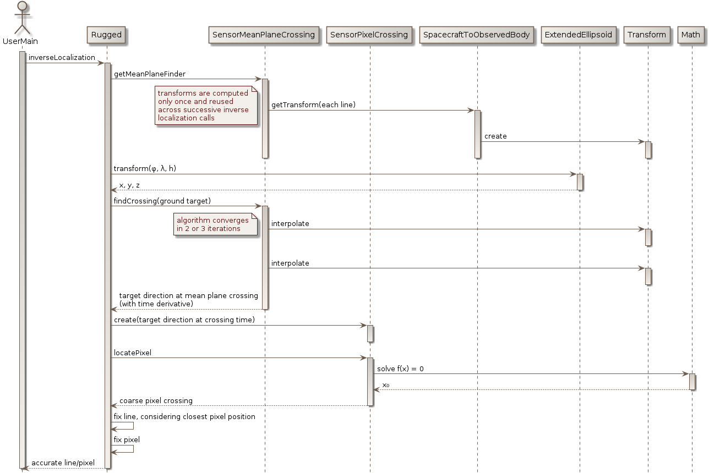
The computation is performed in several steps. The line to which the points belong is first searched using a dedicated solver taking advantage of the first time derivatives automatically included in Orekit transforms. It can therefore set up a model of the angle between the target point and the mean sensor plane, and therefore compute in only two or three iterations the exact crossing of this plane, and hence the corresponding line number. Then, the position of this crossing along the line is searched using a general purpose solver available in Apache Commons Math. As all coordinates are already known in spacecraft frame at this stage, no conversions are performed and this solver find the corresponding pixel very fast. The last two steps correspond to fixing accurately the previous results, which can be important when the various pixels in the line sensor do not really form an exact line and therefore when the previous computation which were done using a mean plane do not represent reality. These final fixes are simple to do because instead of providing simple values as results, the first step in fact provided a Taylor expansion, thus allowing to slightly shift the result at will.

Focus point on Digitla Elevation Model loading
The Digital Elevation Model is used at a very low level in the Rugged library, but read at a high level in the mission specific interface library. The following design has been selected in order to allow the lower layer to delegate the implementation of the loading to the upper layer, and to avoid too many calls. The driving principle is to set up a cache for DEM tiles, keeping a set of recently used tiles in memory up to a customizable maximum number of tiles, and asking for new tiles when what is in memory does not cover the region of interest.
The cache and the tiles themselves are implemented at Rugged library level. The loader is implemented at mission specific interface level, by implementing the TileUpdater interface, which defines a single updateTile method. When this updateTile method is called by the cache, one of its argument is an UpdatableTile instance that must be updated. The implementation must first call once the setGeometry method to set up the global geometry of the tile (reference latitude and longitude, latitude step size, longitude step size, number of rows and columns in the raster), and then call the setElevation method for each element of the raster. The loader can therefore avoid to allocate by itself a large array that will in any case be reallocated by the Tile. The loader only sees interfaces in the API and doesn't know anything about the real specialized tiles that are used under the hood. Different DEM intersection algorithms can use different tiles implementations without any change to the mission specific interface. One example of this independence corresponds to the Duvenhage algorithm, has in addition to the raw elevation grid, the tile will also contain a min/max kd-tree, so there are both a dedicated specialized tile and a corresponding TileFactory in use when this algorithm is run.
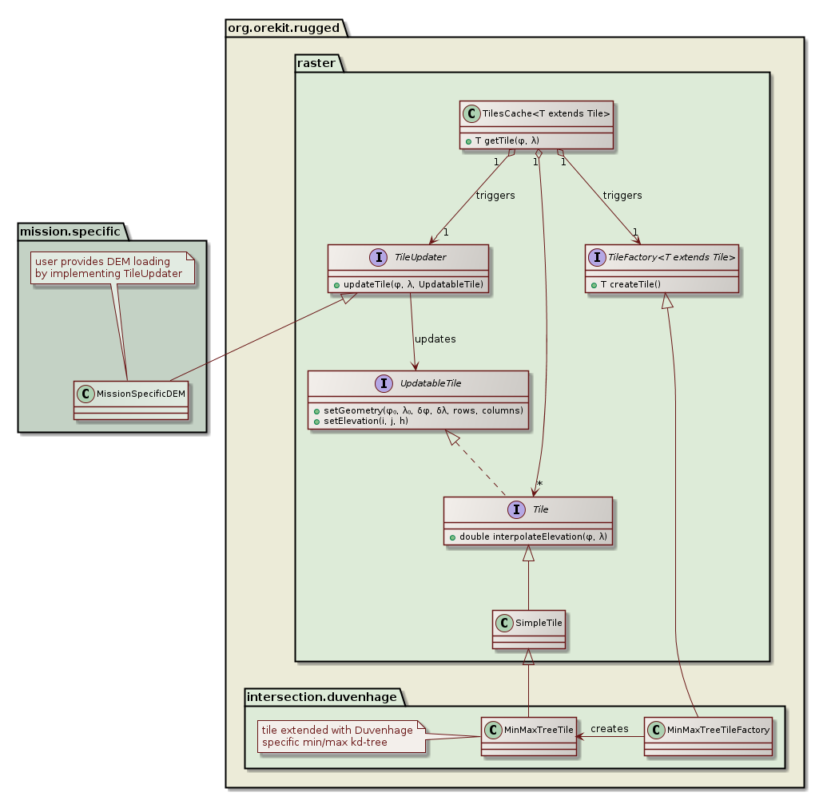Figure 12: DEM loading class diagram

We mainly consider Earth observing mission here, but this feature could be applied to any celestial body large enough to have a roughly ellipsoidal shape like planets or dwarf planets, but not asteroids or comets
We propose to name this new library Rugged, as a hint that it transforms a smooth ellipsoid into rugged terrain
International Earth Rotation and Reference Systems Service, http://www.iers.org/
The EOP files loading and parsing is done automatically and transparently by Orekit, the user is not aware of it.
As velocity is the time derivative of position, in this case a Hermite interpolation is performed, thus preserving derivatives consistency
The first reason is very crude accuracy for linear only, the second reason is that despite quaternion Q1 and -Q1 represent the same rotation, interpolating components between Q1 and Q2 or -Q1 and Q2 leads to completely different rotations and the quaternions in an ephemeris will typically have one sign change per orbit at some random point, the third reason is that instead of doing an interpolation that respect quaternions constraint, the interpolation departs from the constraint first and attempts to recover afterwards in a normalization step
http://www.agi.com/downloads/resources/white-papers/Attitude-interpolation.pdf
http://www.ladispe.polito.it/corsi/Meccatronica/02JHCOR/2011-12/Slides/Shuster_Pub_1993h_J_Repsurv_scan.pdf
the Transform class already exists in Orekit and handles Line transforms
see https://en.wikipedia.org/wiki/Light-time_correction
see https://en.wikipedia.org/wiki/Aberration_of_light
typically an entry point at Digital Elevation Model maximum altitude and an exit point at Digital Elevation Model minimum altitude
Azimuth is computed using the topocentric conventions, 0° at East and counting positively towards North
http://researchspace.csir.co.za/dspace/bitstream/10204/3041/1/Duvenhage_2009.pdf

