Requirements Specifications

P08: Pakistan Startup Intelligence Board (PSIB)

TEAM MEMBER NAMES & IDS

Student ID | Name
27100105 | Huzaif ur Rehman
27100023 | Akbar Munj
27100176 | Minaa Azmat
27100387 | Abdullah Ahmad
26100120 | Subhan Malik

Table of Contents
Update table of contents in Word.

Introduction

The Pakistan Startup Intelligence Board, or PSIB, is a web-based platform designed to help investors and incubation centers in Pakistan evaluate startups more efficiently. It also gives founders a clear and consistent way to present their business information, financial position, ownership structure and supporting documents.
At the moment, startup evaluation often depends on documents that are shared in different formats and at different levels of detail. A founder may provide a pitch deck, a separate cap table, financial statements, incorporation documents and other supporting records, while another startup may provide a completely different set of information. Investors then have to review these documents manually, compare figures across files and identify missing or inconsistent information themselves. This can make due diligence slow, repetitive and difficult to carry out in a consistent way. PSIB addresses this problem by bringing startup information and supporting evidence into one structured system.
For founders, PSIB provides a structured Startup Profile where they can enter information about their team, sector, funding stage, traction, financials, cap table and funding round. They can also upload supporting documents to a private Data Room, including financial statements, incorporation documents, contracts and ownership records. The system checks the information for inconsistencies, such as a cap table that does not add up to 100 percent or a revenue figure in the profile that does not match the uploaded financial statement. Founders can also generate a readiness report that shows which areas are complete, which areas are weak and which supporting documents are still missing. Drafts of the profile are saved automatically while the founder works, so partly completed information is not lost.
For investors, the platform provides a more structured way to review startups that have been shared with their organisation. They can filter startups by factors such as sector, stage, city, round size and readiness. They can open a one-page diligence memo that summarizes the startup's team, market position, traction, financials, risks and red flags. Each factual claim in the memo is linked back to the source document so the investor can verify where the information came from. Investors can also compare multiple startups using the same metrics, ask questions about a startup using only the documents in its Data Room, record private notes and decision stages, request meetings with founders and prepare interview questions based on gaps or weak areas identified by the system.
Incubation centers can use PSIB to manage startups across a cohort rather than reviewing each one separately. A manager can see the completeness level, readiness ratings and open issues for each startup in one place. The platform can also support program applications, allow managers to rank applicants using their own criteria and help them prepare for founder interviews. If a founder has given consent, an incubator can also share selected startups with investor organisations. Incubation centers are also the hub that connects startups with investors. A manager can set up programs and cohorts, keep a network of investor organisations with their sector, stage and ticket-size preferences, and get suggestions of which investor organisations suit a startup. The manager can then filter the startups in a cohort and send a shortlist, with each founder's consent, to selected investor organisations, who review the startups on their own dashboard. Managers can also organise demo days, including postponing or cancelling them, help arrange meetings between founders and investors, and produce a cohort impact report that contains only aggregated figures.
PSIB uses AI where it can reduce manual work, but it does not allow the AI model to make investment decisions on its own. AI is mainly used to extract information from uploaded documents, generate source-linked diligence summaries, answer questions from a startup's own documents and turn identified weaknesses into interview questions. The system uses fixed rules and a versioned readiness rubric for ratings and consistency checks. It also performs calculations such as runway, growth and margins in code rather than relying on an AI model to calculate them. This keeps the results easier to verify and reduces the risk of unsupported or invented information.
Privacy and access control are also important parts of the system because startup documents may contain sensitive financial, legal and ownership information. Founders control which investor organisations can access their Data Room. Access grants, revocations and document activity are recorded so that the system keeps a clear audit trail. Investor notes and scorecards remain private to their own organisation, while startups cannot see another startup's information. New accounts are approved by a platform administrator before they get access and are protected with multi-factor authentication.
The main users of PSIB are founders of early-stage startups, especially those at pre-seed, seed and Series A stages; investors such as venture capital firms, angel networks and family offices; incubation centers and accelerators; and platform administrators, who approve new accounts, publish versions of the readiness rubric and review the audit log. The overall objective is to make startup evaluation in Pakistan more consistent, easier to verify and less dependent on repetitive manual review, while still leaving the final investment decision with the investor.

Why can’t an AI chatbot with well-crafted prompts build your system?

General-purpose AI chatbots (ChatGPT, Claude, Gemini, etc.) can now answer questions, write content, analyze documents and generate code. Before building a system, you must show that your project does something meaningful that a user could not get from a chatbot with good prompts.

Chatbot Test
Item | Details
Chatbot(s) and version used | ChatGPT, GPT-5.6 Sol
Task given | Evaluate a Pakistani startup for investor readiness using its profile, financial information, cap table, legal documents and other supporting records. Identify missing information and inconsistencies, assess the startup across areas such as team, market, traction, financials, legal documentation and ownership, prepare a short due-diligence summary, and suggest questions that an investor should ask the founder.
Best prompt used | “You are helping an investor evaluate an early-stage startup in Pakistan. Review the startup profile and all supporting documents I provide, including its financial statements, cap table, incorporation documents, contracts and pitch deck. Assess the startup across Team, Market, Traction, Financials, Legal and Cap Table, and Documentation. Identify any missing information or inconsistencies between the profile and supporting documents. Give each category a readiness score from 0 to 5 and explain the reason for the score. Prepare a short due-diligence memo covering the startup’s strengths, weaknesses, risks and red flags. Every factual statement must be supported by the information in the supplied documents. If the documents do not contain enough information, clearly state that instead of making an assumption. Finally, suggest up to 10 questions that an investor should ask the founder based on the weaknesses or gaps you identify.”
What the chatbot did well | The chatbot was able to organize the information into a clear structure and summarize a large amount of startup information quickly. When the required documents were provided in the conversation, it could identify obvious missing information, explain possible inconsistencies and produce a readable due-diligence summary. It was also useful for generating possible investor questions based on the weaknesses visible in the supplied material.  The chatbot also understood the general meaning of concepts such as revenue, burn rate, runway, cap tables, funding stages and due diligence. With a detailed enough prompt, it could be instructed not to make assumptions when information was missing and to separate the startup’s strengths from its risks.
Where it fell short | The chatbot could help analyze a set of documents in a single conversation, but it could not provide the complete system that PSIB requires. It had no independent access to a startup’s private Data Room unless the documents were manually supplied to it, and it could not maintain a controlled record of which investor organisations were allowed to view each startup.  Its scoring was also dependent on the instructions and context given in the prompt. Asking the same question differently could change how it interpreted a weakness or assigned a score. It did not automatically apply a fixed, versioned readiness rubric that guarantees the same scoring rules are used across every startup.  The chatbot could point out apparent inconsistencies, but it did not provide the controlled workflow required by PSIB. For example, it could mention that ownership percentages did not add up correctly, but it could not create a persistent Consistency Flag, allow the founder to attach an explanation to that flag, preserve it for later investor review and record the action in an audit log.  It also could not manage the relationships between different users over time. A normal chatbot conversation does not maintain founder accounts, investor organisations, incubator cohorts, access grants, private investor notes, application statuses, meeting requests or interview scorecards as part of one controlled system.  Another problem was verification. Even when instructed to use only the supplied documents, a general-purpose chatbot can still produce an unsupported statement or interpret a document incorrectly. PSIB requires each important claim to be linked back to its source, and its AI components are tested against defined evaluation datasets and measurable quality thresholds rather than relying only on whether an answer appears reasonable.

Justification
Explain what your system adds beyond the chatbot. Address the following points that apply to your project, and give a concrete example from your system for each.
- Data: Does your system depend on private, proprietary, real-time or locally collected data the chatbot cannot access?
- Actions and integration: Does it act in the real world or connect to other systems, such as payments, sensors, databases, hardware or third-party APIs?
- State and workflow: Does it keep persistent records, manage multiple users and roles, or run multi-step workflows over time?
- Reliability and accountability: Does it need consistent, auditable or verifiable results that a chatbot cannot guarantee?
- Scale, cost and privacy: Does it need to run at a speed, cost or level of data privacy that a chatbot conversation cannot meet?
- Domain evaluation: Is your system measured and validated against domain-specific criteria that a chatbot has never been tested on?

Justification
PSIB adds several capabilities that a general-purpose chatbot cannot provide through prompting alone.
Data
PSIB works with private startup information that should not simply be placed into unrelated chatbot conversations. Each startup has its own Data Room containing documents such as financial statements, incorporation records, contracts and cap tables. The system keeps these documents linked to the correct startup and controls who can access them.
A chatbot can analyze documents after a user uploads them, but it does not automatically maintain the complete source of truth for a startup. PSIB stores the structured Startup Profile together with the startup’s supporting documents and keeps track of the version of the Data Room used when a report is produced. This is important because investors need to know exactly which information a rating or memo was based on.
PSIB also handles Pakistan-specific information. Financial information is stored primarily in PKR, and the platform includes locally relevant information such as SECP registration, FBR tax status and Pakistan Startup Fund criteria. Rules that can change over time are stored with their source and date instead of being assumed from an AI model’s general knowledge.
Actions and integration
PSIB does more than return an answer to a prompt. It performs actions within the platform.
A founder can upload documents, grant an investor organisation access to the Data Room and later revoke that access. An investor can save a decision stage, write private notes and request a meeting with the founder. An incubator can receive applications, rank applicants, accept or reject them and add accepted startups to a cohort. The platform administrator can approve accounts and publish new versions of the readiness rubric.
These actions change the state of the system and affect what other users can see or do. A chatbot response by itself cannot provide these controlled interactions between founders, investors, incubators and administrators.
State and workflow
PSIB is designed around workflows that continue over time rather than one conversation.
A founder may first create an incomplete profile, upload documents later, fix inconsistencies, receive a readiness report and then give an investor access. The investor may review the startup, save it as “Interested”, request a meeting, prepare interview questions and later record an interview scorecard. An incubator may follow the same startup throughout a program and monitor whether its readiness improves before demo day.
The system must remember each of these actions and show different information to different users. Investor notes, for example, are visible only within that investor organisation. Founder information is available only to organisations that have been given access. A normal chatbot session does not provide this type of multi-user state management and permission-controlled workflow.
Reliability and accountability
PSIB needs results that users can check rather than simply trust.
The readiness rating is based on a fixed and versioned rubric. If the rubric changes, new reports can use the new version while earlier reports keep the version that was originally used. This makes it possible to understand why a startup received a particular rating at a particular time.
The platform also requires Evidence Links for important claims. If a diligence memo states a revenue figure or identifies a legal issue, the investor should be able to open the document and see the source behind that statement. When there is not enough evidence, the system should say that the information is unavailable instead of filling the gap with an assumption.
Important activities are also recorded in the Audit Log. This includes actions such as viewing a Data Room, granting or revoking access and asking questions through the document assistant. This gives the platform a record of what happened if a startup later raises a concern about its information being accessed.
Scale, cost and privacy
PSIB must support many startups and organisations without mixing their information. A question asked about one startup must never retrieve information belonging to another startup. The system therefore separates data by startup and organisation and checks permissions before returning protected information.
This is especially important because the Data Room may contain commercially sensitive financial information, ownership details and contracts. PSIB is designed so that founders control access to this information and so that AI requests do not create shared memory across startups.
The platform also places limits on AI usage and tracks costs. AI requests have latency and cost targets, and the system can continue providing its non-AI functions if the model provider becomes unavailable. A normal chatbot conversation does not give the project this level of control over system-wide usage, access and operating cost.
Domain evaluation
PSIB does not assume that an AI feature is correct simply because its output sounds convincing. Each AI-dependent capability has defined quality measures and an evaluation dataset.
For the document question-answering feature, PSIB measures whether factual claims are supported by the cited evidence and whether the system correctly refuses to answer questions that cannot be answered from the startup’s documents. The target faithfulness is at least 0.95 and abstention accuracy is at least 0.90, with zero cross-startup data leaks.
The diligence memo is evaluated separately for the accuracy of extracted numeric information and the rate of unsupported claims. Consistency detection is measured using data rooms containing known errors, while readiness ratings are compared with ratings from human reviewers. Interview questions are also checked to make sure they are actually connected to a weakness or missing area identified in the startup’s information.
This testing gives PSIB a defined standard for whether its AI features are performing well enough. A general-purpose chatbot has not been tested specifically against PSIB’s startup documents, readiness rubric, privacy requirements and Pakistan-specific evaluation criteria.
For these reasons, a chatbot can support parts of the work PSIB performs, especially document summarization and question generation, but it cannot replace the platform itself. PSIB combines AI with persistent data, access control, structured workflows, deterministic rules, source-linked evidence and measurable evaluation. Those parts of the system are what allow founders, investors and incubation centers to use the same information over time in a controlled and verifiable way.

System Actors

Actor Name | Description
Founder | A founder or authorised team member of an early-stage startup. Creates and maintains the Startup Profile and Data Room, reviews readiness reports, controls which investors can see the startup, and checks PSF eligibility.
Investor Analyst | An analyst or partner at a VC firm, angel network or family office. Filters and compares startups shared with their organisation, reads Diligence Memos, asks questions about a startup, records decisions and requests meetings.
Incubator Manager | A program manager at an incubation center or accelerator. Monitors readiness across a Cohort and, with each Founder's consent, shares selected startups with investor organisations.
Platform Administrator | The PSIB operator. Approves accounts, publishes Readiness Rubric versions, manages market data sources, and reviews the Audit Log. Cannot change startup-submitted data.

Use Cases

Use Case Diagrams

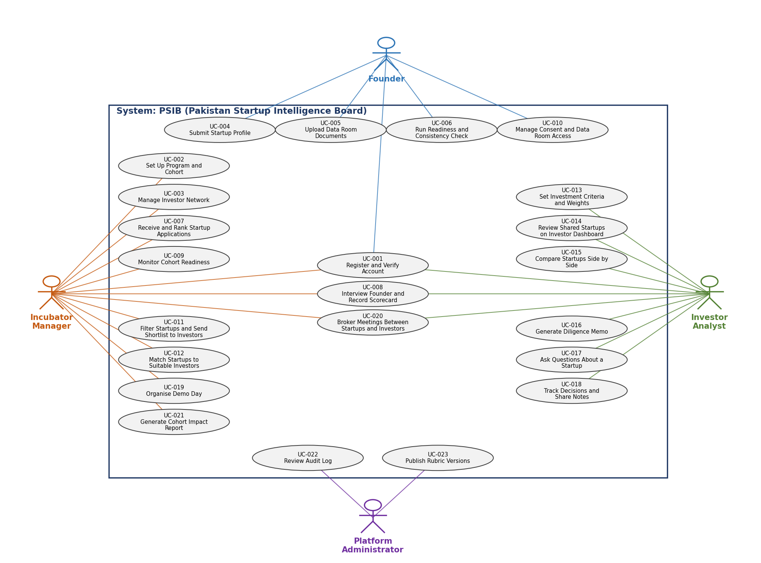

Description of Use Cases

[Select 12 most important use cases of your project and create their comprehensive descriptions. These must include the use cases where AI/ML makes or influences a decision and every use case that touches the sensitive data.]

UC-001: Register and Verify Account
Identifier | UC-001
Purpose | A new user registers, and the Platform Administrator approves the account before any access is given.
Actors | Primary actor(s): Founder, Investor Analyst, Incubator Manager. Secondary actor(s): Platform Administrator, Email Service.
Pre-conditions | The user has no existing account. Investor and Incubator users have an organisation email address. Founders have an SECP registration number.
Post-conditions | Success: Account is active, MFA is set up, and the approval is logged with Administrator and time. Failure: No access is given and the applicant is notified with a reason.

Step # | Typical Course of Action
1 | The user opens registration and selects a role.
2 | The system asks for name, email, organisation and, for Founders, the SECP registration number.
3 | The user submits the form and verifies the email address.
4 | The system creates the account as "Pending" and notifies the Administrator.
5 | The Administrator reviews the organisation email or SECP number.
6 | The Administrator approves the account.
7 | The system activates the account, asks the user to set up MFA, and logs the approval.
Step # | Alternate Courses of Action
A1 | In step 5, the Administrator can request more information. The account stays "Pending" and execution resumes at step 5 when the user replies.
Step # | Exception Paths
E1 | In step 2, if a mandatory field is missing or the email already exists, the system shows a field-level message and stays at step 2.
E2 | In step 3, if the verification link is not used within 24 hours, the registration expires.
E3 | In step 6, if the Administrator rejects the account, the applicant is notified with a reason and the use case ends.

UC-002: Set Up Program and Cohort
Identifier | UC-002
Purpose | The Incubator Manager creates an incubation program, sets its intake details and criteria weights, and creates the cohort that accepted startups will join.
Actors | Primary actor(s): Incubator Manager. Secondary actor(s): None.
Pre-conditions | The Manager's account is active (UC-001). A rubric version is published (UC-023).
Post-conditions | Success: The program is saved with its intake dates, criteria weights and application status, and an empty cohort exists. Failure: Nothing is saved.

Step # | Typical Course of Action
1 | The Manager selects Create Program.
2 | The system asks for program name, intake dates, target sectors and stages.
3 | The Manager enters the details. The system autosaves the draft every 30 seconds.
4 | The system shows the six rubric categories with a weight for each.
5 | The Manager sets weights that add up to 100%.
6 | The Manager chooses to open applications now or later.
7 | The system saves the program, creates an empty cohort and logs the action.
Step # | Alternate Courses of Action
A1 | In step 6, the Manager saves the program as "Draft". Applications stay closed until the Manager opens them.
A2 | In step 3, the Manager leaves before finishing. The autosaved draft is restored on return.
Step # | Exception Paths
E1 | In step 3, if a mandatory field is missing, saving is blocked with a field-level message.
E2 | In step 5, if the weights do not add up to 100%, saving is blocked and the actual total is shown.
E3 | In step 3, if autosave fails, the entries stay in the form, a warning is shown and the system retries.

UC-003: Manage Investor Network
Identifier | UC-003
Purpose | The Incubator Manager records investor organisations (VC firms, angel networks, family offices) with their sector, stage and ticket-size preferences, so startups can be matched and shared with them.
Actors | Primary actor(s): Incubator Manager. Secondary actor(s): Investor Analyst, Email Service.
Pre-conditions | The Manager is logged in. The investor organisation has a contact with an organisation email address.
Post-conditions | Success: The organisation record is saved with its preferences and linked analysts. Failure: No record is created or changed.

Step # | Typical Course of Action
1 | The Manager opens Investor Network and selects Add Organisation.
2 | The Manager enters organisation name, type, contact, preferred sectors, stages and ticket-size range.
3 | The Manager invites analysts using their organisation email addresses.
4 | The system sends the invitations and lists the organisation as "Invited".
5 | Each analyst registers as in UC-001 and is linked to the organisation.
6 | The system shows the organisation as "Active".
Step # | Alternate Courses of Action
A1 | In step 1, the Manager edits an existing organisation. If the Manager deactivates it, its access to all shared startups is removed and the action is logged.
Step # | Exception Paths
E1 | In step 2, if an organisation with the same name exists, the system shows the existing record instead of creating a duplicate.
E2 | In step 5, if an invitation is not accepted within 14 days, it expires and the Manager can resend it.

UC-004: Submit Startup Profile
Identifier | UC-004
Purpose | The Founder enters the startup profile in one standard format, so investors and incubators can compare startups fairly.
Actors | Primary actor(s): Founder. Secondary actor(s): None.
Pre-conditions | The Founder's account is active (UC-001).
Post-conditions | Success: The profile is saved, completeness is 100% and the status is "Ready for review". Failure: The profile stays an autosaved draft and submission is blocked.

Step # | Typical Course of Action
1 | The Founder opens the profile page.
2 | The system shows sections for team, sector, stage, traction, revenue in PKR, cap table and round details.
3 | The Founder fills in the sections. The system autosaves the draft every 30 seconds and when the Founder leaves the page, and shows "Draft saved".
4 | The system updates the completeness percentage as fields are filled.
5 | The Founder submits the profile.
6 | The system checks that all mandatory fields are filled.
7 | The system sets the status to "Ready for review" and saves a new profile version.
Step # | Alternate Courses of Action
A1 | In step 3, the Founder leaves before finishing. The autosaved draft is restored on return and is not visible to investors or incubators.
Step # | Exception Paths
E1 | In step 6, if a mandatory field is missing, submission is blocked and a field-level message lists every missing field. Execution returns to step 3.
E2 | In step 3, if the cap table does not add up to 100%, the system saves it and raises a Consistency Flag (see UC-006).
E3 | In step 3, if autosave fails, the entries stay in the form, a warning is shown and the system retries.

UC-005: Upload Data Room Documents
Identifier | UC-005
Purpose | The Founder uploads financial statements, incorporation documents, contracts and the cap table to a private data room. Key fields are extracted with an AI service, and every file is scanned for malware.
Actors | Primary actor(s): Founder. Secondary actor(s): Malware Scanner, Document Extraction Service (AI).
Pre-conditions | The Founder's account is active and a profile exists (UC-004). The extraction service is deployed and its model version is recorded.
Post-conditions | Success: The file is stored privately and listed with type, uploader and date. Extracted fields are saved with their source references. The upload is logged. Failure: The file is rejected or quarantined and is not visible to other users.

Step # | Typical Course of Action
1 | The Founder opens the Data Room.
2 | The Founder selects a document type and chooses a file.
3 | The system checks that the file is a PDF, XLSX or DOCX of at most 25 MB.
4 | The system sends the file to the malware scan.
5 | The scan passes, so the system encrypts and stores the file as a new version.
6 | The system extracts key fields (revenue, burn, cash, headcount) and records the file and page or cell of each value. Values with confidence below 0.7 are marked "Verify".
7 | The system lists the file with its type, uploader and upload date and logs the upload.
Step # | Alternate Courses of Action
A1 | After step 7, the Founder confirms or corrects each "Verify" value. Confirmed values are then used in calculations.
Step # | Exception Paths
E1 | In step 3, if the file is over 25 MB or of an unsupported type, the upload is rejected and the reason is shown.
E2 | In step 4, if the scan finds malware, the file is quarantined and is visible only to the Administrator. The Founder is notified.
E3 | In step 6, if extraction is unavailable, the file is stored and marked "Not yet extracted". Only Founder-entered fields are used until extraction runs.

UC-006: Run Readiness and Consistency Check
Identifier | UC-006
Purpose | The system checks the profile and documents for inconsistencies and rates the startup from 0 to 5 in each rubric category. Rules written in code decide the flags and ratings. An AI service is used only to extract fields from documents.
Actors | Primary actor(s): Founder. Secondary actor(s): Document Extraction Service (AI), Platform Administrator.
Pre-conditions | A profile is saved (UC-004). A rubric version is published (UC-023). The extraction model version is recorded.
Post-conditions | Success: A report with ratings, flags, criteria met and missing, and the rubric version is stored and logged. Failure: No new report is stored. The previous report stays unchanged.

Step # | Typical Course of Action
1 | The Founder requests a readiness report.
2 | The system loads the latest profile and extracted fields.
3 | The system runs the consistency checks (cap table total, profile revenue against statement revenue, missing documents).
4 | The system raises a Consistency Flag for each problem, with severity and source file.
5 | The system rates each rubric category using the published rubric.
6 | The system shows, within 60 seconds, the 0 to 5 rating, criteria met, criteria missing, rating description and rubric version for each category.
7 | The system stores the report and logs the request.
Step # | Alternate Courses of Action
A1 | After step 6, the Founder adds an explanation to a flag. The flag stays visible to investors together with the explanation.
A2 | After step 6, the Founder disputes a rating. The Administrator can override it with a reason, which is written to the Audit Log.
Step # | Exception Paths
E1 | In step 5, if a category has no supporting evidence, it shows "Not assessed" and no number.
E2 | In step 2, if extraction is unavailable, checks run only on Founder-entered fields and the report states "Documents not checked".

UC-007: Receive and Rank Startup Applications
Identifier | UC-007
Purpose | Founders apply to an incubation program and agree to share their profile. The Incubator Manager ranks the applications with the program's own criteria weights and records a decision.
Actors | Primary actor(s): Incubator Manager. Secondary actor(s): Founder, Email Service.
Pre-conditions | The program is open for applications (UC-002). The applying Founder has a profile with the status "Ready for review" and a readiness report.
Post-conditions | Success: The application is recorded, the decision is saved, the Founder is notified, and an accepted startup is added to the cohort. Failure: No application is recorded.

Step # | Typical Course of Action
1 | The Founder selects a program, agrees to share the profile with the incubator, and submits an application.
2 | The system records the application as "New" and notifies the Manager.
3 | The Manager opens the applications list.
4 | The system shows a fit score for each application, calculated from the program's weights. Categories marked "Not assessed" are left out of the score.
5 | The Manager sorts by fit score and opens an application.
6 | The Manager sets the status to Accepted, Waitlisted or Rejected.
7 | The system notifies the Founder, adds an accepted startup to the cohort and logs the decision.
Step # | Alternate Courses of Action
A1 | In step 5, the Manager filters applications by sector, stage or city before sorting.
Step # | Exception Paths
E1 | In step 1, if the Founder has not agreed to share the profile, the application cannot be submitted.
E2 | In step 1, if the profile is not "Ready for review", submission is blocked and the Founder is asked to complete it.
E3 | After step 2, if the Founder withdraws the application before a decision, its status becomes "Withdrawn" and no further action is possible.

UC-008: Interview Founder and Record Scorecard
Identifier | UC-008
Purpose | The Incubator Manager (for an applicant) or the Investor Analyst (for a shared startup) gets interview questions based on the startup's gaps and records a scorecard on the same rubric, so every startup is screened in the same way.
Actors | Primary actor(s): Incubator Manager, Investor Analyst. Secondary actor(s): Language Model (AI), Founder.
Pre-conditions | For the Manager: an application exists (UC-007). For the Analyst: the startup is shared with the analyst's organisation (UC-010 or UC-011). In both cases the Founder has accepted the interview (UC-020). The language model version is recorded.
Post-conditions | Success: The scorecard is saved with its date, shown beside the pre-interview rating, and visible only to the organisation that recorded it (the incubator or the investor organisation), never to the Founder or other organisations. Failure: No scorecard is saved. An autosaved draft stays private to its author.

Step # | Typical Course of Action
1 | The user opens Interview Prep for an applicant (Manager) or a shared startup (Analyst).
2 | The system checks access: the Manager must own the program, or the analyst's organisation must hold an Access Grant.
3 | The system selects open Consistency Flags and categories rated below 3 or "Not assessed".
4 | The system generates up to 10 questions, each linked to its flag or category and its Evidence Link. The list is labelled "AI-generated, check before use".
5 | The user edits or removes questions.
6 | After the interview, the user enters a 0 to 5 score and a note for each rubric category. The system autosaves them as a private draft every 30 seconds.
7 | The user saves the scorecard. The system stores it with its date, shows it beside the pre-interview rating and logs the action.
Step # | Alternate Courses of Action
A1 | In step 5, the user flags a bad question. Flagged questions are reviewed weekly.
A2 | In step 6, the user leaves before finishing. The autosaved draft is restored on return.
Step # | Exception Paths
E1 | In step 2, if the user has no access, access is denied and the attempt is logged.
E2 | In step 3, if there are no open flags and no weak category, the page shows "No gaps found" and no questions.
E3 | In step 4, if the model is unavailable, the flags and weak categories are shown without questions.
E4 | In step 7, if a score is outside 0 to 5, the scorecard is rejected with a message.
E5 | In step 7, if the Founder has not accepted the interview, the scorecard cannot be saved.
E6 | In step 6, if autosave fails, the entries stay in the form, a warning is shown and the system retries.

UC-009: Monitor Cohort Readiness
Identifier | UC-009
Purpose | The Incubator Manager sees the readiness of every startup in the cohort in one view, to decide who needs help before demo day.
Actors | Primary actor(s): Incubator Manager. Secondary actor(s): Founder, Email Service.
Pre-conditions | The Manager is logged in and the cohort has at least one startup (UC-002, UC-007).
Post-conditions | Success: The dashboard is shown and any reminder is sent and logged. Failure: No dashboard is shown.

Step # | Typical Course of Action
1 | The Manager opens the cohort dashboard.
2 | The system lists each startup with its completeness percentage, latest rating per category and number of open flags.
3 | The system marks startups with no profile or document update in 30 days as "Stale".
4 | The Manager sorts or filters the list by category, flags or status.
5 | The Manager opens a startup's readiness report.
6 | The Manager sends a reminder to the Founder about missing items.
7 | The system delivers the reminder and logs it.
Step # | Alternate Courses of Action
A1 | In step 4, the Manager filters to startups with 100% completeness and no high-severity flag, to see who is ready for investors.
Step # | Exception Paths
E1 | In step 2, if a startup has no readiness report, its categories show "Not assessed".
E2 | In step 7, if delivery fails, the reminder is shown as "Undelivered" and the system retries it.

UC-010: Manage Consent and Data Room Access
Identifier | UC-010
Purpose | The Founder decides which investor organisations and which incubator can see the data room, and can withdraw that access at any time.
Actors | Primary actor(s): Founder. Secondary actor(s): Investor Analyst, Incubator Manager.
Pre-conditions | The startup's status is "Ready for review" (UC-004).
Post-conditions | Success: An Access Grant is created or removed, and the action is written to the Audit Log. Failure: Access stays unchanged.

Step # | Typical Course of Action
1 | The Founder opens Access settings.
2 | The system lists current Access Grants and the consent given to the incubator.
3 | The Founder selects an investor organisation to grant access to.
4 | The system shows exactly what the organisation will see (profile, data room, memo).
5 | The Founder confirms.
6 | The system creates the Access Grant, notifies the organisation and logs the grant.
7 | Only users of that organisation can now open the data room.
Step # | Alternate Courses of Action
A1 | In step 3, the Founder revokes an existing grant. Access is removed within 1 minute and the revocation is logged.
A2 | In step 2, the Founder withdraws consent for sharing by the incubator. Any pending shares by the incubator are cancelled.
Step # | Exception Paths
E1 | In step 3, if the status is not "Ready for review", the grant is blocked with a message.
E2 | In step 6, if saving the grant fails, no access is given and an error is shown.

UC-011: Filter Startups and Send Shortlist to Investors
Identifier | UC-011
Purpose | The Incubator Manager filters the cohort and shares selected startups with selected investor organisations, for example a board of investors, before demo day.
Actors | Primary actor(s): Incubator Manager. Secondary actor(s): Investor Analyst, Founder.
Pre-conditions | The investor organisation is active (UC-003). The startups are in the cohort and "Ready for review". Each Founder has consented to sharing by the incubator (UC-010).
Post-conditions | Success: An Access Grant exists for each startup and organisation pair, the organisations are notified, and the shares are logged. Failure: Nothing is shared.

Step # | Typical Course of Action
1 | The Manager opens the cohort and applies filters (sector, stage, round size, city, readiness).
2 | The system lists the matching startups and the result count.
3 | The Manager selects startups.
4 | The Manager selects investor organisations.
5 | The system checks each selected startup for Founder consent.
6 | The Manager confirms the share.
7 | The system creates the Access Grants, notifies the organisations and logs the share.
Step # | Alternate Courses of Action
A1 | In step 4, the Manager picks organisations from the suggestions in UC-012.
Step # | Exception Paths
E1 | In step 2, if no startup matches, an empty-state message is shown.
E2 | In step 5, if a startup has no consent, it is blocked with the message "consent missing". The Manager can continue with the other startups.

UC-012: Match Startups to Suitable Investors
Identifier | UC-012
Purpose | The system suggests which investor organisations suit a startup by comparing the startup's sector, stage, round size and city with each organisation's saved preferences. Matching uses fixed rules, not a trained model.
Actors | Primary actor(s): Incubator Manager. Secondary actor(s): None.
Pre-conditions | Investor preferences are saved (UC-003). The startup's profile is "Ready for review".
Post-conditions | Success: A list of organisations with the criteria each one matched is shown. Failure: No list is shown.

Step # | Typical Course of Action
1 | The Manager selects a startup and chooses Suggest Investors.
2 | The system compares the startup's sector, stage, round size and city with each organisation's preferences.
3 | The system lists organisations by number of matched criteria and shows which criteria matched.
4 | The Manager reviews the list.
5 | The Manager selects organisations to continue with the sharing steps in UC-011.
Step # | Alternate Courses of Action
A1 | In step 1, the Manager selects an investor organisation instead and sees the startups that match it.
Step # | Exception Paths
E1 | In step 3, if no organisation matches, the system says so and suggests widening the criteria.
E2 | In step 2, if an organisation has no saved preferences, it is listed as "Preferences not set" and is not ranked.

UC-013: Set Investment Criteria and Weights
Identifier | UC-013
Purpose | The Investor Analyst saves the weights their organisation puts on each rubric category, so startups are ranked by what the organisation looks for.
Actors | Primary actor(s): Investor Analyst. Secondary actor(s): None.
Pre-conditions | The analyst's account is active (UC-001).
Post-conditions | Success: The weights are saved for the organisation, visible only to its users, and fit scores are recalculated. Failure: The previous weights remain.

Step # | Typical Course of Action
1 | The analyst opens Investment Criteria.
2 | The system shows the six rubric categories with their current weights.
3 | The analyst enters weights for the categories.
4 | The analyst optionally saves default filters (sector, stage, round size, city).
5 | The analyst saves.
6 | The system checks that the weights add up to 100%.
7 | The system saves the weights, recalculates fit scores and logs the change.
Step # | Alternate Courses of Action
A1 | In step 3, the analyst resets to the default equal weights.
Step # | Exception Paths
E1 | In step 6, if the weights do not add up to 100%, saving is blocked and the actual total is shown.

UC-014: Review Shared Startups on Investor Dashboard
Identifier | UC-014
Purpose | The Investor Analyst sees every startup shared with their organisation on one dashboard and filters and sorts them to build a shortlist.
Actors | Primary actor(s): Investor Analyst. Secondary actor(s): None.
Pre-conditions | At least one startup is shared with the analyst's organisation (UC-010 or UC-011).
Post-conditions | Success: The list is shown and each opened startup is logged in the Audit Log. Failure: No list is shown.

Step # | Typical Course of Action
1 | The analyst opens the dashboard.
2 | The system lists only startups with an Access Grant for the analyst's organisation, with fit score, readiness and open flags.
3 | The analyst filters by sector, stage, round size, city or readiness.
4 | The system shows the matching startups and the result count.
5 | The analyst sorts by fit score.
6 | The analyst opens a startup.
7 | The system logs the view.
Step # | Alternate Courses of Action
A1 | In step 5, the analyst marks startups for side-by-side comparison (UC-015).
Step # | Exception Paths
E1 | In step 4, if no startup matches the filters, an empty-state message is shown and no error occurs.
E2 | In step 6, if the Founder has revoked access, the startup is removed from the list and a message is shown.

UC-015: Compare Startups Side by Side
Identifier | UC-015
Purpose | The Investor Analyst compares two to four startups on the same metrics to rank the shortlist.
Actors | Primary actor(s): Investor Analyst. Secondary actor(s): None.
Pre-conditions | Two to four startups are shared with the analyst's organisation (UC-014).
Post-conditions | Success: The comparison is shown and can be saved to the shortlist. Failure: No comparison is shown.

Step # | Typical Course of Action
1 | The analyst selects two to four startups.
2 | The analyst opens the comparison.
3 | The system shows the same metrics for each startup in PKR (any USD value shows the rate and date used), with readiness ratings, fit score and open flags.
4 | The analyst sorts or highlights a metric.
5 | The analyst opens the memo of a startup (UC-016).
6 | The analyst saves the comparison to the organisation's shortlist.
Step # | Alternate Courses of Action
A1 | In step 4, the analyst removes a startup from the comparison and the system redraws the table.
Step # | Exception Paths
E1 | In step 3, if a metric is missing for a startup, its cell reads "Not provided" and is never shown as zero.
E2 | In step 2, if fewer than two or more than four startups are selected, the comparison is blocked with a message.

UC-016: Generate Diligence Memo
Identifier | UC-016
Purpose | The system produces a one-page memo (team, market position, traction, financials, risks, red flags) from the startup's profile and documents, with every claim linked to its source. Numbers are calculated in code, and an AI model writes the narrative only from extracted fields.
Actors | Primary actor(s): Investor Analyst. Secondary actor(s): Language Model (AI), Document Extraction Service (AI).
Pre-conditions | The startup is shared with the analyst's organisation. Its data room has a profile and at least one financial statement. Model versions are recorded.
Post-conditions | Success: The memo is shown with its generation date and Data Room version. Every claim has an Evidence Link, and the request is logged. Failure: The memo shows only Founder-entered data and the narrative is marked "Unavailable".

Step # | Typical Course of Action
1 | The analyst opens the memo of a startup.
2 | The system retrieves the extracted fields and their source references.
3 | The system calculates runway, growth and margins in code.
4 | The system writes the narrative from the extracted fields only.
5 | The system attaches an Evidence Link (file and page or cell) to every claim.
6 | The system shows the memo within 90 seconds, labelled "AI-generated, verify against source".
7 | The system logs the view.
Step # | Alternate Courses of Action
A1 | After step 6, the analyst clicks an Evidence Link and the source passage opens.
Step # | Exception Paths
E1 | In step 4, if a section has insufficient data, it reads "Insufficient data" and names the document that would fill it.
E2 | In step 2, if a value has confidence below 0.7, it is marked "Verify" and is left out of calculations until the Founder confirms it.
E3 | In step 4, if the model is unavailable, the memo shows only Founder-entered data and marks the narrative "Unavailable". No value is invented.

UC-017: Ask Questions About a Startup
Identifier | UC-017
Purpose | The Investor Analyst asks a question and gets an answer based only on the selected startup's own documents, with citations, or is told that nothing was found.
Actors | Primary actor(s): Investor Analyst. Secondary actor(s): Language Model (AI).
Pre-conditions | The startup is shared with the analyst's organisation (UC-010 or UC-011). The data room has documents. The model version is recorded.
Post-conditions | Success: The answer with citations is shown and the question and answer are logged. Failure: No answer is shown. The reason is logged.

Step # | Typical Course of Action
1 | The analyst opens the assistant of a startup.
2 | The analyst types a question.
3 | The system checks that the analyst's organisation has an Access Grant.
4 | The system retrieves passages from that startup's documents only.
5 | The model answers using only those passages.
6 | The system shows the answer with at least one citation, labelled "AI-generated, verify against source".
7 | The system logs the question and answer.
Step # | Alternate Courses of Action
A1 | In step 6, the analyst clicks a citation and the source passage opens.
A2 | After step 6, the analyst flags a wrong answer. Flagged answers are reviewed weekly.
Step # | Exception Paths
E1 | In step 4, if no passage supports an answer, the system replies "Not found in submitted documents" and shows no citation.
E2 | In step 3, if there is no Access Grant, access is denied and no content is returned.
E3 | In step 2, if the analyst asks about a different startup, the system says it cannot answer for it.
E4 | In step 5, if the model is unavailable, the system shows "Answer not available" and offers plain document search.
E5 | In step 2, if the analyst exceeds 30 questions per hour, the question is blocked with a message.

UC-018: Track Decisions and Share Notes
Identifier | UC-018
Purpose | The Investor Analyst records a decision stage and notes for each startup, so the investment team stays aligned. This information is private to the organisation.
Actors | Primary actor(s): Investor Analyst. Secondary actor(s): None.
Pre-conditions | The startup is shared with the analyst's organisation.
Post-conditions | Success: The stage and note are saved with author and time, and are visible only to users of the same organisation. Failure: The previous stage and note remain.

Step # | Typical Course of Action
1 | The analyst opens a startup.
2 | The analyst selects a stage: Screening, Interested or Passed.
3 | The analyst writes a note. The system autosaves it as a draft, visible only to its author, every 30 seconds.
4 | The analyst saves.
5 | The system stores the entry with author and time.
6 | Other users of the same organisation see the updated stage on their dashboard.
Step # | Alternate Courses of Action
A1 | In step 2, the analyst changes an earlier stage. The system keeps the history of changes.
Step # | Exception Paths
E1 | In step 4, if saving fails, the entry stays in the form and an error is shown.
E2 | In step 1, if the Founder has revoked access, the startup's data is no longer visible. The organisation's own notes remain.
E3 | In step 3, if autosave fails, the note stays in the form, a warning is shown and the system retries.

UC-019: Organise Demo Day
Identifier | UC-019
Purpose | The Incubator Manager creates a demo day, picks startups and invited investor organisations, tracks who accepts and attends, and can postpone or cancel the event.
Actors | Primary actor(s): Incubator Manager. Secondary actor(s): Investor Analyst, Founder, Email Service.
Pre-conditions | The cohort has startups that are "Ready for review" with Founder consent (UC-010). Investor organisations are active (UC-003).
Post-conditions | Success: The event is saved with its status (Scheduled, Rescheduled or Cancelled), invitations are sent, and startup slots and attendance are recorded. Every status change is logged. Failure: The event is not created or changed.

Step # | Typical Course of Action
1 | The Manager creates an event with date and venue or online link.
2 | The Manager selects the startups that will present.
3 | The system assigns time slots.
4 | The Manager selects the investor organisations to invite.
5 | The system sends the invitations.
6 | The organisations accept or decline.
7 | The system shows confirmed attendees and slots, and the Manager marks attendance after the event.
Step # | Alternate Courses of Action
A1 | In step 3, the Manager reorders the slots.
A2 | After step 5, the Manager postpones the event by choosing a new date. The status becomes "Rescheduled", all earlier confirmations are cleared, invited organisations and startups are notified, and execution resumes at step 6 for re-confirmation.
A3 | After step 5, the Manager cancels the event and enters a reason. The status becomes "Cancelled", slots are released, invitations are withdrawn, everyone invited is notified, and the use case ends.
Step # | Exception Paths
E1 | In step 2, if a startup has no Founder consent, it cannot be added to the event.
E2 | In step 6, if no organisation has replied by the deadline, the Manager is notified to follow up.
E3 | In the postpone or cancel flow, if attendance has already been marked, the change is blocked with the message "event already held".
E4 | In the postpone or cancel flow, if a notification cannot be delivered, it is shown as "Undelivered" and the system retries.

UC-020: Broker Meetings Between Startups and Investors
Identifier | UC-020
Purpose | An Investor Analyst, or the Incubator Manager on an organisation's behalf, requests a meeting with a Founder, and the Founder accepts, declines or proposes another time.
Actors | Primary actor(s): Investor Analyst, Incubator Manager. Secondary actor(s): Founder, Email Service.
Pre-conditions | The startup is shared with the requesting investor organisation (UC-010 or UC-011).
Post-conditions | Success: The request has a final status (Accepted, Declined, Rescheduled or Expired) and every change is logged. Failure: No request is created.

Step # | Typical Course of Action
1 | The requester selects Request Meeting from the memo page or the shortlist.
2 | The requester enters proposed times and a short note.
3 | The system sends the request to the Founder with the status "Pending" and logs it.
4 | The Founder reviews the request.
5 | The Founder accepts a time or declines.
6 | The system shows the new status to the requester within 1 minute.
7 | For an accepted request, the system adds the meeting to both calendars.
Step # | Alternate Courses of Action
A1 | In step 5, the Founder proposes a different time. The status becomes "Rescheduled" and the requester accepts or declines.
Step # | Exception Paths
E1 | In step 5, if the Founder does not reply within 7 days, the status becomes "Expired" and the requester is notified.
E2 | In step 4, if the Founder revokes access to the organisation, the request is cancelled.

UC-021: Generate Cohort Impact Report
Identifier | UC-021
Purpose | The Incubator Manager produces a summary of cohort progress for donors and stakeholders using aggregated figures only. Investor notes, stages and scorecards are never included.
Actors | Primary actor(s): Incubator Manager. Secondary actor(s): None.
Pre-conditions | The cohort has data for at least one period (UC-009).
Post-conditions | Success: The report is shown, can be exported as a PDF, and the export is logged. Failure: No report is produced.

Step # | Typical Course of Action
1 | The Manager opens Reports.
2 | The Manager selects a cohort and a period.
3 | The system calculates readiness at intake against now, startups shared, investor views, meeting requests and meetings accepted.
4 | The system shows the aggregated figures.
5 | The Manager reviews the report.
6 | The Manager exports it as a PDF.
7 | The system logs the export.
Step # | Alternate Courses of Action
A1 | In step 2, the Manager compares two cohorts or two periods.
Step # | Exception Paths
E1 | In step 3, if there is no data for the period, the system shows "No data for this period".
E2 | In step 6, if the export fails, an error is shown and the Manager can retry.

UC-022: Review Audit Log
Identifier | UC-022
Purpose | The Platform Administrator investigates who viewed, downloaded or shared startup data, for example after a complaint about leaked data.
Actors | Primary actor(s): Platform Administrator. Secondary actor(s): None.
Pre-conditions | The Administrator is logged in with MFA.
Post-conditions | Success: Matching entries are shown and the Administrator's own access is logged. Failure: No entries are shown.

Step # | Typical Course of Action
1 | The Administrator opens the Audit Log.
2 | The Administrator selects a startup, date range and action type.
3 | The system returns matching entries newest first, each with user, time, action and startup.
4 | The Administrator opens an entry for details.
5 | The Administrator exports the results for the investigation.
6 | The system logs the Administrator's own access.
Step # | Alternate Courses of Action
A1 | After a bulk-download alert (over 20 documents in 10 minutes), the log opens already filtered to that user.
Step # | Exception Paths
E1 | In step 3, if no entries match, an empty-state message is shown.
E2 | In any step, no role can edit or delete an entry. Any attempt is refused and logged.

UC-023: Publish Rubric Versions
Identifier | UC-023
Purpose | The Platform Administrator publishes a new version of the readiness rubric, with a written meaning for every rating level, without changing past reports.
Actors | Primary actor(s): Platform Administrator. Secondary actor(s): None.
Pre-conditions | The Administrator is logged in. A draft rubric version exists.
Post-conditions | Success: The new version is published. New reports use it and earlier reports keep their version number. Failure: The draft stays unpublished.

Step # | Typical Course of Action
1 | The Administrator opens the Rubric page.
2 | The Administrator creates a draft from the current version.
3 | The Administrator edits the criteria and the description of each 0 to 5 level in every category. The system autosaves the draft every 30 seconds.
4 | The Administrator selects Publish.
5 | The system checks that every level in every category has a description.
6 | The system publishes the new version and logs it.
7 | New reports use the new version. Earlier reports keep their version number.
Step # | Alternate Courses of Action
A1 | In step 3, the Administrator leaves before finishing. The autosaved draft is restored on return and is not used for any report.
Step # | Exception Paths
E1 | In step 5, if any level has no description, publishing is blocked with a field-level message.
E2 | In step 6, if reports are being generated, they finish with the old version.
E3 | In step 3, if autosave fails, the entries stay in the form, a warning is shown and the system retries.

Class Diagram

Diagram

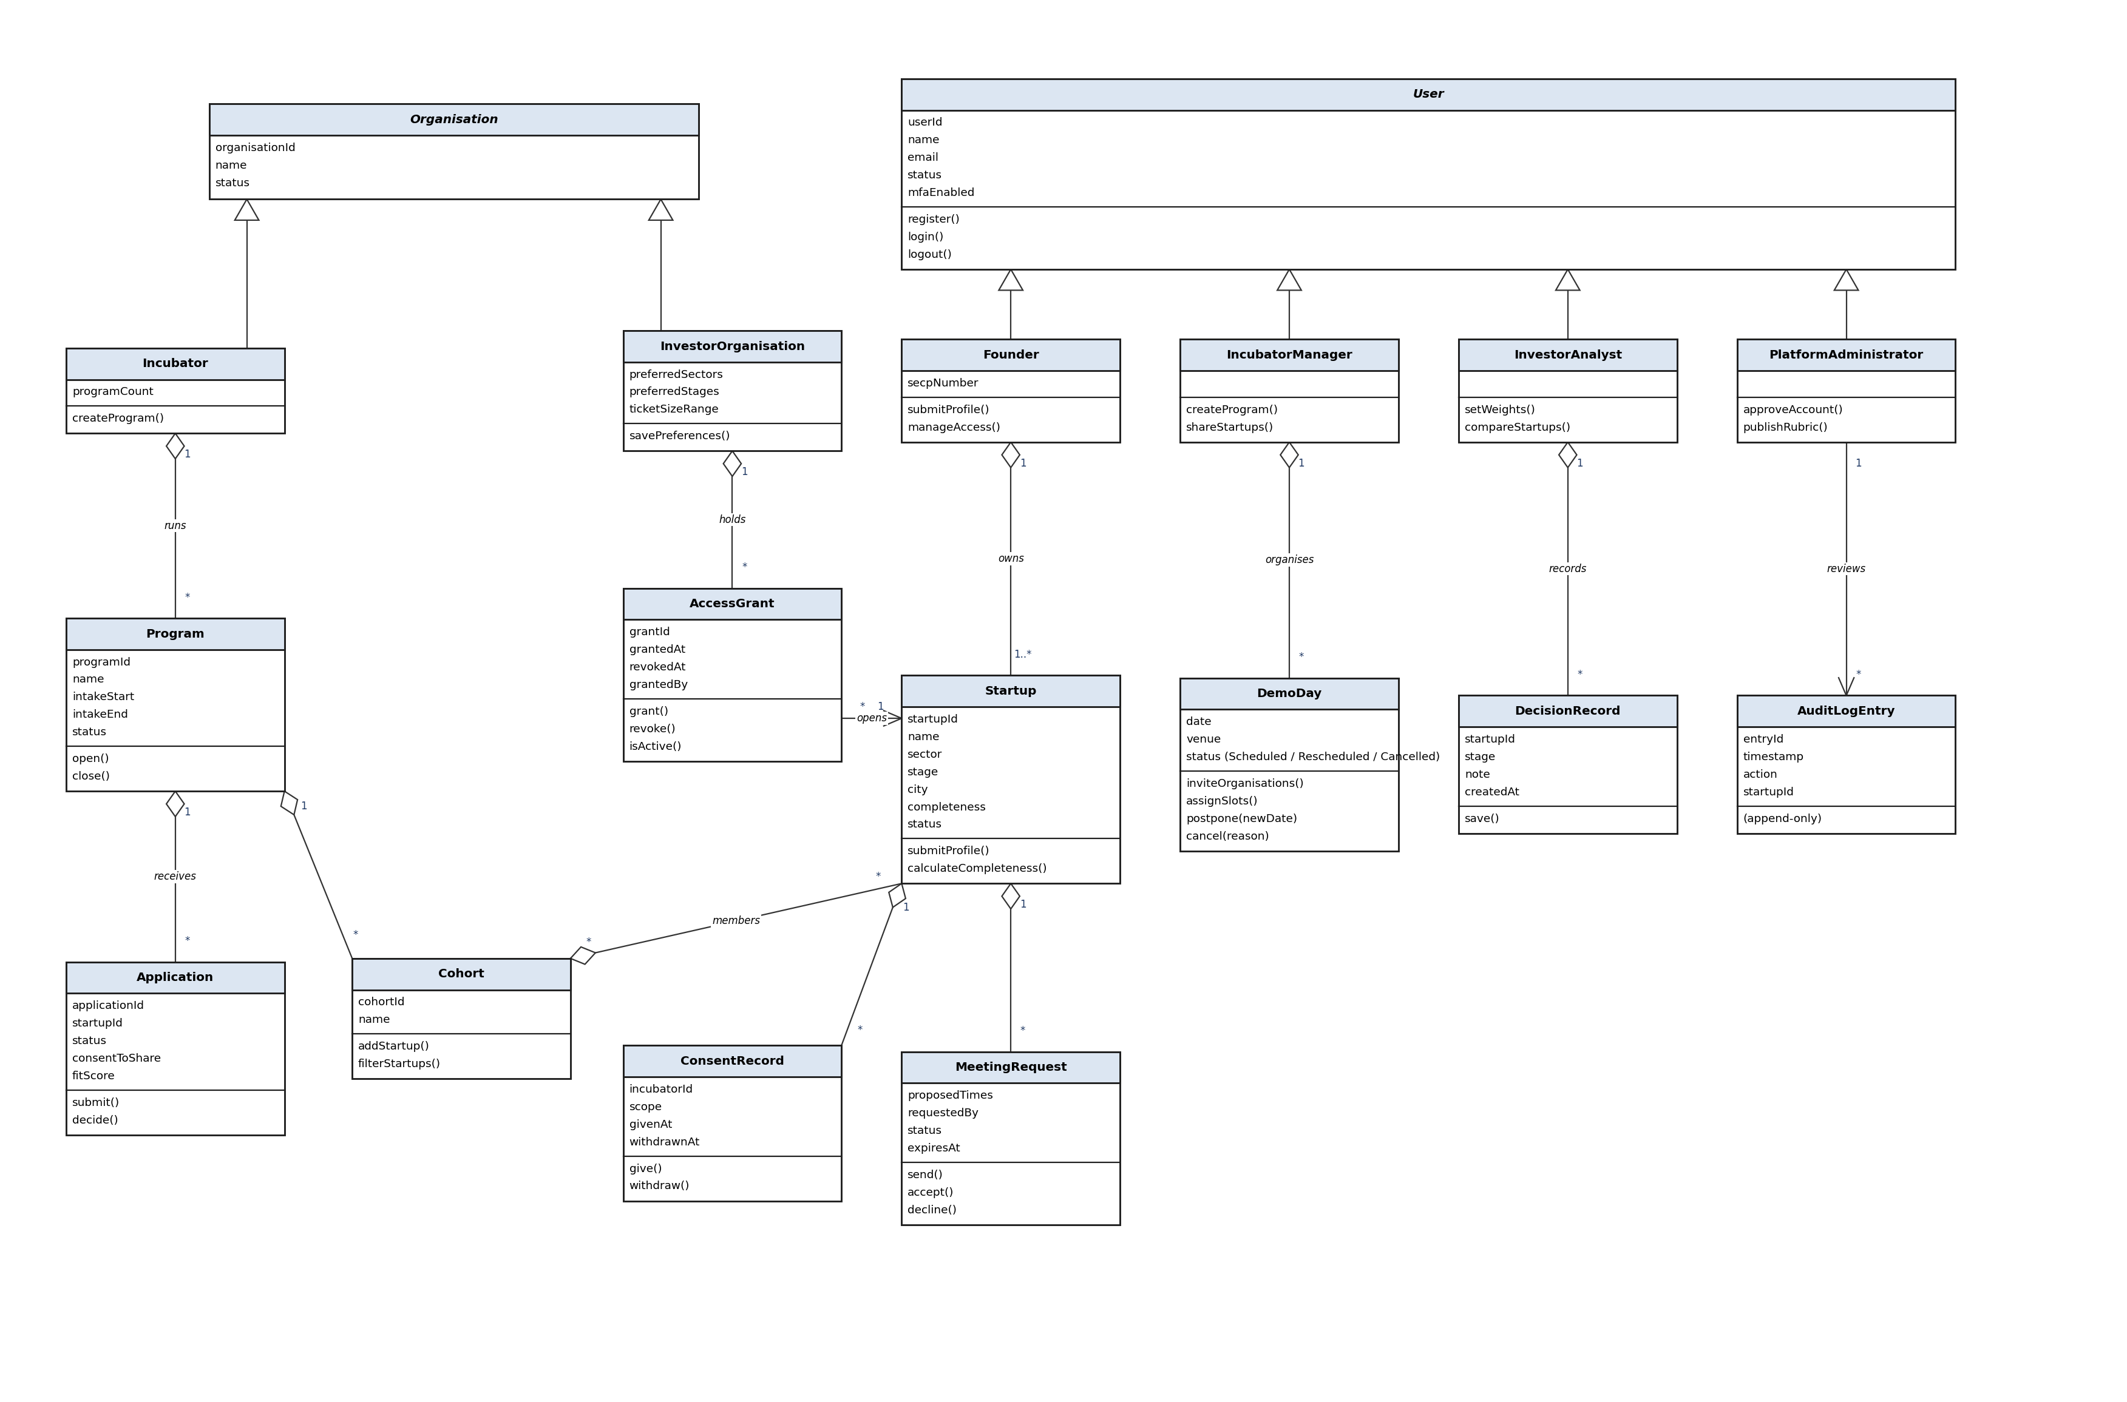
Figure 1: Users, organisations, programs and sharing

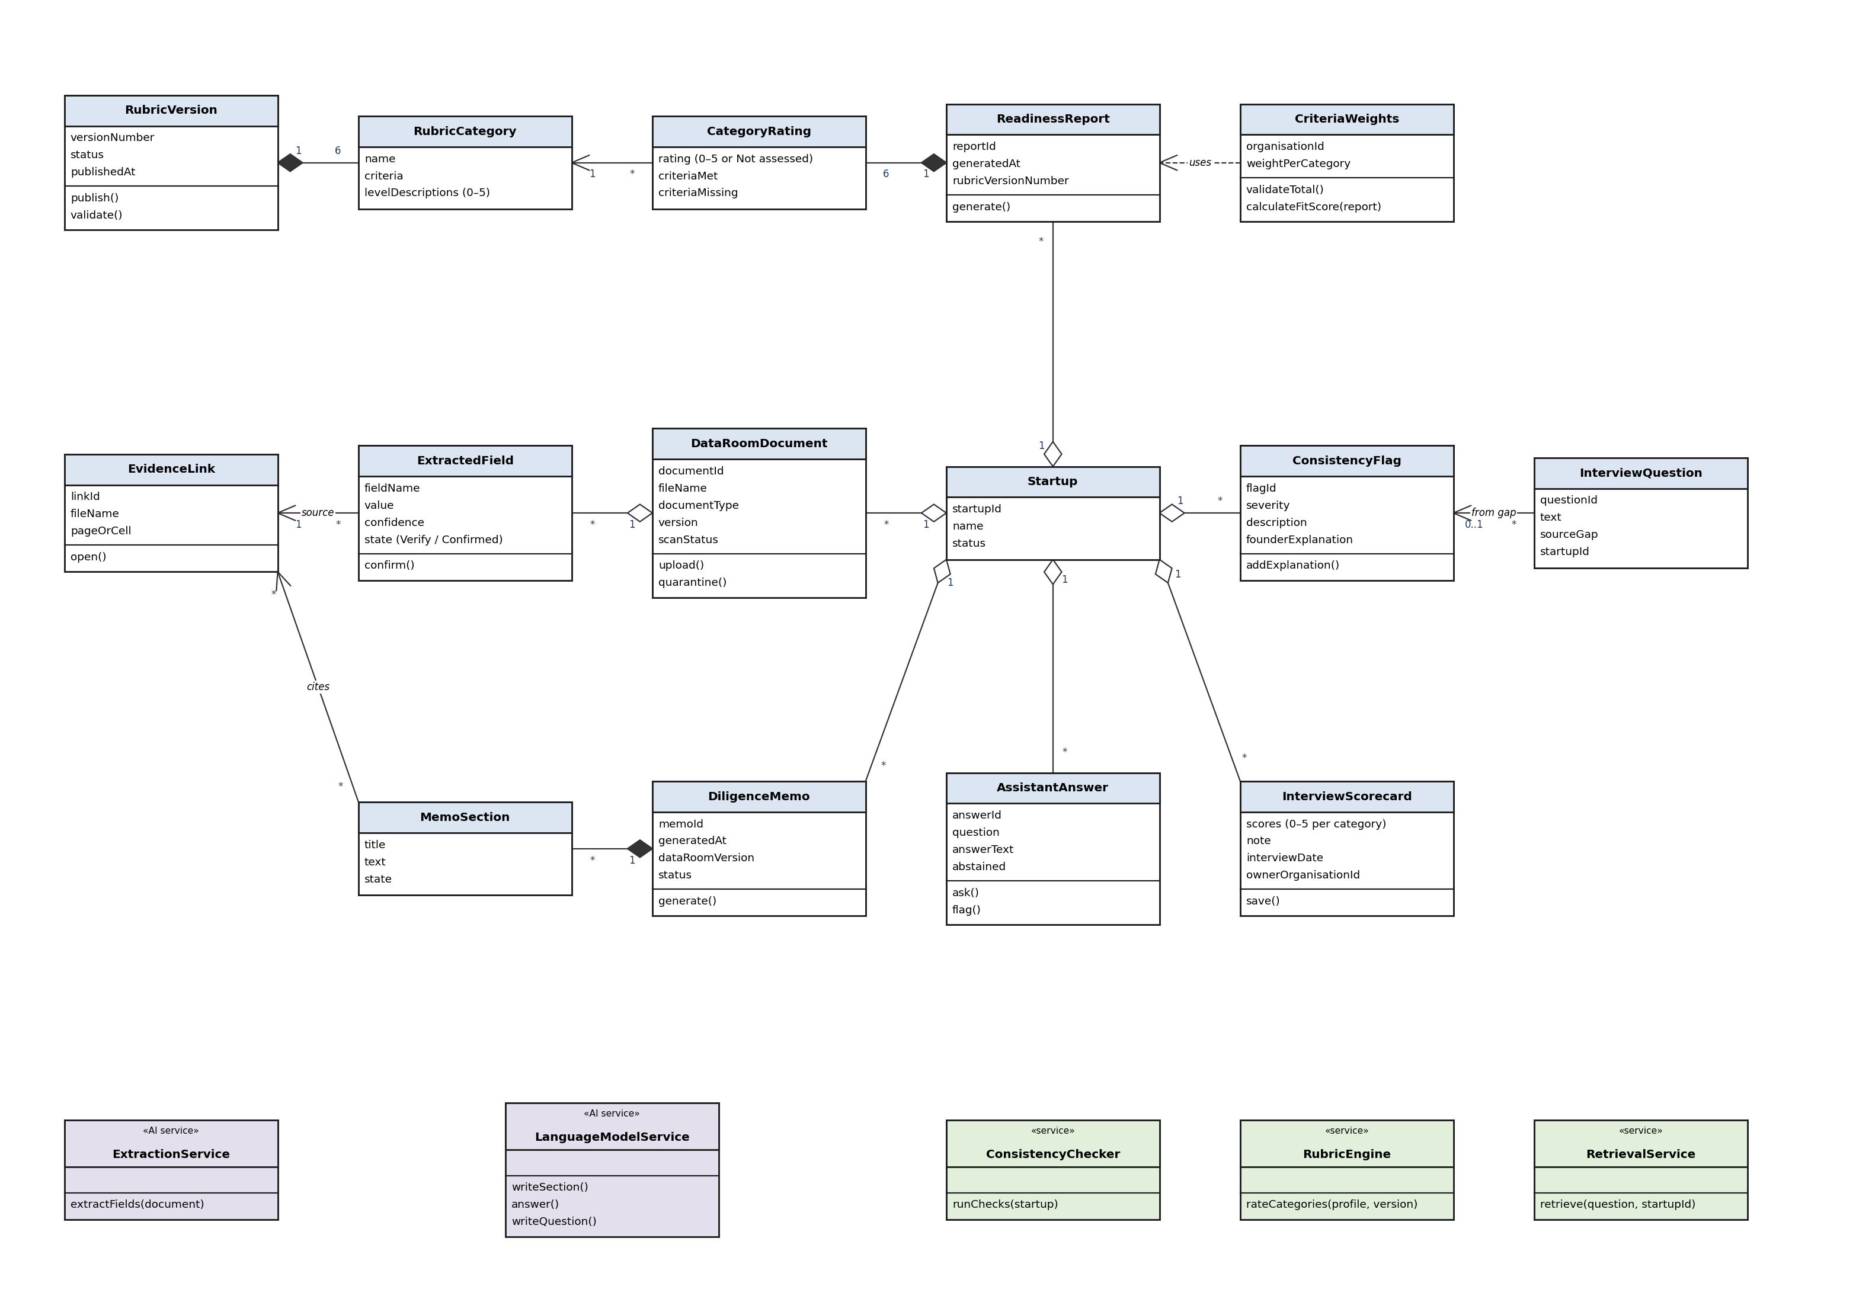 Figure 2: Assessment, evidence and AI-assisted outputs

Description

Class | Purpose
Figure 1: Users, organisations, programs and sharing
User (abstract) | Base class for every person who logs in. Holds identity, status and MFA setting, and the register, login and logout actions.
Founder | Owns one or more startups. Submits profiles and decides who can see the data room (UC-004, UC-010).
IncubatorManager | Runs programs and cohorts, shares startups with investors and organises demo days (UC-002, UC-011, UC-019).
InvestorAnalyst | Sets criteria weights, reviews and compares shared startups and records decisions (UC-013 to UC-018).
PlatformAdministrator | Approves accounts, publishes rubric versions and reviews the audit log (UC-001, UC-022, UC-023).
Organisation (abstract) | Base class for the two kinds of organisation, with an identifier, a name and a status.
Incubator | The incubation center that runs programs. It is the hub that connects startups and investors.
InvestorOrganisation | A VC firm, angel network or investor board. Stores sector, stage and ticket-size preferences used for matching (UC-003, UC-012).
Startup | The company being assessed. Holds the standard profile and its completeness and status; every other class hangs off it.
Program | One intake run by an incubator, with dates, status and the criteria weights used to rank its applicants.
Application | A startup's application to a program, with its consent to share and its fit score (UC-007).
Cohort | The accepted startups of a program. Can be filtered and shared (UC-009, UC-011).
ConsentRecord | Records that a Founder agreed to sharing by a named incubator, and when it was withdrawn.
AccessGrant | A permission that lets one investor organisation see one startup's data room. Can be revoked at any time (UC-010).
MeetingRequest | A request from an investor or incubator to meet a Founder, with proposed times and status (UC-020).
DemoDay | An event organised by an incubator with invited investor organisations and startup slots. Can be postponed or cancelled (UC-019).
DecisionRecord | An investor team's private stage and note for a startup (UC-018).
AuditLogEntry | An append-only record of who did what to which startup. It cannot be edited or deleted (UC-022).
Figure 2: Assessment, evidence and AI-assisted outputs
DataRoomDocument | A file uploaded by a Founder, with type, version and malware scan status (UC-005).
ExtractedField | A value read from a document by the extraction service, with its confidence. Values below 0.7 are marked "Verify" and left out of calculations.
EvidenceLink | Points to the exact file and page or cell behind a value, claim or answer.
ConsistencyFlag | A warning raised when data disagrees with itself, with severity and the Founder's explanation (UC-006).
RubricVersion | One published version of the readiness rubric. Older reports keep the version they used (UC-023).
RubricCategory | One of the six rubric categories, with its criteria and a written meaning for each 0 to 5 level.
ReadinessReport | The result of one readiness check: a rating for each category, the flags found and the rubric version used.
CategoryRating | A 0 to 5 rating for one category, with criteria met and missing. Shows "Not assessed" when there is no evidence.
CriteriaWeights | An organisation's saved weights. Calculates the fit score from a readiness report in code (UC-013).
DiligenceMemo | The one-page memo for an investor, with generation date and Data Room version (UC-016).
MemoSection | One section of a memo. Each claim carries an Evidence Link, and the section can read "Insufficient data" or "Unavailable".
AssistantAnswer | A question and its answer from one startup's documents only, with citations, or an "abstained" answer (UC-017).
InterviewQuestion | A question generated from one open flag or weak category, linked to its evidence (UC-008).
InterviewScorecard | A 0 to 5 score per category with a note, visible only to the organisation that recorded it.
ExtractionService (AI) | Reads key fields from uploaded documents. Used only for extraction, never for ratings.
LanguageModelService (AI) | Writes memo sections and interview questions and answers questions, using only the data it is given.
ConsistencyChecker | Rules in code that find cap table, revenue and missing-document problems.
RubricEngine | Rules in code that turn evidence into 0 to 5 ratings with the published rubric.
RetrievalService | Finds passages in one startup's documents only and enforces the citation rule.

Sequence Diagrams
UC-001: Register and Verify Account
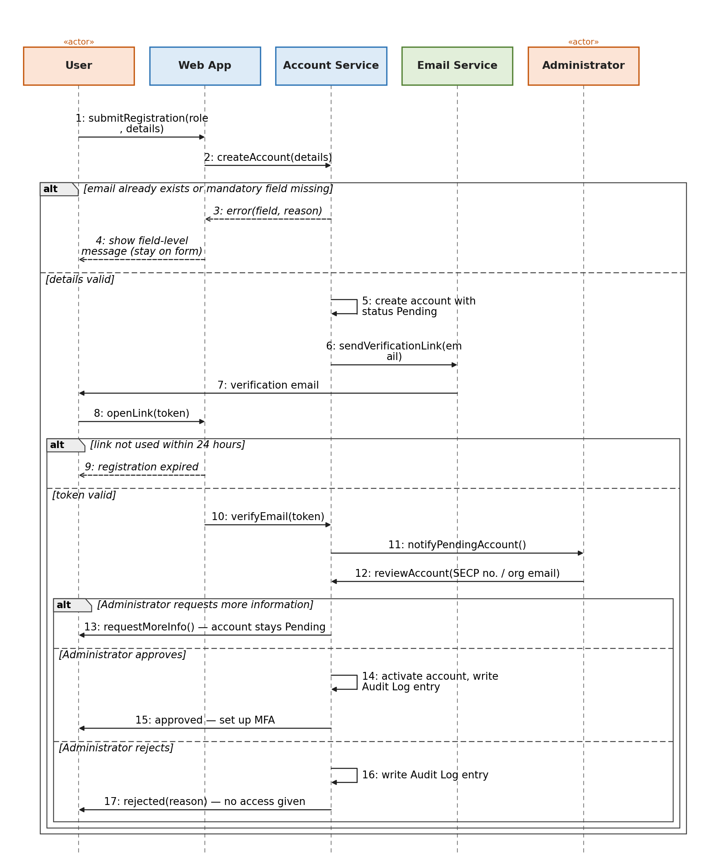
Alternate: A1 more information requested. Exceptions: E1 missing field or duplicate email, E2 link expired, E3 account rejected.
UC-005: Upload Data Room Documents
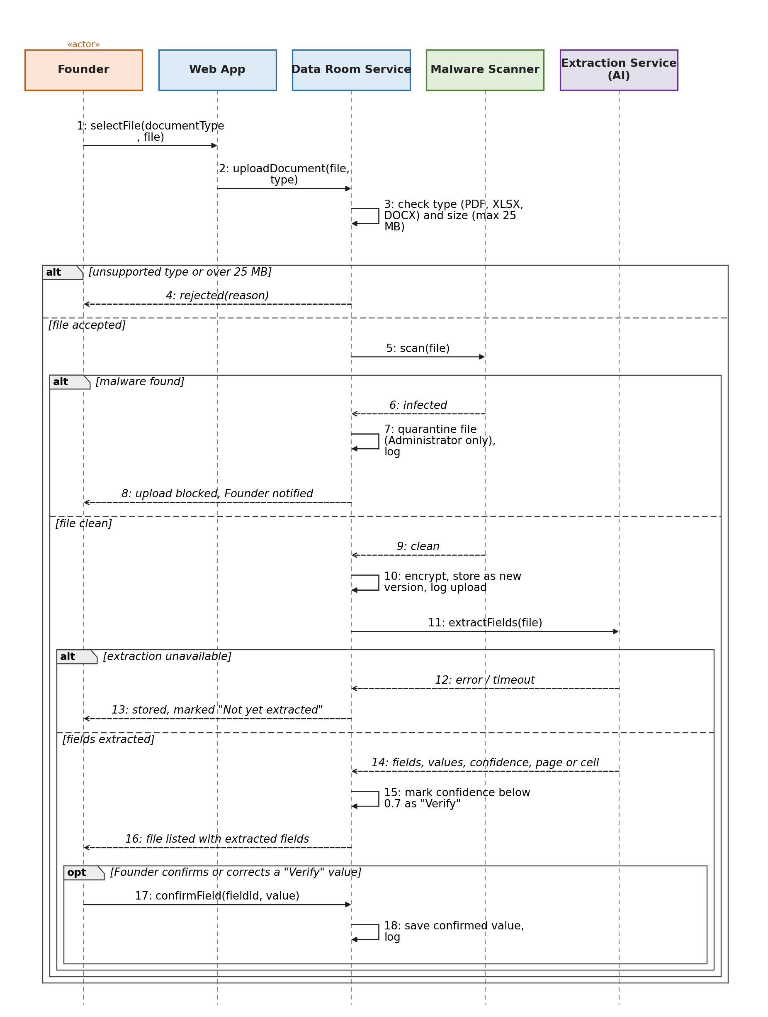
Alternate: A1 Founder confirms "Verify" values. Exceptions: E1 unsupported type or over 25 MB, E2 malware found, E3 extraction unavailable.
UC-006: Run Readiness and Consistency Check
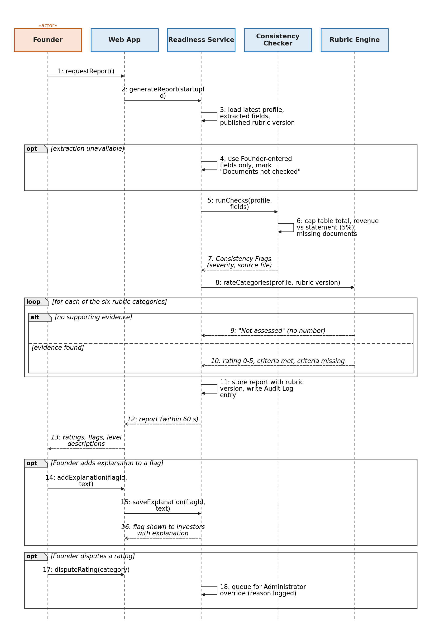
Alternate: A1 explanation added, A2 rating disputed. Exceptions: E1 category "Not assessed", E2 extraction unavailable.
UC-008: Interview Founder and Record Scorecard
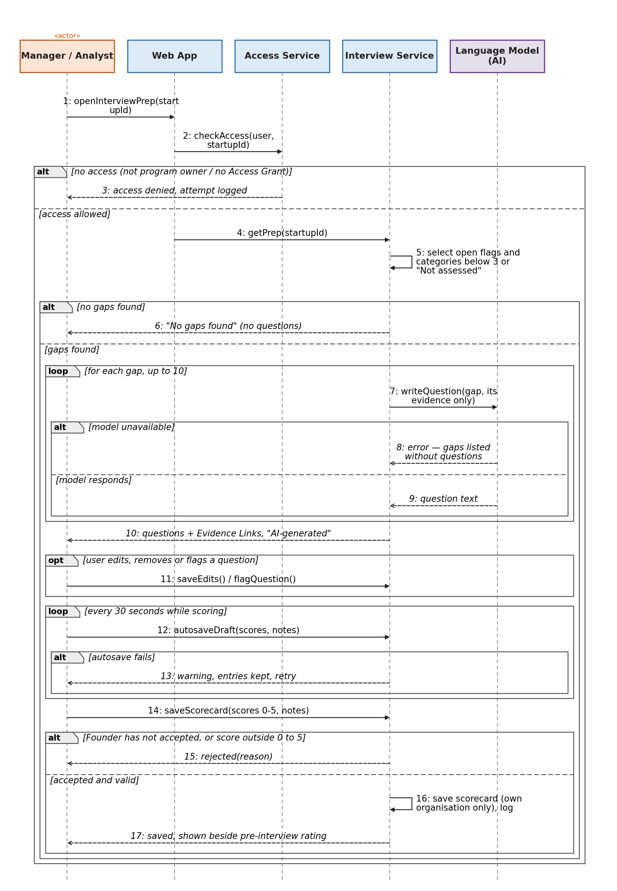
Alternate: A1 question flagged, A2 draft restored. Exceptions: E1 access denied, E2 no gaps, E3 model unavailable, E4 invalid score, E5 meeting not accepted, E6 autosave fails.
UC-010: Manage Consent and Data Room Access
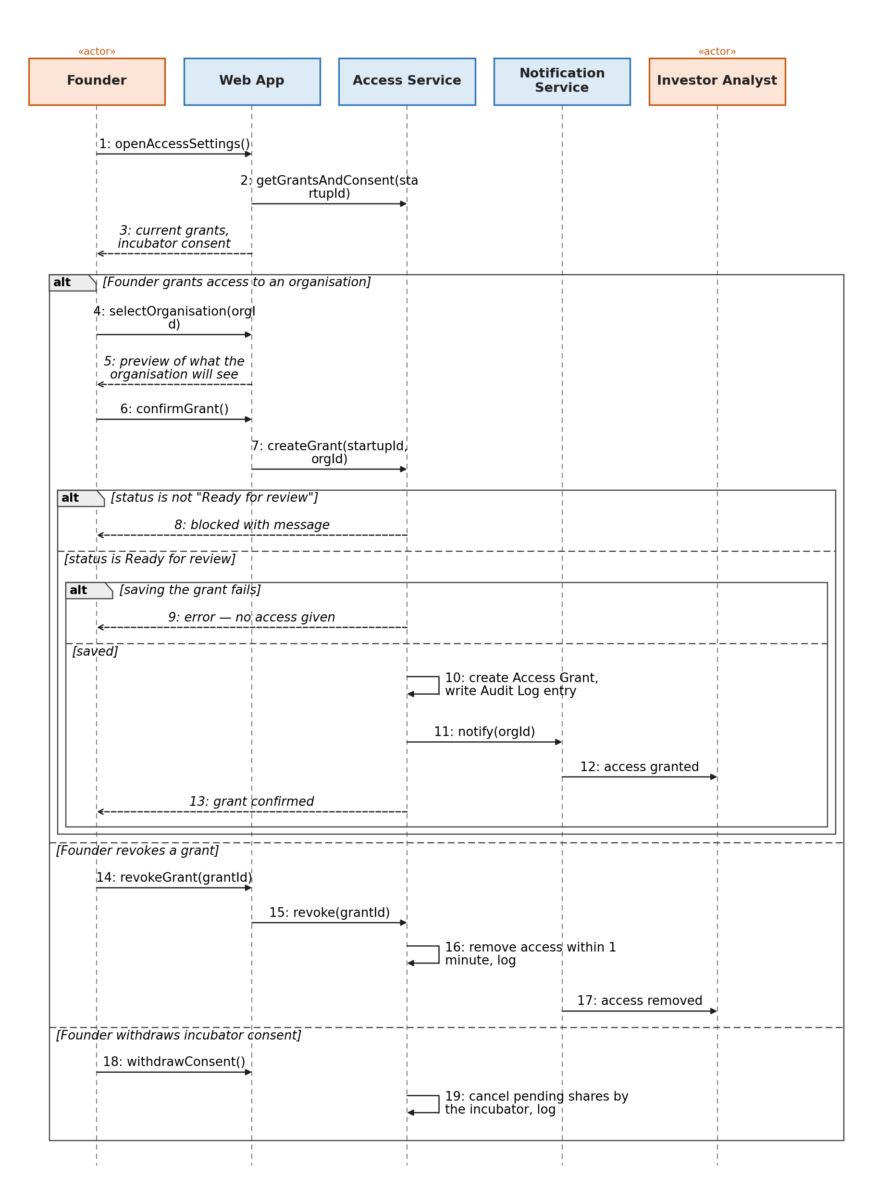
Alternate: A1 grant revoked, A2 incubator consent withdrawn. Exceptions: E1 status not "Ready for review", E2 saving fails.
UC-011: Filter Startups and Send Shortlist to Investors
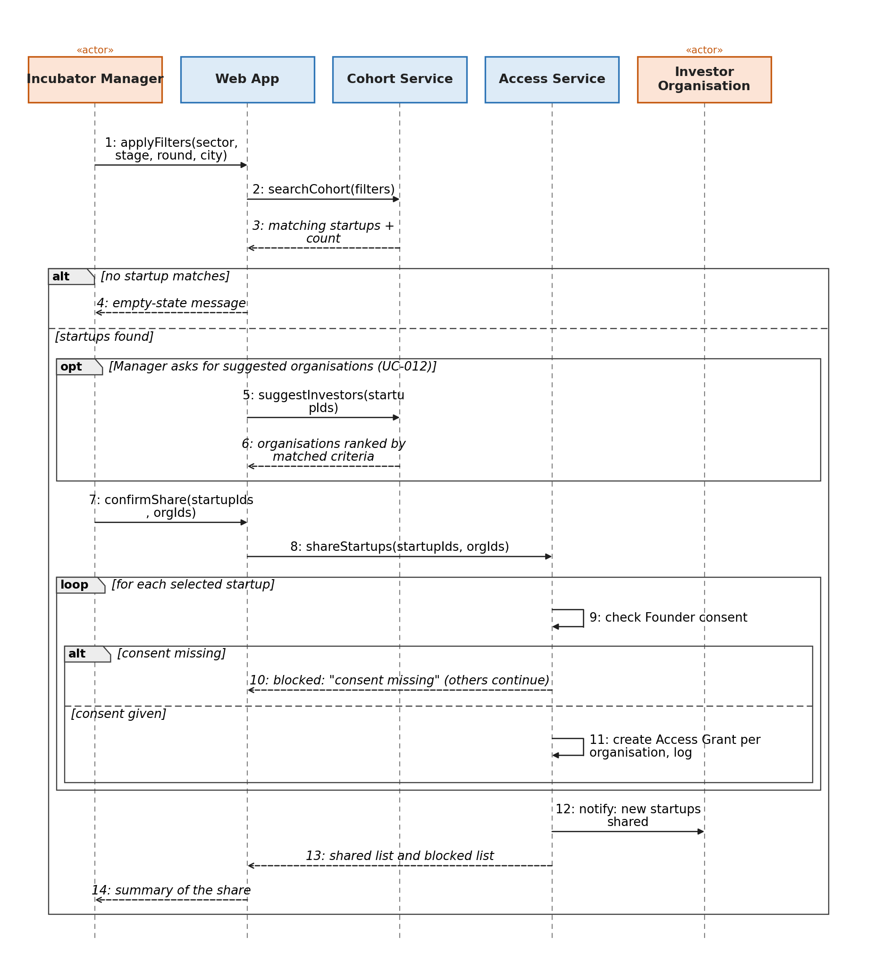
Alternate: A1 suggested organisations used. Exceptions: E1 no startup matches, E2 Founder consent missing.
UC-016: Generate Diligence Memo
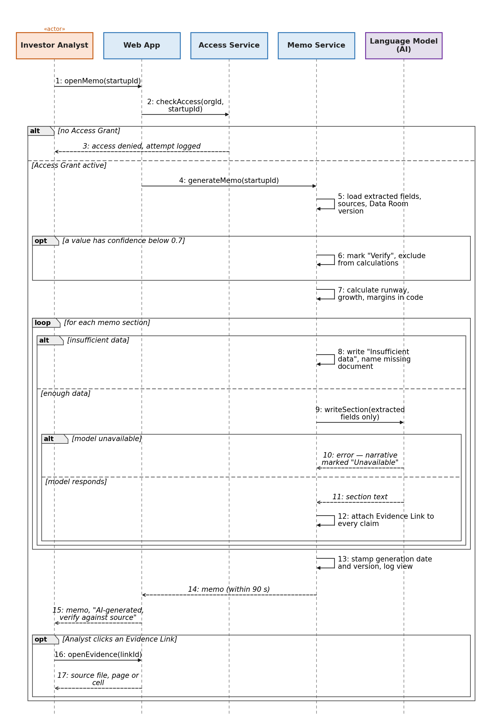
Alternate: A1 Evidence Link opened. Exceptions: E1 insufficient data, E2 low-confidence value, E3 model unavailable, no Access Grant.
UC-017: Ask Questions About a Startup
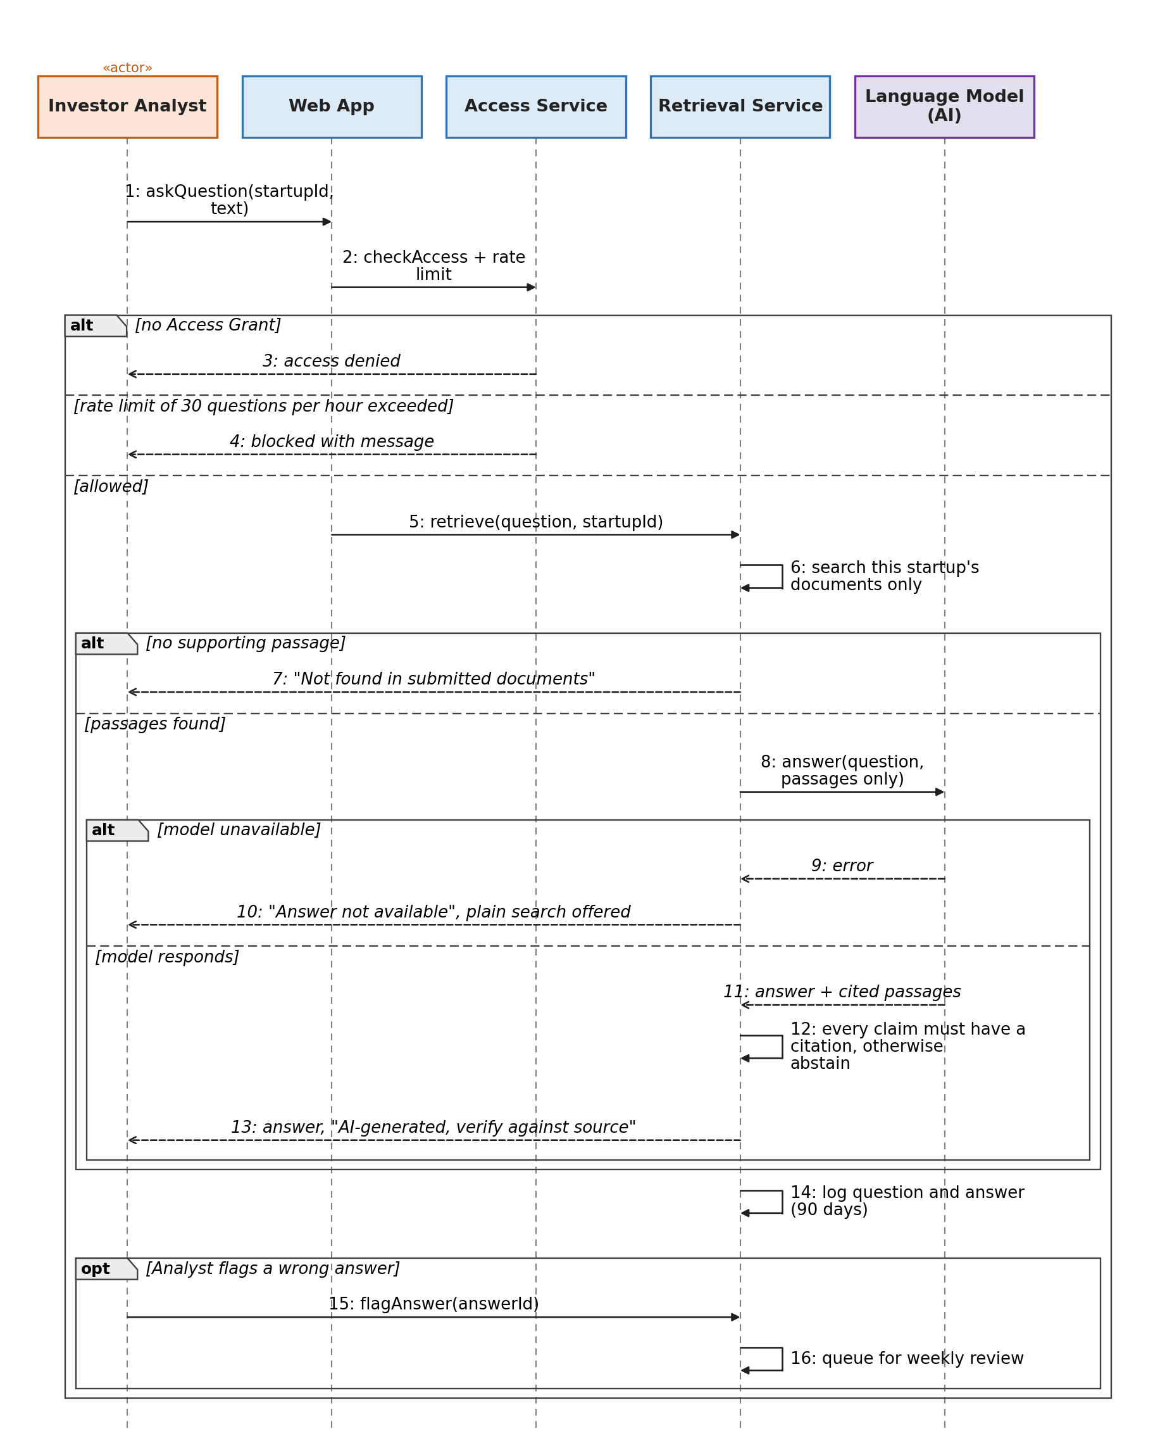
Alternate: A1 citation opened, A2 wrong answer flagged. Exceptions: E1 not found, E2 no Access Grant, E3 model unavailable, E5 rate limit.
UC-019: Organise Demo Day
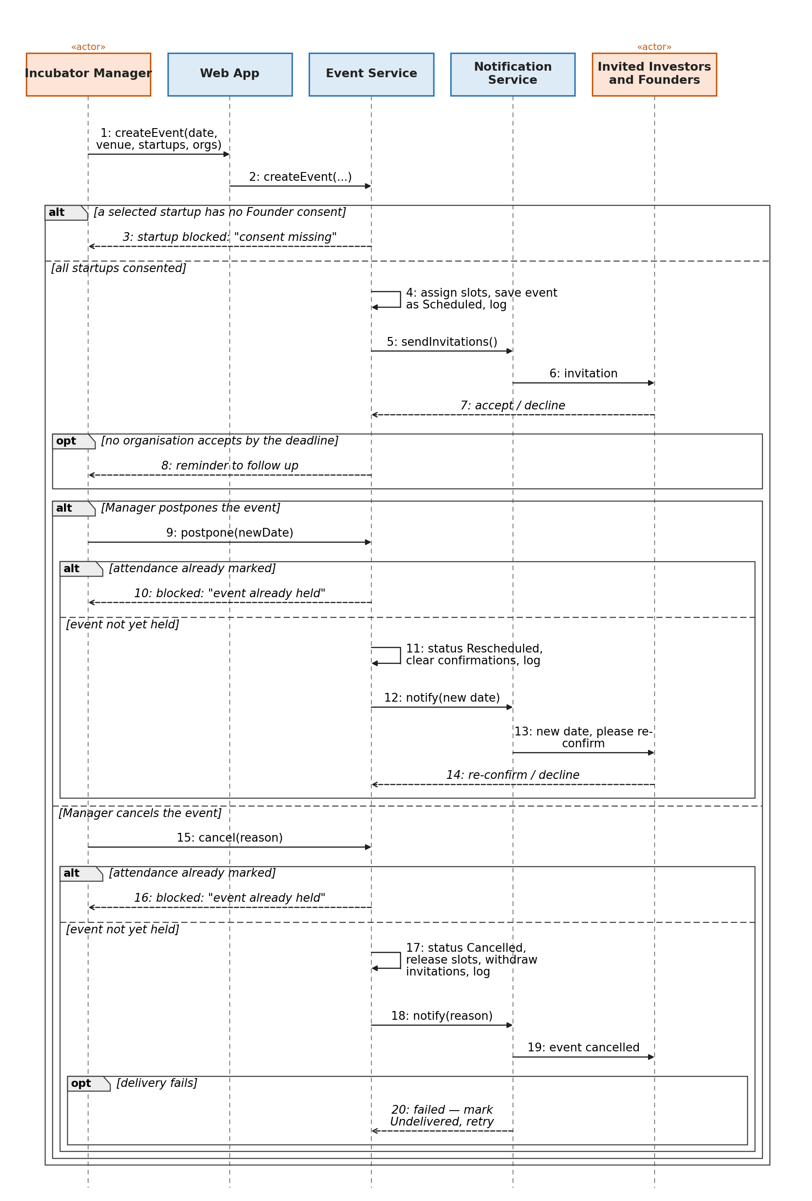
Alternate: A2 postponed, A3 cancelled. Exceptions: E1 consent missing, E2 no organisation accepts, E3 event already held, E4 notification undelivered.

AI / ML Requirements

AI / ML Requirements
The AI-dependent capabilities below are measurable, reviewable and designed with explicit human oversight and fallback behaviour.

AIR-001 - Grounded Q&A
AI Requirement ID | AIR-001
Related functional requirement | FR-010
Capability | Answer investor questions using only the selected startup’s Data Room documents, with source citations or an explicit abstention.
Autonomy level | Assists the Investor Analyst; it cannot make investment decisions or access documents outside the authorised startup.
Approach | Retrieval-augmented generation (RAG) over one startup’s documents only; retrieved passages are supplied to the language model and cited in the answer.
Quality metric | Faithfulness ≥ 0.95 and abstention accuracy ≥ 0.90; zero cross-startup data leaks.
Threshold | Faithfulness ≥ 0.95; abstention accuracy ≥ 0.90; 0 cross-startup leaks.
Evaluation dataset | 150 questions across 10 data rooms, including answerable, unanswerable and adversarial questions.
Measurement method | Run the labelled evaluation set after model, prompt or retrieval changes; record results against the dataset version.
Human oversight | The Investor Analyst verifies cited evidence and can flag an incorrect answer. AI output is labelled “AI-generated, verify against source”.
Fallback behavior | If evidence is insufficient or the model is unavailable, the system abstains and provides ordinary document search instead of inventing an answer.
Fairness / safety criterion | The system must not reveal information from another startup; protected or unrelated topics must not be answered from unauthorised data.
Cost and latency budget | p95 response latency ≤ 8 seconds; cost ≤ PKR 20 per question; maximum 30 questions per user per hour.
Data retention | Questions and answers are retained for 90 days; source documents follow the Data Room retention policy.

AIR-002 - Diligence Memo
AI Requirement ID | AIR-002
Related functional requirement | FR-008
Capability | Generate a source-linked one-page diligence memo from the startup profile and Data Room evidence.
Autonomy level | Assists the Investor Analyst; it summarizes evidence but does not make an investment recommendation or decision.
Approach | Document fields are extracted at upload; financial metrics are calculated deterministically in code; narrative sections are generated only from extracted, source-linked fields.
Quality metric | Extraction accuracy ≥ 0.90 and unsupported-claim rate ≤ 3%.
Threshold | Extraction accuracy ≥ 0.90; unsupported-claim rate ≤ 3%.
Evaluation dataset | 30 labelled data rooms reviewed by two reviewers.
Measurement method | Compare extracted numeric fields with labelled ground truth and manually audit memo claims against their Evidence Links.
Human oversight | Investor Analysts review the memo and its Evidence Links. Low-confidence extracted values are marked “Verify” and excluded from calculations until confirmed.
Fallback behavior | If AI generation fails, show structured startup information and available evidence rather than generating unsupported narrative.
Fairness / safety criterion | Every factual claim must have an Evidence Link; insufficient evidence must be shown as “Insufficient data”.
Cost and latency budget | Memo generation ≤ 90 seconds; cost ≤ PKR 40 per memo.
Data retention | Memos are retained for 90 days; extracted fields remain while the source document exists.

AIR-003 - Consistency and Readiness
AI Requirement ID | AIR-003
Related functional requirement | FR-003, FR-004
Capability | Support document field extraction used by consistency checks and readiness reporting without allowing the AI to determine ratings.
Autonomy level | Extraction only. Deterministic rules and the published rubric make consistency decisions and readiness ratings.
Approach | LLM/document-extraction service reads key fields; code performs consistency checks and rubric scoring.
Quality metric | Extraction-supported consistency checks: recall ≥ 0.90 and false-alarm rate ≤ 0.10; at least 80% of ratings within one point of reviewer consensus.
Threshold | Recall ≥ 0.90; false-alarm rate ≤ 0.10; ≥ 80% of ratings within one point of reviewer consensus.
Evaluation dataset | 40 data rooms containing seeded inconsistencies and human readiness ratings.
Measurement method | Run seeded-error detection and compare generated ratings with reviewer consensus; record results per rubric version.
Human oversight | Founders can explain flags or dispute ratings. Administrator overrides require a reason and are logged. Categories without evidence are “Not assessed”.
Fallback behavior | If extraction fails, use founder-entered fields and mark the report “Documents not checked”. No missing value is treated as zero.
Fairness / safety criterion | Ratings must be determined by the published rubric and evidence, not by free-form model judgement.
Cost and latency budget | Readiness report ≤ 60 seconds; AI extraction cost allocated to a report ≤ PKR 15.
Data retention | Ratings are stored with the rubric version; extracted fields remain while the document exists.

AIR-004 - Interview Questions
AI Requirement ID | AIR-004
Related functional requirement | FR-020, FR-023
Capability | Generate interview questions from open consistency flags and weak or unassessed rubric categories.
Autonomy level | Assists the Incubator Manager or Investor Analyst; users edit or remove questions before use.
Approach | Code selects the relevant flags/categories and their evidence; an LLM converts them into up to 10 evidence-based interview questions.
Quality metric | Question relevance ≥ 0.90 and zero questions targeting protected or unrelated topics.
Threshold | Relevance ≥ 0.90; protected-topic questions = 0.
Evaluation dataset | 30 labelled data rooms reviewed by two reviewers.
Measurement method | Review generated questions against the linked gap/evidence and label relevance and protected-topic violations.
Human oversight | Users can edit, remove or flag questions. The interface labels them “AI-generated, check before use”.
Fallback behavior | If the model is unavailable, show the identified flags and weak categories without generated questions.
Fairness / safety criterion | Every question must be traceable to an identified gap or evidence; no protected-topic probing is permitted.
Cost and latency budget | Question list ≤ 30 seconds; cost ≤ PKR 10 per list.
Data retention | Generated question lists are retained for 90 days.

Data Requirements

PSIB uses founder-entered startup data, private Data Room documents, platform workflow data and controlled evaluation datasets.

Data Sources | Startup Profile: team, sector, stage, traction, financials, cap table, round details and incorporation details. Data Room: financial statements, incorporation documents, contracts and cap tables. Platform data: accounts, organisations, investor preferences, criteria weights, programs, cohorts, applications, consent records, access grants, meetings, demo days, scorecards, decisions and audit logs. Evaluation data: synthetic test data and anonymised real data only with explicit consent.
Data Requirements | QA evaluation: 150 questions across 10 data rooms. Diligence memo: 30 labelled data rooms. Consistency/readiness: 40 data rooms. Interview questions: 30 labelled data rooms. Evaluation data should cover different startup sectors and cities. Missing information must remain missing and must never be guessed or treated as zero.
Pre-processing | Validate document type and malware-scan files before extraction. Extract text and structured fields with page/cell references. Normalise monetary values to PKR where applicable, dates to a common format and percentages to a consistent representation. Preserve source references. Mark extracted values below 0.70 confidence as “Verify” and exclude them from calculations until confirmed. Split evaluation data by startup/data-room so no startup appears in both evaluation and test subsets.
Model Requirements | Version 1 does not train a proprietary scoring model. Readiness scoring, consistency checks, financial calculations, fit scores and investor matching use deterministic rules in code. AI-dependent capabilities use versioned model/provider identifiers and are re-evaluated after model, prompt, retrieval or extraction changes. Use an AI provider whose terms prohibit training on PSIB data and provide appropriate retention controls.
Privacy and Retention | Startup documents and user questions must not be used to train external models. AI outputs are retained for 90 days where specified. Startup documents and AI-related stored outputs are deleted within 30 days of account deletion. Audit logs are retained for at least one year and contain no document content. After account deletion, retained audit entries replace the user name with an anonymous identifier. Autosaved drafts remain private to their author and are deleted when discarded or when the account is deleted. Retrieval is limited to the selected startup’s Data Room and only to users whose organisation has an Access Grant.

Non-functional Requirements / Quality Attributes

ID | Category | Requirement (measurable) | How it will be measured
NFR-001 | Performance | At least 95% of non-AI pages, including the startup profile, startup list, comparison view and cohort dashboard, should load within 2 seconds with up to 100 concurrent users. | Run load tests in staging using k6 or Locust before each release and record the results in the project repository.
NFR-002 | Performance | A file of up to 25 MB should upload within 30 seconds on a 10 Mbps connection. After upload, the file should be processed and shown as available in the Data Room within 2 minutes. | Test uploads using a throttled 10 Mbps connection and measure both upload time and document-processing time from system logs.
NFR-003 | Performance | At least 95% of AI-based question-answering requests should return within 8 seconds, and at least 95% of diligence memos should be generated within 90 seconds, with up to 20 concurrent AI requests. | Record latency through the API gateway during load testing at the target concurrency level.
NFR-004 | Reliability | PSIB should maintain at least 99% availability per month during the pilot, excluding planned maintenance. If the system fails, normal service should be restored within 4 hours. An outage of the AI provider should not stop non-AI features from working. | Use an uptime monitor and incident log. Review availability weekly and simulate one AI provider outage before the pilot.
NFR-005 | Reliability | System data should be backed up at least once every 24 hours. After a failure, no more than 24 hours of data should be lost, and a complete restore should be possible within 4 hours. | Carry out at least one restore test from backup during the project and record restore time and any data loss.
NFR-006 | Scalability | The initial system should support at least 20 startups, 10 investor users and 5 incubator users. At 10 times this load, with 200 startups, 100 investor users and 50 incubator users, the performance targets in NFR-001 and NFR-003 should still be met. | Run load tests with synthetic data at both the expected launch load and 10 times that load. Monitor API latency, queue length, model rate limits and server resources to identify bottlenecks.
NFR-007 | Usability and Accessibility | At least 8 out of 10 pilot users should be able to complete their main task within 10 minutes without assistance. For a Founder, this means uploading documents and opening the readiness report. For an Investor Analyst, this means finding a startup and opening its diligence memo. The overall System Usability Scale score should be at least 70. | Conduct moderated usability sessions with pilot users, record task completion time and assistance required, and collect a System Usability Scale questionnaire after testing.
NFR-008 | Usability and Accessibility | Core PSIB pages should meet WCAG 2.1 Level AA requirements. Automated accessibility testing should report no critical accessibility issues, and all main tasks should be possible using only a keyboard. | Run axe accessibility scans in CI for core pages and carry out a manual keyboard-only walkthrough before each release.
NFR-009 | Cost | The total monthly running cost should not exceed PKR 3,000 per active startup, including hosting, document storage, OCR and AI inference. This target should be reviewed after real usage data becomes available. | Add monthly hosting, storage, OCR and AI provider costs and divide the total by the number of active startups. Review the result at the end of each sprint.
NFR-010 | Maintainability | The system should keep authentication, Data Room management, document extraction, readiness scoring and question answering in separate modules. Unit test coverage for the readiness rubric and consistency-checking logic should be at least 70%. No function in these modules should have a cyclomatic complexity above 15. | Generate test coverage and code complexity reports automatically in CI on every merge to the main branch.
NFR-011 | Observability | Every AI request should record the model used, request latency, token usage and retrieval identifiers, but should not store the actual private document text in application logs. Every access to a startup Data Room should also be logged. The system should raise an alert if the error rate exceeds 5% over a 5-minute period or if daily AI spending exceeds the configured limit. | Review the logging configuration and run simulated failures and cost spikes in staging. The relevant alert should be triggered within 5 minutes.
NFR-012 | Portability and Compatibility | The web application should work on the latest two versions of Chrome, Edge, Safari and Firefox. Core pages should also remain usable on mobile browsers with screen widths down to 360 pixels. | Run a cross-browser and responsive-design test checklist before each release.
NFR-013 | Legal and Compliance | PSIB should record consent whenever startup information is shared with an investor or incubator. Users should be able to request access to, correction of or deletion of their personal data, and deletion requests should be completed within 30 days. The system should also record the region where startup data is hosted. | Review a compliance checklist before the pilot and carry out at least one complete test of a data deletion request from submission to removal.
NFR-014 | Legal and Compliance | Every external dataset or published market benchmark used by PSIB should have its source, publication date and usage terms recorded. Data should only be used where its licence or terms allow the intended use. | Maintain a data-source register and review it before each release.

These requirements are meant to support the actual way PSIB will be used. For example, performance targets cover both normal web pages and slower AI-based features, while reliability requirements make sure the rest of the platform can continue working even if the AI provider is unavailable. The cost requirement is also important because document processing and AI usage can become expensive as the number of startups grows.
The usability targets focus on the main tasks that founders and investors are expected to perform during the pilot. Accessibility is included because users should be able to complete core tasks regardless of device or input method. Maintainability and observability requirements help the team detect problems and change individual parts of the system without affecting the entire platform.
The legal and compliance requirements focus on consent, access to personal data, deletion and the use of external datasets. Since PSIB may store sensitive startup documents and ownership information, these requirements are treated as part of the system design rather than something to add after development.

Security Requirements

- OWASP Top Ten: https://owasp.org/www-project-top-ten/
- OWASP Mobile Top 10: https://owasp.org/www-project-mobile-top-10/
- OWASP Machine Learning Security Top Ten: https://owasp.org/www-project-machine-learning-security-top-10/
- OWASP Top 10 for LLM Applications: https://owasp.org/www-project-top-10-for-large-language-model-applications/
- OWASP Top 10 API Security Risks: https://api-security.owasp.org/editions/2023/en/0x11-t10/

Security Requirements

PSIB stores private financial statements, cap tables, contracts, incorporation documents and other sensitive startup information. It also uses AI to process some of these documents. The main security risks therefore come from unauthorized access to startup data, compromised accounts, unsafe file uploads, attacks against the AI features and failures in monitoring or access control.
The following requirements identify the main risks that apply to PSIB, the possible impact of each risk and the controls that should be implemented.

ID | Security Risks | Potential Losses | Controls
SEC-001 | Broken access control: A user from one investor organisation, incubator or startup gains access to another startup’s private Data Room without permission. | Confidential financial, legal or ownership information may be exposed. Startups may lose trust in PSIB and stop using the platform. The platform may also face complaints or legal consequences for exposing private information. | Use role-based access control together with startup-specific Access Grants. Check authorization on the server for every protected request. Include the startup and organisation identifier in database queries. Run automated cross-tenant access tests in CI. Record Data Room access in the Audit Log. Limit an incubator's access to startups in its own cohorts for which the Founder has given consent. Show notes, decision stages, interview scorecards and autosaved drafts only to the author's organisation or to the author.
SEC-002 | Identification and authentication failures: An attacker takes over a legitimate account or creates a fake investor account to access startup information. | An attacker could view or download confidential startup documents, impersonate a legitimate user or collect commercially sensitive information. This could cause data loss, reputational damage and loss of user trust. | Require MFA for all user roles. Require Administrator approval for new accounts and verify organisation information for investor accounts. Apply login rate limits and temporary lockouts after repeated failed attempts. Use secure session management and automatically expire inactive sessions after 30 minutes. Verify the email address with a link that expires after 24 hours before the account reaches the Administrator, and require users to set up MFA when the account is activated. Show the Founder's SECP registration number to the Administrator during review.
SEC-003 | Cryptographic failures and sensitive data exposure: Financial statements, cap tables, contracts or other private information are exposed while being transferred or stored. | Startups could lose confidential business information. The exposure could lead to privacy complaints, legal consequences and loss of confidence in the platform. | Use TLS 1.2 or higher for data in transit and encryption for stored documents and sensitive database fields. Store credentials and API keys in a managed secrets vault rather than in source code. Use short-lived signed links for document downloads. Do not place private document text in application logs.
SEC-004 | Injection and unsafe file uploads: A malicious user uploads a harmful PDF, DOCX or XLSX file, or sends input designed to perform SQL or other injection attacks. | An attacker could compromise the application, access or modify stored information, execute malicious code or cause the platform to become unavailable. Script code entered in profile or note fields could also run in another user's browser. | Use parameterized database queries and server-side input validation. Allow only approved file types and verify the actual file content rather than trusting the extension. Scan uploaded files for malware, remove or reject active macros where applicable and process documents in an isolated environment. Quarantine files that fail security checks. Encode all user-entered text, such as profile fields and notes, when it is displayed to other users, and use a Content Security Policy to reduce stored cross-site scripting. Keep quarantined files visible only to the Administrator.
SEC-005 | Prompt injection: Instructions hidden inside an uploaded document attempt to make the AI ignore PSIB’s rules, change a rating or memo, or reveal information belonging to another startup. | The system could produce misleading diligence information or expose confidential information from another startup. Investors could make decisions based on manipulated output. | Treat retrieved document content as data rather than system instructions. Restrict retrieval to the startup currently being reviewed. Do not allow the model to decide readiness scores directly. Require citations for document-based answers and memos. Include prompt-injection examples in the AI evaluation dataset. The model used for document analysis should not receive unnecessary tools or network access. Apply the same rules to interview-question generation, which should use only the selected gap and its evidence.
SEC-006 | Sensitive information disclosure through the AI provider: Private startup information sent for AI processing is retained, used for training or becomes available across different startup sessions. | Confidential startup information could leave the intended environment or become exposed to another user. This could result in privacy violations, commercial harm and loss of trust in PSIB. | Use an AI provider whose terms allow no training on PSIB data and appropriate limits on retention. Keep AI context separate for every startup and never share conversation memory between startups. Send only the information needed for the task. Redact unnecessary personal identifiers before model requests where possible.
SEC-007 | Misinformation and over-reliance: The AI generates an incorrect figure, unsupported statement or misleading interpretation in a diligence memo or document-based answer. | Investors may make decisions using incorrect information, and a startup may be unfairly assessed. Repeated errors could reduce confidence in the platform. | Require Evidence Links for factual AI-generated claims. Make the system abstain when supporting evidence cannot be found. Mark low-confidence extracted information as “Verify” and exclude it from calculations until confirmed. Perform financial calculations in deterministic code rather than through the LLM. Allow users to report incorrect AI outputs.
SEC-008 | Security logging and monitoring failures: Unauthorized access or suspicious activity occurs without being recorded, or audit information can be changed or deleted. | Data leaks may be difficult to investigate and PSIB may be unable to determine who accessed a startup’s information. Disputes between users may also be difficult to resolve. | Maintain an append-only Audit Log that normal users cannot edit or delete. Record important actions such as Data Room views, downloads, access grants, revocations and AI questions. Restrict Audit Log access to authorized administrators. Raise an alert for suspicious activity such as more than 20 document downloads by one user within 10 minutes. Keep security audit records for at least one year. Also log Administrator rating overrides with a reason, rubric publications and every access to the Audit Log itself. Refuse and log any attempt to edit or delete an entry. Audit entries contain no document content. Question and answer text is kept for 90 days.
SEC-009 | Unbounded AI consumption: A user repeatedly calls the question-answering, memo or interview-preparation features and causes excessive AI usage. | AI costs could increase unexpectedly and model rate limits could make the service unavailable to other users. In a severe case, operating costs could make the pilot unsustainable. | Apply per-user rate limits, including a limit of 30 document questions per hour. Set maximum input and output token limits. Use a queue for long-running AI tasks. Set a daily AI spending limit and alert administrators when usage approaches or exceeds the configured limit.
SEC-010 | Tampering with the readiness rubric or ratings: a rubric version is changed without authorization, or a rating is overridden without a valid reason, for example through a compromised Administrator account. | Startups could be rated unfairly and investors could rely on manipulated ratings. Earlier reports could no longer be explained, and trust in PSIB's ratings would fall. | Only Administrators with MFA can publish rubric versions or override ratings. Block publishing if any rating level in any category has no description. Do not allow a published version to be edited, and store the rubric version used in every report. Require a reason for every override and write it to the Audit Log. Do not allow external information to silently change the rubric criteria.
SEC-011 | Broken object-level authorization in APIs: A user changes a startup, document, memo or application identifier in an API request to access an object they are not authorized to view. | An authenticated user could bypass the interface and access another startup’s documents, reports or private investor information directly through the API. | Check object-level authorization on the server for every API request rather than relying on the user interface. Verify the user’s role, organisation and Access Grant before returning an object. Use non-predictable identifiers where appropriate and include negative authorization tests in CI.
SEC-012 | Excessive data exposure through APIs: An API response returns more startup or user information than the current screen or user actually requires. | Sensitive fields could be exposed even when the user does not have a legitimate reason to receive them. Information may also be captured by browser tools, logs or compromised clients. | Define explicit response schemas for each API endpoint and return only the fields required for that operation. Perform authorization before serialization. Do not return hidden sensitive fields and rely on the client to remove them. Test API responses for each role and access level. The cohort impact report should return aggregated figures only and never include investor notes, decision stages or scorecards.
SEC-013 | Unrestricted access to sensitive business flows: a user floods Founders with meeting requests or invitations, or an Incubator Manager shares startups with investor organisations without the Founder's consent. | Founders could be spammed or phished through platform notifications, startup information could be shared without permission, and users could lose trust in PSIB. | Check the Founder's consent on the server before every share. Meeting requests expire after 7 days and Founders can decline them. Limit each user to 5 meeting requests per day. Only approved Incubator Managers can send demo day invitations. Notification emails contain no document content, only a link to the platform. Log every request, invitation and share.

Security Engineer

Name of the Security Engineer | Subhan Malik

Use of Generative AI

AI Usage Log

Sr# | 1 | Section(s) | Purpose of use
Tools & Version | ChatGPT (GPT-5)
Section(s) | Use case descriptions; requirements review
Purpose of use | Generated and refined draft exception paths and alternate flows for selected use cases, and helped identify inconsistencies and missing requirement details.

Verification and Modification

Sr# | 1 |  | Changes Made by the Team
  Errors Found in AI Output
How the Output Was Verified | The team checked generated flows against the PSIB actors, permissions, preconditions/postconditions, data-access rules and existing project decisions.
Errors Found in AI Output | Generic or unsupported workflow details could appear when they were not grounded in PSIB’s actual roles or data-access rules.
Changes Made by the Team | Removed unsupported details, aligned terminology and IDs with the PSIB model, and retained only flows that matched the project requirements.

Reflection

(a) Which parts of this deliverable were done without AI, and why?
(b) Where did AI help most, and where was it unhelpful or misleading?
(c) Did using AI change any design or requirements decision? If yes, explain.
a. Parts completed without AI: The team’s project-specific decisions, system scope, actors, workflows, diagrams, security priorities and final validation were reviewed and determined by the team. AI was used only as an assisting tool; the team remained responsible for the final requirements.
b. Where AI helped / where it was unhelpful: AI helped most with drafting alternative and exception paths, identifying missing cases and improving wording. It was less reliable when a generic workflow did not match PSIB’s specific roles, consent rules or access-control model, so generated content had to be checked against the project design.
c. Effect on design decisions: AI did not replace the team’s core architecture or investment-decision rules. It helped the team make explicit that AI should remain assistive: readiness ratings, consistency checks, financial calculations and investor matching are deterministic, while AI outputs require evidence, human review and defined fallbacks.

Who Did What?

Name of the Team Member | Tasks done
Minaa Azmat | Introduction; Why can’t an AI chatbot with well-crafted prompts build your system?; Non-functional Requirements / Quality Attributes.
Huzaif ur Rehman | System Actors; Use Cases and use-case descriptions; actor and permission consistency.
Abdullah Ahmad | Class Diagram; Sequence Diagrams; consistency checks between diagrams and use-case IDs.
Subhan Malik | AI / ML Requirements; Data Requirements; AI capability evaluation criteria.
Akbar Munj | Security Requirements; Security Engineer coordination and security-control review.

Review checklist

Section Title | Reviewer Name(s)
Introduction | Huzaif ur Rehman
Why can’t an AI chatbot with well-crafted prompts build your system? | Abdullah Ahmad
System Actors | Akbar Munj
Use Cases | Minaa Azmat
Class Diagram | Subhan Malik
Sequence Diagrams | Huzaif ur Rehman
AI / ML Requirements | Akbar Munj
Data Requirements | Abdullah Ahmad
Non-functional Requirements / Quality Attributes | Subhan Malik
Security Requirements | Minaa Azmat
Security Engineer | Huzaif ur Rehman
Use of Generative AI | Abdullah Ahmad
Who Did What? | Akbar Munj
Review Checklist | Minaa Azmat

